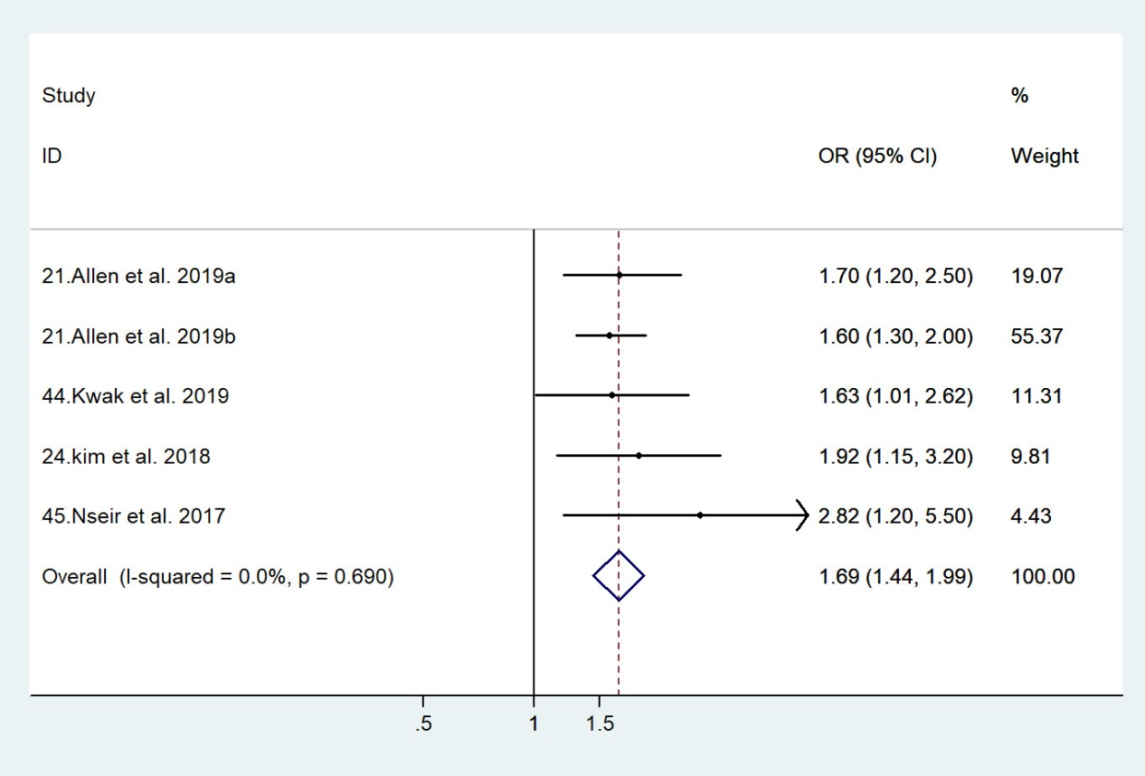
Supplementary Figure 1. Forest plot of the meta-analysis of the association between NAFLD and breast cancer.

