Electronic Supplementary Material (ESM)

Systematic variation of film production parameters of edible pectin-alginate/orange peel biocomposites

Sinan Barış Uncu,ª Merve Mocan,^{b*}

ª Materials Engineering and Nanotechnology, Politecnico di Milano, Italy
^{b} Materials Science and Engineering, Gebze Technical University, Türkiye

*Corresponding author:
E-mail: mmocan@gtu.edu.tr

Figure S1. Particle size distribution of coarse orange peel powder, prior to grinding.
Table S1. Particle size analysis results of coarse orange peel powder, prior to grinding.
 | d (0.1) | d (0.5) | d (0.9)
Coarse opp | 23,173 | 163,376 | 607,536

Figure S2. Particle size distribution of fine orange peel powder, after grinding.
Table S2. Particle size analysis results of fine orange peel powder, after grinding.
 | d (0.1) | d (0.5) | d (0.9)
FINE opp | 8,192 | 61,616 | 214,031

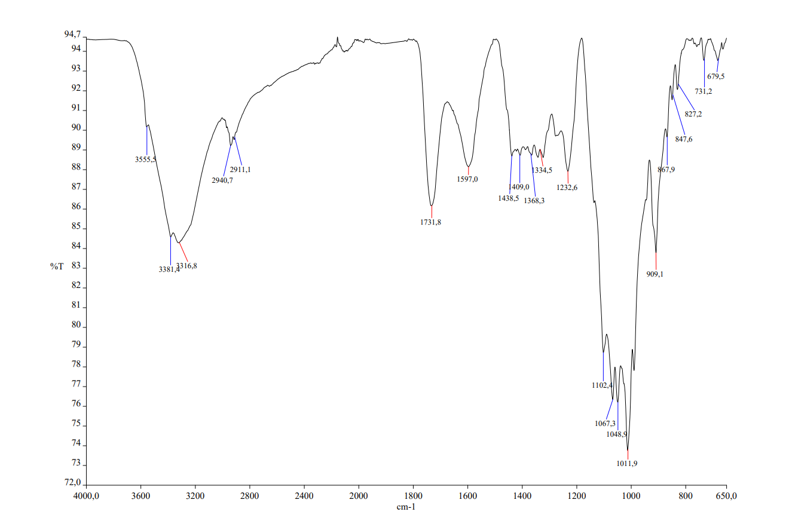
Figure S3. FTIR spectrum of pectin.
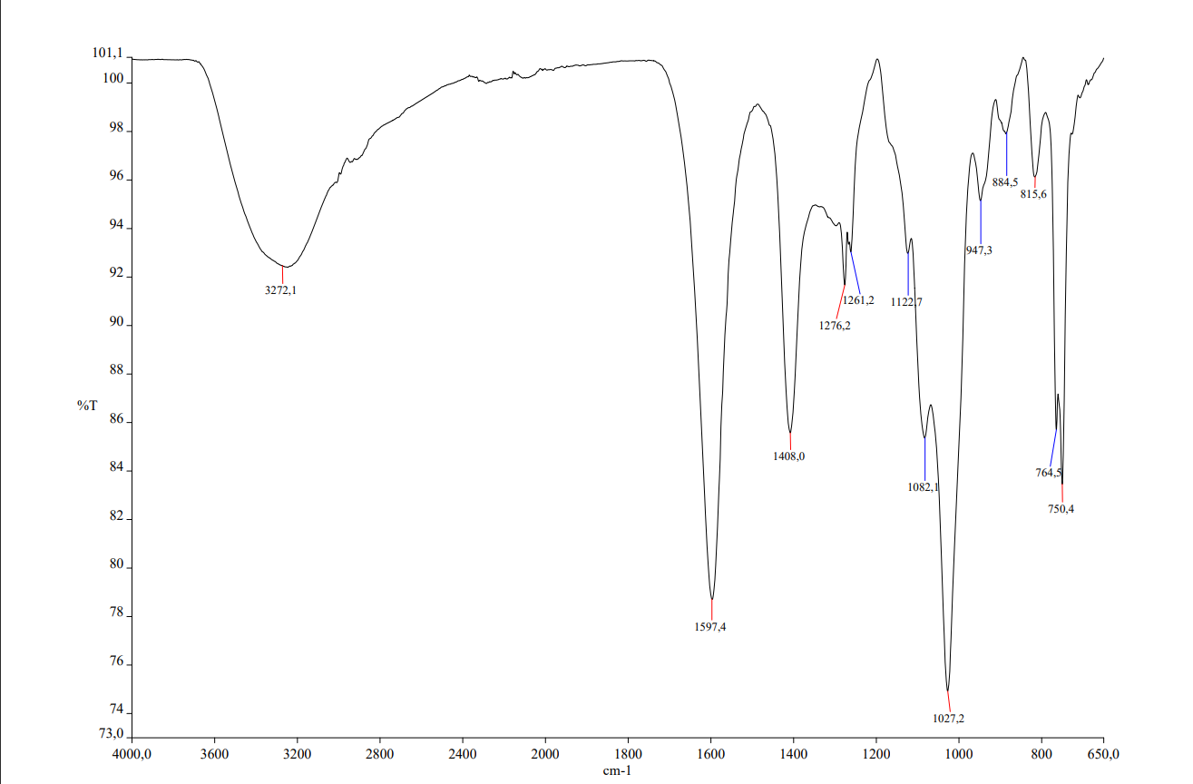
Figure S4. FTIR spectrum of alginate.
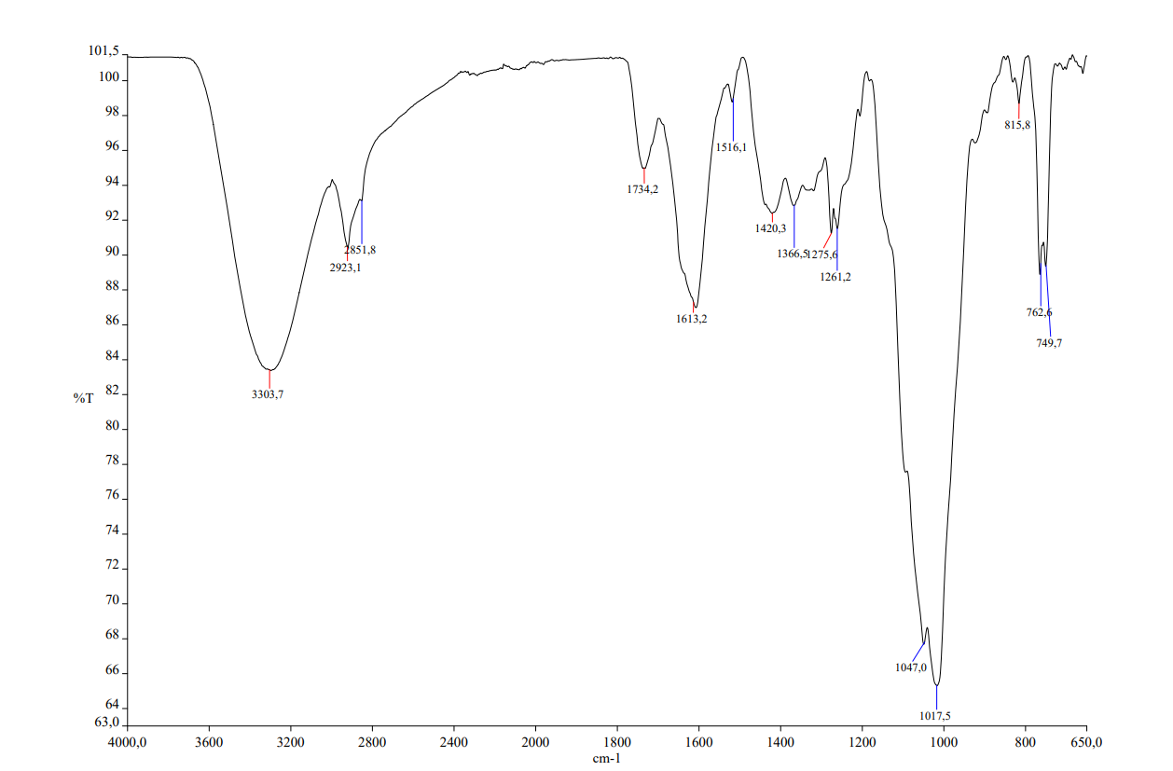
Figure S5. FTIR spectrum of orange peel powder.
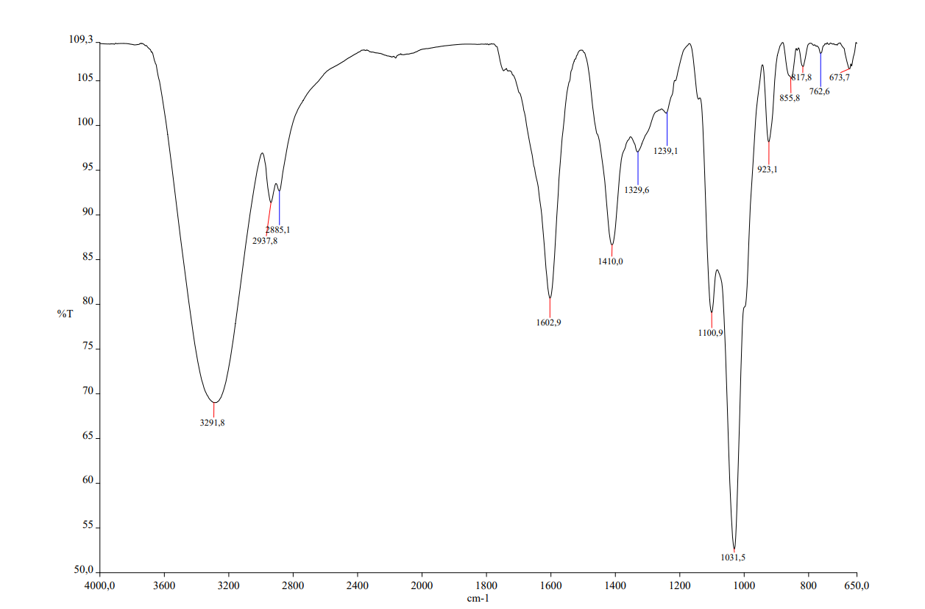
Figure S6. FTIR spectrum of a blend film containing 2% CaCl₂ and 0.7 (w/w%) glycerol.
Table S3. Weight loss of several films over 4 weeks, displaying the effect of film components on the biodegradability behavior of the films.
Film Composition |  |  |  |  | Weight Loss (%)
Polymer | CaCl₂ | Plasticizer |  | OPP | Week 1 | Week 2 | Week 3 | Week 4
P | 1% |  | 0.5 Gly | - | 71 ± 1.68 | 81 ± 1.45 | 95 ± 1.03 | 97 ± 0.94
P | 0% |  | 0.6 Gly | - | 78 ± 1.02 | 81 ± 1.37 | 93 ± 0.88 | 98 ± 0.62
P+A | 2% |  | 0.6 Gly | - | 72 ± 2.02 | 80 ± 1.95 | 92 ± 1.14 | 98 ± 0.74
P+A | 2% |  | 0.7 Gly | - | 74 ± 1.98 | 82 ± 1.48 | 94 ± 1.13 | 99 ± 0.42
P+A | 2% |  | 0.6 Gly | 1% | 74 ± 1.61 | 81 ± 1.82 | 86 ± 1.27 | 92 ± 1.34
P+A | 2% |  | 0.6 Gly | 5% | 61 ± 2.13 | 67 ± 1.92 | 72 ± 1.94 | 85 ± 1.25
P+A | 2% |  | 0.7 Gly | 3% | 72 ± 0.98 | 78 ± 1.43 | 84 ± 1.29 | 90 ± 1.12
P+A | 2% |  | 0.7 Gly | 5% | 71 ± 1.36 | 77 ± 2.13 | 83 ± 1.41 | 89 ± 1.08
P+A | 2% |  | 0.7 Gly | 10% | 62 ± 1.57 | 76 ± 1.13 | 81 ± 2.16 | 86 ± 0.98
P+A | 2% |  | 0.7 Gly | 20% | 62 ± 2.11 | 71 ± 1.55 | 79 ± 1.28 | 83 ± 1.41
P+A | 2% |  | 0.7 Gly | 30% | 52 ± 1.36 | 67 ± 1.21 | 69 ± 0.96 | 78 ± 0.76
P+A | 2% |  | 0.8 Gly | 5% | 52 ± 2.01 | 77 ± 1.34 | 98 ± 1.56 | 100

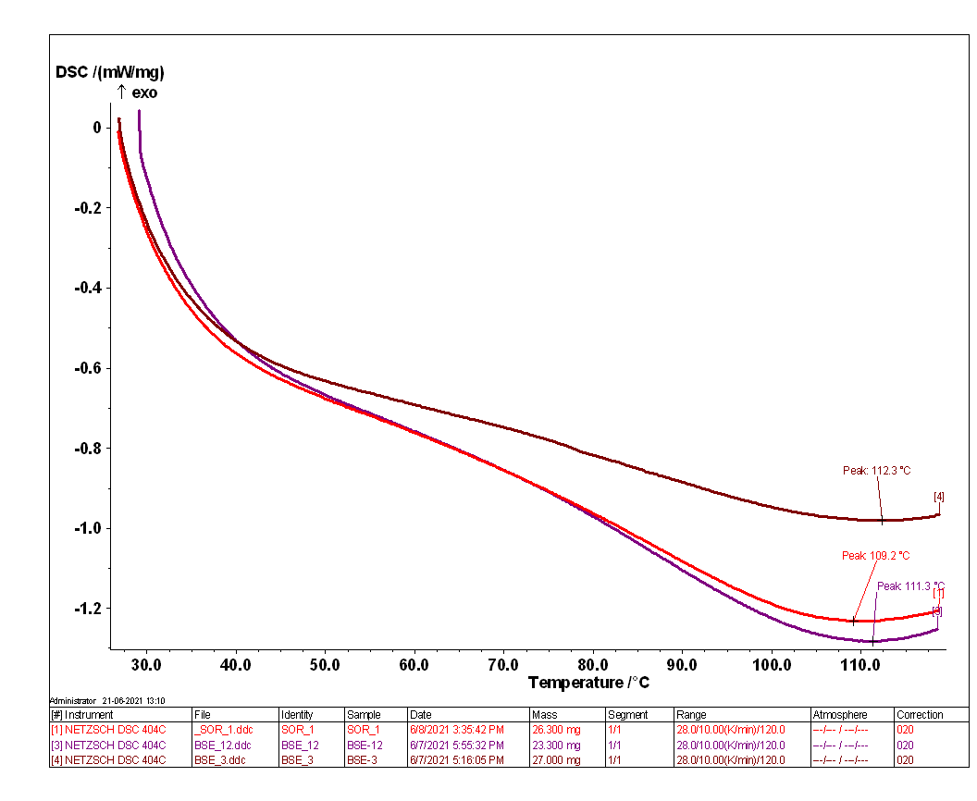
Figure S7. DSC analysis of several films prepared for this study (BSE_3 = Pectin film containing 0% CaCl₂ and 0.5 (w/w%) glycerol; BSE_12 = Blend film containing 3% CaCl₂ and 0.6 (w/w%) glycerol, SOR_1 = Blend film containing 2% CaCl₂ and 0.6 (w/w%) sorbitol).
Figure S8. TGA analysis of a blend film displaying a typical thermal degradation curve for biocomposites (blend film containing 3% CaCl₂ and 0.6 (w/w%) glycerol).

