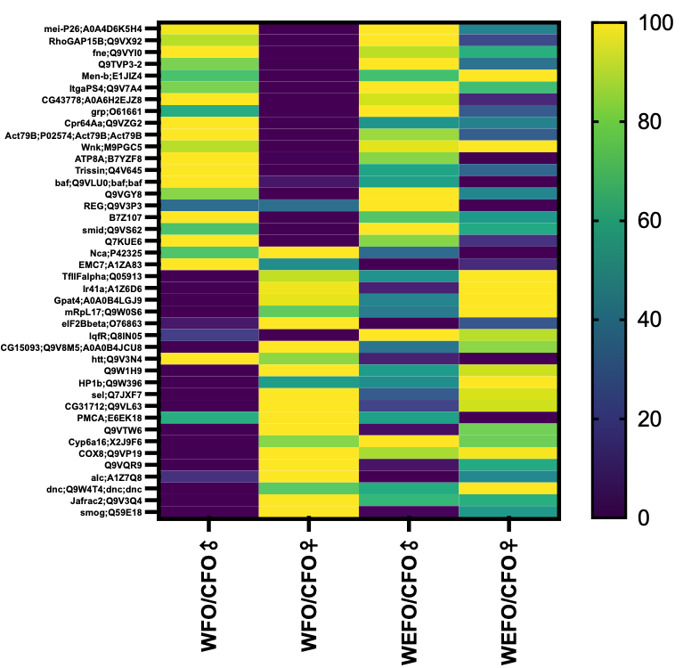

SI Fig. 2 Normalized heat map of significantly changed proteins expressed in F1 WFO vs CFO brains. P<0.01.

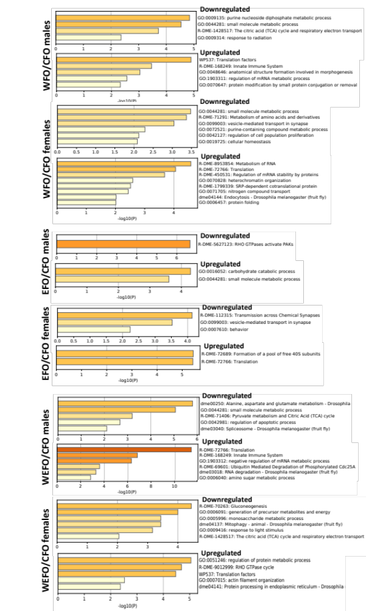
SI Fig. 3A. Metascape Pathway Enrichment Analysis for up- and down-regulated proteins in WFO vs CFO brains.
SI Fig. 3B. Metascape Pathway Enrichment Analysis for up- and down-regulated proteins in EFO vs CFO brains.

SI Fig. 3C. Metascape Pathway Enrichment Analysis for up- and down-regulated proteins in WEFO vs CFO brains.

