SUPPLEMENTARY MATERIAL

Main crops’ yield risks of the Belt and Road terrestrial countries under 1.5°C and 2°C global warming scenarios

Miao Tong^{1,2}，Erfu Dai^{*1,2}
1. Lhasa Plateau Ecosystem Research Station, Key Laboratory of Ecosystem Network Observation and Modeling, Institute of Geographic Sciences and Natural Resources Research, CAS. daief@igsnrr.ac.cn Beijing 100101, China；
2. University of Chinese Academy of Sciences, Beijing 100049, China

S1. Figure displays distribution of the Belt and Road subregions
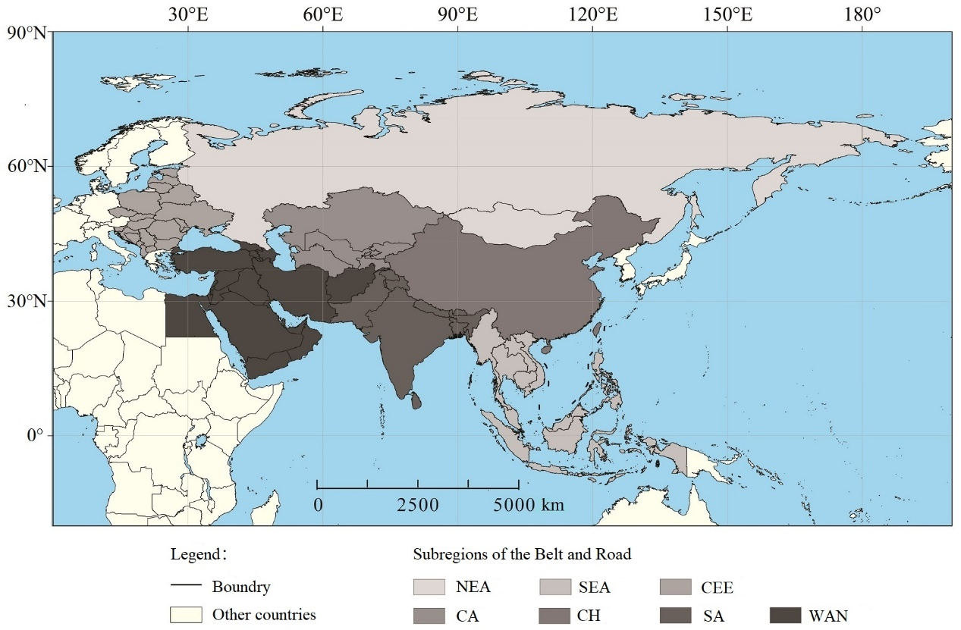
NEA(Northeast Asia), SEA(Southeast Asia), CEE(Central and Eastern Europe), CA(Central Asia), CH(China), SA(South Asia) and WAN(West Asia and North Africa)

S2. Table of detailed information of 116 GCM-GGCM sets for maize, soybean and wheat
NUMBER means the number of GCM-GGCM sets with different parameter combinations.
4: co2_firr、co2_noirr、noco2_firr、noco4_noirr
2: co2_firr、co2_noirr
co2 / noco2: with or without CO2
firr / noirr: with or without irrigation

S3. Table of detailed information of 96 GCM-GGCM sets for rice
NUMBER means the number of GCM-GGCM sets with different parameter combinations.
4: co2_firr、co2_noirr、noco2_firr、noco4_noirr
2: co2_firr、co2_noirr
co2 / noco2: with or without CO2
firr / noirr: with or without irrigation

S4. Figure displays the spatial distribution of likelihood for maize(a), rice(b), soybeans(c), and wheat(d) yield loss of the Belt and Road for 2.0℃ global warming under RCP8.5 scenario