Supplement to: Unveiling a hotspot of genetic diversity in southern Italy for the endangered Hermann’s tortoise Testudo hermanni

Additional file 1 – Supplementary results from the TESS Analysis.
Bar plots showing the admixture proportions of each individual for the genetic clusters recovered in the Bayesian clustering analysis performed on TESS, setting the number of genetic clusters (K) from 2 to 9; each colour represents a different clusters. Details are provided in the main text.

K = 2
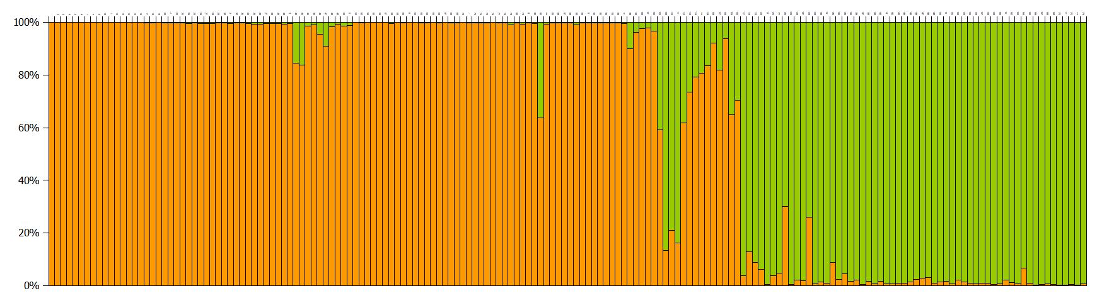

K = 3
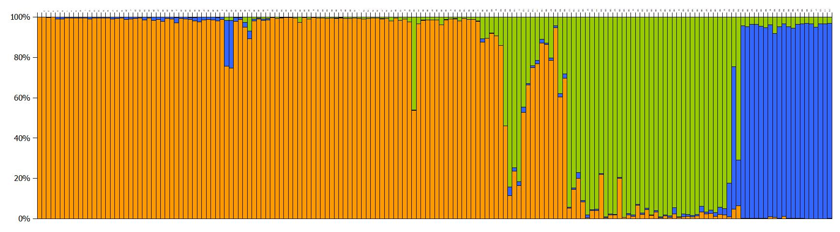
K = 4
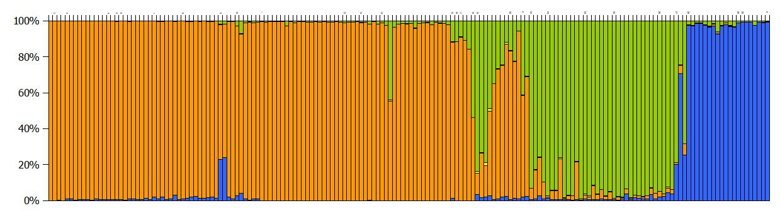
K = 5
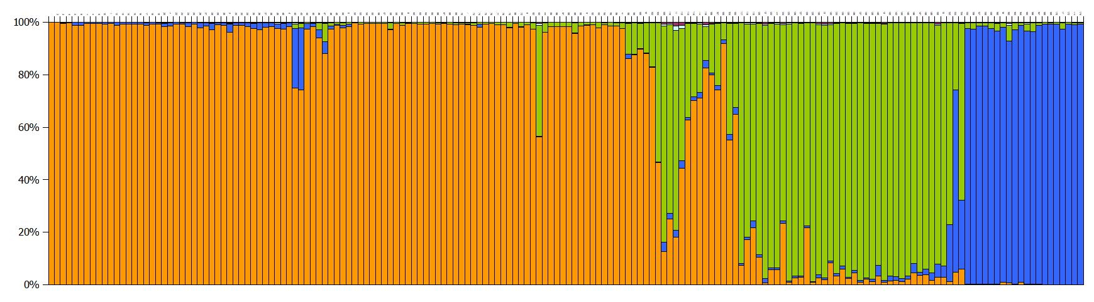

K = 6
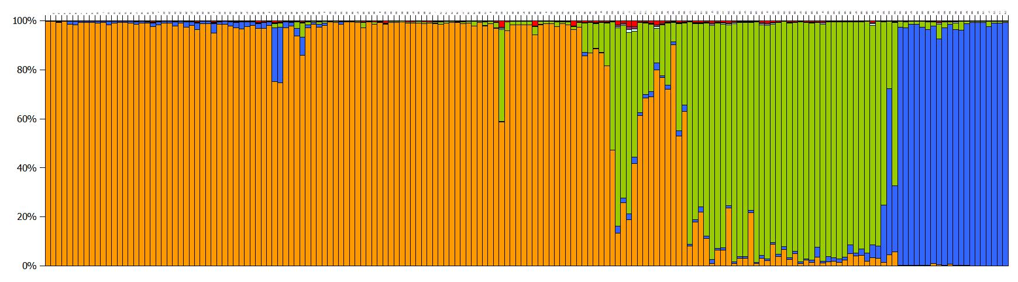
K = 7
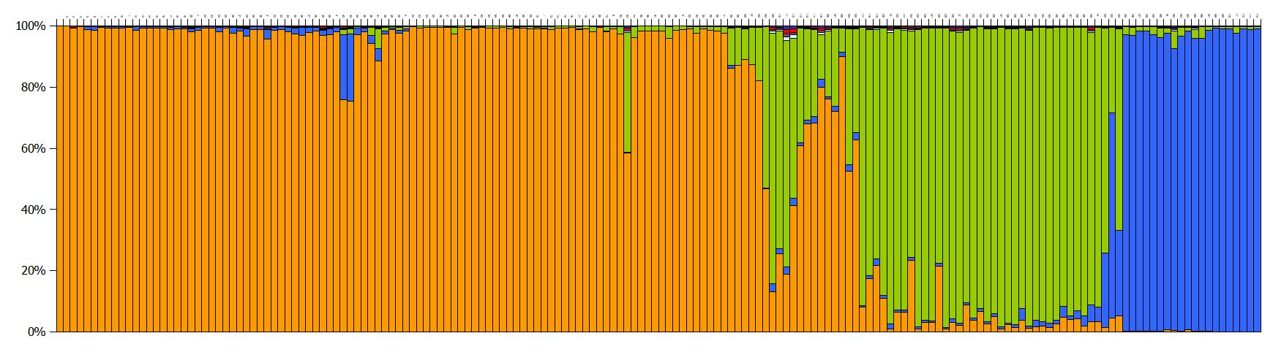

K = 8
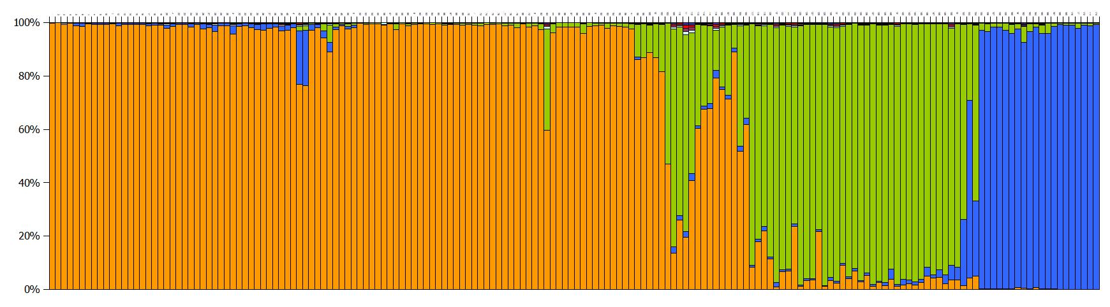

K = 9
