Supplementary material
Stimuli examples
Full ANOVA tables
Cases | Sum of Squares | df | Mean Square | F | p
Group | 0.129 | 1 | 0.129 | 6.148 | 0.015
Condition | 0.981 | 2 | 0.490 | 23.426 | < .001
Group * Condition | 0.017 | 2 | 0.009 | 0.413 | 0.663
Residual | 2.469 | 118 | 0.021

Supplementary Table 1: Analysis from the categorical statistical learning task. Full results from the 2-way ANOVA with the proportion of correct responses as the dependent variable and both ‘Group’ (autism or control) and ‘Condition’ (standard, category or generalisation) as between-subject measures.
 |  | Mean Difference | SE | t | Cohen’s d | p
Standard | Category | 0.188 | 0.032 | 5.892 | 1.303 | < .001
 | Generalisation | 0.192 | 0.032 | 6.009 | 1.170 | < .001
Category | Generalisation | 0.004 | 0.032 | 0.114 | 0.028 | 1.000

Supplementary Table 2: Analysis from the categorical statistical learning task. Post Hoc comparisons of performance across condition types in the recall phase.
Recall effect at the participant level
Methods
We also carried out an additional analysis to assess evidence for a recall effect at an individual level for each participant, using a Sequential Bayesian analysis (Schönbrodt and Wagenmakers, 2018).

The Sequential Bayesian analysis consisted of calculating the evidence in support of the presence of a true learning effect on a trial by trial basis for each participant. To do this, we evaluated the evidence for two alternative models: $M_{0}$, which assumes the participant is guessing and has a 50% chance of identifying the correct triplet, and $M_{1}$, which assumes the participant’s responses tend towards an unknown value within the range of possible performance scores p∈[0,1]. It is worth noting that the latter model was equally sensitive to participants who showed a bias towards incorrect identification as it is possible that implicit awareness of transitional contingencies could bias attention towards unfamiliar stimuli instead of familiar stimuli (Itti and Baldi, 2006).
Rather than using Bayes factors as a measure of evidence in support of the two models, as is traditionally done in such an approach (Schönbrodt and Wagenmakers, 2018), the ratio of the natural logs of the likelihood estimates for the two models were used. This was done to allow for comparable scaling for likelihood ratios in support of the null hypothesis model $M_{0}$(where the equivalent Bayes factors would be $BF_{01}>1$ or $BF_{10}<1$) and likelihood ratios in support of the alternative hypothesis model $M_{1}$(where the equivalent Bayes factors would be $BF_{10}>1$ or $BF_{01}<1$).

Log likelihood ratios were calculated in relation to $M_{1}$, so positive values represented evidence to support a recall effect and negative values represented evidence to support random guessing. Values with a magnitude above 2 are considered as substantial evidence in support of one of the two models and values above 6 are considered to be strong evidence (Kass and Raftery, 1995). Positive values show evidence in favour of model $M_{1}$, suggesting evidence to support a recall effect, and negative values show evidence in favour of model $M_{0}$, suggesting evidence to support the absence of a recall effect.

It is also worth noting that, based on the relatively small number of trials, the model would not be able to confidently support the null hypothesis. A participant who was correct on exactly 50% of trials would yield a log likelihood ratio of -1.53 ($BF_{01}=4.62$), which is considered to be insignificant evidence in support of the null. Whereas, if a participant were to correctly identify the triplet on every trial it would produce a log probability ratio greater than 10 ($BF_{10}>150$), which would be considered very strong evidence in support of a recall effect. Therefore, the nature of the task means that it is not possible to have strong confidence for the true absence of a recall effect. Nonetheless, it allows for testing of whether there was evidence in favour of a recall effect to be assessed as the individual participant level.

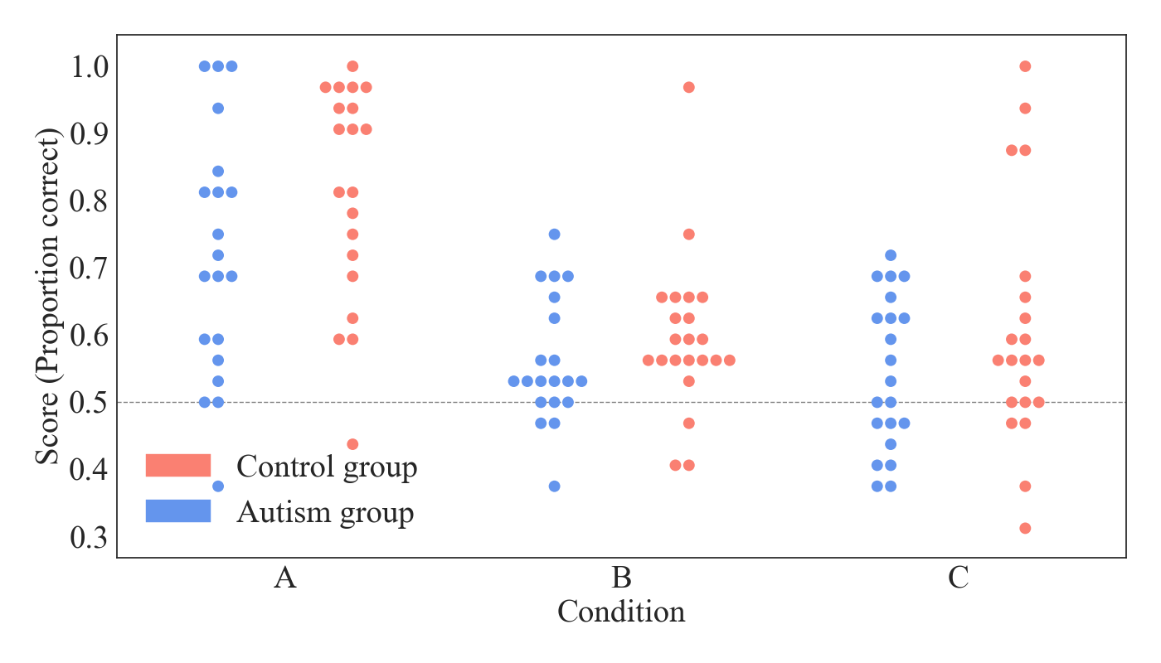
Supplementary Figure 1: Log likelihood ratios after all trials in the recall phase for each participant. Ratios are stratified by group and condition type. Suggested boundaries for different evidence levels are indicated by the dashed lines. The different regions represent ‘insignificant evidence’, ‘positive evidence’, ‘strong evidence’ and ‘very strong evidence’, with increasingly dark shading representing increasing levels of evidence (Kass and Raftery, 1995).

Results

A Sequential Bayesian analysis (Schönbrodt and Wagenmakers, 2018) was carried out across each participants’ set of responses in the recall phase, as detailed in the methods section. The final log likelihood ratios obtained at the end of the recall phase are shown for all participants in supplementary figure 1. The different levels of evidence strength (as suggested by Kass and Raftery (1995)) are also indicated on the figure. The results show that moderate or higher evidence was found to support a learning effect in 20 of the 63 control participants (14 of which were in the standard condition, 2 in the category condition and 4 in the generalisation condition). For the autism group, 10 of the 61 participants gave responses that provided a moderate or higher evidence to support a learning effect (9 of which were in the standard condition and 1 in the category condition). These relative proportions of participants for which there was at least moderate evidence of a learning effect were then compared between the two groups using a Chi-squared test, however this failed to reach significance (${\overset{˜}{χ}}^{2}\left(1\right)=3.19,p=0.074$). The average paths for the sequential accumulation of evidence from participant responses are shown in supplementary figure 2.
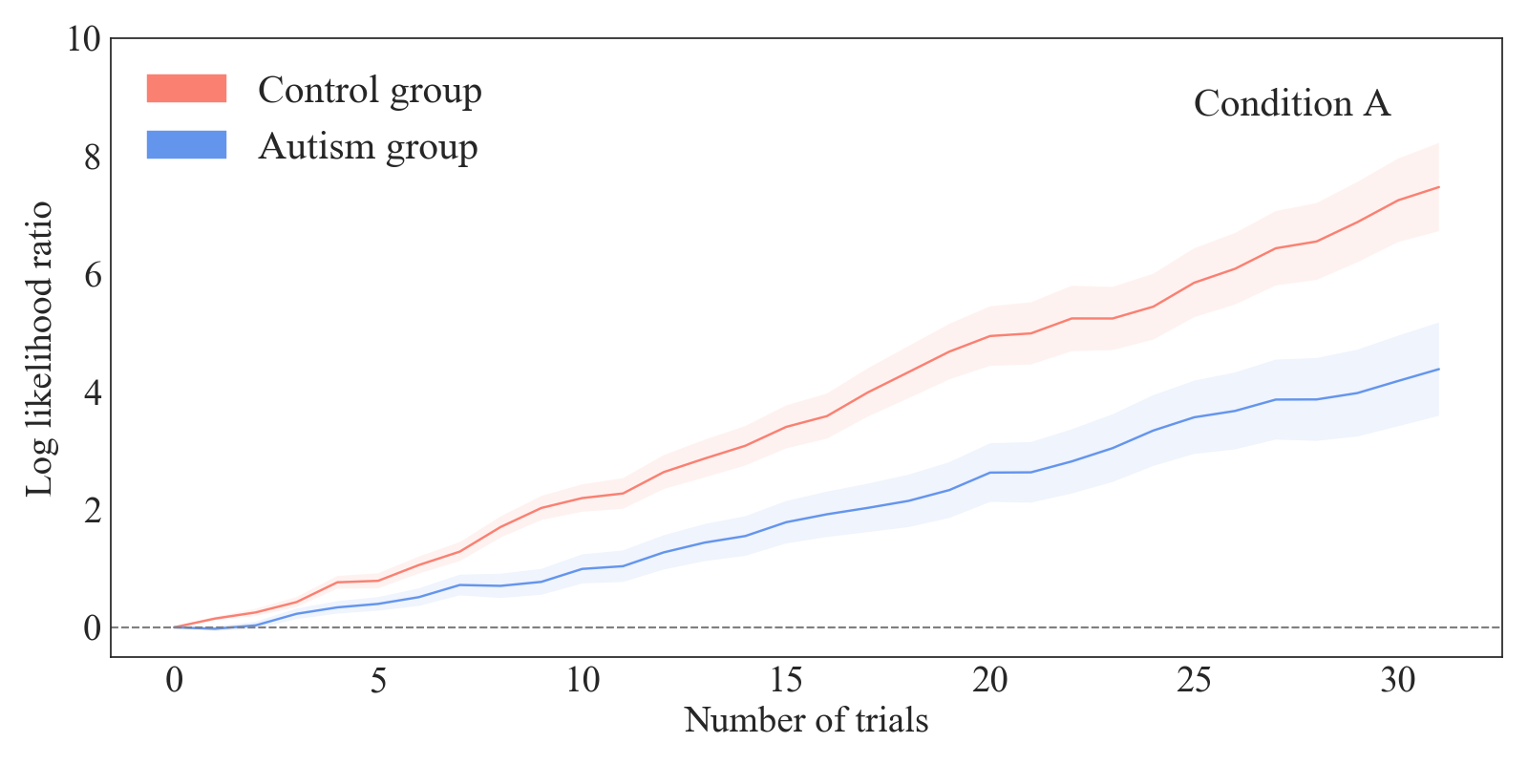
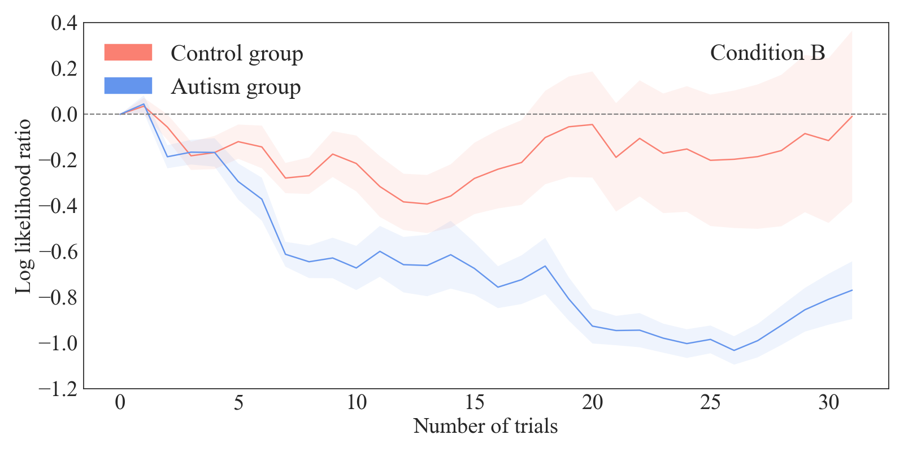
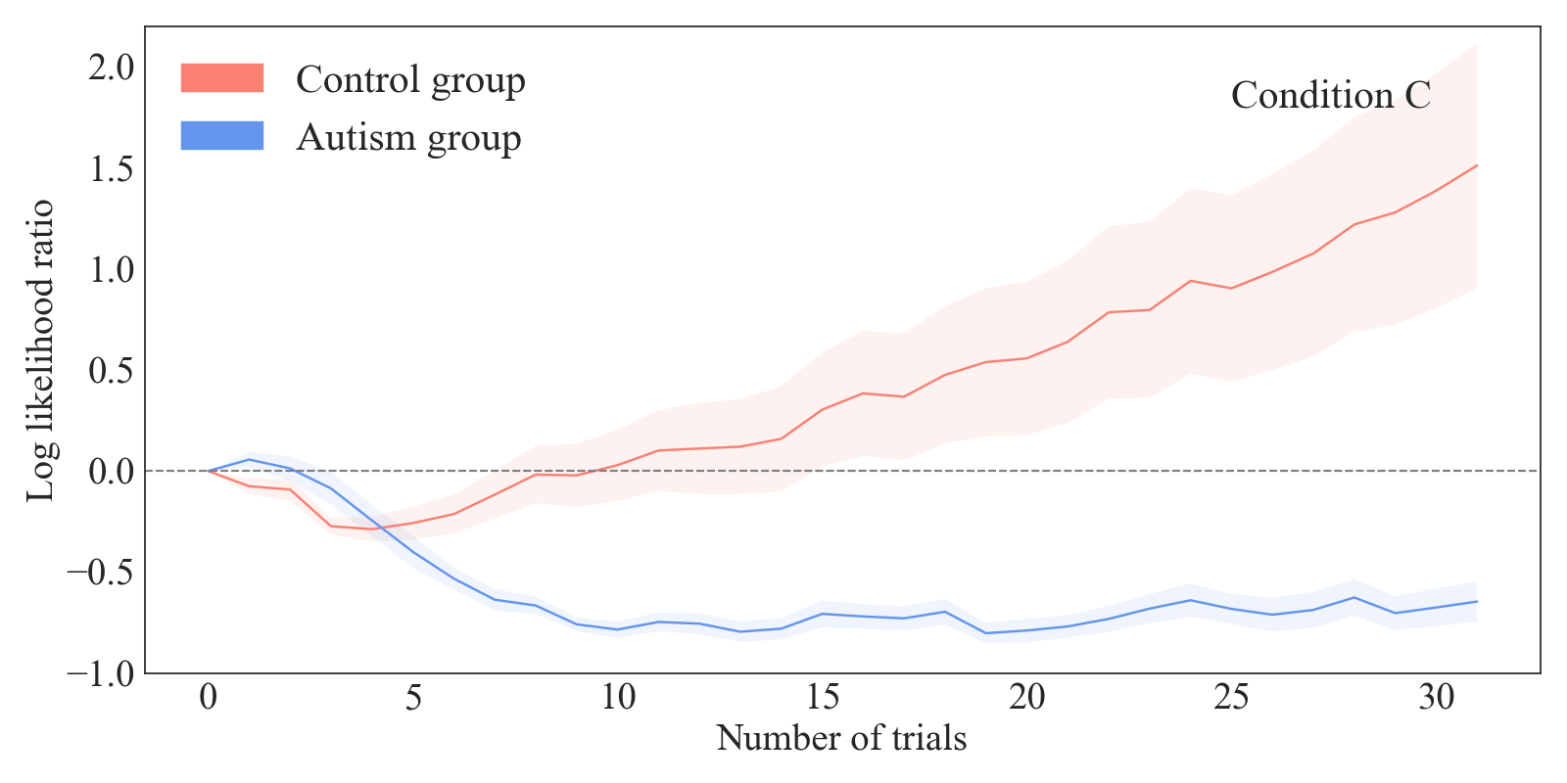
Supplementary Figure 2: A plot of the average outcome on the log likelihood ratio as data is collected across all trials of the recall phase. Data are shown for each of the three conditions, with separate averages for the two groups. Standard errors are shown by the shaded regions. Positive values indicate that, on average, participants were considered to have shown responses that were more likely to occur based on the alternative hypothesis model ($M_{1}$, the existence of a recall effect). Negative values indicate that participants showed responses that were more likely to occur based on the null hypothesis model ($M_{0}$, the absence of a recall effect).

Additional references
Laurent Itti and Pierre F Baldi. Bayesian surprise attracts human attention. In Advances in Neural Information Processing Systems, pages 547–554, 2006.
Robert E. Kass and Adrian E. Raftery. Bayes Factors. Journal of the American Statistical Association, 90 (430): 773–795, June 1995. ISSN 0162-1459. 10.1080/01621459.1995.10476572.
Felix D. Schönbrodt and Eric-Jan Wagenmakers. Bayes factor design analysis: Planning for compelling evidence. Psychonomic Bulletin & Review, 25 (1): 128–142, February 2018. ISSN 1531-5320. 10.3758/s13423-017-1230-y.

