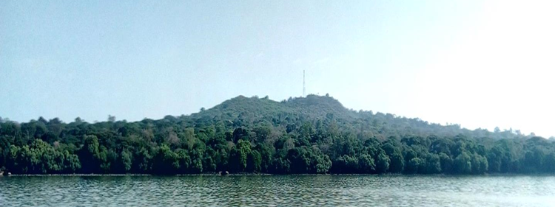
Plate 1. Partial view of Zegie Peninsula which enclosed by Lake Tana (photo by: Yibelu Yitayih, 2020).

