Supplementary information

Spin-orbit torque mediated coupling of terahertz light with nanometer-wavelength magnon modes

Ruslan Salikhov^{1*}, Igor Ilyakov², Lukas Körber¹, Attila Kákay¹, Rodolfo A. Gallardo³, Alexey Ponomaryov², Jan-Christoph Deinert², Thales Oliveira², Kilian Lenz¹, Jürgen Fassbender^{1,4}, Stefano Bonetti^{5,6}, Olav Hellwig^{1,7}, Jürgen Lindner¹, and Sergey Kovalev^{2*}
¹Institute of Ion Beam Physics and Materials Research, Helmholtz-Zentrum Dresden-Rossendorf, Bautzner Landstrasse 400, 01328 Dresden, Germany
²Institute of Radiation Physics, Helmholtz-Zentrum Dresden-Rossendorf, Bautzner Landstrasse 400, 01328 Dresden, Germany
³Departamento de Física, Universidad Técnica Federico Santa María, Avenida España 1680, Valparaíso, Chile
⁴Fakultät Physik, Technische Universität Dresden, D-01062 Dresden, Germany
⁵Department of Physics, Stockholm University, 106 91 Stockholm, Sweden
⁶Department of Molecular Sciences and Nanosystems, Ca’ Foscari University of Venice, 30172 Venice, Italy
⁷Institute of Physics, Chemnitz University of Technology, Reichenhainer Strasse 70, 09107 Chemnitz, Germany
Email: r.salikhov@hzdr.de; s.kovalev@hzdr.de

Supplementary Note 1
Figure S1a presents the Faraday signals from the 8.6-nm-thin Py layers, sandwiched by Ta or by Pt, compared to the signal from the asymmetric Ta/Py/Pt sample. While the Ta/Py/Pt shows clear spin wave resonance (SWR) oscillations, Py with symmetric interfaces reveals no SWR signal. Small higher frequency oscillations in the Ta/Py/Ta and Pt/Py/Pt samples are attributed to the signal from the water vapor, which is still present to a certain extend even in the purged sample stage. The influence of the water vapor was minimized on samples grown on thicker (3 mm) SiO₂ substrates by using a dry nitrogen atmosphere, as is evident in Fig. S1b for the Ta/Py/Ta samples.
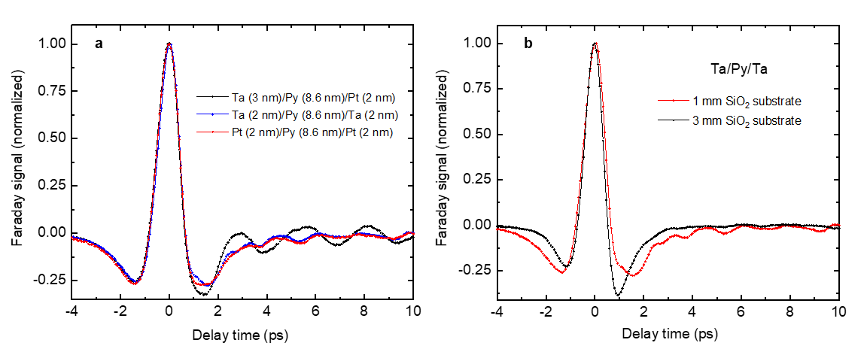
Supplementary Figure S1 a THz-pulse-driven Faraday signal of the Ta(2 nm)/Py(8.6 nm)/Ta(2 nm) (blue), Pt(2 nm)/Py(8.6 nm)/Pt(2 nm) (red) and Ta(3 nm)/Py(8.6 nm)/Pt(2 nm) (black) samples. All measurements are performed in a purged environment for samples, grown on 1-mm-thick SiO₂ (glass) substrates. b Comparison of signals from the Ta/Py/Ta trilayer, grown on 1-mm- (red) and 3-mm-thick (black) SiO₂ substrates. Samples, grown on the 3-mm-thick substrates, were measured in a dry nitrogen atmosphere.

Supplementary Note 2
To study the influence of the THz radiation amplitude on the SWR signal we use two wire-grid polarizers with variable angles, in our case between 0° and 40°. Figure S2a shows the evolution of the detected signals for three different angles between the grids of the two polarizers. In the next step, we detect the amplitude of the direct THz signal via electro-optical sampling (EOS) using a ZnTe crystal for all angles. Figure S2b plots the amplitude of the Zeeman torque signal (ZTS) as a function of the normalized EOS signal. All data points show linear behavior, as is evident from a good linear fit. The linear dependence of the ZTS on the THz field amplitude is in line with the literature (see, e.g., Ref. [23] in the main text). We further normalize all signals in Fig. S2a and plot the result in Fig.S2c. The accurate matching of signals at three different THz amplitudes confirms that, similar to the ZTS, the SWR signal is linear with the THz field amplitude.
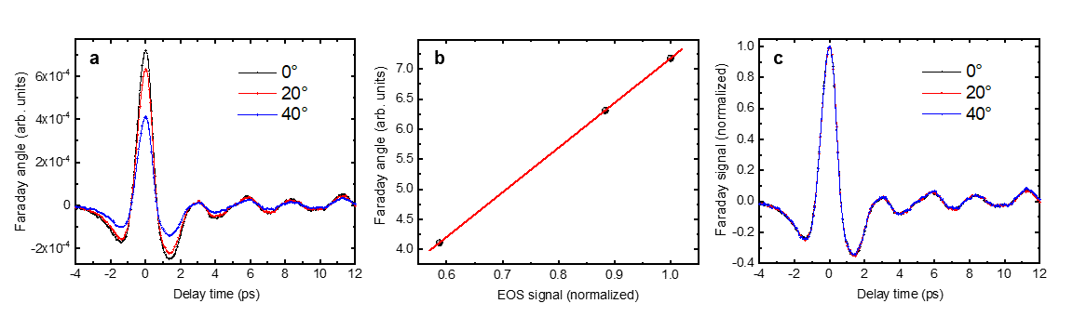Supplementary Figure S2 a THz-pulse-driven Faraday signal in the Ta(3 nm)/Py(8.6 nm)/Pt(2 nm) sample for three different angles between the two wire grid polarizers. b Dependence of the ZTS on the normalized THz field amplitude. The red solid line is a linear fit to all data points. c Same as in a, but this time all signals are normalized to the ZTS amplitude.

Supplementary Note 3
In order to account for an interface induced magnetic anisotropy, which results in an asymmetric pinning of the magnetization at two different interfaces in the Ta/Py/Pt trilayer, we perform broadband ferromagnetic resonance (FMR) measurements. In contrast to the samples with symmetric interfaces, the asymmetric pinning has an influence on the PSSW mode profile, at least at GHz frequencies. We quantified the surface anisotropies (K_{S}) at Py/Pt and Py/Ta interfaces using FMR in the three different samples: Ta/Py/Pt, Ta/Py/Ta and Pt/Py/Pt. Figures S3a and S3b plot the frequency dependence of the resonance field and FMR linewidth, correspondingly. Using the fit to the data points, we determine the magnetic parameters, which are summarized in Table S1. The surface anisotropy constants K_{S} = 0.2 mJ/m² and K_{S} = 0.1 mJ/m² are used for Py/Pt and Py/Ta, respectively, in order to account for their influence on the THz-pulse driven dynamics. It is also evident from Table S1 that the average surface anisotropy in the Ta/Py/Pt is in between the surface anisotropies of the Ta/Py/Ta and Pt/Py/Pt samples.
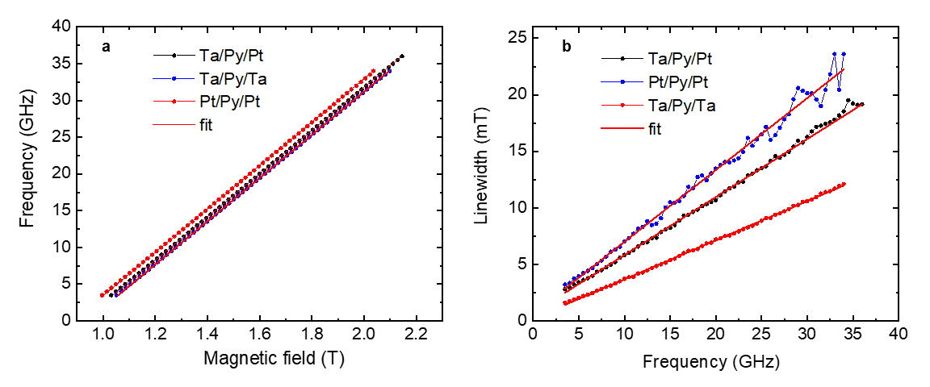
Supplementary Figure S3 Frequency dependence of the FMR a resonance field, and b linewidth for the studied Ta(3 nm)/Py(8.6 nm)/Pt(2 nm) (black circles), Ta(2 nm)/Py(8.6 nm)/Ta(2 nm) (blue circles) and Pt(2 nm)/Py(8.6 nm)/Pt(2 nm) (red circles) trilayers. The red solid lines represent fits to the data points using a Landau–Lifshitz–Gilbert equation solver.

Table S1. Spectroscopic splitting g-factor, magnetic damping parameter α, effective magnetization µ₀M_{eff} = µ₀M_{S} – 2K_{U}/M_{S}, where M_{S} is the Py saturation magnetization and is assumed to be µ₀M_{S} = 1 T. The out-of-plane magnetic anisotropy constant K_{U} in Py is considered to be the only origin of the surface anisotropy K_{U} = 2K_{S}/d_{py}, where d_{py} = 8.6 nm. The volume contribution to K_{U} is neglected.

Sample | g-factor | damping, α | µ₀M_{eff}  (mT) | K_{U}  (kJ/m³) | K_{S}  (mJ/m²)
Ta(3 nm)/Py(8.6 nm)/Pt(2 nm) | 2.1 | 0.013 | 920 | 31.8 | 0.14
Ta(2 nm)/Py(8.6 nm)/Ta(2 nm) | 2.1 | 0.009 | 940 | 32.8 | 0.1
Pt(2 nm)/Py(8.6 nm)/Pt(2 nm) | 2.11 | 0.016 | 890 | 46.1 | 0.2

Supplementary Note 4
In order to calculate the current density in metallic films induced by the THz pulse we estimate refractive indexes as well as the dissipated power density using the transfer matrix method (TMM) (see Ref. [42] in the main text). The refractive index ñ = n + ik for metals was verified using the experimental transmission presented in Fig. S4. At low (THz) frequencies the good approximation for metals is to consider ε_{r} = n² – k² = 0 and ε_{i} = 2nk, where the subscripts r and i correspond to the real and imaginary parts. In that case it follows that |ε_{i} ε₀| = |σ/ω|, where σ is the conductivity and ω is the angular frequency. We find that for Pt σ ≈ 4 MS/m, which is in a reasonable agreement with the conductivity of 2-nm thick Pt (see, e.g., Ref. [45] in the main text). For simplicity, we estimated the THz electric field (E_{c}) in the less transmittable Pt layer using the equation for two semi-infinite air/Pt layers (Ref. [41] in the main text): E_{c} ≈ √(µ₀ω/σ)H_{THz}, where H_{THz} is the magnetic field component of the THz light, which is normally incident. We arrived at E_{c} = 0.2 MV/m, accordingly, the current density j = σ E_{c} ≈ 10¹² A/m². Calculating the dissipated power density (jE_{c}) we find the absorbed power is about 10% of the THz power, which is in line with the TMM simulations.
For the simulations of the transmitted power through the Ta(3 nm)/Py(d_{Py})/Pt(2 nm) stack we measured the THz field amplitude as a function of Py thickness (d_{Py}) in transmission geometry using electro-optical sampling (EOS). Figure S4a demonstrates some examples of the detected broadband THz pulses transmitted through the samples with different Py thicknesses. The amplitude of the incident THz pulse is kept constant. The decrease of the sample transmittance with Py thickness is evident. Figure S4b plots the transmitted THz power as a function of Py thickness. We use a simple exponential decay function to fit the data points with the decay constant of about 5 nm. Accordingly, the THz field characteristic penetration depth at normal incidence is considered to be about 10 nm. We also measured the transmissivity of 4-nm thick single Pt, Py, and Ta films caped by 10 nm SiO₂ layers using narrow band (1.5 THz) radiation. From the data, shown in Fig. S4c we find the total transmission T = 0.07, 0.22 and 0.7 for the Pt, Py and Ta samples, respectively.
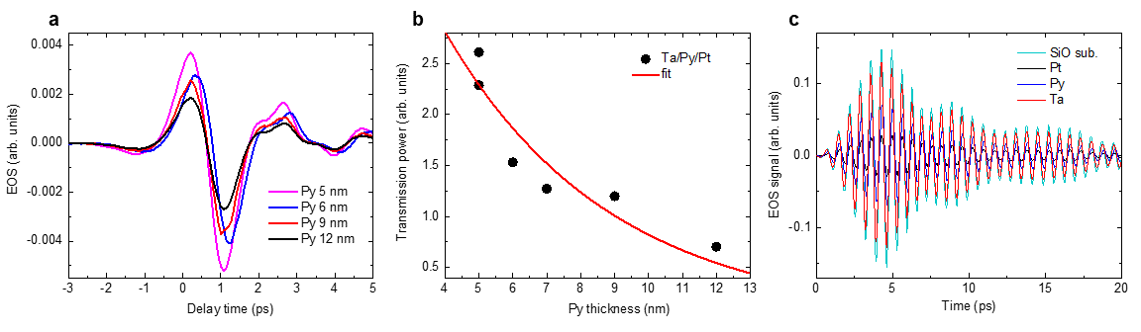
Supplementary Figure S4 a EOS signal from the broadband THz radiation transmitted through the Ta(3 nm)/Py(d_{Py})/Pt(2 nm) sample with d_{Py} = 5 nm, 6 nm, 9 nm and 12 nm. b The transmitted THz power as a function of Py thickness in the Ta(3 nm)/Py(d_{Py})/Pt(2 nm) samples. The solid red curve represents the fit using an exponential decay function with the characteristic decay length of 5 nm. c EOS signal from the narrowband 1.5 THz radiation transmitted through the bare SiO₂ quartz glass substrate and SiO₂(sub.)/X(4 nm)/SiO₂(10 nm) samples with X = Pt, Py and Ta. The smallest transmission through the SiO₂(sub.)/Pt(4 nm)/SiO₂(10 nm) sample is evident.

