Supplementary Figures and Tables

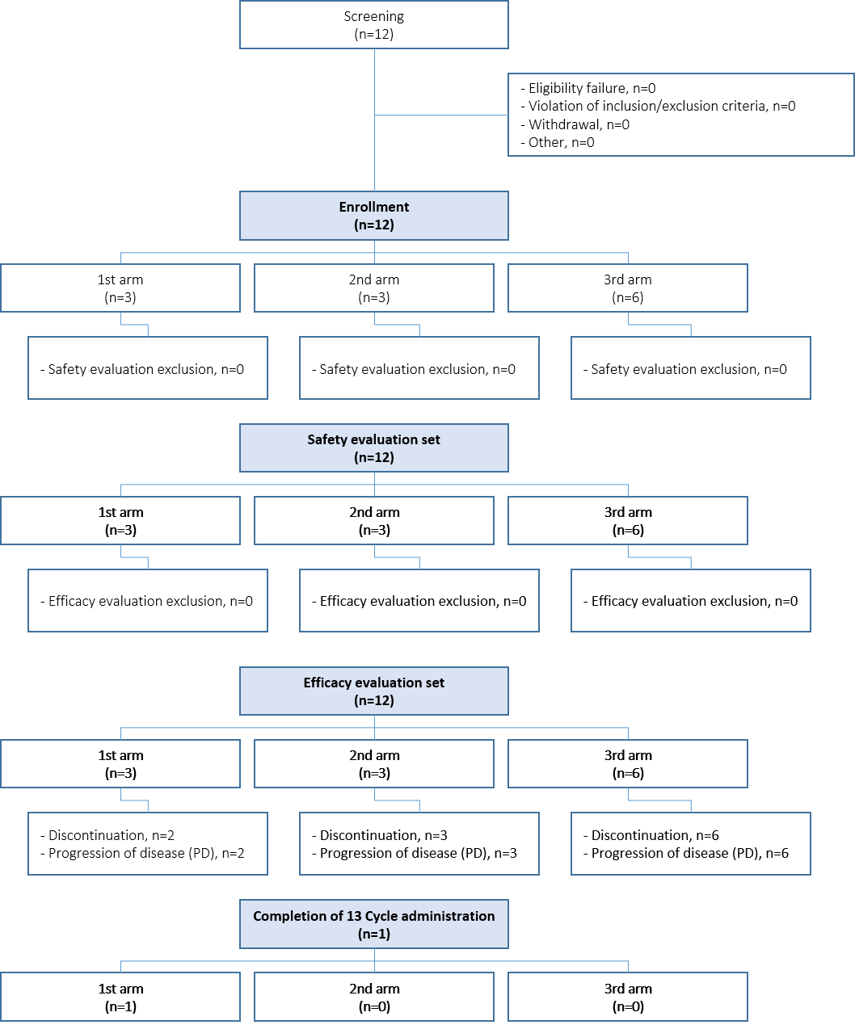
Supplementary Figure 1: CONSORT diagram

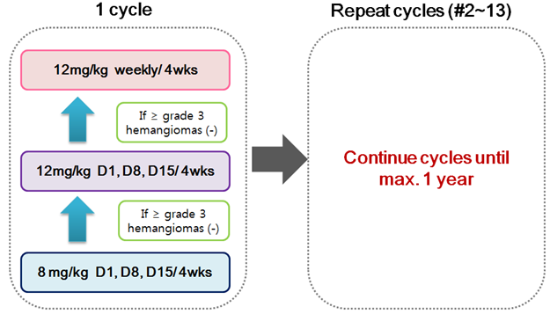
Supplementary Figure 2: Study Schema

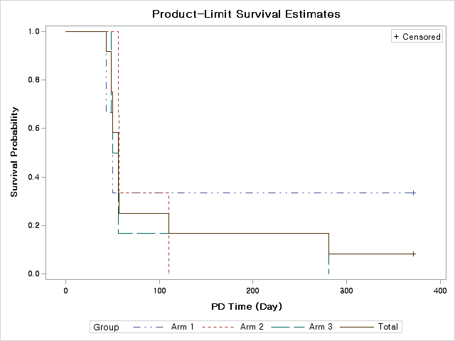
Supplementary Figure 3a: PFS outcomes stratified by arm

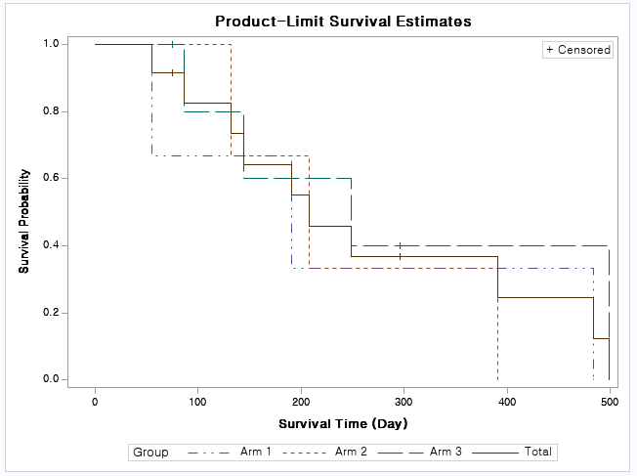
Supplementary Figure 3b: OS outcomes stratified by arm

Progression-free Survival |  | Dose level 1 |  | Dose level 2 |  | Dose level 3 |  | Total
 |  | (n=3) |  | (n=3) |  | (n=6) |  | (n=12)
 |  | n | (%) | n | (%) | n | (%) | n | (%)
Event | n (%) | 2 | (67) | 3 | (100) | 6 | (100) | 11 | (92)
Progression-Free survival rate at 6-month | 6-month PFS rate(%) | 33 |  | 0.00 |  | 17 |  | 17
Progression-Free survival rate at 6-month | [95% CI] | [1, 77] |  | - |  | [1, 52] |  | [3, 41]
Progression-Free survival | Median PFS time# | 50 |  | 57 |  | 53 |  | 56
Progression-Free survival | [95% CI] | [43, -] |  | [56, 110] |  | [49, 281] |  | [49, 110]

Supplementary Table 1: Progression-Free Survival (PFS)

Overall Survival |  | Dose level 1 | Dose level 2 | Dose level 3 | Total
 |  | (n=3) | (n=3) | (n=6) | (n=12)
Event | n (%) | 3 (100) | 3 (100) | 3 (50) | 9 (75)
Overall Survival | Median survival time# | 191 | 208 | 196 | 208
Overall Survival | [95% CI] | [55, 484] | [132, 391] | [86, -] | [86, 391]
#Days : (Death Date or Censoring Date - First drug administration Date)

Supplementary Table 2: Overall Survival (OS)

