Urban tree composition is associated with breeding success of a passerine bird, but effects vary within and between years
Johan Kjellberg Jensen^{1,2*}, Johan Ekroos^{2,3}, Hannah Watson¹, Pablo Salmón⁴, Peter Olsson², Caroline Isaksson¹

¹ Department of Biology, Lund University, Lund, Sweden
² Centre for Environmental and Climate Science (CEC), Lund University, Lund, Sweden
³ Department of agricultural sciences, University of Helsinki, Helsinki, Finland
⁴ Institute of Biodiversity, Animal Health and Comparative Medicine, University of Glasgow, Glasgow, UK

* Correspondence to: Johan Kjellberg Jensen, Lund University, Sweden
E-mail: johan.kjellberg_jensen@biol.lu.se

APPENDIX
Table S1. Bud burst phenology depending on tree species and origin in the system. Bud burst dates of locally common tree species, recorded in 2019. Bold denotes focal species of the current study. Adapted from Jensen et al. (2021), see original publication for details.
Species | Origin | N | Mean bud burst (days from March 31st) |  | Standard error (SE)
Acer platanoides | Native | 6 | 29 | 1.00
Betula pendula | Native | 5 | 21.6 | 1.99
Crataegus monogyna | Native | 4 | 24 | 1.22
Fagus sylvatica | Native | 5 | 25.2 | 1.20
Prunus avium | Native | 5 | 23.4 | 1.12
Quercus robur | Native | 5 | 30 | 1.34
Salix caprea | Native | 4 | 20.25 | 1.44
Sorbus intermedia | Native | 1 | 12 | NA
Tilia x europaea | Native | 5 | 25.8 | 0.73
Ailanthus altissima | Nonnative | 4 | 33.75 | 1.44
Ginkgo biloba | Nonnative | 5 | 28.2 | 2.24
Gleditsia triacanthos | Nonnative | 4 | 34.5 | 1.50
Platanus x hispanica | Nonnative | 5 | 37.2 | 1.20
Pterocarya fraxinifolia | Nonnative | 5 | 29.4 | 1.12
Quercus cerris | Nonnative | 5 | 30 | 0.00
Robinia pseudoacacia | Nonnative | 5 | 32.4 | 0.60
Native average |  | 40 | 24.83 | 0.72
Nonnative average |  | 33 | 32.09 | 0.70

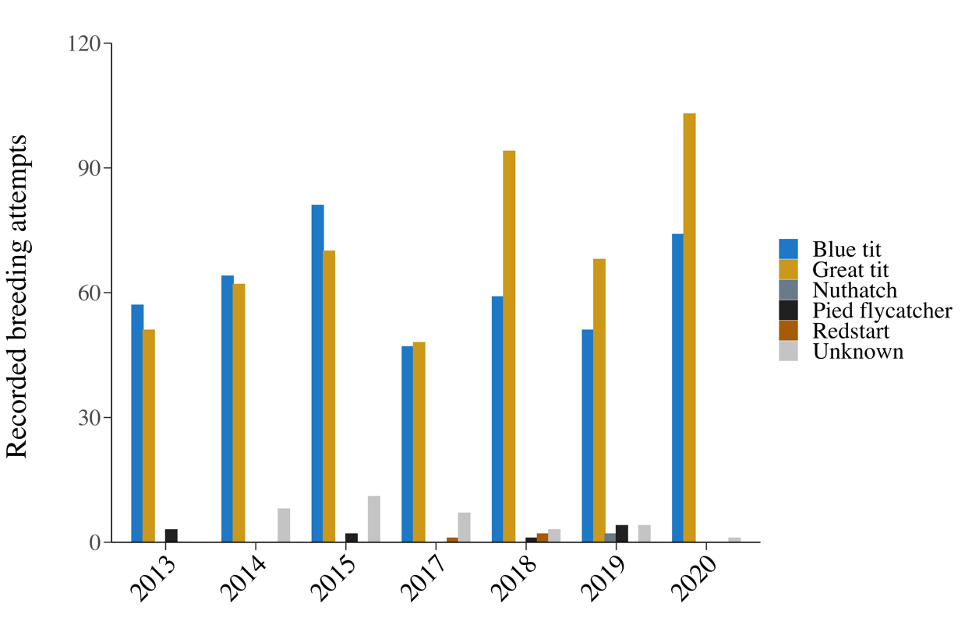
Figure S2. Distribution of breeding attempts by species over years. The absolute number of breeding attempts (defined as an egg being laid; see Methods) within the population varied between years and was dominated by great tits (Parus major) and blue tits (Cyanistes caeruleus). A low number of nuthatch (Sitta europaea), pied flycatcher (Ficedula hypoleuca) and redstart (Phoenicurus phoenicurus) breeding attempts were also recorded. In certain cases, species could not be reliably determined; note however that these nests likely belonged to either great or blue tits. Colour denotes species.

Table S3. Variance inflation factors (VIFs) of initial models. Output from the inspection of potential co-linearity between fixed effects for initial models. VIFs below > 2 indicate low co-linearity.
Model | Fixed effects | VIF | Increased SE | Tolerance
Breeding attempt (1/0) | Year | 1.00 | 1.00 | 1.00
 | Birch trees | 1.04 | 1.02 | 0.97
 | Oak trees | 1.03 | 1.01 | 0.97
 | Beech trees | 1.30 | 1.14 | 0.77
 | Tree diversity | 1.45 | 1.20 | 0.69
 | Non-native trees | 1.41 | 1.19 | 0.71
Lay date date (days) | Year | 1.04 | 1.02 | 0.97
 | Birch trees | 1.08 | 1.04 | 0.92
 | Oak trees | 1.04 | 1.02 | 0.96
 | Beech trees | 1.70 | 1.30 | 0.59
 | Tree diversity | 1.90 | 1.38 | 0.53
 | Non-native trees | 1.38 | 1.18 | 0.72
Offspring survival | Lay date | 1.05 | 1.02 | 0.96
 | Year | 1.03 | 1.02 | 0.97
 | Birch trees | 1.09 | 1.05 | 0.91
 | Oak trees | 1.09 | 1.04 | 0.92
 | Beech trees | 1.71 | 1.31 | 0.58
 | Tree diversity | 1.88 | 1.37 | 0.53
 | Non-native trees | 1.40 | 1.18 | 0.71
Nestling weight (g) | Lay date | 1.05 | 1.03 | 0.95
 | Year | 1.10 | 1.05 | 0.91
 | Birch trees | 1.12 | 1.06 | 0.90
 | Oak trees | 1.08 | 1.04 | 0.92
 | Beech trees | 1.62 | 1.27 | 0.62
 | Tree diversity | 1.65 | 1.28 | 0.61
 | Non-native trees | 1.41 | 1.19 | 0.71

Table S4. Statistical output from the elimination process. Output from the backward elimination process for all models, sorted in the order in which each variable was removed.
Model | Fixed effects | Eliminated | χ² | df | p-value
Breeding attempt (1/0) | Non-native trees x Year | 1 | 1.583 | 6 | 0.954
 | Birch trees x Year | 2 | 1.622 | 6 | 0.951
 | Oak trees x Year | 3 | 3.594 | 6 | 0.731
 | Tree diversity x Year | 4 | 7.126 | 6 | 0.309
 | Beech trees x Year | 5 | 9.369 | 6 | 0.154
 | Tree diversity | 6 | 0.025 | 6 | 0.873
 | Oak trees | 7 | 1.708 | 6 | 0.191
 | Birch trees | 8 | 1.465 | 6 | 0.226
Lay date (days) | Oak trees × Year | 1 | 1.695 | 6 | 0.946
 | Birch trees × Year | 2 | 4.089 | 6 | 0.665
 | Beech trees × Year | 3 | 7.206 | 6 | 0.302
 | Tree diversity × Year | 4 | 4.437 | 6 | 0.618
 | Non-native trees × Year | 5 | 6.284 | 6 | 0.392
 | Year | 6 | 0.207 | 6 | 1.000
 | Non-native trees | 7 | 0.212 | 1 | 0.645
 | Birch trees | 8 | 0.199 | 1 | 0.656
 | Tree diversity | 9 | 0.359 | 1 | 0.549
Offspring survival | Non-native trees × Year | 1 | 0.284 | 1 | 0.594
 | Birch × Lay date | 2 | 0.024 | 1 | 0.876
 | Beech trees × Lay date | 3 | 0.318 | 1 | 0.573
 | Non-native trees × Lay date | 4 | 0.711 | 1 | 0.399
 | Oak trees × Year | 5 | 7.985 | 6 | 0.239
 | Beech × Year | 6 | 10.766 | 6 | 0.096
 | Simpson × Year | 7 | 6.782 | 6 | 0.341
 | Birch × Year | 8 | 8.427 | 6 | 0.208
 | Beech trees | 9 | 0.041 | 1 | 0.840
 | Non-native trees | 10 | 1.705 | 1 | 0.192
 | Birch trees | 11 | 3.330 | 1 | 0.068
Nestling weight (g) | Tree diversity x Lay date | 1 | 0.158 | 1 | 0.691
 | Beech trees x Lay date | 2 | < 0.001 | 1 | 0.990
 | Tree diversity x Year | 3 | 2.857 | 6 | 0.827
 | Non-native trees x Lay date | 4 | 1.293 | 1 | 0.256
 | Birch trees x Lay date | 5 | 1.406 | 1 | 0.236
 | Oak trees x Year | 6 | 9.579 | 6 | 0.144
 | Non-native trees x Year | 7 | 8.990 | 6 | 0.174
 | Birch trees x Year | 8 | 9.316 | 6 | 0.157
 | Oak trees x Lay date | 9 | 3.300 | 1 | 0.069
 | Tree diversity | 10 | 0.156 | 1 | 0.693
 | Oak trees | 11 | 0.217 | 1 | 0.641
 | Birch trees | 12 | 1.003 | 1 | 0.317
Table S5. Model trends from year × lay date interactions. Output of function emtrends function of the emmeans package (Lenth 2021) for (a) lay date trends of individual years, tested against zero and (b) pairwise comparison of lay date trends between years. Significant results are typed in bold.
a)
Model | Year | Lay date trend |  | SE | df | t-ratio | p-value
Offspring survival | 2013 | -0.538 | 0.156 |  | 3366 | -3.450 | 0.001
(1/0) | 2014 | -0.020 | 0.155 |  | 3366 | -0.128 | 0.898
 | 2015 | -0.085 | 0.130 |  | 3366 | -0.656 | 0.512
 | 2017 | 0.130 | 0.111 |  | 3366 | 1.170 | 0.242
 | 2018 | 0.016 | 0.074 |  | 3366 | 0.211 | 0.833
 | 2019 | -0.097 | 0.112 |  | 3366 | -0.864 | 0.388
 | 2020 | 0.001 | 0.079 |  | 3366 | 0.008 | 0.994
Nestling weight (g) | 2013 | -0.288 | 0.057 |  | 1239 | -5.020 | < 0.001
 | 2014 | -0.138 | 0.066 |  | 1239 | -2.096 | 0.036
 | 2015 | -0.039 | 0.063 |  | 1239 | -0.615 | 0.539
 | 2017 | -0.052 | 0.066 |  | 1239 | -0.792 | 0.428
 | 2018 | -0.051 | 0.037 |  | 1239 | -1.384 | 0.167
 | 2019 | -0.104 | 0.050 |  | 1239 | -2.099 | 0.036
 | 2020 | 0.073 | 0.047 |  | 1239 | 1.551 | 0.121

b)
Model | Contrast | Estimate | SE | df | t-ratio | p-value
Offspring survival | 2013-2014 | -0.518 | 0.218 | 3366 | -2.372 | 0.211
(1/0) | 2013-2015 | -0.452 | 0.200 | 3366 | -2.267 | 0.261
 | 2013-2017 | -0.668 | 0.192 | 3366 | -3.484 | 0.009
 | 2013-2018 | -0.553 | 0.175 | 3366 | -3.170 | 0.026
 | 2013-2019 | -0.441 | 0.190 | 3366 | -2.321 | 0.234
 | 2013-2020 | -0.539 | 0.175 | 3366 | -3.075 | 0.035
 | 2014-2015 | 0.066 | 0.201 | 3366 | 0.326 | 1.000
 | 2014-2017 | -0.150 | 0.191 | 3366 | -0.786 | 0.986
 | 2014-2018 | -0.035 | 0.173 | 3366 | -0.205 | 1
 | 2014-2019 | 0.077 | 0.192 | 3366 | 0.402 | 1.000
 | 2014-2020 | -0.021 | 0.175 | 3366 | -0.118 | 1
 | 2015-2017 | -0.216 | 0.170 | 3366 | -1.265 | 0.868
 | 2015-2018 | -0.101 | 0.151 | 3366 | -0.669 | 0.994
 | 2015-2019 | 0.012 | 0.173 | 3366 | 0.067 | 1
 | 2015-2020 | -0.086 | 0.154 | 3366 | -0.561 | 0.998
 | 2017-2018 | 0.115 | 0.132 | 3366 | 0.867 | 0.977
 | 2017-2019 | 0.227 | 0.158 | 3366 | 1.437 | 0.782
 | 2017-2020 | 0.130 | 0.136 | 3366 | 0.950 | 0.964
 | 2018-2019 | 0.113 | 0.134 | 3366 | 0.842 | 0.981
 | 2018-2020 | 0.015 | 0.106 | 3366 | 0.140 | 1
 | 2019-2020 | -0.098 | 0.136 | 3366 | -0.718 | 0.992
Nestling weight (g) | 2013-2014 | -0.150 | 0.087 | 1239 | -1.732 | 0.595
 | 2013-2015 | -0.248 | 0.086 | 1239 | -2.907 | 0.057
 | 2013-2017 | -0.235 | 0.087 | 1239 | -2.698 | 0.100
 | 2013-2018 | -0.237 | 0.067 | 1239 | -3.540 | 0.008
 | 2013-2019 | -0.183 | 0.075 | 1239 | -2.449 | 0.179
 | 2013-2020 | -0.361 | 0.075 | 1239 | -4.839 | < 0.001
 | 2014-2015 | -0.099 | 0.091 | 1239 | -1.084 | 0.933
 | 2014-2017 | -0.086 | 0.093 | 1239 | -0.924 | 0.969
 | 2014-2018 | -0.087 | 0.075 | 1239 | -1.171 | 0.905
 | 2014-2019 | -0.033 | 0.082 | 1239 | -0.408 | 1.000
 | 2014-2020 | -0.211 | 0.081 | 1239 | -2.601 | 0.127
 | 2015-2017 | 0.013 | 0.091 | 1239 | 0.143 | 1.000
 | 2015-2018 | 0.011 | 0.072 | 1239 | 0.159 | 1.000
 | 2015-2019 | 0.065 | 0.079 | 1239 | 0.825 | 0.982
 | 2015-2020 | -0.112 | 0.080 | 1239 | -1.399 | 0.803
 | 2017-2018 | -0.002 | 0.075 | 1239 | -0.020 | 1.000
 | 2017-2019 | 0.052 | 0.083 | 1239 | 0.633 | 0.996
 | 2017-2020 | -0.125 | 0.081 | 1239 | -1.545 | 0.717
 | 2018-2019 | 0.054 | 0.061 | 1239 | 0.885 | 0.975
 | 2018-2020 | -0.124 | 0.060 | 1239 | -2.054 | 0.381
 | 2019-2020 | -0.178 | 0.070 | 1239 | -2.552 | 0.142

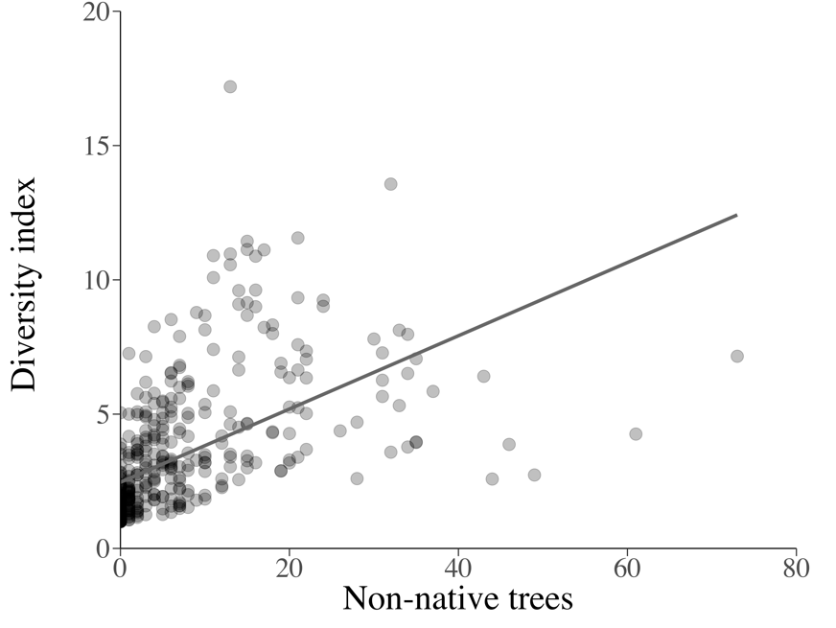
Figure S6. The relationship between the number of non-native trees and diversity index within territories. While no co-linearity was found in the models (VIFs < 2), non-native tree species represent the majority of species present in the urban parks and thus relate to tree diversity (estimated as the inverse Simpson’s index).

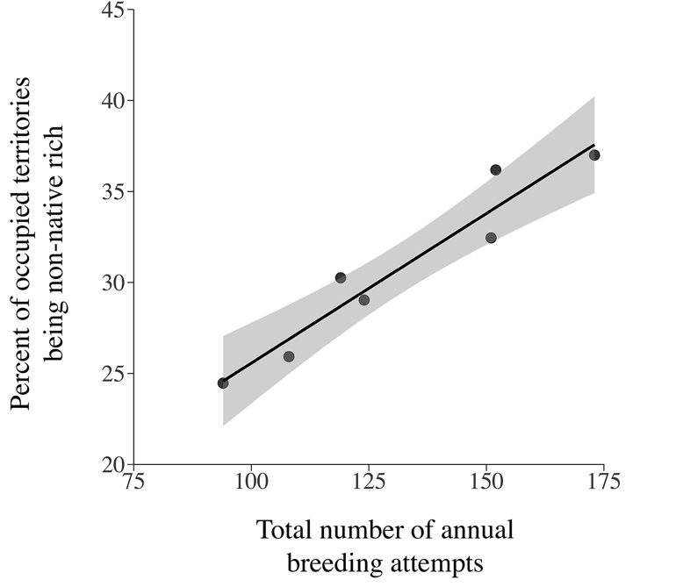
Figure S7. Correlation between population size per year and non-native rich territories occupied. To test if blue and great tits avoided occupying nest boxes situated in areas with high numbers of non-native trees in years when assumed competition between nest boxes were low, we tested the relationship between the percentage of territories found in areas with high numbers of non-native trees (y-axis) and total number of annual breeding events (x-axis). The linear model showed a significant correlation (F = 60.67, df = 1, p < 0.001) between the proportion of breeding attempts in territories with an above-average number of non-native trees and the total number of breeding attempts. A value of 50 % (y-axis) would indicate no preference between non-native rich and poor territories. Shaded area shows standard error of the mean (SE).

