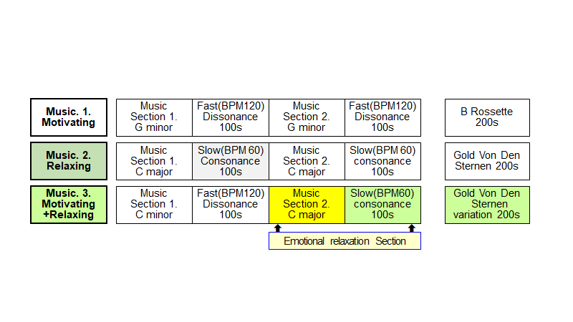
Additional file 1. Listening to music with Auditory Stimuli

The parts suitable for each condition were extracted from the basic music and consisted of 1. Music section: 100s, 2. Music section: 100s - a total of 200s. Music therapy was performed twice a week for 24 sessions. Considering the concentration span of children and adolescents with ADHD, 2 minutes of listening and 2 minutes of rest were performed for each condition. Overall, the music listening activity was performed for a total of 12 minutes.

