Field testing of abundance estimation methods for monitoring mammals: a case study of Simbalbara Wildlife Sanctuary and Churdhar Wildlife Sanctuary, Himachal Pradesh, India
Nidhi Singh¹, Urjit Bhatt¹, Saurav Chaudhary¹, Salvador Lyngdoh¹*
¹Department of Animal Ecology and Conservation Biology, Wildlife Institute of India, Dehradun, Uttarakhand, India.
*salvador@wii.gov.in

Supplementary Material
Tables
Table S1. List of mammalian species of (a) SWLS and (b) CWLS, representing RAI₂ and RAI₃. RAI₂ = Trap nights / independent photographs. RAI₃ was calculated through frequency distribution of nights to the first detection of photo-captured species.
Species | SWLS |  | CWLS
Species | RAI2 | RAI3 | RAI2 | RAI3
Chital Axis axis | 4 | 4
Nilgai Boselaphus tragocamelus | 444 | 14 | - | -
Golden jackal Canis aureus | 887 | 14 | - | -
Jungle cat Felis chaus | - | - | 1804 | 10
Indian crested porcupine Hystrix indica | 6 | 1 | 21 | 4
Rhesus macaque Macaca mulatta | 4 | 1 | 27 | 36
Yellow-throated marten Martes flavigula | - | - | 45 | 9
Barking deer Muntiacus muntjac | 7 | 1 | 95 | 5
Himalayan brown goral Nemorhaedus goral | 99 | 25 | 1804 | 36
Masked palm civet Paguma larvata | 55 | 4 | 601 | 11
Leopard Panthera pardus | 59 | 5 | 41 | 6
Asitic palm civet Paradoxurus hermaphroditus | 177 | 10 | - | -
Leopard cat Prionailurus bengalensis | 111 | 4 | 18 | 4
Sambar Rusa unicolor | 1 | 3 | - | -
Himalayan langur Semnopithecus schistaceus | 12 | 9 | 18 | 12
Wild boar Sus scrofa | 3 | 2 | - | -
Asiatic black bear Ursus thibetanus | - | - | 56 | 7
Small Indian civet Viverricula indica | 444 | 12 | - | -
Red fox Vulpes vulpes | - | - | 7 | 1

Table S2. A table representing the models and functions used for calibration of density by CTDS method for SWLS.
Species | CV | 95% CI | Function
Spotted Deer Axis axis | 0.34 | 2.35-9.42 | Half-normal / Hermite
Sambar Rusa unicolor | 0.18 | 3.65-7.96 | Uniform / Cosine
Barking Deer Muntiacus muntjac | 0.29 | 1.97-6.32 | Half-normal / Hermite
Wild Pig Sus scrofa | 0.36 | 0.96-4.77 | Half-normal / Hermite
Rhesus Macaque Macaca mulatta | 0.47 | 0.48-3.51 | Uniform / Cosine
Himalayan Langur Semnopithecus schistaceus | 0.48 | 0.47-3.12 | Half-normal / Hermite

Table S3. A table representing the models and functions used for calibration of density by CTDS method for CWLS.
Species | CV | 95% CI | Function
Asiatic Black bear Ursus thibetanus | 0.48 | 0.16-1.48 | Uniform / Cosine
Red fox Vulpes vulpes | 0.34 | 0.77-3.32 | Uniform / Cosine
Yellow throated marten Martes flavigula | 0.34 | 0.88-3.54 | Uniform / Cosine
Barking Deer Muntiacus muntjac | 0.44 | 0.47-13.46 | Uniform / Cosine
Indian crested porcupine Hystrix indica | 0.38 | 0.64-2.90 | Half-normal / hermite
Himalayan Langur Semnopithecus schistaceus | 0.4 | 1.69-8.89 | Half-normal / hermite

Table S4. Densities of ungulate species in Simbalbara Wildlife Sanctuary, estimated via field calibration through CTDS method with θ=42° (0.733 radians), and analysis using point transect method in ‘distance’ software with varying grid sizes.
Species | Density CTDS (individual / km²) | CV | 95% CI | Function
(a). Grid size: 1.5 km²
Spotted Deer  Axis axis | 0.6 ± SE 0.3 | 0.58 | 0.21-1.95 | Half-normal / hermite
Sambar  Rusa unicolor | 4.3 ± SE 1.3 | 0.31 | 2.35-8.18 | Hazard-rate / hermite
Barking Deer Muntiacus muntjac | 0.2 ± SE 0.1 | 0.49 | 0.09-0.61 | Half-normal / hermite
Wild Pig  Sus scrofa | 0.5 ± SE 0.2 | 0.39 | 0.24-1.13 | Half-normal / hermite
(b). Grid size: 2 km²
Spotted Deer  Axis axis | 0.5 ± SE 0.3 | 0.65 | 0.15-1.81 | Half-normal / hermite
Sambar  Rusa unicolor | 3.2 ± SE 1.1 | 0.35 | 1.64-6.56 | Hazard-rate / hermite
Barking Deer Muntiacus muntjac | 0.2 ± SE 0.1 | 0.52 | 0.07-0.57 | Half-normal / hermite
Wild Pig  Sus scrofa | 0.3 ± SE 0.1 | 0.49 | 0.13-0.88 | Half-normal / hermite

Figures
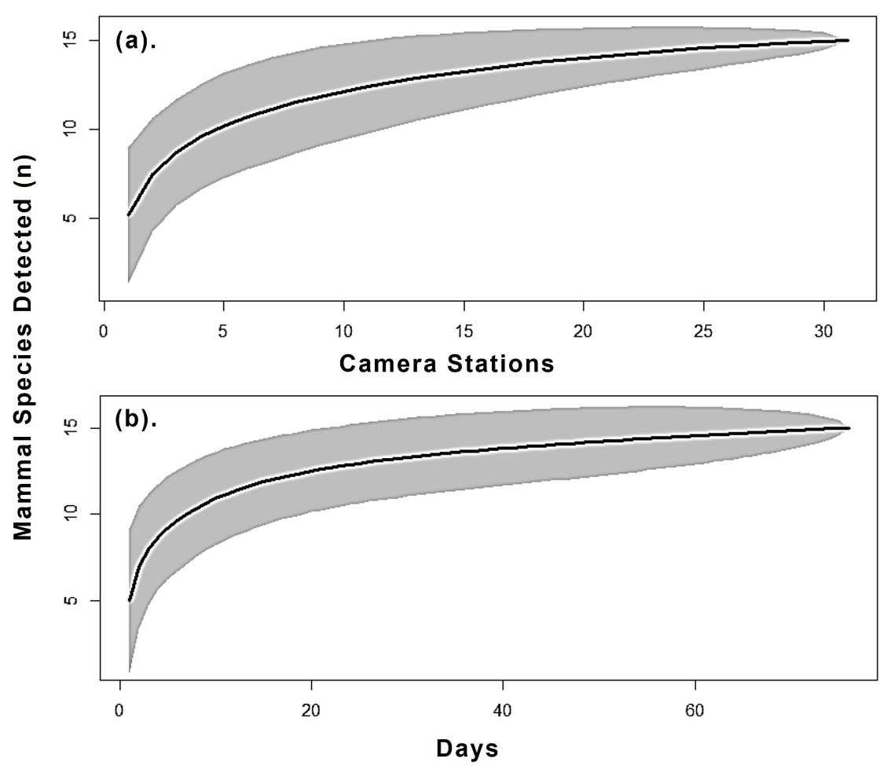
Figure S1. Species accumulation curve for mammals estimated, depicting the relationship to the number of mammal species (n=15) detected over (a). 31 camera stations and (b). 76 days, in SWLS. The black line indicates the modelled species accumulation curve, and the shaded area indicates 95 % confidence interval.

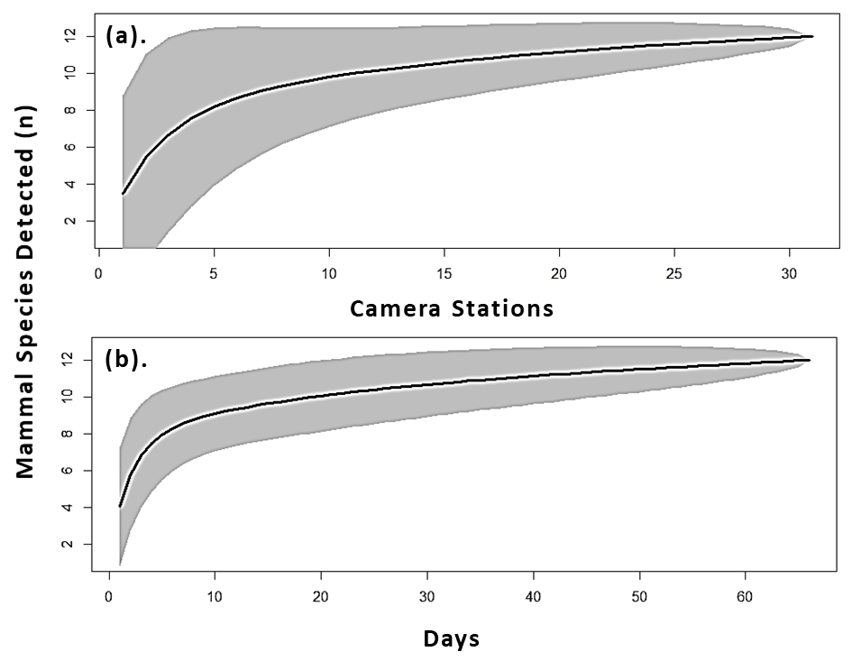
Figure S2. Species accumulation curve for mammals estimated, depicting the relationship to the number of mammal species (n=15) detected over (a). 31 camera stations and (b). 67 days, in CWLS. The black line indicates the modelled species accumulation curve, and the shaded area indicates 95 % confidence interval.

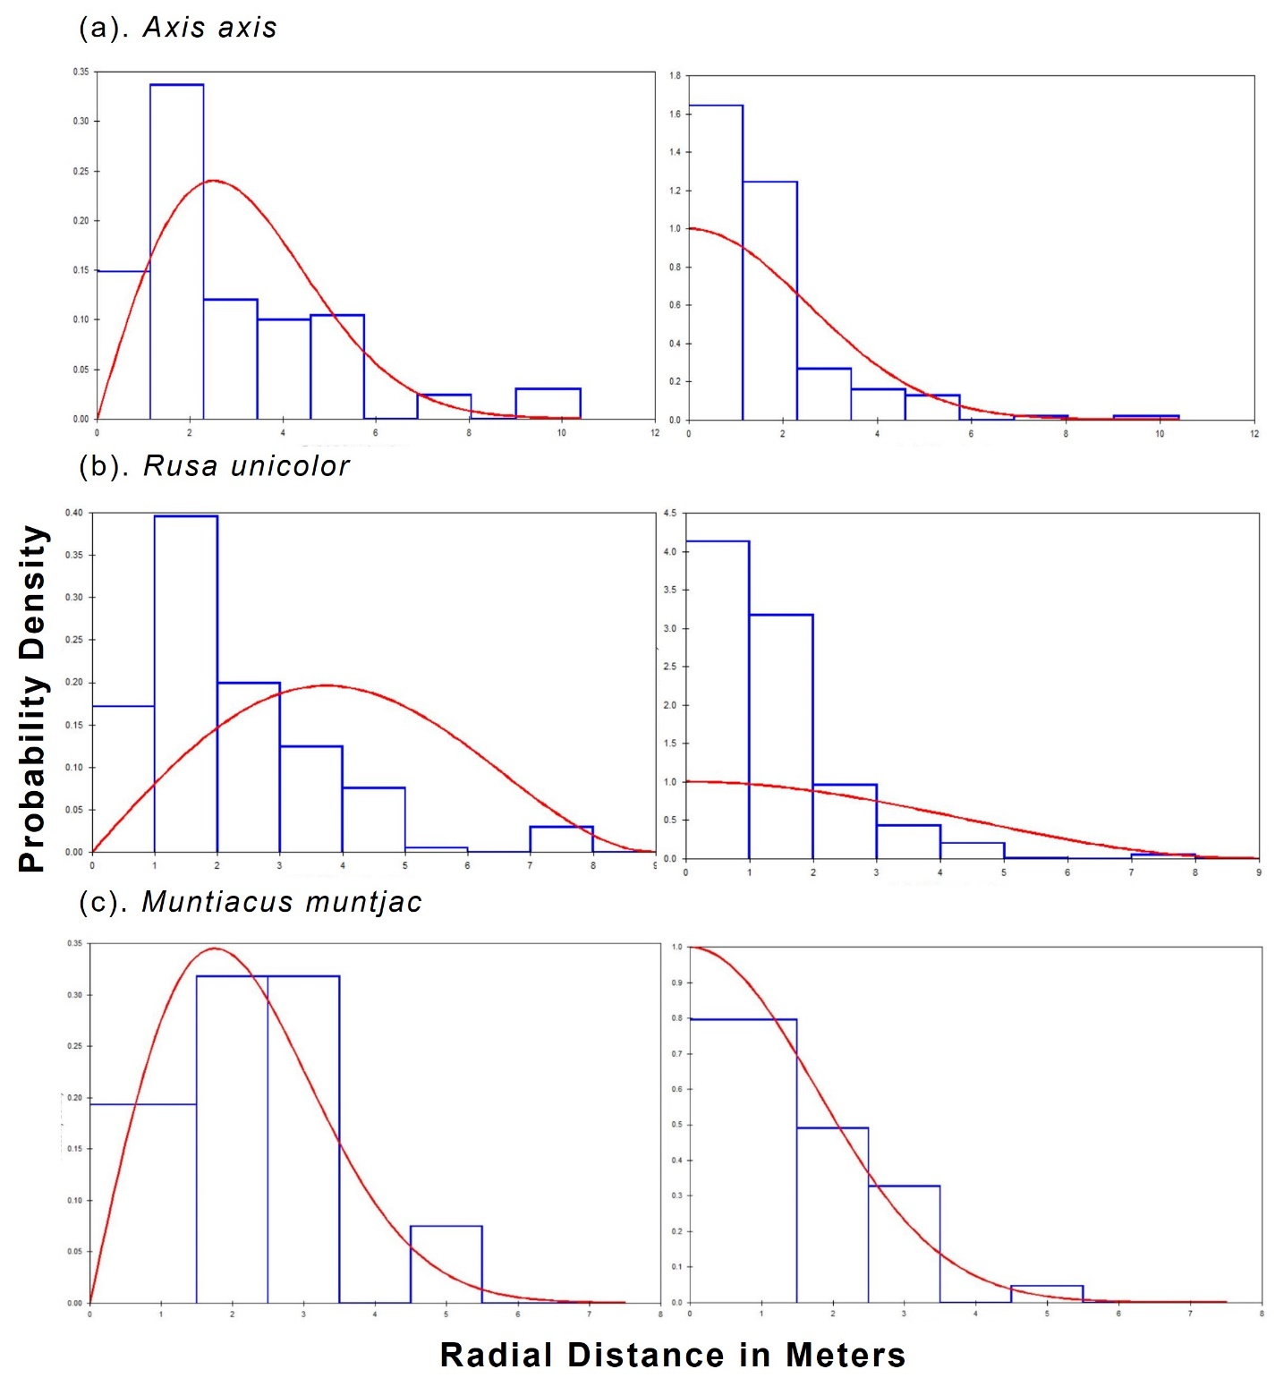
Figure S3. The detection probability and probability density for the models selected for estimating density by CTDS method for SWLS. The bars show the data distribution, and the line represents the model fit. The heights of the bars are scaled so that they cover the same total area as the area under the line, to show how well the detection function fits the data.

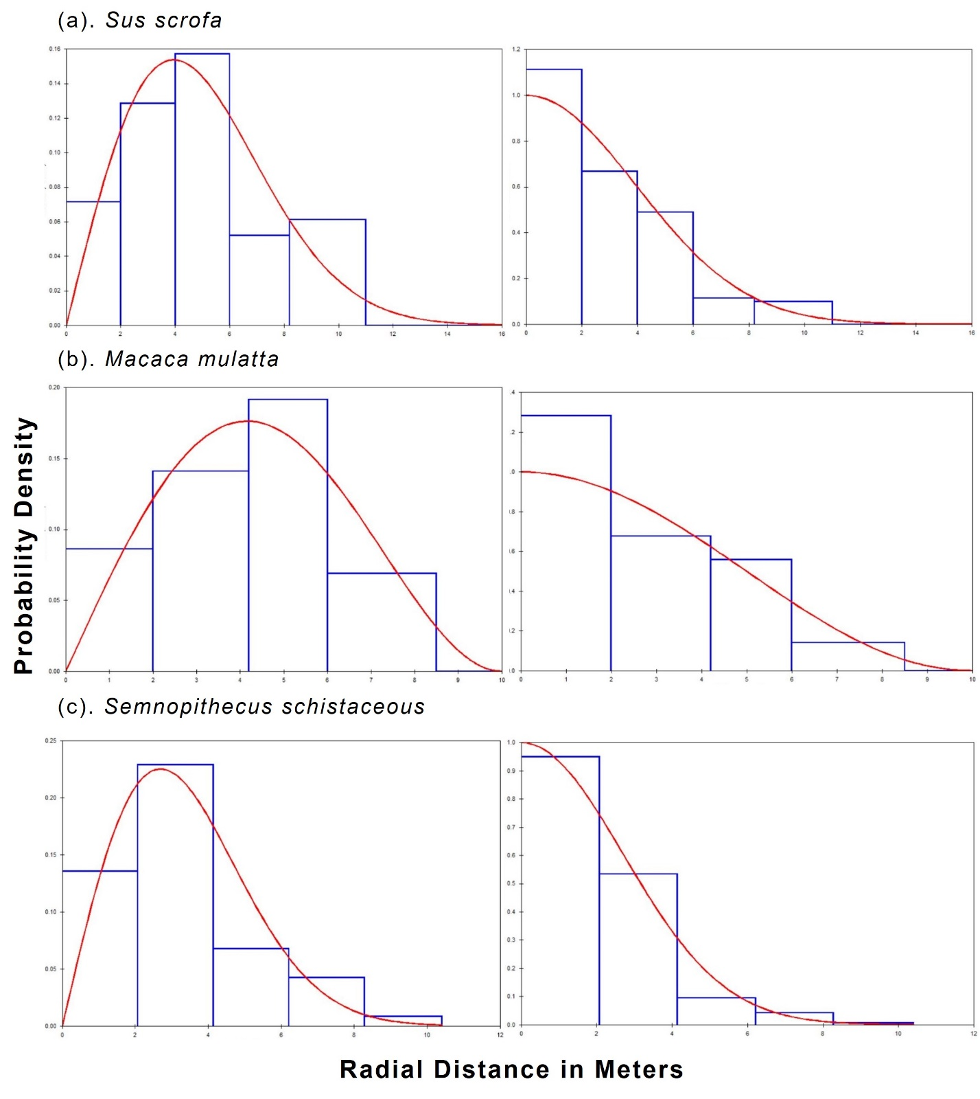
Figure S4. The detection probability and probability density for the models selected for estimating density by CTDS method for SWLS. The bars show the data distribution, and the line represents the model fit. The heights of the bars are scaled so that they cover the same total area as the area under the line, to show how well the detection function fits the data.

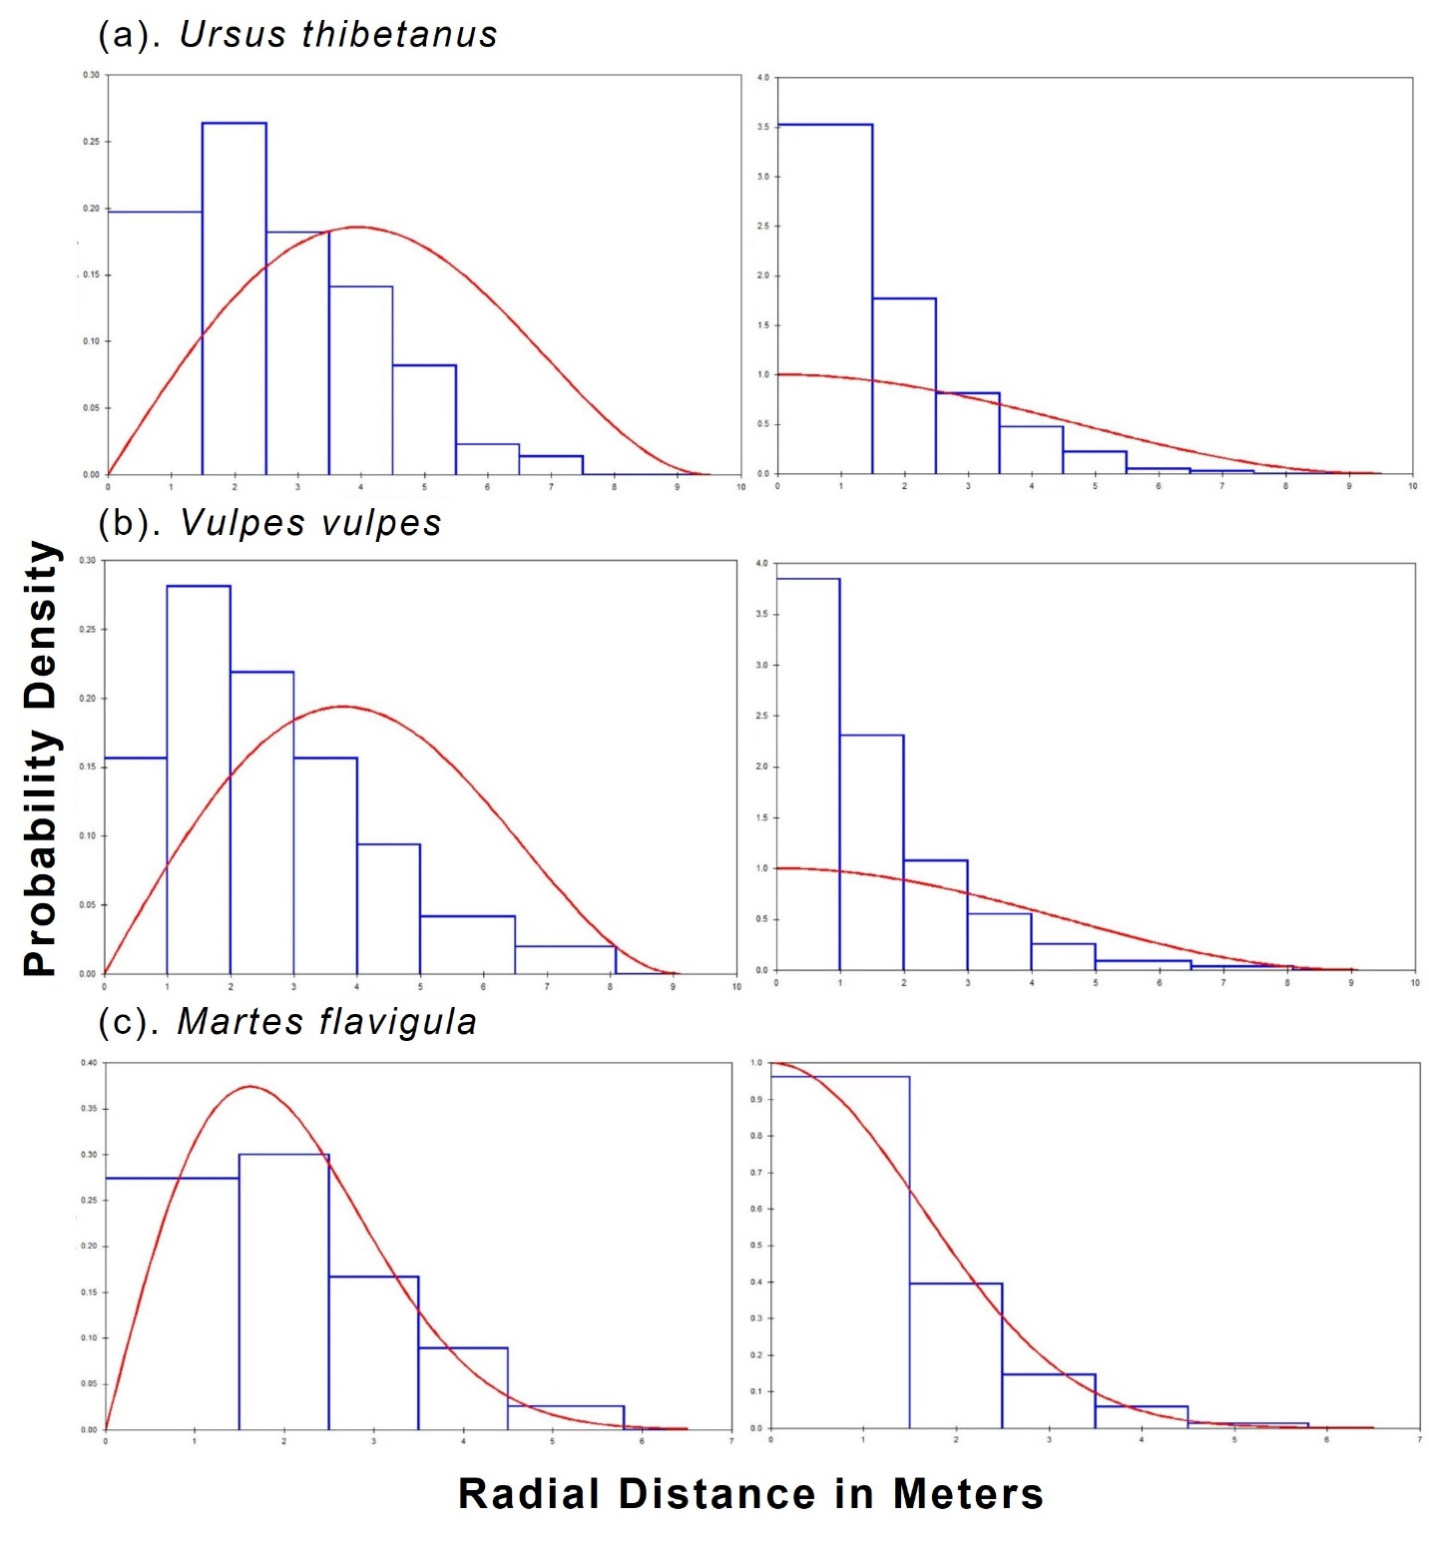
Figure S5. The detection probability and probability density for the models selected for estimating density by CTDS method for CWLS. The bars show the data distribution, and the line represents the model fit. The heights of the bars are scaled so that they cover the same total area as the area under the line, to show how well the detection function fits the data.

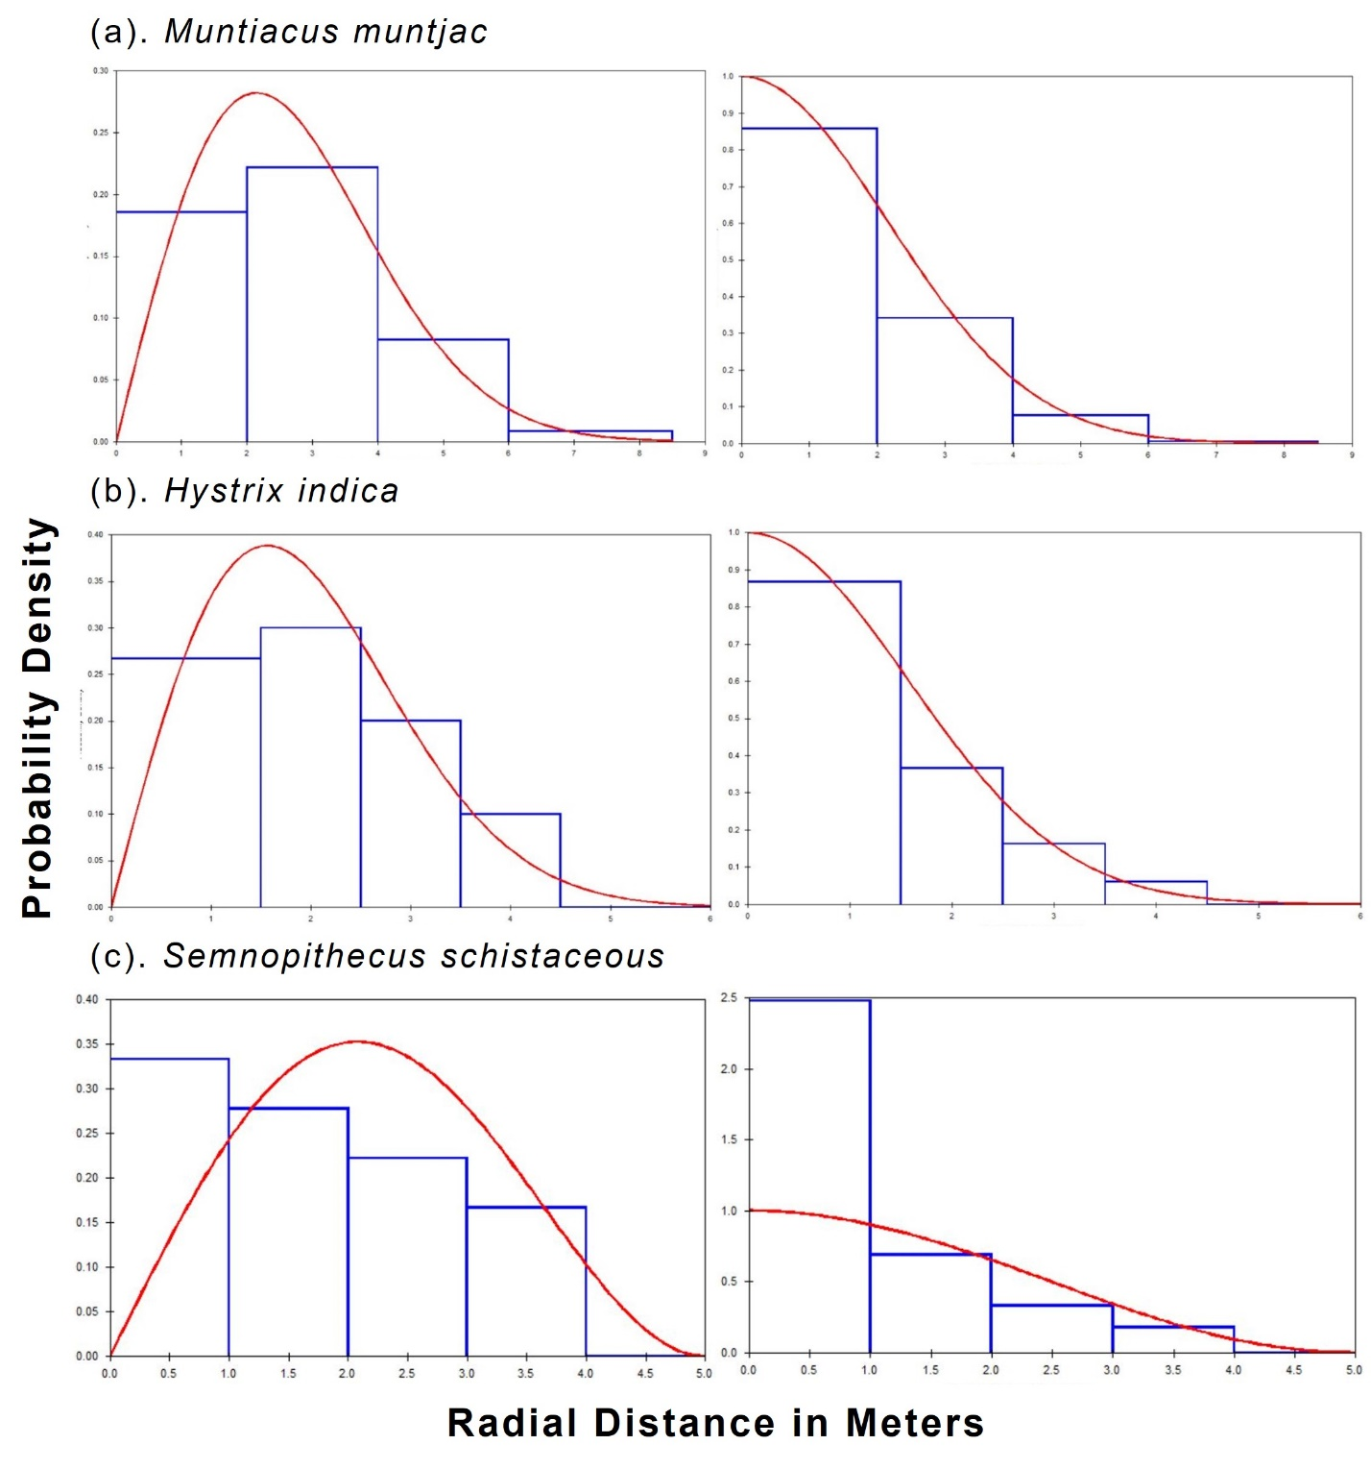
Figure S6. The detection probability and probability density for the models selected for estimating density by CTDS method for CWLS. The bars show the data distribution, and the line represents the model fit. The heights of the bars are scaled so that they cover the same total area as the area under the line, to show how well the detection function fits the data.

Figure S7. The detection probability for the models selected for estimating density by LTDS method for SWLS. The bars show the data distribution, and the line represents the model fit. The heights of the bars are scaled so that they cover the same total area as the area under the line, to show how well the detection function fits the data.
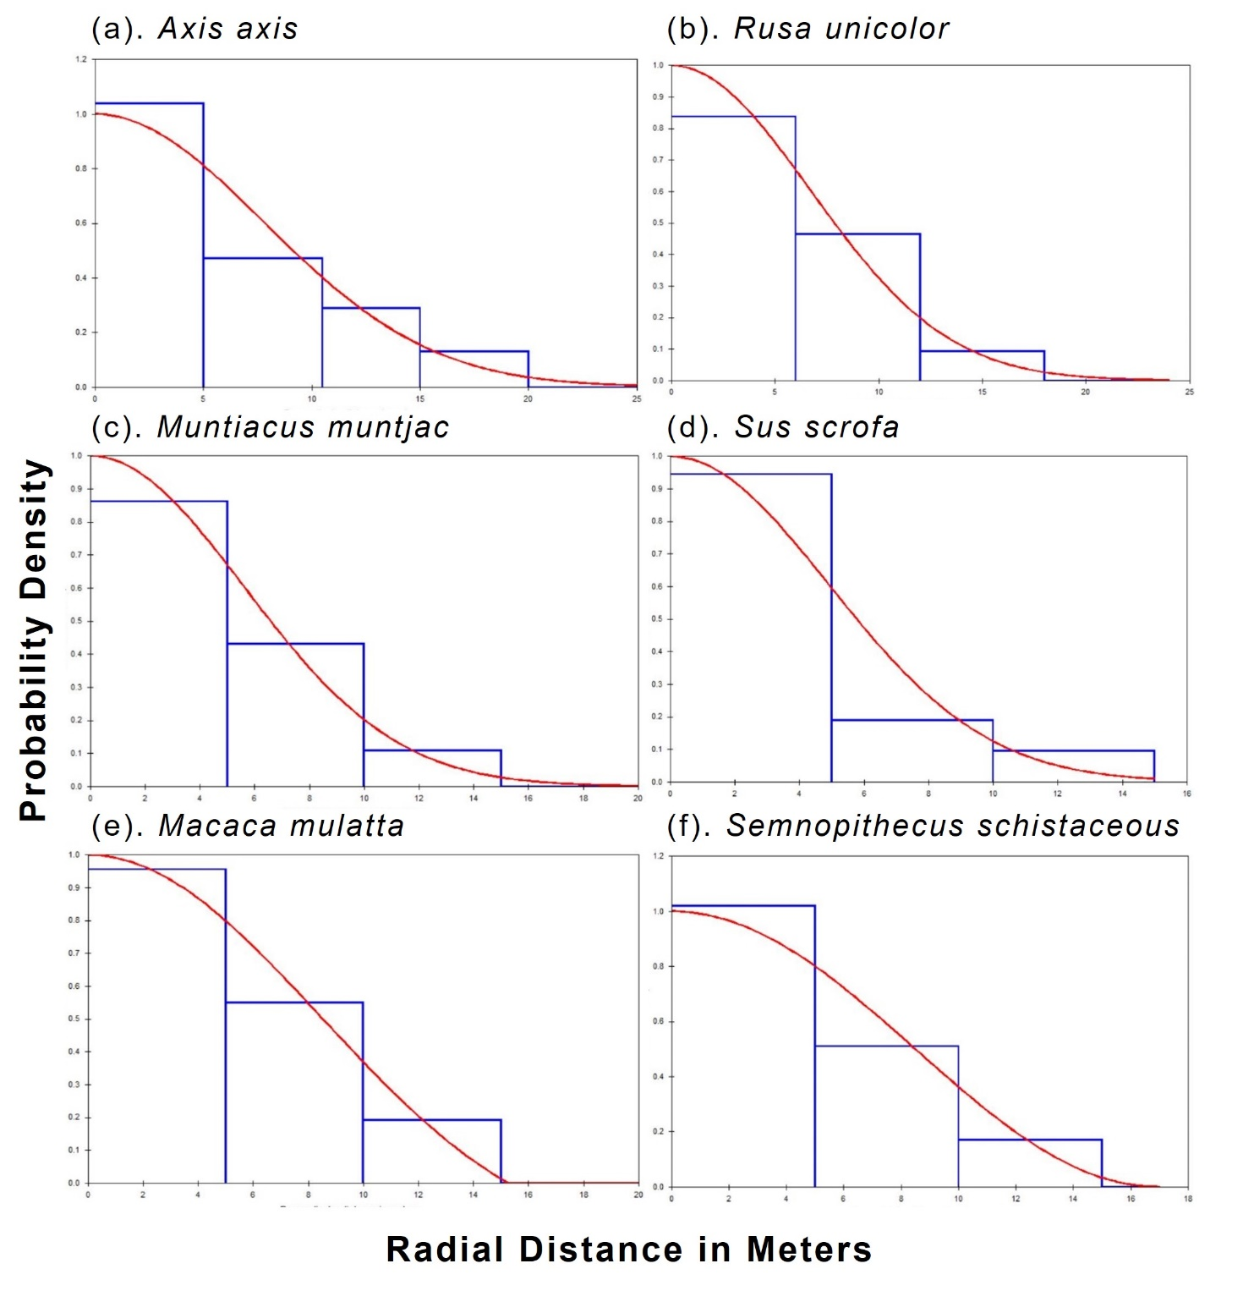

Figure S8. The bar graph compares densities estimated for mammalian species using the CTDS method in CWLS.
