The significance of recycled oceanic mantle lithosphere beneath the Arctic Gakkel ridge
A. Y. Yang^{1,2,3}, C. H. Langmuir⁴, P. Michael⁵
¹State Key Laboratory of Isotope Geochemistry, Guangzhou Institute of Geochemistry, Chinese Academy of Sciences, Guangzhou 510640, China. ²CAS Center for Excellence in Deep Earth Science, Guangzhou, China. ³Southern Marine Science and Engineering Guangdong Laboratory (Guangzhou), Guangzhou, China. ⁴Department of Earth and Planetary Sciences, Harvard University, MA, USA. ⁵University of Tulsa, Tulsa, OK, USA.
Supplementary materials
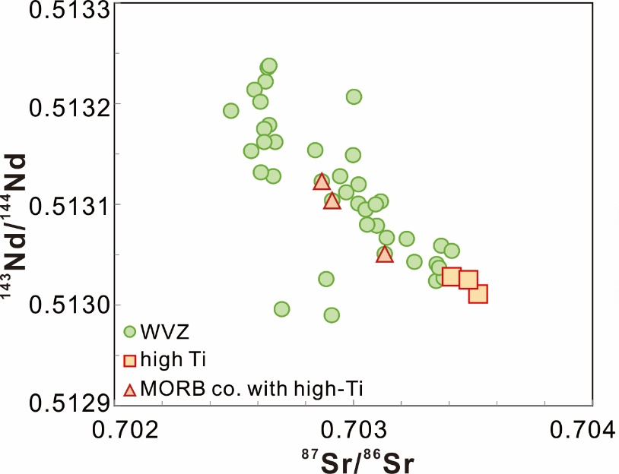
Fig. S1 Sr-Nd isotopic compositions of high-Ti MORB and Gakkel MORB from WVZ. All data are from Goldstein, et al. ¹.
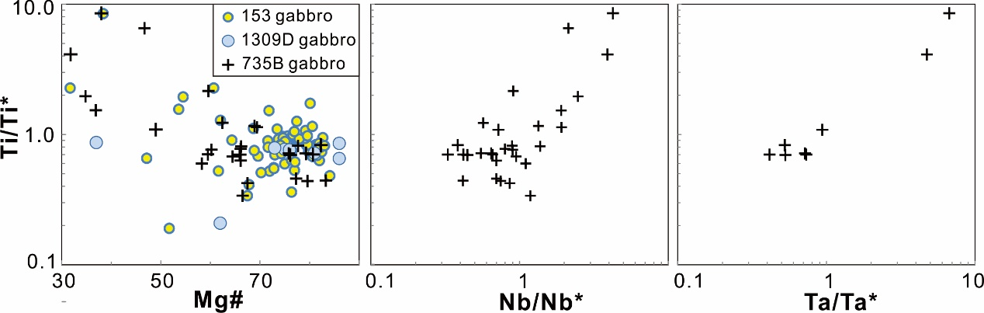
Fig. S2 Ti/Ti* vs. Mg#, Nb/Nb*(Nb_{N}/$√$(Th_{N}$×$La_{N})) and Ta/Ta* (Ta_{N}/$√$(Th_{N}$×$La_{N})) for gabbros from holes 1309D² and 735B³ as well as Leg 153⁴.
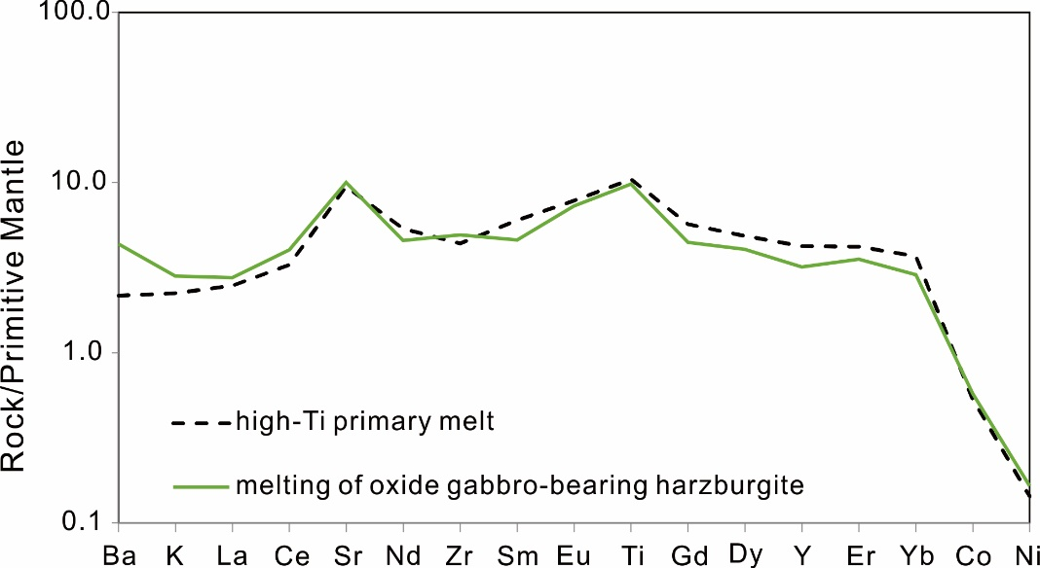
Fig. S3 Quantitative modeling on the melting of recycled oxide gabbro-bearing ocean lithosphere. The modeled melt compositions agree well with the primary melt compositions calculated for high-Ti MORB. The modeling parameters are listed in Supplementary Table S2.
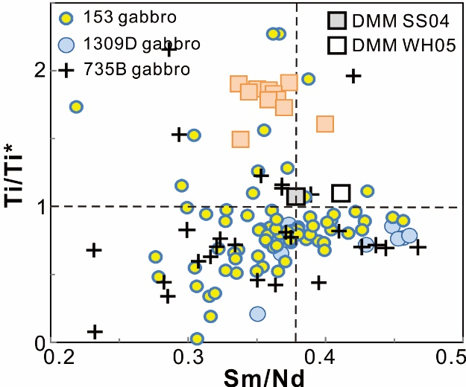
Fig. S4 Ti/Ti* vs. Sm/Nd for gabbros from lower oceanic crust holes 1309D² and 735B³, as well as from Leg 153⁴. It is clearly shown that gabbros with Ti enrichments (Ti/Ti*>1) mostly have Sm/Nd ratios lower than that of the depleted MORB mantle (DMM), with the latter from Salters and Stracke ⁵ and Workman and Hart ⁶ plotted as comparison.
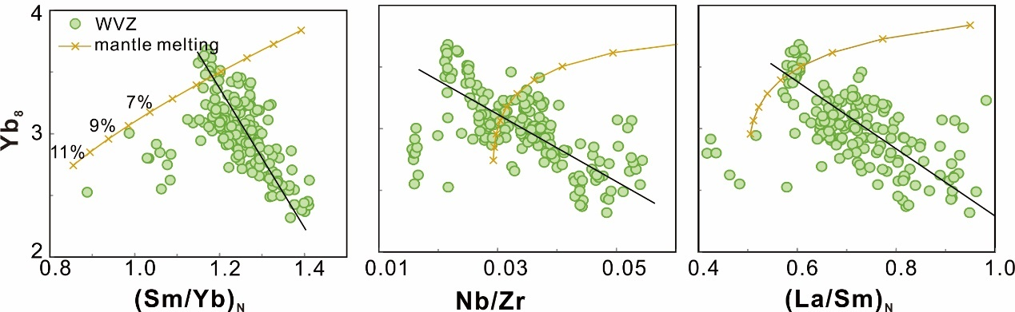
Fig. S5 Correlation of Yb₈ with trace element ratios which are sensitive to source enrichments for MORB from west volcanic zone (WVZ), Gakkel Ridge. Flat heavy rare element patterns (Figs. 2e, 3b and 4e in the main text) suggest melting mainly occurs in the spinel field for the majority of WVZ MORB. Thus, mantle melting models are shown for partial melting of depleted MORB mantle from Workman and Hart ⁶ in the spinel field from 1-11% with 1% increments. Black lines show the negative correlation of Yb₈ with (Sm/Yb)_{N}, Nb/Zr and (La/Sm)_{N} ratios, opposite to the partial melting trends, instead indicating decreasing melting degrees of a more refractory mantle.
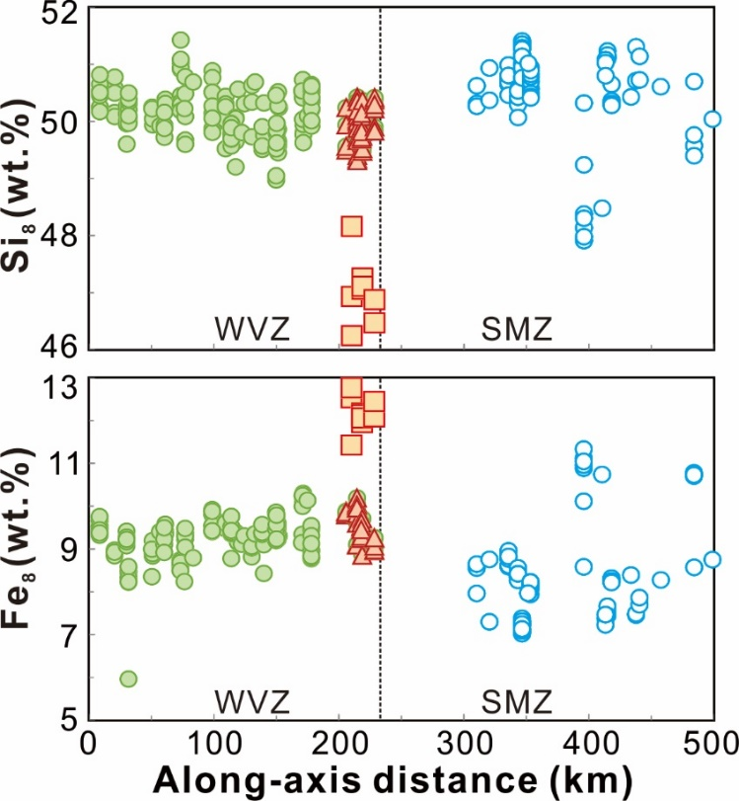
Fig. S6 Along-axis variations of Si₈ and Fe₈ for Gakkel MORB. It can be seen that most of the MORB from the SMZ shifted to higher Si₈ and lower Fe₈ contents. The calculation method of Si₈ and Fe₈ can be found in Table S1.
References
1 Goldstein, S. L. et al. Origin of a ‘Southern Hemisphere’geochemical signature in the Arctic upper mantle. Nature 453, 89-93 (2008).
2 Godard, M. et al. Geochemistry of a long in-situ section of intrusive slow-spread oceanic lithosphere: Results from IODP Site U1309 (Atlantis Massif, 30 N Mid-Atlantic-Ridge). Earth Planet. Sci. Lett. 279, 110-122 (2009).
3 Hart, S. R., Blusztajn, J., Dick, H. J. B., Meyer, P. S. & Muehlenbachs, K. The fingerprint of seawater circulation in a 500-meter section of ocean crust gabbros. Geochim. Cosmochim. Acta 63, 4059-4080, doi:http://dx.doi.org/10.1016/S0016-7037(99)00309-9 (1999).
4 Casey, J. in Proceedings of the Ocean Drilling Program. Scientific Results. 181-241.
5 Salters, V. J. M. & Stracke, A. Composition of the depleted mantle. Geochemistry Geophysics Geosystems 5, Q05B07 (2004).
6 Workman, R. K. & Hart, S. R. Major and trace element composition of the depleted MORB mantle (DMM). Earth Planet. Sci. Lett. 231, 53-72, doi:10.1016/j.epsl.2004.12.005 (2005).

