Supplementary Information

Section A:

Shape
Fibres were the dominant shape identified in atmospheric deposition, lake water and inflow streams with more than 60% of the anthropogenic particles identified being fibres (Figure SI-1). Conversely, in the sediment, the proportion of fragments was two times greater the proportion of fibres. If the sediment is broken down into the top 0–3 cm section and 30–33 cm section, fragments were more common in the top 0–3 cm section (67%) whereas in the bottom 30–33 cm section, fibres were more common (75%). These results are very similar to the literature (Cai et al. 2017; Brahney et al. 2020; Wright et al. 2020; Szewc et al. 2021; Abbasi and Turner 2021; Welsh et al. 2022; Anderson et al. 2017; Lenaker et al. 2019; Baldwin et al. 2016; Welsh et al. 2021). The dominant nature of fibres in atmospheric deposition is likely because fibres easily detach from textiles during laundry drying and everyday wear (Brahney et al. 2020; Szewc et al. 2021). Secondly, several studies suggest that fibres tend to dominant atmospheric deposition in remote or background regions as they remain suspended in the atmosphere longer and can travel to remote regions or globally, depending on their size, wind trajectory and speed (Allen et al. 2019; Brahney et al. 2020; Loppi et al. 2021; Welsh et al. 2022). Fragments, on the other hand, may deposit closer to the source, thus resulting in a lower proportion in atmospheric deposition compared to fibres (Loppi et al. 2021; Welsh et al. 2022). In the lake, fragments may settle at a greater rate than fibres, resulting in more fibres staying suspended in the lake, which may also explain why there was a higher proportion of fragments in the sediment than fibres (Loppi et al. 2021; Dusaucy et al. 2021).

Colour
Across all sample media, blue was the most common coloured anthropogenic particle identified with more than 59% of the fibres and 54% of the fragments identified being blue (Table SI-2). Red, green and white were also common colours identified for fragments whereas red, grey and black were common fibre colours. Blue appears to be the most common colour identified in the literature; but despite their prevalent nature, their source remains unclear (Zhang et al. 2020; Baldwin et al. 2016) Blue jeans and denim garments are worn by roughly 50% of the world’s population at any moment in time, with approximately 56,000 microfibres being released per wash of one used pair of jeans (Athey et al. 2020). Furthermore, bright eye-catching colours, such as blue, may be easily recognized during visual identification and thus overestimated compared to other dull or transparent colours which may be harder to identify (Hildago-Ruz et al. 2012; Dris et al. 2015; Zhang et al. 2020).

Size
Across all sample media, the size of anthropogenic particles size ranged from 20–4,980 μm, however, most sampled particles had a size less than 2,000 μm, with particle size exhibiting a right skewed distribution (Table SI-1). Of the particles that were identified down to a size class of 20 μm, 7 were fibres (precipitation: 1; streams: 6) and 249 were fragments (precipitation: 69; lake water: 32; streams: 128; sediment: 20).
The mean fibre and fragment sizes were highest in the lake sediment followed by atmospheric deposition and was the lowest in the outflow streams, possibly suggesting that larger sized particles settle at a rate faster than smaller sized particles (Kowalski et al. 2016; Semcesen and Wells 2016). Across all sample media, approximately 90% of the fibres and 99% of the fragments had a size less 2,000 μm which is consistent with the literature. The majority of studies examining the presence of microplastics in freshwater environments, found that particles predominantly had a size less than 1,000 μm with some studies even finding particles to predominantly have a size smaller than 500 μm (Dusaucy et al. 2021; Zhang et al. 2020; Kallenbach et al. 2021). Furthermore, Klein and Fischer (2019), Allen et al. (2019), and Brahney et al. (2020) found all fragments in atmospheric deposition to have a size less than 350 μm with the majority being <63 μm.
The fragment and fibres sizes observed in atmospheric deposition are similar to fragment and fibre sizes observed in the French Pyrenees mountain, Ireland and protected areas of the USA, suggesting that smaller particles may be dominant in remote or rural sites, distant from urban or industrial centres due to long-range atmospheric transport (Allen et al. 2019; Roblin et al. 2020; Brahney et al. 2020). The lack of large sized particles in the headwater lakes could suggest that larger particles were either flushed away, leaving behind smaller ones, were degraded into smaller sizes, or sink more quickly than smaller particles (Li et al. 2019). Particle abundance is expected to decrease with increasing size class, and display a right skewed distribution, because fragmentation and weathering of microplastics causes them to breakdown into even smaller particles (Kooi and Koelmans 2019). Therefore, since the highest proportion of fibres and fragments in this study had a size less than 600 μm the particles are likely secondary microplastics (Roblin et al. 2020; Kooi and Koelmans 2019).
Table SI-1: The mean and median size (μm) as well as the range (μm) and coefficient of variation (%) for anthropogenic particles (fibres and fragments combined), fibres only, and fragments only, collected from atmospheric deposition, lake water, sediment, inflow stream and outflow streams in Muskoka-Haliburton, Canada.
Sample Type |  | Number of Particles | Median (μm) | Mean  (μm) | Range  (μm) | Coefficient of Variation (%)
Atmospheric Deposition | Particles  Fibres  Fragments | 2,663  2,268  395 | 440  510  100 | 680  770  190 | 20 – 4,980  20 – 4,980  20 – 3,480 | 105  95  162
Lake Water | Particles  Fibres  Fragments | 306  226  80 | 300  435  50 | 534  686  106 | 20 – 4,650  50 – 4,650  20 – 1,210 | 123  102  159
Sediment* | Particles  Fibres  Fragments | 153  51  102 | 260  760  160 | 543  1015  307 | 20 – 4,860  110 – 4,860  20 – 2,960 | 135  94  144
Inflow Streams | Particles  Fibres  Fragments | 766  570  196 | 280  440  60 | 551  708  92 | 20 – 4,610  20 – 4,610  20 – 940 | 128  106  107
Outflow Streams | Particles  Fibres  Fragments | 277  168  109 | 210  270  40 | 377  578  69 | 20 – 2,700  50 – 2,700  20 – 940 | 131  94  157
* Some of the anthropogenic particle pictures were lost and therefore the size of the particles were not measured and the particles were not included in the table above
Table SI-2: The proportion (%) of fibres and fragments and their colour that were identified in atmospheric deposition, lake water, sediment and stream water (inflows and outflows) samples collected from the three study sites in Muskoka-Haliburton, Canada.
Colour | Fragments (%) | Fibres (%)
Black | 0.22 | 4.31
Blue | 53.86 | 59.47
Clear | 0.76 | 0.09
Green | 22.73 | 0.86
Green-white | 0.11 | N/A
Grey | 0.65 | 9.57
Orange | 1.52 | 0.30
Pink | 0.11 | 0.86
Purple | N/A | 0.47
Red | 10.39 | 23.99
White | 6.17 | 0.06
Yellow | 3.68 | 0.03

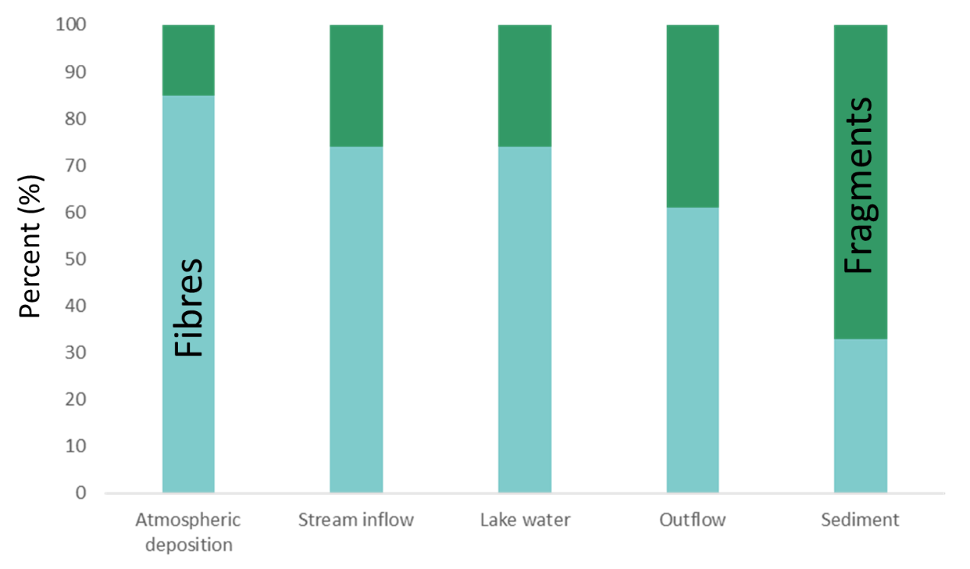
Figure SI-1: Proportion of fibres and fragments identified in atmospheric deposition, sediment, lake water and stream (inflow and outflow) samples collected in Muskoka-Haliburton.

Section B:
Table SI-3: Concentration of microplastics (MP/L), coefficient of variation (%), daily microplastic flux (MP/m²/day) and daily microplastic input rate (MP/day) for each of the gauged inflows as well as for the ungauged inflows for Plastic, Harp and Dickie Lake in Muskoka-Haliburton, Canada.
Lake | Station | Concentration (MP/L) | Coefficient of Variation (%) | Daily Microplastic Flux (MP/m²/day) | Daily Input Rate  (x10⁶ MP/day)
Plastic | PC1 | 0.71 | 110 | 2.34 | 0.55
Plastic | Ungauged Inflows | N/A | – | 2.34 | 1.58
Harp | HP3 | 0.68 | 109 | 1.24 | 0.32
Harp | HP3A | 0.89 | 98 | 2.40 | 0.47
Harp | HP4 | 0.77 | 61 | 1.86 | 2.21
Harp | HP5 | 1.45 | 59 | 2.89 | 5.51
Harp | HP6 | 0.73 | 70 | 2.28 | 0.23
Harp | HP6A | 1.13 | 94 | 2.01 | 0.31
Harp | Ungauged Inflows | N/A | – | 2.38 | 2.14
Dickie | DE5 | 0.94 | 103 | 1.77 | 0.53
Dickie | DE6 | 1.34 | 73 | 2.28 | 0.50
Dickie | DE8 | 0.97 | 50 | 2.98 | 2.00
Dickie | DE10 | 1.08 | 99 | 1.32 | 1.04
Dickie | DE11 | 1.34 | 59 | 2.44 | 1.86
Dickie | Ungauged Inflows | N/A | – | 2.16 | 2.86
Table SI-4: Concentration of microplastics (MP/g) in the top 0-3 cm section and bottom 30–33 cm section of the sediment cores collected from the 3 study lakes in Muskoka-Haliburton, Canada between June and August 2019.
Lake | Top: 0–3 cm | Bottom: 30–33 cm
Plastic | 2.71 ± 0.15 | 1.28 ± 0.22
Harp | 6.81 ± 1.59 | 0.99 ± 0.12
Dickie | 4.79 ± 0.63 | 0.67 ± 0.40

Table SI-5: The location (latitude and longitude) and number of sampling events collected for each of the gauged inflow and outflow stations for Plastic Lake, Harp Lake and Dickie Lake, the description (lake, inflow or outflow), daily mean flow (L/s) and the catchment area for each of the gauged and ungauged inflow/outflow streams as well as the lake area.
Lake | Station | Description | Number of Sample Events | Daily Mean Flow (L/s) | Latitude | Longitude | Area  (10⁴ m²) | % of Catchment
Plastic | PC | Lake | 10 | – | 45.1800 | -78.8300 | 32.14 | 25.79
Plastic | PC1 | Inflow | 9 | 5.07 | 45.1784 | -78.8282 | 23.34 | 18.73
Plastic | Ungauged | Inflow | – | – | – | – | 69.16 | 55.49
Plastic | PCOL | Outflow | 15 | 25.85 | 45.1732 | -78.8231 | 124.64 | –
Harp | HP | Lake | 7 | – | 45.3800 | -79.1500 | 71.38 | 13.17
Harp | HP3 | Inflow | 10 | 7.00 | 45.3735 | -79.1413 | 26.00 | 4.80
Harp | HP3A | Inflow | 8 | 4.33 | 45.3742 | -79.1438 | 19.65 | 3.63
Harp | HP4 | Inflow | 13 | 23.88 | 45.3797 | -79.1418 | 119.09 | 21.97
Harp | HP5 | Inflow | 8 | 42.90 | 45.3835 | -79.1313 | 190.53 | 35.15
Harp | HP6 | Inflow | 9 | 2.24 | 45.3792 | -79.1265 | 9.97 | 1.84
Harp | HP6A | Inflow | 7 | 4.08 | 45.3801 | -79.1274 | 15.28 | 2.82
Harp | Ungauged | Inflow | – | – | – | – | 90.14 | 16.63
Harp | HPOF | Outflow | 11 | 117.82 | 45.3761 | -79.1264 | 542.02 | –
Dickie | DE | Lake | 7 | – | 45.1500 | -79.0800 | 93.60 | 18.72
Dickie | DE5 | Inflow | 17 | 4.71 | 45.1418 | -79.0897 | 29.98 | 6.00
Dickie | DE6 | Inflow | 19 | 4.79 | 45.1441 | -79.0890 | 21.80 | 4.36
Dickie | DE8 | Inflow | 17 | 19.68 | 45.1530 | -79.0900 | 66.96 | 13.39
Dickie | DE10 | Inflow | 15 | 15.95 | 45.1561 | -79.0804 | 78.89 | 15.78
Dickie | DE11 | Inflow | 15 | 15.52 | 45.1480 | -79.0780 | 76.27 | 15.25
Dickie | Ungauged | Inflow | – | – | – | – | 132.52 | 26.50
Dickie | DEOF | Outflow | 19 | 107.71 | 45.1427 | -79.0947 | 500.02 | –

Table SI-6: The total number of cottages or home on the lake as well as the physical characteristics (lake area, watershed area, lake volume, mean depth, max depth and sedimentation rate for the last 50 years) of the three study lakes in Muskoka-Haliburton, Canada.
Lake | Number of Cottages | Lake Area (ha) | Watershed Area (ha) | Lake Volume (10⁴ m³) | Mean Depth (m) | Max Depth (m) | Sedimentation Rate Last 50 years  (g cm⁻² year⁻¹)
Plastic | 0 | 32.14 | 127.64 | 253.9 | 7.9 | 16.3 | 0.0097
Harp | 96 | 71.38 | 542.04 | 949.4 | 13.3 | 37.5 | 0.0202
Dickie | 133 | 93.6 | 500.02 | 468 | 5.0 | 12.0 | 0.0227
Table SI-7: Location (latitude and longitude) and annual precipitation of the three bulk precipitation chemistry monitoring stations and the lake they are located near during the sampling period from February 2019 – March 2020.
Site ID | Lake | Latitude | Longitude | Annual Precipitation (mm) | Sampling Period (dd/mm/yyyy)
PCP-PCP2 | Plastic | 45.1816 | 78.8246 | 1081 | 11/04/2019 – 04/03/2020
SE2P | Harp | 45.3991 | -79.0032 | 1075 | 20/02/2019 – 25/02/2020
HYP2 | Dickie | 45.1304 | -79.0979 | 1112 | 20/02/2019 – 11/03/2020

Table SI-8: Average concentration of anthropogenic particles and microplastics in each of the blank samples collected and their coefficient of variation.
QA/QC Sample (liquid) | Average Microplastic Concentration  (MP/L) * | Coefficient of Variation (%)
Unfiltered B-Pure (n = 16) | 0.46 | 65
Unfiltered Deionised (DI) water (n = 8) | 0.16 | 90
Unfiltered H₂O₂ (n = 6) | 1.26 | 64
Unfiltered ZnCl₂ (n = 5) | 7.38 | 9
Precipitation Bag Blank (n=6) | 0.00 | 65
500 mL Lake Field Blank  (n = 6) | 0.00 | 62
1 L Lake Field Blank (n=6) | 0.00 | 35
500 mL Stream Field Blank (n=6) | 0.00 | 68
1 L Stream Field Blank (n=6) | 0.00 | 48
QA/QC Sample (open-air) | Average Microplastic Concentration (MP/hr) * | Coefficient of Variation (%)
Oven (n = 12) | 0.00 | 87
Filtering (n = 51) | 0.20 | 178
Fume hood (n=11) | 0.24 | 100
Microscope (n = 21) | 0.07 | 78
* The average concentration of particles and microplastics in the liquid and air QA/QC samples have been normalized to MP L⁻¹ and MP hr⁻¹ respectively
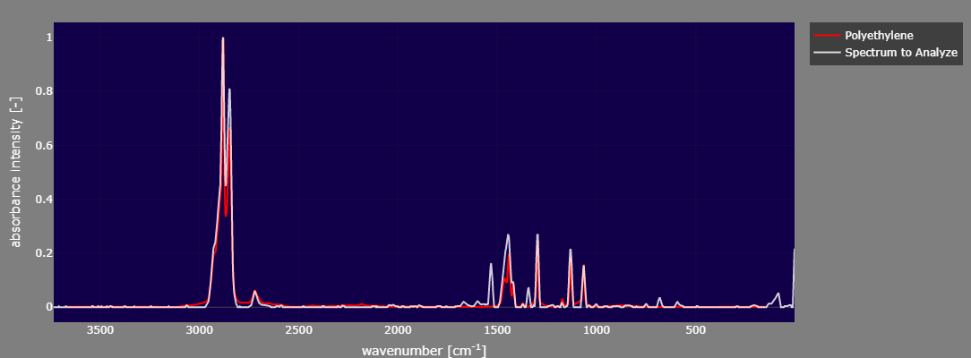
Figure SI-2a: Spectra from micro-Raman spectroscopy analyzed through the commercial library Open Specy for polyethylene microplastic observed in a sediment sample collected from Dickie Lake in Muskoka-Haliburton, Canada.

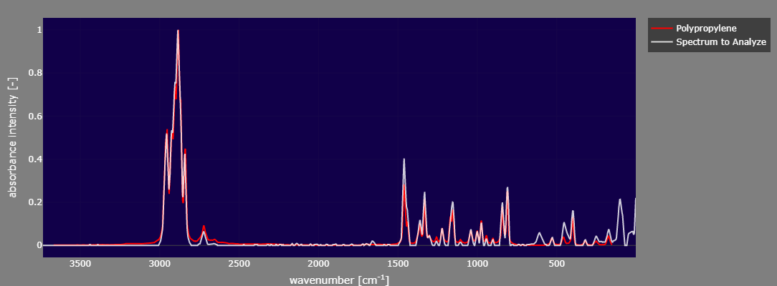
Figure SI-2b: Spectra from micro-Raman spectroscopy analyzed through the commercial library Open Specy for polypropylene microplastic observed in a lake sample collected from Plastic Lake in Muskoka-Haliburton, Canada.

