Supporting Information for
Adsorption of fungal ice-binding proteins to whole ice crystal surface is deficient for high thermal hysteresis activity but strongly inhibits ice recrystallization.

Tatsuya Arai§, Akari Yamauchi, Yue Yang, Shiv Mohan Singh, Yuji C. Sasaki, and Sakae Tsuda.

§Correspondence
E-mail: t.arai@edu.k.u-tokyo.ac.jp
Telephone: +81-4-7136-3892
Address: Department of Advanced Materials Science, Graduate School of Frontier Sciences, the University of Tokyo, 7H8 #609 Kiban Bldg., 5-1-5 Kashiwanoha, Kashiwa, Chiba 277-8561, Japan

This file includes:
Figure. S1

Figure S1
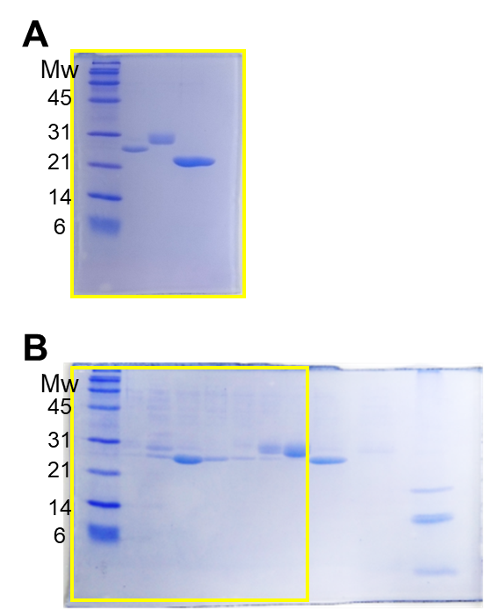

Raw uncropped images of SDS-PAGE gels for Fig. 2B (A) and Fig. 2C (B). Yellow box indicates the region used for the figure in the main text.

