Supporting Information
Synthetic control of the surface area in nickel cobalt oxide for glucose detection via additive-assisted wet chemical method
Kyu-bong Jang^{a,†}, Kyoung Ryeol Park^{b,†}, Chan Bin Moª, Seongtak Kimª, Jaeeun Jeon^{c}, Sung-chul Lim^{c}, Chisung Ahn^{c}, HyukSu Han^{d}, Dongju Kim^{e}, Kang min Kim^{a,*}, and Sungwook Mhin^{e,*}

ª Korea Institute of Industrial Technology, 137-41 Gwahakdanji-ro, Gangneung, 25440, Republic of Korea
^{b} Korea Institute of Industrial Technology, 55, Jongga-ro, Jung-gu, Ulsan, 44413, Republic of Korea
^{c} Korea Institute of Industrial Technology, 156 Gaetbeol-ro, Incheon, 21999, Republic of Korea
^{d} Department of Energy Engineering, Konkuk University, 120 Neungdong-ro, Seoul, 05029, Republic of Korea
^{e} Department of Advanced Materials Engineering, Kyonggi University, 154-42 Gwanggyosan-ro, Suwon, 16227, Republic of Korea

† These authors contributed equally to this work.
* Correspondence and request for materials should be addressed to K. M. Kim (kmkim@kitech.re.kr) or S. Mhin (swmhin@kgu.ac.kr)

Figure S1. FE-SEM image of the NCO nanomaterials. The different nanostructures are also shown.
Figure S2. EDS mapping image of Ni, Co, and O in the NCO nanomaterials.
Figure S3. The XPS spectra of Ni2p and Co2p; (a) PNCO, (b) TNCO, and (c) FNCO
Figure S4. The XPS spectra of O1s; (a) UNCO, (b) PNCO, (c) TNCO, and (d) FNCO
Figure S5. FE-SEM image of the as-prepared NCO nanomaterials.
Figure S6. XRD patterns of the as-prepared NCO nanomaterials; (a) as-prepared UNCO, (b) as-prepared PNCO, (c) as-prepared TNCO, and (d) as-prepared FNCO.
Figure S7. FE-SEM image of the as-prepared NCO nanomaterials.
Figure S8. The XPS spectra of Ni2p and Co2p of the as-prepared NCO nanomaterials.
Figure S9. The XPS spectra of C1s, N1s, and O1s of the as-prepared NCO nanomaterials.
Figure S10. Cyclic Voltammetry curves of (a) UNCO, (b) PNCO, (c) TNCO, and (d) FNCO electrodes at different scan rates in 0.1M NaOH solution.
Figure S11. Chronoamperometry response of (a) UNCO, (b) PNCO, (c) TNCO, and (d) FNCO electrodes for stability in 0.1 M NaOH. The stability of the nanomaterials was examined by a chronoamperometry response under alkaline conditions (0.1 M NaOH) containing 1 mM for an extended period of time (80,000 s).
Figure S12. Morphological and structural characterizations of UNCO after 24 h of chronoamperometry at 0.5 V in an electrolyte containing 0.1 M NaOH and 1 mM glucose. (a) TEM images along with the SAED patterns, lattice-resolved HRTEM image, and corresponding HADDF images of Ni, Co, and O. (b) The XPS spectra of Ni2p, Co2p, and O1s.
Figure S13. Chronoamperometry response of UNCO electrode for long-term stability in 0.1 M NaOH. The long-term stability of the UNCO was examined by a chronoamperometry response under alkaline conditions (0.1 M NaOH) containing 5 mM for 7 days.
Figure S14. Schematic illustration of electro paths on the morphology-controlled NiCo2O4 nanostructure
Table S1. Electrochemical performance of NCO in our work to that of non-enzymatic glucose sensors in other works.
Table S2. Synthetic details of NiCo2O4 (NCO) with controlled morphology via additive-assisted hydrothermal synthesis. For controlling the morphology of NCO, additives such as urea, hexamethylene-tetramine (HMT), and ammonium fluoride (NH4F) were selectively added in the above solution.

Figure S1

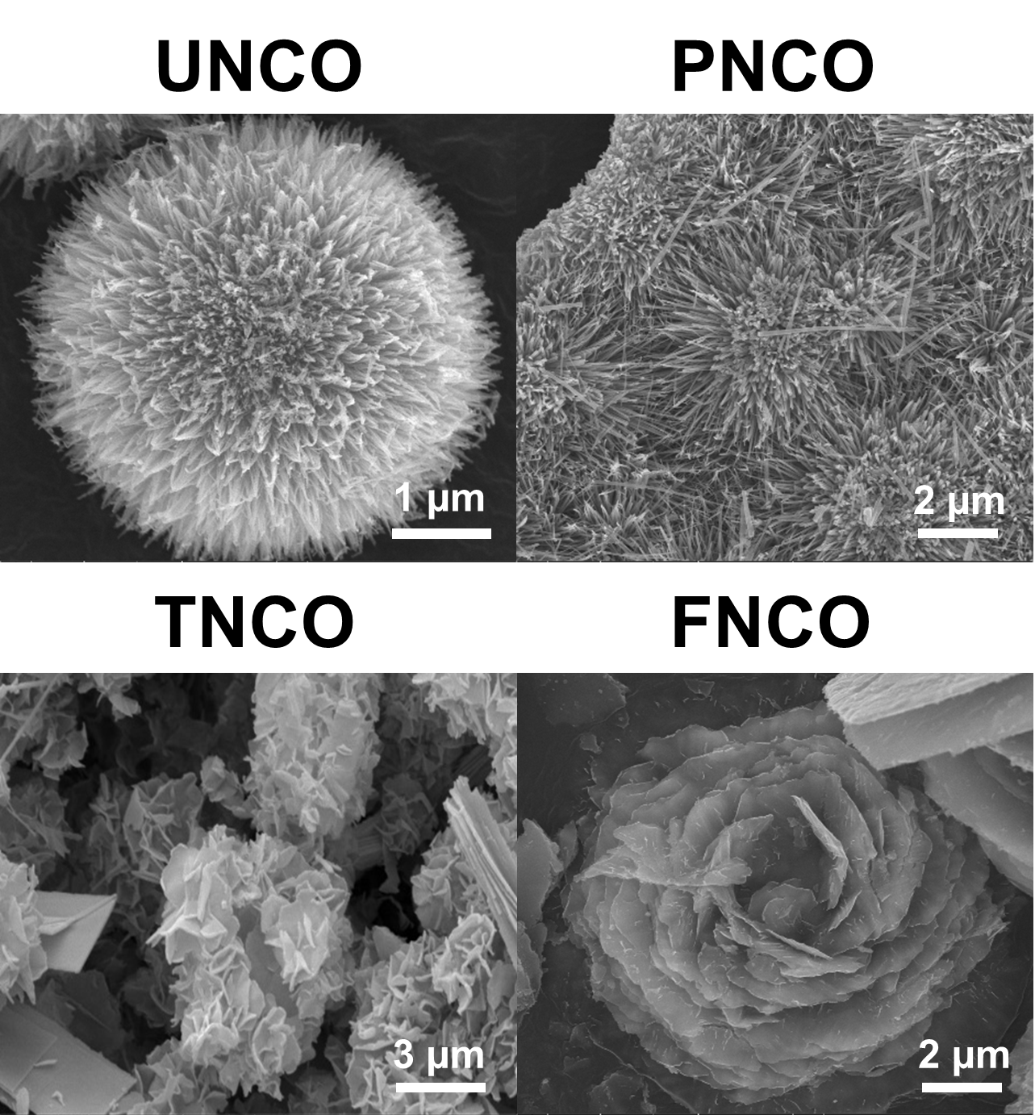
Figure S1. FE-SEM image of the NCO nanomaterials. The different nanostructures are also shown.

Figure S2

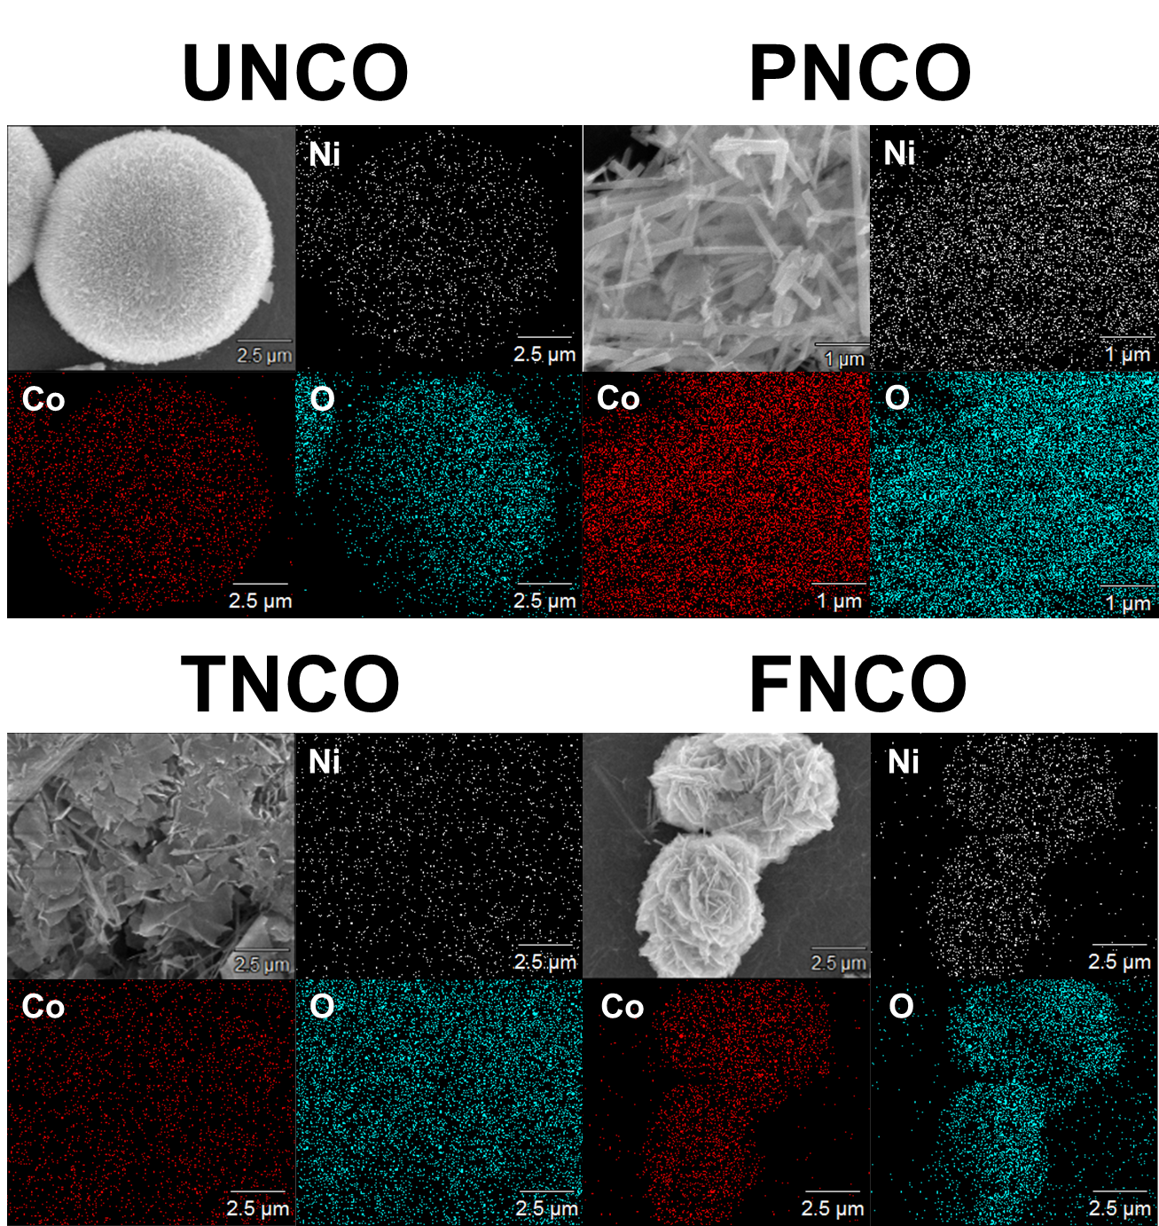
Figure S2. EDS mapping image of Ni, Co, and O in the NCO nanomaterials.

Figure S3

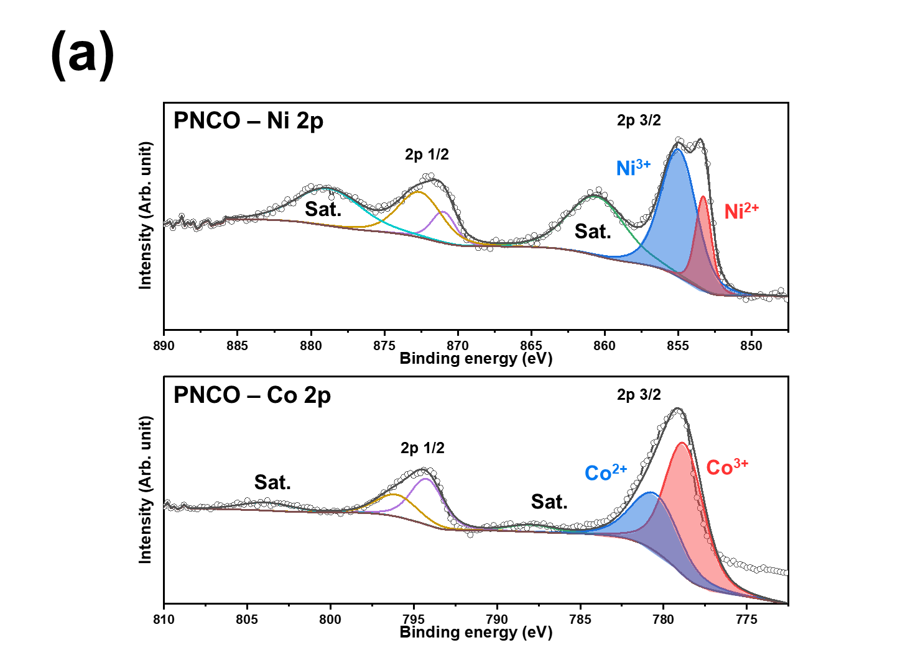
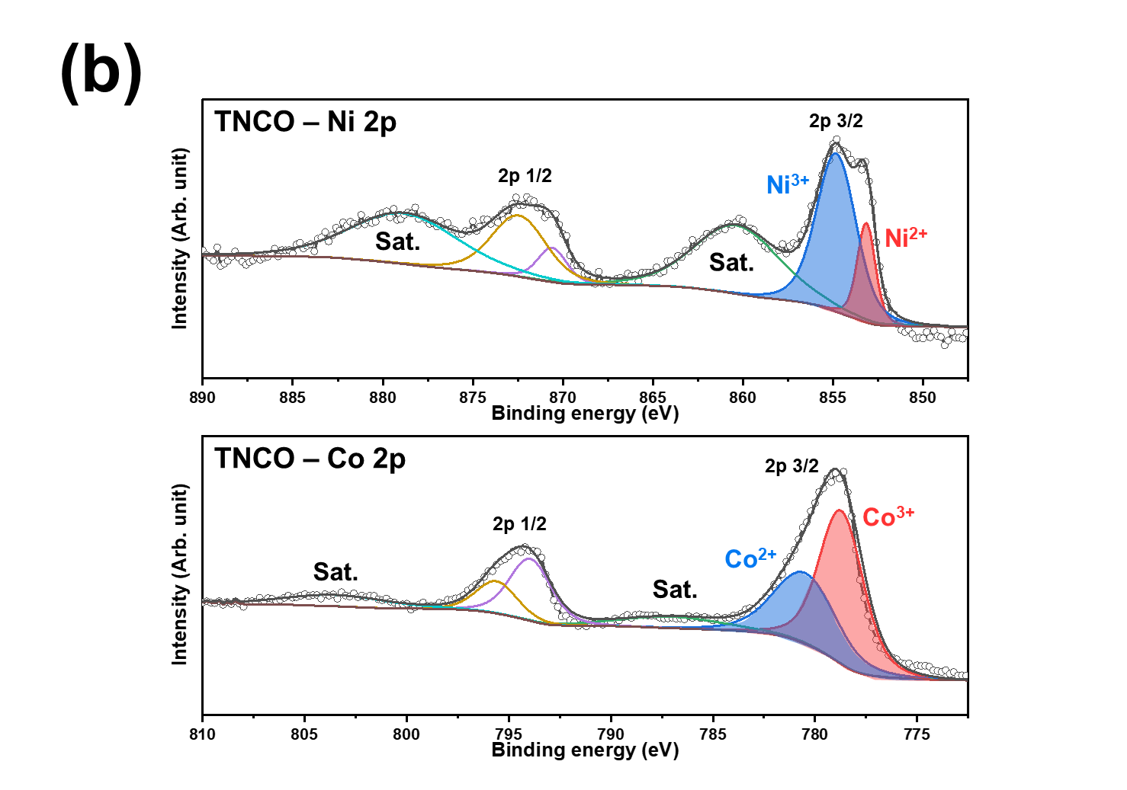
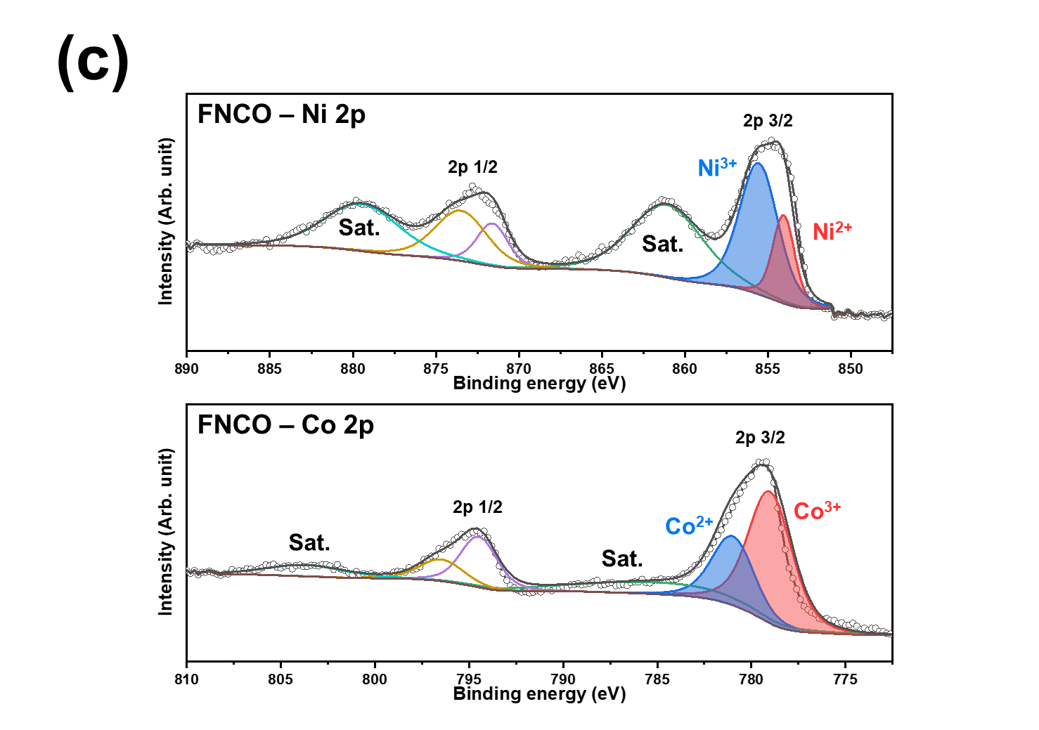
Figure S3. The XPS spectra of Ni2p and Co2p; (a) PNCO, (b) TNCO, and (c) FNCO

Figure S4

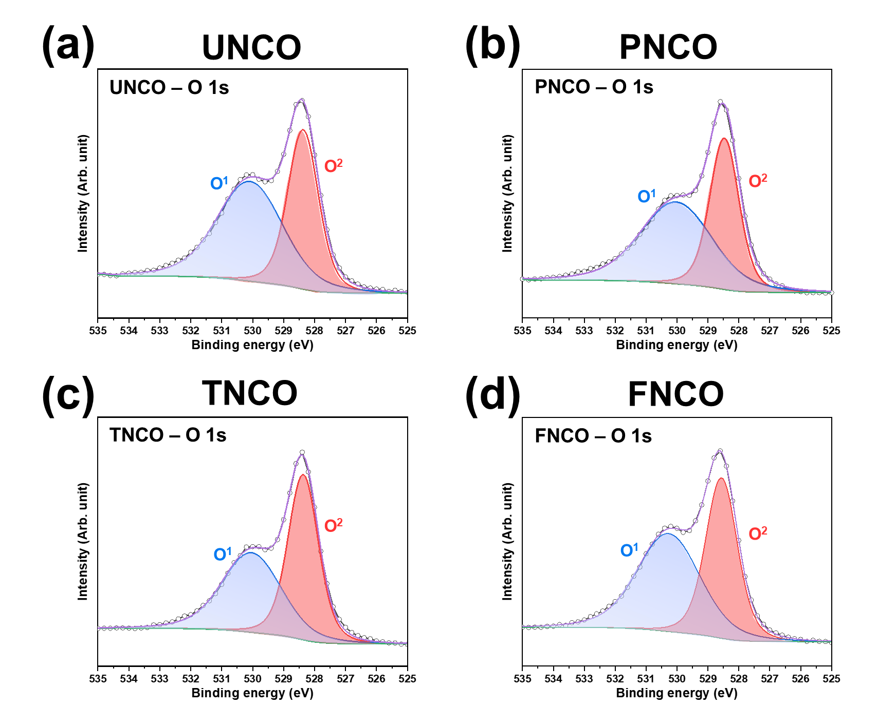
Figure S4. The XPS spectra of O1s; (a) UNCO, (b) PNCO, (c) TNCO, and (d) FNCO

Figure S5

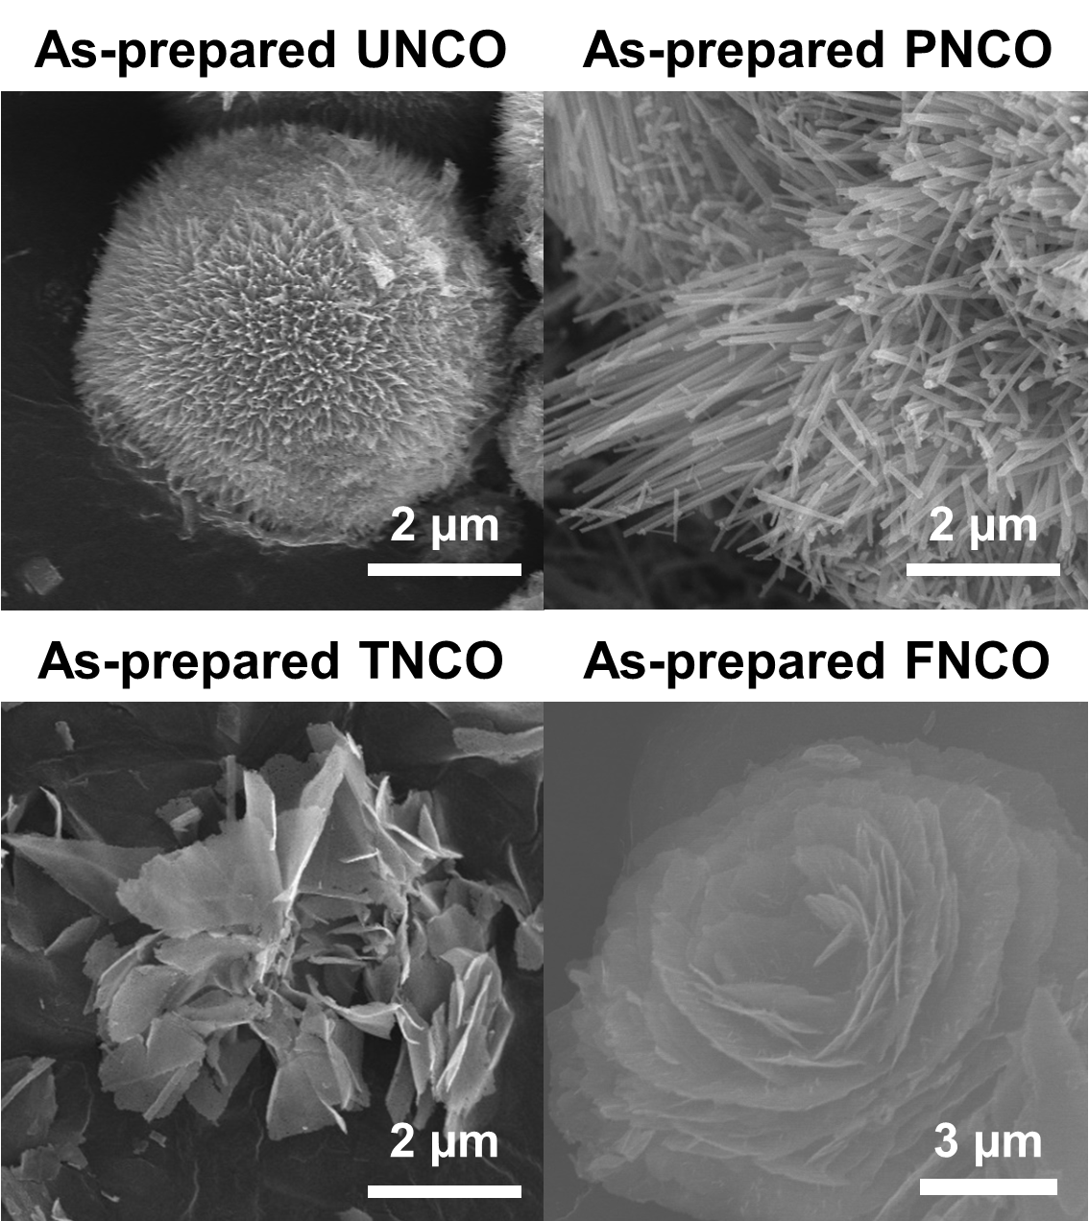
Figure S5. FE-SEM image of the as-prepared NCO nanomaterials.

Figure S6

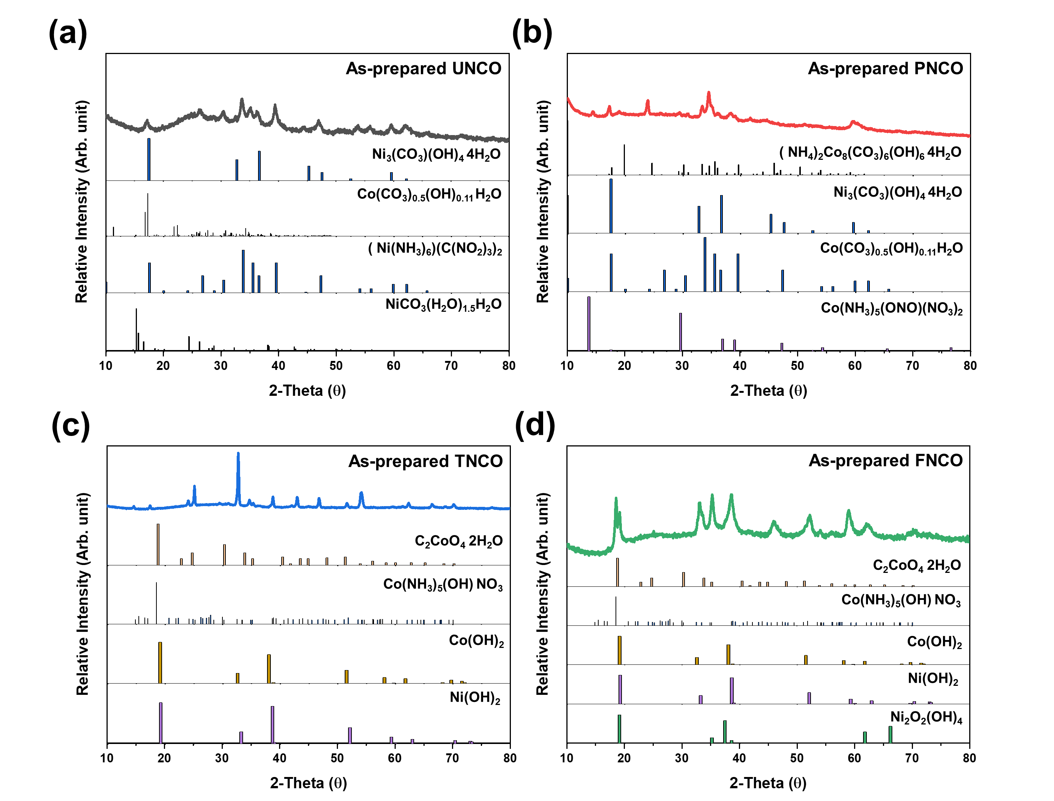
Figure S6. XRD patterns of the as-prepared NCO nanomaterials; (a) as-prepared UNCO, (b) as-prepared PNCO, (c) as-prepared TNCO, and (d) as-prepared FNCO.

Figure S7

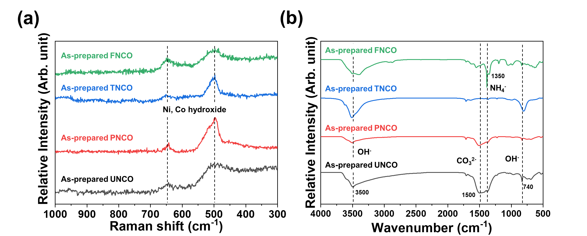
Figure S7. (a) Raman spectra, (b) FT-IR spectra of the as-prepared NCO nanomaterials.

Figure S8

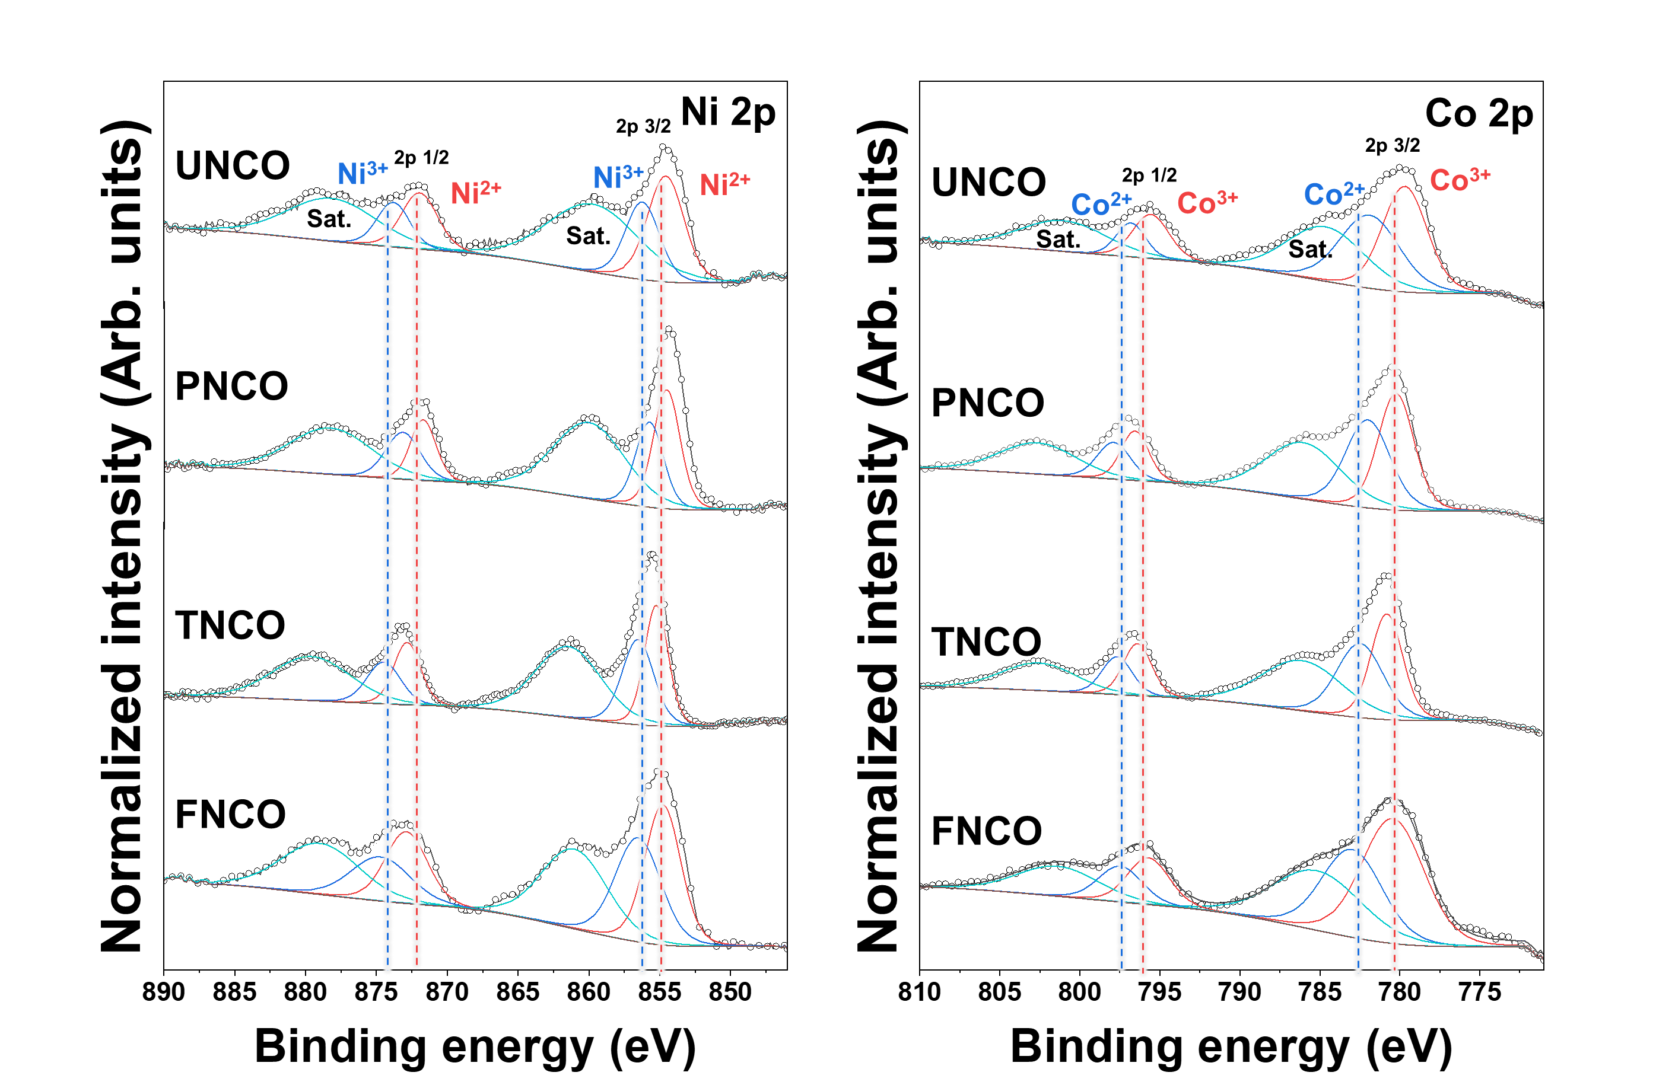
Figure S8. The XPS spectra of Ni2p and Co2p of the as-prepared NCO nanomaterials.

Figure S9

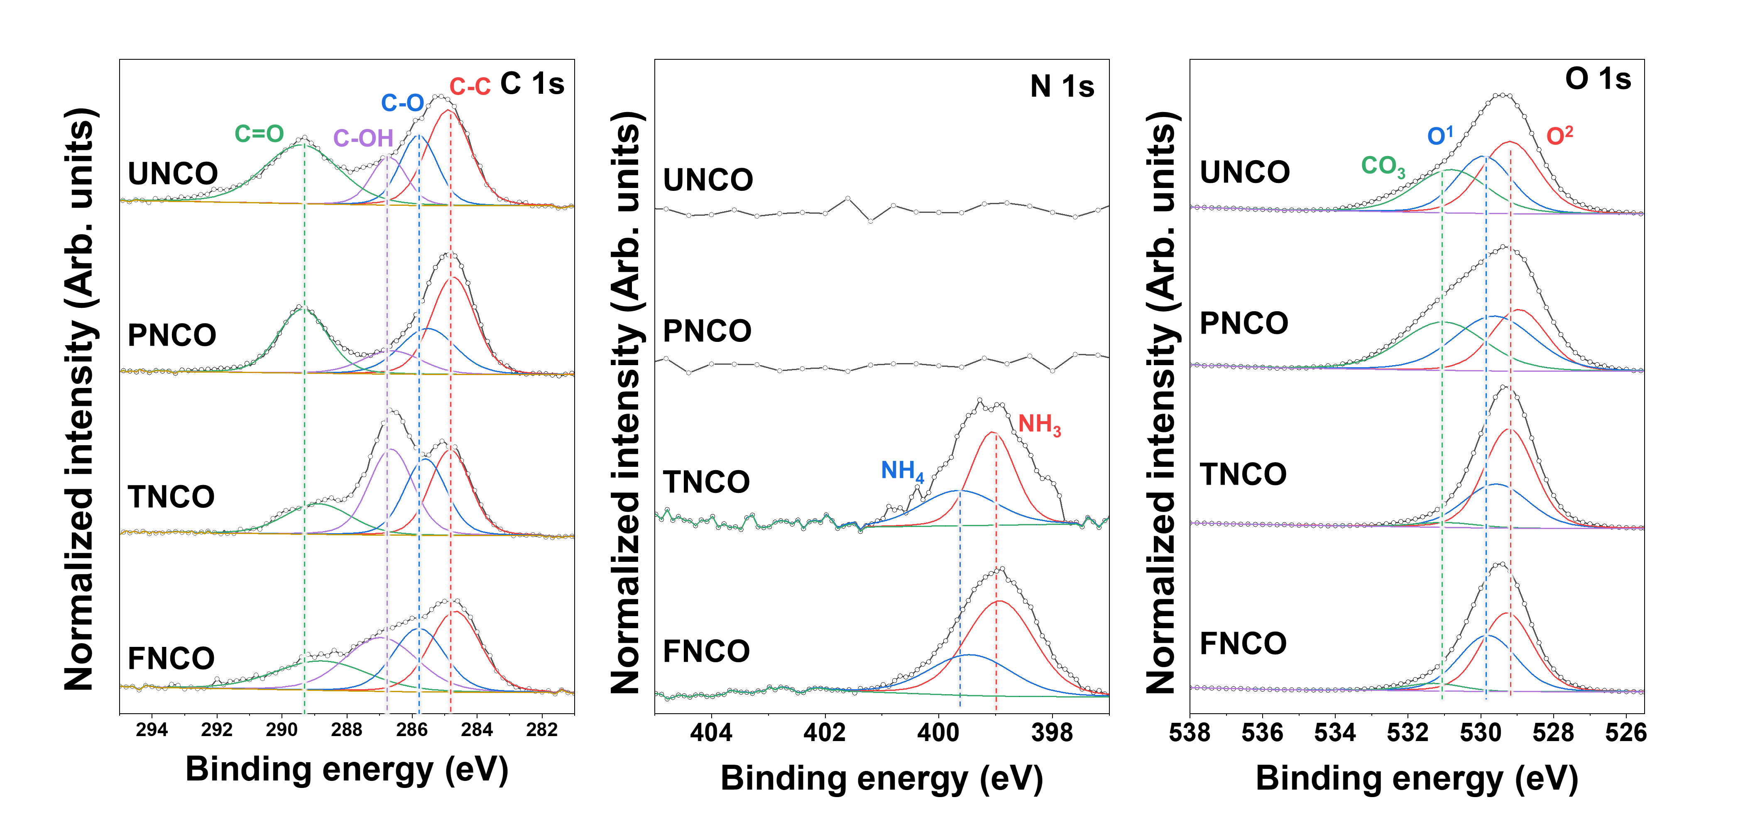
Figure S9. The XPS spectra of C1s, N1s, and O1s of the as-prepared NCO nanomaterials.

Figure S10

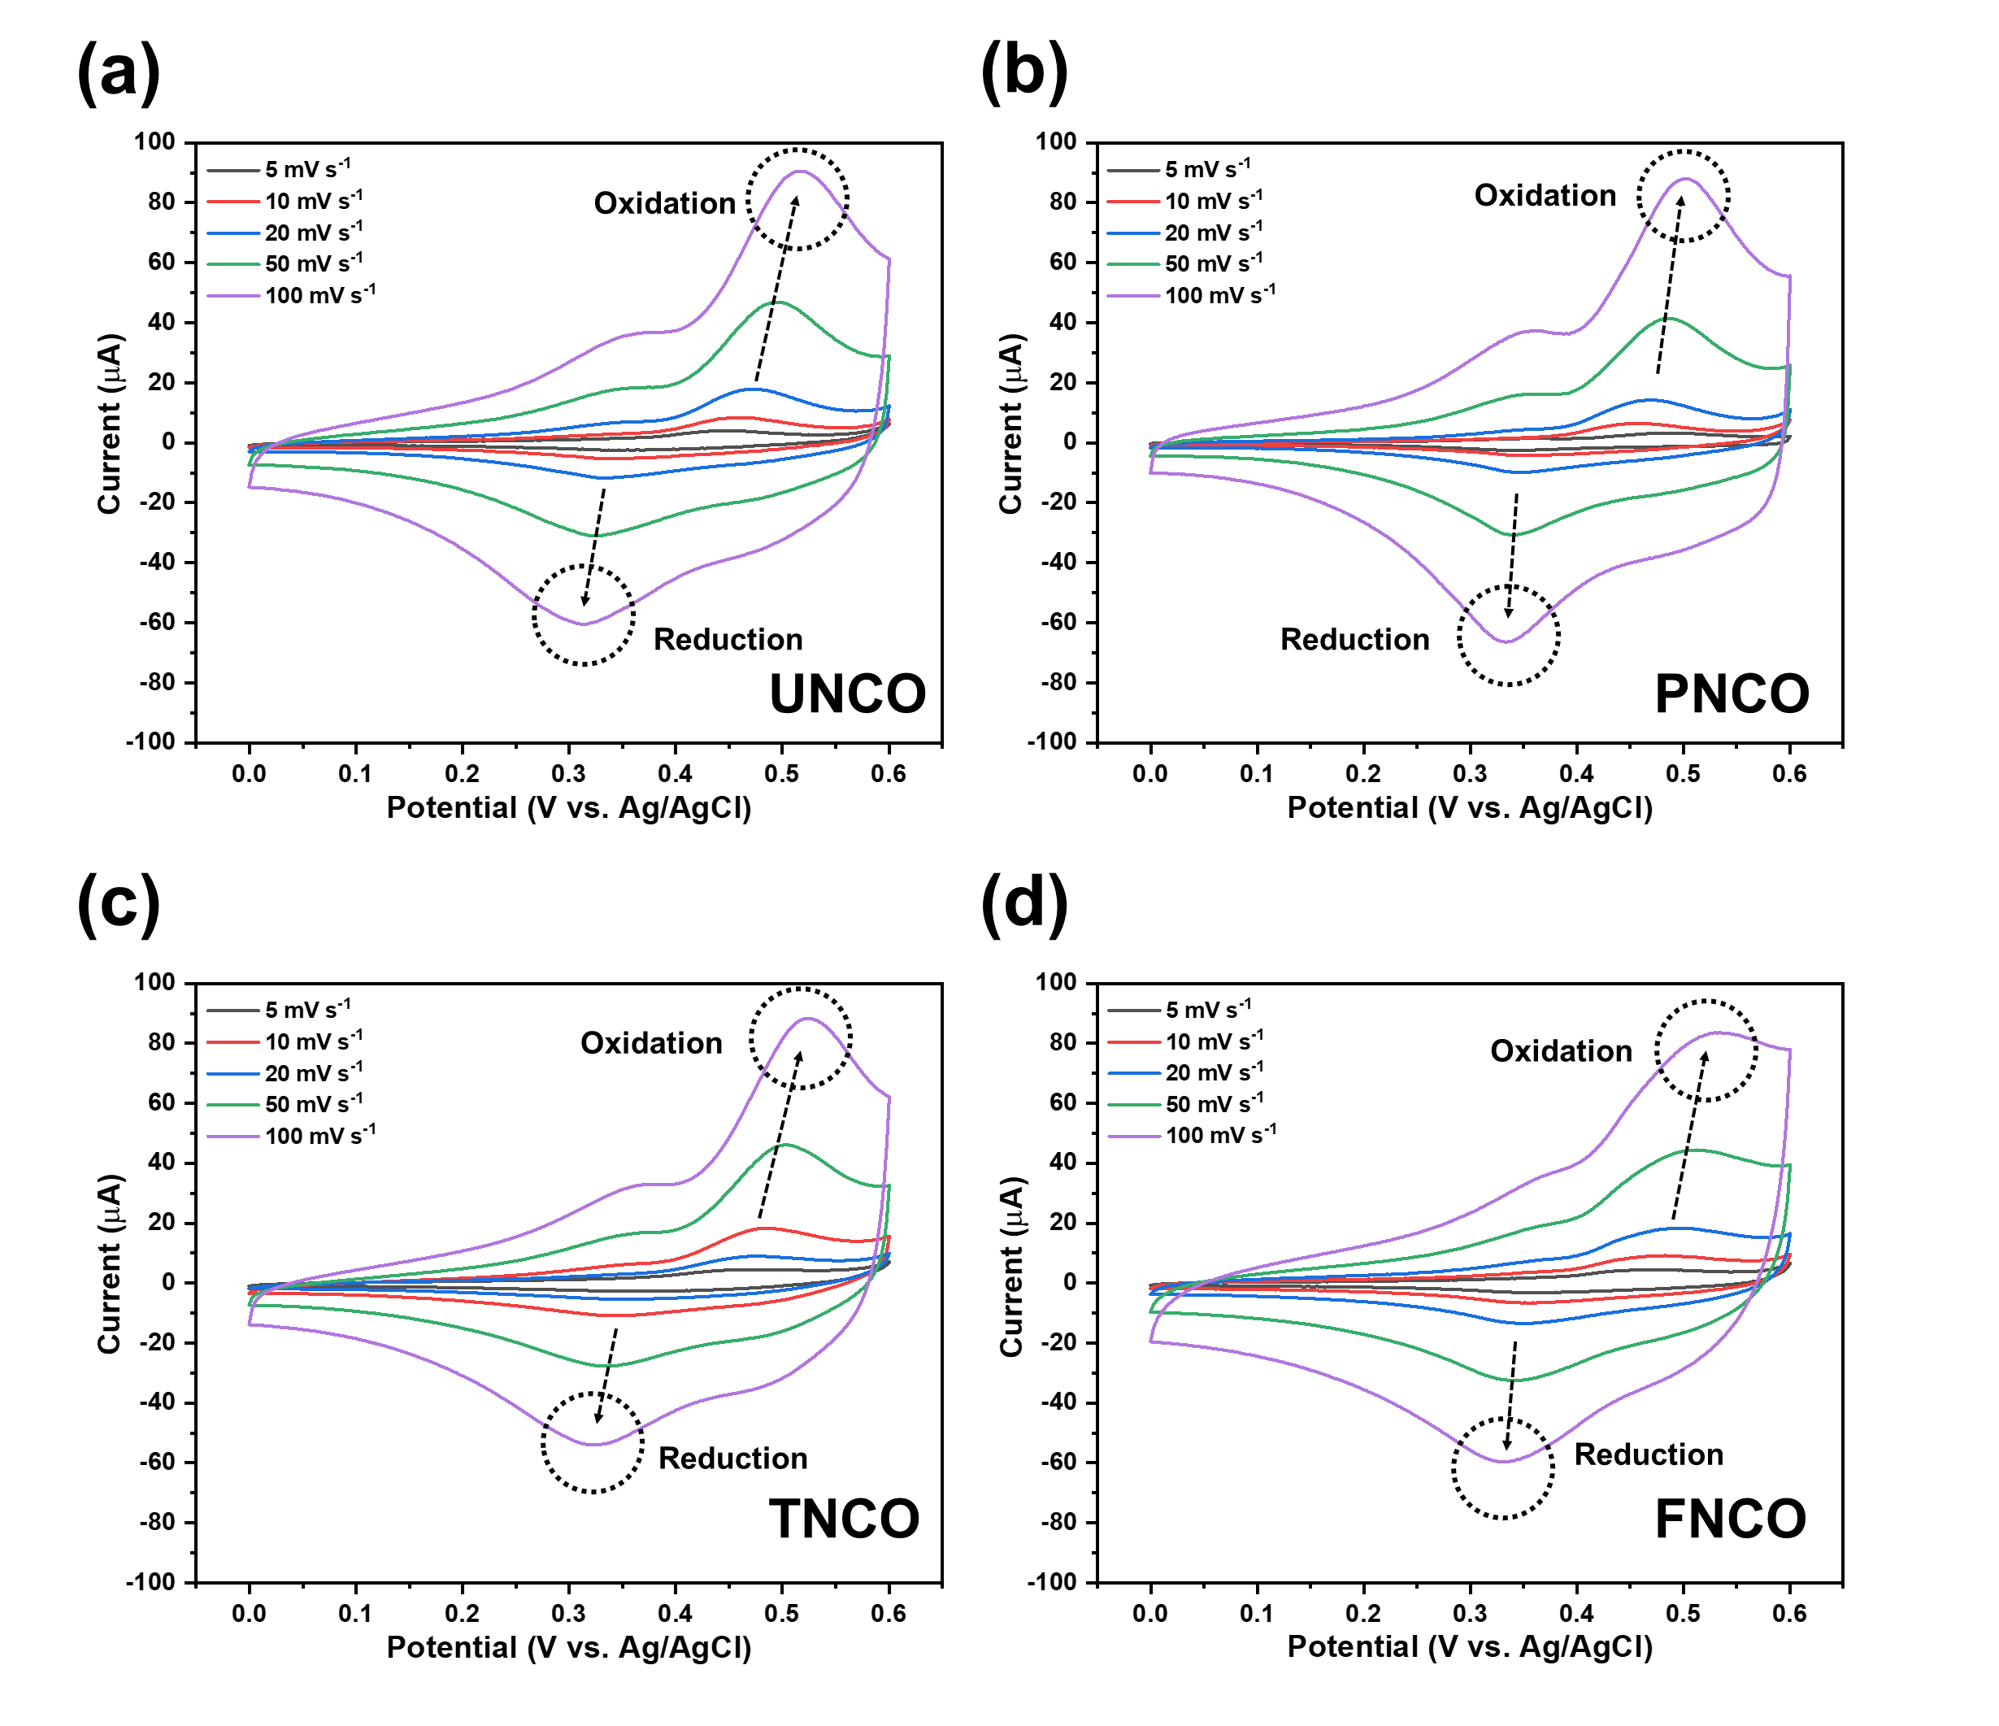
Figure S10. Cyclic Voltammetry curves of (a) UNCO, (b) PNCO, (c) TNCO, and (d) FNCO electrodes at different scan rates in 0.1M NaOH solution.

Figure S11

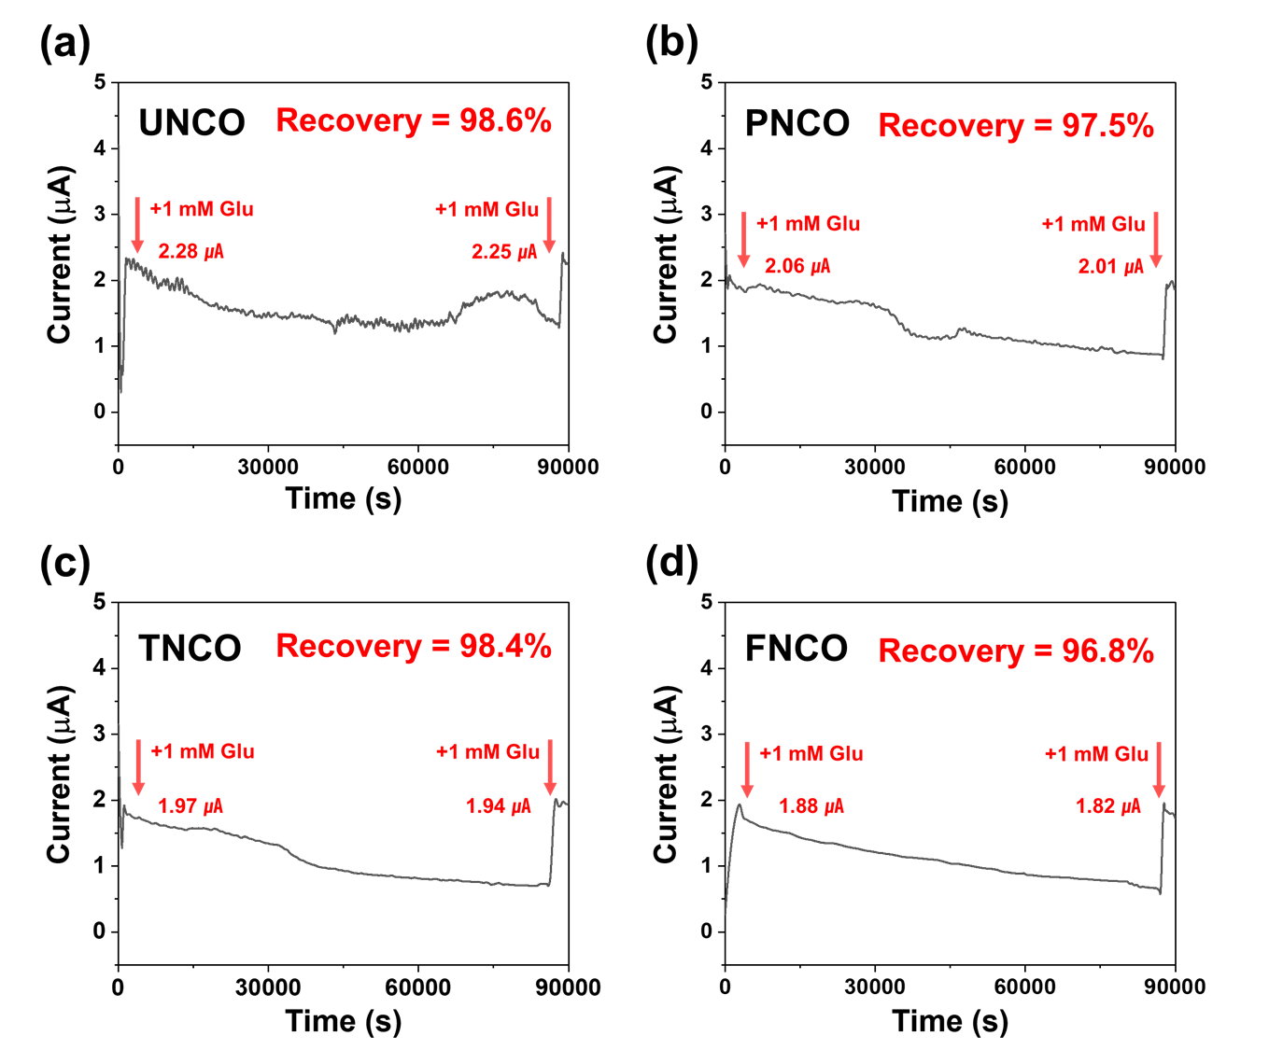
Figure S11. Chronoamperometry response of (a) UNCO, (b) PNCO, (c) TNCO, and (d) FNCO electrodes for stability in 0.1 M NaOH. The stability of the nanomaterials was examined by a chronoamperometry response under alkaline conditions (0.1 M NaOH) containing 1 mM for an extended period of time (80,000 s).

Figure S12
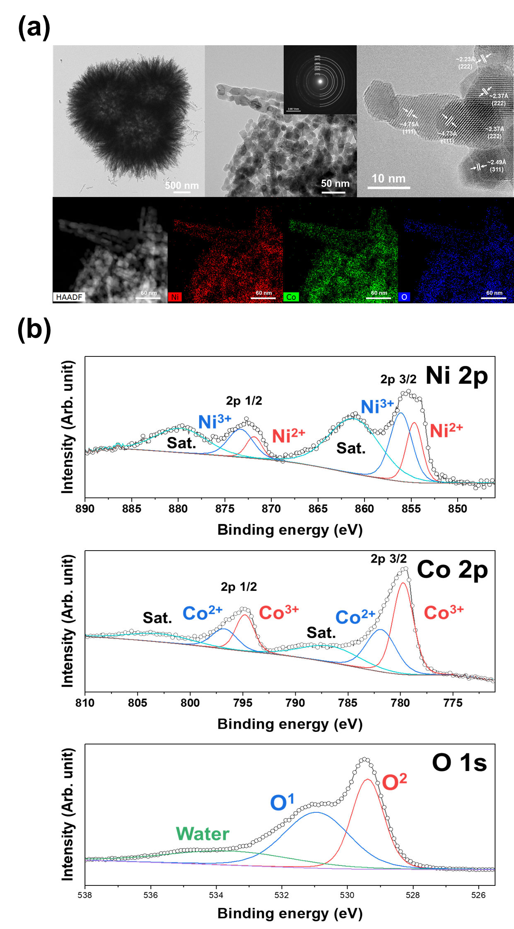
Figure S12. Morphological and structural characterizations of UNCO after 24 h of chronoamperometry at 0.5 V in an electrolyte containing 0.1 M NaOH and 1 mM glucose. (a) TEM images along with the SAED patterns, lattice-resolved HRTEM image, and corresponding HADDF images of Ni, Co, and O. (b) The XPS spectra of Ni2p, Co2p, and O1s.

Figure S13

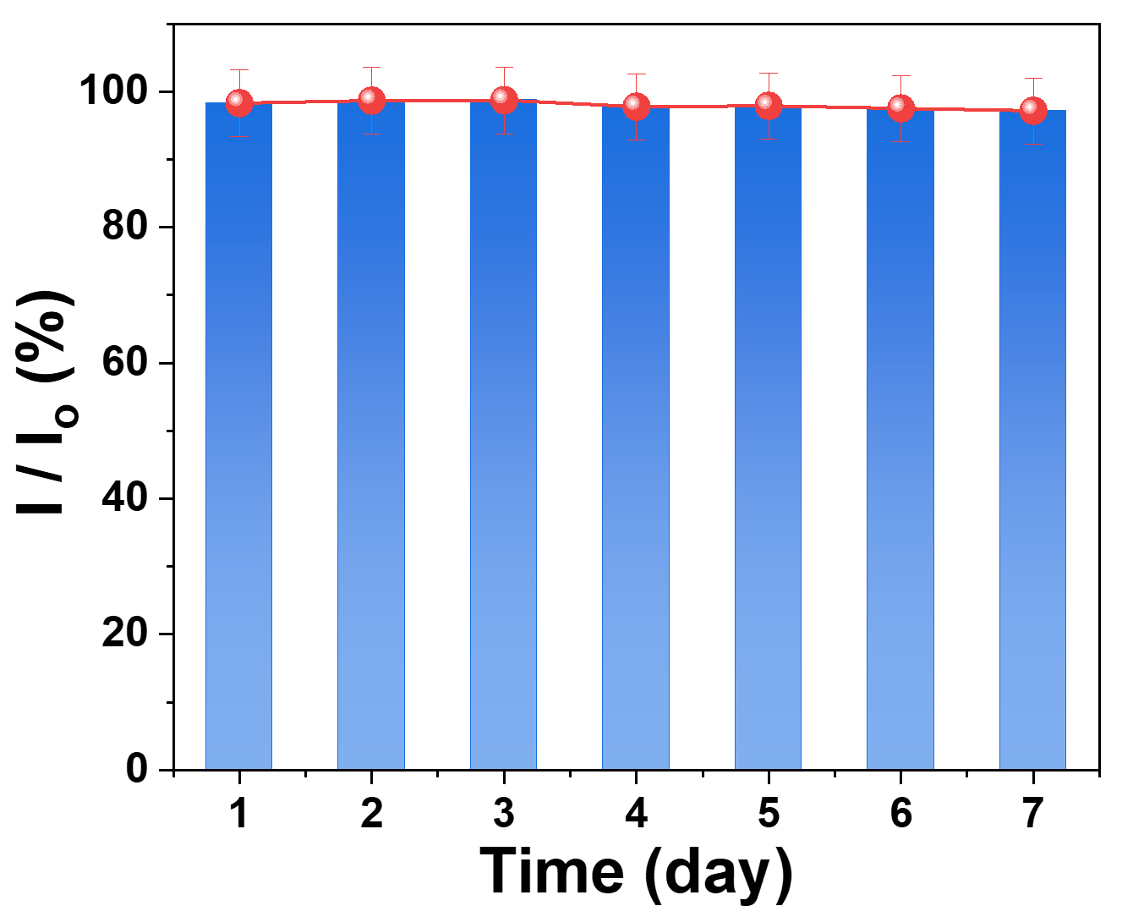
Figure S13. Chronoamperometry response of UNCO electrode for long-term stability in 0.1 M NaOH. The long-term stability of the UNCO was examined by a chronoamperometry response under alkaline conditions (0.1 M NaOH) containing 5 mM for 7 days.

Figure S14

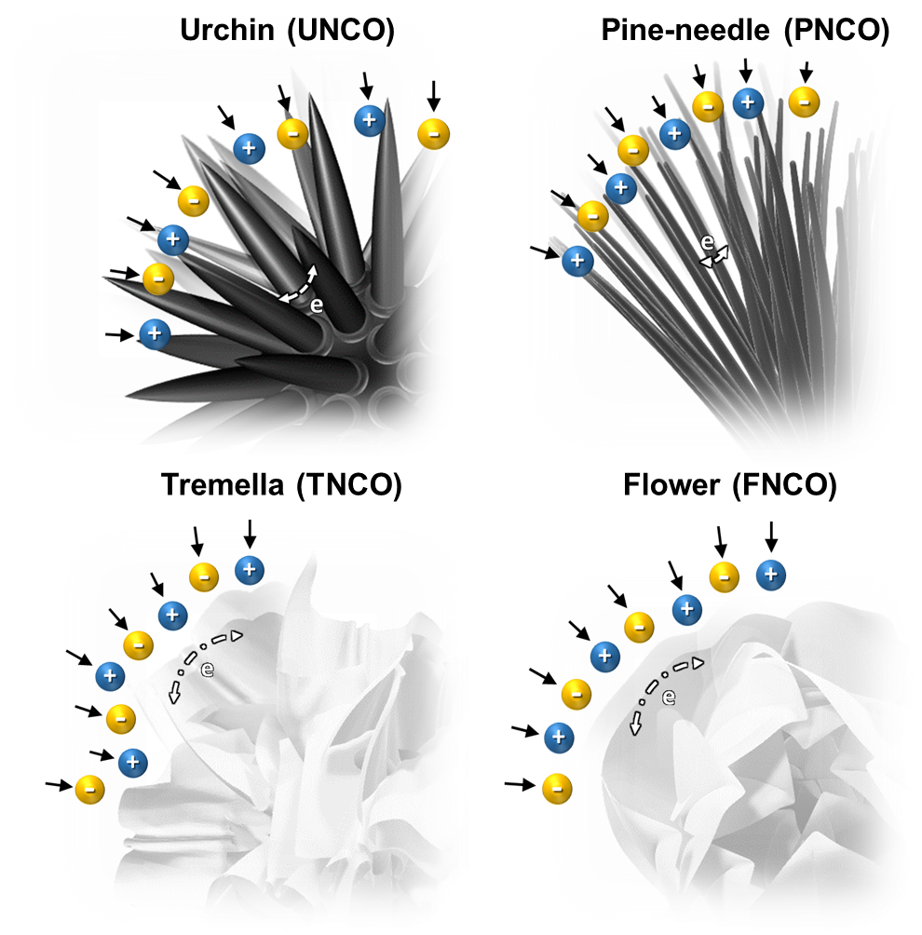
Figure S14. Schematic illustration of electro paths on the morphology-controlled NiCo₂O₄ nanostructure

Table S1

Table S1. Electrochemical performance of NCO in our work to that of non-enzymatic glucose sensors in other works.
Electrode | Method | Sensitivity | Linear range | Correlation  Coefficient | Detection  limit | Refs.
Electrode | Method | (μAmM⁻¹ cm⁻²) | (mM) | (R²) | (μM) | Refs.
UNCO | CA | 116.33 | 0.01 – 6 | 0.99 | 0.0783 | This work
PNCO | CA | 103.48 | 0.01 – 6 | 0.99 | 0.0623 | This work
TNCO | CA | 95.72 | 0.01 – 6 | 0.992 | 0.0673 | This work
FNCO | CA | 84.72 | 0.01 – 6 | 0.993 | 0.0723 | This work
NCO/CNT | CA | 66.15 | 0.02 – 12.12 | 0.99 | 5 | [S1]
CuCo₂O₄ | CA | 3.625 | Up to 0.32 | - | 5 | [S2]
NiO | CA | 32.91 | Up to 1.94 | - | 1.28 | [S3]
Co₃O₄ | CA | 36.25 | Up to 2.04 | - | 0.97 | [S4]

The LOD (Limit of detection) calculated by the formula in term of LOD = 3𝜎/𝑏, where 𝜎 is the standard deviation of background which is obtained by measuring the current response of NCO electrode in the 0.1M NaOH solution without glucose, and 𝑏 is the sensitivity of the NCO.
[S1] L. Wang, X. Lu, Y. Ye, L. Sun, Y. Song, Electrochim. Acta. 114, (2016) 484.
[S2] P. K. Kannan, C. Hu, H. Morgan, C. S. Rout, Chem. Asian. J. 11, (2016) 1837.
[S3] S. Liu, K. S. Hui, K. N. Hui, ACS Appl. Mater. Interfaces. 8, (2016) 3258.
[S4] Y. Ding, Y. Wang, L. Zhang, H. Zhang, Y. Lei, J. Mater. Chem. 22, (2012) 980.

Table S2

Table S2. Synthetic details of NiCo₂O₄ (NCO) with controlled morphology via additive-assisted hydrothermal synthesis. For controlling the morphology of NCO, additives such as urea, hexamethylene-tetramine (HMT), and ammonium fluoride (NH₄F) were selectively added in the above solution.

Material | Sample | Morphology | Urea | HMT | NH₄F | Hydrothermal | Heat  treatment
Material | Sample | Morphology | (mmol) | (mmol) | (mmol) | Hydrothermal
NiCo₂O₄ | UNCO | Urchin | 12 | - | - | 120 ℃  6 h | 400 ℃  4 h
NiCo₂O₄ | PNCO | Pine-needle | 12 | - | 6 | 120 ℃  6 h | 400 ℃  4 h
NiCo₂O₄ | TNCO | Tremella | - | 12 | - | 120 ℃  6 h | 400 ℃  4 h
NiCo₂O₄ | FNCO | Flower | - | 12 | 6 | 120 ℃  6 h | 400 ℃  4 h

