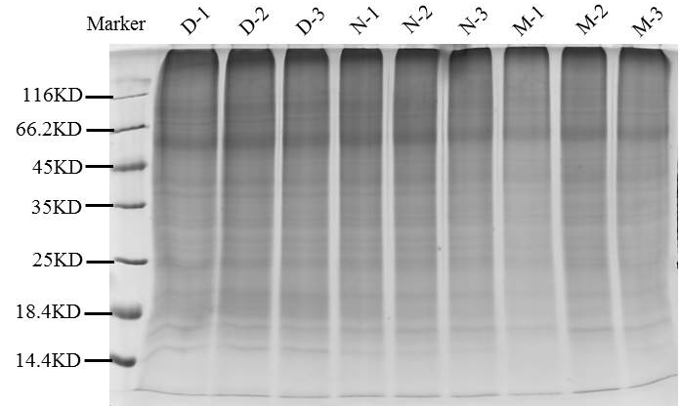
Supplementary Figure 1: 1D SDS PAGE for confirming the protein extraction.

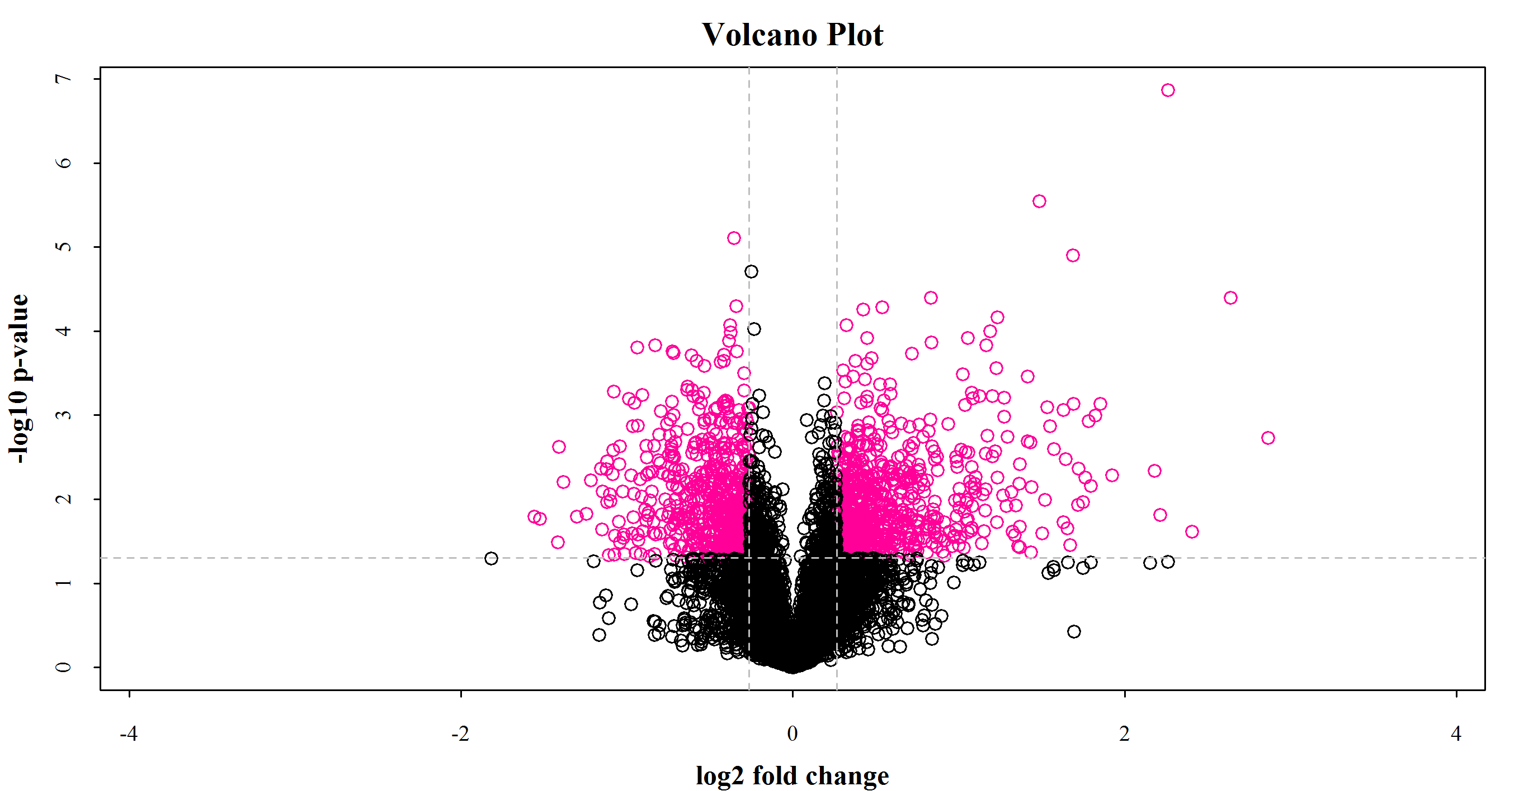
A
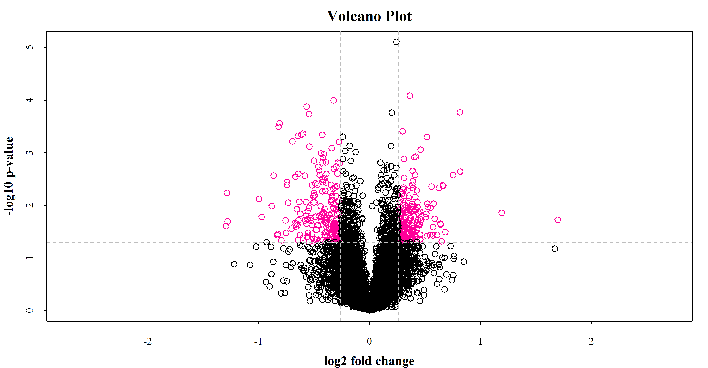
B

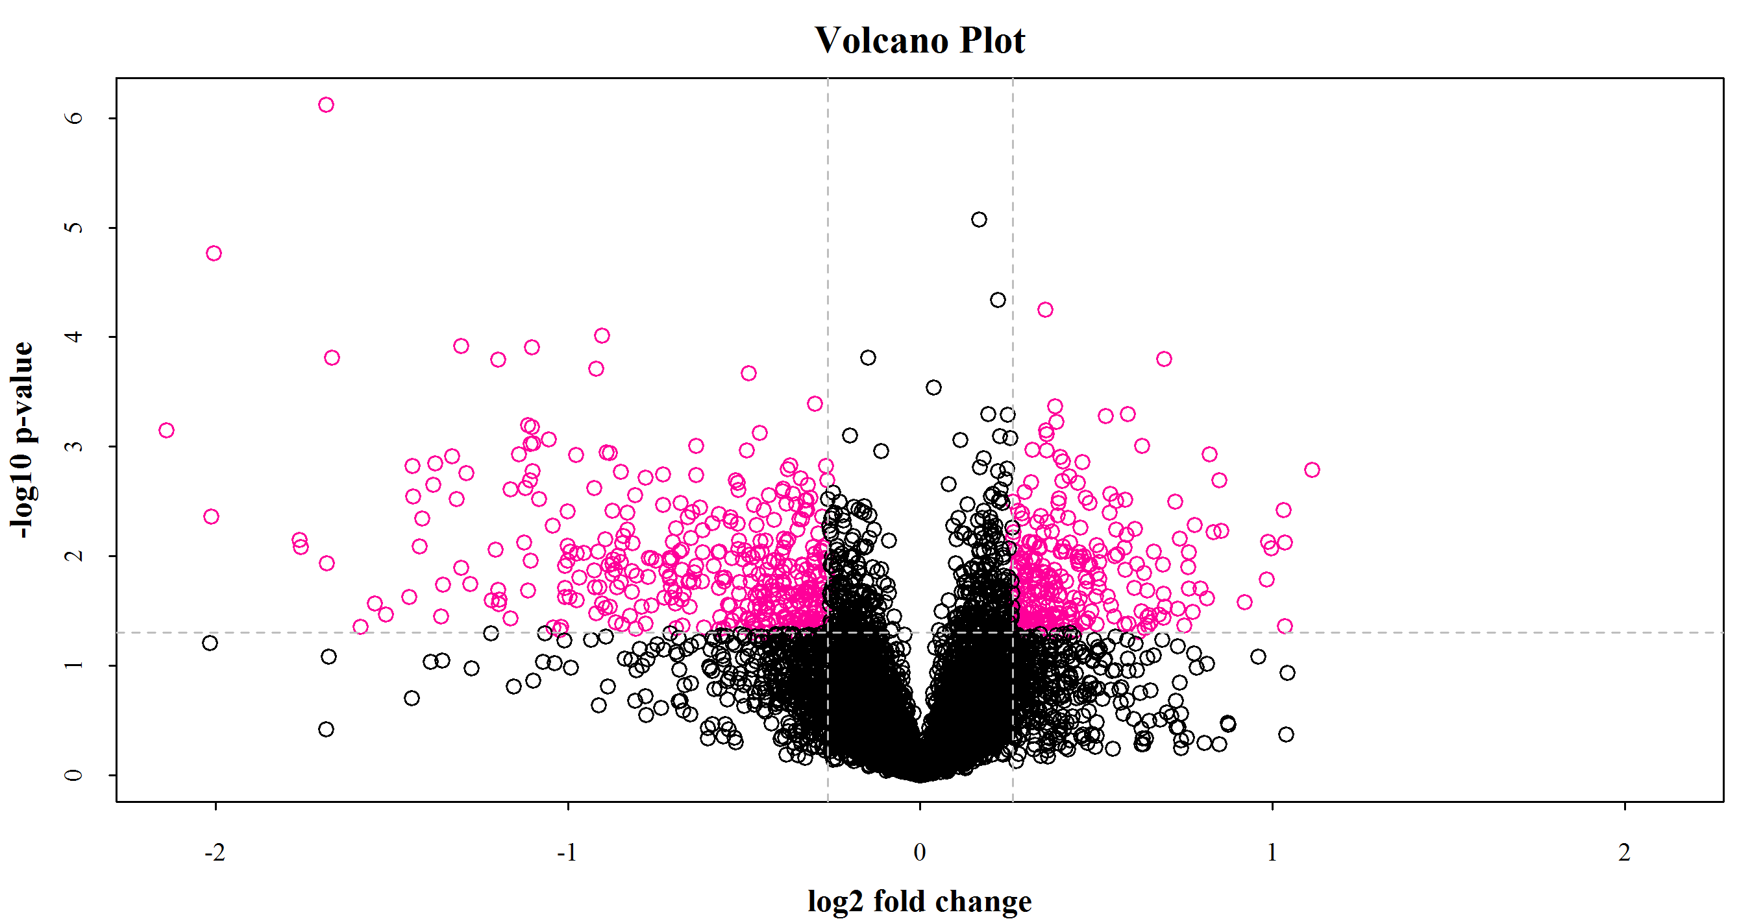
C
Supplementary Figure 2: Statistical analysis of volcano plot for evaluating the quality of fold change in each group ASB/DSB (A), RLB/DSB (B) and RLB/ASB (C), respectively. Data upon the horizontal and vertical dotted lines, which colored in pink, means the significant changes in the abundance of DEPs with 1.2-fold-change cut-off and P value<0.05.

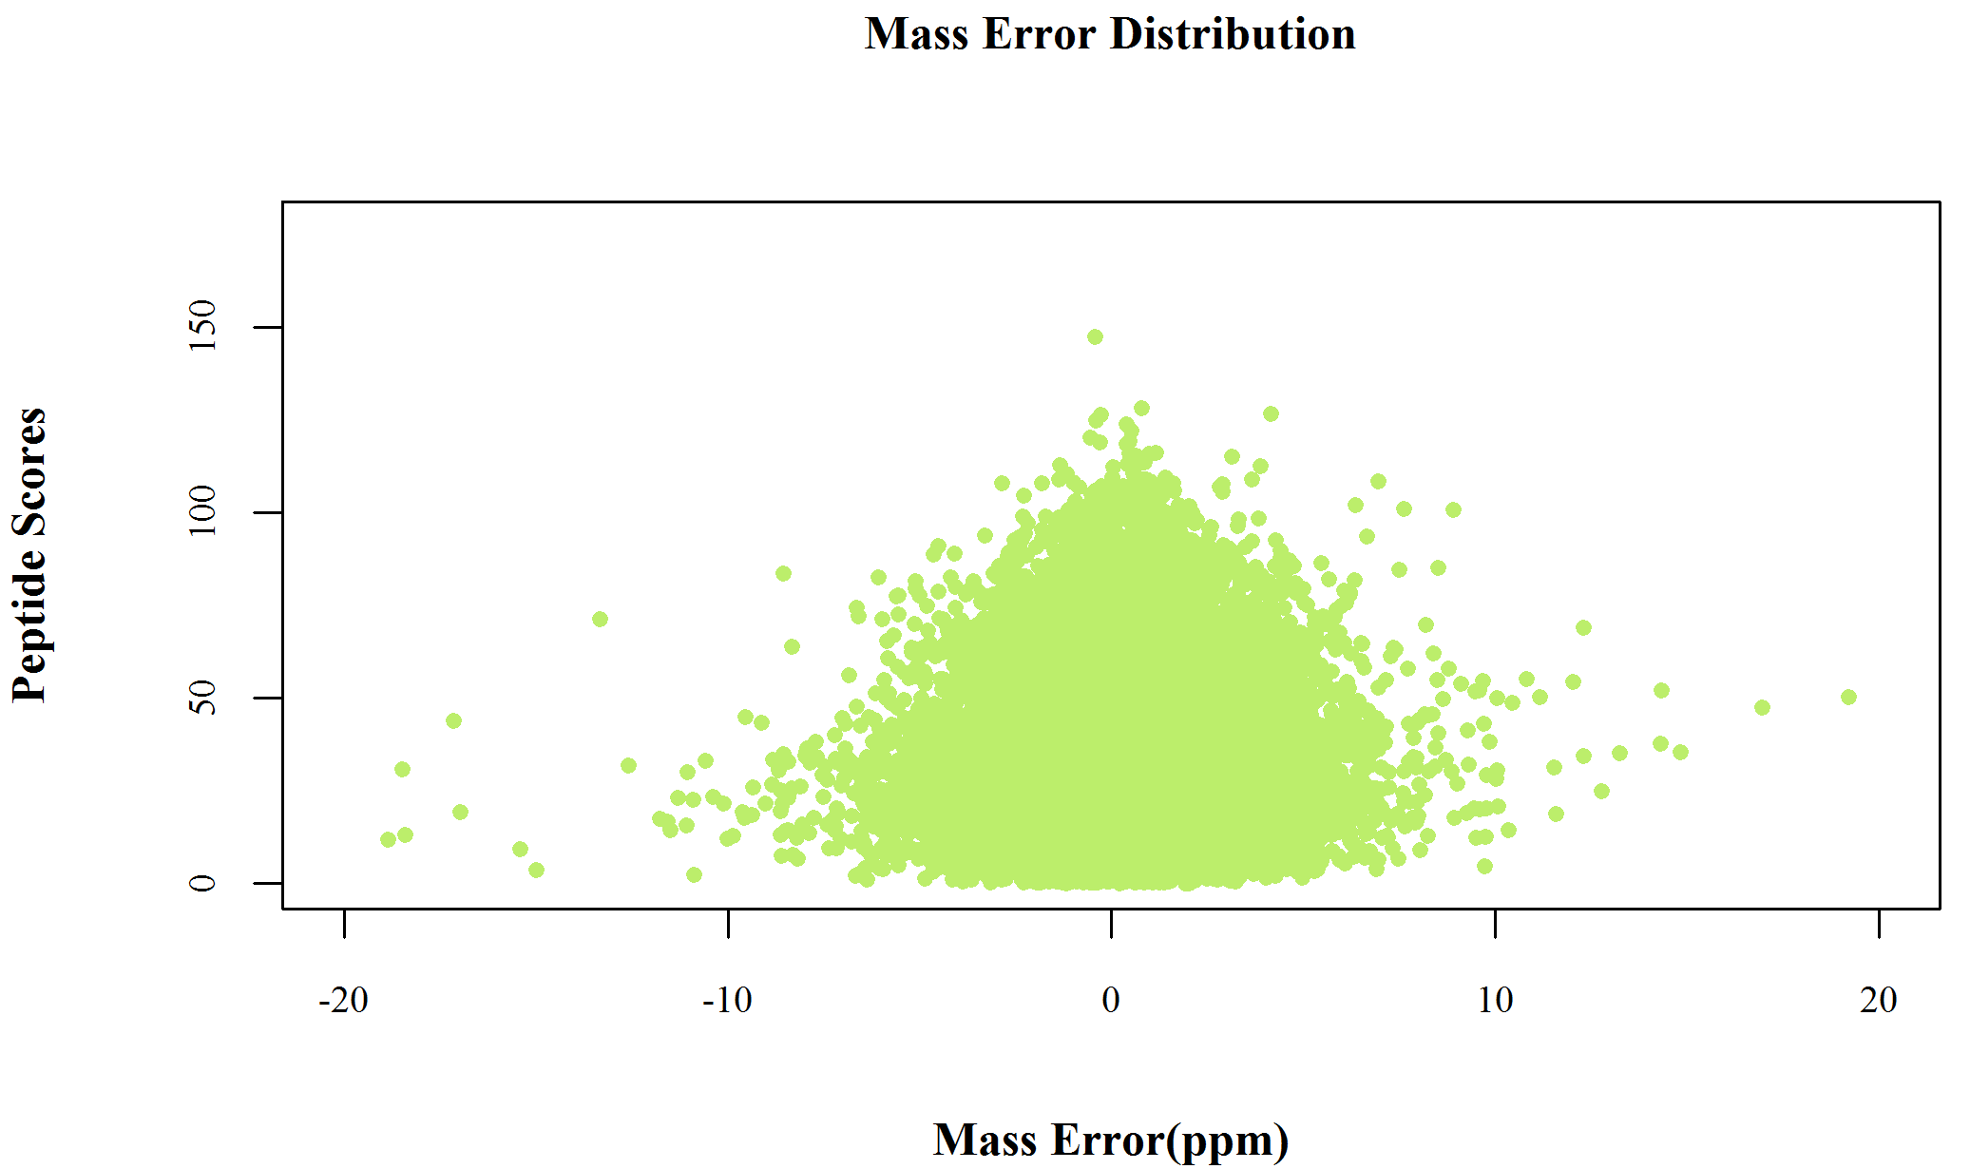
Supplementary Figure 3: Quality deviation of all identified peptides was mainly within 10ppm.
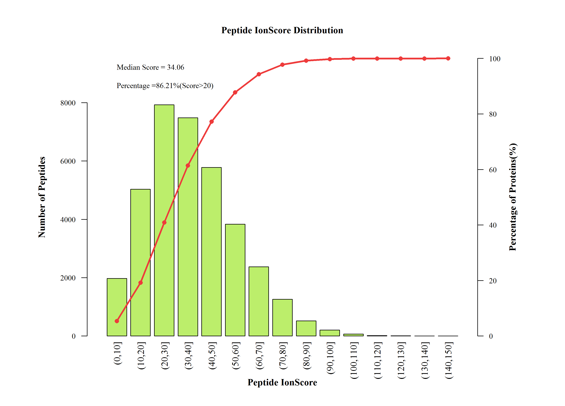
Supplementary Figure 4: Tool of MASCOT in judging each MS2 spectrograms, the median score is 34.06, and more than 86.21% peptides are score higher than 20. Red line means the cumulative curve.

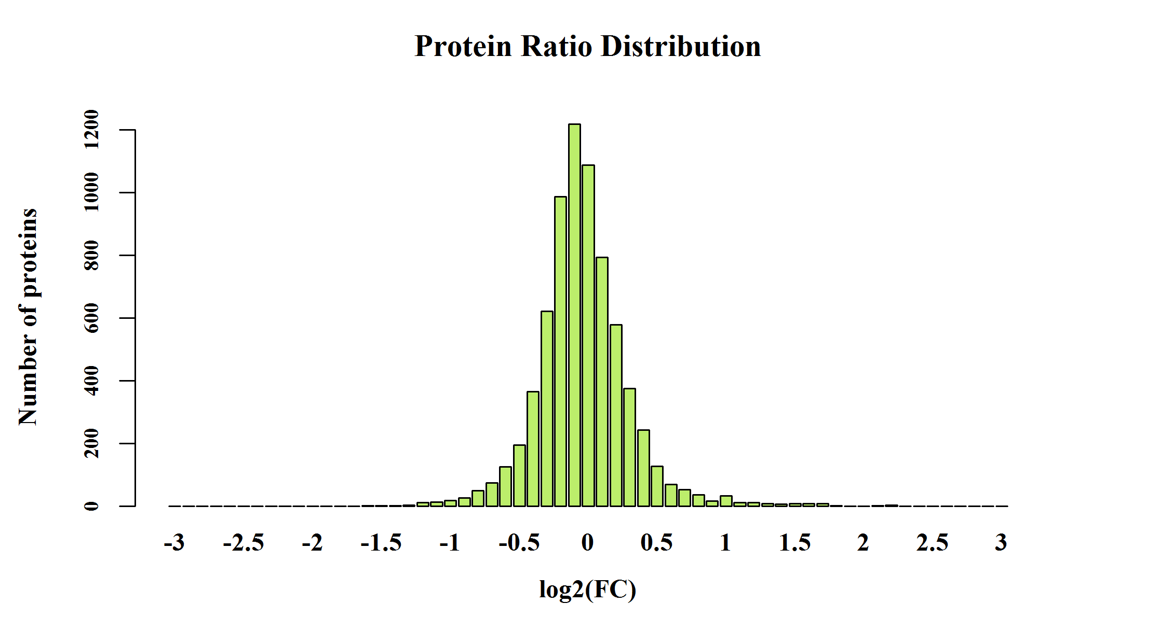
A

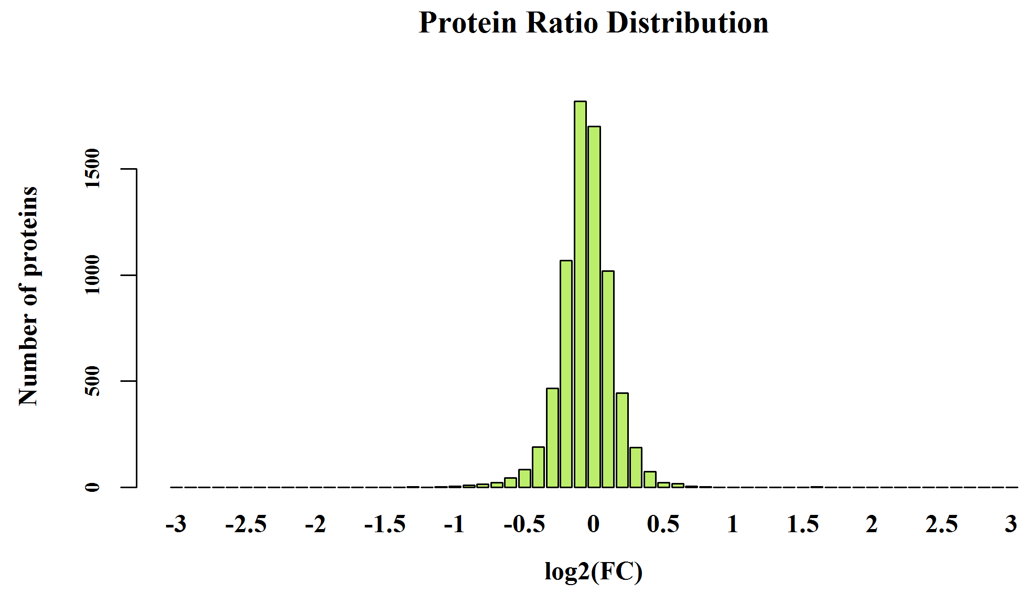
B
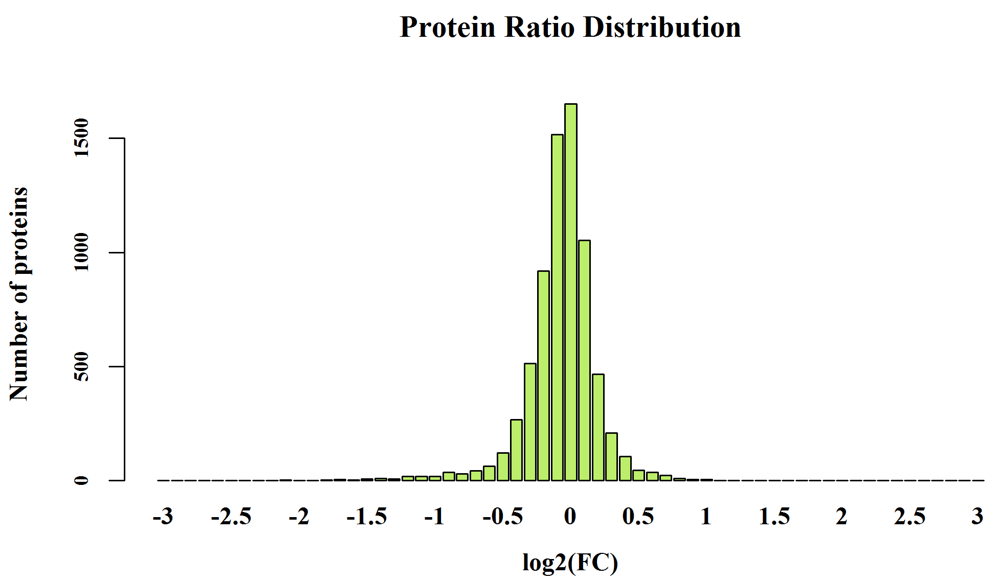
C
Supplementary Figure 5: Protein ratio (around 1.0) distribution of groups (A: ASB/DSB; B: RLB/DSB; C: RLB/ASB). FC is short for fold change.

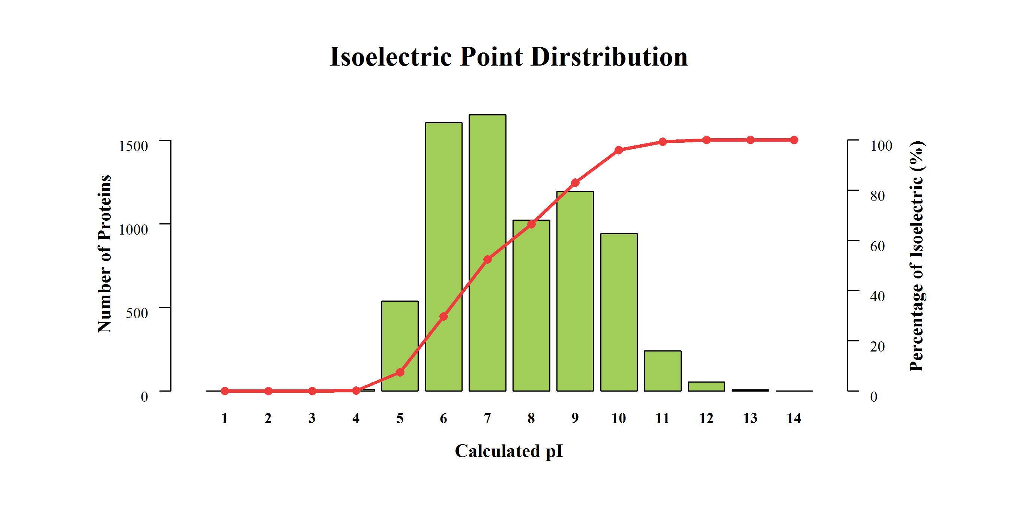
Supplementary Figure 6: Distribution of the identified protein isoelectric point (main area is concentrated in 5-10, with the mostly PI is 6-7). Red line is the cumulative curve.

Supplementary Figure 7: The repeatability of quantification data among three biological replicates of each group (A: DSB; B: ASB; C: RLB) according to their quantitative data. Red line means the cumulative curve.

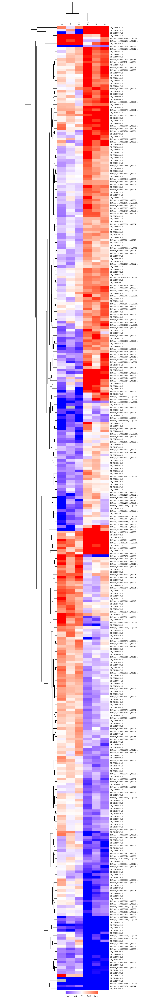
C
B
A
Supplementary Figure 8: Cluster analysis of differentially expressed proteins. Through horizontal comparison, samples could be classified into three categories, suggesting that the selected DEPs could effectively distinguish samples. Vertical comparison indicated that proteins could be classified into two categories with opposite directional variation, demonstrating the rationality of the selected DEPs. M, N and D correspondingly represent the DSB, ASB and RLB, respectively, (A)—DSB/ASB, (B)—RLB/DSB, (C)—RLB/ASB.
- Go analysis in ASB/DSB

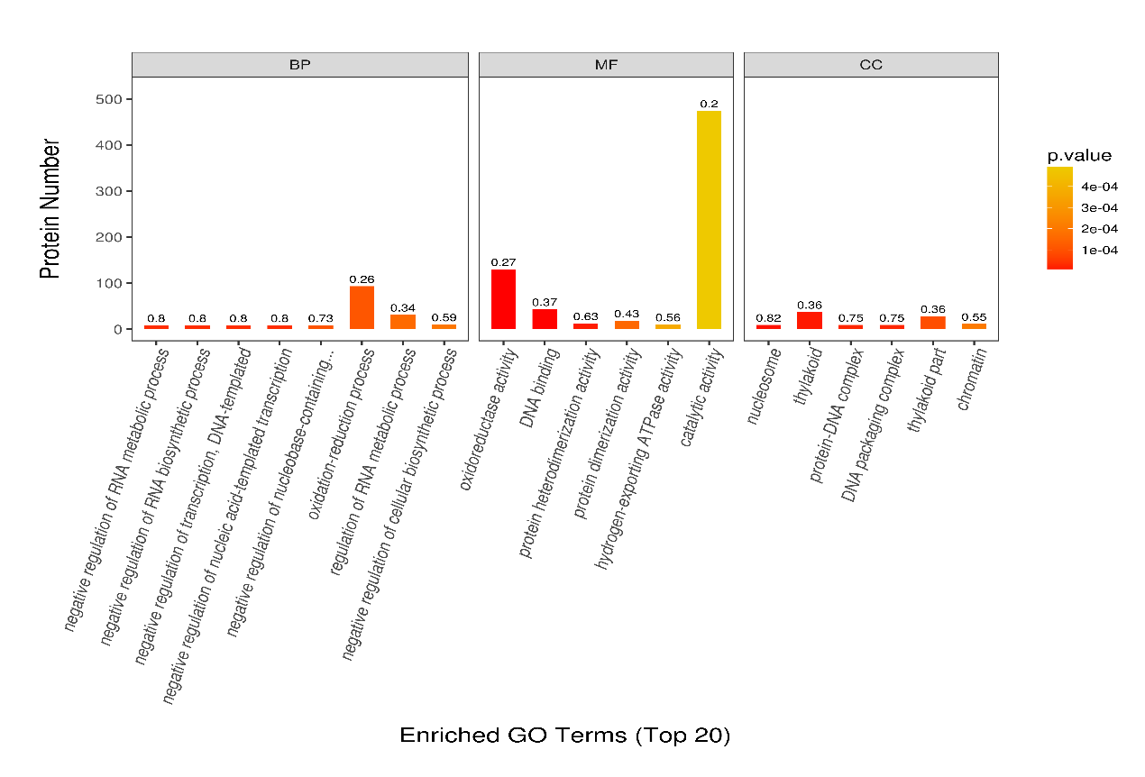
- Go analysis in RLB/DSB

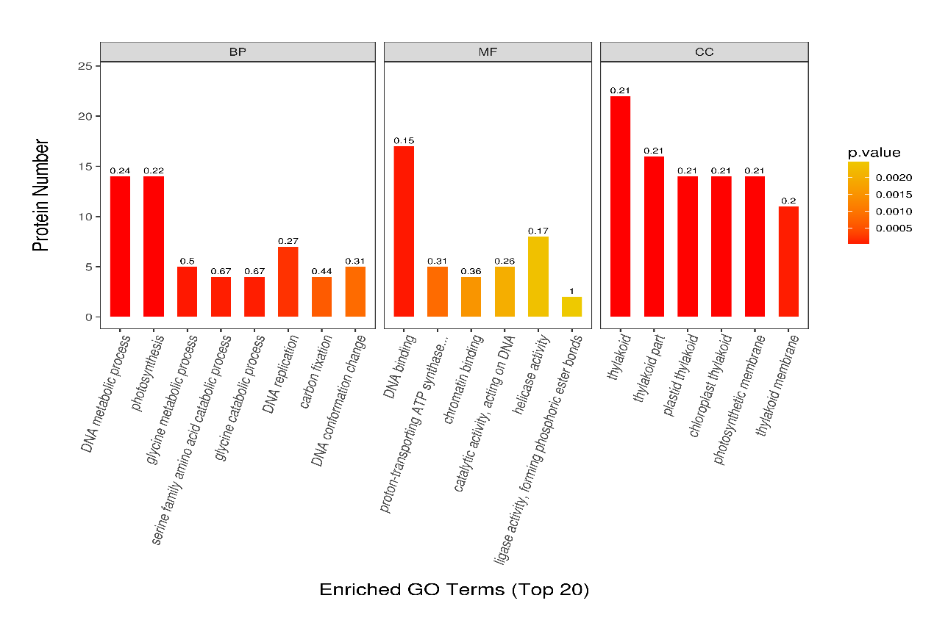
- Go analysis in RLB/ASB
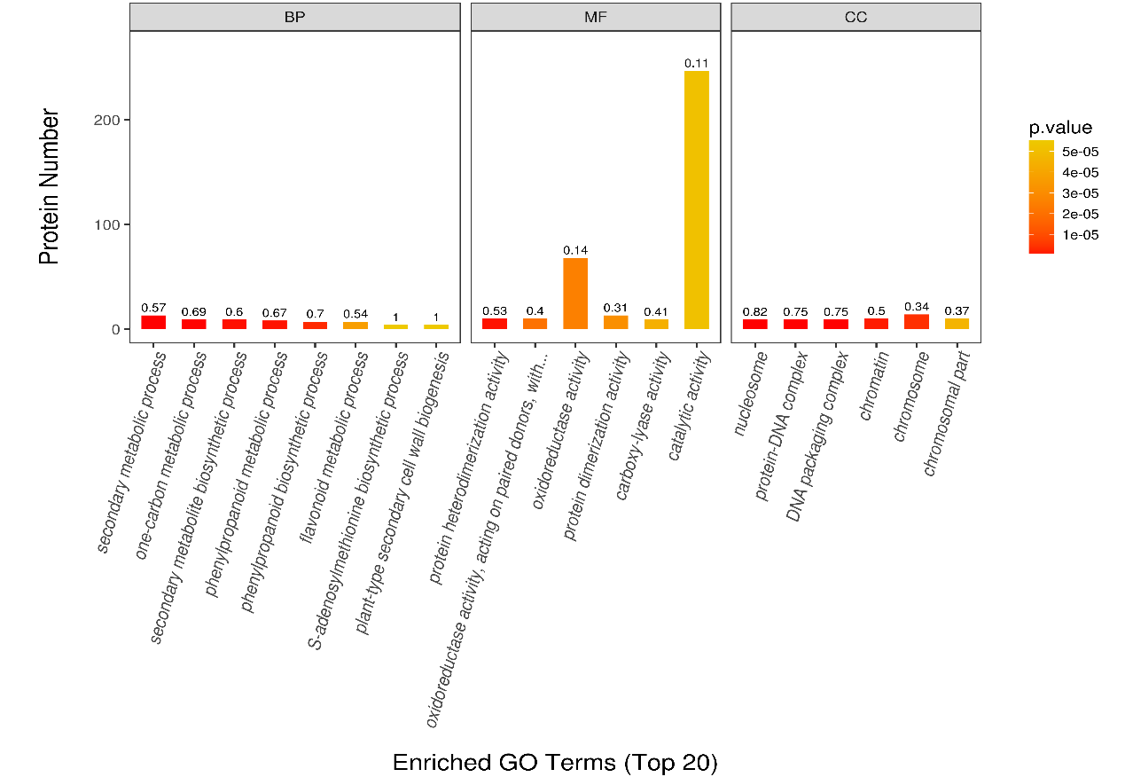
Supplementary Figure 9: Top 20 DEPs in each terms of GO analysis among ASB/DSB, RLB/DSB, and RLB/ASB.

