Supplementary Materials for

Directly Grown Universally Doped Ultrathin Nanocrystalline Carbon Overlayer Sustains Pragmatic Zinc Metal Anodes

Xianzhong Yang#, Jiaze Lv#, Cai Cheng, Zixiong Shi, Jun Peng, Ziyan Chen, Xueyu Lian, Weiping Li, Yuhan Zou, Yu Zhao, Mark H. Rümmeli, Shixue Dou & Jingyu Sun*

*Corresponding author. E-mail: sunjy86@suda.edu.cn.
#These authors contributed equally to this work.

This PDF file includes:
Fig. S1 to S27
Table S1 to S5
Video S1 and S2

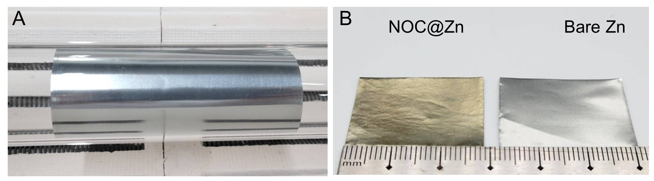
Fig. S1. (A) Photograph of rolled Zn foils in quartz tube before CVD growth. (B) Photograph of unfolded NOC@Zn foil grown in 1-inch quartz tube and bare Zn foil.

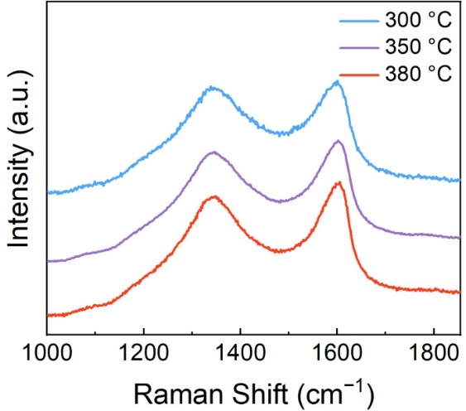
Fig. S2. Raman spectra of NOC@Zn grown under different temperatures.

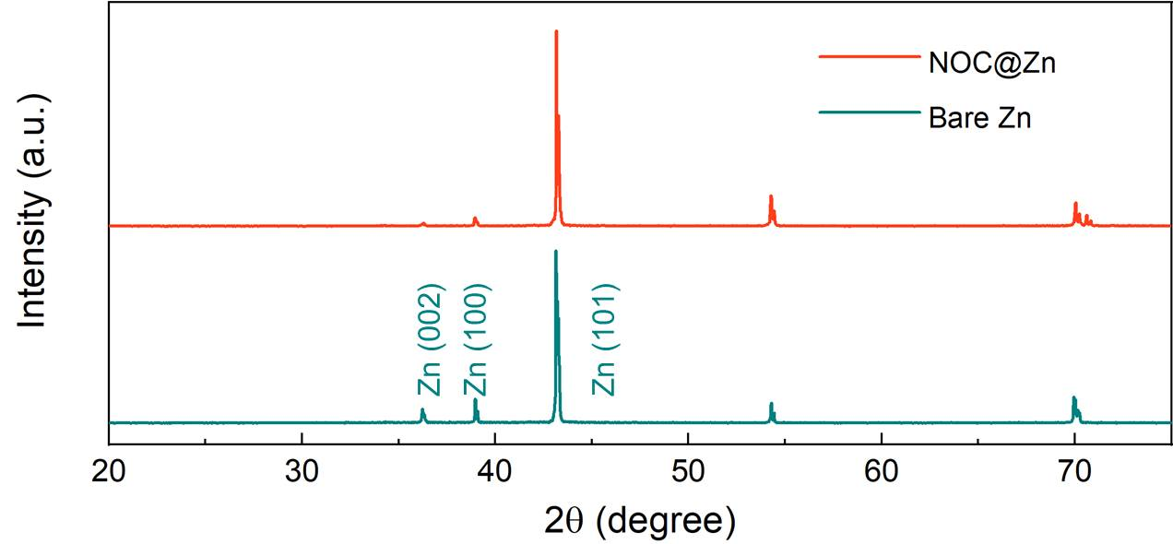
Fig. S3. XRD patterns of bare Zn and NOC@Zn.
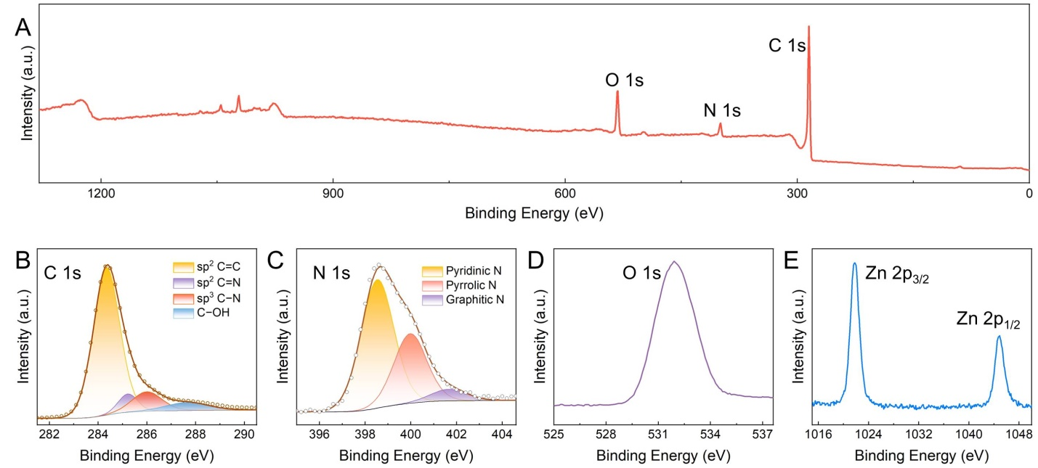
Fig. S4. (A) XPS survey spectrum of NOC@Zn. High-resolution XPS spectra of (B) C 1s, (C) N 1s, (D) O 1s, and (E) Zn 2p.

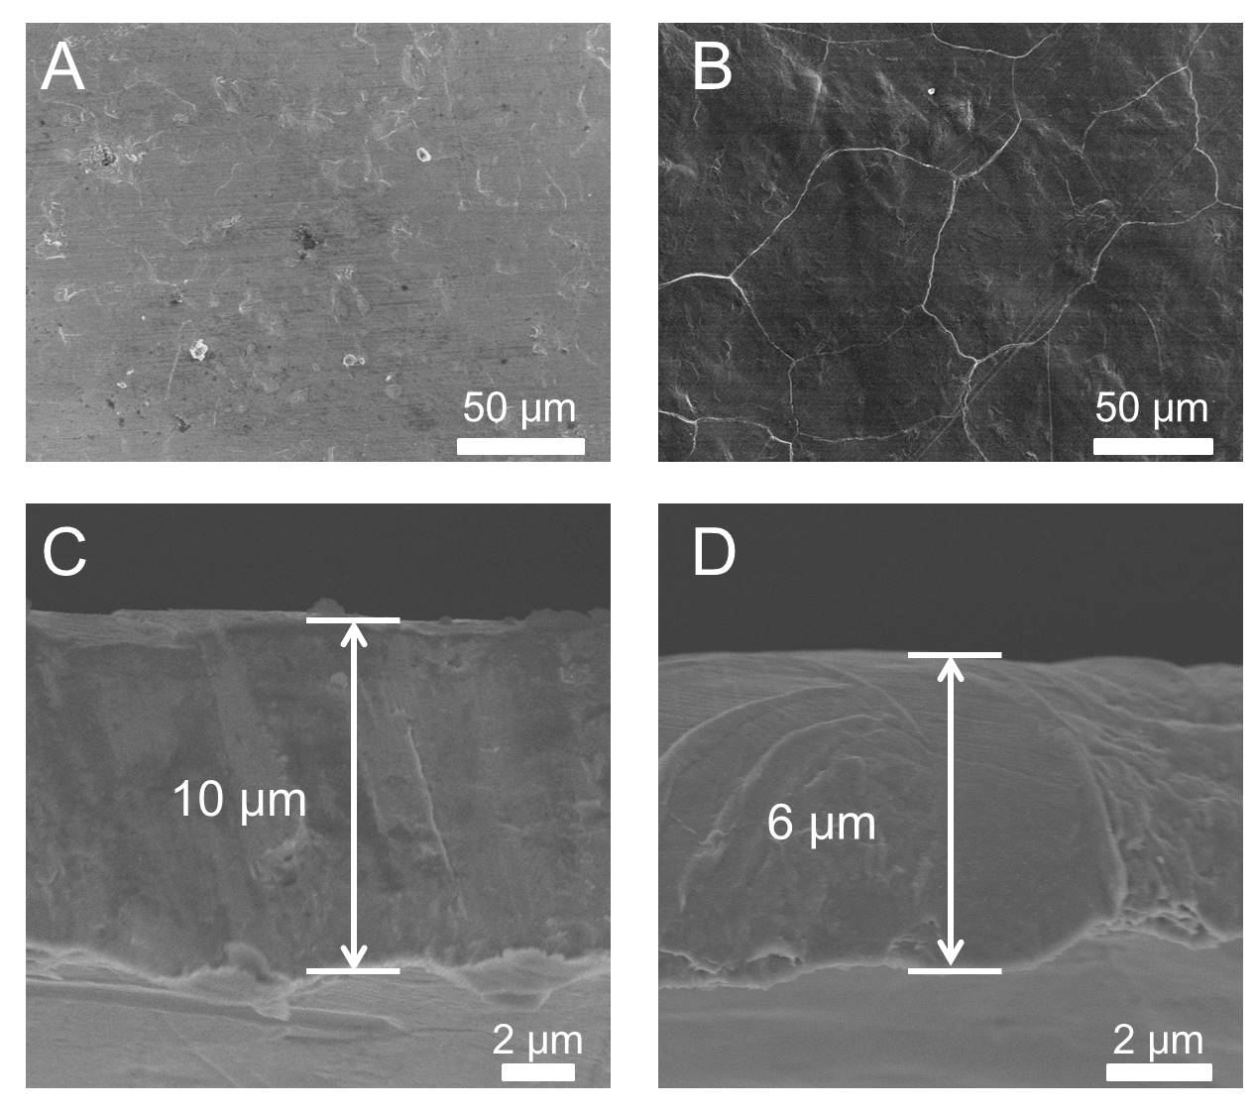
Fig. S5. (A) Top-view SEM image of bare Zn. (B) Top-view SEM of NOC@Zn. (C) Side-view SEM image of bare Zn. (D) Side-view SEM image of NOC@Zn.

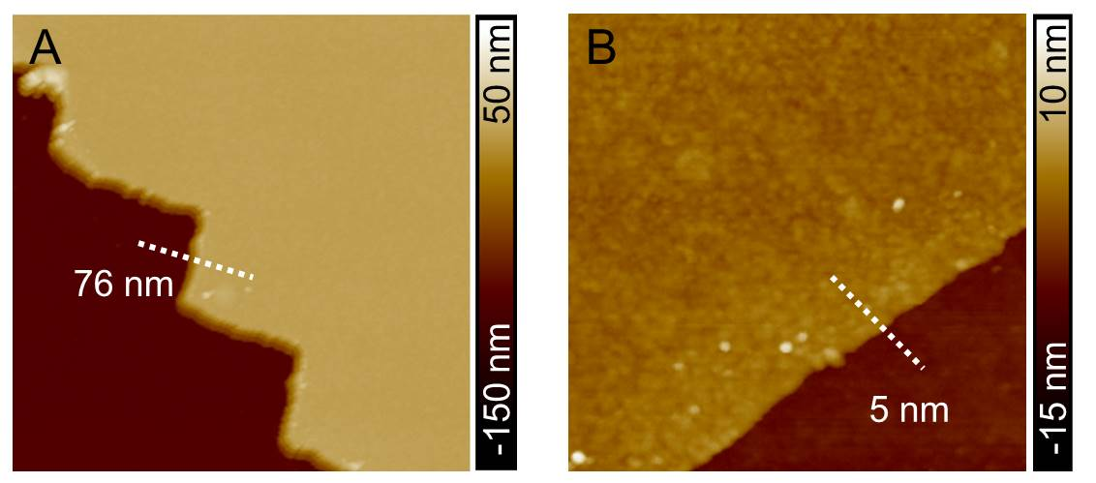
Fig. S6. Atomic force microscopy (AFM) images of the NOC layer with a thickness of (A) 76 nm and (B) 5 nm.

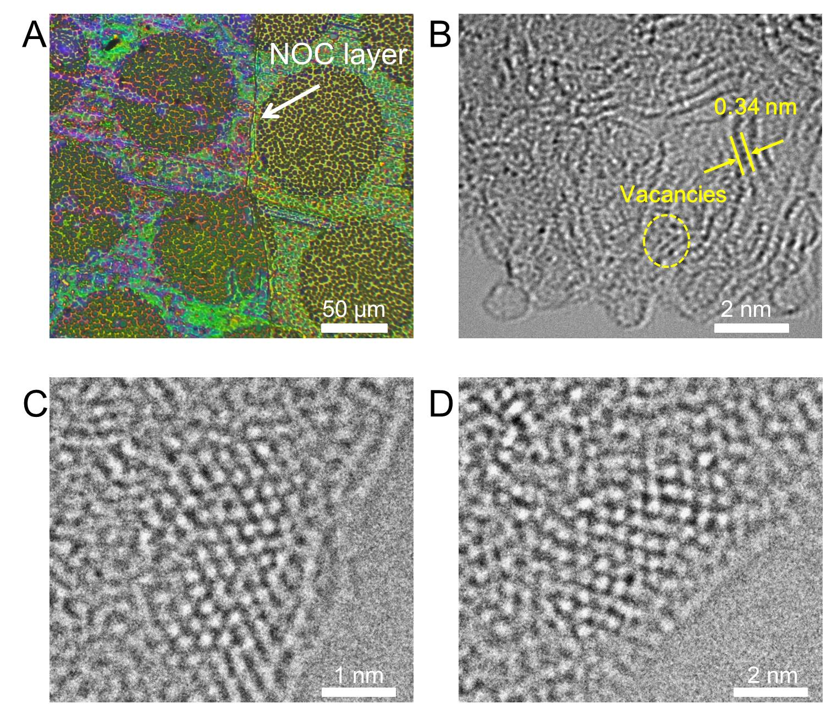
Fig. S7. (A) Optical microscopy image of the transferred NOC layer on copper grid. (B) High resolution transmission electron microscopy (HRTEM) image of NOC overlayer. (C) Enlarged image of area A in Fig. 1F. (D) Enlarged image of area B in Fig. 1F.

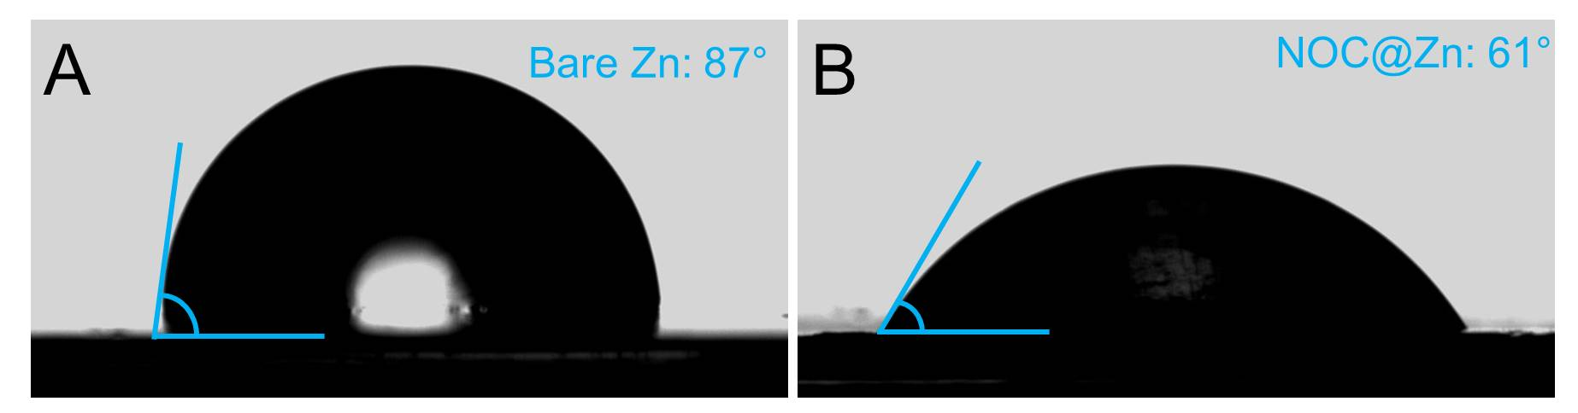
Fig. S8. Contact angles of ZnSO₄ electrolyte on (A) bare Zn foil and (B) NOC@Zn foil.

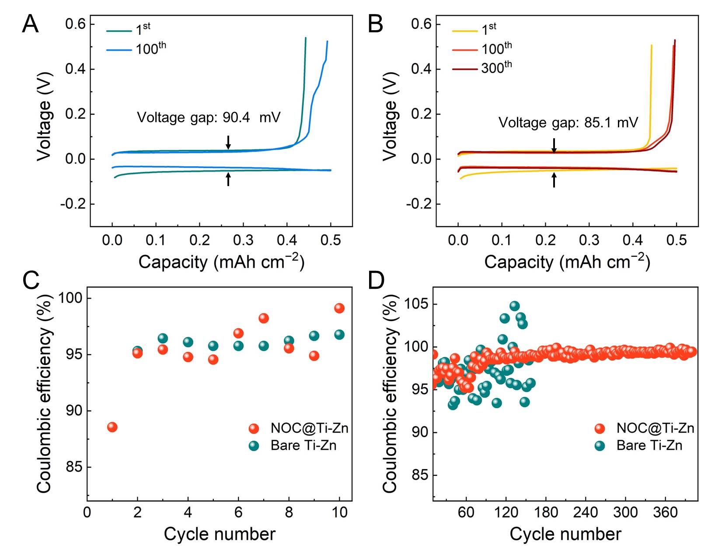
Fig. S9. Charge-discharge voltage profiles of (A) bare Ti-Zn cell and (B) NOC coated Ti-Zn cell at the 1st, 100th, and 300th cycles under 2.0 mA cm^{–2}/0.5 mAh cm^{–2}. The enlarged images of Coulombic efficiencies shown in Fig. 2B: (C) 1st-10th and (D) 10th-400th cycles.
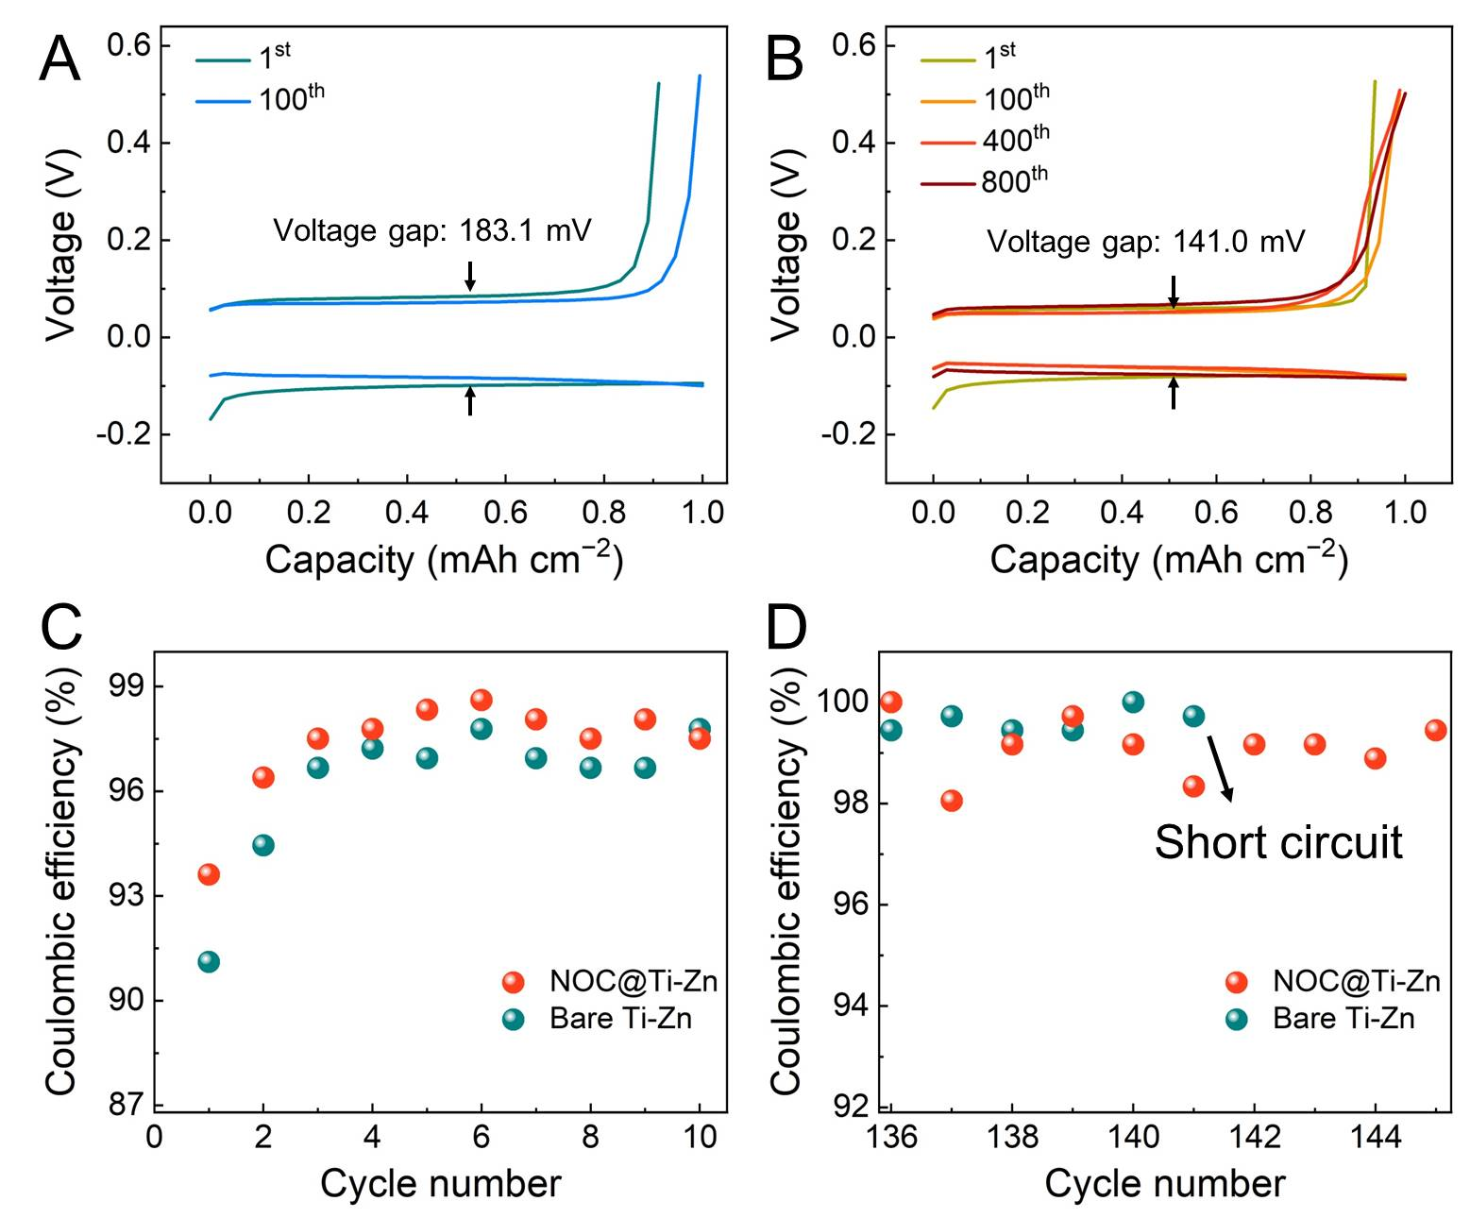
Fig. S10. Charge-discharge voltage profiles of (A) bare Ti-Zn cell and (B) NOC coated Ti-Zn cell at the 1st, 100th, 400th and 800th cycles under 10.0 mA cm^{–2}/1.0 mAh cm^{–2}. The enlarged images of Coulombic efficiencies shown in Fig. 2C: (C) 1st-10th and (D) 136th-145th cycles.

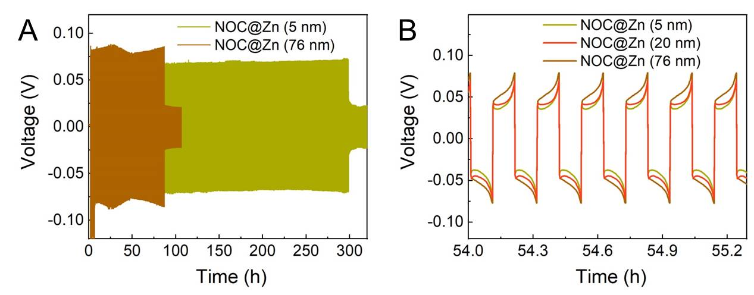
Fig. S11. (A) Long-term galvanostatic cycling of NOC@Zn symmetric cells at a current density of 10.0 mA cm⁻² and a capacity of 1.0 mAh cm⁻². The thickness of the NOC overlayer is 5 nm and 76 nm, respectively. (B) Detailed voltage profiles of symmetric cells shown in (A) and Fig. 2D at specific cycling time.
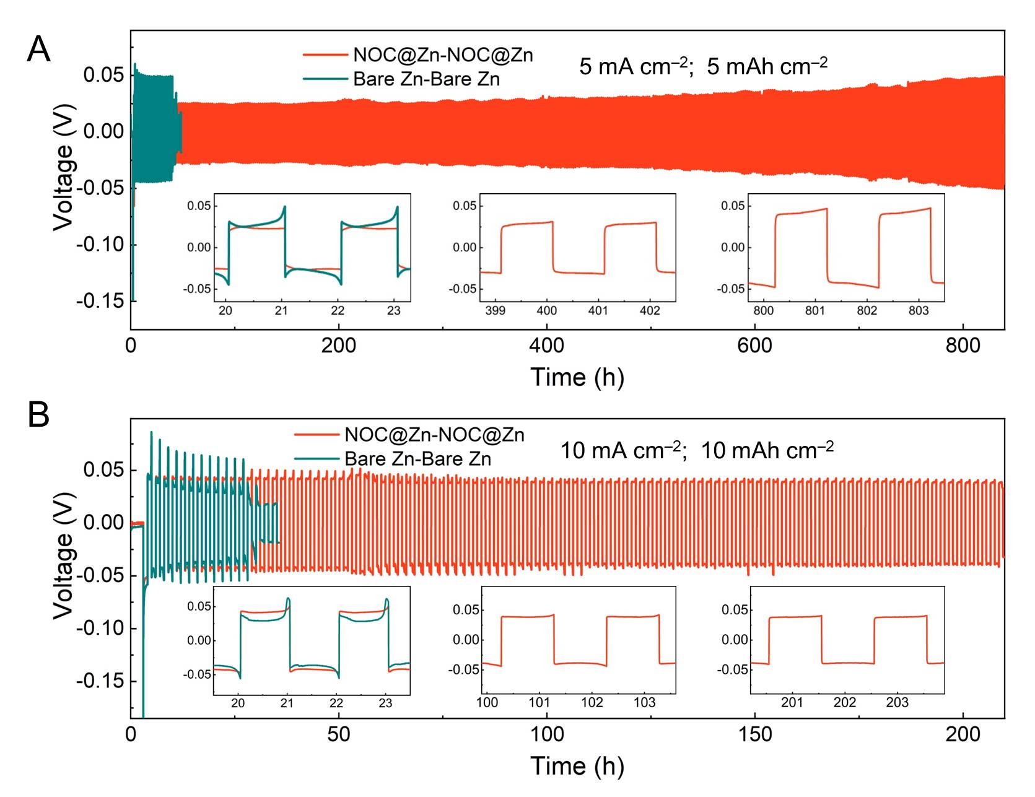
Fig. S12. Long-term galvanostatic cycling of NOC@Zn and bare Zn symmetric cells at a current density of (A) 5.0 mA cm⁻² /5.0 mAh cm⁻² and (B) 10.0 mA cm⁻² /10.0 mAh cm⁻². Insets: Detailed voltage profiles at specific cycling time.

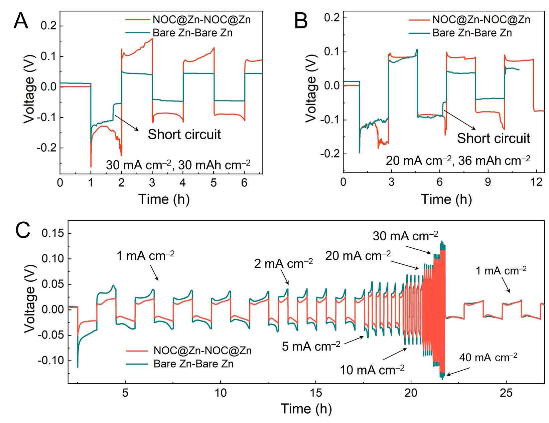
Fig. S13. (A) Enlarged image of the initial cycle in Fig. 2E. (B) Enlarged image of the initial cycle in Fig. 2F. (C) Rate performances of NOC@Zn and bare Zn symmetric cells at various current densities under a capacity of 1.0 mAh cm⁻².
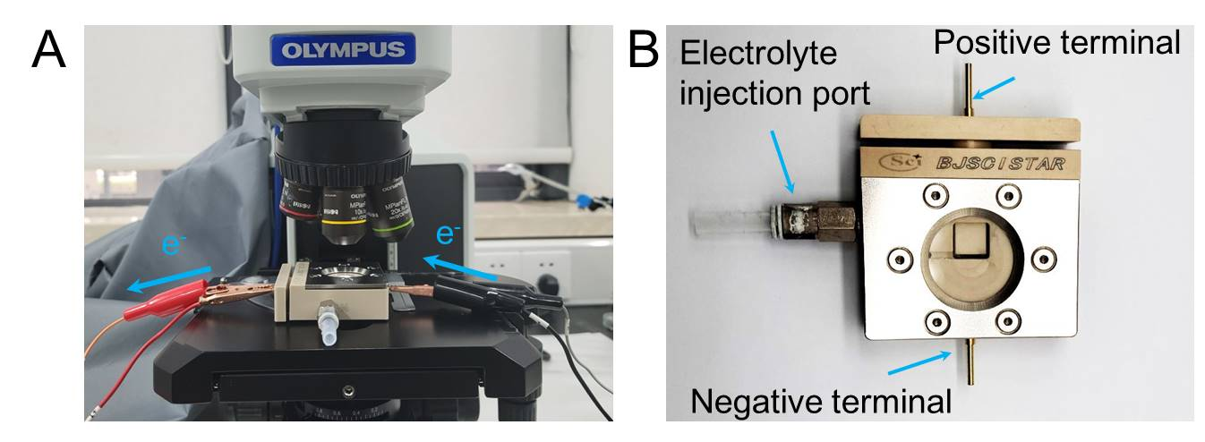
Fig. S14. (A) Digital image of the in-situ optical microscopy system for studying the electrodeposition processes of Zn anodes. (B) Digital image of the transparent cell for in-situ optical visualization. The positive and negative terminals are connected to Neware testing system.
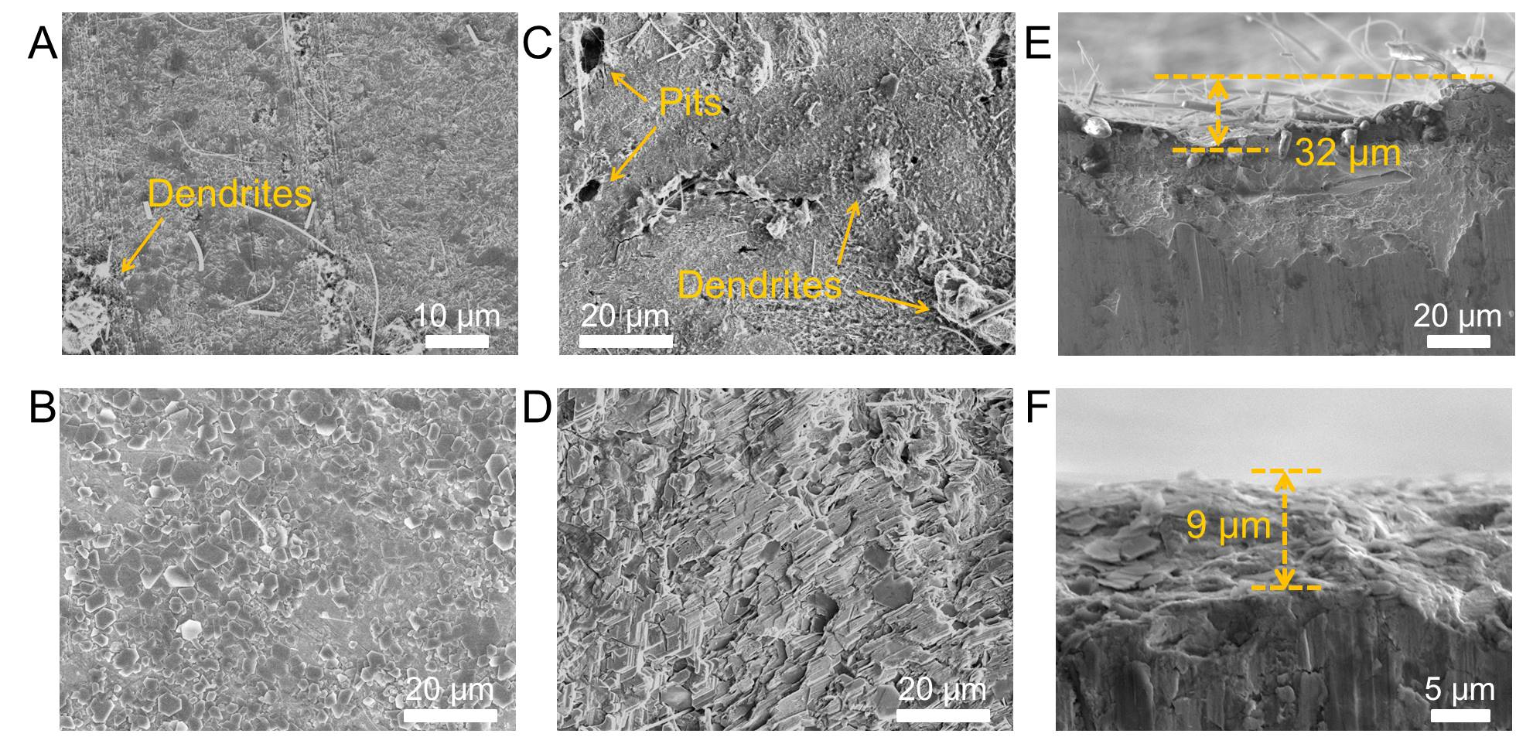
Fig. S15. Top-view SEM images of (A) bare Zn and (B) NOC@Zn electrodes after plating of 1.0 mAh cm^{–2} with a current density of 10.0 mA cm^{–2}. Top-view SEM images of (C) bare Zn and (D) NOC@Zn electrodes after 100 cycles under 10.0 mA cm^{–2}/1.0 mAh cm^{–2}. Side-view SEM images of (E) bare Zn and (F) NOC@Zn electrodes after 100 cycles under 10.0 mA cm^{–2}/1.0 mAh cm^{–2}.

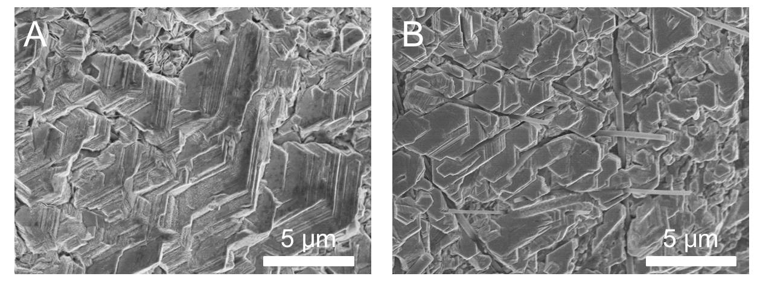
Fig. S16. Top-view SEM images of NOC@Zn electrodes after plating of 1.0 mAh cm^{–2} with a current density of (A) 20.0 mA cm^{–2} and (B) 30.0 mA cm^{–2}.

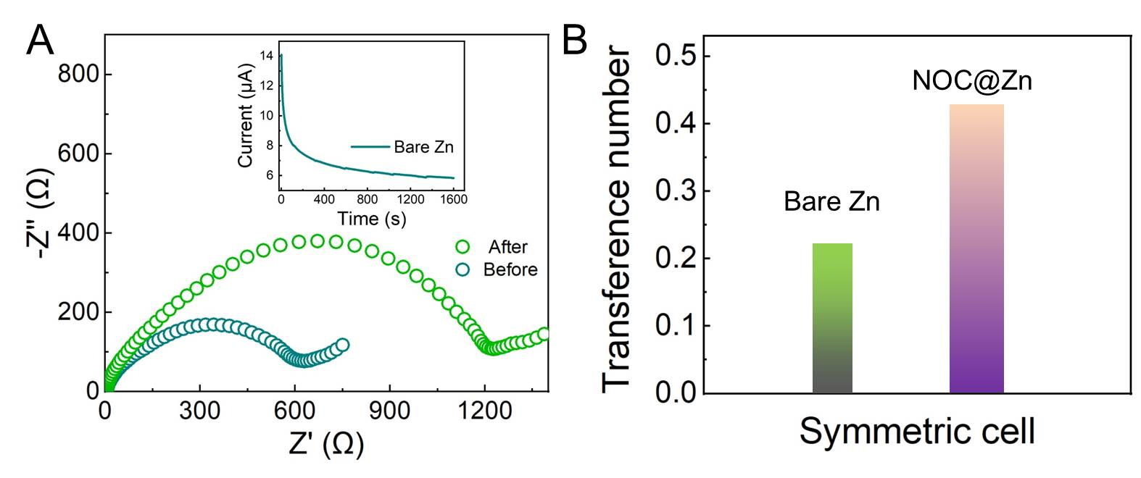
Fig. S17. (A) Nyquist plots of bare Zn symmetric cell before and after polarization. Inset: Current evolution of bare Zn symmetric cell under polarization of 10 mV. (B) Calculated transference number of bare Zn and NOC@Zn symmetric cell. The Zn²⁺ transfer number can be deduced from the equation (30) $T_{{Zn}^{2+}}$=$\frac{I_{s}(∆V-I_{0}R_{0})}{I_{0}(∆V-I_{s}R_{s})}$, where I₀/I_{s} and R₀/R_{s} are the initial/steady current and interfacial resistance, respectively. ∆V was set as 10 mV. The calculated transfer number for bare Zn and NOC@Zn symmetric cell is 0.22, 0.43, respectively.

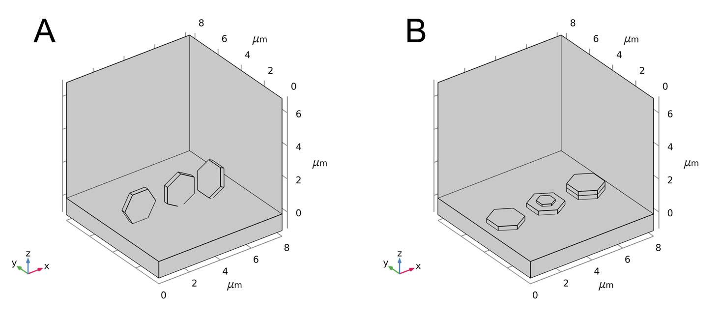
Fig. S18. Schematic diagram of the COMSOL simulation model: (A) Zn nanoplates on bare Zn; (B) Zn nanoplates on NOC@Zn.

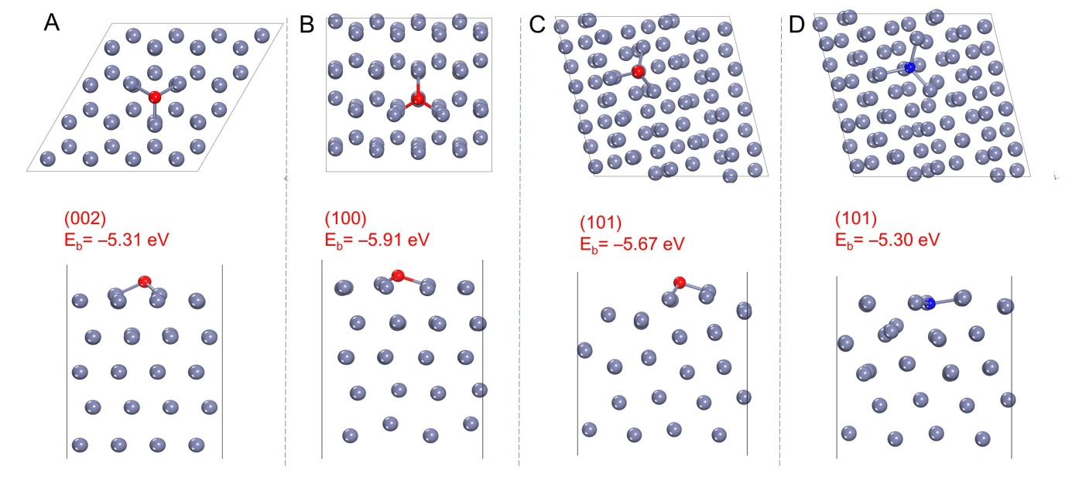
Fig. S19. Optimized configurations with top (up) and side (down) view of the O adsorption on (A) Zn (002) surface; (B) Zn (100) surface; (C) Zn (101) surface. (D) Optimized N adsorption on Zn (101) surface. The gray, blue, and red balls denote the zinc, nitrogen and oxygen atoms, respectively.

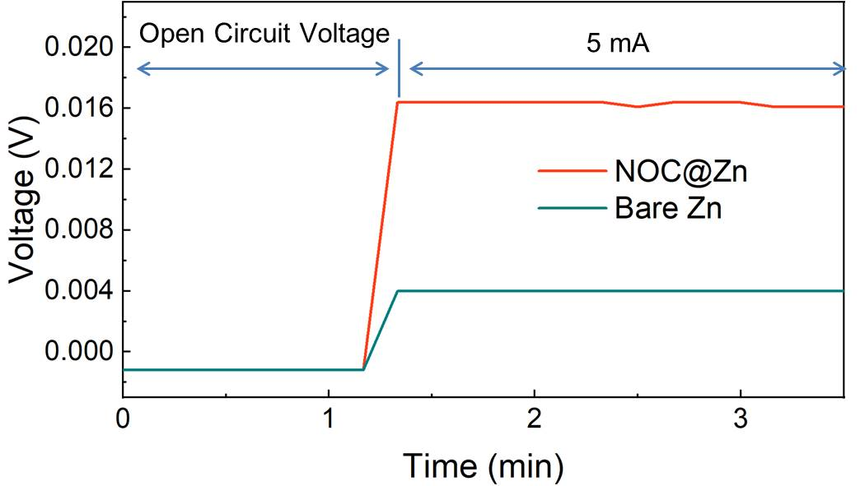
Fig. S20. Electron conductivity measurements of bare Zn and NOC@Zn foils using blocking electrodes with an applied current of 5.0 mA. The bare Zn and NOC@Zn foils were fabricated into coin cells using blocking electrodes without electrolyte to measure the electron conductivity of NOC film by galvanostatic charge. The bias voltage between two electrodes increases to 4.0 mV (bare Zn) and 16.4 mV (NOC@Zn), respectively. By using the following formula: ρ=(R*S)/L, where R, S, L is the resistance, area (1.0 cm²) and thickness of NOC layer (76 nm), the conductivity can be calculated as ~3.0×10^{–6} S cm^{–1}.
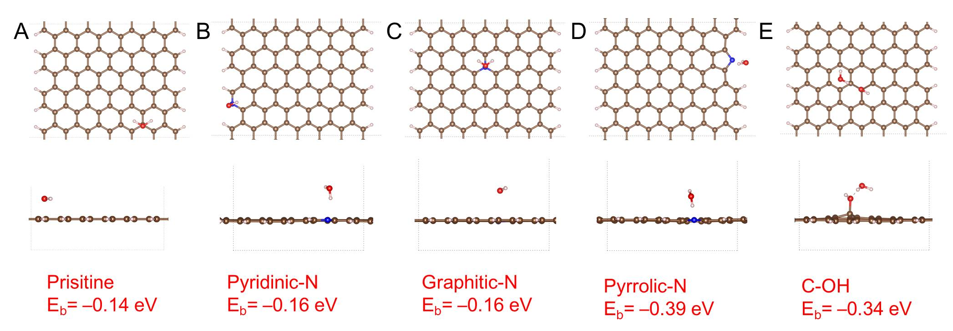
Fig. S21. The adsorption configuration of H₂O molecule on NOC layer with different adsorption sites: (A) prisitine; (B) pyridinic-N; (C) graphitic-N; (D) pyrrolic-N; (E) C-OH. The brown, blue, red and white balls denote the carbon, nitrogen, oxygen and hydrogen atoms, respectively.

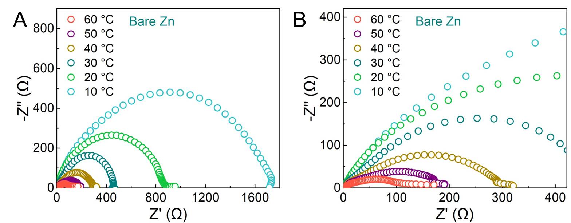
Fig. S22. (A) Nyquist plots at diﬀerent temperatures for bare Zn. (B) Enlarged view of (A).

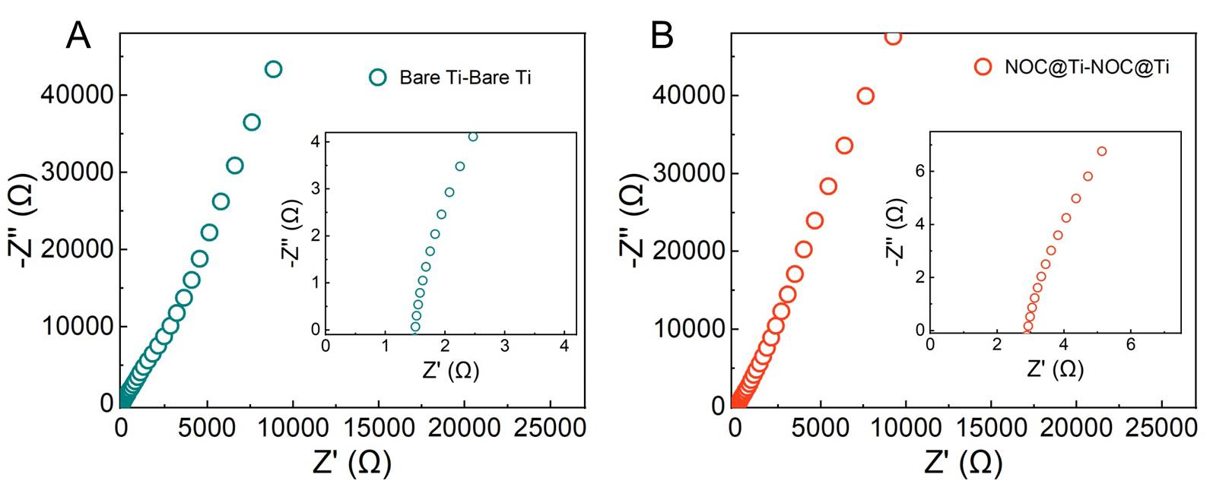
Fig. S23. (A) Nyquist plots for Ti-Ti symmetric cells. (B) Nyquist plots for NOC@Ti-NOC@Ti symmetric cells. The resistance of NOC layer can be obtained from the Nyquist plots (4) of Ti-Ti symmetric cells. R(NOC) = R(total) – R(glass fiber) = 1.39 Ω. Thus, the ionic conductivity of the NOC layer is ~6.9 × 10^{–6} S cm^{–1} by the following equation σ=L/(R*S), in which L is the thickness of the NOC layer (76 nm), S is the contact area (0.785 cm²), and R = 1.39 Ω.

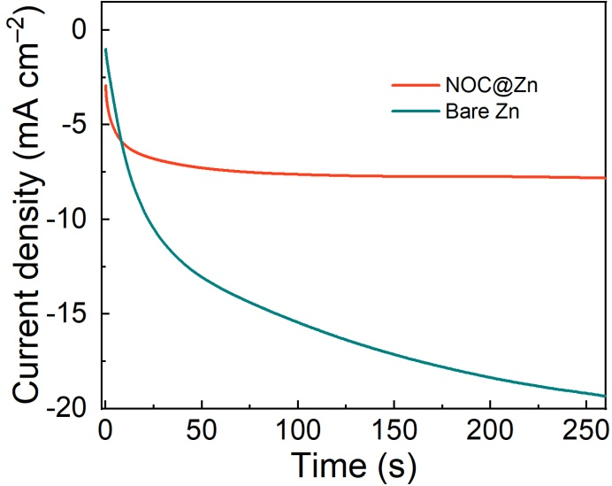

Fig. S24. Chronoamperometry curves of NOC@Zn and bare Zn symmetric cells at a constant potential of –150 mV.

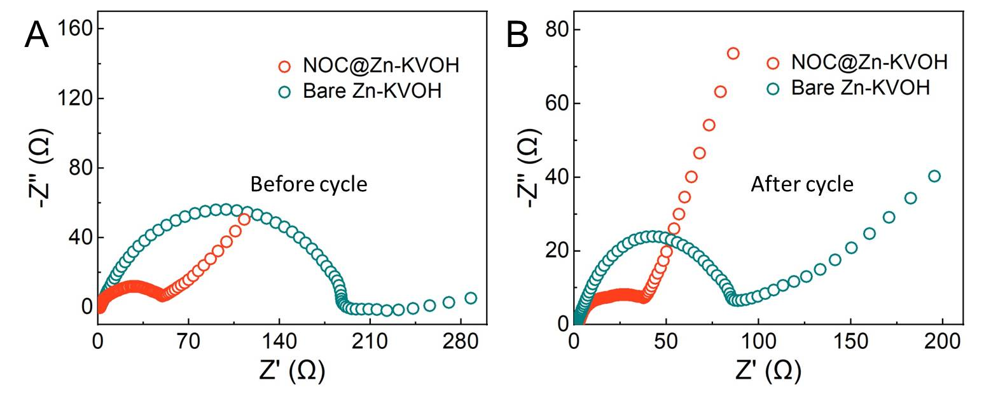
Fig. S25. (A) Nyquist plots of full cells before cycling. (B) Nyquist plots of full cells after 100 cycles at 5 A g^{–1}.

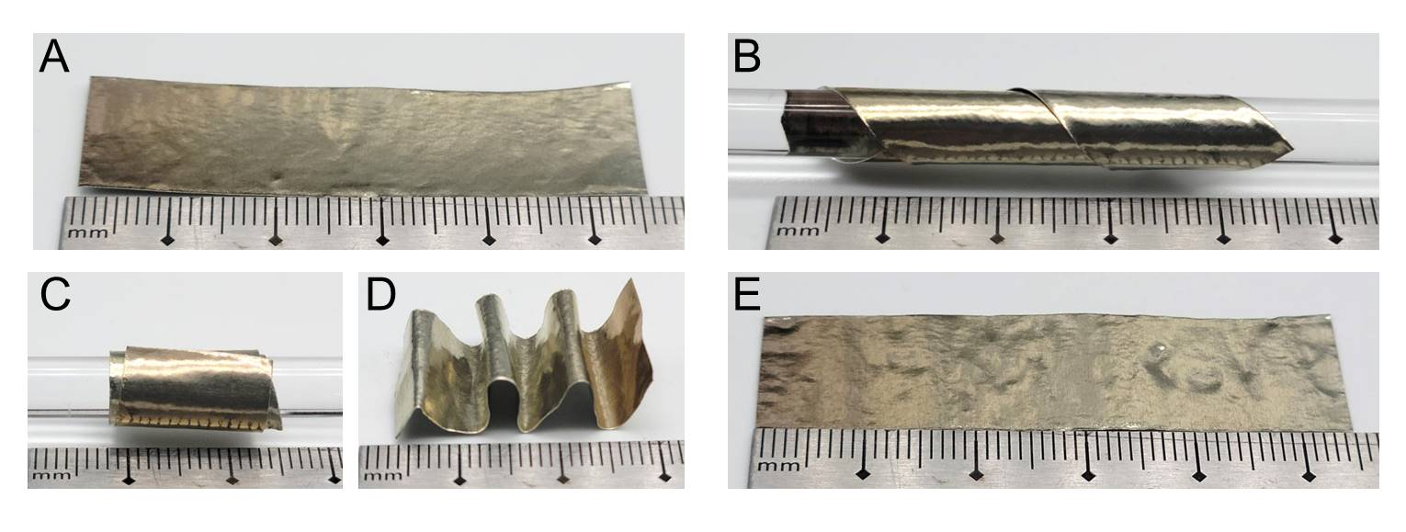
Fig. S26. (A) Digital image of as-grown NOC@Zn foil. Digital images of the (B) twisting, (C) rolling, and (D) folding processes for NOC@Zn foil. (E) Digital image of the NOC@Zn foil after twisting, rolling and folding processes. The NOC protective layer does not detach from the substrate after above operations.

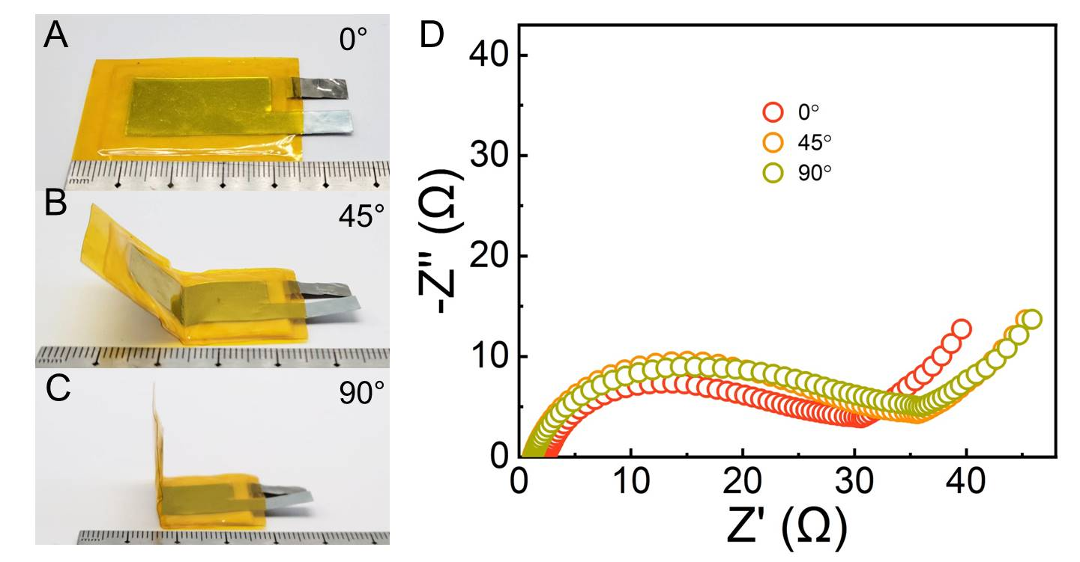
Fig. S27. Digital images of ﬂexible transparent NOC@Zn-KVOH cell under bending angles of: (A) 0°, (B) 45° (C) 90°. (D) Nyquist plots of NOC@Zn-KVOH cell under various bending angles.

Table S1. Performance comparisons of reported dendrite-free Zn anode strategies.
Materials | Areal current  (mA cm^{–2}) | Areal capacity  (mAh cm^{–2}) | Voltage hysteresis (mV) |  | Depth of discharge (DOD) | Lifespan (h) | Ref.
NOC | 10 | 1 |  | 60 | - | 1125 | This work
NOC | 30 | 30 |  | 100 | 53.5% | 136 | This work
NOC | 20 | 35 |  | 75 | 64.0% | 60 | This work
CNG membrane | 10 | 10 |  | 100 | 17.1% | 850 | (56)
NGO | 5 | 5 |  | 48 | 36% | 300 | (14)
Zn/Sn₍₀₀₂₎ | 0.5 | 1 |  | 8 | 1.2% | 500 | (31)
Gel-MA | 2 | 2 |  | 130 | 6.8% | 200 | (57)
FCOF | 5 | 3 |  | 50 | 5.1% | 360 | (58)
Sb | 3 | 1 |  | 34 | 1.2% | 1000 | (59)
Nanoporous CaCO₃ | 0.25 | 0.05 |  | 52 | 0.2% | 836 | (60)
ZF@F-TiO₂ | 2 | 2 |  | 40 | 12.2% | 280 | (61)
ZnSe | 1 | 1 |  | 16 | 1.9% | 1530 | (4)
ZnSe | 30 | 10 |  | 75 | 18.9% | 172 | (4)
ZnO | 5 | 1.25 |  | 42 | 2.1% | 500 | (36)
ZnS | 2 | 2 |  | 35 | 17.1% | 1100 | (62)
Kaolin layer | 4.4 | 1.1 |  | 70 | 1.9% | 800 | (63)
In | 1 | 1 |  | 54 | 1.7% | 520 | (64)
Polyamide | 0.5 | 0.25 |  | 100 | - | 8000 | (10)
Polyamide | 10 | 10 |  | 80 | 85.0% | 150 | (10)
Cyanoacrylate Adhesive | 0.5 | 0.25 |  | 50 | - | 800 | (65)
Cyanoacrylate Adhesive | 2 | 1 |  | 55 | 1.7% | 400 | (65)
ZnP | 2 | 0.5 |  | 25 | - | 3300 | (9)
ZnP | 15 | 48 |  | 110 | 82% | 100 | (9)

Table S2. Performance comparisons of reported Zn anode protective strategies based on carbon materials.
Materials | Protecting  methods | Preparation  methods | Areal current  (mA cm^{–2}) | Areal capacity  (mAh cm^{–2}) | Voltage hysteresis (mV) | Lifespan  (h) | Ref.
NOC@Zn | Artificial SEI | PECVD | 10 | 1 | 60 | 1125 | This work
NGO | Artificial SEI | Langmuir–Blodgett method | 5 | 5 | 48 | 300 | (14)
CNG | Artificial SEI | Acid hydrolysis  method | 1 | 0.5 | 21 | 2956 | (56)
CNT foam | Host | CVD | 3 | 0.5 | 143 | 167 | (66)
CNT@CC | Host | CVD | 2 | 2 | 27 | 200 | (67)
GO | Separator | Vacuum  filtration | 5 | - | 100 | 500 | (68)
DY | Separator | Cross-coupling reaction | 10 | 1 | 41 | 200 | (35)
VG | Separator | CVD | 1 | 1 | 40 | 250 | (8)
Nitrogen doped carbon | Separator | PECVD | 1 | 1 | 27 | 1100 | (20)

Table S3. Adsorption energy of the O/N atoms on different crystal planes encompassing Zn (002), Zn (100) and Zn (101).
Adsorbed atoms | Zn (002) | Zn (100) | Zn (101)
O atom | –5.31 eV | –5.91 eV | –5.67 eV
N atom | –4.32 eV | –5.14 eV | –5.30 eV
Table S4. The fitting resistance results of symmetric cells for NOC@Zn and bare Zn at different temperatures.
Symmetrical cells | Resistance | 10 ℃ | 20 ℃ | 30 ℃ | 40 ℃ | 50 ℃ | 60 ℃
Bare Zn- Bare Zn | R_{ct} (Ω) | 2220.6 | 829.8 | 350.5 | 300.5 | 150.4 | 99.6
NOC@Zn-NOC@Zn | R_{ct} (Ω) | 61.7 | 42.0 | 30.4 | 25.9 | 18.5 | 15.8

Table S5. Summary and comparison of current density and areal capacity of full batteries between this work and previous reports.
Cathode | Protection strategy | Areal current (mA cm^{–2}) | Mass loading  (mg cm^{–2}) | Areal capacity  (mAh cm^{–2}) | Ref.
KVOH | NOC@Zn | 27.95 | 5.59 | 1.006 | This work
MnO₂ | Al₂O₃ | 1 | 1.947 | 0.345 | (39)
MnO₂ | TiO₂/PVDF | 0.616 | 1.000 | 0.244 | (40)
VS₂ | Polyzwitterionic hydrogel electrolyte | 0.25 | 5 | 0.75 | (41)
KB | Zn-BTC-modified separator | 3.84 | 2 | 0.2 | (42)
AC | ZIF-8-derived carbon | 24 | 6 | 0.348 | (43)
MnO₂ | KPF₆ additives | 5 | 1 | 0.15 | (44)
Na:MnO₂/GCF | Carbon film current collector | 1.5 | 1.5 | 0.375 | (45)
AC | Graphene | 10 | 2 | 0.116 | (8)
V₆O₁₃ | N-Modified Graphdiyne | 20.65 | 4.13 | 1.07 | (35)
MnO₂ | TiO₂ | 3 | 3 | 0.472 | (46)
KVOH | ZnSe | 5 | 1 | 0.194 | (4)

Movie S1. Operando optical microscopy was employed to elucidate the morphology for bare Zn electrode during Zn plating process at 5 mA cm^{–2} (speeding-up 240×).

Movie S2. Operando optical microscopy was employed to elucidate the morphology for NOC@Zn electrode during Zn plating process at 5 mA cm^{–2} (speeding-up 240×).

