Supplementary Information
for
Guided anisotropic oxygen transport in vacancy ordered oxides
Zhenzhong Yang^{1,†}, Le Wang^{1,†}, Mark E. Bowden², Wen Liu^{2,3}, Zihua Zhu², Chongmin Wang², Scott A. Chambers¹, Peter V. Sushko^{1,}*, and Yingge Du^{1,}*
¹Physical and Computational Sciences Directorate, Pacific Northwest National Laboratory, Richland, WA 99354, USA
²Environmental Molecular Sciences Laboratory, Pacific Northwest National Laboratory, Richland, WA 99354, USA
³State Key Laboratory of Biogeology and Environmental Geology, China University of Geosciences, Wuhan, 430074, China
†Z. Yang and L. Wang contributed equally to this work
Correspondence and requests for materials should be addressed to P.V.S. (peter.sushko@pnnl.gov) and Y.D. (email: yingge.du@pnnl.gov)

Supplementary Figures

Figure S1 | Structural characterization of epitaxial BM-SFO thin films. a, High-resolution XRD out-of-plane θ-2θ scans for BM-SFO grown on STO and LSAT. The STO and LSAT substrate peaks are marked with ‘♣’ and ‘♥’, respectively. b, Reciprocal space maps near the (103) reflection for these two samples, confirming structural coherence.
For BM-SFO on STO, the half-order peaks appear in the out-of-plane XRD θ-2θ scan, originating from the alternate stacking of FeO₆ octahedral and FeO₄ tetrahedral layers along the out-of-plane direction (OVCs parallel to the substrate surface), which is consistent with our STEM observation shown in Fig. 1e. By contrast, the absence of half-order peaks for BM-SFO on LSAT suggests that OVCs are vertical to the substrate surface, which is further confirmed by our STEM image shown in Fig. 1f.
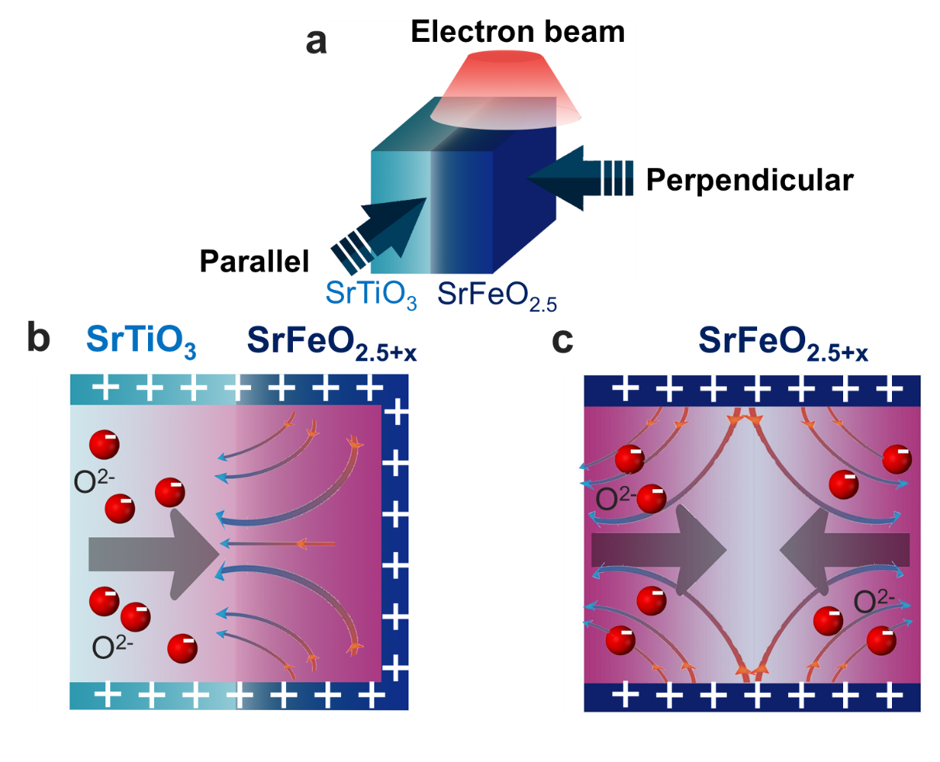
Figure S2 | Effect of the electron beam on the O ions diffusion. a, Schematics of the sample orientation relative to the electron beam and viewing directions parallel (b) and perpendicular (c) to the interface. b, Schematics of electric field component perpendicular to the interface (shown in the viewing direction parallel to the interface) provides the driving force for O^{2–} ions diffusion from STO to SFO. c, Schematics of electric field component parallel to the interface (shown in the viewing direction perpendicular to the interface) provides the driving force for O^{2–} ions diffusion along the SFO film.
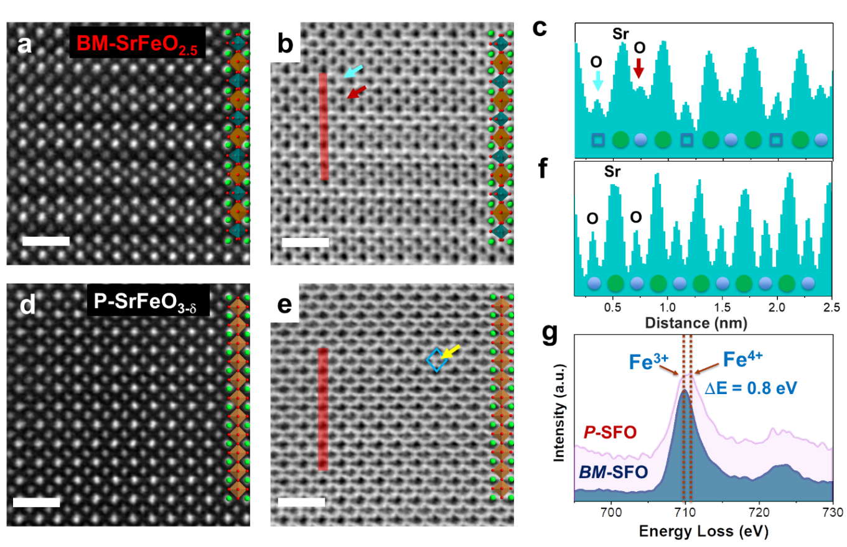
Figure S3 | Evolution of the lattice structure and oxygen occupancy in BM-SFO and P-SFO phases. HAADF and ABF-STEM images for the pristine state BM-SrFeO_{2.5} (a, b) and O rich P-SrFeO_{3-δ} (d, e). Line intensity profiles of inversed ABF contrast (c and f) corresponding to red lines in ABF images of b and e, respectively. The small hollow blue squares and purple spheres are used to indicate the half and fully occupied oxygen sites, respectively. The large green spheres indicate the Sr columns. The scale bars in a, b, d, and e are 1 nm. g, EELS of Fe L_{2,3} edge shows the valence change during the phase transformation from BM-SFO to P-SFO.
Atomic structures (including O) of the pristine BM-SFO and new formed P-SFO can be clearly demonstrated by aberration-corrected HAADF and annular bright-field (ABF)-STEM. The oxygen vacancy ordering of BM-SFO is clearly visible in Fig. S3a. Since the contrast of ABF images exhibits a Z^{1/3} dependence (Z being the atomic number), they are more sensitive to lighter atoms, such as lattice oxygen. In Fig. S3c, the line profile corresponding to ABF-STEM image (Fig. S3b) shows alternating intensities for oxygen layers, revealing that each FeO₄-connected OVC is sandwiched by stoichiometric FeO₆ layers, consistent with the HAADF-STEM image. In contrast, for the P-SFO phase, such modulation disappears in the HAADF (Fig. S3d) as well as the O intensity line profile (Fig. S3f), indicating the O ions insertion into OVCs. As P-SFO is unstable under high temperature and sensitive to the electron beam¹⁻³, the slight octahedral distortions in Fig. S3e are most likely due to the slight reduction of P-SFO. Theoretical studies also suggested that the existence of V_{O}s in SrFeO_{x} may lead to such structural asymmetry⁴. A clear energy shift in electron energy loss spectra (EELS) (Fig. S3g) is observed for BM-SFO and P-SFO, further confirming the oxidation of Fe³⁺ to Fe⁴⁺.
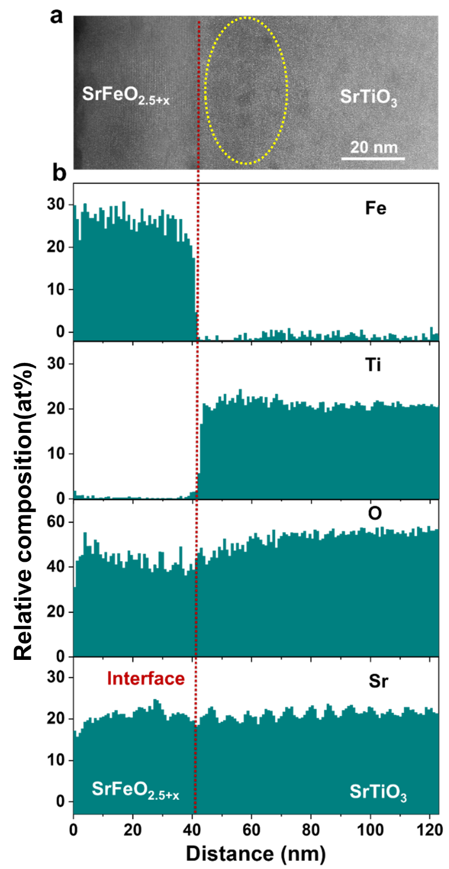
Figure S4 | Elemental composition profiles across SFO/STO interface subjected to simultaneously applied heating and in situ TEM beam illumination. a, HAADF-STEM image of the SFO/STO sample after the in situ TEM experiment (simultaneously applied 300°C sample heating and electron beam illumination) was completed. b, Relative composition of O, Fe, Ti, and Sr estimated using STEM-EELS maps corresponding to a. The element composition profile for oxygen provides further evidence for the oxygen ions diffusion from STO to SFO under the combined influence of elevated temperature and in situ TEM illumination.

Figure S5 | Diffusion of O^{2–} in the BM-SFO vacancy channels parallel to the substrate surface (the case of BM-SFO on STO). a, Calculated potential energy surface for O^{2–} diffusion in the strained BM-SFO. b, A fragment of the diffusion pathway. Only the FeO plane of the BM-SFO lattice and neighboring SrO planes are shown. Sr, Fe, and O atoms are shown with green, orange, and red spheres, respectively. The additional oxygen atom is shown with a large red sphere; small dark blue spheres indicate points along the diffusion path.

Figure S6 | Modification of the charge density distribution upon oxidation of SFO_{x}. a, Effect of oxygen incorporation on the Bader charges Q of oxygen ions (|e| indicates the absolute value of the electron charge e) as a function of the number of oxygen atoms (N) incorporated into a single FeO_{1+y} (0≤y≤1) plane. b, Structural model of the SFO_{x} lattice with the OVCs oriented parallel to the substrate surface. Sr, Fe, and O atoms are shown with green, orange, and red spheres, respectively. Additional oxygens are shown as large red spheres. As N increases from 0 to 16, the local atomic structure evolves from BM-SFO (y=0) to P-SFO (y=1) and ions in the oxygen-rich region become less negative.

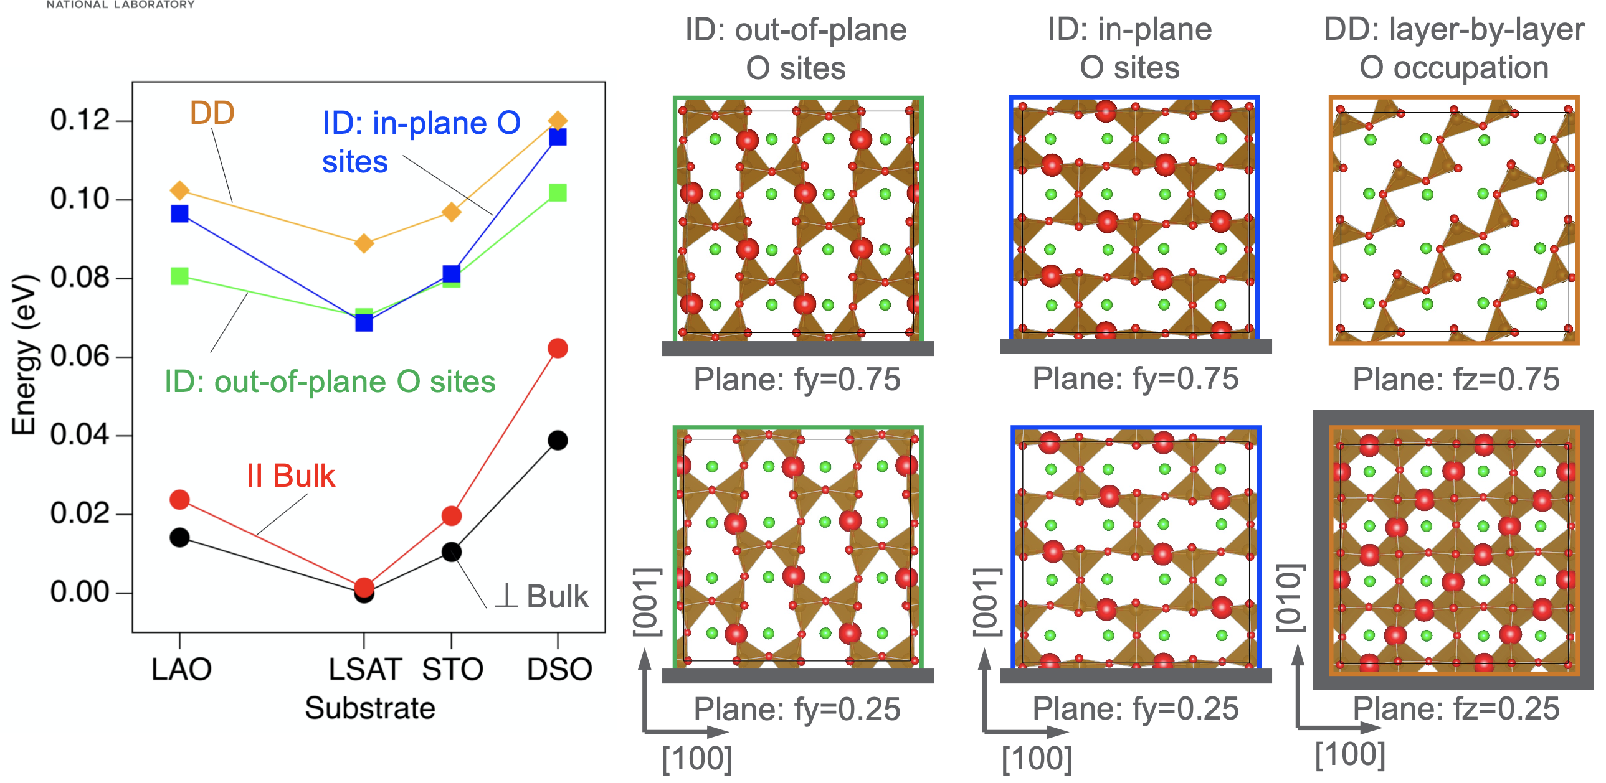
Figure S7 | Stability and structure of the SrFeO_{2.75} phases. Relative stability of the nominal SrFeO_{2.75} phases (energy per formula unit) calculated as a function of substrate-induced strain (left) and the corresponding structural configurations of the OVC planes partially occupied with additional Oxygens shows with large spheres (right). In all cases, substrate strain was applied in the [100]-[010] plane; the location of the substrate is indicated with gray bars. In-plane lattice parameters of the SrFeO_{2.75} phases were fixed at the values 3.790, 3.868, 3.905, and 3.950 Å to reproduce strain induced by the LAO, LSAT, STO, and DSO substrates, respectively. Bulk-like phases with oxygen vacancies rows oriented in out-of-plane and in-plane directions are the most stable among all considered SrFeO_{2.75} phases. Intercalation diffusion (ID) phases have OVC planes oriented perpendicular to the substrate and fractional coordinates along the [010] direction fy=0.25 and fy=0.75; 50% of the vacant sites in each OVC is occupied with the additional oxygens. Two ID phases corresponds to the additional oxygens located at the out-of-plane (O-oop) and in-plane (O-ip) oxygen sites, respectively. Phase corresponding to disruptive diffusion (DD) has OVC planes stack along the [001] direction with fractional coordinates fz=0.25 and fz=0.75. In the considered SrFeO_{2.75} phase, one OVC plane has 100% of the vacant sites occupied (fz=0.25) and the other OVC plane has no additional oxygens (fz=0.75).

Captions for the in-situ captured movies
Movie S1:
In-situ atomic-scale observation of dynamical phase transition processes in BM-SFO/STO under simultaneously applied 300°C sample heating and electron beam illumination. The video is accelerated by the factor of 20 relative to the actual time.
Movie S2:
In-situ atomic-scale observation of nucleation and phase transition processes in BM-SFO/STO under simultaneously applied 200°C sample heating and electron beam illumination. The video is 15 times faster than actual time.
Movie S3:
In-situ observation of phase transition processes in BM-SFO/LSAT under simultaneously applied 200°C sample heating and electron beam illumination. The video is 5 times faster than actual time.
Movie S4:
In-situ observation of phase transition processes in BM-SFO/LSAT under simultaneously applied 200°C sample heating and electron beam illumination. The video is 5 times faster than actual time.

Reference

1 Wang, L., Yang, Z. Z., Bowden, M. E. & Du, Y. G. Brownmillerite phase formation and evolution in epitaxial strontium ferrite heterostructures. Appl. Phys. Lett. 114, 231602 (2019).
2 Yao, L. et al. Electron-beam-induced Perovskite-Brownmillerite-Perovskite structural phase transitions in epitaxial La_{2/3}Sr_{1/3}MnO₃ films. Adv. Mater. 26, 2789-2793 (2014).
3 Jang, J. H. et al. In Situ Observation of Oxygen Vacancy Dynamics and Ordering in the Epitaxial LaCoO₃ System. ACS Nano 11, 6942-6949 (2017).
4 Das, T., Nicholas, J. D. & Qi, Y. Long-range charge transfer and oxygen vacancy interactions in strontium ferrite. J. Mater. Chem. A 5, 4493-4506 (2017).

