Supplementary Information
The non-volatile electrostatic doping effect in MoTe₂ field-effect transistors controlled by hexagonal boron nitride and a metal gate
Muhammad Asghar Khan^{1#}, Muhammad Farooq Khan^{2#}, Shania Rehman^{2,3}, Harshada Patil^{2,3}, Ghulam Dastgeer¹, Byung Min Ko¹ and Jonghwa Eom^{1*}
¹Department of Physics & Astronomy and Graphene Research Institute-Texas Photonics Center International Research Center (GRI–TPC IRC), Sejong University, Seoul 05006, Korea
²Department of Electrical Engineering, Sejong University, Seoul 05006, Korea
³Department of Convergence Engineering for Intelligent Drone, Sejong University, Seoul 05006, Korea

#These authors contributed equally.
*Corresponding author: eom@sejong.ac.kr

Figure S1. Raman spectrum of the 2 nm-thick h-BN.

Figure S2. The transfer curve (I_{ds}-V_{g-Si}) of the 0.8 nm-thick MoTe₂ FET shows p-type behavior using Si as the back gate with sweeping from −60 to +60 V.

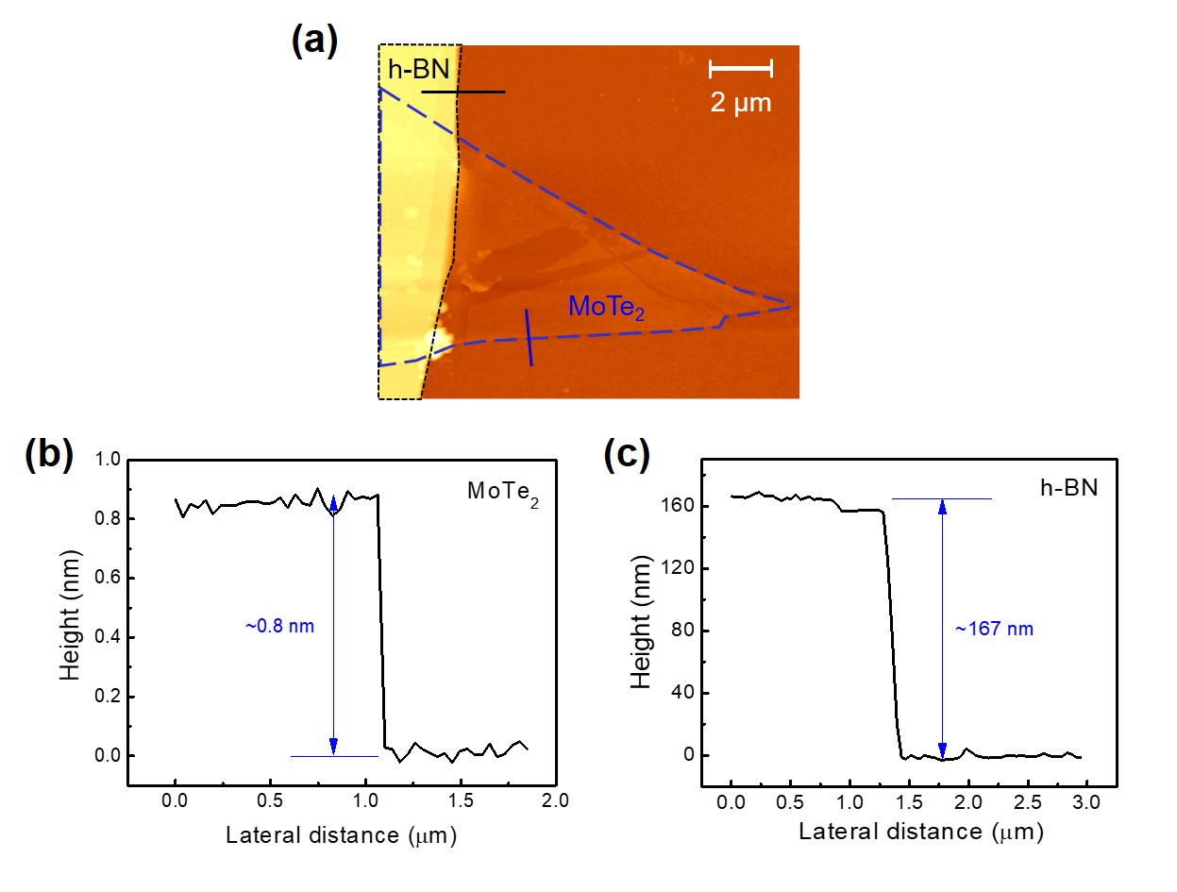
Figure S3. (a) AFM image of the MoTe₂ FET on h-BN. (b) Height profile of MoTe₂ along the blue line indicated in the AFM image (thickness ≈ 0.8 nm). (c) h-BN height profile, where the thickness is ~167 nm.

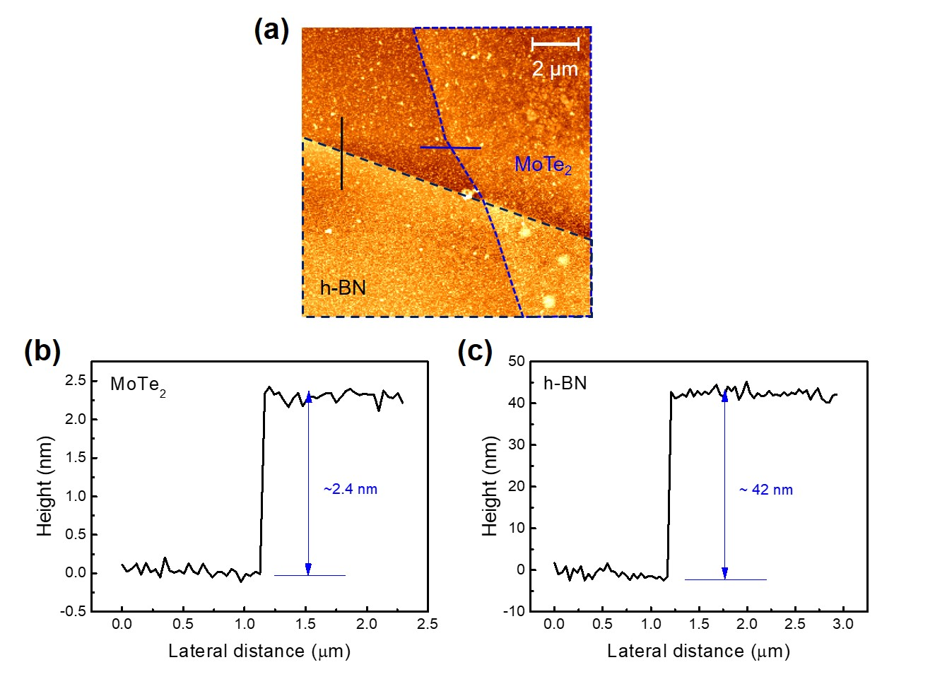
Figure S4. (a) AFM image of the MoTe₂ FET on h-BN. (b) Height profile of MoTe₂ along the blue line indicated in the AFM image (thickness ≈ 2.4 nm). (c) h-BN height profile, where the thickness is ~42 nm.

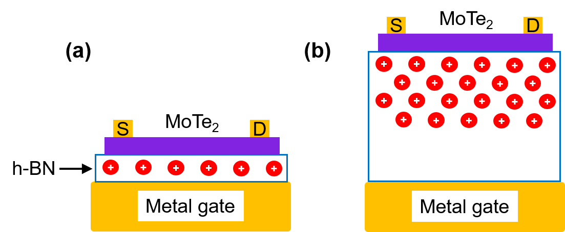

Figure S5. (a) Schematic diagram of the MoTe₂ FET on a thin h-BN substrate after the photo-induced doping treatment, where donor-like defects are located around the upper side of the h-BN component. (b) Schematic diagram of the MoTe₂ FET on a thick h-BN substrate after the photo-induced doping treatment, where the donor-like defects are distributed in the h-BN bulk.

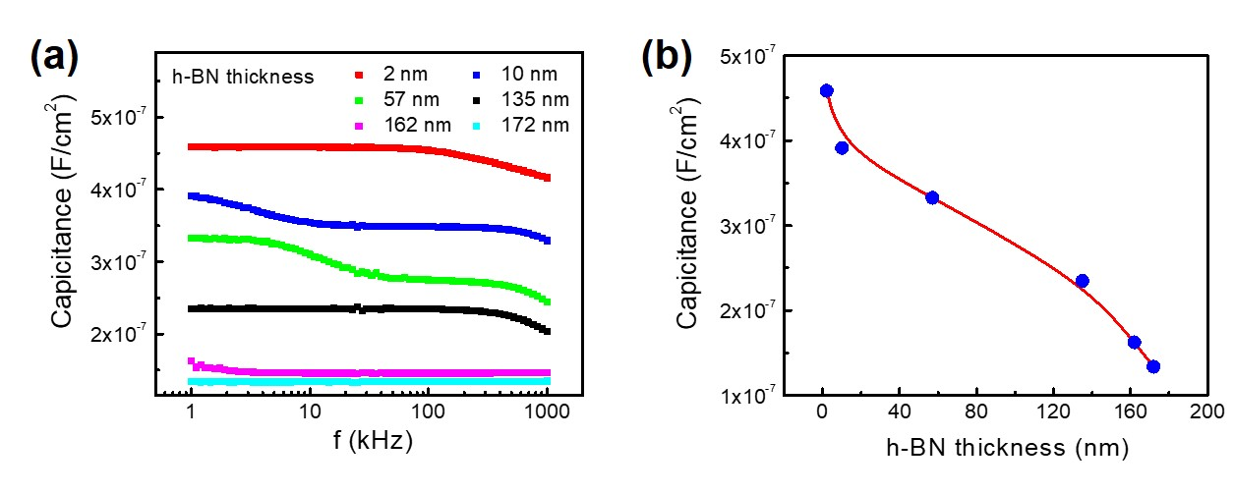
Figure S6. (a) Capacitance as a function of the h-BN frequency as a dielectric material. (b) Capacitance as a function of the h-BN thickness.

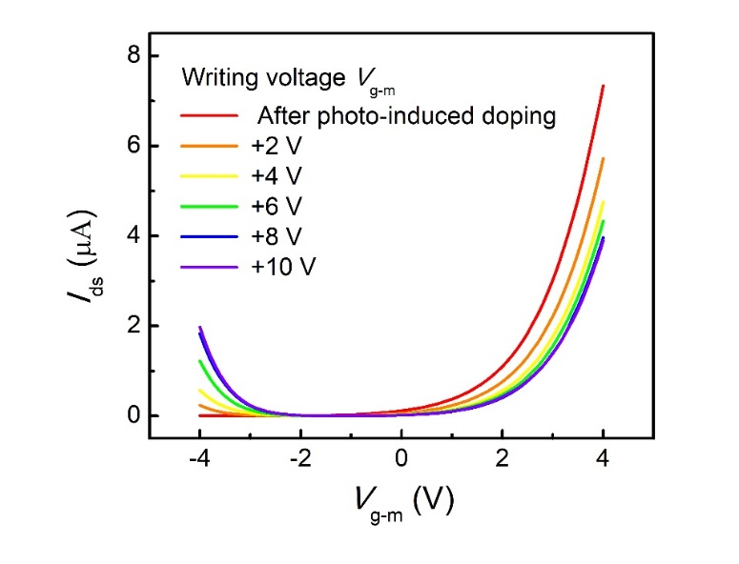
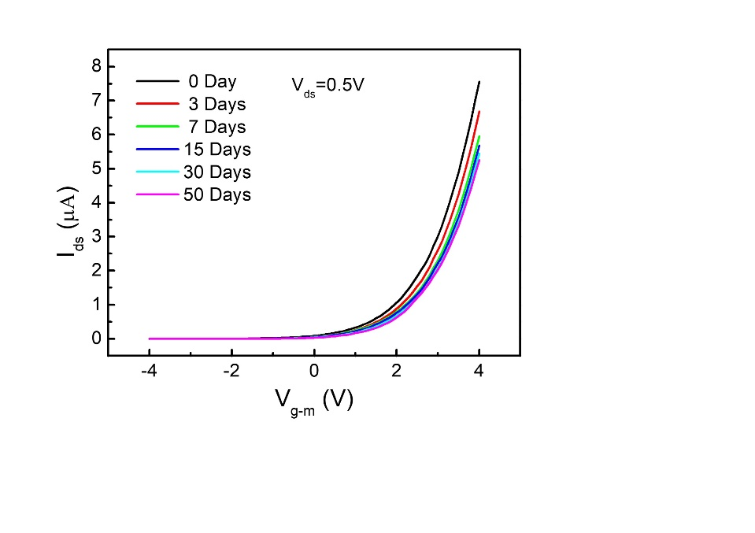
(b)
(a)

Figure S7. (a) The transfer characteristics of n-MoTe2 demonstrate the stability of photo-induced doping. (b) Transfer characteristics of the MoTe₂ (0.8 nm) FET on a 167 nm-thick h-BN substrate after photo-induced doping for 5 min with different writing voltages. The MoTe₂ (0.8 nm) FET on h-BN (167 nm) was prepared by photo-induced doping with the writing voltage of -10 V before starting the experiment, so that MoTe₂ (0.8 nm) FET became n-type.

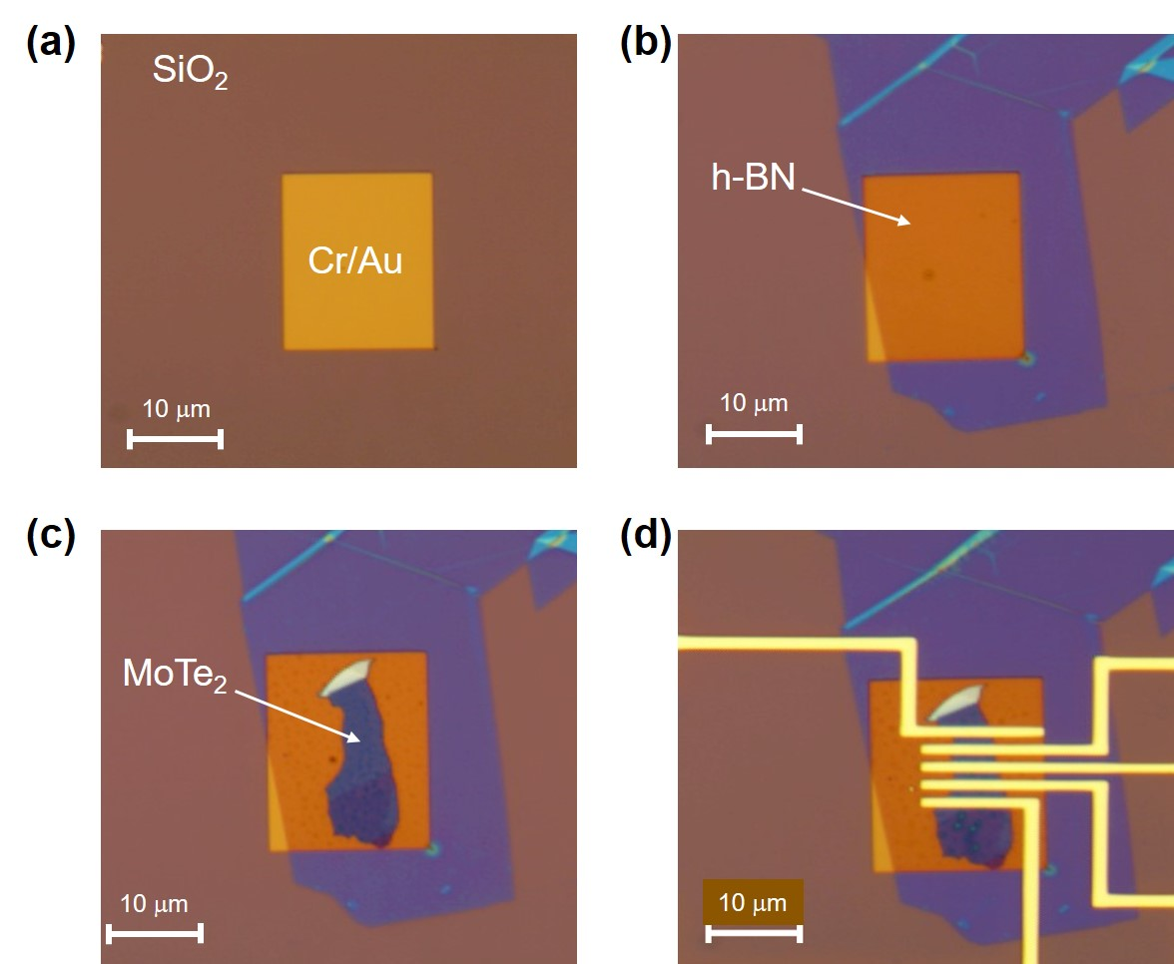
Figure S8. Step-by-step fabrication process of the MoTe₂ FET on the h-BN substrate for the generation of a floating-gate structure. (a) The lower isolated Cr/Au (1/10 nm) layer was patterned using e-beam lithography. (b) The h-BN substrate was transferred onto the top of the Cr/Au layer. (c) A MoTe₂ flake was transferred onto the top of the h-BN layer. (d) The top Cr/Au (6/90 nm) electrodes were deposited using a thermal evaporator.

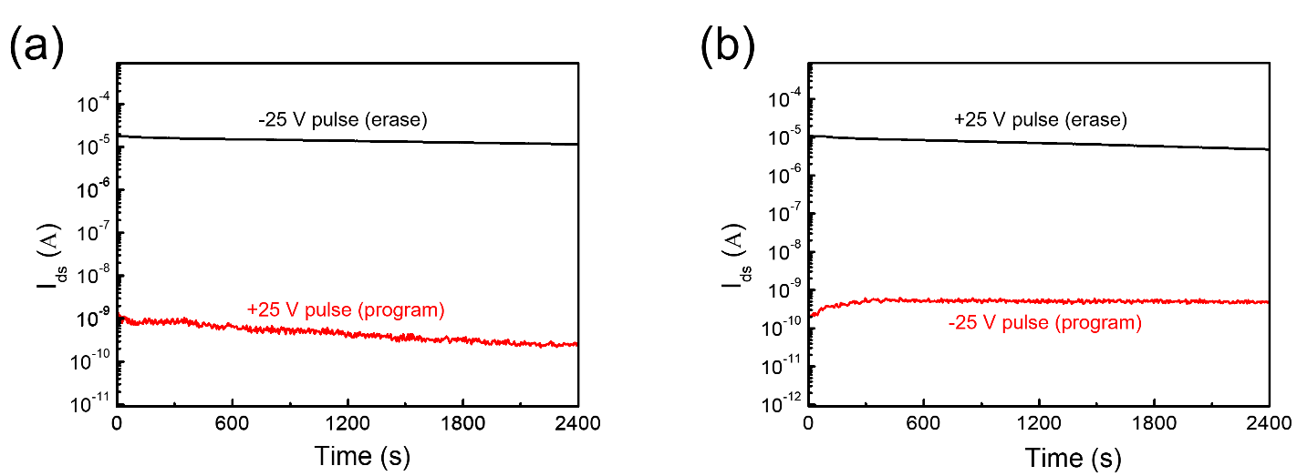

Figure S9. (a) N-type memory retention characteristics for program state (+25 V pulse) and erase state (-25 V pulse). (b) P-type memory retention characteristics for program state (-25 V pulse) and erase state (+25 V pulse).

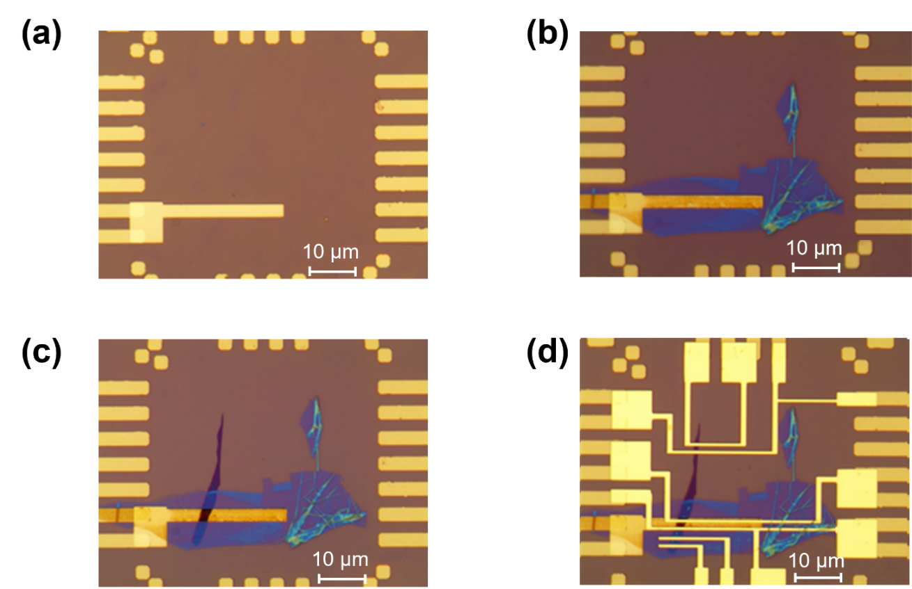

Figure S10. Step-by-step fabrication process of the MoTe₂ FET on the h-BN substrate for photo-induced doping. (a) The lower Cr/Au (3/13 nm) electrode was fabricated for use as the writing line voltage. (b) The h-BN substrate was transferred onto the top of the writing voltage electrode. (c) A MoTe₂ flake was transferred onto the top of the h-BN substrate. (d) The source and drain Cr/Au (10/80 nm) electrodes were deposited using a thermal evaporator.

