Supplemental Online Materials

Atomic-resolution scanning transmission electron microscope imaging and electron beam-induced current measurements in GaAs Nanowire p-i-n Diodes
Juan Pablo Oviedo,† Enrique Barrigon,‡ Ryan Sellers,⊥ Magnus T. Borgström,‡ Robert F. Klie†⊥*
†Sivananthan Laboratories, Inc., Bolingbrook, IL, 60440, USA.
‡Nanolund, Lund University, 223 63 Lund, Sweden.
⊥Department of Physics, University of Illinois Chicago, Chicago, IL 60607, USA.

Supplemental Figure 1:

Current measured as a function of beam exposure on the GaAs nanodiode. As noted in the main text, the electron probe was placed manually at different positions along the nanowire length for 10 s and the current was measured directly as a function of time. Two important points need to be highlighted here. First, the overall noise in the EBIC signal (+/- 20 pA) is very low compared to the measured signal. This low noise floor makes direct measurement of EBIC combined with atomic resolution STEM imaging possible. Second, there is no EBIX signal measurable at either end of the nanowires, as expected, since the distance for the electron-hole pairs from the p-i-n junction is too far and there is build-in field to separate the charges.
Supplemental Figure 2:
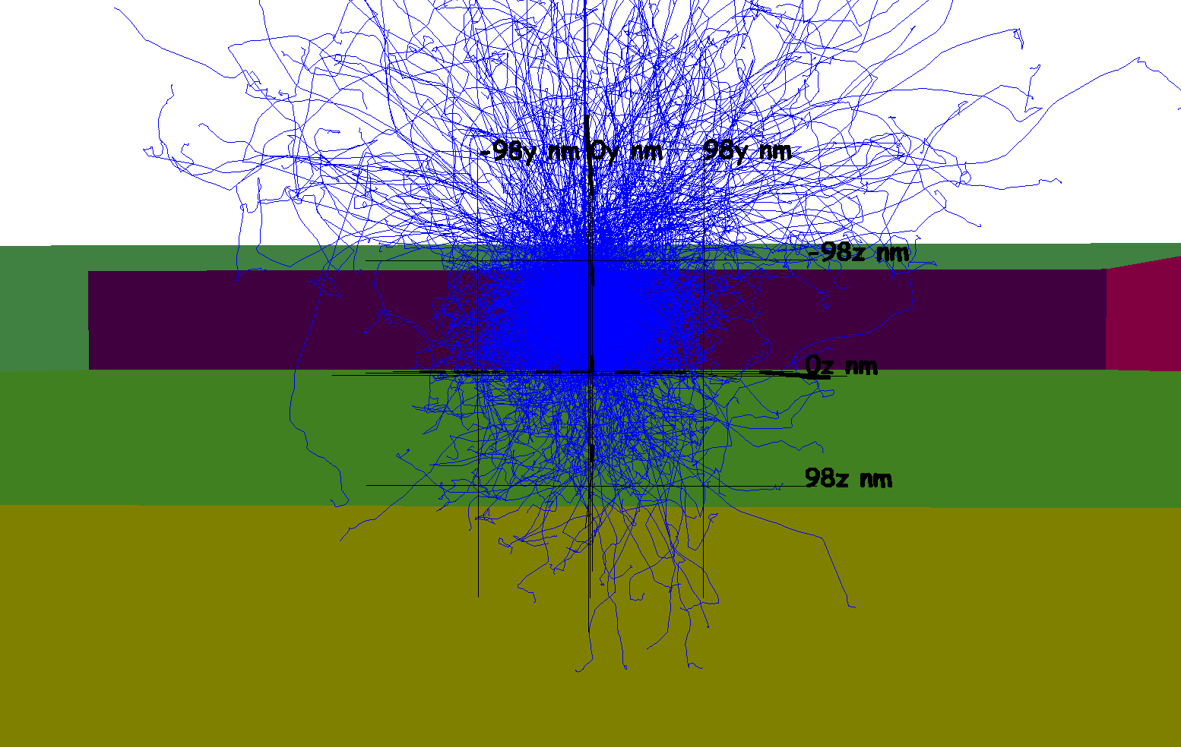

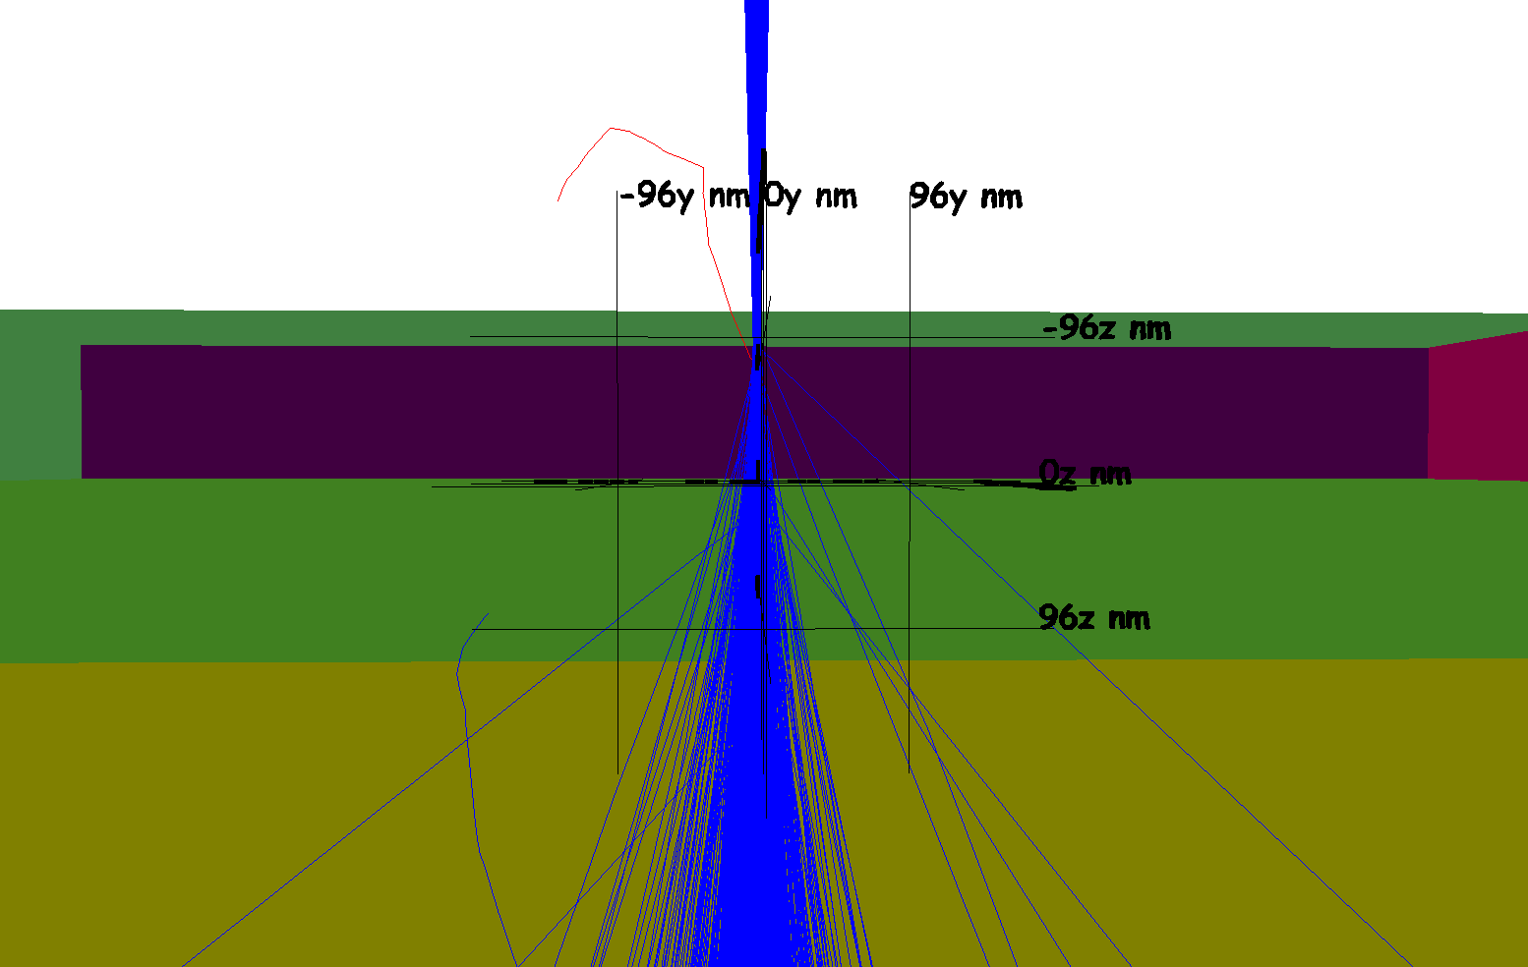

Monte Carlo simulations of electron trajectories in the GaAs nanowire using the CASINO v3.3 code [1]. Figure S2a) shows the electron trajectories for the SEM EBIC setup, where an electron probe diameter of 1 nm is chosen at a primary beam energy of 5 kV. The nanowire thickness is set at 200 nm and a planar SiN_{x} substrates is also present. Figure S2b) shows the electron trajectories for the same sample but for an electron beam at 200 kV and an incoming electron probe size of 0.15 nm, similar to what was used for the STEM-EBIC measurements. The comparison of the electron trajectories clearly shows the difference in the excitation volume inside the GaAs sample, leading to the different EBIX profiles.

Reference:

[1] H. Demers, N. Poirier-Demers, A. Réal Couture, D. Joly, M. Guilmain, N. de Jonge, and D. Drouin. (2011). "Three-dimensional electron microscopy simulation with the CASINO Monte Carlo software." Scanning 33(3): 135-146.

