The effects of native oxides on the selective photo-reduction property of Cu nanoparticles induced by the localized surface plasmon

Yingcui Fang^{1,2*}, Lei Li¹, Huanhuan Li¹, Shiqi Zhao¹, Zhitao Cheng¹, Xiangqian Chu¹, Mengtao Sun^{3,4,*}
¹Department of Vacuum Science and Technology, Hefei University of Technology, Hefei 230009, China
² Intelligent Manufacturing Institute of Hefei University of Technology, Hefei 230051, China
³School of Mathematics and Physics, University of Science and Technology Beijing, Beijing 100083, China
³Collaborative Innovation Center of Light Manipulations and Applications, Shandong Normal University, Jinan 250358, China
E-mail: ycfang@hfut.edu.cn (Y.C. Fang)； mengtaosun@sutb.edu.cn (M. Sun)

- Fig. S1. The histograms of the CuNPs of 0.5nmAgNPs (a), 1.0nmAgNPs (b), 0.5nmCuNPs (c), 1.0nmCuNPs (d), 0.5nmCuNPs-AN (e), 1.0nmCuNPs-AN (f). The mean nanoparticles sizes and corresponding nanoparticles densities are listed in Table 1.

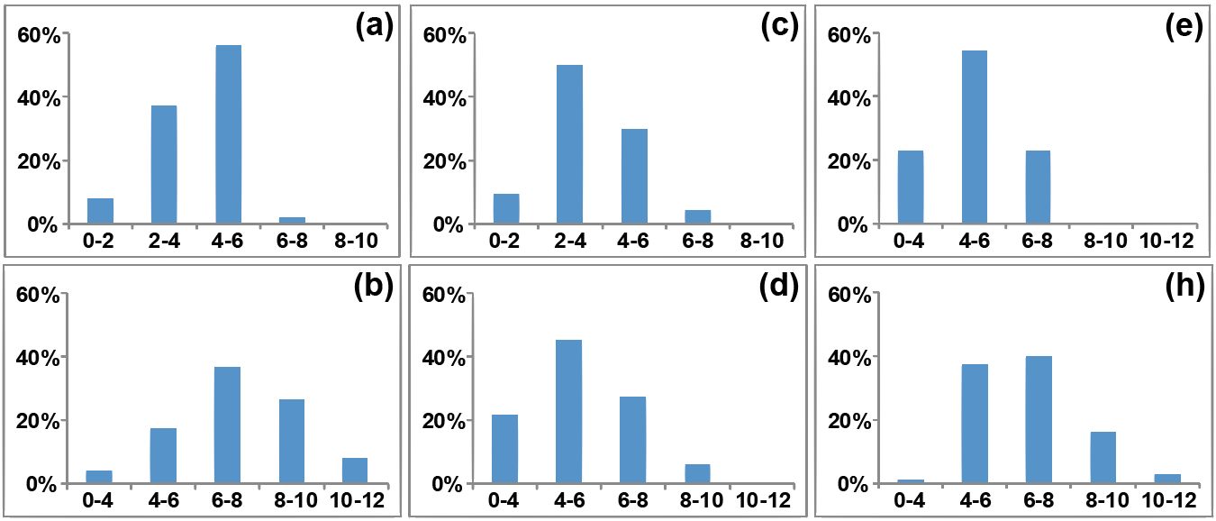

Fig. S1

Table 1

Samples | Sizes φ (/nm) | Density n (/100nm²)
0.5nm AgNPs | 3.8 | 0.8
1.0nm AgNPs | 6.7 | 1.1
0.5nm CuNPs | 3.4 | 1.7
1.0nm CuNPs | 5.4 | 2.3
0.5nm CuNPs-AN | 4.2 | 0.9
1.0nm CuNPs-AN | 6.8 | 1.2

- The XPS spectral fitting details of the xnmAgNPs, Fig. S2 (a)-(d), and the ynmCuNPs, Fig. S2 (e)-(h).

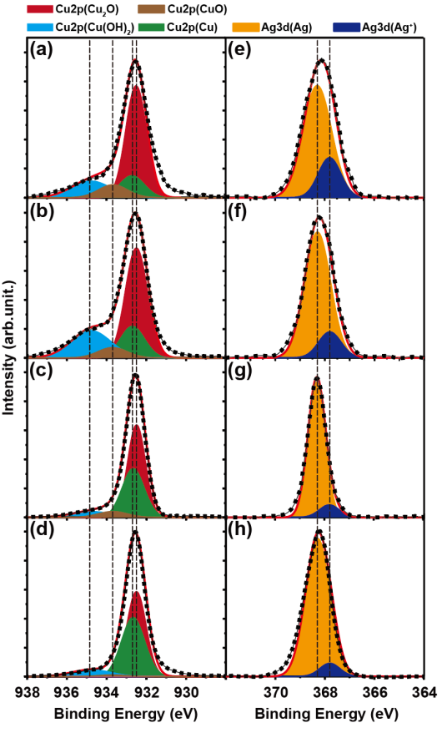
Fig. S2

- Fig. S3. The PRE-t of the 1nmCuNPs (a) and the 0.5nmCuNPs (b) from PNTP to DMAB excited by lasers of 532 and 633 nm. Since the PREs caused by 532 nm laser are only a little larger than those caused by 633 nm laser, and considering that the AgNPs must be excited by 532 nm, in our experiments, 532 nm was chosen as the excitation wavelength.
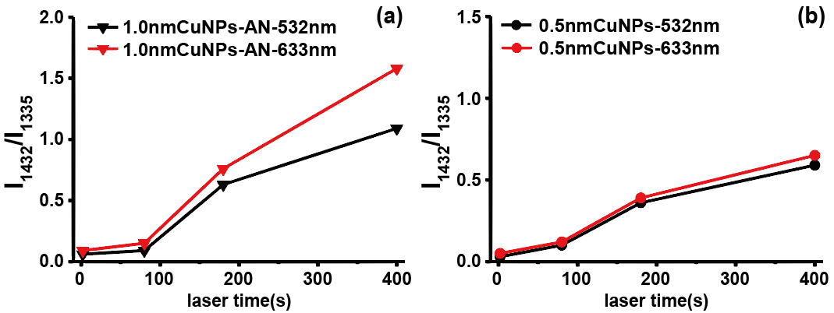

Fig. S3

