Supplementary figures and tables for

PRDM15 interacts with DNA-PK-Ku complex to promote radioresistance in rectal cancer by facilitating DNA damage repair
Yue Yu^{1#}, Tingting Liu^{2#}, Guanyu Yu^{1#}, Hang Wang², Zhipeng Du^{1,3}, Yuanyuan Chen², Nan Yang⁴, Kun Cao², Chunlei Liu⁵, Zhijie Wan², Hui Shen², Fu Gao^{2*,} Yanyong Yang²*, Wei Zhang¹*
#Authors contributed equally to this work.
1 Department of Colorectal Surgery, Changhai Hospital, Naval Medical University, Shanghai, China;
2 Department of Radiation Medicine, Faculty of Naval Medicine, Naval Medical University, Shanghai, China;
3 School of Public Health and Management, Wenzhou Medical University, University Town, Wenzhou, Zhejiang, China;
4 Pharmacy Department, Qingdao Special Servicemen Recuperation Center of CPLA Navy, Qingdao 266071, China;
5 Chifeng Municipal Hospital, Chifeng Clinical Medical School of Inner Mongolia Medical University, Chifeng 024000, China;

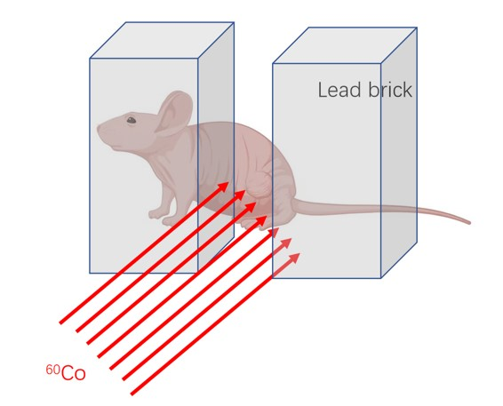
Supplementary Fig. 1 Schematics of local irradiation strategy of tumor bearing mice of CDX and PDX model.

Supplementary Fig. 2 Expression of PRDM15 in different CRC cell lines.

Supplementary Fig. 3 Flow cytometry analyzing cell cycle distribution in response to IR (Relative to Fig. 2I).
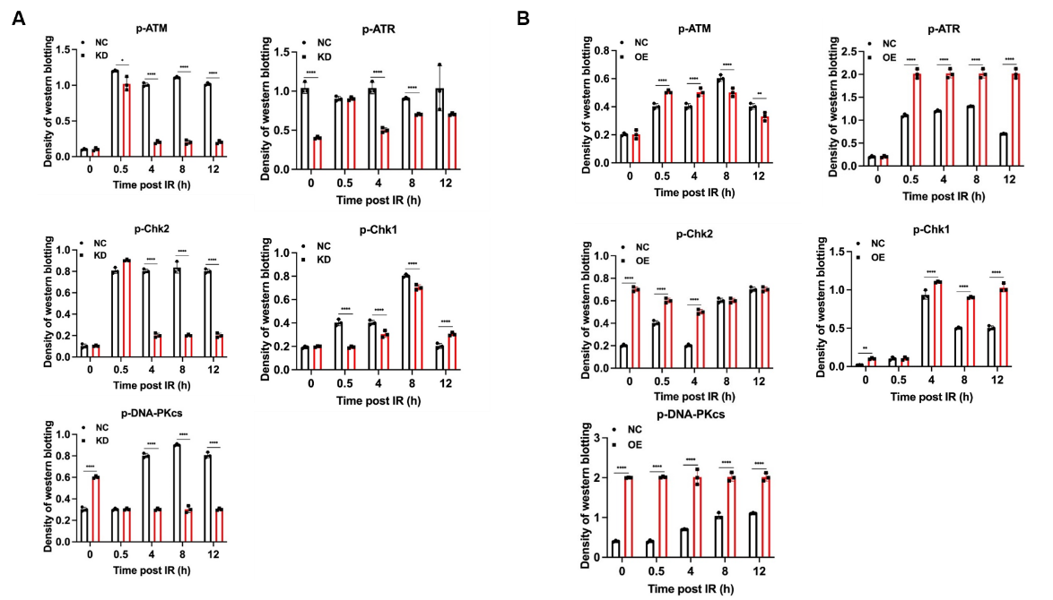
Supplementary Fig. 4 Quantitative analysis of raw density of Western blot of molecules in DNA damage response. (A) Quantitative analysis of raw density of Western blot of PRDM15-NC and PRDM15-KD after IR at different time points. (B) Quantitative analysis of raw density of Western blot of PRDM15-NC and PRDM15-OE after IR at different time points.
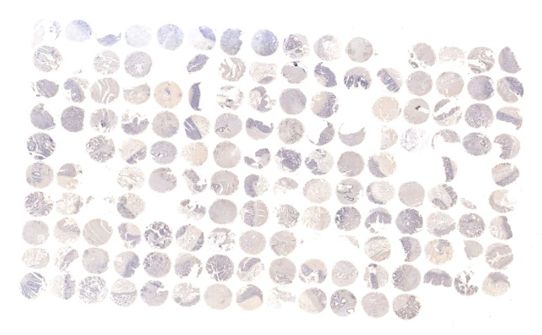
Supplementary Fig. 5 Scanned image of tissues microarray including CRC patients classified with radiosensitivity by TRG score.

Supplementary Tables
Supplementary Table 1

Supplementary Table 2

Supplementary Table 3

Supplementary Table 4

Table S4. The H-score of each sample in the tissue microarray
Number | TRG | H score
A01 | 2 | 82.154
A02 | 2 | 34.808
A03 | 0 | 15.498
A04 | 0 | 25.851
A05 | 3 | 14.889
A06 | 3 | 9.908
A07 | not found | 7.668
A08 | not found | 0
A09 | 3 | 0
A10 | 3 | 0.261
A11 | 3 | 7.956
A12 | 3 | unable to detect
A13 | 2 | 63.69
A14 | 2 | 164.948
A15 | 3 | 252.745
A16 | 3 | unable to detect
B01 | 3 | 174.479
B02 | 3 | unable to detect
B03 | 0 | 83.18
B04 | 0 | 68.266
B05 | 3 | unable to detect
B06 | 3 | 20
B07 | 2 | 98.689
B08 | 2 | 67.114
B09 | 3 | 34.088
B10 | 3 | 10.217
B11 | 2 | 47.695
B12 | 2 | 38.652
B13 | 3 | 111.439
B14 | 3 | 165.126
B15 | 3 | 119.4
B16 | 3 | 75.332
C01 | 3 | 71.005
C02 | 3 | 70.136
C03 | 1 | 107.326
C04 | 1 | 87.451
C05 | 3 | 132.919
C06 | 3 | 30.515
C07 | 3 | 87.859
C08 | 3 | 145.1
C09 | 3 | 76.586
C10 | 3 | 52.505
C11 | 3 | unable to detect
C12 | 3 | 90.783
C13 | 1 | 139.452
C14 | 1 | 198.601
C15 | 0 | 151.356
C16 | 0 | 83.96
D01 | 1 | 50.807
D02 | 1 | 69.296
D03 | 3 | 123.216
D04 | 3 | 157.572
D05 | 3 | 137.327
D06 | 3 | 79.72
D07 | 2 | 97.799
D08 | 2 | 105.325
D09 | not found | 202.705
D10 | not found | 114.981
D11 | 1 | 110.663
D12 | 1 | 117.235
D13 | 2 | 21.714
D14 | 2 | 219.198
D15 | 1 | 167.663
D16 | 1 | 116.983
E01 | 1 | 73.281
E02 | 1 | unable to detect
E03 | 2 | 235.605
E04 | 2 | 149.498
E05 | 2 | 154.597
E06 | 2 | 202.062
E07 | 2 | 135.561
E08 | 2 | 111.147
E09 | 1 | 126.462
E10 | 1 | 139.881
E11 | 2 | 186.379
E12 | 2 | 109.326
E13 | 0 | unable to detect
E14 | 0 | 132.97
E15 | 1 | unable to detect
E16 | 1 | 95.76
F01 | 2 | 106.97
F02 | 2 | 141.565
F03 | 1 | unable to detect
F04 | 1 | 183.217
F05 | 0 | 84.731
F06 | 0 | 142.763
F07 | 3 | 181.47
F08 | 3 | 140.791
F09 | 1 | 165.674
F10 | 1 | 192.651
F11 | 2 | 207.063
F12 | 2 | 162.073
F13 | 2 | 152.136
F14 | 2 | 228.397
F15 | 1 | 219.139
F16 | 1 | 194.7
G01 | 2 | 183.929
G02 | 2 | 192.297
G03 | 1 | 201.304
G04 | 1 | 153.499
G05 | 2 | unable to detect
G06 | 2 | 106.257
G07 | 1 | 103.25
G08 | 1 | 146.544
G09 | 2 | 166.053
G10 | 2 | 157.746
G11 | 2 | 146.118
G12 | 2 | 130.877
G13 | 2 | 184.044
G14 | 2 | 157.177
G15 | 3 | 235.514
G16 | 3 | 167.368
H01 | 2 | 178.451
H02 | 2 | 174.938
H03 | 2 | 116.28
H04 | 2 | 92.409
H05 | 3 | 120.84
H06 | 3 | 107.785
H07 | 2 | 158.254
H08 | 2 | 136.23
H09 | 2 | 133.801
H10 | 2 | unable to detect
H11 | 0 | unable to detect
H12 | 0 | 179.762
H13 | 1 | 138.589
H14 | 1 | 196.638
H15 | 0 | 242.857
H16 | 0 | 221.931
I01 | 2 | 200.309
I02 | 2 | 192.551
I03 | 2 | 95.365
I04 | 2 | 71.869
I05 | 2 | 115.003
I06 | 2 | 136.151
I07 | 2 | 138.39
I08 | 2 | 149.162
I09 | 3 | 166.192
I10 | 3 | 126.299
I11 | 1 | 109.224
I12 | 1 | 105.473
I13 | 3 | 155.664
I14 | 3 | 111.037
I15 | 3 | 236.162
I16 | 3 | 210.47
J01 | 0 | 192.011
J02 | 0 | 170
J03 | 2 | 218.595
J04 | 2 | 154.693
J05 | 2 | 104.443
J06 | 2 | 139.091
J07 | 3 | 103.983
J08 | 3 | 127.55
J09 | 1 | 167.763
J10 | 1 | 136.751
J11 | not found | 153.377
J12 | not found | 106.075
J13 | 2 | 151.035

