Figure S1. PCR amplified products of polyamine metabolic pathway genes identified in barley.

Figure S2. Constructions of conserved motifs on the multiple sequence alignments (MSAs) of CuAOs from barley (Hv), Arabidopsis (At), rice (Os) and maize (Zm) plants. The conserved motifs are presented in black boxes on the consensus sequence, and the predicted secondary structure elements are presented below the MSAs in red and green color as alpha-helix and beta sheet, respectively.

Figure S3. Constructions of conserved motifs on the multiple sequence alignments (MSAs) of PAOs from barley (Hv), Arabidopsis (At), rice (Os) and maize (Zm) plants. The conserved motifs are presented in black boxes on the consensus sequence, and the predicted secondary structure elements are presented below the MSAs in red and green color as alpha-helix and beta sheet, respectively.

Figure S4. Constructions of conserved motifs on the multiple sequence alignments (MSAs) of SAMDCs from barley (Hv), Arabidopsis (At), rice (Os) and maize (Zm) plants. The conserved motifs are presented in black boxes on the consensus sequence, and the predicted secondary structure elements are presented below the MSAs in red and green color as alpha-helix and beta sheet, respectively.
Figure S5. Constructions of conserved motifs on the multiple sequence alignments (MSAs) of SPDSs/SPMSs from barley (Hv), Arabidopsis (At), rice (Os) and maize (Zm) plants. The conserved motifs are presented in black boxes on the consensus sequence, and the predicted secondary structure elements are presented below the MSAs in red and green color as alpha-helix and beta sheet, respectively.

Figure S6. Constructions of conserved motifs on the multiple sequence alignments (MSAs) of ODCs/ADCs from barley (Hv), Arabidopsis (At), rice (Os) and maize (Zm) plants. The conserved motifs are presented in black boxes on the consensus sequence, and the predicted secondary structure elements are presented below the MSAs in red and green color as alpha-helix and beta sheet, respectively.
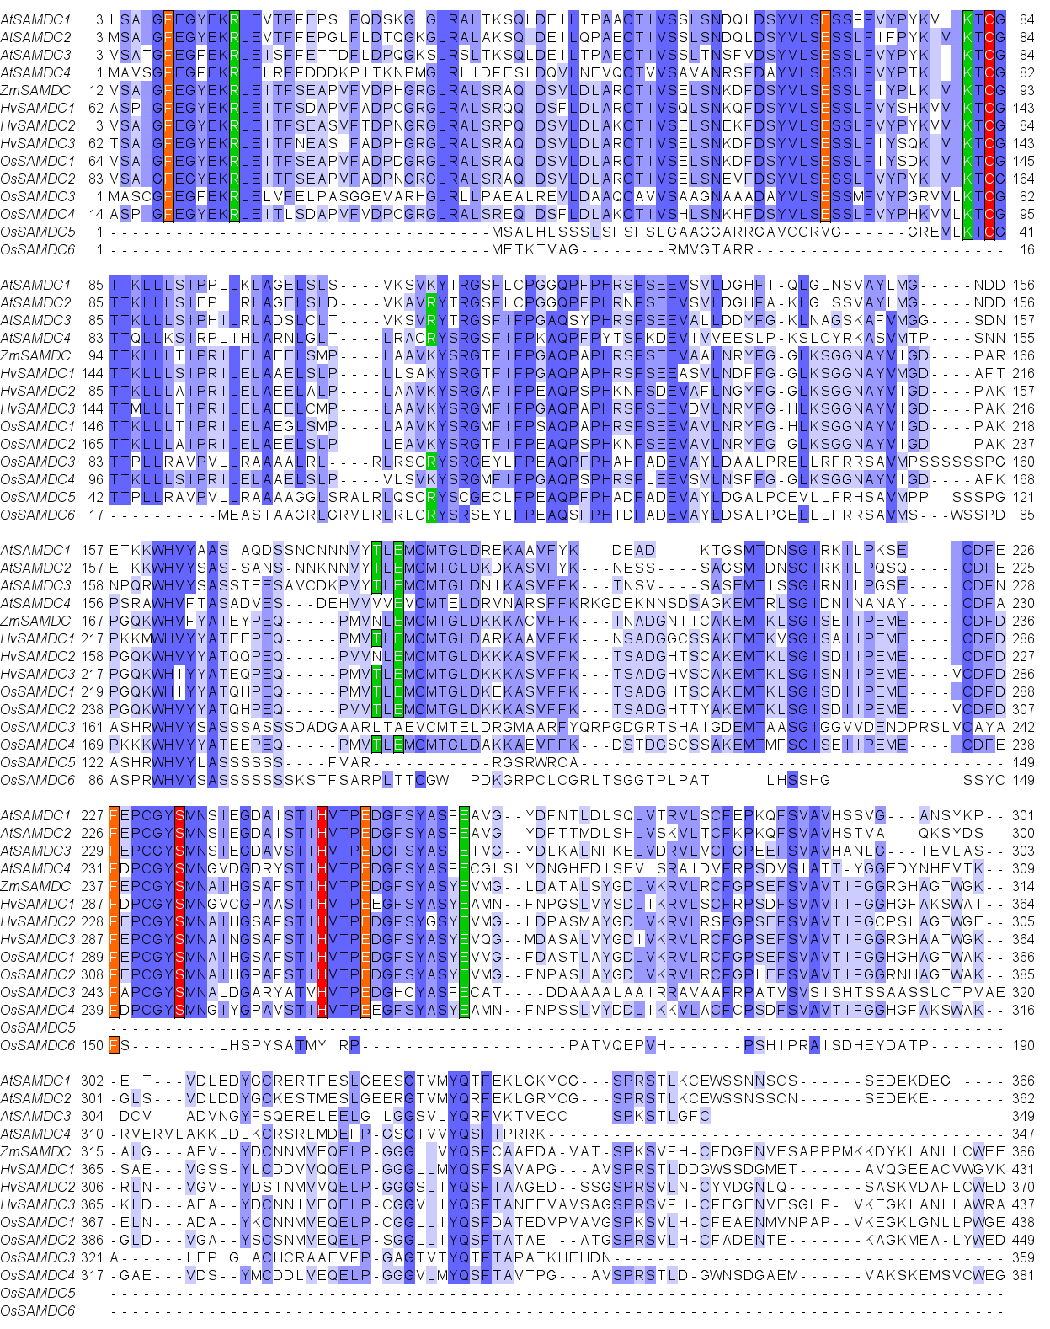
Figure S7. Multiple sequence alignment of HvSAMDCs with Arabidopsis (At), rice (Os) and maize (Zm) SAMDCs showing structurally conserved residues. The alignment was performed by the ClustalW software and exhibited by the Jalview software. Blue color indicates the complete and partial homology of the amino acid sequences. The highlighted residues srepresent: His249, Cys87, Ser236 for Processing (Red color); Glu253, Phe230, Phe12, Glu72 for Substrate binding (Orange color); and Arg18, Arg114, Glu185, Glu262, Glu20, Thr183, Lys85 for Buried charge site (Green color).

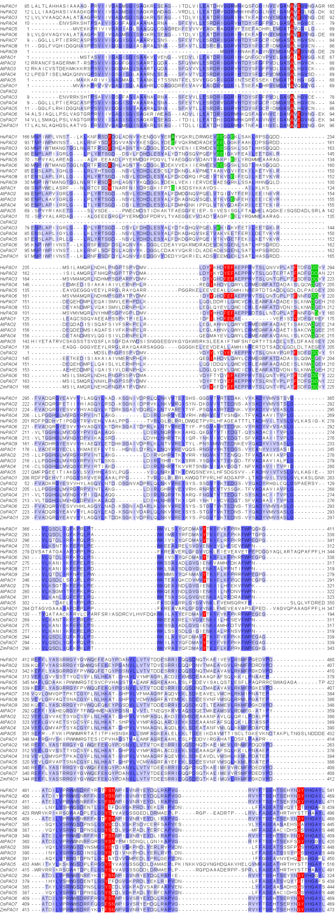
Figure S8. Multiple sequence alignment of HvPAOs with Arabidopsis (At), rice (Os) and maize (Zm) PAOs showing structurally conserved residues. The alignment was performed by the ClustalW software and exhibited by the Jalview software. Blue color indicates the complete and partial homology of the amino acid sequences. Residues organizing the catalytic U-tunnel are in bold letters, those putatively involved in the catalytic activity are indicated in red, and those composing the tunnel entrance (carboxylate ring and aromatic portion) are labelled in green (74).

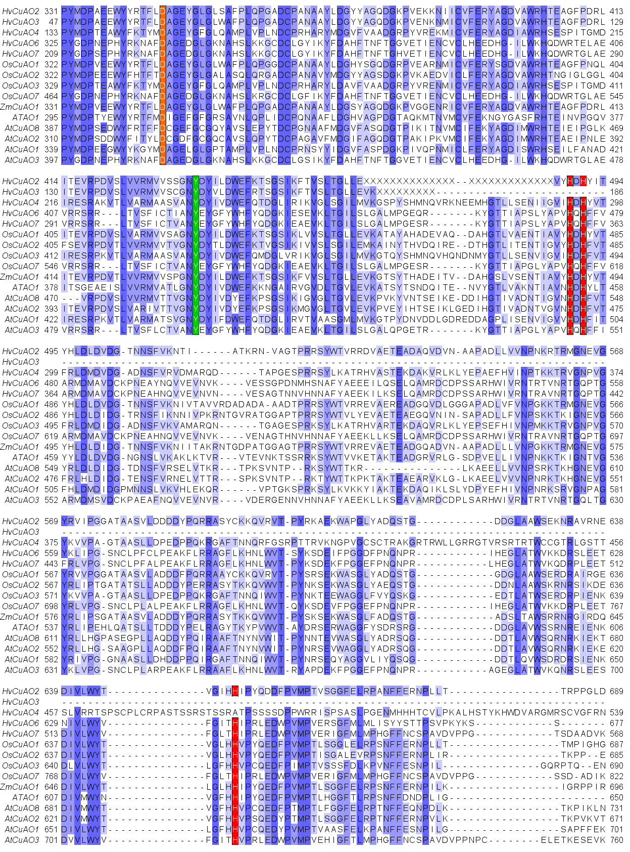
Figure S9. Multiple sequence alignment of HvCuAOs with Arabidopsis (At), rice (Os) and maize (Zm) CuAOs showing structurally conserved residues. The alignment was performed by the ClustalW software and exhibited by the Jalview software. Blue color indicates the complete and partial homology of the amino acid sequences. The copper binding histidine residues and the tyrosine modified to TPQ are marked in red and green, respectivelly. The aspartic acid active site base is indicated by orange (84).
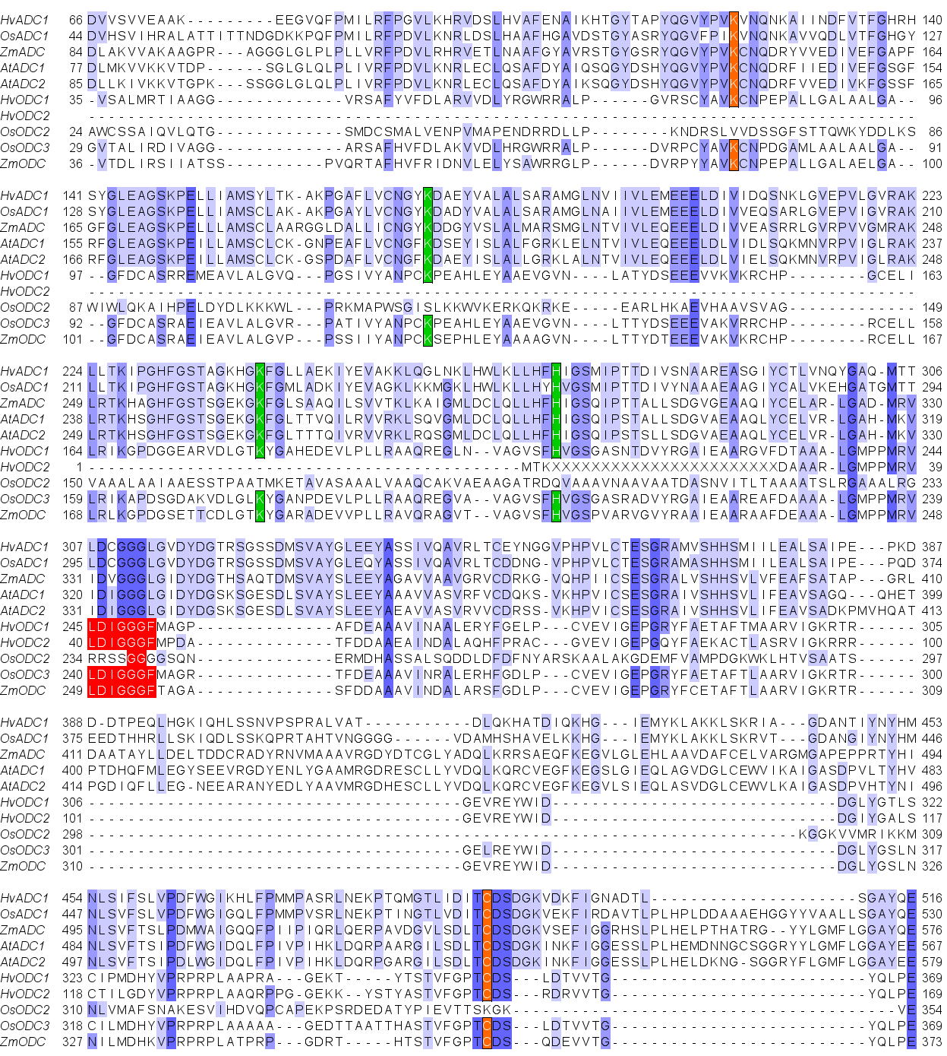
Figure S10. Multiple sequence alignment of HvODCs and HvADCs with Arabidopsis (At), rice (Os) and maize (Zm) ODCs and ADCs, respectively, showing structurally conserved residues. The alignment was performed by the ClustalW software and exhibited by the Jalview software. Blue color indicates the complete and partial homology of the amino acid sequences. Residues Lys69 and Cys360 of mouse ODC that have been found to participate in binding of the cofactor PLP and a specific inhibitor DFMO of ODC, respectively, are marked in orange. Green marks the residues Lys115, Lys169 and His197 of mouse ODC that have been shown to participate in active site formation. The motifs in ODC proteins, showing resemblance to conserved sequence motifs in methyltransferases and spermidine synthases, are marked in red (85).

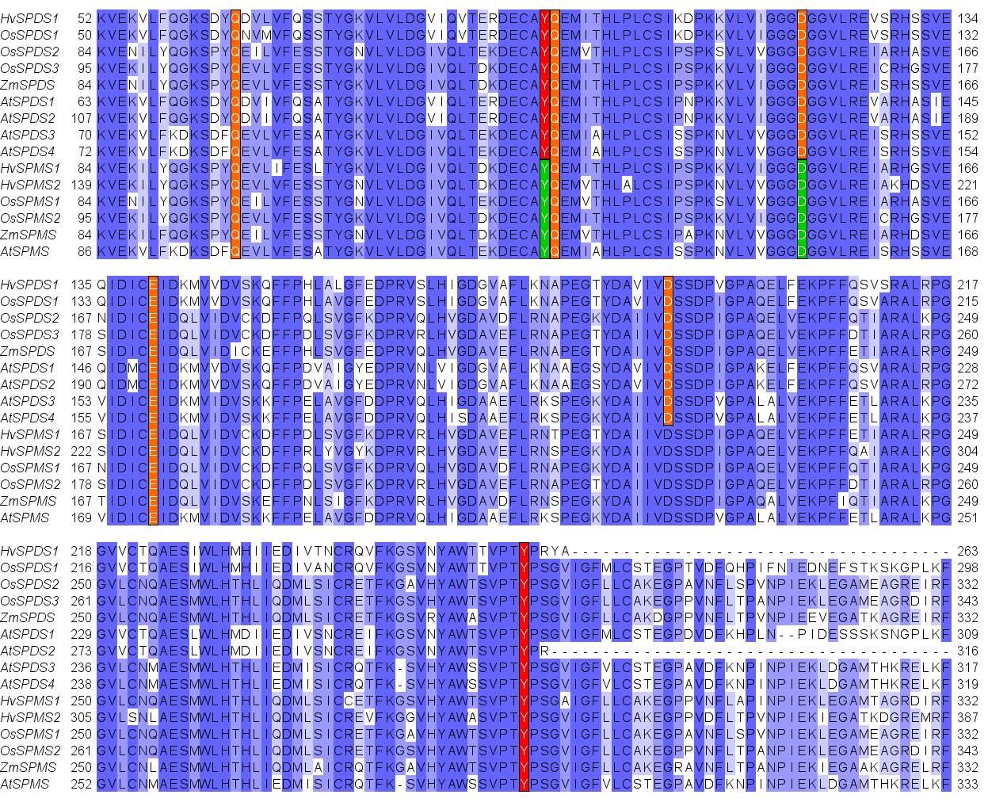
Figure S11. Multiple sequence alignment of HvSPMS/SPDS with Arabidopsis (At), rice (Os) and maize (Zm) SPMS/SPDS showing structurally conserved residues. The alignment was performed by the ClustalW software and exhibited by the Jalview software. Blue color indicates the complete and partial homology of the amino acid sequences. The colored residues indicates the catalytic active site residues (https://www.uniprot.org/).
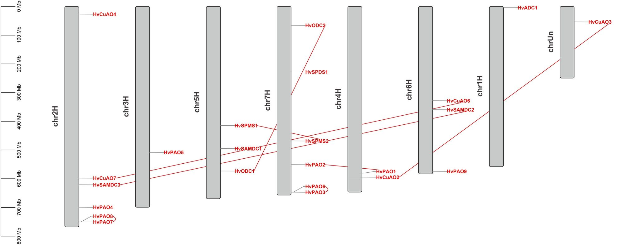
Figure S12. Chromosomal location and duplication of polyamine metabolic pathway genes in barley

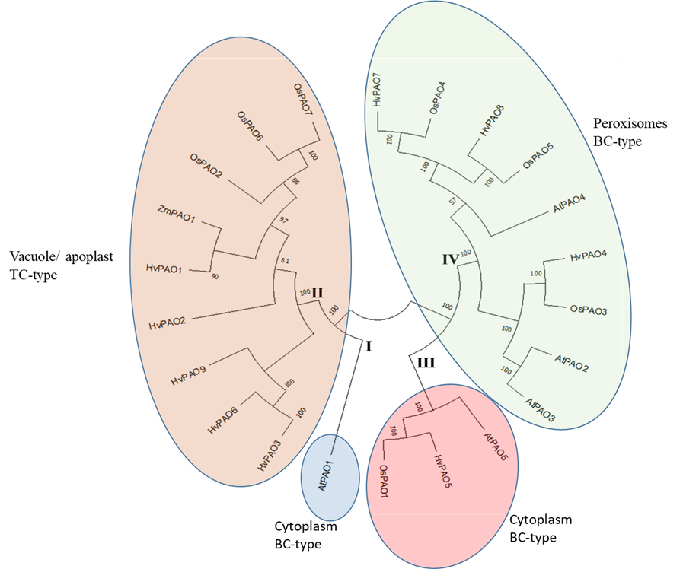
Figure S13. Phylogenetic relationships of PAOs in barley, Arabidopsis, maize and rice plants. The Neighbor-Joining tree was built by alignment of the amino acid sequences using clustal W in MEGA-11. Bootstrap values, obtained with 1000 replicates, are indicated at the nodes. Roman letters (I-IV) indicate the clades.

