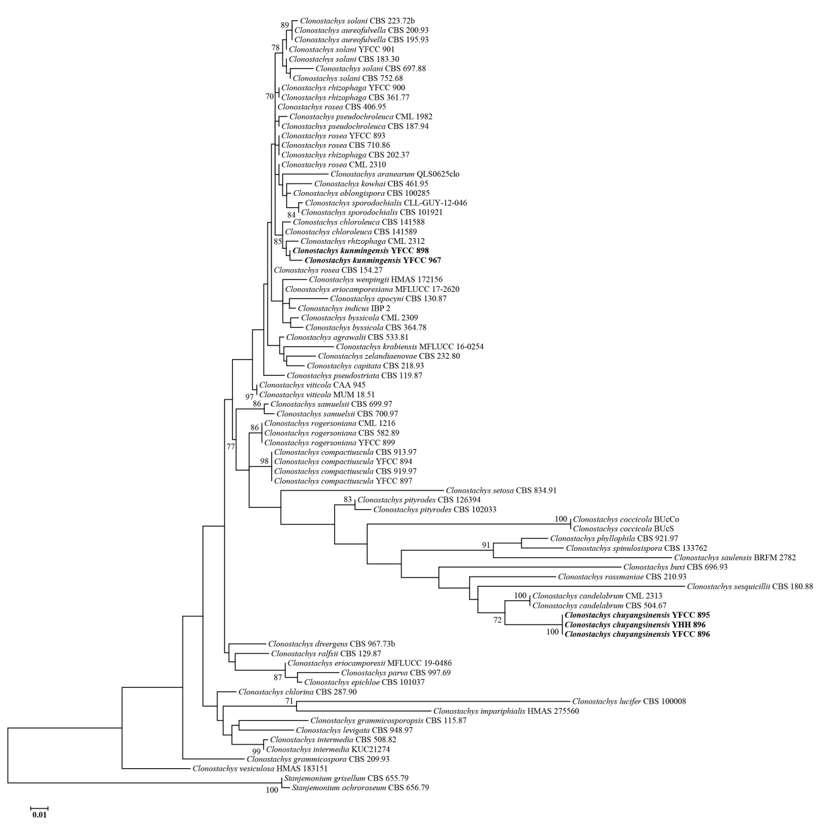
Fig. S1 Phylogenetic tree of Clonostachys based on Maximum Likelihood (ML) analysis from the ITS sequences. Statistical support values (≥70%) are shown at the nodes for ML boostrap support

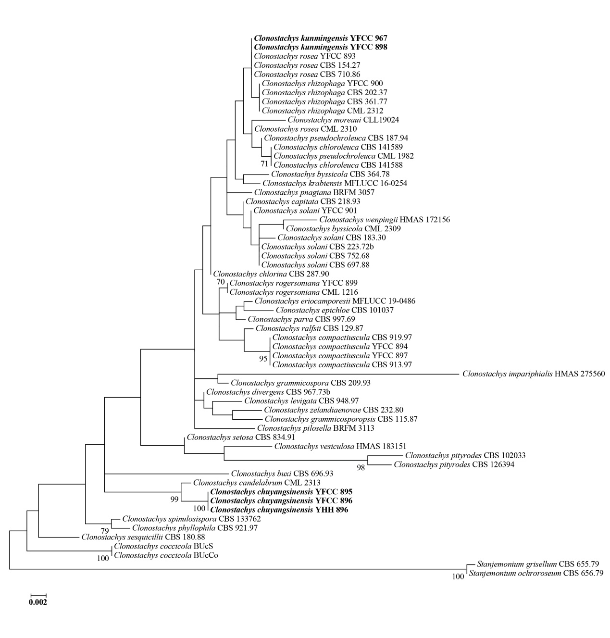
Fig. S2 Phylogenetic tree of Clonostachys based on Maximum Likelihood (ML) analysis from the nrLSU sequences. Statistical support values (≥70%) are shown at the nodes for ML boostrap support

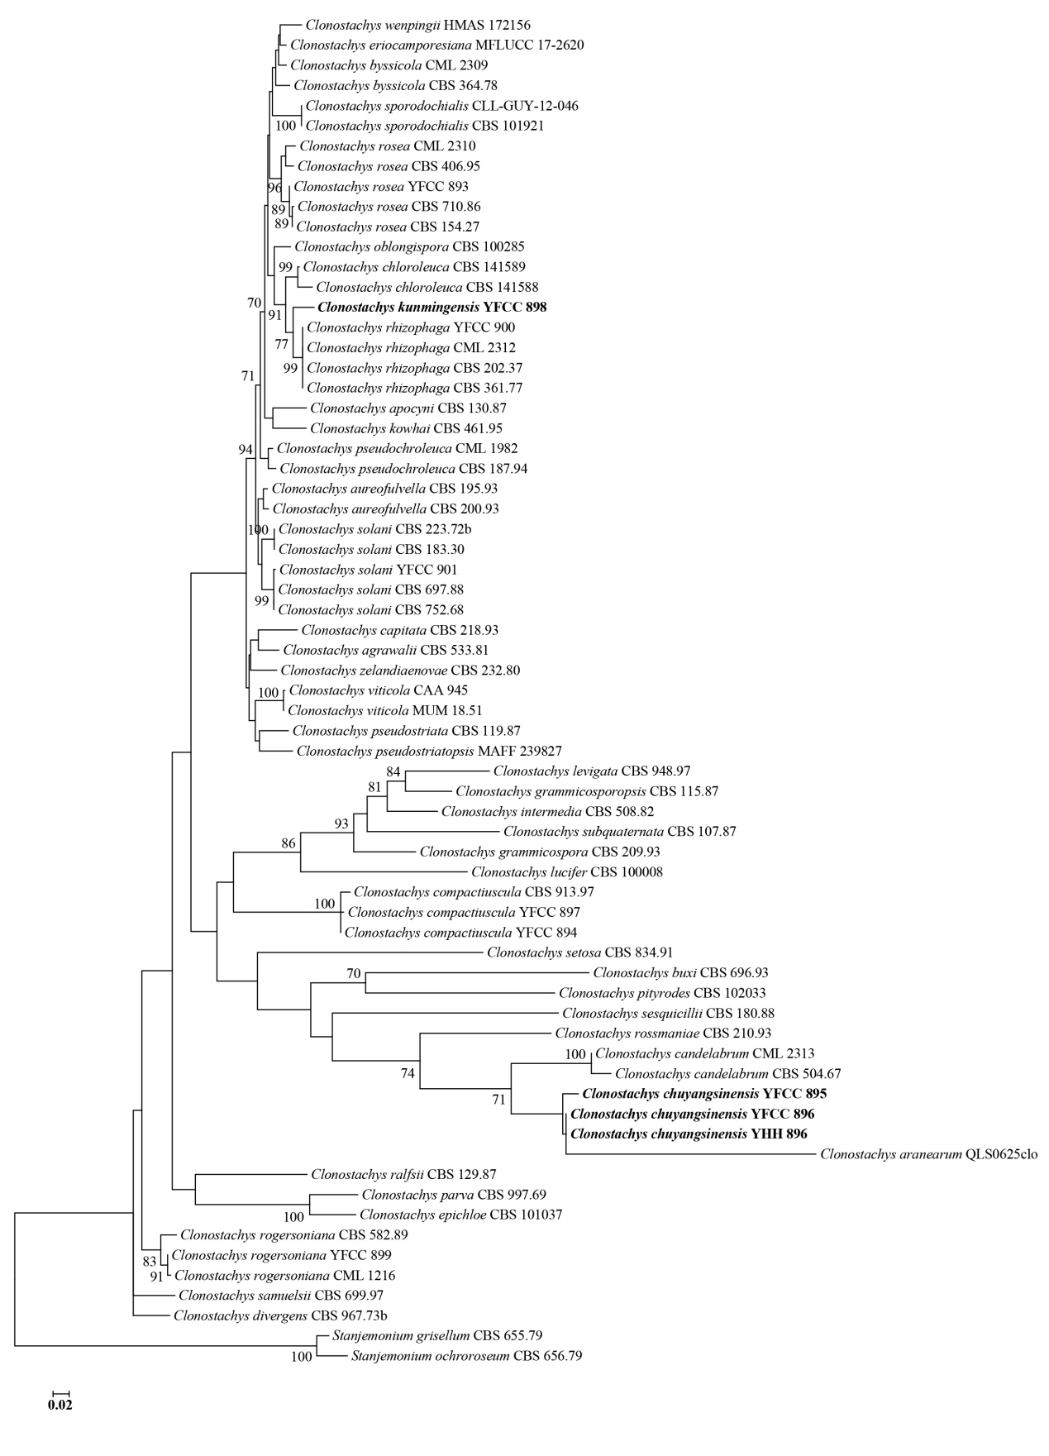
Fig. S3 Phylogenetic tree of Clonostachys based on Maximum Likelihood (ML) analysis from the TUB2 sequences. Statistical support values (≥70%) are shown at the nodes for ML boostrap support

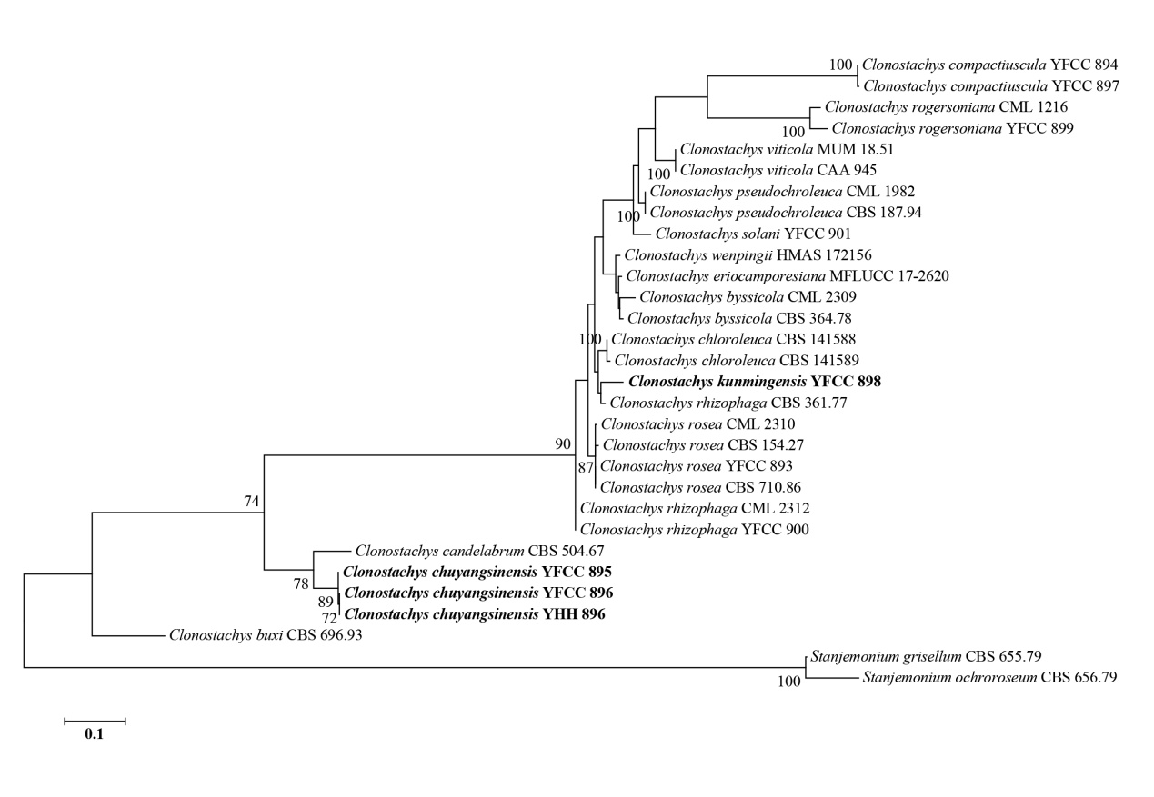
Fig. S4 Phylogenetic tree of Clonostachys based on Maximum Likelihood (ML) analysis from the TEF1 sequences. Statistical support values (≥70%) are shown at the nodes for ML boostrap support

