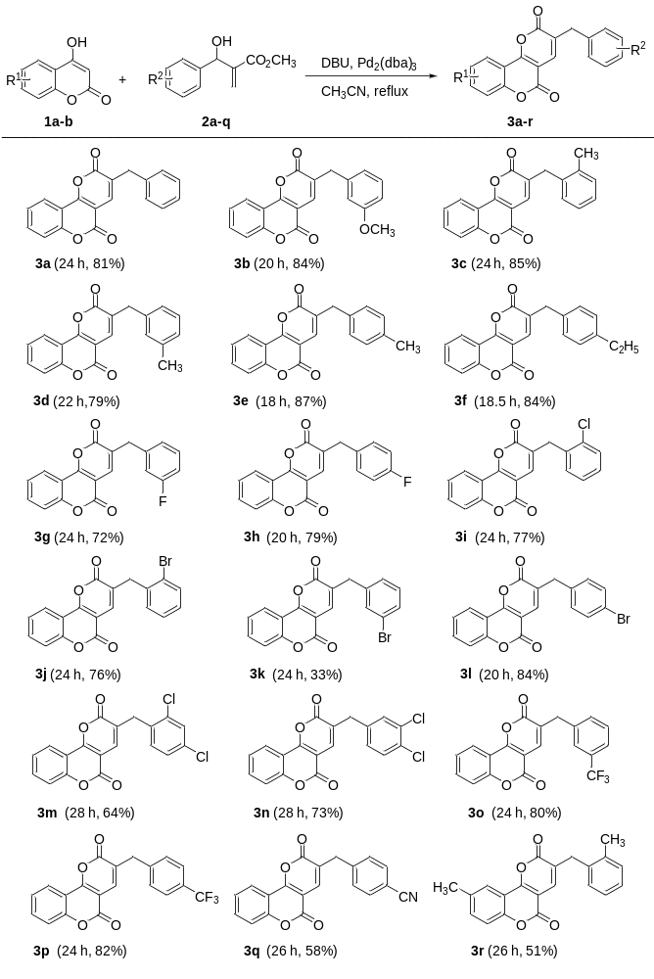Table 1 Synthesis of 3-benzylpyrano[3,2-c]chromene-2,5-diones 3a-r^{a,b}

ªReaction conditions: 1a (1.0 equiv.), 2a (1.0 equiv.), DBU (4.0 equiv), ^{b}Isolated yields.

Table 2 Synthesis of 3-benzylpyrano[3,2-c]chromene-2,5-diones 3s-x^{a,b}
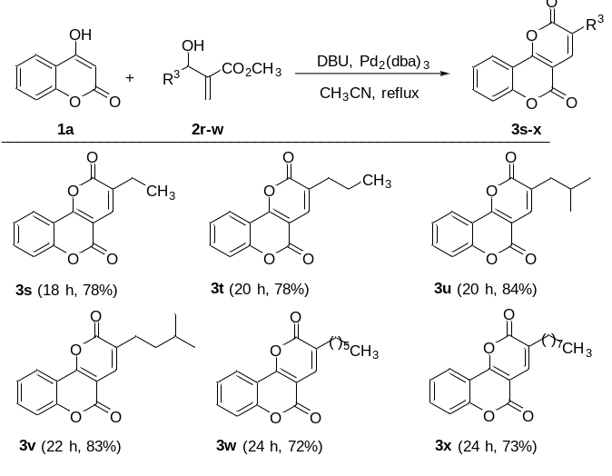

ªReaction conditions: 1a (1.0 equiv.), 2a (1.0 equiv.), DBU (4.0 equiv), ^{b}Isolated yields.

Table-3. Photophysical, electrochemical, and band gap calculations of pyranochromene-dione derivatives 3a-x.
Compound | λ_{max} nm  (log ɛ, M⁻¹cm⁻¹)ª | λ_{em}  nm^{b} | τ, ns (A%)^{c} | E₀₋₀ (eV)^{d} | E_{ox}  (V)e | E_{red}  (V)^{e} | HOMO  (eV)^{f} | LUMO  (eV)^{f} | Band gap (eV)^{g}
3a | 276 (4.80)  346 (5.03) | 406 | 3.10 (100) | 3.200 | 1.77 | -1.64 | -6.429 | -2.303 | 4.126
3b | 275 (4.80)  347 (5.01) | 406 | 1.08(45)  6.50 (55) | 3.204 | 1.76 | -1.60 | -6.012 | -2.252 | 3.760
3c | 275 (4.66)  346 (4.92) | 371  485 | 0.89 (21)  2.74 (59)  9.59 (21) | 3.246 | 1.72 | -1.58 | -6.440 | -2.317 | 4.123
3d | 276 (4.92)  348 (5.18) | 376  477 | 2.12(61)  5.13 (39) | 3.258 | 1.78 | -1.59 | -6.189 | -2.854 | 3.335
3e | 274 (4.81)  347 (5.10) | 373  491 | 3.09 (45)  0.84 (25)  9.90 (30) | 3.241 | 1.78 | -1.60 | -6.4 | -2.276 | 4.124
3f | 273 (4.88)  349 (5.15) | 376  475 | 2.01 (76)  9.09 (24) | 3.247 | 1.77 | -1.61 | -6.402 | -2.278 | 4.124
3g | 276 (4.62)  346 (5.04) | 373  483 | 2.74 (83)  7.29 (17) | 3.254 | 1.79 | -1.54 | -6.498 | -2.373 | 4.125
3h | 277 (4.71)  343 (4.95) | 370  498 | 0.97 (17)  3.14 (62)  1.00 (21) | 3.246 | 1.75 | -1.56 | -6.501 | -2.37 | 4.131
3i | 276 (4.90)  347 (5.18) | 375  475 | 2.74 (83)  7.04 (17) | 3.252 | 1.78 | -1.58 | -6.464 | -2.33 | 4.137
3j | 277 (4.81)  348 (5.04) | 375  480 | 2.73 (79)  7.33 (21) | 3.248 | 1.77 | -1.54 | -6.441 | -2.309 | 4.132
3k | 276 (4.69)  347 (4.83) | 417 | 3.34 (100) | 3.201 | 1.80 | -1.53 | -6.501 | -2.38 | 4.121
3l | 273 (4.85)  348 (5.13) | 417 | 2.06 (55)  5.29 (45) | 3.200 | 1.80 | -1.55 | -6.517 | -2.385 | 4.132
3m | 275 (4.64)  347 (4.94) | 375  478 | 2.26 (64)  6.89 (36) | 3.250 | 1.78 | -1.56 | -6.568 | -2.434 | 4.138
3n | 276 (4.63)  348 (4.91) | 373  497 | 2.29 (65)  7.10 (35) | 3.249 | 1.79 | -1.51 | -6.643 | -2.509 | 4.134
3o | 271 (4.95)  347 (5.02) | 382  466 | 2.82 (76)  4.77 (24) | 3.245 | 1.78 | -1.55 | -6.568 | -2.434 | 4.134
3p | 274 (4.87)  347 (5.09) | 376  473 | 2.83 (85)  7.33 (15) | 3.247 | 1.78 | -1.49 | -8.965 | -0.988 | 7.977
3q | 274 (4.64)  347 (4.88) | 371  491 | 0.88 (20)  3.16 (58)  9.73 (22) | 3.243 | 1.80 | -1.45 | -6.643 | -2.508 | 4.135
3r | 277 (4.92)  351 (5.18) | 379  472 | 1.85 (86)  7.40 (14) | 3.254 | 1.01 | -1.66 | -6.367 | -2.262 | 4.105
3s | 274 (4.76)  343 (5.00) | 370  480 | 2.14 (74)  7.60 (26) | 3.251 | 1.80 | -1.65 | -6.445 | -2.307 | 4.138
3t | 275 (4.87)  345 (5.12) | 373  476 | 2.51 (84)  7.51 (16) | 3.252 | 1.78 | -1.65 | -6.436 | -2.3 | 4.136
3u | 276 (4.95)  345 (5.17) | 374  477 | 2.54 (82)  7.07 (18) | 3.249 | 1.78 | -1.64 | -6.424 | -2.354 | 4.07
3v | 276 (4.87)  346 (5.13) | 371  479 | 2.37 (78)  7.41 (22) | 3.246 | 1.79 | -1.63 | -6.437 | -2.339 | 4.098
3w | 276 (4.84)  346 (4.06) | 373  474 | 2.86 (100) | 3.245 | 1.80 | -1.63 | -6.437 | -2.339 | 4.098
3x | 276 (4.84)  345 (5.10) | 376  470 | 2.50 (85)  7.06 (15) | 3.246 | 1.80 | -1.62 | -6.436 | -2.338 | 4.097
ªSolvent CH₂Cl₂. Error limits: λ_{max}, ±1 nm; log ε, ±10%. ^{b}Solvent Error limits: λex, ±2 nm; λem, ±1 nm. ^{c}All lifetimes are in nanoseconds (ns); Error limits of τ ∼10%. Values in parentheses are relative amplitudes of the corresponding decay components. ^{d}Singlet state energies as estimated by the intersection between the absorption and the emission spectra; Error limits: ±0.05. ^{e}CH₂Cl₂, 0.1 M TBAP. Glassy carbon working electrode; standard calomel electrode is reference electrode, Pt electrode is auxiliary electrode. Error limits, E1/2 ± 0.03 V. ^{f}HOMO and LUMO energy level calculations using the Gaussian 09 package with a functional basis set of the B3LYP/6-31G (d, p). ^{g}Band gap values calculated from the optimized dye structures using E_{HOMO}-E_{LUMO}.

