Near-Source Ground Motion Estimation for Assessing the Seismic Hazard of Critical Facilities in Central Italy
Luca Moratto, Marco Santulin, Alberto Tamaro, Angela Saraò, Alessandro Vuan, and Alessandro Rebez
National Institute of Oceanography and Applied Geophysics - O.G.S., Borgo Grotta Gigante 42/C, 34010 Sgonico (Trieste), Italy

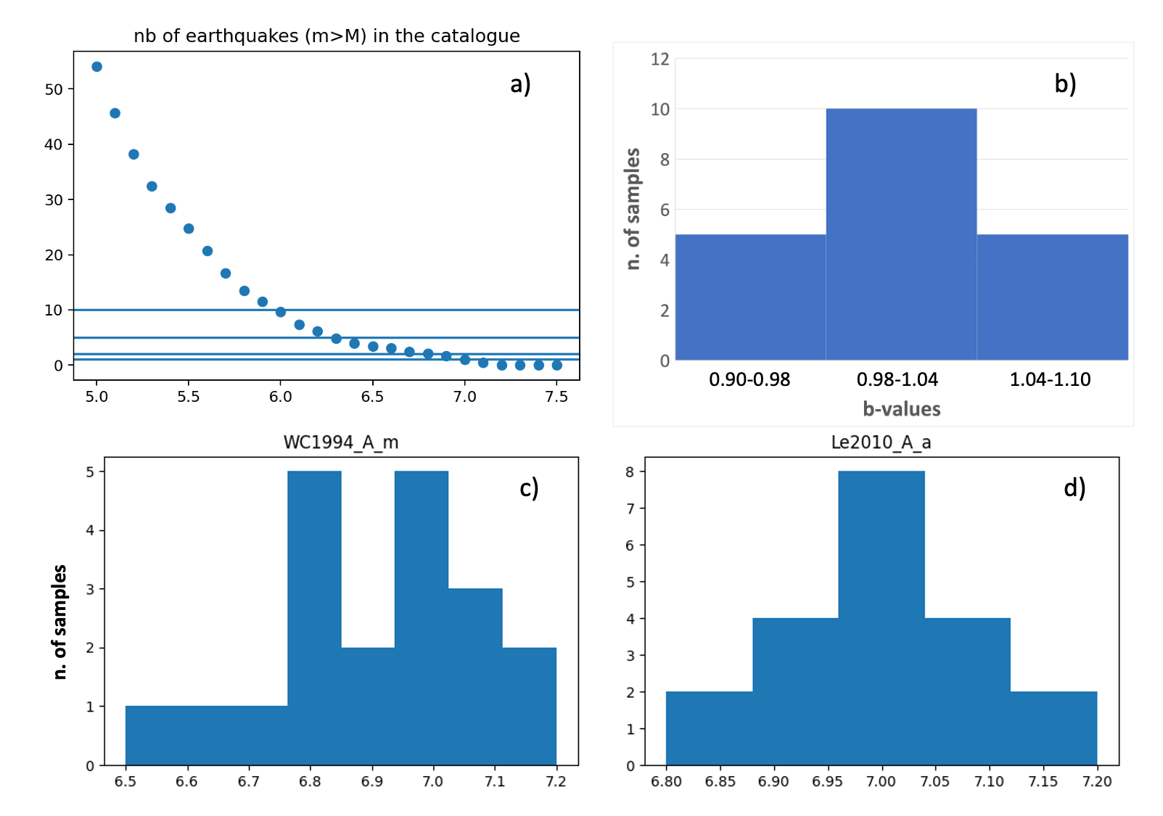
Fig. ES1 Main parameters to define the target MFD of the SHERIFS computation: a) background catalogue; b) the 20 random samples b-value distribution; c) and d) the distribution of the 20 random values of the Mmax, respectively for the Wells and Coppersmith (1994) and Leonard (2010) scaling laws.

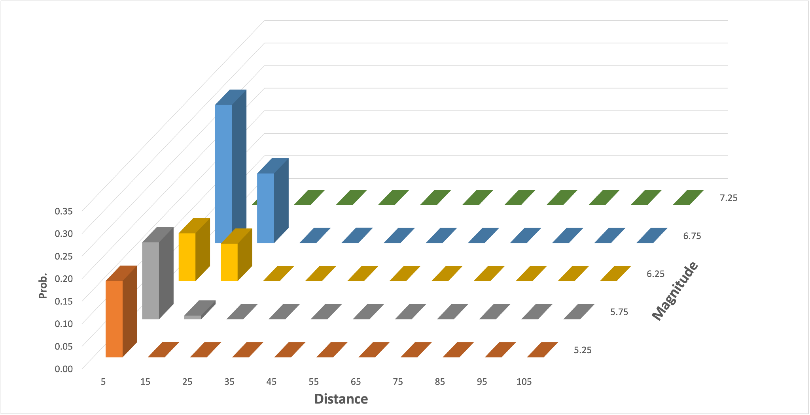a)
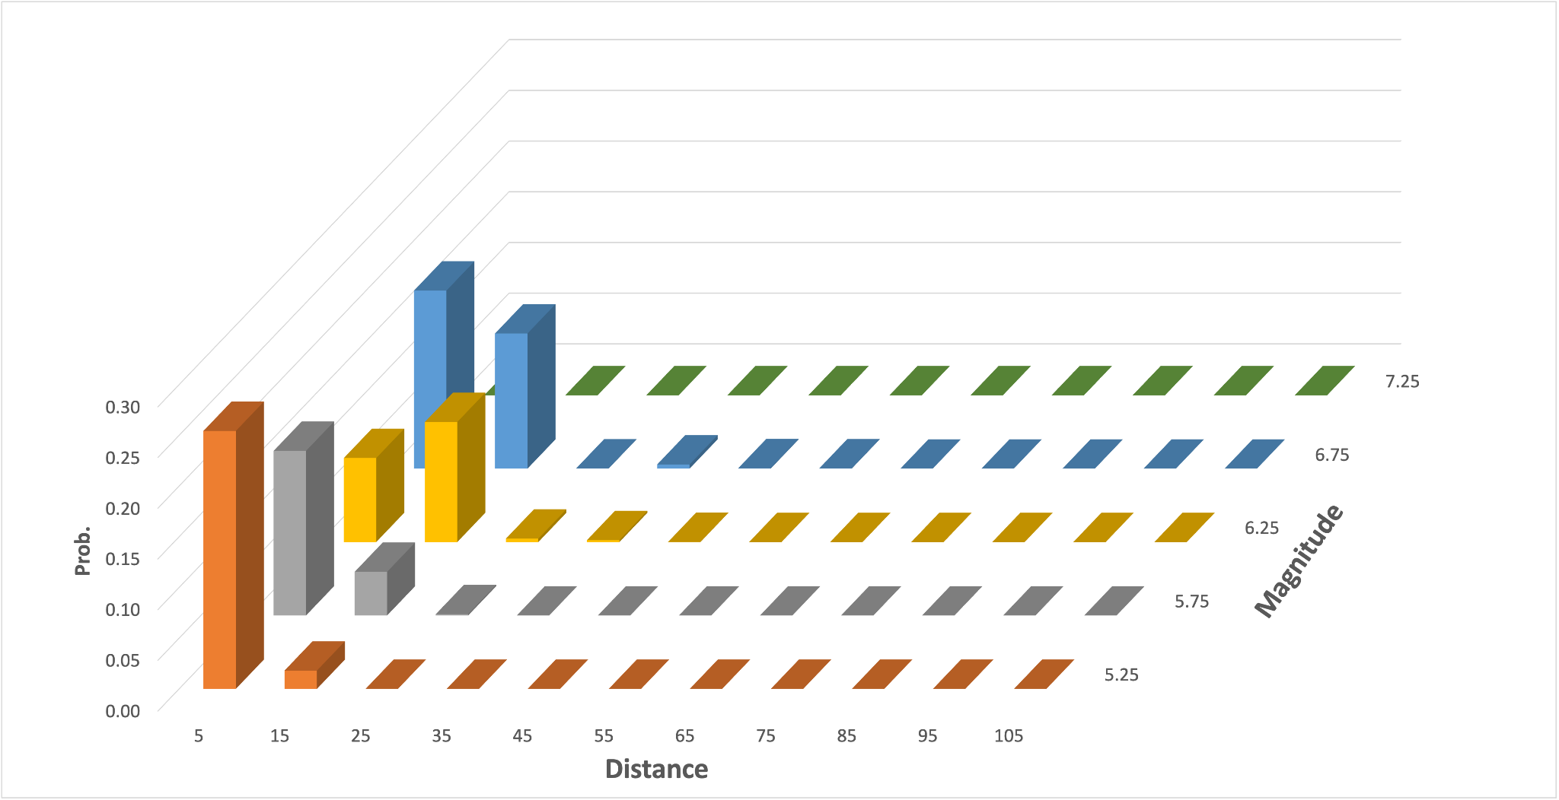b)
Fig. ES2 Disaggregation results for the Campotosto site, expressed in terms of magnitude-distance pair for: a) a 2475 years return period and b) a 475 years return period.

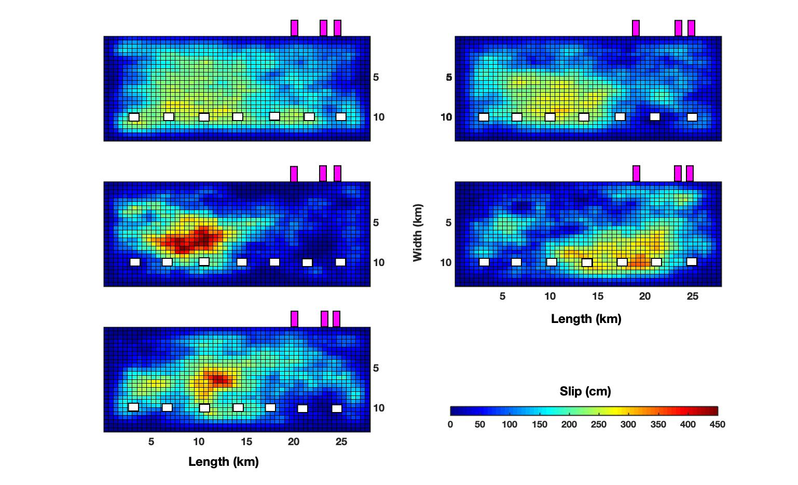
Fig. ES3 Slip distributions utilized in the simulations for the Campotosto receivers (magenta rectangles); white stairs indicate the positions of nucleation points on the rupture area.

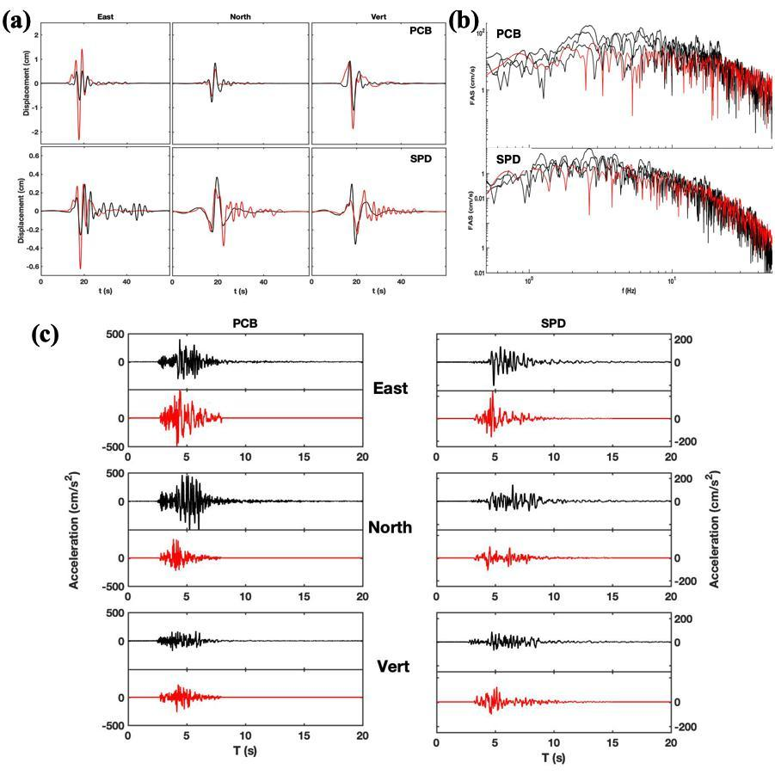
Fig. ES4 Comparison between recorded (black lines) and simulated waveforms (red lines) for the earthquake (M_{W}=5.6) occurred on 2017 January 18 at 10:14. (a) recorded vs deterministic displacement signals filtered between 0.08 and 0.5 Hz, (b) recorded vs stochastic accelerometric spectra, (c) recorded vs broadband simulated waveforms.
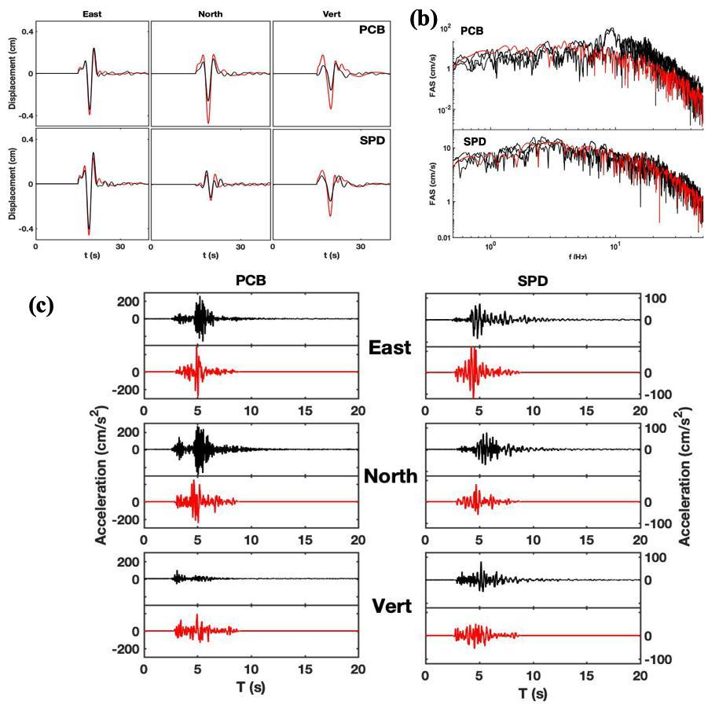
Fig. ES5 Comparison between recorded (black lines) and simulated waveforms (red lines) for the earthquake (M_{W}=5.1) occurred on 2017 January 18 at 13:33. (a) recorded vs deterministic displacement signals filtered between 0.08 and 0.5 Hz, (b) recorded vs stochastic accelerometric spectra, (c) recorded vs broadband simulated waveforms.

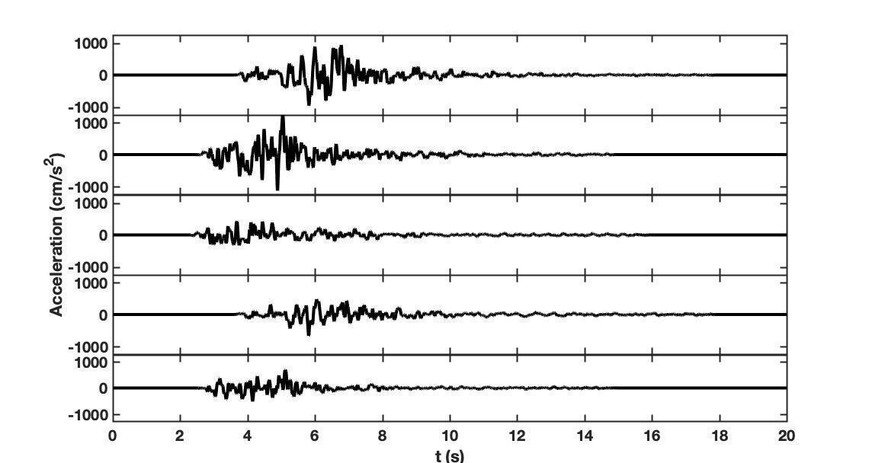
Fig. ES6 Examples of simulated accelerograms for the vertical component computed at PCB.

