Supplementary file 1
Table 6a: Serum Urea pattern among children suffering from acute uncomplicated malaria treated with pyronaridine-artesunate or artemether-lumefantrine in Ibadan Southwest Nigeria
Characteristics on study days | Serum urea level (mg/dl) in drug groups |  |  | ρ-value
Characteristics on study days | AL  n (%) | PA  n (%)] | Total  n (%) | ρ-value
Day 0
Mean (±sd) | 20.75±9.07 | 23.52±10.45 | 22.12±9.83 | 126
Range | 10 – 55 | 10 – 68 | 10 – 68
No with raised value | 3 | 3 | 6 | 1.000
No with ≥ 2ce ULN | NIL | NIL | NIL
Day 3
Mean (±sd) | 18.76±7.82 | 18.64±7.47 | 18.70±7.62 | 0.698
Range | 9 – 50 | 10 – 39 | 9 – 50
No with raised value | 1 | 0 | 1
No with ≥ 2ce ULN | NIL | NIL | NIL
Day 7
Mean (±sd) | 18.62±7.24 | 18.41±6.99 | 18.51±7.09 | 0.859
Range | 10 – 42 | 10 – 41 | 10 – 42
No with raised value | NIL | NIL | NIL
No with ≥ 2ce ULN | NIL | NIL | NIL
Day 28
Mean (±sd) | 19.21±7.20 | 18.53±7.6 | 16.87±7.38 | 0.527
Range | 8 - 57 | 9 - 52 | 8 - 57
No with raised value | 1 | 2 | 3 | 0.613
No with ≥ 2ce ULN | NIL | NIL | NIL
Normal laboratory range of serum Urea 15-45mg/dl Normal value

Table 6b: Serum Creatinine pattern among children suffering from acute uncomplicated malaria treated with pyronaridine-artesunate or artemether-lumefantrine in Ibadan Southwest Nigeria
Characteristics on study days | Serum creatinine level in mg/dl in drug groups |  |  | ρ-value
Characteristics on study days | AL  n (%) | PA  n (%)] | Total  n (%) | ρ-value
Day 0
Mean (±sd) | 0.72±0.29 | 0.79±0.30 | 0.754±0.30 | 0.107
Range | 0.1 – 2.0 | 3 – 2.0 | 1 – 2.0
No with raised value | 1 | 1 | 2 | 0.691
No with ≥ 2ce ULN | NIL | NIL | NIL | NIL
Day 3
Mean (±sd) | 0.64±0.21 | 0.65±0.23 | 0.64±0.22 | 0.985
Range | 0.3 – 1.8 | 0.3 – 1.5 | 0.2 – 1.8
No with raised value | 1 | 0 | 1 | 0.547
No with ≥ 2ce ULN | NIL | NIL | NIL
Day 7
Mean (±sd) | 0.64±0.21 | 0.64±0.23 | 0.64±0.22 | 0.886
Range | 0.3 – 1.3 | 0.3 – 1.5 | 0.3 – 1.5
No with raised value | NIL | NIL | NIL
No with ≥ 2ce ULN | NIL | NIL | NIL
Day 28
Mean (±sd) | 0.68±0.26 | 0.63±0.21 | 0.66±0.23 | 0.144
Range | 0.2 – 1.8 | 0.2 – 1.3 | 0.2 – 1.8
No with raised value | 1 | 0 | 1 | 0.368
No with ≥ 2ce ULN | NIL | NIL | NIL
Normal laboratory range of serum Creatinine level = 0.5 – 1.5 mg/dl

Table 6c: Serum Random Blood Glucose pattern among children suffering from acute uncomplicated malaria treated with pyronaridine-artesunate or artemether-lumefantrine in Ibadan Southwest Nigeria
Characteristics on study days | Serum blood sugar in mg/dl |  |  | ρ-value
Characteristics on study days | AL  n (%) | PA  n (%)] | Total  n (%) | ρ-value
Day 0
Mean (±sd) | 98.95±22.16 | 96.68±24.54 | 97.8±23.35 | 0.197
Range | 49 – 158 | 33 – 160 | 33 – 160
No with raised random serum blood sugar level | 4 | 5 | 9 | 0.342
No with ≥ 2ce ULN | NIL | NIL | NIL
Day 3
Mean (±sd) | 98.33±18.4 | 97.3±23.6 | 97.32±21.1 | 0.986
Range | 36 – 143 | 38 – 157 | 36 – 157
No with raised random serum blood sugar level | 0 | 2 | 2 | 0.217
No with ≥ 2ce ULN | NIL | NIL | NIL
Day 7
Mean (±sd) | 96.08±18.4 | 97.81±23.09 | 96.96±20.86 | 0.590
Range | 51 – 150 | 53 – 165 | 51 – 165
No with raised random serum blood sugar level | 3 | 6 | 9 | 0.623
No with ≥ 2ce ULN | NIL | NIL | NIL
Day 28
Mean (±sd) | 93.07±19.31 | 95.70±19.51 | 94.39±19.39 | 0.394
Range | 61- 144 | 56 – 159 | 56 – 159
No with raised random serum blood sugar level | 1 | 1 | 2 | 0.605
No with ≥ 2ce ULN | NIL | NIL | NIL | ---

Normal laboratory range of plasma random blood sugar = Normal – 60 – 140mg/dl

Table 6d: Serum Total Bilirubin pattern among children suffering from acute uncomplicated malaria treated with pyronaridine-artesunate or artemether-lumefantrine in Ibadan Southwest Nigeria
Characteristics on study days | Total Serum Bilirubin in mg/dl |  |  | ρ-value
Characteristics on study days | AL  n (%) | PA  n (%) | Total  n (%) | ρ-value
Day 0
Mean ±sd | 0.63 ± 0.27 | 0.63 ± 0.26 | 0.63±0.26 | 0.969
Range | 0.5 – 2.0 | 0.3 – 1.9 | 0.3 – 2.0
No with raised ALP | 1 | 3 | 4 | 0.369
ALP ≥ 2ce ULN | 1 | 0 | 1 | ---
Day 3
Mean ±sd | 0.62 ± 0.12 | 0.60 ± 0.17 | 0.61 ± 0.18 | 0.534
Range | 0.3 – 1.1 | 0.4 – 1.3 | 0.3 – 1.3
No with raised ALP | 1 | 2 | 3 | 1.000
ALP ≥ 2ce ULN | NIL | NIL | NIL | ---
Day 7
Mean ±sd | 0.60±0.21 | 0.58±0.19 | 0.59±0.20 | 0.511
Range | 0.3 – 1.3 | 2 – 1.4 | 0.2 – 1.4
No with raised ALP | 1 | 2 | 3 | 1.000
ALP ≥ 2ce ULN | NIL | NIL | NIL | ---
Day 28
Mean ±sd | 0.57±0.17 | 0.60±0.18 | 0.59±0.18 | 0.280
Range | 0.2 - 1.1 | 0.3 – 1.1 | 0.2 – 1.1
No with raised ALP | 1 | 3 | 4 | 0.367
ALP ≥ 2ce ULN | 0 | 1 | 1 | ---
Normal laboratory range of total serum bilirubin = 0.2 – 1.0mg/dl

Table 6e: Serum Conjugated Bilirubin pattern among children suffering from acute uncomplicated malaria treated with pyronaridine-artesunate or artemether-lumefantrine in Ibadan Southwest Nigeria
Characteristics on study days | Serum bilirubin conjugated level in mg/dl |  |  | ρ-value
Characteristics on study days | AL  n (%) | PA  n (%) | Total  n (%) | ρ-value
Day 0
Mean ±sd | 0.31±0.11 | 0.31±0.12 | 0.31±0.12 | 0.866
Range | 0.1 – 0.5 | 0.1 – 0.9 | 0.1 – 0.9
No with raised ALP | 7 | 9 | 16 | 0.794
ALP ≥ 2ce ULN | 0 | 1 | 1 | ---
Day 3
Mean ±sd | 0.30±0.10 | 0.29±0.11 | 0.30±0.11 | 0.532
Range | 0.1 – 0.6 | 0.1 – 0.8 | 0.1 – 0.8
No with raised ALP | 6 | 5 | 11 | 1.000
ALP ≥ 2ce ULN | 0 | 1 | 1 | ---
Day 7
Mean ±sd | 0.3±0.12 | 0.3±0.14 | 0.3±0.13 | 0.948
Range | 0.1 – 0.6 | 0.1 – 0.8 | 0.1 – 0.8
No with raised ALP | 12 | 10 | 22 | 0.820
ALP ≥ 2ce ULN | 0 | 1 | 1 | --
Day 28
Mean ±sd | 0.30±0.11 | 0.28±0.12 | 0.28±0.12 | 0.870
Range | 0.1 - 0.7 | 0.1 – 0.6 | 0.1 – 0.7
No with raised ALP | 5 | 9 | 14 | 0.278
ALP ≥ 2ce ULN | NIL | NIL | NIL | NIL
Normal laboratory range of serum conjugated bilirubin = 0 – 0.4/dl

Table 6f: Aspartate transaminase (AST) pattern among children suffering from acute uncomplicated malaria treated with pyronaridine-artesunate or artemether-lumefantrine in Ibadan Southwest Nigeria

Characteristics on study days | Serum level of AST in IU/L |  |  | ρ-value
Characteristics on study days | AL  n (%) | PA  n (%)] | Total  n (%) | ρ-value
Day 0
Mean ±sd | 22.21±8.04 | 20.98±11.58 | 21.59±10.00 | 0.419
Range | 7 – 44 | 5 – 92 | 5 – 92
No with raised ALP | 2 | 3 | 5 | 1.000
ALP ≥ 2ce ULN | 0 | 1 | 1 | --
Day 3
Mean ±sd | 22.39±8.55 | 20.94±11,96 | 21.53±10.02 | 0.208
Range | 7 – 75 | 7 – 46 | 7 – 75
No with raised ALP | 4 | 3 | 7 | 0.720
ALP ≥ 2ce ULN | 1 | 0 | 1
Day 7
Mean ±sd | 21.36±8.90 | 20.94±11.06 | 20.15±10.02 | 0.783
Range | 2 – 58 | 3 – 76 | 2 – 76
No with raised ALP | 3 | 4 | 7 | 1.000
ALP ≥ 2ce ULN | 0 | 1 | 1
Day 28
Mean ±sd | 22.46±10.27 | 18.95±6.59 | 20.70±8.78 | 0.011*
Range | 4 – 66 | 5 – 43 | 4 – 66
No with raised ALP | 5 | 1 | 6 | 0.211
ALP ≥ 2ce ULN | NIL | NIL | NIL | --
AST - aspartate Transaminases
Normal laboratory range of serum AST = 0 – 37 in IU/L

Table 6g: Alanine transaminase (ALT) pattern among children suffering from acute uncomplicated malaria treated with pyronaridine-artesunate or artemether-lumefantrine in Ibadan Southwest Nigeria
Characteristics on study days | Serum ALT in IU/L |  |  | ρ-value
Characteristics on study days | AL  n (%) | PA  n (%)] | Total  n (%) | ρ-value
Day 0
Mean ±sd | 19.95±7.65 | 20.55±14.18 | 20.25±11.38 | 0.734
Range | 4 – 40 | 3 – 97 | 3 – 97
No with raised ALP | 0 | 4 | 4 | 0.121
ALP ≥ 2ce ULN | NIL | 2 | 2 | NA
Day 3
Mean ±sd | 20.06±9.07 | 18.82 ±7.81 | 19.42±8.90 | 0.361
Range | 3 – 49 | 5 – 52 | 3 – 52
No with raised ALP | 3 | 1 | 4 | 0.621
ALP ≥ 2ce ULN | NIL | NIL | NIL | NIL
Day 7
Mean ±sd | 19.71±8.44 | 18.77±9.35 | 19.23+ 8.90 | 0.492
Range | 4 – 45 | 5 – 48 | 4 – 48
No with raised ALP | 1 | 4 | 5 | 0.019*
ALP ≥ 2ce ULN | NIL | NIL | NIL | NIL
Day 28
Mean ±sd | 20.00±8.92 | 17.21±5.67 | 18.60±7.58 | 0.019*
Range | 4 – 54 | 5 – 34 | 4 – 54
No with raised ALP | 1 | 0 | 1 | 1.000
ALP ≥ 2ce ULN | NIL | NIL | NIL | NIL
Normal laboratory range of serum ALT = 0 – 40 in IU/L

Table 6h: Alkaline phosphatase (ALP) pattern among children suffering from acute uncomplicated malaria treated with pyronaridine-artesunate or artemether-lumefantrine in Ibadan Southwest Nigeria

Characteristics on study days | Serum ALP in IU/L |  |  | ρ-value
Characteristics on study days | AL  n (%) | PA  n (%)] | Total  n (%) | ρ-value
Day 0
Mean ±sd | 68.85±10.85 | 67.03±14.61 | 67.69±12.80 | 0.504
Range | 48– 101 | 30 – 125 | 30 – 125
No with raised ALP | 0 | 2 | 2 | 0.497
ALP ≥ 2ce ULN | NIL | NIL | NIL | NIL
Day 3
Mean ±sd | 68.07±13.21 | 67.73±13.94 | 67.90±13.54 | 0.871
Range | 35 – 109 | 25 –128 | 25 –128
No with raised ALP | 2 | 2 | 4 | 0.601
ALP ≥ 2ce ULN | NIL | NIL | NIL | NIL
Day 7
Mean ±sd | 68.01±12.21 | 67.60±13.14 | 67.81+ 12.65 | 0.984
Range | 43 – 100 | 44 – 110 | 43 – 110
No with raised ALP | 0 | 2 | 2 | 0.497
ALP ≥ 2ce ULN | NIL | NIL | NIL | NIL
Day 28
Mean ±sd | 71.36±13.35 | 66.20±8.26 | 68.76±11.35 | 0.003
Range | 50 – 116 | 54 – 99 | 50 – 119
No with raised ALP | 1 | 0 | 1 | 0.497
ALP ≥ 2ce ULN | NIL | NIL | NIL | NIL

Normal laboratory range for serum ALP = 35 – 105 in IU/L

Table 7a: Post-Hoc Comparisons of mean serum urea between PA And AL treated groups by days of follow up among children with uncomplicated malaria in Ibadan, Southwest Nigeria.

Days of follow up | Mean difference | SE | t | ρ-value
Days 0 vs 3 | 3.461 | 0.659 | 5.256 | < 0.001
Days 0 vs 7 | 3.669 | 0.725 | 5.057 | < 0.001
Days 0 vs 28 | 3.056 | 0.889 | 3.438 | 0.005
Days 3 vs 7 | 0.208 | 0.534 | 0.389 | 1.000
Days 3 vs 28 | -0.405 | 0.757 | -0.535 | 1.000
Days 7 vs 28 | -0.613 | 0.619 | -0.991 | 1.000

Figure 4: Mean of Serum Urea of Participants in the PA and AL treated groups by days of follow up among children with uncomplicated malaria in Ibadan, Southwest Nigeria.
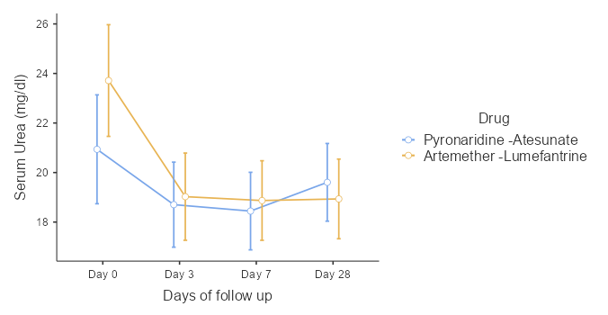

Table 7b: Post Hoc Comparisons of Serum Creatinine Mean Difference Between PA and AL treated groups by days of follow up among children with uncomplicated malaria in Ibadan, Southwest Nigeria.

Days of follow up | Mean Difference | SE | t | ρ-value
Days 0 vs 3 | 0.11665 | 0.0233 | 0.0233 | < 0.001
Days 0 vs 7 | 0.10967 | 0.0259 | 0.0259 | < 0.001
Days 0 vs 28 | 0.10420 | 0.0277 | 0.0277 | 0.001
Days 3 vs 7 | -0.00698 | 0.0210 | 0.0210 | 1.000
Days 3 vs 28 | -0.01244 | 0.0263 | 0.0263 | 1.000
Days 7 vs 28 | -0.00547 | 0.0215 | 0.0215 | 1.000

Figure 5: Mean of Serum Creatinine of Participants in the PA and AL treated groups by days of follow up among children with uncomplicated malaria in Ibadan, Southwest Nigeria.
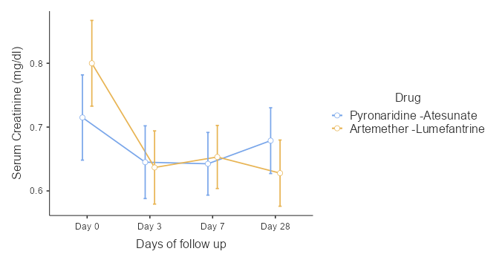

Table 7c: Post Hoc Comparisons of Blood Glucose Mean Difference Between PA and AL treated groups by days of follow up among children with uncomplicated malaria in Ibadan, Southwest Nigeria.
Days of follow up | Mean Difference | SE | t | ρ- value
Days 0 vs 3 | 0.02498 | 0.0187 | 1.333 | 1.000
Days 0 vs 7 | 0.04484 | 0.0209 | 2.149 | 0.199
Days 0 vs 28 | 0.04038 | 0.0201 | 2.004 | 0.280
Days 3 vs 7 | 0.01985 | 0.0183 | 1.087 | 1.000
Days 3 vs 28 | 0.01539 | 0.0154 | 0.999 | 1.000
Days 7 vs 28 | -0.00446 | 0.0172 | -0.259 | 1.000

Figure 6: Mean of Blood Glucose of Participants in the PA and AL treated Groups by days of follow up among children with uncomplicated malaria in Ibadan, Southwest Nigeria.

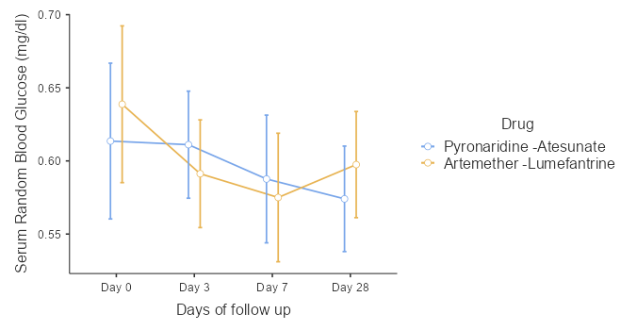

Table 7d: Post Hoc Comparisons of Serum total bilirubin mean difference between PA and AL treated groups by days of follow up among children with uncomplicated malaria in Ibadan, Southwest Nigeria.
Days of follow up | Mean Difference | SE | t | ρ- value
Days 0 vs 3 | 0.02498 | 0.0187 | 1.333 | 1.000
Days 0 vs 7 | 0.04484 | 0.0209 | 2.149 | 0.199
Days 0 vs 28 | 0.04038 | 0.0201 | 2.004 | 0.280
Days 3 vs 7 | 0.01985 | 0.0183 | 1.087 | 1.000
Days 3 vs 28 | 0.01539 | 0.0154 | 0.999 | 1.000
Days 7 vs 28 | -0.00446 | 0.0172 | -0.259 | 1.000

Figure 7: Mean of Serum Total Bilirubin of Participants in the PA and AL treated groups by days of follow up among children with uncomplicated malaria in Ibadan, Southwest Nigeria.
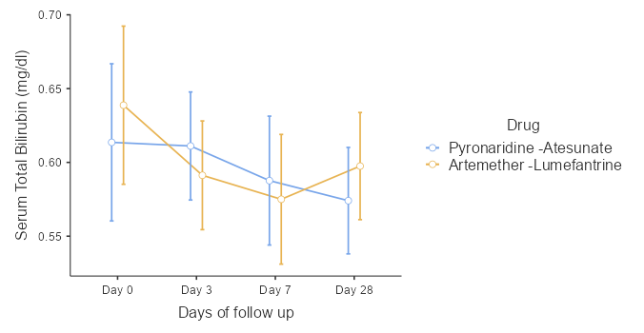

Table 7e: Post Hoc Comparisons of Serum Conjugated Bilirubin Mean Difference Between PA and AL treated groups by days of follow up among children with uncomplicated malaria in Ibadan, Southwest Nigeria.

Days of follow up | Mean Difference | SE | t | ρ- value
Days 0 vs 3 | 0.01258 | 0.00894 | 1.407 | 0.968
Days 0 vs 7 | 0.01624 | 0.01080 | 1.503 | 0.809
Days 0 vs 28 | 0.02073 | 0.01048 | 1.978 | 0.298
Days 3 vs 7 | 0.00366 | 0.01031 | 0.355 | 1.000
Days 3 vs 28 | 0.00814 | 0.01036 | 0.786 | 1.000
Days 7 vs 28 | 0.00449 | 0.01075 | 0.417 | 1.000

Figure 8: Mean of Serum Conjugated Bilirubin of Participants in the PA and AL treated Groups by days of follow up among children with uncomplicated malaria in Ibadan, Southwest Nigeria.
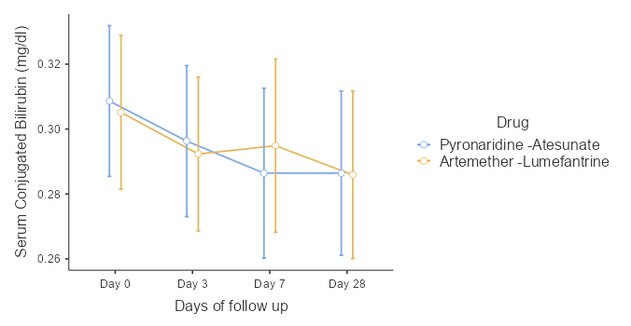

Table 7f: Post Hoc Comparisons of Serum Aspartate Transaminase Mean Difference Between PA and AL treated groups by days of follow up among children with uncomplicated malaria in Ibadan, Southwest Nigeria.

Days of follow up | Mean Difference | SE | t | ρ- value
Days 0 vs 3 | -0.00324 | 0.672 | -0.00483 | 1.000
Days 0 vs 7 | 0.75309 | 0.853 | 0.88325 | 1.000
Days 0 vs 28 | 0.86329 | 0.924 | 0.93399 | 1.000
Days 3 vs 7 | 0.75633 | 0.854 | 0.88515 | 1.000
Days 3 vs 28 | 0.86653 | 0.719 | 1.20482 | 1.000
Days 7 vs 28 | 0.11021 | 0.855 | 0.12885 | 1.000

Figure 9: Mean of Serum Aspartate Transaminase of Participants in the PA and AL treated groups by days of follow up among children with uncomplicated malaria in Ibadan, Southwest Nigeria.
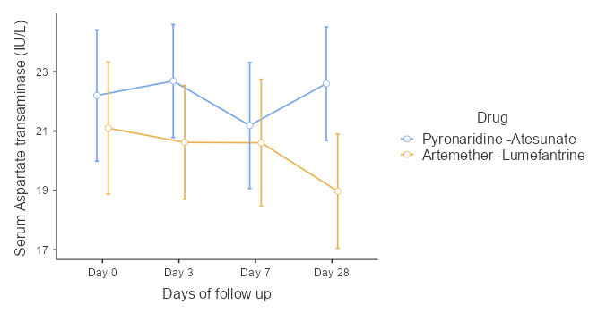

Table 7g: Post Hoc Comparisons of Serum Alanine Transaminase Mean Difference Between PA and AL treated groups by days of follow up among children with uncomplicated malaria in Ibadan, South-west Nigeria.

Days of follow up | Mean Difference | SE | df | t | p
Days 0 vs 3 | 0.996 | 0.834 | 158 | 1.194 | 1.000
Days 0 vs 7 | 1.208 | 0.862 | 158 | 1.402 | 0.977
Days 0 vs 28 | 1.798 | 0.949 | 158 | 1.895 | 0.360
Days 3 vs 7 | 0.212 | 0.692 | 158 | 0.306 | 1.000
Days 3 vs 28 | 0.802 | 0.670 | 158 | 1.197 | 1.000
Days 7 vs 28 | 0.590 | 0.704 | 158 | 0.838 | 1.000

Figure 10: Mean of Serum Alanine Transaminase of Participants in the PA and AL treated groups by days of follow up among children with uncomplicated malaria in Ibadan, South-west Nigeria.

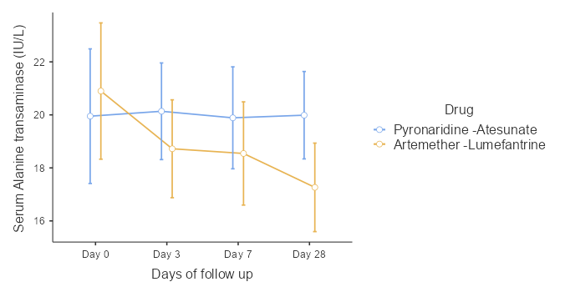

Table 7h: Post-Hoc Comparisons of Serum Alkaline Phosphatase Mean Difference Between PA and AL treated groups by days of follow up among children with uncomplicated malaria in Ibadan, South-west Nigeria
Days of follow up | Mean Difference | SE | df | t | ρ- value
Days 0 vs 3 | -0.278 | 1.13 | 158 | -0.2454 | 1.000
Days 0 vs 7 | -0.105 | 1.12 | 158 | -0.0940 | 1.000
Days 0 vs 28 | -1.123 | 1.28 | 158 | -0.8773 | 1.000
Days 3 vs 7 | 0.173 | 1.05 | 158 | 0.1646 | 1.000
Days 3 vs 28 | -0.846 | 1.16 | 158 | -0.7274 | 1.000
Days 7 vs 28 | -1.019 | 1.07 | 158 | -0.9501 | 1.000

Figure 11: Mean of Serum Alkaline Phosphatase Participants in the PA and AL treated Groups by Days of Follow Up among children with uncomplicated malaria in Ibadan, South-west Nigeria.


