Supplementary File
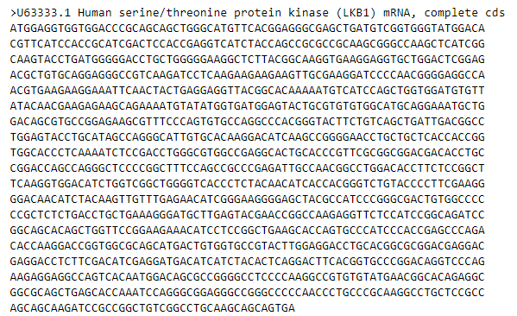
Figure S1. FASTA sequence of LKB1 gene retrieved from NCBI

Table S1. Validation of detected mutations.

Sr. | Mutation name | Polphen-2 | PROVEN | PHD-SNP | SWIFT | I-MUTANT | MUPRO
1. | Q7P | Benign | Neutral | Deleterious | Not  tolerated | decrease | Decrease  stability
2. | E2D | benign | neutral | Deleterious | not  tolerated | decrease | decrease  stability
3. | V4A | benign | neutral | Deleterious | not  tolerated | decrease | decrease  stability
4. | M11V | benign | neutral | Deleterious | not  tolerated | decrease | decrease  stability
5. | K108R | benign | Neutral | Deleterious | tolerated | increase | decrease  stability
6. | L67P | probably damage | deleterious | Deleterious | tolerated | decrease | decrease  stability
7. | I161V | benign | neutral | Deleterious | tolerated | decrease | decrease  stability
8. | G187S | benign | neutral | Deleterious | tolerated | decrease | decrease  stability
9. | A206E | benign | neutral | Deleterious | tolerated | decrease | decrease  stability
10. | A206V | benign | neutral | Deleterious | tolerated | increase | decrease  stability
11 | R211S | benign | neutral | Deleterious | tolerated | decrease | decrease  stability
12 | R405K | benign | neutral | Deleterious | not  tolerated | decrease | decrease  stability
13 | A273T | benign | neutral | Deleterious | tolerated | decrease | decrease  stability
14 | S271N | benign | neutral | Deleterious | tolerated | decrease | decrease  stability
15 | K287R | benign | neutral | Deleterious | tolerated | decrease | decrease  stability
16 | R301Q | benign | neutral | Deleterious | tolerated | decrease | decrease  stability
17 | A318E | benign | neutral | Deleterious | tolerated | increase | decrease  stability
18 | H379Q | benign | neutral | Deleterious | tolerated | decrease | decrease
19 | S334G | benign | Neutral | Deleterious | tolerated | decrease | decrease  stability
20 | R383S | benign | neutral  (0.511) | Deleterious | tolerated | decrease | decrease  stability
21 | R409G | benign | neutral | Deleterious | not  tolerated | decrease | decrease  stability
22 | W239R | probably damage | deleterious | Deleterious | not tolerated | decrease | decrease stability
23 | g408a | benign | Neutral | Deleterious | not  tolerated | decrease | decrease  stability

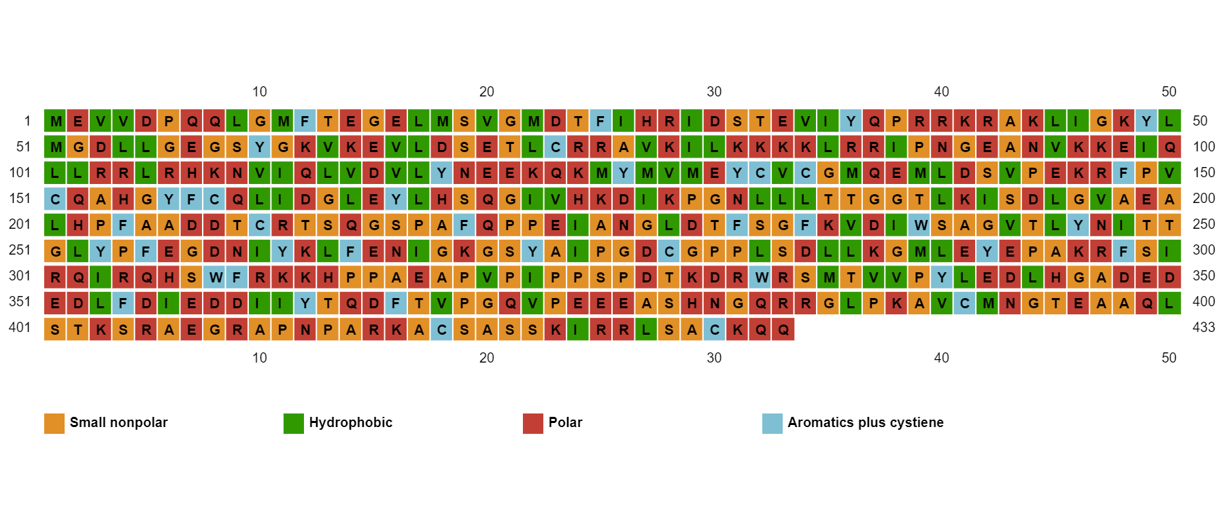
Hydrophobic Aromatic & Cysteine

Polar Non Polar

Figure S2. Secondary structure prediction through PSIPRID

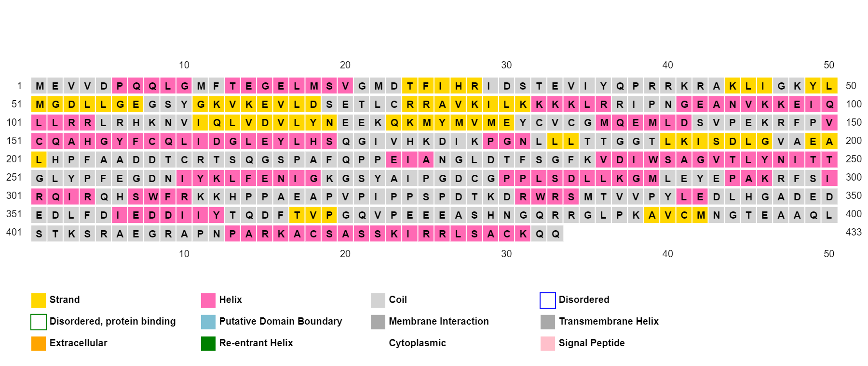

Strand
Coil
Alpha helix

Figure S3. Presence of Alpha helices and beta sheets in LKB1 gene.

Table S2. Honokiol ligand Retrieval from PubChem
Sr. No. | Honokiol derivate | PubChem ID
1. | 3’_Formylhonokiol | 25104462
2. | 5’_Formylhonokil | 25104463
3. | 3’,5’_DiFormylhonokiol | Draw by ChemDraw

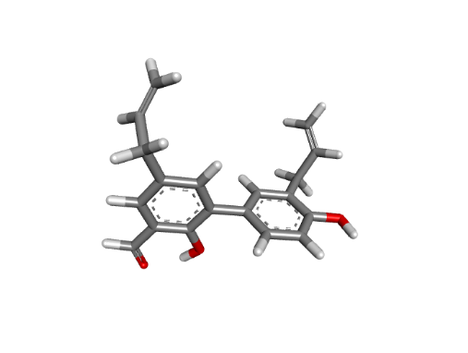
Structure of 5’-formylhonokiol
Structure of 3’-formylhonokiol

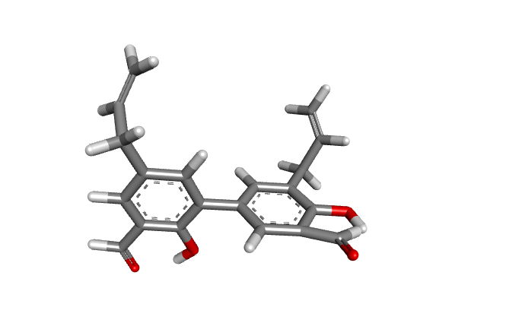
Structure of 3, 5’-diformylhonokiol

Figure S4. Honokiol ligands retrieved from PubChem

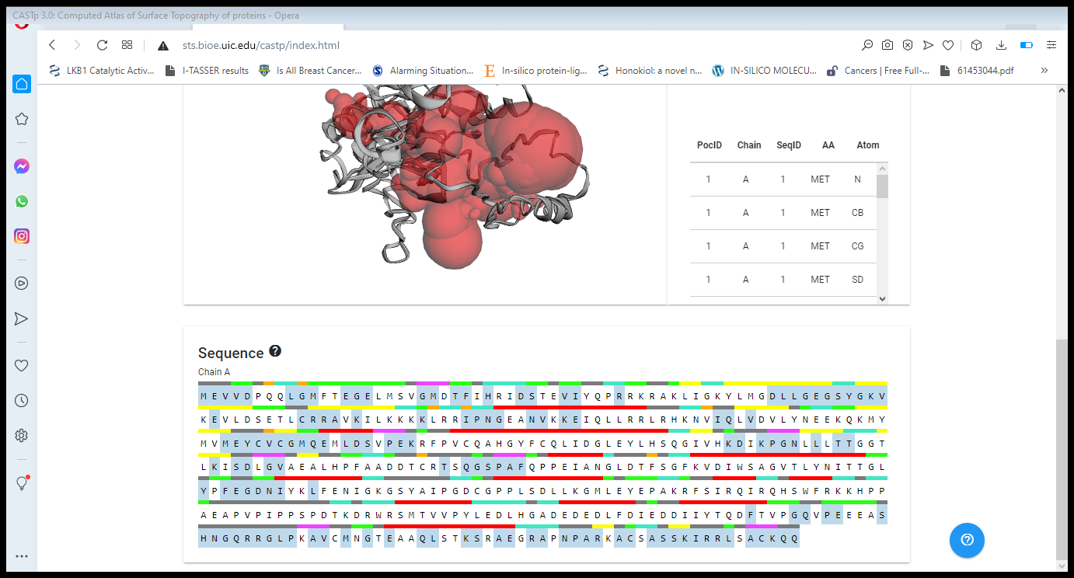

Figure S5. Ligand binding sites or residues through AutoDock Vina

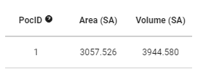

Figure S6. CASTp pocID

Table S3. Binding affinities of Honokiol derivatives

Sr. | Ligand name | AffinityKcal/mol
1. | 3’_formyl honokiol | -7.8
2. | 5’_formylhonokiol | -7.2
3. | 3’,5’_diformylhonokil | -7.9

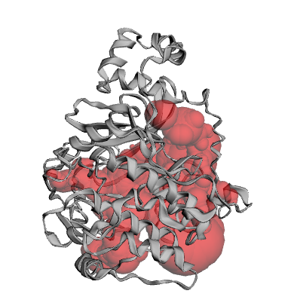

Figure S7. Ligand Binding Sites

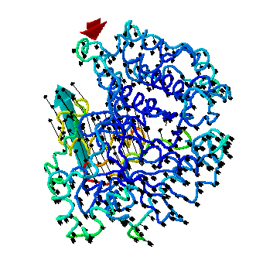

Figure S8. NMA mobility

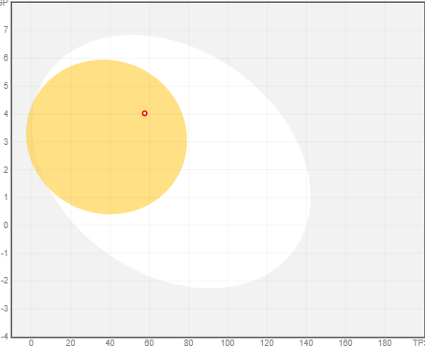
5’-formyl honokiol

3’,5-diformylhonokiol
3’-formyl honokiol
= BBB

Figure S9. Pharmacokinetics of honokiol derivative
Lipophilicity | 3’_formylhonokiol | 3,5_diformylhonokiol
Consensus Log p_{w/o} | 4.0 | 3.89
Table S4. Lipophilicity of honokiol derivative show lipophilicity of honokiol derivative

