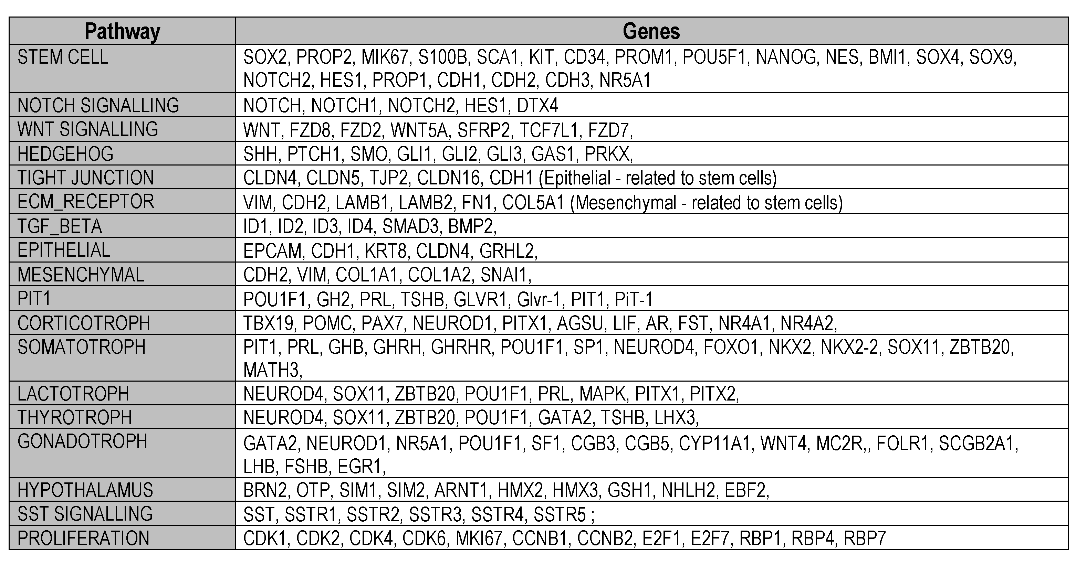
Supplemental Table 5: Pituitary Cell Lineage or Stem Cell Markers used in the
scRNA-seq Analysis.

