Appendix A
Examples of the rhetorical analysis of (de)legitimation acts taken from OBL's texts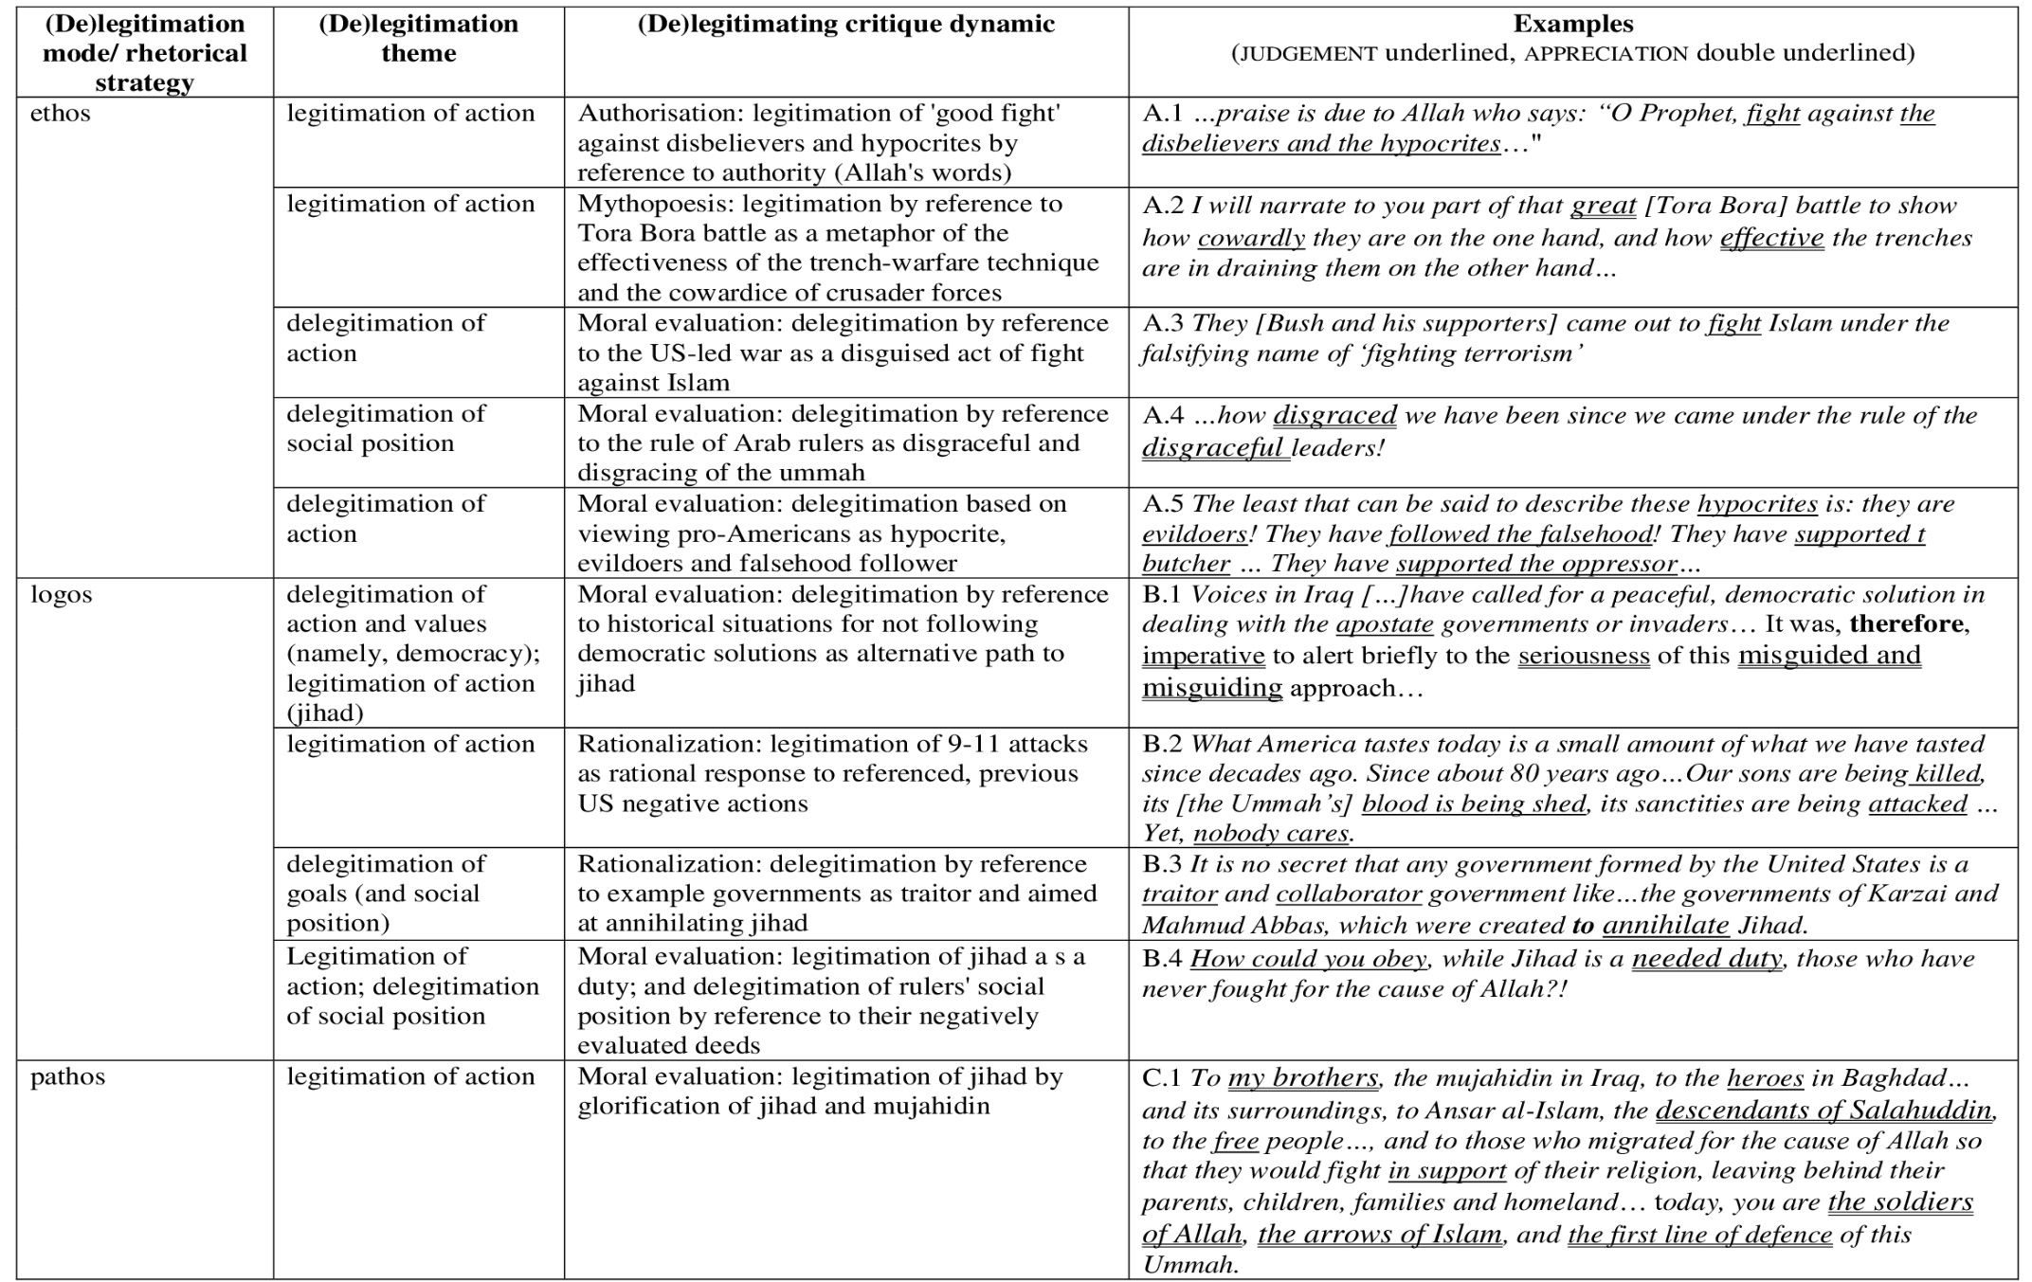

Appendix B
Examples of the rhetorical analysis of (de)legitimation acts taken from Tarrant's manifesto
