Electronic Supplementary Material

ESM Table 1

Electronic Search Strategy- PubMed Search Terms

Database |  |  | Index and Keywords
PubMed | #1 | "Diabetes Mellitus, Type 2"[Mesh] OR ((type 2[Title/Abstract] OR type II[Title/Abstract] OR type2[Title/Abstract] OR typeII[Title/Abstract] OR non insulin depend*[Title/Abstract] OR noninsulin depend*[Title/Abstract] OR maturity onset[Title/Abstract] OR maturity-onset[Title/Abstract] OR slow-onset[Title/Abstract] OR adult onset[Title/Abstract] OR stable[Title/Abstract]) AND (diabet*[Title/Abstract])) OR MODY[Title/Abstract] OR NIDDM[Title/Abstract] OR T2DM[Title/Abstract] OR T2D[Title/Abstract]
 | #2 | "Models, Theoretical"[Mesh] OR model*[Title/Abstract] OR theor*[Title/Abstract]
 | #3 | "Disease Management"[Mesh] OR "Patient Care Team"[Mesh] OR "Patient-Centered Care"[Mesh] OR "Patient Care Management"[Mesh] OR "Self Care"[Mesh] OR "Self Efficacy" [Mesh] OR "Delivery of Health Care"[Mesh] OR "Self-Management"[Mesh] OR "Chronic Disease"[Mesh] OR chronic care [Title/Abstract] OR chronic disease*[Title/Abstract] OR chronic illness*[Title/Abstract]
 | #4 | #1 AND #2 AND #3

ESM Fig. 1

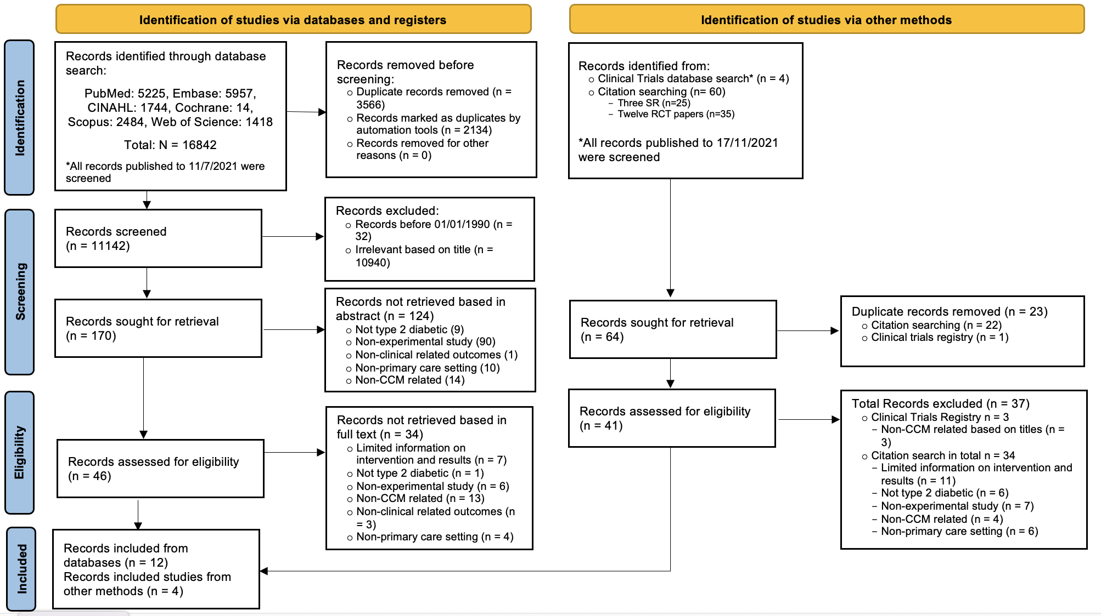
Fig 1. PRISMA flow diagram

ESM Fig. 2

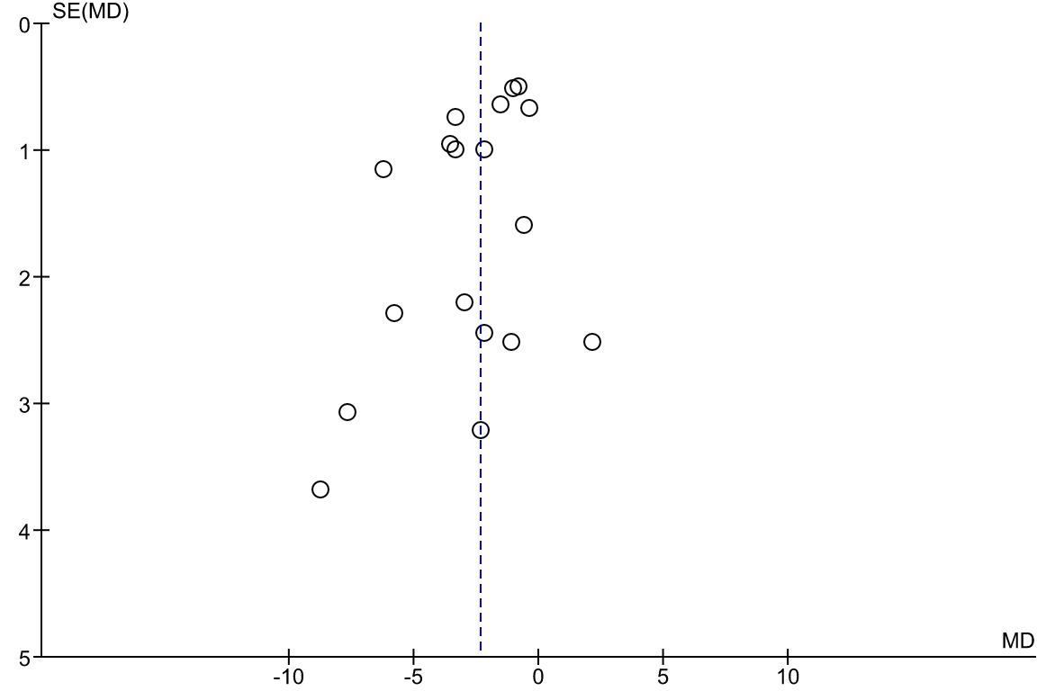

Fig. 2 Funnel plot on HbA_{1c}

ESM Fig. 3 Risk of bias

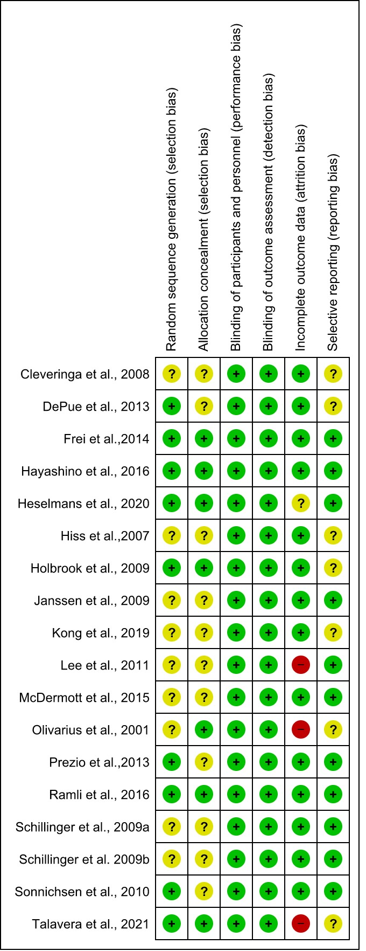

(i) Risk of bias summary

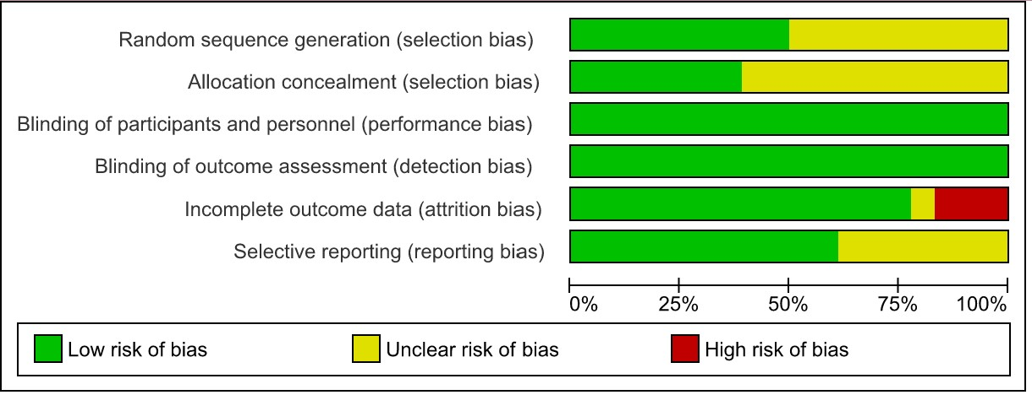

(ii) Risk of bias graph

ESM Fig. 4

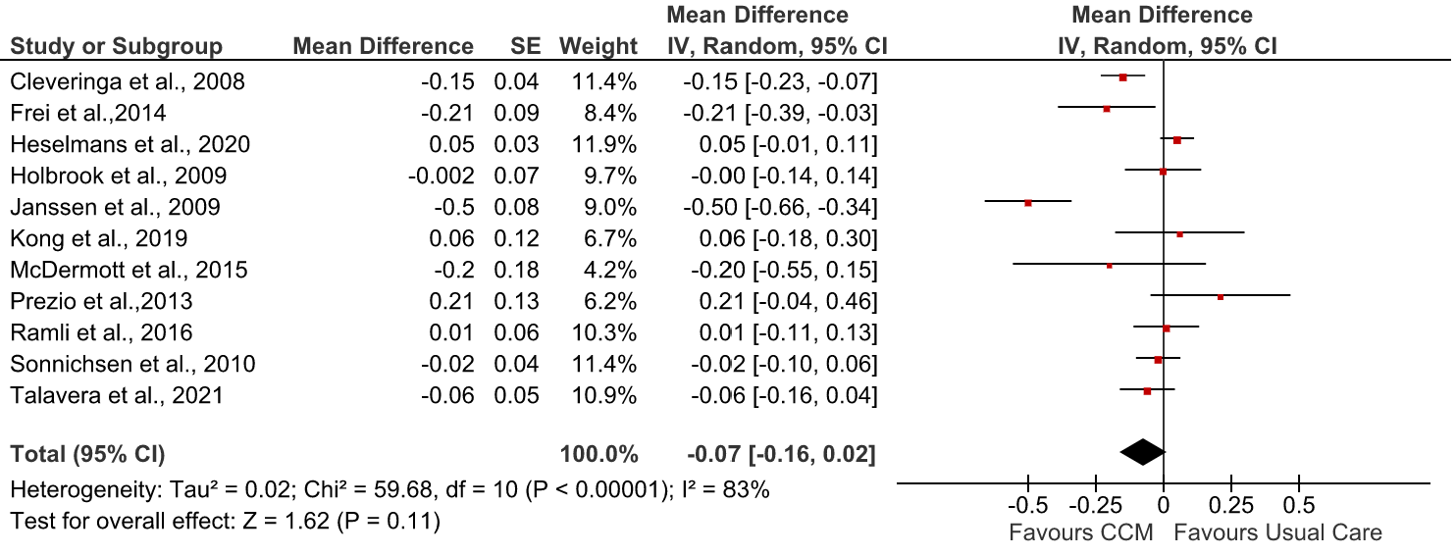

Fig. 4 Forest plot showing the effect of CCM on post-intervention LDL cholesterol (mmol/L). IV, inverse variance

ESM Fig. 5

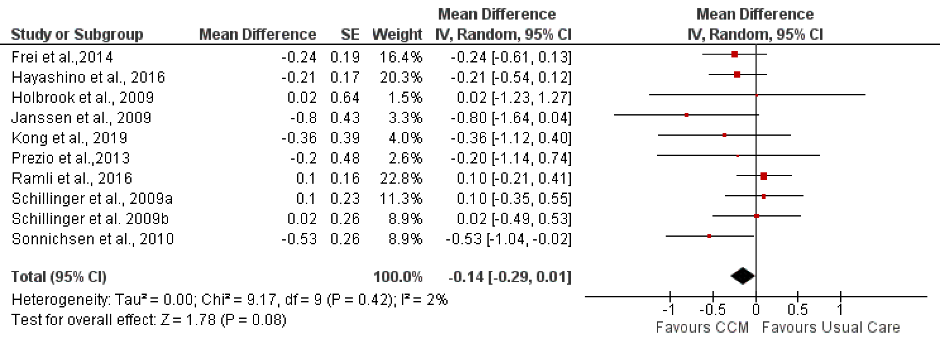

Fig. 5 Forest plot showing the effect of CCM on post-intervention BMI (kg/m²). IV, inverse variance

ESM Fig. 6

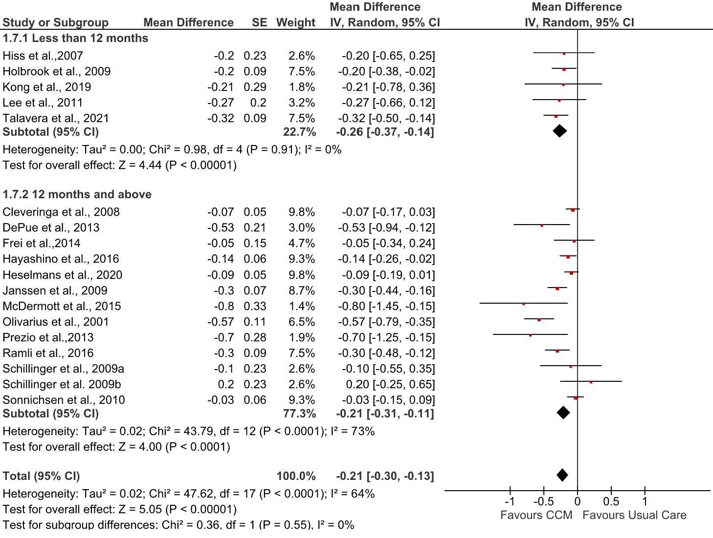

Fig. 6 Forest plot showing subgroup analysis of post-intervention HbA_{1c}
(%) according to study duration. IV, inverse variance

