Supplementary Section

ToxR is a c-di-GMP binding protein that modulates surface-associated behaviour in Pseudomonas aeruginosa.
Jean-Frédéric Dubern^{1*}, Manuel Romero^{1*}, Anne Mai-Prochnow^{1, 2}, Marco Messina^{1, 3}, Eleftheria Trampari^{4, 5}, Hardeep Naghra-van Gijzel^{1, 6}, Kok-Gan Chan^{7,8}, Alessandro M. Carabelli^{9, 10}, Nicolas Barraud^{11, 12}, James Lazenby^{1, 5}, Ye Chen^{1,13}, Shaun Robertson¹, Jacob Malone^{4,14}, Paul Williams¹, Stephan Heeb¹ and Miguel Cámara^{1‡}

¹National Biofilms Innovation Centre, Biodiscovery Institute and School of Life Sciences, University of Nottingham, Nottingham, UK.
⁴Department of Molecular Microbiology, John Innes Centre, Norwich, UK.
⁷Institute of Biological Sciences, Faculty of Science, University of Malaya, Kuala Lumpur, Malaysia.
⁸International Genome Centre, Jiangsu University, Zhenjiang, China.
⁹School of Pharmacy, Boots Science Building, University of Nottingham, Nottingham, UK.
¹¹Centre for Marine Bio-Innovation, School of Biotechnology and Biomolecular Science, University of New South Wales, Sydney, Australia.
¹⁴School of Biological Sciences, University of East Anglia, Norwich, UK.

² Present address: School of Chemical and Biomolecular Engineering, University of Sydney, Australia.
³ Present address: Department of Science, University Roma Tre, Rome, Italy.
⁵Present address: Quadram Institute Bioscience, Norwich Research Park, Norwich, Norfolk, UK.
⁶Present address: Genomic Sciences, GlaxoSmithKline Research and Development, Stevenage, UK.
¹⁰Present address: Department of Medicine, University of Cambridge, Cambridge, UK.
¹²Present address: Genetics of Biofilms Unit, Institut Pasteur, Paris, France.
¹³Present address: Q Squared Solutions, Crystal Plaza, Pudong, Shanghai, China.

*These authors contributed equally to this work
‡Corresponding author: miguel.camara@nottingham.ac.uk

Supplementary Table 1. Single nucleotide polymorphisms (SNPs) and small insertions/deletions (INDELs) present in the genomic sequences of PAO1-L and PAO1-N sublines when compared to the reference genome of PAO1-UW¹.
Locus ID | Gene name | SNPs/INDELs | Description | Subline
PA0373 | ftsY | GCCGAGC | 6-bp insertion, in-frame insertion of glutamic acid-poline (EP) to a stretch of 8 EP repeats | PAO1-N
PA0683 | hxcY | GC | 1-bp insertion, frameshift at codon 73 (out of 382) | PAO1-L
PA1843 | metH | A | GTc to GTt, silent V547V | PAO1-N
PA2492 | mexT | - | 1-bp deletion, frameshift at codon 83 (out of 348) | PAO1-N
PA2494 | mexF | G | TAc to Tag, Y326* premature translation termination (1,062 codons in total) | PAO1-N
PA3578 | - | A | Agc to Agt, silent S65S | PAO1-N
- | - | G | Intergenic PA3969-amn region, downstream of both | PAO1-L
- | - | C | Intergenic PA3969-amn region, downstream of both | PAO1-L
PA4367 | bifA | G | tAC to gAC, Y442D substitution (687 codons in total) | PAO1-N
PA4498 | mdpA | CGGTGC | 5-bp insertion, frameshift at codon 333 (out of 406) | PAO1-N
PA4514 | piuA | - | 1-bp insertion, frameshift at codon 311 (out of 754) | PAO1-N
PA4525 | pilA | C | aGC to gGC, S64G substitution (150 codons in total) | PAO1-N
PA5100 | hutU | GC | Acg to Agc, T431S substitution (560 codons in total) | PAO1-L

Supplementary Table 2. Genetic elements missing in PAO1-N as part of the ~59-kb deletion
Locus ID | Name | Description
PA0707 | toxR | ToxR/RegA protein regulating exotoxin A production. Deletion starts 1 bp before start codon.
PA0706 | cat | chloramphenicol acetyltransferase, antibiotic resistance gene
PA0705 | migA | alpha-1,6-rhamnosyltransferase MigA, possibly involved in lipopolysaccharide biosynthesis
PA0704 | gatA | putative aspartyl/glutamyl-tRNA amidotransferase subunit A
PA0703 | - | probable major facilitator superfamily (MFS) transporter
PA0702 | - | hypothetical protein similar to sterol desaturase/fatty acid hydroxylase
PA0701.1 | - | probable AraC-like transcriptional regulator (unannotated)
PA0701 | - | probable LysR-like transcriptional regulator
PA0700 | - | hypothetical protein of unknown function
PA0699 | - | probable peptidyl-prolyl isomerase (chaperones & heat shock protein family)
PA0698 | - | hypothetical protein of unknown function
PA0697 | - | hypothetical protein of unknown function
PA0696 | - | hypothetical protein of unknown function
PA0695 | - | probable TonB-like membrane-linking protein
PA0694 | exbD2 | predicted biopolymer transport protein ExbD2
PA0693 | exbB2 | predicted biopolymer transport protein ExbB2
PA0692 | pdtB | phosphate depletion regulated TPS partner B
PA0691 | phdA | prevent host death protein A
PA0690 | pdtA | phosphate depletion regulated TPS partner A
PA0689 | lapB | low-molecular-weight alkaline phosphatase B
PA0688 | lapA | low-molecular-weight alkaline phosphatase A
PA0687 | hxcS | type II secretion system protein involved in alkaline phosphatase secretion
PA0686 | hxcR | type II secretion system protein involved in alkaline phosphatase secretion
PA0685 | hxcQ | type II secretion system protein involved in alkaline phosphatase secretion
PA0684 | hxcZ | type II secretion system protein involved in alkaline phosphatase secretion
PA0683 | hxcY | type II secretion system protein involved in alkaline phosphatase secretion
PA0682 | hxcX | type II secretion system protein involved in alkaline phosphatase secretion
PA0681 | hxcT | type II secretion system protein involved in alkaline phosphatase secretion
PA0680 | hxcV | type II secretion system protein involved in alkaline phosphatase secretion
PA0679 | hxcP | type II secretion system protein involved in alkaline phosphatase secretion
PA0678 | hxcU | type II secretion system protein involved in alkaline phosphatase secretion
PA0677 | hxcW | type II secretion system protein involved in alkaline phosphatase secretion
PA0676 | vreR | sigma factor regulator VreR, PUMA3 cell-surface signaling system
PA0675 | vreI | ECF sigma factor VreI, PUMA3 cell-surface signaling system
PA0674 | vreA | TonB-like ECF receptor VreA, PUMA3 cell-surface signaling system
PA0673 | - | hypothetical protein of unknown function
PA0672 | hemO | predicted heme oxygenase HemO
PA0671 | - | probable SOS-response cell division inhibitor
PA0670 | - | probable DNA Polymerase Y-family protein
PA0669 | - | Probable DNA polymerase alpha chain
PA4280.1 | - | 5S ribosomal RNA subunit, identical to PA0668.5
PA4280.2 | - | 23S ribosomal RNA subunit, identical to PA0668.4 but 2 bp. smaller
PA4280.3 | - | tRNA-Ala, identical to PA PA0668.3
PA4280.4 | - | tRNA-Ile, identical to PA0668.2
PA4280.5 | - | 16S ribosomal RNA, 1536 bp long, identical to PA0668.1  Deletion starts 308 bp after transcriptional start site

Supplementary Table 3. Bacterial strains, plasmids and oligonucleotides used in this study.
Strain, plasmid or oligonucleotide | Relevant characteristics | Reference or origin
Strain
P. aeruginosa
PAO1-N | Nottingham collection wild type P. aeruginosa strain | Holloway collection, source unknown
PAO1-L | Lausanne collection wild type P. aeruginosa strain | Holloway collection, via D. Haas
PAZH13-N | rsmA in frame deletion mutant, derivative of PAO1-N | ²
PAZH13-L | rsmA in frame deletion mutant, derivative of PAO1-L | This study
PASK10-L | rsmA::Sm/Spc-lacIQ-Ptac-rsmA; IPTG-inducible, conditional rsmA mutant of PAO1-L | ³
PAAMP2 | toxR::Sm/Spc-lacIQ-Ptac-toxR; IPTG-inducible, conditional toxR mutant, obtained by allelic exchange using pAMP5 on PAO1-L | This study
PAJD55 | toxR in frame deletion mutant, obtained by allelic exchange using pJD22 on PAO1-L | This study
PAJD56 | pvdS in frame deletion mutant, obtained by allelic exchange using pJD93 on PAO1-L | This study
PAJD58 | toxR in frame deletion mutant, obtained by allelic exchange using pJD22 on PAZH13-L | This study
PAJD173 | pvdS in frame deletion mutant, obtained by allelic exchange using pJD93 on PASK10-L | This study
PAJL176 | Site-targeted Y442D mutation in bifA, obtained by allelic exchange using pJL108 on PAJD58 | This study
PAJL186 | Site-targeted D442Y mutation in bifA, obtained by allelic exchange using pJL103 on PAZH13-N | This study
PAJL196 | Site-targeted Y442D mutation in bifA, obtained by allelic exchange using pJL108 on PAO1-L | This study
E. coli
DH5α | F– endA1 glnV44 thi-1 recA1 relA1 gyrA96 deoR nupG purB20 φ80dlacZΔM15 Δ(lacZYA-argF)U169, hsdR17(r_{K}–m_{K}⁺), λ– | ⁴
S17.1 λpir | pro, res− hsdR17 (rK− mK+) recA− with an integrated RP4-2-Tc::Mu-Km::Tn7, Tpr λpir | ⁵
BL21 (DE3) | F– ompT gal dcm lon hsdS_{B}(r_{B}–m_{B}–) λ(DE3 [lacI lacUV5-T7p07 ind1 sam7 nin5]) [malB⁺]_{K-12}(λ^{S}) | ⁶
Plasmids
pBluescript-II KS+ | Cloning vector; ColE1 replicon; Amp^{R} | Stratagene
mini-CTXlux | Promoter-probe vector containing the luxCDABE operon; Tc^{R} | ⁷
pME6000 | pBBR1MCS-derived broad host range multicopy vector, Tc^{R} | ⁸
pME6032 | pVS1-p15A shuttle expression vector; IPTG inducible; Tc^{R} | ⁹
pME3087 | Suicide vector, ColE1 replicon, Mob; Tc^{R} | ¹⁰
pDM4 | Suicide vector; sacBR, oriR6K; Cm^{R} | ¹¹
pHP45Ω | Source of ΩSm/Spc interposon; Amp^{R} | ¹²
pBAD TOPO TA | Topoisomerase I-activated vector for cloning of Taq-amplified PCR products, araBAD promoter for regulated expression, C-terminal polyhistidine (6xHis) tag; Amp^{R} | Invitrogen
pUCP18 | pUC18 derivative containing a stabilising fragment for maintainance in Pseudomonas; Amp^{R}, E.coli/Cb^{R}, P. aeruginosa | ¹³
pCMVDsRed-Express2 | pCMV-based vector harbouring dsRed-express2; Amp^{R} | Takara Bio USA, Inc
P_{cdrA} - gfp(ASV)^{C} | pUCP22Not-P_{cdrA}-RBSII-gfp(ASV)-T0-T1; Amp^{R}, Gent^{R} | ¹⁴
pMRE147 | pPROBE-based vector harbouring mClover3; Cm^{R}, Gent^{R} | ¹⁵
pAMP11 | mini-CTXlux based transcriptional fusion containing P_{toxR1} promoter; Tc^{R} | This study
pAMP12 | mini-CTXlux based transcriptional fusion containing P_{toxR2} promoter; Tc^{R} | This study
pAMP13 | mini-CTXlux based transcriptional fusion containing P_{toxR1,2} promoter; Tc^{R} | This study
pSH30 | mini-CTXlux based transcriptional fusion containing P_{rhlA} promoter; Tc^{R} | This study
pSH32 | mini-CTXlux based transcriptional fusion containing P_{rhlI} promoter; Tc^{R} | This study
pSC581 | pBluescript II KS⁺ derivative containing dsRed-express2; Amp^{R}. | This study
pSC855 | pUCP18 derivative containing P_{pel} - dsRed transcriptional fusion; Amp^{R} | This study
pSC856 | pUCP18 derivative containing P_{psl} - dsRed transcriptional fusion; Amp^{R} | This study
pMMB-1 | pME6000 derivative harbouring a genomic fragment of 2.2 kb; Tc^{R} | This study
pMMB-2 | pME6000 derivative harbouring a genomic fragment of 2.7 kb; Tc^{R} | This study
pMMB-3 | pME6000 derivative harbouring a genomic fragment of 2 kb; Tc^{R} | This study
pMMB-4 | pME6000 derivative harbouring a genomic fragment of 3 kb; Tc^{R} | This study
pMMB-5 | pME6000 derivative harbouring a genomic fragment of 3 kb; Tc^{R} | This study
pMMB-6 | pME6000 derivative harbouring a genomic fragment of 3.7 kb; Tc^{R} | This study
pMMB-7 | pME6000 derivative harbouring a genomic fragment of 2.7 kb; Tc^{R} | This study
pMMB-8 | pME6000 derivative harbouring a genomic fragment of 3.5 kb; Tc^{R} | This study
pMMB-10 | pME6000 derivative harbouring a genomic fragment of 3.5 kb; Tc^{R} | This study
pMMB-11 | pME6000 derivative harbouring a genomic fragment of 3.1 kb; Tc^{R} | This study
pMMB-13 | pME6000 derivative harbouring a genomic fragment of 3.1 kb; Tc^{R} | This study
pMMB-14 | pME6000 derivative harbouring a genomic fragment of 3.5 kb; Tc^{R} | This study
pMMB-16 | pME6000 derivative harbouring a genomic fragment of 2.5 kb; Tc^{R} | This study
pJD22 | pDM4 suicide plasmid with upstream and downstream regions of toxR joined together for the generation of toxR in frame deletion; Cm^{R} | This study
pAMP5 | pDM4 suicide plasmid for the generation of the toxR-inducible strain; Sm/Spc-lacIQ-Ptac-toxR; Sm^{R}, Spc^{R} | This study
pJD93 | pME3087 suicide plasmid containing upstream and downstream regions of pvdS joined together for the generation of pvdS in frame deletion; Tc^{R} | This study
pJL103 | pME3087 suicide plasmid harbouring bifA with a Y442D point mutation from PAO1-N; Tc^{R} | This study
pJL108 | pME3087-based suicide plasmid harbouring bifA from PAO1-L; Tc^{R} | This study
pAMP14 | pBAD TOPO-based vector harbouring toxR-6His; Amp^{R} | This study
Oligonucleotides | Sequence (5’-3’)# | Modification
ToxRp1FW | TATAAGCTTGCGATATCCATTTCGTCTGG | HindIII
ToxRp1RV | TATGAATTCAGGGTACTTCCGGTGTCGC | EcoRI
ToxRp2FW | TATAAGCTTCGGCGGCCGATTGCCGA | HindIII
ToxRp2RV | TATGAATTCGCGCGTTATCGGATGATTAGG | EcoRI
ToxRp12FW | TATAAGCTTGCGATATCCATTTCGTCTGG | HindIII
ToxRp12RV | TATGAATTCGCGGAGACGACCCTACCTC | EcoRI
RhlApFW | TATCTCGAGGTTTCGACACCGGAAACCG | XhoI
RhlApRV | TATCTGCAGTACCAACAGACTTTCGCGCC | PstI
RhlIpFW | TATCTCGAGCGCTGGGTCTCATCTGAAG | XhoI
RhlIpRV | TATCTGCAGCGATTCAGAGAGCAATTCGA | PstI
PpelAdsRedFW | ATAGGTACCACGCAACTGAAGGCGGTGCGA | KpnI
PpelAdsRedRV | ATAAAGCTTCCATGCCCAGCCTACGCGGCA | HindIII
PpslAdsRedFW | ATAGGTACCTCTTCCGCCTTCGACGAGGGC | KpnI
PpslAdsRedRV | ATAAAGCTTCCATGTTGTTTGCTCTGCCGA | HindIII
dsRedFW | ATAGGATCCATGGaagcttTGGATAGCACT* | BamHI
dsRedRV | ATAGAATTCCTACTGGAACAGGTGGTGG | EcoRI
ToxRtopoFW | GAGGAATAATAAATGACTGCGACAGACAGAACGCCCC | N/A
ToxRtopoRV | GCAGGCCGGACTGCTGAACGGCCA | N/A
toxRD1FW | TATGAATTCGCGATATCCATTTCGTCTGG | EcoRI
toxRD1RV | ATAGGATCCAGAGCTCGAATCCGTCGTT | BamHI
toxRD2FW | ATAGGATCCCACTATTCGGAGCCTTTCCA | BamHI
toxRD2RV | ATATCTAGAAAGACAGGCTCTTCGTGCAT | XbaI
toxRpFW | TATAAGCTTGCGATATCCATTTCGTCTGG | HindIII
toxRpRV | TATGAATTCAAGTGATGGCTCTATGGGC | EcoRI
pvdSD1FW | TATAAAGCTTATAGCGATGTACGCCATGGA | HindIII
pvdSD1RV | TATAGAATTCGTATCGCATCTGCGGGTAGA | EcoRI
pvdSD2FW | TATAGAATTCGGTGCACTGCCGCAAGGTCA | EcoRI
pvdSD2RV | TATATCTAGAACCTGCGCATTCATCGAGGA | XbaI
BifAFW | TATGAATTCAGCAACTCGACCAGATCCTC | EcoRI
BifARS | TATAAGCTTGGTCCTGGACGAAACTCTTG | HindIII
* Lowercase bases indicate an internal HindIII restriction site located 1bp from the ATG translational start site in dsRed coding nucleotide sequence.
#nucleotide sequences of restriction sites are underlined.

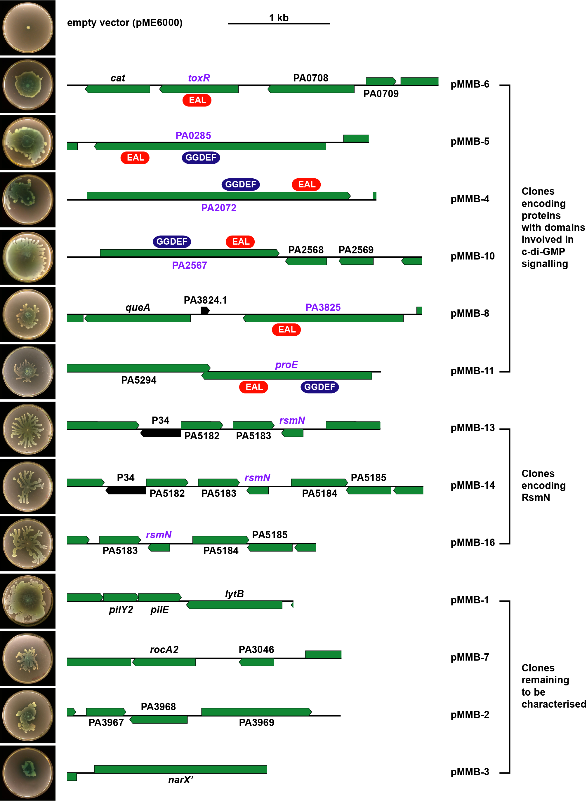
Supplementary Figure 1. Clones complementing swarming motility in PAO1-N. DNA fragments from PAO1-L WT restoring swarming motility (insert images) in the PAO1-N ΔrsmA mutant PAZH13-N when overexpressed from the pME6000 vector. Typical EAL (red framed) and GGDEF (blue framed) domains of proteins involved in c-di-GMP metabolism were identified in the predicted proteins. Green arrows represent ORFs and black arrows non-coding RNAs. Genes labelled purple were identified as complementing swarming in PAZH13-N when individually sub-cloned.

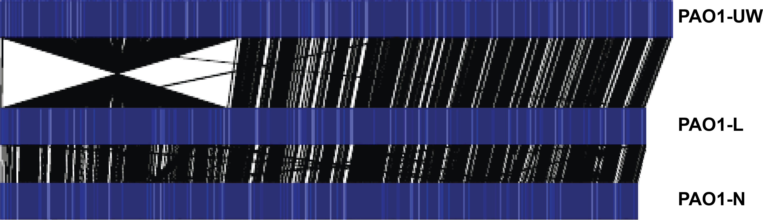
Supplementary Figure 2. The 2.2-Mb inversion is not present in the PAO1 sublines used in this study. Alignment of the optical map of PAO1-UW reference sequence (Genbank Accession Number: NC 002516) produced in silico with the optical maps of PAO1 sublines PAO1-L or PAO1-N obtained experimentally. Optical maps are shown in blue, and the alignment of restriction enzyme cut sites between optical maps are shown in black.

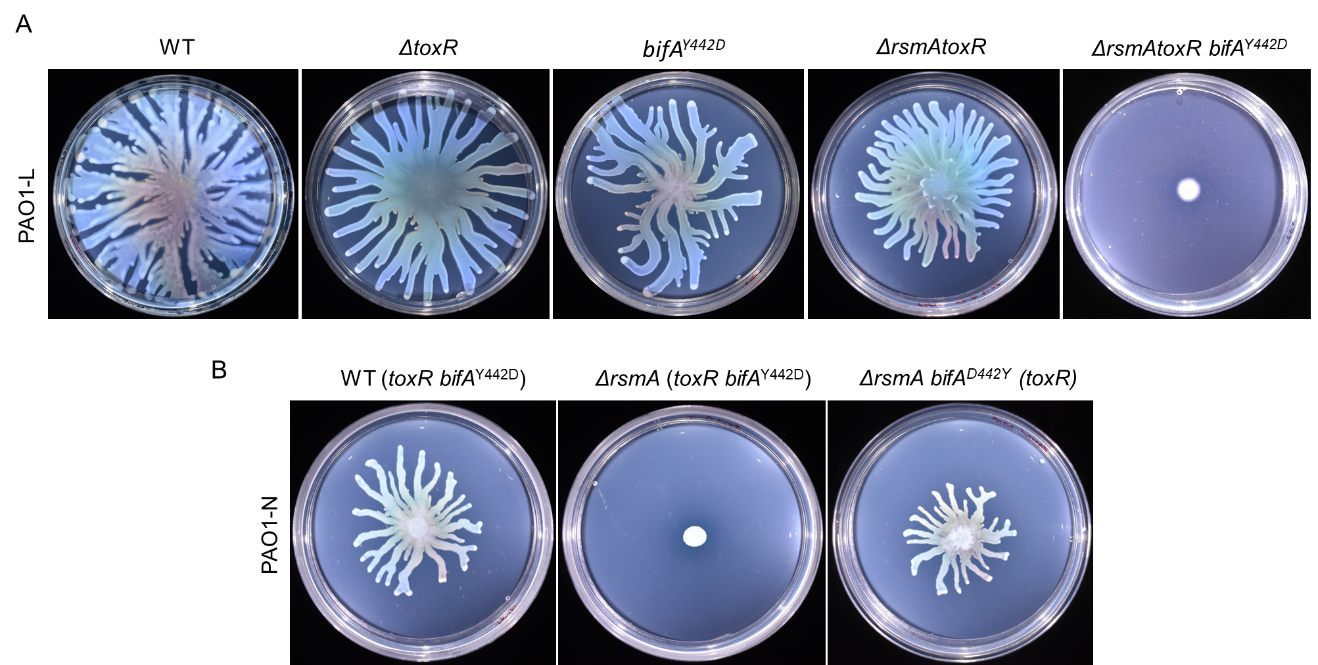
Supplementary Figure 3. Impact of rsmA, toxR, bifA mutations on swarming. Swarming motility of PAO1-L (A) and PAO1-N (B) WT strains and the corresponding mutants.

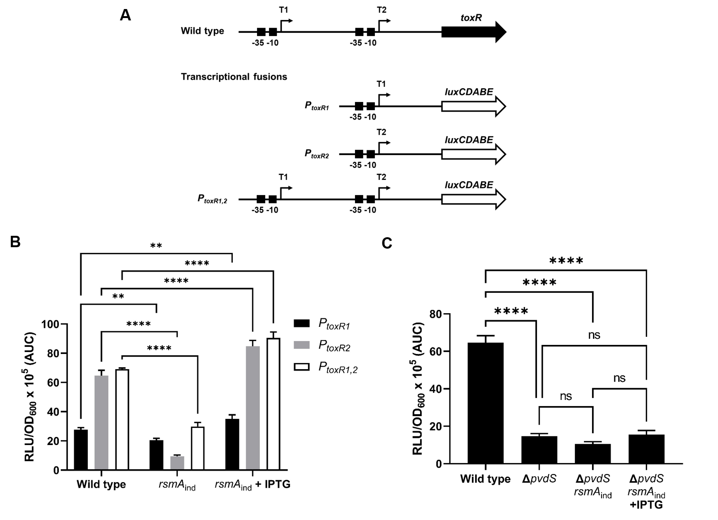
Supplementary Figure 4. Effect of RsmA and PvdS on toxR expression. (A) Schematic of the toxR promoter region used to build mini-CTX::P_{toxR1}, P_{toxR2} and P_{toxR1,2} - luxCDABE transcriptional fusions. (B) Effect of rsmA mutation on the transcriptional activity of the toxR promoters measured in PAO1-L and PASK10-L (rsmA_{ind}) under ion limiting conditions in CAA medium. (C) Transcriptional activity of mini-CTX::P_{toxR2} - luxCDABE in P. aeruginosa PAO1-L wild type and its corresponding mutants PAJD56 (ΔpvdS) and PAJD173 (ΔpvdS rsmA_{ind}) measured under iron starvation in CAA medium. Cells were grown in a 96-well microplate. Bioluminescence and absorbance (OD₆₀₀) were measured using an automated luminometer-spectrometer (TECAN Genios Pro). Reported values are averages from three different cultures ± standard deviation and correspond to the area under the curve (AUC) derived from plotting relative luminescence units normalized to culture density (RLU/OD₆₀₀) over time (24 h). Statistical differences between group means were determined by two-way ANOVA tests. (*p < 0.05, **p < 0.01, ***p < 0.005, ****p < 0.0001).

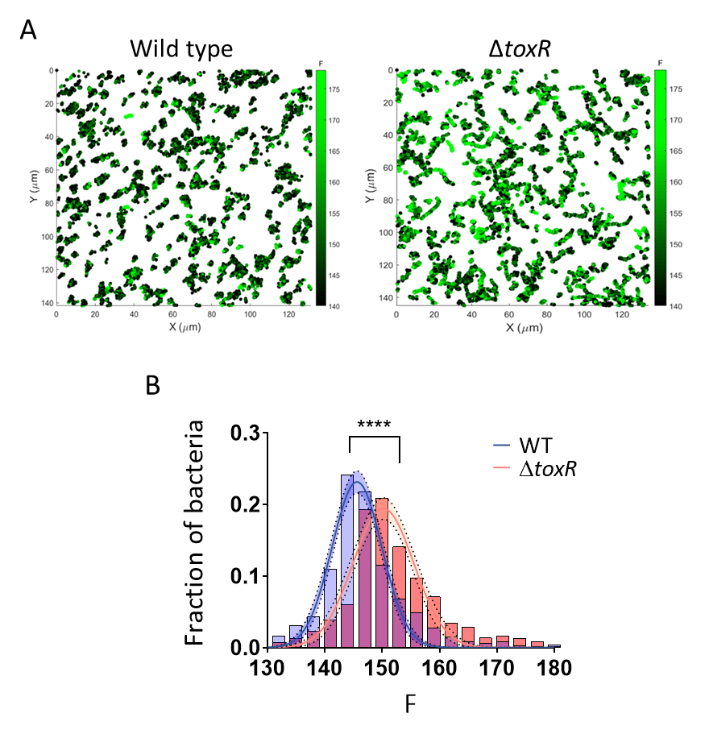
Supplementary Figure 5. Impact of ToxR on the levels of cdrA expression at individual cell level within the bacterial population. (A) Representative coloured maps of PAO1-L WT and PAJD55 (ΔtoxR) cells expressing the P_{cdrA} - gfp(ASV)^{C} transcriptional fusion reporter. Colours show instantaneous fluorescence intensity measured (F) according to the intensity scale shown. Tracks were obtained from combined images acquired using DIC and widefield epifluorescence microscopy every 30 s for 60 min and then processed through a custom single-cell tracking algorithm. (B) Histogram of F for all tracks on WT and PAJD55 (N > 1,000). Unpaired t-test with Welch’s correction was used to compare curves (****p < 0.0001). Dashed lines represent data fit to Gaussian functions. Shaded areas represent 95% CI of the fits.

Sid 1 80
Cd01948 100% ADLRRALERGEFELYYQPIVDLRTGRIVGY--EALLRWRHPEGGL-ISPAEFIPLAEETGLIVELGRWVLEEACRQLARW
PA2133 27.2% RRFQAALARGRVRLDWQAVRHAGHPEWEPLYRETLLRVTAASGEPPLPTQELILALERLGLVRLLDRCVLGTVLDRLN--
PA2200 36.4% ARLLRALKREALEVHYQPIVRLASGRCAGV--EALARWTDSSLGR-VSPDVFIGALEESGDIELLTRFVFRRALKQLGPL
PA2818 39.2% GDMYRAMRAREFHMVYQPIIHLDTGECRGV--EALVRWQRPDRSQ-VRPDIFIPLAEDNGMIGDLTRHIFGLVAADLAQL
PA3825 41.7% SELRRALEANEFIPYYQPLSPGQGGRWIGV--EVLMRWRHPREGL-IRPDLFIPFAERSGLIVPMTRALMRQVAEDLGGH
RocR 38.6% ADVVRGLDNGEFEAYYQPKVALDGGGLIGA--EVLARWNHPHLGV-LPPSHFLYVMETYNLVDKLFWQLFSQGLATRRKL
FimX 33.5% AILQQALETNSFRLLFQPVISLRGDSHENY--EVLLRLLNPQGQE-VPPAEFLHAAKEAGLAEKIDRWVILNSIKLLAEH
LapD 30.5% DWIDQALTERRLLLYFQPVVDCLDTQRV-LHHKVLARLLDPQATA-IAAGRFLPWIERFGWAARMDLAMLEQSLEHLRR-
ToxR 20.0% WLCLGNRDANDGFELFAHGIYARNGALVGS--KLSLRERRQRVDLSAFLSGAPPLLAEAAVKHLLARLLCVHRHNT----

81 160
Cd01948 100% Q-AGGPDLRLSVNLSARQLRDPDFLDRLLELLAETGLPPRRLVLEITESALIDDLEEALATLRRLRALGVRIALDDFGTG
PA2133 27.2% ---AEPTLRLACNLSRQSAAMDAWWEAVCRWLAARPQVARRLTLELTETAVGERVA-TREFIRRLREHGVRIAIDDFGAA
PA2200 36.4% L-REQRSFYVSVNVTGKDIADPGFIDFAMRQMARESVRPEQVALELTERTT-EAQGCLLAGMNRLRELGLKIYVDDFGTG
PA2818 39.2% G--LGAGDHLGVNVSGSHLASHGFVDDVRRLLGAIGSEGPQLVLEVTEREALPHDAQLQHNIQQLRELGVQWALDDFGTG
PA3825 41.7% AGKLEPGFHIGFNISATHCHELALVDDCRELLAAFPPGHITLVLELTERELIESSEVTDRLFDELHALGVKIAIDDFGTG
RocR 38.6% A-QLGQPINLAFNVHPSQLGSRALAENISALLTEFHLPPSSVMFEITETGLISAPASSLENLVRLRIMGCGLAMDDFGAG
FimX 33.5% R-AKGHQTKLFVHLSSASLQDPGLLPWLGVALKAARLPPESLVFQISEADATSYLKQAKQLTQGLATLHCQAAISQFGCS
LapD 30.5% -----HPRPLALSLSAASVRNAQTFAPLLALLKAHPQEARQLTLELDERHL-PAAAELERLSQVLRELGCGLGLQHFGGR
ToxR 20.0% --DLELLGKNFIPLHASSLGNAGVCERILASARQLQQHQVELCLLLAIDEQEPASAEYLTSLARLRDSGVRIALHPQRID

161 240
Cd01948 100% YSSLSYLKRLPV---DYLKIDRSFVRD--IETDPEDRAIVRAIIALAHSLGLKVVAEGVETEEQLELLRELGCD-YVQGY
PA2133 27.2% HNNLDFVLDARP---DVIKIDCRYTRE--ARRSAKGAEVLRHLLALCRELAPCVVLEGLEEDDAFARLPTGDV--YLQGN
PA2200 36.4% HSNLVYLANLPV---DAIKIDKVFTQS--IGDSSAVELIFDKLCSMAEHLEIGVVVEGIETQAQADHVLRRSPEALGQGW
PA2818 39.2% QSSLSHLQKLHA---DFLKIDRSFVSS--VGSGSVNAVVLETIIALAQRLDLAMTAEGIETREQEQYLCGHSIQ-WGQGY
PA3825 41.7% HSSLAYLRKFQV---DCLKIDQSFVAR--IGIDTLSGHILDSIVELSAKLDLDIVAEGVETPEQRDYLAARGVD-YLQGY
RocR 38.6% YSSLDRLCEFPF---SQIKLDRTFVQK--MKTQPRSCAVISSVVALAQALGISLVVEGVESDEQRVRLIELGCS-IAQGY
FimX 33.5% LNPFNALKHLTV---QFIKIDGSFVQD--LNQVENQEILKGLIAELHEQQKLSIV-PFVESASVLATLWQAGAT-YIQGY
LapD 30.5% FSLIGNLTHLGL---AYLKLDGCYLHA--VDREGDKRLFIEAVYRTTHSIDLPLIAEQVETLGELEVLREMGLR-GAMGR
ToxR 20.0% TDARQCFAEVDAGLCDYLGLDARLLAPGPLTRNLRQRKSIEYLNRLLVAQDIQMLCLNVDNEELHQQANALPFA-FRHGR

Supplementary Figure 6. Level of conservation between the ToxR EAL domain and other c-di-GMP binding proteins in P. aeruginosa. Clustal Omega Alignment of the conserved active EAL site (cd01948) and EAL sequences from EAL-only proteins of Pseudomonas aeruginosa PAO1 including ToxR. The residues that form the active site of c-di-GMP PDEs are highlighted in red; conserved residues located in the vicinity of the active site are highlighted in green.

References:
1 Stover, C. K. et al. Complete genome sequence of Pseudomonas aeruginosa PAO1, an opportunistic pathogen. Nature 406, 959-964, doi:10.1038/35023079 (2000).
2 Pessi, G. et al. The global posttranscriptional regulator RsmA modulates production of virulence determinants and N-acylhomoserine lactones in Pseudomonas aeruginosa. Journal of bacteriology 183, 6676-6683, doi:10.1128/jb.183.22.6676-6683.2001 (2001).
3 Kulkarni, P. R. et al. A sequence-based approach for prediction of CsrA/RsmA targets in bacteria with experimental validation in Pseudomonas aeruginosa. Nucleic acids res 42, 6811-6825, doi:10.1093/nar/gku309 (2014).
4 Hanahan, D. Studies on transformation of Escherichia coli with plasmids. J Mol Biol 166, 557-580, doi:10.1016/s0022-2836(83)80284-8 (1983).
5 Metcalf, W. W., Jiang, W. & Wanner, B. L. Use of the rep technique for allele replacement to construct new Escherichia coli hosts for maintenance of R6K gamma origin plasmids at different copy numbers. Gene 138, 1-7, doi:10.1016/0378-1119(94)90776-5 (1994).
6 Studier, F. W. & Moffatt, B. A. Use of bacteriophage T7 RNA polymerase to direct selective high-level expression of cloned genes. J Mol Biol 189, 113-130, doi:https://doi.org/10.1016/0022-2836(86)90385-2 (1986).
7 Becher, A. & Schweizer, H. P. Integration-proficient Pseudomonas aeruginosa vectors for isolation of single-copy chromosomal lacZ and lux gene fusions. Biotechniques 29, 948-950, 952 (2000).
8 Maurhofer, M. et al. Salicylic Acid Biosynthetic Genes Expressed in Pseudomonas fluorescens Strain P3 Improve the Induction of Systemic Resistance in Tobacco Against Tobacco Necrosis Virus. Phytopathology 88, 678-684, doi:10.1094/PHYTO.1998.88.7.678 (1998).
9 Heeb, S., Blumer, C. & Haas, D. Regulatory RNA as mediator in GacA/RsmA-dependent global control of exoproduct formation in Pseudomonas fluorescens CHA0. Journal of bacteriology 184, 1046-1056, doi:doi:10.1128/jb.184.4.1046-1056.2002 (2002).
10 Voisard, C. et al. in Molecular ecology of rhizosphere microorganisms 67-89 (1994).
11 Milton, D. L., O'Toole, R., Horstedt, P. & Wolf-Watz, H. Flagellin A is essential for the virulence of Vibrio anguillarum. J Bacteriol 178, 1310-1319 (1996).
12 Prentki, P. & Krisch, H. M. In vitro insertional mutagenesis with a selectable DNA fragment. Gene 29, 303-313 (1984).
13 Schweizer, H. P. Escherichia-Pseudomonas shuttle vectors derived from pUC18/19. Gene 97, 109-121, doi:10.1016/0378-1119(91)90016-5 (1991).
14 Rybtke, M. T. et al. Fluorescence-based reporter for gauging cyclic di-GMP levels in Pseudomonas aeruginosa. Appl Environ Microbiol 78, 5060-5069, doi:10.1128/aem.00414-12 (2012).
15 Schlechter, R. O. et al. Chromatic bacteria – a broad host-range plasmid and chromosomal insertion toolbox for fluorescent protein expression in bacteria. Front Microbiol 9, doi:10.3389/fmicb.2018.03052 (2018).

