Supplementary Figure 1
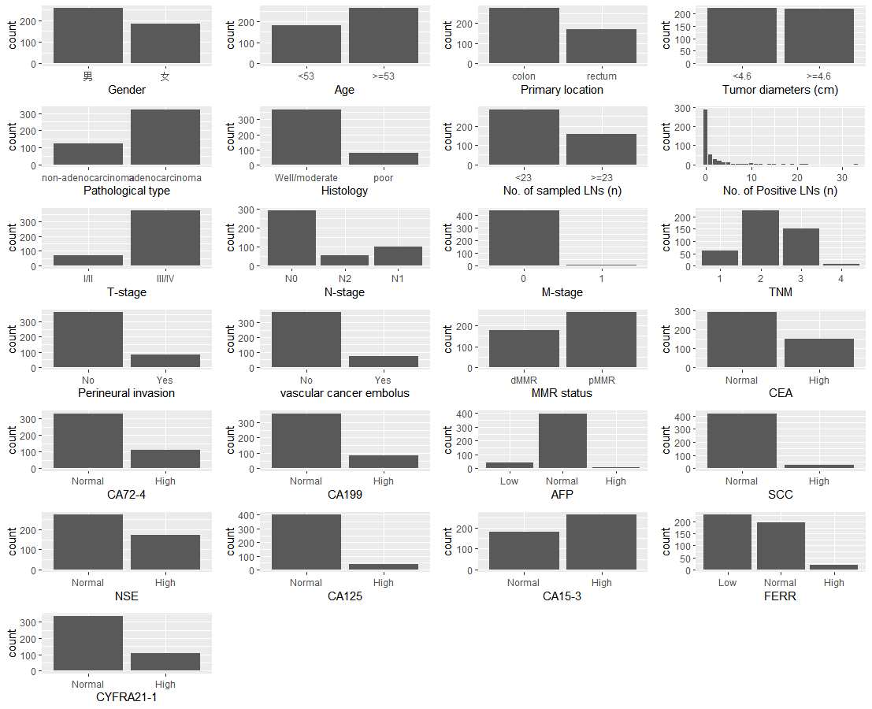
Analytical diagram of the percentage of the situation within each variable.

