Supplementary Information For
Smoke-weather interaction feeds extreme wildfires in Mediterranean and monsoon climate regimes
Xin Huang, Ke Ding, Jingyi Liu, Zilin Wang, Rong Tang, Lian Xue, Hai-Kun Wang, Qiang Zhang, Zhe-Min Tan, Congbin Fu, Steven J. Davis, Meinrat O. Andreae, Aijun Ding
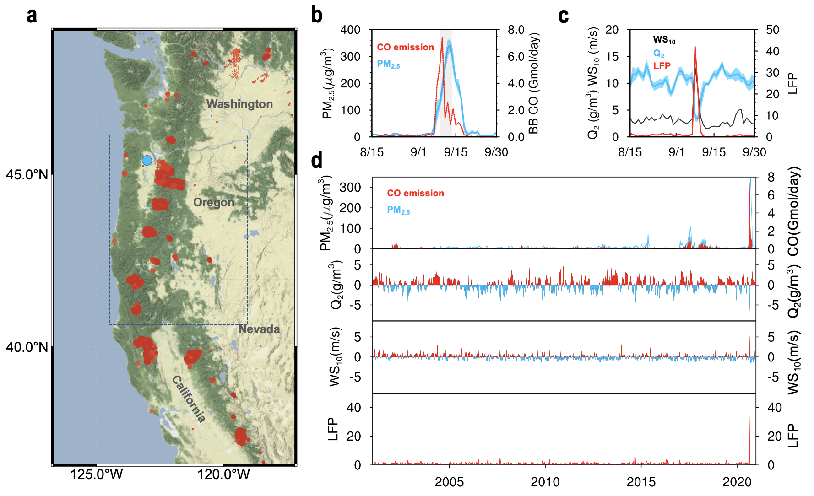
Supplementary Fig. 1 |Record-breaking western USA wildfire events and weather anomalies in 2020. a, Vegetation map and fire spots over the western USA in September 2020. Salem station in Oregon is marked in blue dot. b, c, Daily variations of biomass burning CO emission, PM_{2.5} observations in Oregon Cascade Mountains (blue rectangle in (a)), 2-m water vapor (Q₂) and 10-meter wind speed (WS₁₀) and large fire potential (LFP) at Salem station in August–September 2020. The shading in (b) and (c) shows the 25–75th percentile of PM_{2.5} and Q₂. d, Time series of CO emission, PM_{2.5}, Q₂, WS₁₀ and LFP in August–September from 2001 to 2020.

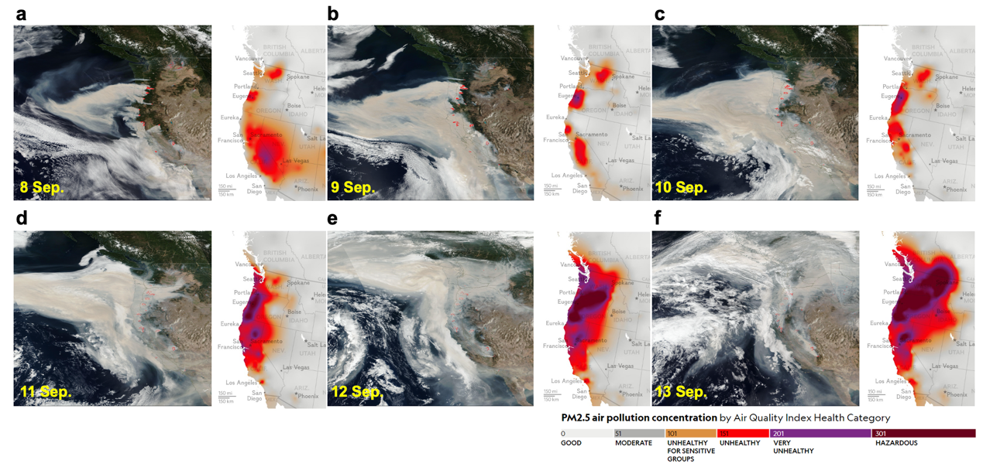
Supplementary Fig. 2 | Satellite image and air quality map during the 2020 western USA gigafire events. a–f, MODIS true color image observed by Terra satellite (left panel) and the USEPA’s Air Quality Index map (right panel) during 8–13 September 2020 over the western USA. These images are openly accessible at https://worldview.earthdata.nasa.gov and http://berkeleyearth.org.
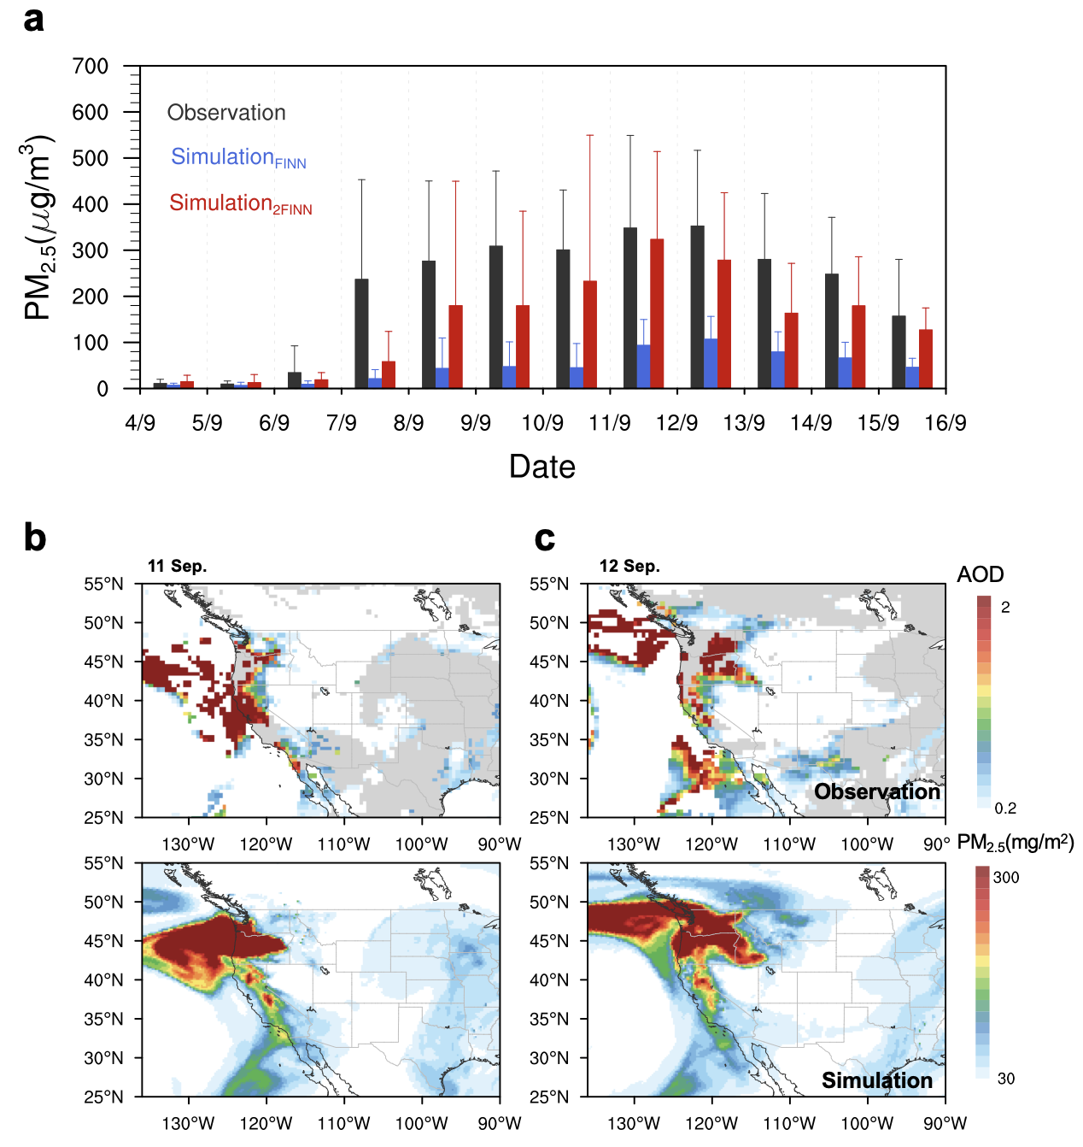

Supplementary Fig. 3 | Evaluation of WRF-Chem simulation by in-situ PM_{2.5} observations and satellite-derived AOD. a, Comparison of simulated and observed daily PM_{2.5} concentrations in Oregon. b, c, Spatial patterns of MODIS-retrieved (MOD04_L2) and simulated aerosol optical depth on 11 and 12 September 2020. Note that the upper and bottom panels show the observations and corresponding simulations, respectively.

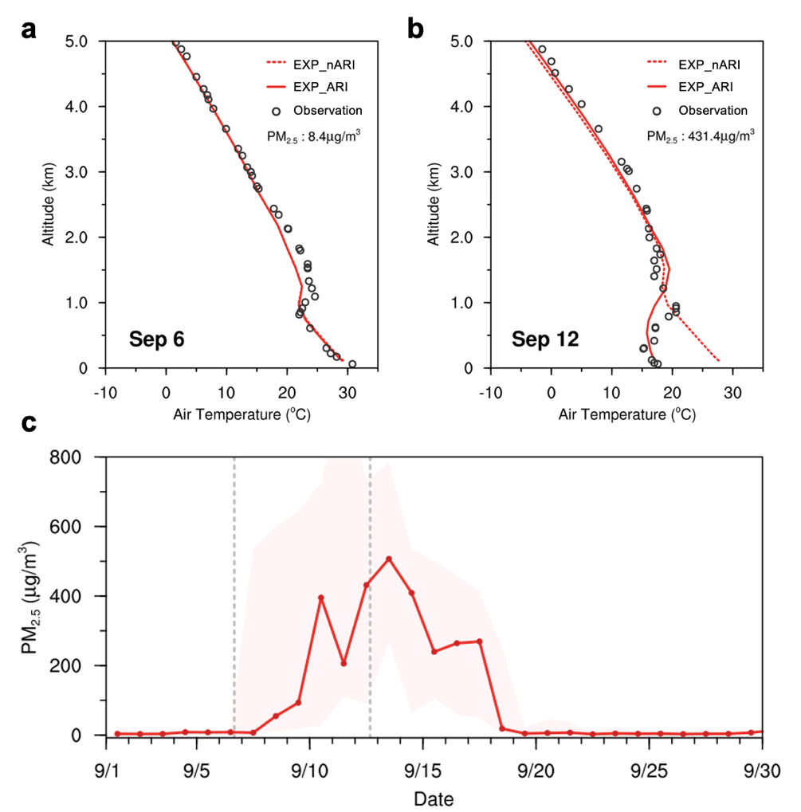

Supplementary Fig. 4 | Evaluation of WRF-Chem simulation by radiosonde measurement of temperature. a, b, Vertical profiles of observed and model simulated air temperature at the Salem radiosonde station on 6 and 12 September. Dashed and solid red lines present simulations with and without considering ARI, respectively. PM_{2.5} concentrations are labeled in the top right corner. c, Time series of daily average (line) and standard deviation (shading) of PM_{2.5} concentrations at Salem in September 2020.
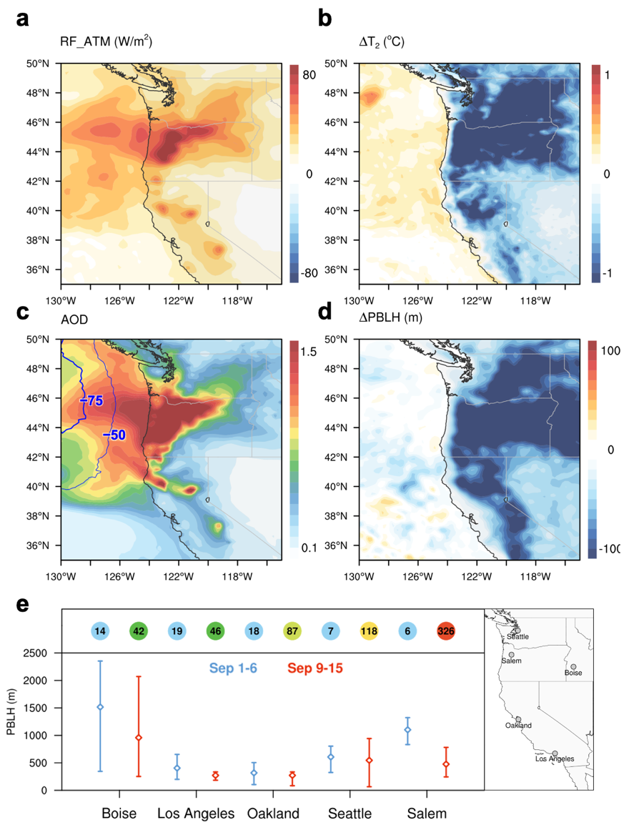

Supplementary Fig. 5 | ARI-induced changes in radiation energy balance, air temperature and PBL in the western USA. a, Spatial distribution of atmospheric warming (radiative forcing in the atmosphere, RF_ATM) during 10–13 September 2020. b, ARI-induced 2-m air temperature perturbations. c, Aerosol optical depth and 1-km pressure (hPa) changes due to ARI. d, Planetary boundary layer height (PBLH) changes due to ARI. e, comparisons of PBLH during clean (blue) and polluted (red) time periods at five radiosonde stations in the western USA. The dots and bars show the average and ranges of PBLH at 16:00 local time during the two different periods. Numbers in circles label the averaged PM_{2.5} concentrations. The geographic locations of radiosonde stations are marked in the right panel.
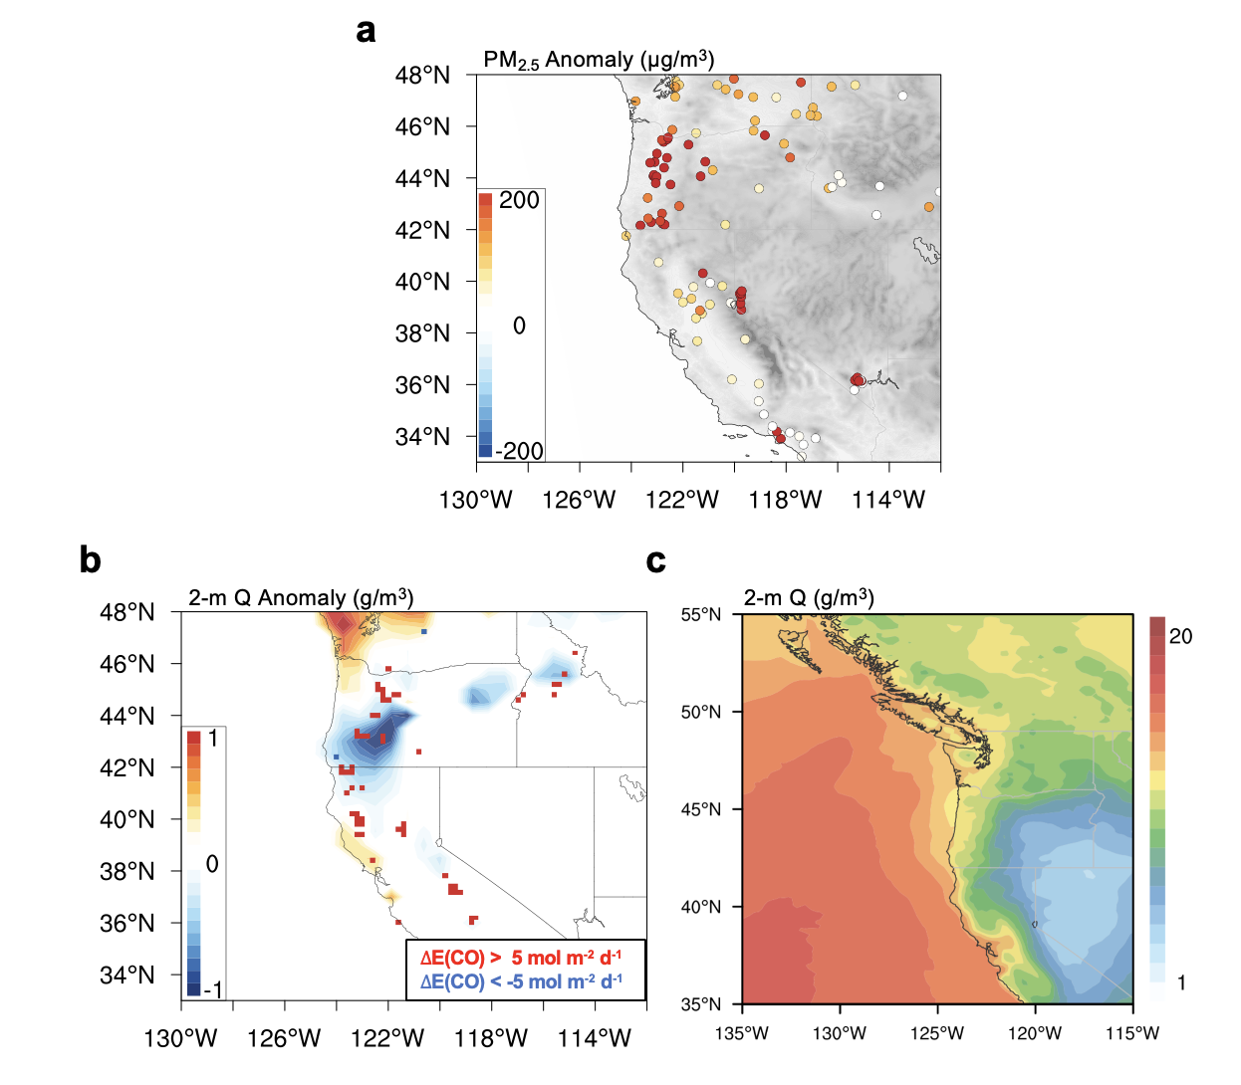

Supplementary Fig. 6 | PM_{2.5} and Q₂ anomaly compared with the climatology. a, Anomaly in PM_{2.5} concentration on 9–15 September 2020 compared with climatological average of September 2010–2019, b, Same with a, but for anomaly in 2-meter water vapor over forest area. Red and blue squares mark the locations with abnormally high and low biomass emission (CO emission is 5 mol m⁻² d⁻¹ higher/lower than the climatological average) in September 2020. c, Spatial distribution of humidity over weastern USA in September.
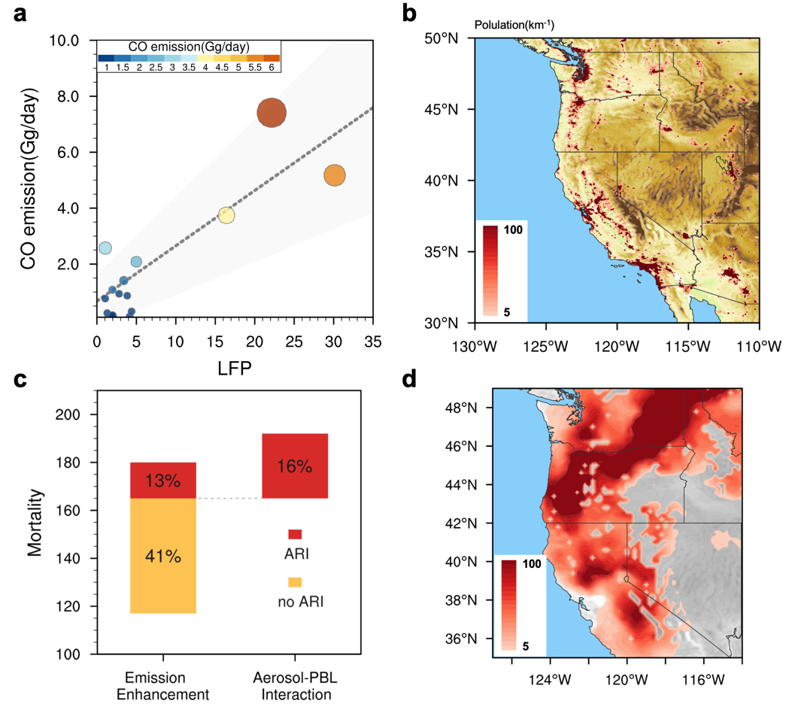

Supplementary Fig. 7 | Wildfire Emission, large fire potential, population density and excess mortality. a, Relationship between 2-day moving average of LFP and daily fire CO emission in the western USA in September 2020. b, Map showing spatial distribution of topography and population density in the western USA. c, Attribution of excess mortality to emission enhancement and aerosol-PBL interaction in the western USA. d, relative change of mortality due to fire-weather interaction during 10–13 September in the western USA.
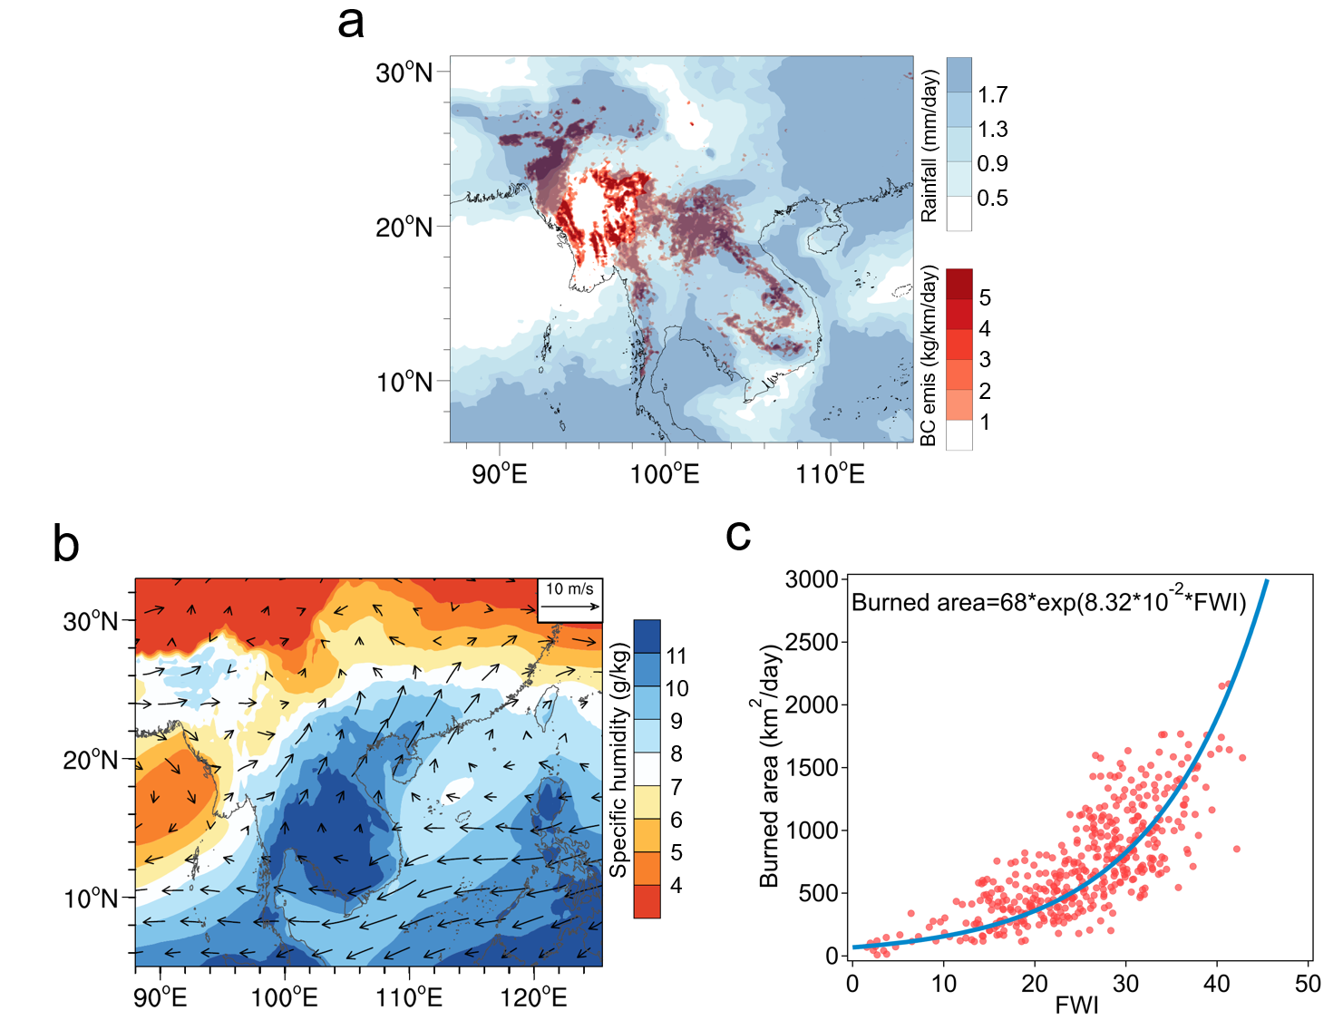

Supplementary Fig. 8 | Characteristics of biomass burning and meteorology in Indochina Peninsula. a, Distribution of BC emission and precipitation in March during 2002-2019. b, Similar with a but for specific humidity and wind field at 850 hPa. c, Relationship between FWI and burned area in the north part of Indochina Peninsula (95-105°E, 17-25°N).

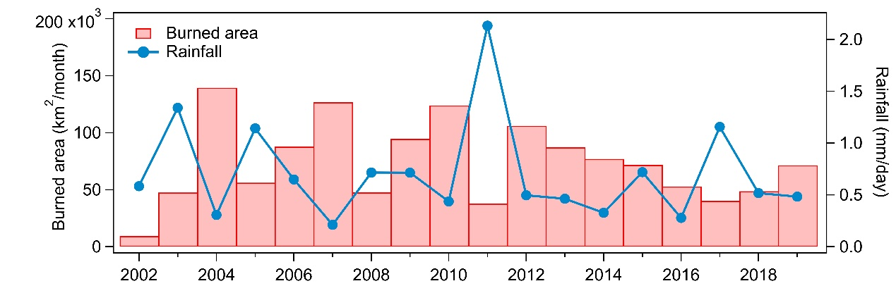

Supplementary Fig. 9 | The interannual variability of burned area and rainfall in north Indochina Peninsula in March during 2002-2019. The burned area is got form FINN data, and the Rainfall data is from TRMM 3B43.

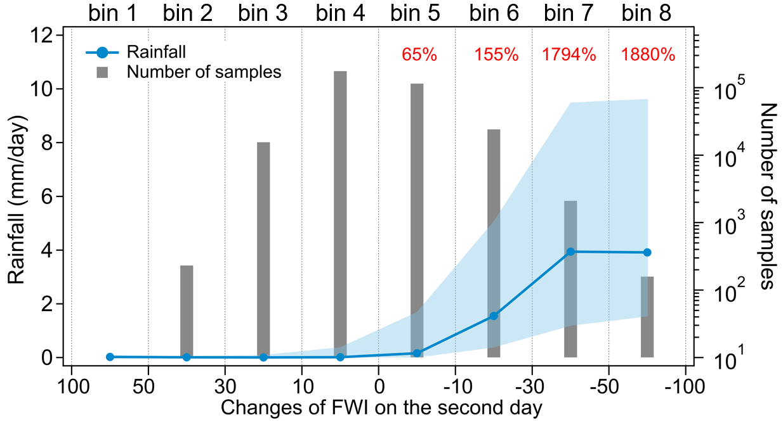

Supplementary Fig. 10 | The effect of rainfall on daily FWI in the north Indochina Peninsula. The sample number and corresponding rainfall of the CFWI (Changes of FWI on the second day) in every grid in the north ICP region in March 2001-2020. The solid line gives the median of rainfall, and the shaded area shows each bin's 25–75th percentile rainfall. The values above the bars denote the ratio of the sample numbers between corresponding bins (e.g., the ratio of the sample number of bin 8 to the sample number of bin 1).

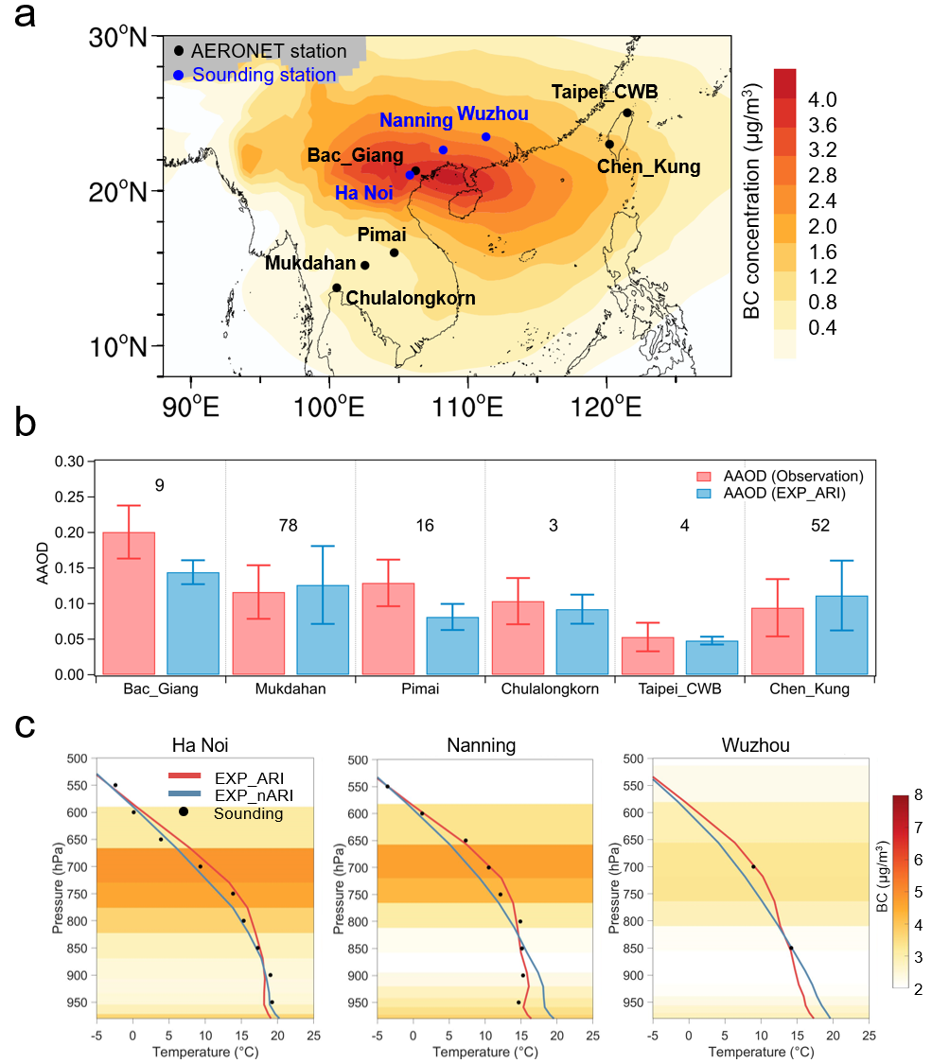

Supplementary Fig. 11 | Model validation of simulated absorptive aerosol optical depth (AAOD) and vertical temperature structure. a, Monthly mean BC distribution at 3km in March 2004. Black and blue markers give the locations of AERONET and sounding stations used for validation. b, Comparisons between simulated and observed AAOD (from AERONET stations) along the smoke plume in March 2004. The numbers denote the number of samples used in each AERONET station. c, Comparisons between simulated and observed vertical temperature profiles during March 13–21, 2004.
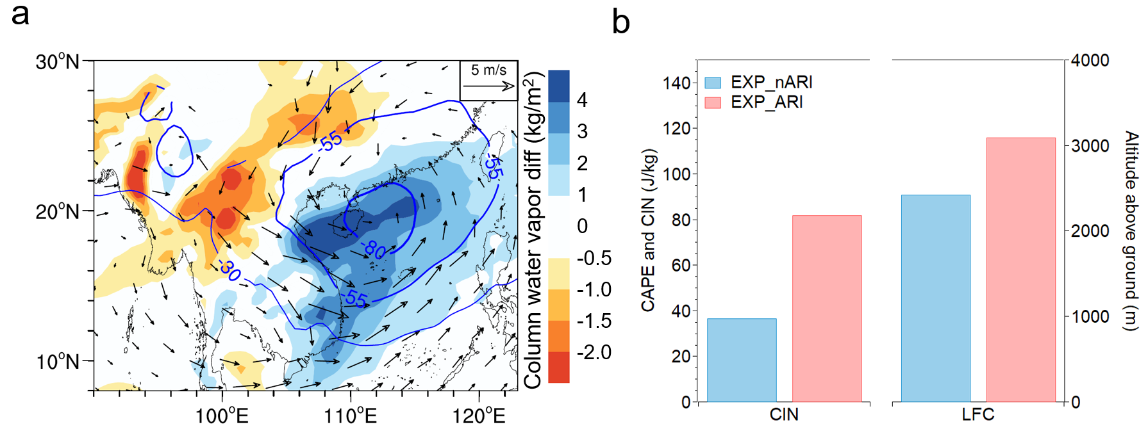

Supplementary Fig. 12 | ARI-induced changes in meteorological fields during March 13-21, 2004. a, Changes of column water vapor, pressure (blue contours, unit: Pa) and wind fields at 1.5 km altitude due to ARI effect. b, The values of LFC (level of free convection) and CIN (convective inhibition) in experiments with (EXP_ARI) and without (EXP_nARI) considering ARI effect. LFC gives the altitude where an air mass begins to initiate self-sustained convection by adiabatic rising. CIN gives the amount of energy required to lift the parcel to the LFC.

\ 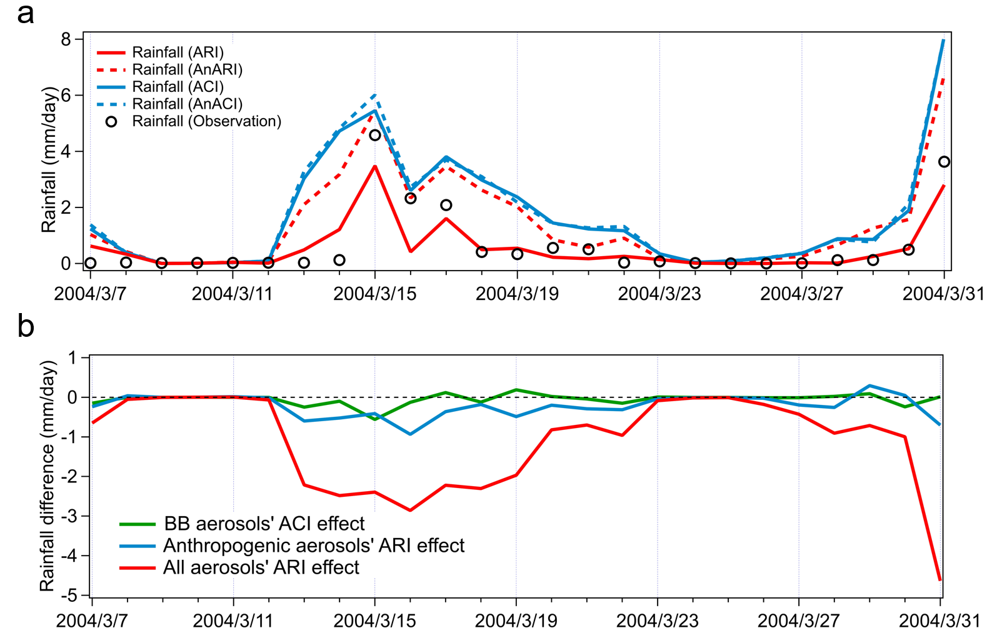

Supplementary Fig. 13 | Aerosols effects on rainfall during in the north Indochina Peninsula. a, The comparisons of observed and simulated rainfall from different experiments. The region is defined in Fig.3d as a grey box. b, Different aerosols’ effect on rainfall. BB aerosols’ ACI effect is the bias between experiment EXP_ACI and EXP_AnACI. Anthropogenic aerosols’ ARI effect is calculated by subtracting the result form EXP_nARI from EXP_AnARI. All aerosols’s ARI effect can be got by the difference between EXP_ARI and EXP_nARI.

Supplementary Table 1 | WRF-Chem modeling configuration options and settings
Domain setting
Region |  | Western USA |  | Southeastern Asia
Horizontal grid |  | 240 × 400 |  | 90 × 170
Grid spacing | 18 km × 18 km |  |  | 50 km × 50 km
Vertical layers | 35 eta levels |  |  | 30 eta levels
Center point | 108 ºW, 40 ºN |  |  | 105 ºE, 25 ºN
Map projection |  | Lambert |  | Lambert
Paramerization configuration
Long-wave radiation |  |  | RRTMG
Short-wave radiation |  |  | RRTMG
Cumulus parameterization |  |  | Grell–Deveny
Land-surface |  |  | Noah
PBL |  |  | MYJ
Microphysics |  |  | Lin et al.
Photolysis |  |  | Fast-J
Gas chemistry |  |  | CBMZ
Aerosol chemistry |  |  | MOSAIC

Supplementary Table 2 | WRF-Chem parallel numerical experiment design
Experiments | Emissions |  | ARI | ACI
Experiments | Anthropogenic | Biomass burning | ARI | ACI
EXP_nARI | √ | √ | × | ×
EXP_ARI | √ | √ | √ | ×
EXP_AnARI | √ | × | √ | ×
EXP_ACI | √ | √ | × | √
EXP_AnACI | √ | × | × | √

Supplementary Table 3 | Excess morality due to enhanced air pollution by smoke-weather interaction

Fire regions | Radiative effect of smoke aerosol | Fire enhancement
Western USA | ↑16.4% | ↑41.0%
Southeastern Asia | ↑18.5% | ↑24.7

