Supplementary Information

Novel pseudo-crown ether-like lithium salt enabling fast charging/discharging high-energy lithium metal batteries
Yingchun Xia¹, Pan Zhou¹, Xian Kong^{2,3}, Jiekang Tian⁴, Weili Zhang¹, Shuaishuai Yan¹, Houwen Hui¹, Hangyu Zhou¹, Dong Hao¹, Xiaoxia Chen¹, Peican Wang¹, Ziang Xu¹, Lei Wan¹, Baoguo Wang¹, Kai Liu^{1*}

¹ Department of Chemical Engineering, Tsinghua University, Beijing, China
² South China Advanced Institute for Soft Matter Science and Technology, School of Emergent Soft Matter, South China University of Technology, Guangzhou, China.
³ Guangdong Provincial Key Laboratory of Functional and Intelligent Hybrid Materials and Devices, South China University of Technology, Guangzhou, China.
⁴ Center of Pharmaceutical Technology, School of Pharmaceutical Sciences, Tsinghua University, Beijing, China

Email: liukai2019@tsinghua.edu.cn

- Supplementary Tables
Supplementary Table 1. Solvent DN and its corresponding ²³Na NMR shift.
Solvent | Chemical shift of  ²³Na NMR (ppm) | DN (kcal/mol)
Acetic anhydride | -11.2685 | 10.5
ACN | -6.842 | 14
DME | -5.7581 | 20
DMSO | -0.19 | 30
pyridine | 0.3349 | 33
1-methylimidazole | 9.1152 | 47

Supplementary Table 2. Impedance of the Li||NCM811 cycles with LAN and RCE under a high charging/discharging current of 5 C rate.
Electrolytes | Resistance of electrodes (Ohm)
Electrolytes | Cycles | R_{s}ª | R_{sf}^{b} | R_{ct}^{c}
LAN | 5 th | 6.75 | 8.91 | 17.23
LAN | 75 th | 6.69 | 15.17 | 72.25
RCE | 5 th | 7.35 | 1.76 | 18.42
RCE | 75 th | 11.82 | 26.13 | 700.50
ª Ohmic resistance; ^{b} the resistance of CEI layer; ^{c} charge transfer resistance of batteries.

Supplementary Table 3. Comparison of our work with recent electrolyte works on lithium batteries.
Electrolyte | Cell condition | Cell capacity | Cycling Condition &Capacity Retention | Fast charging  /discharging | Energy density | (Maximum) Power density (W/kg)
1M LiFSI DMTMSA (ref.¹) | NCM811/Li pouch cell, 4.3mAh/cm² | Not mentioned | 0.2C charge/0.5C discharge,  ~75% after 80 cycles | Not mentioned | 353 Wh/kg | 176.5 (calculated)
1M LiPF6 in EC/EMC/DEC (v/v/v=1:1:1) (ref.²) | LFP/Li@ICPC pouch cell, 2.3mA/cm²;  NCM811/Li@ICPC pouch cell, 6mA/cm² | 500 mAh;  40 mAh | 0.2C charge/0.5C discharge; charge/discharge at 0.2C | Not mentioned | 120 Wh/kg | 60 W/kg; 24 W/kg (calculated)
1.5 M LiFSI-DME-TTE (ref.³) | Li/NCM622 pouch cell, N/P=1:1, 4.0 mA/cm² | 2.0 Ah | 0.1C charge/0.3C discharge, ~81% after 510 cycles | Not mentioned | 350 Wh/kg | 105 W/kg
1.0M LiTFSI+1.5M LiFSI +10%HFE in triethylene glycol dimethyl ether (ref.⁴) | NCM811@Li2O/Cu, pouch cell, E/C=2.5g/Ah | 2.46 Ah | 0.375C charge/0.5C discharge, ~80% after 300 cycles | Not mentioned | 320 Wh/kg | 160 W/kg
1 M LiFSI/FDMB (ref.⁵) | Pouch cell:  Cu/NCM622; Cu/NCM811 | ~190 to 250 mAh | 0.2C charge/2C discharge, 80% after 60 cycles;  0.2C charge/0.3C discharge | Fast-discharging | Unknown;  ~325 Wh/kg | Unknown; 97.5 W/kg
1.2 M LiFSI TEP/BTFE (n/n=1:2) (ref.⁶) | NMC622||Li, 3.8 mAh/cm², pouch cell | 1.17 Ah | 0.1C charge/ C/3 discharge, 83% after 200 cycles | NO | 313 Wh/kg | 104.3 W/kg
1M LiFSI-DME-TFEO (ref.⁷) | Li/NCM811, 4.4V, coin cell, 1.5 mAh/cm² | Not mentioned | Charge/discharge at C/3 | NO | NO | NO
1.2 M LiFSI/F5DEE (ref.⁸) | pouch cell: NCM811/Li, 3.8 mAh/cm²;  Cu/micro-LFP | 120mAh (0.5C discharge); 170 mAh (2C) | 0.2C charge/0.5C discharge, 85% after 150 cycles;  0.5C charge 2C discharge, 80% after 110 cycles | NO;  Fast charging | Unknown | Unknown
Li₂O particles+1M LiPF₆ EC/DEC+10%FEC (SCE);  1M LiFSI FDMB (SFE) (ref.⁹) | NCM811/Li, coin cell, ~3.5 mAh/cm²; | Not mentioned | 0.5C charge/1.0C discharge, ~100% after 150 cycles for SCE; 0.2C charge/0.3C discharge, 80% after ~50 cycles for SFE | NO | NO | NO
1M LiDFTFSI EC/EMC(V/V=3/7) (ref.¹⁰) | NCM811||Li, coin cell, 4.2V, 1.9 mAh/cm² | Not mentioned | charge/discharge at 0.2C, 80% after 200 cycles | NO | NO | NO
1M LiTFSI-FEC/FDMA (ref¹¹) | NCM811||Li, coin cell, 3.5 mAh/cm² | Not mentioned | charge/discharge at 0.25C, 92% after 100 cycles | NO | NO | NO
0.6M LiTFSI+0.4M LiBOB+0.05M LiPF₆ EC/EMC (v/v=4/6) (ref.¹²) | LiNi_{0.4}Mn_{0.4}Co_{0.2}O₂ (NMC, 1.75 mAh/cm²), coin cell | Not mentioned | charge/discharge at 1.0C, 97.1% after 500 cycles | Fast charging | NO | NO
1M LiPF₆ FEC/DMC (v/v=1/4) with LiNO₃ sustained-release membrane (ref.¹³) | NCM523||Li, 4.4 mAh/cm², pouch cell | 3.5 Ah | Charge/discharge at 0.1C, 90% capacity after 60 cycles | NO | 340 Wh/kg | 34 W/kg
0.6M LiTFSI+0.4M LiBOB+0.4M LiF+0.1M LiNO₃+0.05M LiPF₆+0.03M LiBF₄ EC/DMC (V/V=2:1)+ 1WT% FEC+3 wt% TFEC (ref.¹⁴) | NCM811||LBASEI Li | Not mentioned | 0.1C charge/1.0C discharge, ~85% capacity after 120 cycles | Fast discharging | 260 Wh/kg | 260 W/kg
1M LiPF₆ EC/EMC (v/v=3/7) +2 wt% VC (ref.¹⁵) | Li-C||NMC622,  N/P 1.58, 4mAh/cm² | Not mentioned | 0.2Ccharge and C/3 discharge, 91% capacity after 200 cycles | NO | 350 Wh/kg | 116.7 W/kg
Advanced LiFEA-based carbonate electrolytes, LAN (this work) | NCM811||Li,  3.66 mAh/cm² | 440 mAh | 0.4C charge/xC discharge (x=0.2 to 1.8C);  0.4C charge/1.0C discharge, 84% capacity after 100 cycles; 0.2C charge/0.6C discharge, 90% capacity after 120 cycles | Fast charging/discharging | 310 Wh/kg;  401 Wh/kg without counting tap and packing foil | 408 W/kg;  530 W/kg without counting tap and packing foil

- Supplementary Figures
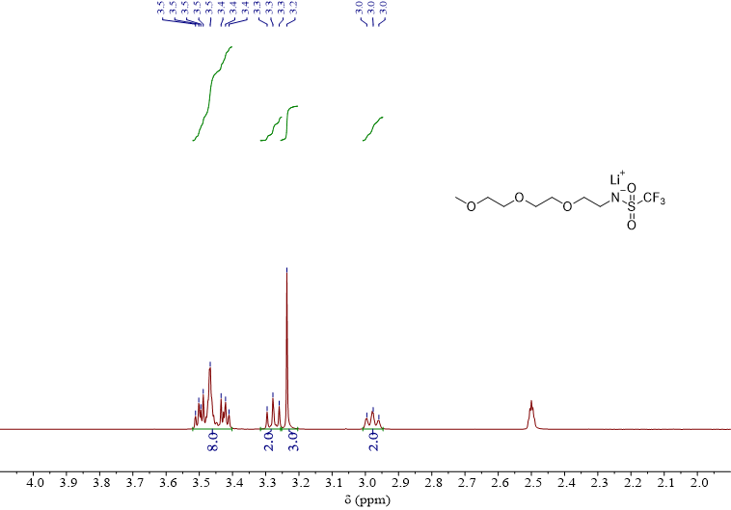
Supplementary Fig. 1. ¹H NMR spectrum of LiFEA in DMSO-d₆.

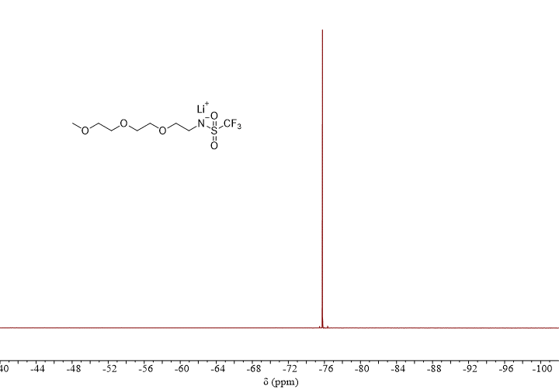
Supplementary Fig. 2. ¹⁹F NMR spectrum of LiFEA in DMSO-d₆.

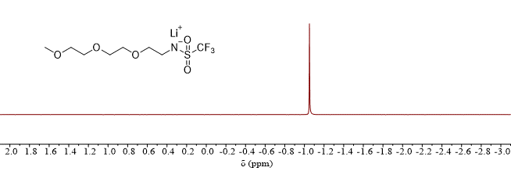
Supplementary Fig. 3. ⁷Li NMR spectrum of LiFEA in DMSO-d₆.

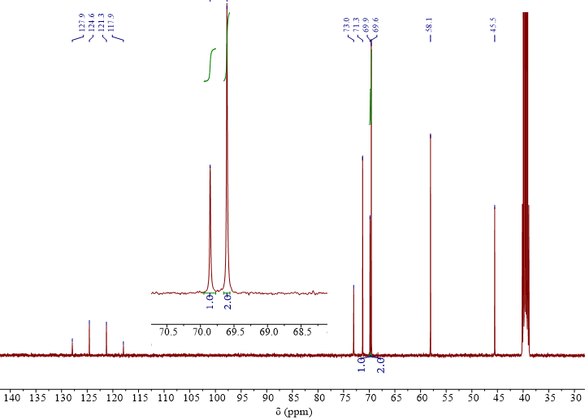
Supplementary Fig. 4. ¹³C NMR spectrum of LiFEA in DMSO-d₆.

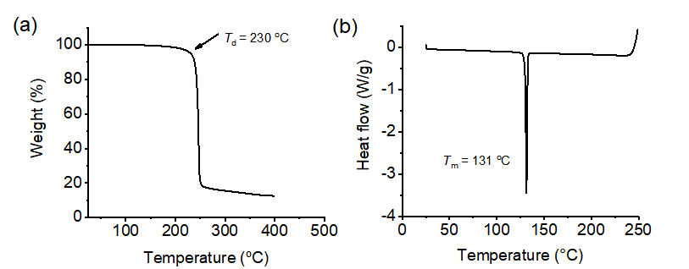
Supplementary Fig. 5. Thermal stability of neat LiFEA salt. (a) Thermal gravimetric analysis (TGA) for determining the thermal decomposition temperature; (b) differential scanning calorimetry (DSC) thermogram for measuring the melting point.

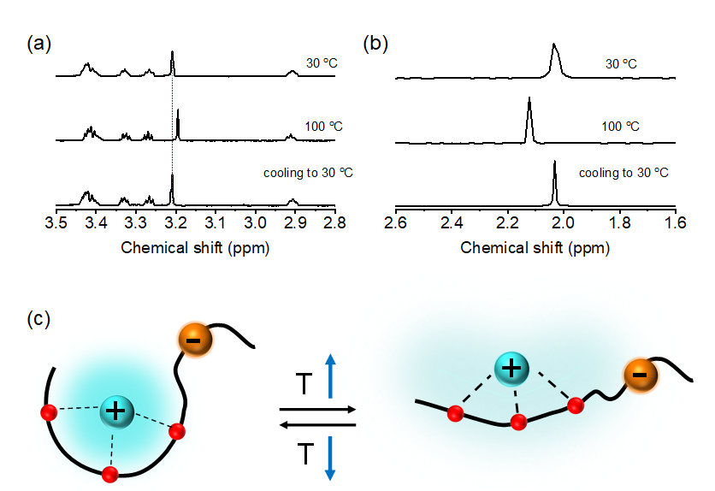
Supplementary Fig. 6. Reversible changes in chemical shifts of LiFEA during a heating and cooling process. (a) ¹H NMR and (b) ⁷Li NMR spectra of LiFEA in EC/DEC (v/v = 1:1). NMR sample tubes were equipped with a coaxial tube for DMSO-d₆. (c) Reversible conformational change of LiFEA induced by heating and cooling.

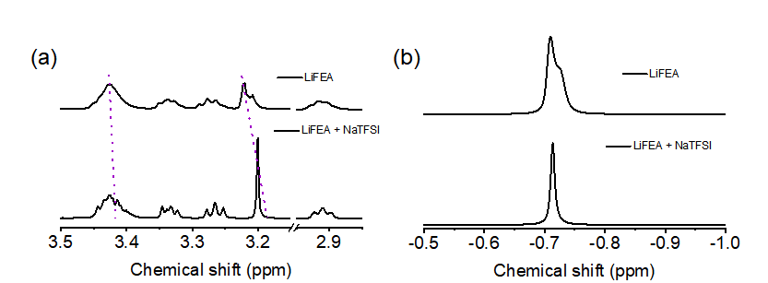
Supplementary Fig. 7. Unfolding LiFEA structure induced by competing Na⁺. (a) ¹H NMR and (b) ⁷Li NMR spectra of LiFEA with or without NaTFSI in EC/DEC (v/v = 1:1). NMR sample tubes were equipped with a coaxial tube for DMSO-d₆.

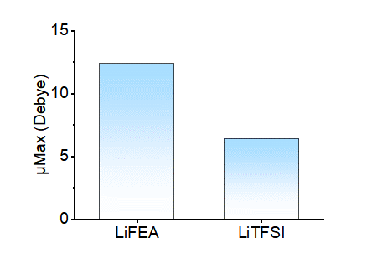
Supplementary Fig. 8. Molecular dipole moment of LiFEA and LiTFSI. The results were obtained from DFT calculations.

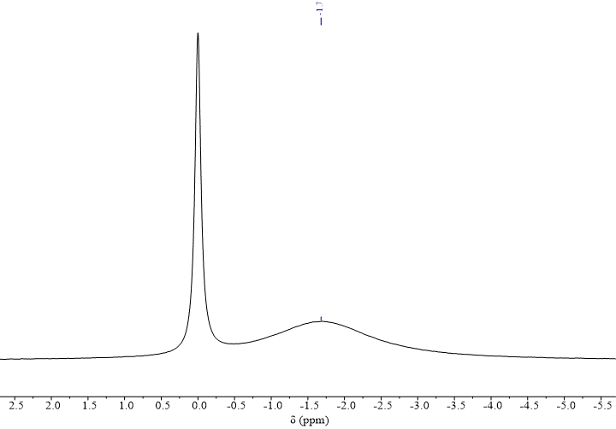
Supplementary Fig. 9. ²³Na NMR spectrum of NaMEA dissolved in ACN using 3 M NaCl in D₂O as an external standard.

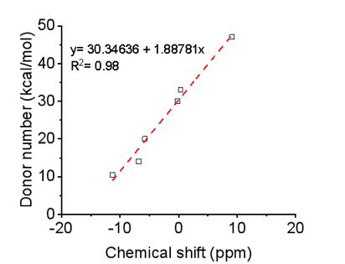
Supplementary Fig. 10. Correlation between our measured ²³Na NMR chemical shift vs. reported DNs. The DNs of unknown solvents (or solutions) were calculated from their corresponding ²³Na chemical shift. The detailed data was listed in Supplementary Table 1.

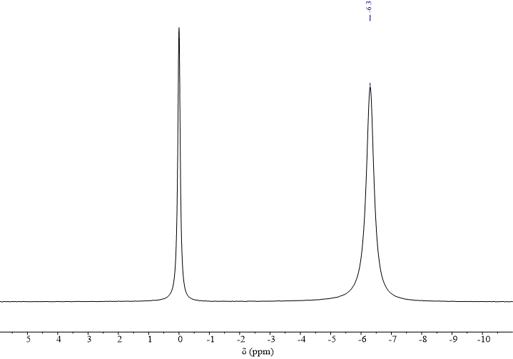
Supplementary Fig. 11. ²³Na NMR spectrum of 0.1-LiFEA dissolved in ACN using 3 M NaCl in D₂O as an external standard.

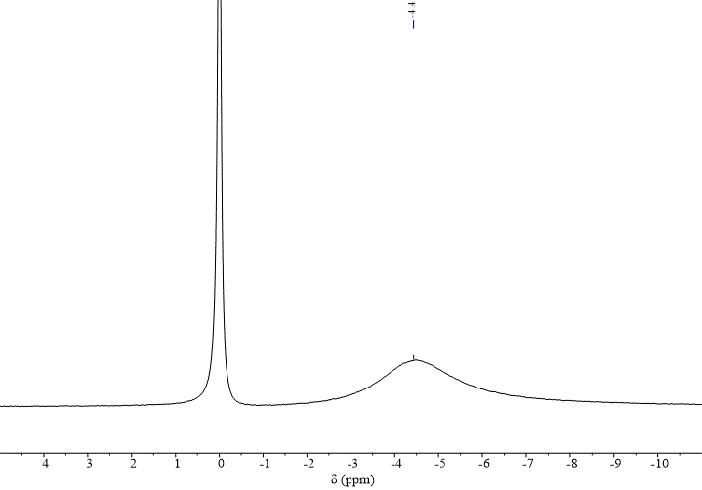
Supplementary Fig. 12. ²³Na NMR spectrum of 1.0- LiFEA dissolved in ACN using 3 M NaCl in D₂O as an external standard.

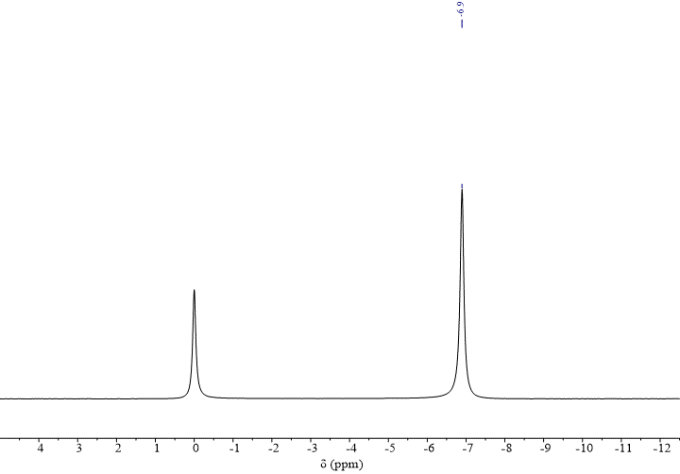
Supplementary Fig. 13. ²³Na NMR spectrum of 0.1-LiTFSI dissolved in ACN using 3 M NaCl in D₂O as an external standard.

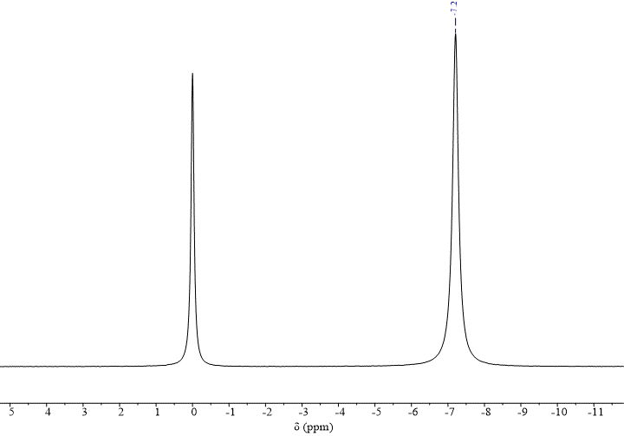
Supplementary Fig. 14. ²³Na NMR spectrum of 1.0-LiTFSI dissolved in ACN using 3 M NaCl in D₂O as an external standard.

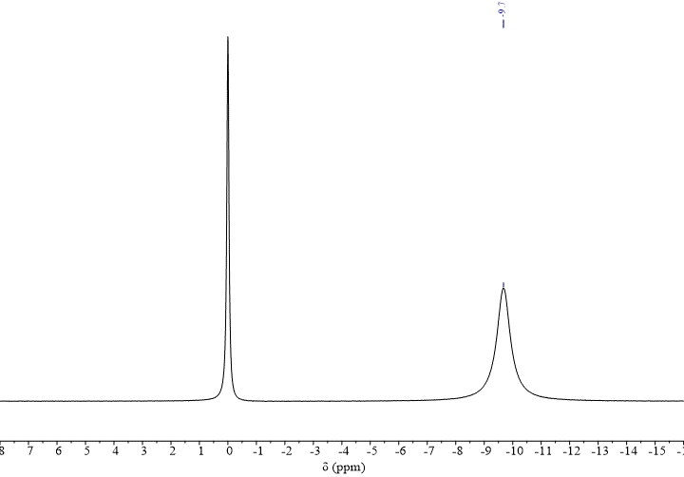
Supplementary Fig. 15. ²³Na NMR spectrum of EC/DEC (v/v = 1:1) using 3 M NaCl in D₂O as an external standard.

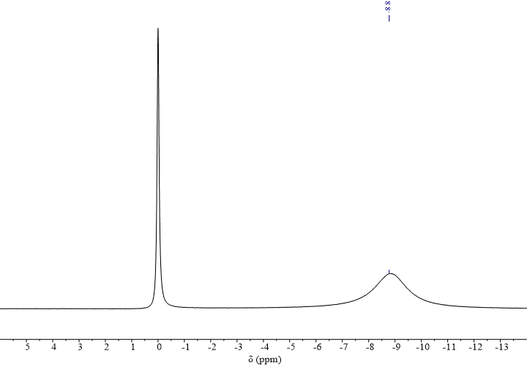
Supplementary Fig. 16. ²³Na NMR spectrum of 0.1- LiFEA in EC/DEC (v/v = 1:1) using 3 M NaCl in D₂O as an external standard.

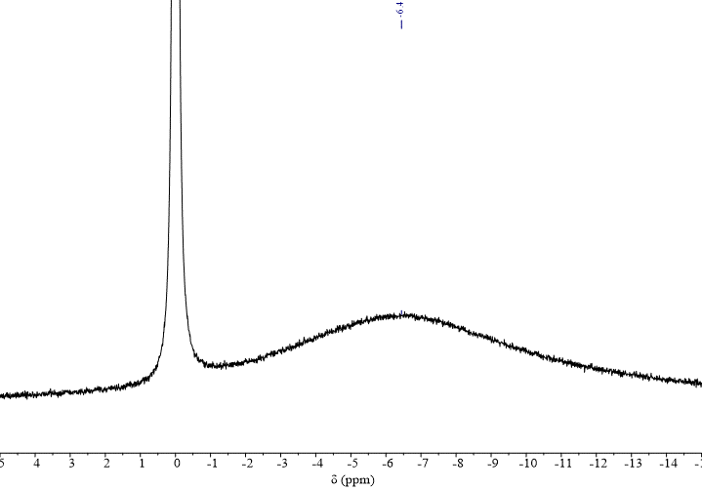
Supplementary Fig. 17. ²³Na NMR spectrum of 0.1-LiFEA in EC/DEC (v/v = 1:1) using 3 M NaCl in D₂O as an external standard.

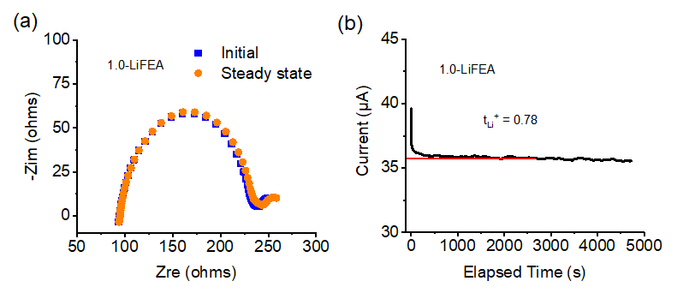
Supplementary Fig. 18. Li⁺ transference number measurement of 1.0-LiFEA in RCE with Li||Li symmetric cells. (a) Nyquist plots of the initial and steady state with a 10-mV polarization for transference number calculation. (b) Current changes under constant polarization.

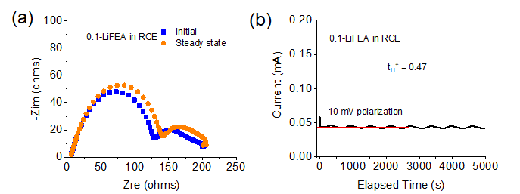
Supplementary Fig. 19. Li⁺ transference number measurement of 0.1-LiFEA in RCE. (a) Nyquist plots of the initial and steady state with a 10-mV polarization for transference number calculation. (b) Current changes under constant polarization.

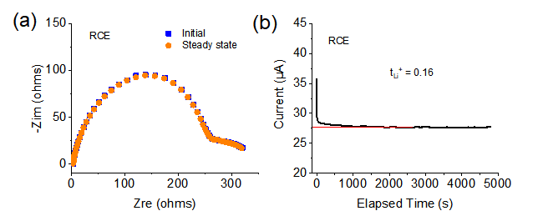
Supplementary Fig. 20. Li⁺ transference number measurement of RCE. (a) Nyquist plots of the initial and steady state with a 10-mV polarization for transference number calculation. (b) Current changes under constant polarization.

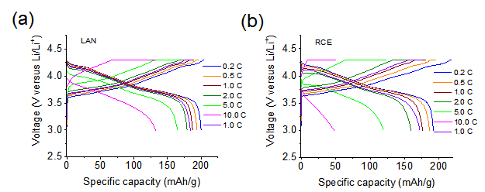
Supplementary Fig. 21. Voltage curves of LAN (a) and RCE (b) under different current rates from 0.2 to 10 C.

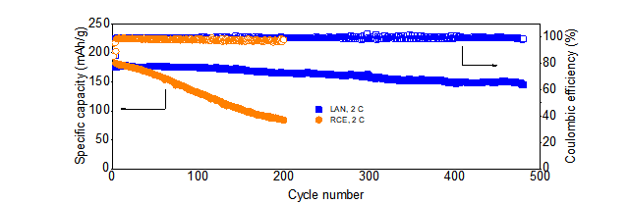
Supplementary Fig. 22. Cycling performance of Li||NCM811 coin cells with LAN and RCE at a current rate of 2 C.

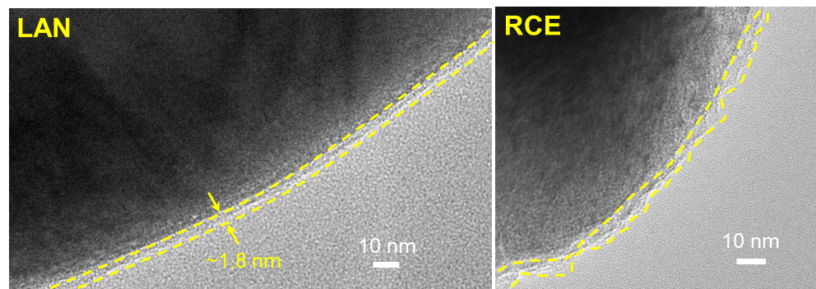
Supplementary Fig. 23. TEM images of CEI layers coated on the NCM811 particle surface. NCM particles cycled in LAN and RCE. The cells were operated for 20 cycles at a 5 C rate.

LiFEA electrolytes contributed to stabilize the NCM811 cathodes by ultrathin, robust CEI layers. For the electrode cycled in RCE, some NCM particles carried a highly heterogeneous layer of CEI (Supplementary Fig. 23), but that coating layer did not cover each individual particle with an even thickness, in accordance with previous reports¹⁶. This kind of CEI resulted in continuing side reactions and repeated reconstructing of the fragile CEI, inducing a soaring interfacial resistance and internal resistance (Supplementary Fig. 24). Contrastingly, the cathode particles are uniformly coated with thin CEI layers at the edges of interfaces when LiFEA-based electrolyte was applied, as outlined by the yellow dashed lines. Specifically, for the same cycling condition in LA and LAN, the thickness of CEI layers varied slightly from ~1.6 to ~1.8 nm. The unlike CEI structures were found to greatly affect the interface and charge transfer resistance throughout whole cycling life. Supplementary Fig. 24 clearly illustrates a two-semicircle curve, which revealed the rapid formation of the CEI layer in LAN during the initial 5 cycles. Benefiting from this established CEI layer, the battery maintained a lower interface resistance after 75 cycles because the well-defined CEI layer protected cathodes from directly contacting electrolytes, largely suppressing side reactions between electrode and electrolyte. Strikingly, this result supports solid proof that LiFEA is capable of endowing carbonate electrolytes with a nature of fast charging/discharging capability.
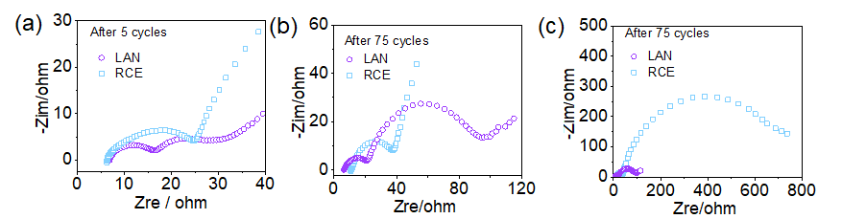
Supplementary Fig. 24. Nyquist plots of Li||NCM811 batteries for LAN and RCE after 5 cycles (a) and 75 cycles (b). c, A full scale of figure b.

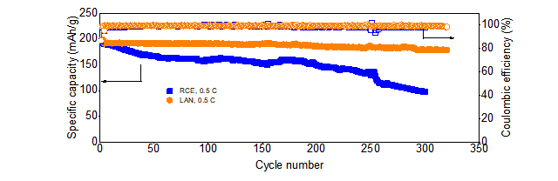Supplementary Fig. 25. Cycling performance comparison of LAN and RCE under a current rate of 5 C for Li||NCM811 coin cells.

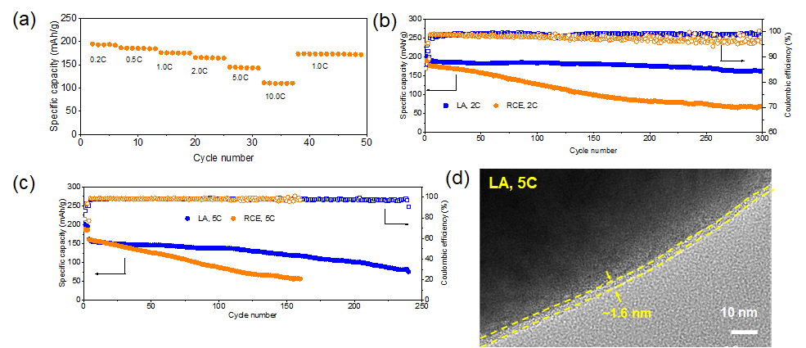
Supplementary Fig. 26. LA enabling a superb rate capability, cycling performance and uniform CEI layer for Li||NCM811 coin cells. (a) Cycling performance at different charging/discharging rates. (b) Discharging capacity retention performance compared to RCE at 2 C rate. (c) Fast charging/discharging performance at 5 C rate. (d) TEM image of CEI layer coated on the NCM811 particle surface.
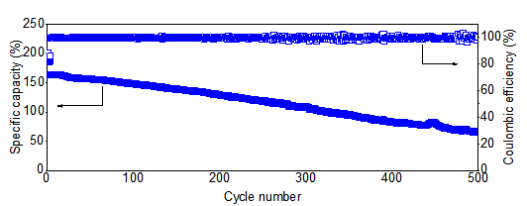
Supplementary Fig. 27. Poor cyclability of Li||NCM811 cells using the electrolyte of DGE-LN at a charging/discharging rate of 5 C.

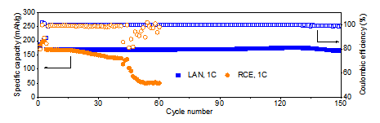
Supplementary Fig. 28. Full cell cycling performance of the LAN and RCE.

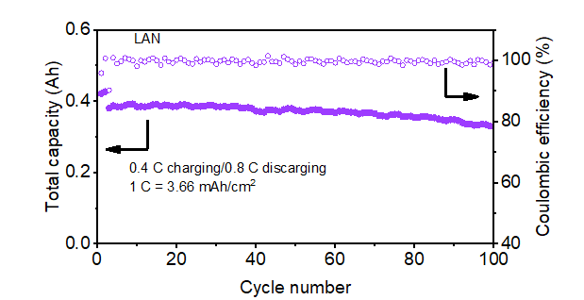
Supplementary Fig. 29. Fast discharging performance of Li||NCM811 pouch cell at 0.4 C charging and 0.8 C discharging.

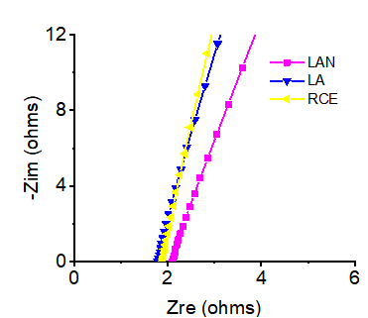
Supplementary Fig. 30. Electrical impedance spectroscopy (EIS) of RCE and LiFEA-based electrolytes (LA and LAN).

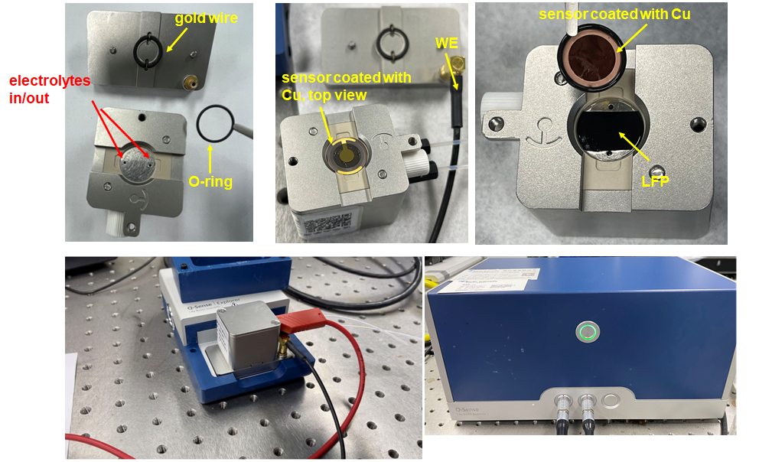
Supplementary Fig. 31. Photograph of QCM instrument and some important accessories exhibited in Fig. 6b.

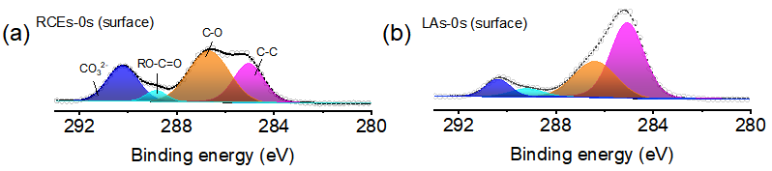
Supplementary Fig. 32. XPS spectra of C 1s for SEI layers soaked in RCE or LA. The SEI layers were generated in RCE after cycling at 3 mA/cm² (1 mAh/cm²) for 10 cycles. SEI layers were treated with electrolytes over 2 days.

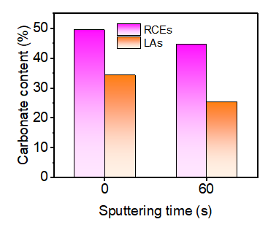
Supplementary Fig. 33. Different soaking electrolytes resulted in the changes of carbonate contents in SEI layers. The contents were calculated from respective peaks area in O 1s spectra, according to the followed equation:
$$\text{Carbonate} \text{contents }\left(\text{\%}\right)={100\%×A(Li\text{2}CO\text{3}/ROCO\text{2}Li)}/{A(O 1s)}$$

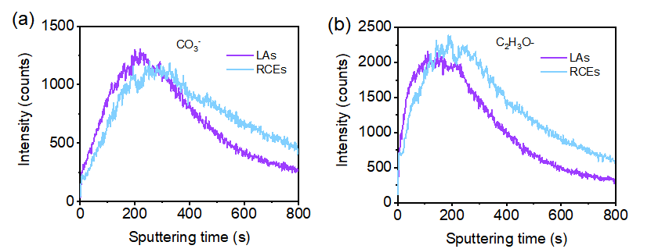
Supplementary Fig. 34. TOF-SIMS depth profiles of CO₃⁻ (a) and C₂H₃O⁻ (b) from SEI layers soaked in LA or RCE. Its normalized data listed in Fig. 7c.

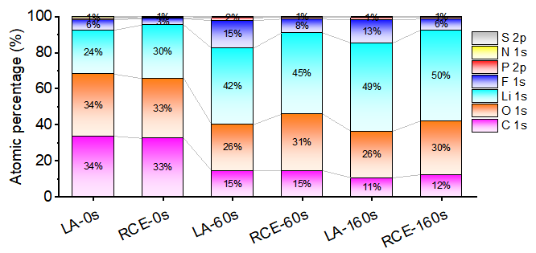
Supplementary Fig. 35. The elemental compositions of SEI layers formed in LA and RCE at different sputtering depths.

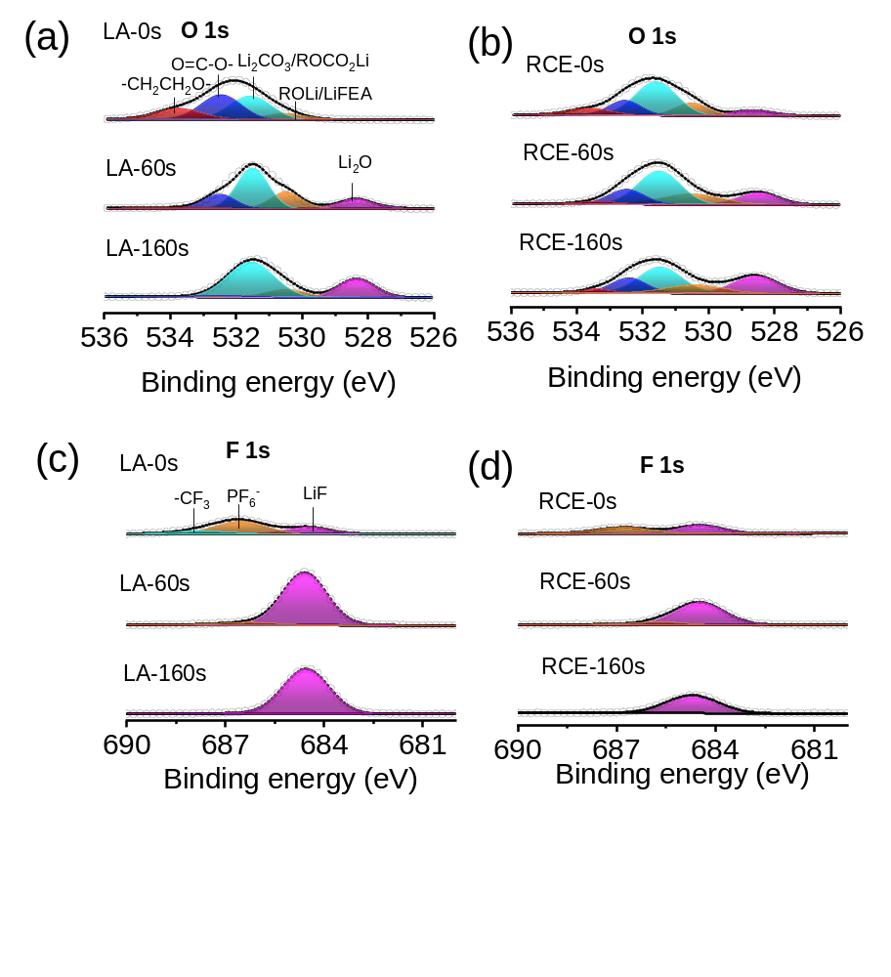
Supplementary Fig. 36. XPS spectra of SEI layers formed in LA or RCE. The O 1s (a, b) and F 1s (c, d) spectra showed in columns indicating depth profiling results.

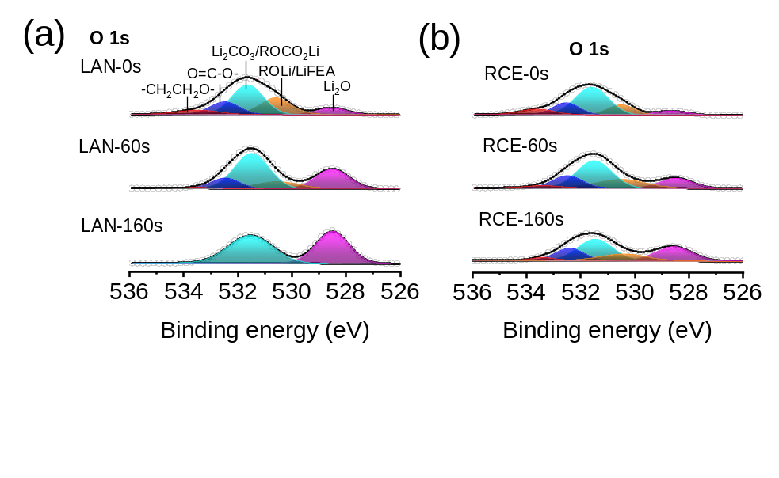
Supplementary Fig. 37. XPS O 1s spectra of SEI layers formed in LAN (a) as compared to those of RCE (b).

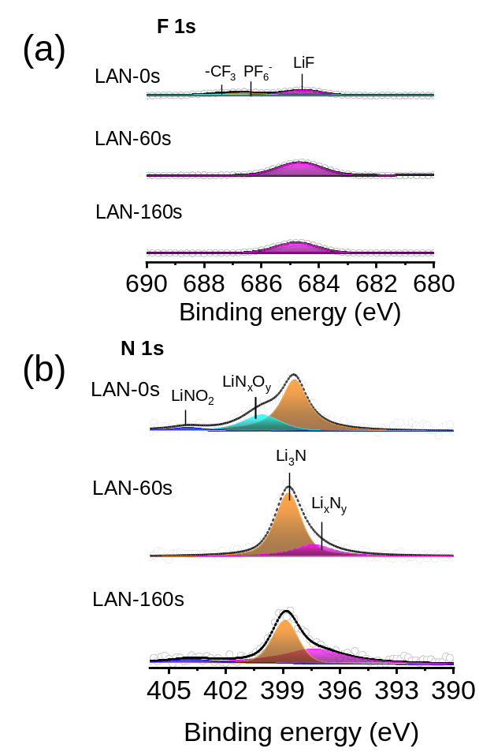
Supplementary Fig. 38. XPS spectra of SEI layers formed in LAN. The F 1s (a) and N 1s (b) spectra showed in columns indicating depth profiling results.

Supplementary Fig. 39. SEM images of Li metal deposited on Cu substrates in LA, LAN and RCE at different current densities with an areal capacity of 1 mAh/cm². The used Li||Cu cells were obtained after one discharge/charge cycles.

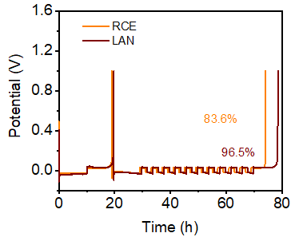
Supplementary Fig. 40. Coulombic efficiency of Li metal in Li||Cu half cells measured by Aurbach measurement¹⁷. LAN and RCE were used for cycling these half cells, respectively.

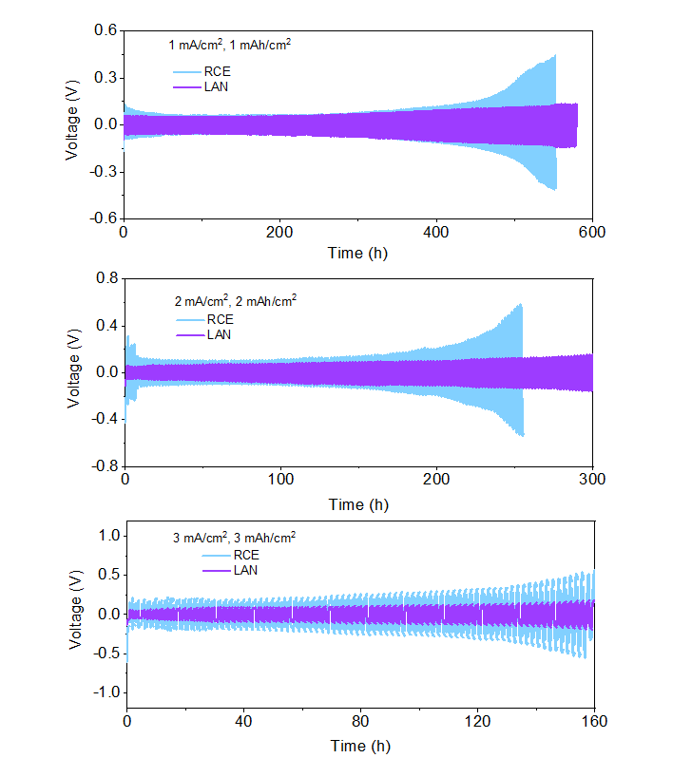
Supplementary Fig. 41. Cycling performance of Li||Li symmetric cells with LAN and RCE under current densities of 1 mA/cm², 2 mA/cm² and 3 mA/cm².

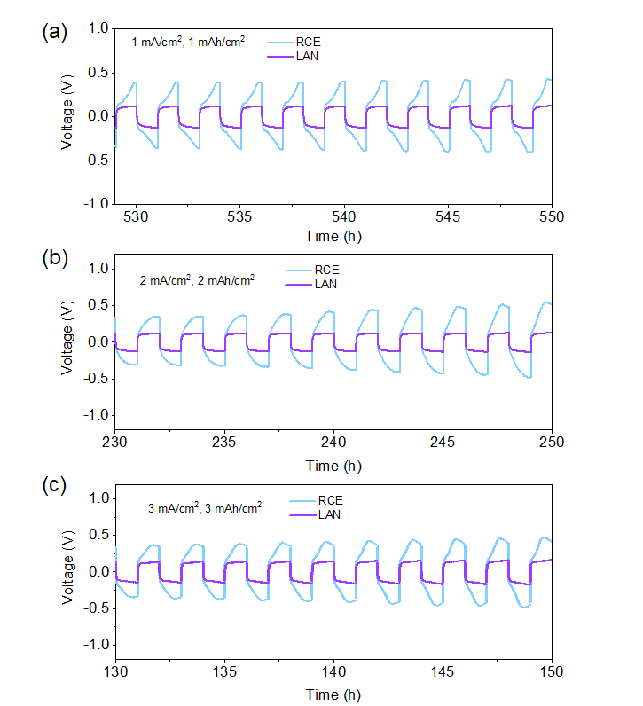
Supplementary Fig. 42. Stable cycling overpotential of LAN. The charge/discharge curves are enlarged portions of Supplementary Fig. 41 to enable a contrast comparison.
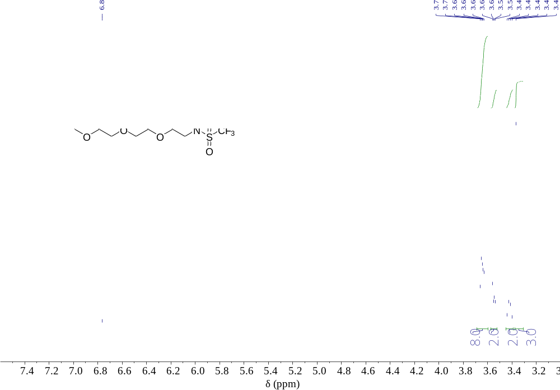
Supplementary Fig. 43. ¹H NMR spectrum (400 MHZ) of HFEA in CDCl₃.

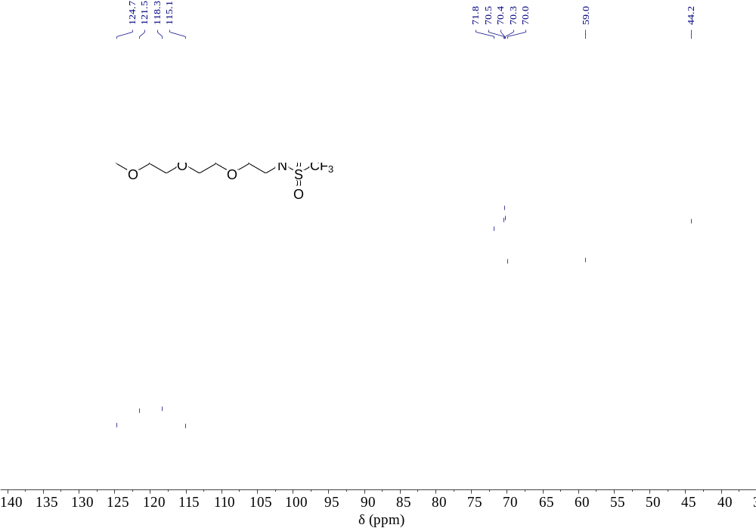
Supplementary Fig. 44. ¹³C NMR spectrum (100 MHZ) of HFEA in CDCl₃.

Supplementary Fig. 45. ¹⁹F NMR spectrum of HFEA in CDCl₃.

References
1. Xue, W. et al. Ultra-high-voltage Ni-rich layered cathodes in practical Li metal batteries enabled by a sulfonamide-based electrolyte. Nature Energy 6, 495-505 (2021).

2. Jin, C. et al. Rejuvenating dead lithium supply in lithium metal anodes by iodine redox. Nature Energy 6, 378-387 (2021).

3. Niu, C. et al. Balancing interfacial reactions to achieve long cycle life in high-energy lithium metal batteries. Nature Energy 6, 723-732 (2021).

4. Qiao, Y. et al. A high-energy-density and long-life initial-anode-free lithium battery enabled by a Li2O sacrificial agent. Nature Energy 6, 653-662 (2021).

5. Yu, Z. et al. Molecular design for electrolyte solvents enabling energy-dense and long-cycling lithium metal batteries. Nature Energy 5, 526-533 (2020).

6. Niu, C. et al. High-energy lithium metal pouch cells with limited anode swelling and long stable cycles. Nature Energy 4, 551-559 (2019).

7. Cao, X. et al. Monolithic solid–electrolyte interphases formed in fluorinated orthoformate-based electrolytes minimize Li depletion and pulverization. Nature Energy 4, 796-805 (2019).

8. Yu, Z. et al. Rational solvent molecule tuning for high-performance lithium metal battery electrolytes. Nature Energy 7, 94-106 (2022).

9. Kim, M. S. et al. Suspension electrolyte with modified Li(+) solvation environment for lithium metal batteries. Nature Materials 21, 445-454 (2022).

10. Qiao, L. et al. Stable non-corrosive sulfonimide salt for 4-V-class lithium metal batteries. Nature Materials 21, 455-462 (2022).

11. Wang, Q. et al. Interface chemistry of an amide electrolyte for highly reversible lithium metal batteries. Nature Communications 11, 4188 (2020).

12. Zheng, J. et al. Electrolyte additive enabled fast charging and stable cycling lithium metal batteries. Nature Energy 2, (2017).

13. Zhang, X. Q. et al. A Sustainable Solid Electrolyte Interphase for High-Energy-Density Lithium Metal Batteries Under Practical Conditions. Angewandte Chemie 59, 3252-3257 (2020).

14. Kim, M. S. et al. Langmuir–Blodgett artificial solid-electrolyte interphases for practical lithium metal batteries. Nature Energy 3, 889-898 (2018).

15. Niu, C. et al. Self-smoothing anode for achieving high-energy lithium metal batteries under realistic conditions. Nature Nanotechnology 14, 594-601 (2019).

16. Zhang, Z. et al. Cathode-Electrolyte Interphase in Lithium Batteries Revealed by Cryogenic Electron Microscopy. Matter 4, 302-312 (2021).

17. Adams, B. D. et al. Accurate Determination of Coulombic Efficiency for Lithium Metal Anodes and Lithium Metal Batteries. Advanced Energy Materials 8, (2017).

