Supplementary Material
Identification of disinfection by-product precursors by natural organic matter fractionation: a review
Karlien Dejaeger^{a,b,c}, Justine Criquet^{b}, Marjolein Vanoppen^{a,d}, Cécile Vignal^{c}, Gabriel Billon^{b} and Emile R. Cornelissen^{*,a,d,e}
Corresponding author: Emile Cornelissen, emile.cornelissen@ugent.be. Coupure Links 653, 9000 Ghent, Belgium
ª PaInT, Particle and Interfacial Technology group, Department of Green Chemistry and Technology, Faculty of Bioscience Engineering, Ghent University, Coupure Links 653, 9000 Ghent, Belgium
^{b} Univ. Lille, CNRS, UMR 8516 - LASIRE, Laboratoire Avancé de Spectroscopie pour les Interactions, la Réactivité et l’Environnement F-59000 Lille, France
c Univ. Lille, Inserm, CHU Lille, U1286 - INFINITE - Institute for Translational Research in Inflammation, F-59000 Lille, France
^{d} Centre for Advanced Process Technology for Urban Resource Recovery (CAPTURE), www.capture-resources.be, Belgium
^{e} KWR Water Research Institute, Groningenhaven 7, 3433 PE Nieuwegein, Netherlands

Table S1 Specific disinfection by-product formation potential (%) of halo-aldehydes, halo-ketones, haloacetonitriles and nitrogenous disinfection by-products (N-DBPs) in different membrane fractions with high chlorine dose. SUVA₂₅₄ = specific ultraviolet absorbance at 254 nm. The chlorination time is given in the last column. All fractions seem to contribute to the same extent towards emerging disinfection by-product formation potential, but the data is too limited for a thorough assessment. (Hua et al., 2015; Hua et al., 2020; Lin et al., 2014; Zhang et al., 2021; Zhang et al., 2020)
 | <1kDa | 1-3kDa | 3-5kDa | 5-10kDa | >10kDa | SUVA₂₅₄ (L/(mg∙m)) | Time (h)
Halo-aldehydes | 26 | 23 | 23 | 28 |  |  | 72
Halo-aldehydes | 34 | 20 | 22 | 24 |  |  | 72
Halo-ketones | 32 | 25 | 22 | 21 |  |  | 72
Halo-ketones | 23 | 8 | 15 |  | 54 | 0.97 | 168
Halo-ketones | 37 | 27 | 18 | 18 |  |  | 72
Halo-ketones | 28 |  | 35 |  | 37 | 4.4 | 48
Halo-ketones | 28 |  | 38 |  | 34 | 2.9 | 48
Halo-ketones | 50 |  | 5 |  | 45 | 1.8 | 48
Haloacetonitriles | 30 | 25 | 25 | 20 |  |  | 72
Haloacetonitriles | 0 | 0 | 27 |  | 73 | 0.97 | 168
Haloacetonitriles | 31 | 23 | 31 | 15 |  |  | 72
Haloacetonitriles | 39 |  | 28 |  | 33 | 4.4 | 48
Haloacetonitriles | 46 |  | 26 |  | 28 | 2.9 | 48
Haloacetonitriles | 55 |  | 24 |  | 21 | 1.8 | 48
N-DBPs | 14 | 37 |  |  | 49 |  | 168
N-DBPs | 22 | 44 |  |  | 34 |  | 168

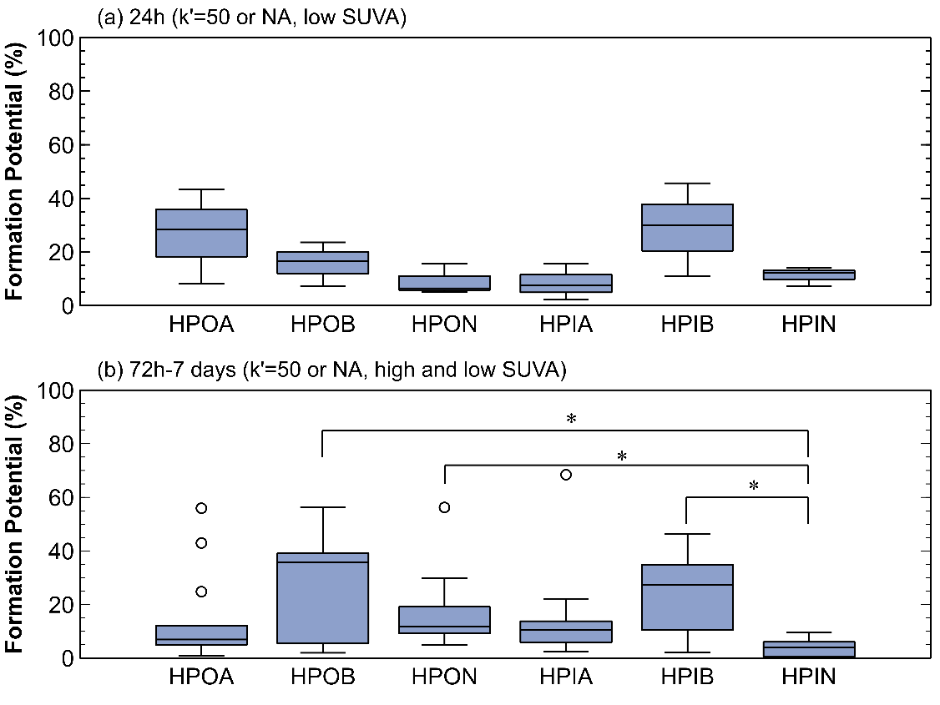
Fig. S 1 Specific trihalomethane formation potential (%) in the hydrophobic acid (HPOA), base (HPOB), neutral (HPON) and hydrophilic acid (HPIA), base (HPIB) and neutral (HPIN) fraction after (a) 24h, low specific ultraviolet absorbance at 254 nm (SUVA₂₅₄), column capacity factor k’ is 50 or not available (NA), low chlorine dose (3 water samples) (b) 7 days, SUVA₂₅₄ is high, low or not available and k’ is 50 or not available, high chlorine dose (12 water samples). * = statistical difference, ° = outlier. Both hydrophobic and hydrophilic base compounds are identified as important contributors to trihalomethane formation potential, especially compared to hydrophilic neutrals at high chlorine dose. Low SUVA₂₅₄ waters (<2 L/(mg∙m)) showed slightly higher contribution of hydrophobic acid and hydrophilic base fractions
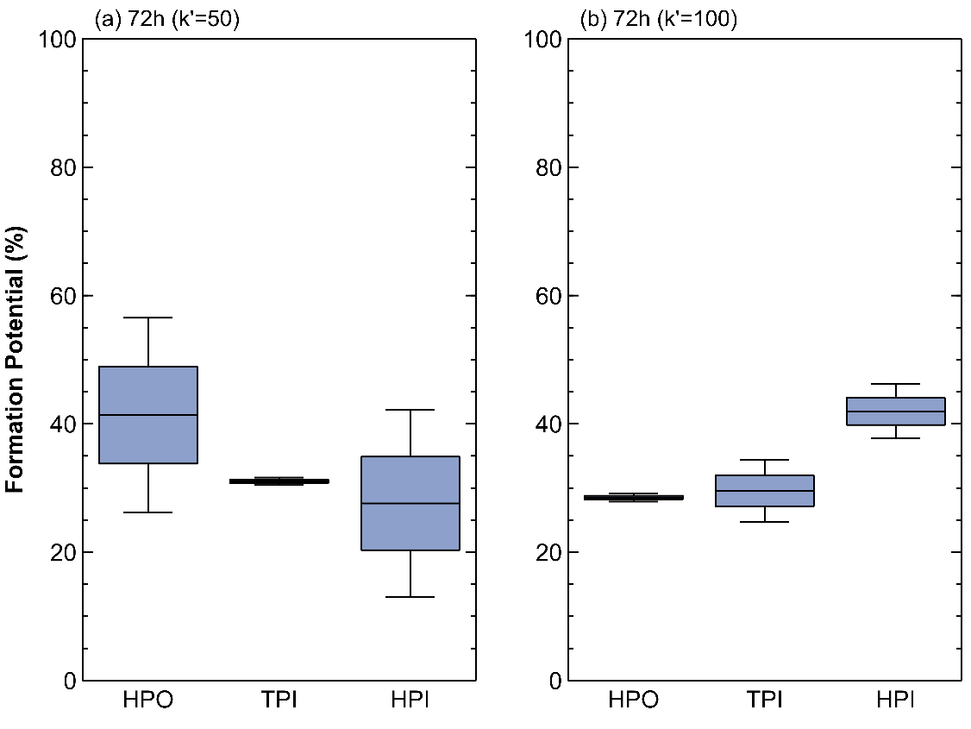
Fig. S 2 Specific trihalomethane formation potential (%) in the hydrophobic (HPO), transphilic (TPI) and hydrophilic (HPI) fraction after 72h, specific ultraviolet absorbance at 254 nm (SUVA₂₅₄) is high, low or not available, high chlorine dose (a) column capacity factor k’ is 50 (2 water samples) and (b) the column capacity factor k’ is 100 (2 water samples). When the column capacity factor k’ increases from 50 to 100, a shift in highest specific trihalomethane formation potential is seen from the hydrophobic towards the hydrophilic fraction.
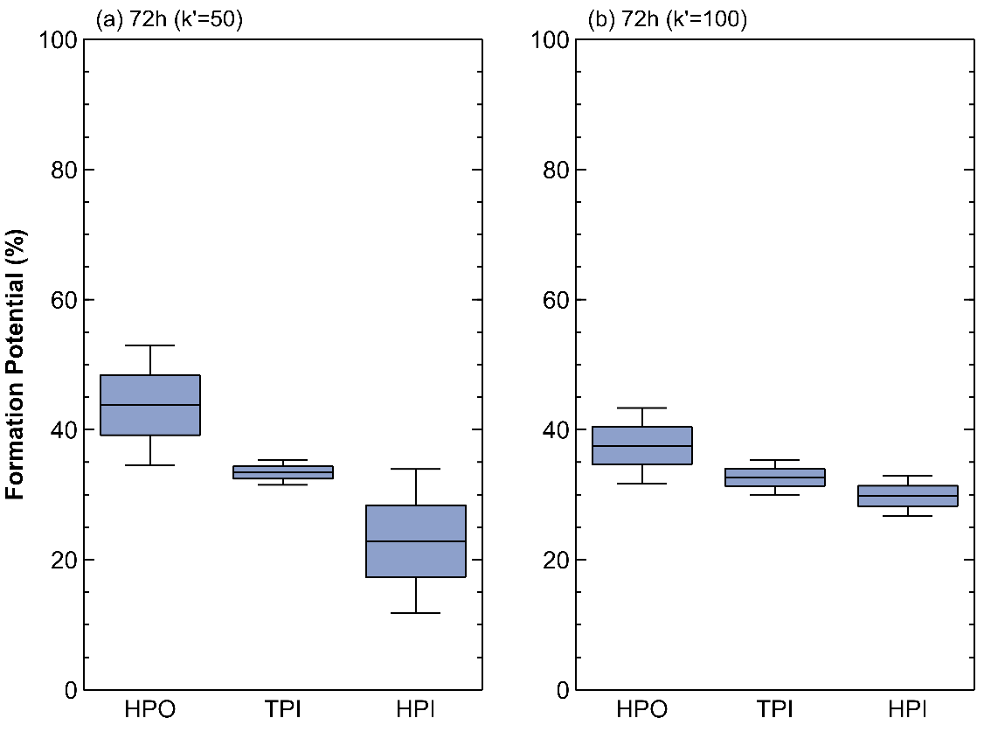
Fig. S 3 Specific haloacetic acid formation potential (%) in the hydrophobic (HPO), transphilic (TPI) and hydrophilic (HPI) fraction after 72h, specific ultraviolet absorbance at 254 nm (SUVA₂₅₄) is high, low or not available, high chlorine dose (a) column capacity factor k’ is 50 (2 water samples) and (b) column capacity factor k’ is 100 (2 water samples). When the column capacity factor k’ increases from 50 to 100, the difference in specific haloacetic acid formation potential between hydrophobic and hydrophilic fractions becomes substantially smaller.
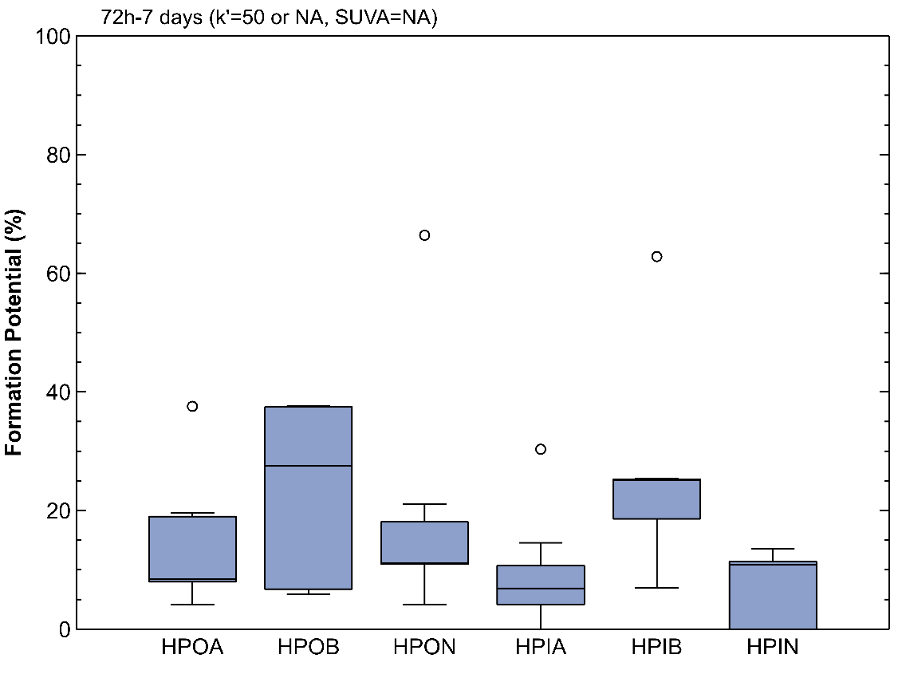
Fig. S 4 Specific haloacetic acid formation potential (%) in the hydrophobic acid (HPOA), base (HPOB), neutral (HPON) and hydrophilic acid (HPIA), base (HPIB) and neutral (HPIN) fraction after 72h and 7 days, specific ultraviolet absorbance at 254 nm (SUVA₂₅₄) is not available (NA) (1x high), column capacity factor k’ is 50 or not available, high chlorine dose (7 water samples). ° = outlier. Hydrophobic and hydrophilic base fractions appear to have slightly higher tendency to form haloacetic acids, although this tendency is not statistically significant.
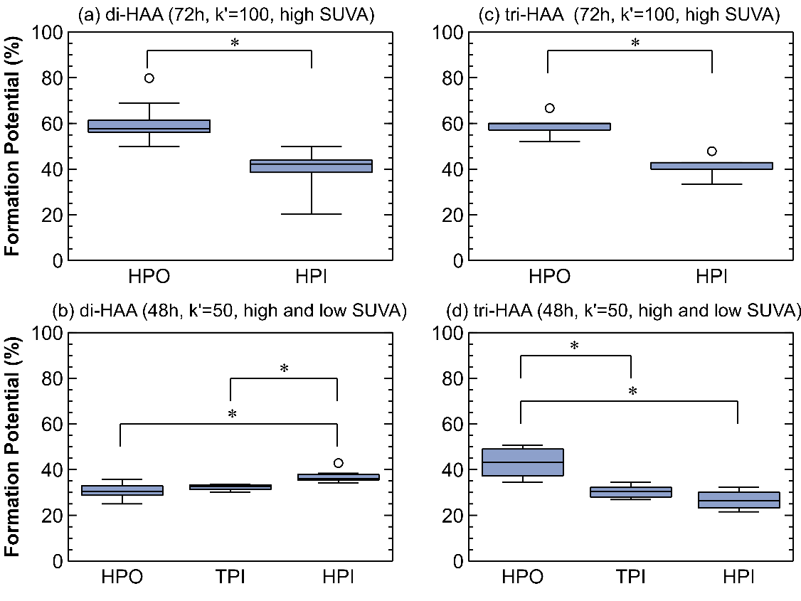
Fig. S 5 Specific haloacetic acid formation potential (%) in (a,c) the hydrophobic (HPO) and hydrophilic (HPI) fraction after 72h, high specific ultraviolet absorbance at 254 nm (SUVA₂₅₄), column capacity factor k’ is 100 and low chlorine dose (b,d) hydrophobic (HPO), transphilic (TPI) and hydrophilic (HPI) fraction after 48h, high and low SUVA₂₅₄, k’ is 50, low chlorine dose (a,b) Specific di-halogenated acetic acid formation potential (%) (c,d) Specific tri-halogenated acetic acid formation potential (%) (a) 10 water samples (b) 6 water samples (c) 5 water samples (d) 6 water samples. * = statistical difference, ° = outlier. The hydrophobic fraction has significantly higher tri-halogenated acetic acid formation potential regardless of the column capacity factor. On the other hand, hydrophobic compounds are only important for di-halogenated acetic acid formation when the column capacity factor is 100. For a k’-factor of 50, hydrophilic compounds have significantly higher di-halogenated acetic acid formation potential.

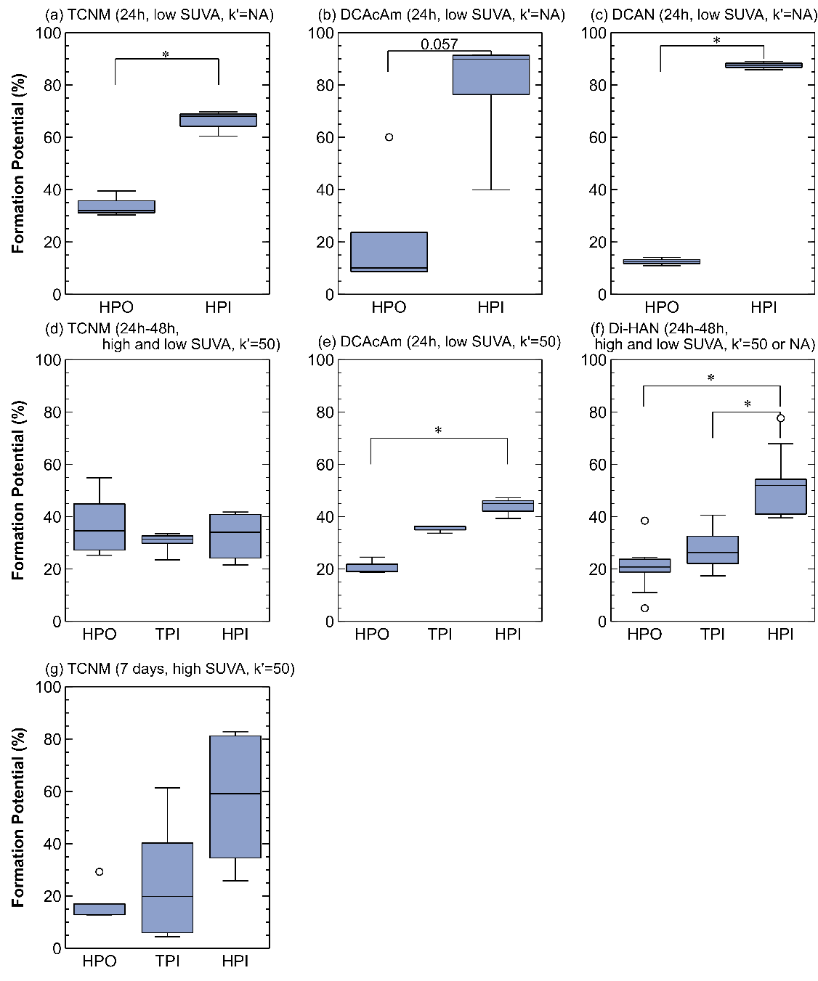
Fig. S 6 Specific disinfection by-product formation potential (%) in the hydrophobic (HPO) and hydrophilic (HPI) fraction after 24h chlorination, low specific ultraviolet absorbance at 254 nm (SUVA₂₅₄), column capacity factor k’ is not available (NA), high chlorine dose of (a) trichloronitromethane (TCNM) (3 water samples) (b) dichloroacetamide (DCAcAm) (4 water samples) and (c) dichloroacetonitrile (DCAN) (3 water samples). Specific disinfection by-product formation potential (%) in the hydrophobic (HPO), transphilic (TPI) and hydrophilic (HPI) fraction of (d) TCNM after 24h-48h, high and low SUVA₂₅₄ , k’ is 50, high and low chlorine dose (6 water samples) (e) DCAcAm after 24h, low SUVA₂₅₄, k’ is 50, high chlorine dose (3 water samples) (f) di-halogenated acetonitrile, 24h-48h, high and low SUVA₂₅₄, k’ is 50 or not available, high and low chlorine dose (12 water samples) and (g) TCNM after 7 days, high SUVA₂₅₄ and k’ is 50 (4 water samples). * = statistical difference, ° = outlier. From the data, it is clear that all families are preferentially formed in the hydrophilic fraction, although this was not always statistically significant for trichloronitromethane

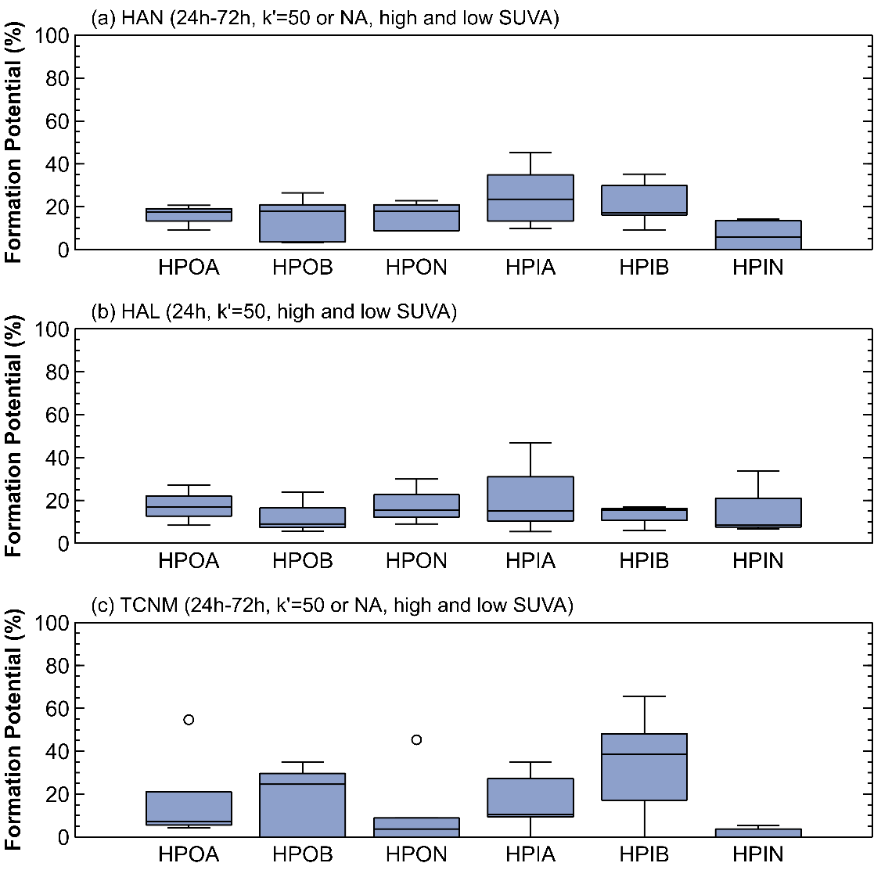
Fig. S 7 Specific disinfection by-product formation potential (%) in the hydrophobic acid (HPOA), base (HPOB), neutral (HPON) and the hydrophilic acid (HPIA), base (HPIB) and neutral (HPIN) fraction (a) haloacetonitrile (HAN) formation potential after 24h-72h, column capacity factor k’ is 50 or not available (NA), specific ultraviolet absorbance at 254 nm (SUVA₂₅₄) is high, low or not available (5 water samples) (b) halo-aldehyde (HAL) formation potential after 24h, k’ is 50, high and low SUVA₂₅₄ (3 water samples) and (c) trichloronitromethane (TCNM) formation potential after 24h-72h, k’ is 50 or not available, SUVA₂₅₄ is high, low or not available (5 water samples). All fractions seem to contribute to the same extent to the specific formation potential of each disinfection by-product. More data is needed to highlight any trends.
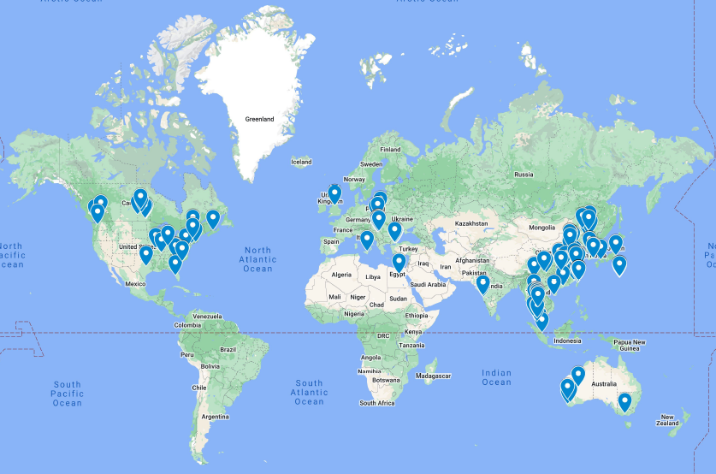
Fig. S 8 Overview of all fresh water sources included in this review. A high number of publications were found in the United States and Asia.

References
Hua, G.H., Reckhow, D.A. and Abusallout, I. 2015. Correlation between SUVA and DBP formation during chlorination and chloramination of NOM fractions from different sources. Chemosphere 130, 82-89. https://doi.org/10.1016/j.chemosphere.2015.03.039
Hua, L.-C., Chao, S.-J., Huang, K. and Huang, C. 2020. Characteristics of low and high SUVA precursors: Relationships among molecular weight, fluorescence, and chemical composition with DBP formation. Science of The Total Environment 727, 138638. https://doi.org/10.1016/j.scitotenv.2020.138638
Lin, L., Xu, B., Lin, Y.-L., Hu, C.-Y., Ye, T., Zhang, T.-Y. and Tian, F.-X. 2014. A comparison of carbonaceous, nitrogenous and iodinated disinfection by-products formation potential in different dissolved organic fractions and their reduction in drinking water treatment processes. Separation and Purification Technology 133, 82-90. https://doi.org/10.1016/j.seppur.2014.06.046
Zhang, X., Shen, J., Huo, X., Li, J., Zhou, Y., Kang, J., Chen, Z., Chu, W., Zhao, S., Bi, L., Xu, X. and Wang, B. 2021. Variations of disinfection byproduct precursors through conventional drinking water treatment processes and a real-time monitoring method. Chemosphere 272, 129930. https://doi.org/10.1016/j.chemosphere.2021.129930
Zhang, X.X., Chen, Z.L., Shen, J.M., Zhao, S.X., Kang, J., Chu, W., Zhou, Y.Y. and Wang, B.Y. 2020. Formation and interdependence of disinfection byproducts during chlorination of natural organic matter in a conventional drinking water treatment plant. Chemosphere 242. https://doi.org/10.1016/j.chemosphere.2019.125227

