Supplementary Material to:
An impedance flow cytometry with integrated dual microneedle for electrical properties characterization of single cell

Muhammad Asraf Mansorª, Mohd Ridzuan Ahmad*ª, Michal Petrů^{b} and Seyed Saeid Rahimian Koloor^{b}

ªDivision of Control and Mechatronics Engineering, School of Electrical Engineering, Faculty of Engineering, Universiti Teknologi Malaysia, 81310 Skudai, Johor, Malaysia.
^{b}Institute for Nanomaterials, Advanced Technologies and Innovation, Technical University of Liberec, Studentska 2, 461 17 Liberec, Czech Republic.

S.1 Single cell measurement concept
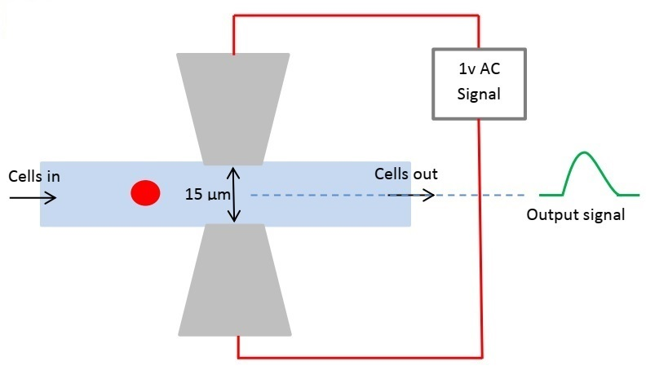
Figure S1: A multifrequency AC voltage signal is applied to the electrode when a single cell flows through and the measured impedance as an output signal.

S.2 Electric model of a single-shell spherical cell
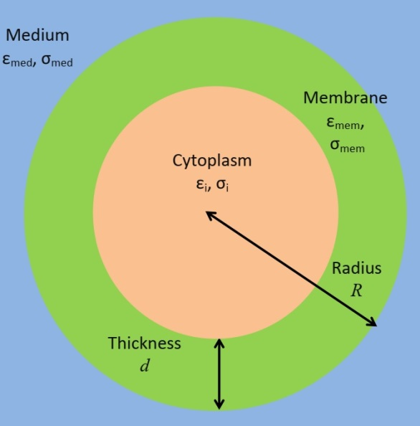

Figure S2: Diagram showing a single spherical particle in suspension

The estimation of the effective complex permittivity of a single shell spherical particle in suspension becomes extremely simple and straightforward when using Maxwell's Mixture Theory (MMT). As shown in Figure S1, for a suspension of the spherical particle (e.g. cells) in a medium, the total equivalent complex permittivity of the mixture suspending ${\tilde{ε}}_{mix}$ is given by:
$${\tilde{ε}}_{mix}={\tilde{ε}}_{med}\frac{1+2Φf_{cm}}{1- Φf_{cm}}$$
with $f_{cm}=\left(\frac{{\tilde{ε}}_{p}- {\tilde{ε}}_{med}}{{\tilde{ε}}_{p}+2 {\tilde{ε}}_{med}}\right)$ (the Clausius-Mossotti factor) and $\tilde{ε}=ε-j\frac{σ}{ω}$ , where ${\tilde{ε}}_{med}$ and ${\tilde{ε}}_{p}$ are the complex permittivity of the suspending medium and single shell cell, respectively. $\tilde{ε}$ is the complex permittivity, $ε$ is the permittivity, σ is the conductivity and ω is the angular frequency. Where $Φ$ is the volume fraction, the ratio between the volume of the cells to the detection volume is given by [1,2]:
$$Φ=\frac{4}{3}πR^{3}\frac{1}{A_{e}g}$$
where $A_{e}$ and g are the area of the electrode and the gap between electrode, respectively. Thus, ${\tilde{ε}}_{p}$ is given as follows:
$${\tilde{ε}}_{p}={\tilde{ε}}_{mem}\frac{{\left(\frac{R}{R-d}\right)}^{3}+2\left(\frac{{\tilde{ε}}_{i}-{\tilde{ε}}_{mem}}{{\tilde{ε}}_{i}+2{\tilde{ε}}_{mem}}\right)}{{\left(\frac{R}{R-d}\right)}^{3}-\left(\frac{{\tilde{ε}}_{i}-{\tilde{ε}}_{mem}}{{\tilde{ε}}_{i}+2{\tilde{ε}}_{mem}}\right)}$$
where ${\tilde{ε}}_{mem}$, ${\tilde{ε}}_{i}$ , $R$ and $d$ are the complex permittivity of the cell membrane, the complex permittivity of cytoplasm, the radius of the cell, and the thickness of the membrane. Thus, by using Maxwell's mixture theory, the complex impedance of a system may be directly linked to its geometric and dielectric characteristics.
$${\tilde{Z}}_{mix}=\frac{1}{jω{\tilde{ε}}_{mix}G}$$
Where G is the geometric cell constant of the system, which for an ideal and uniform electric field of parallel plate electrode system is A/g.
S.3 Dielectric dispersions
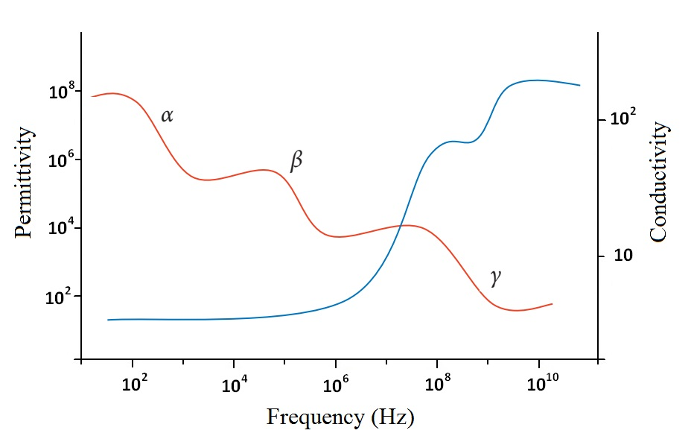
Figure S3: Permittivity and conductivity over the frequency spectrum, α, β, and γ dispersions

S.3.1 Alpha Dispersion
The α-dispersion occurs in low frequency at the range of 10 Hz to 10 kHz. This dispersion occurs near the cell membrane, where charged particle mobility is restricted.
S.3.2 Beta Dispersion
The β-dispersion arises within the frequency of 10 kHz–10MHz, which the cellular membranes and other intracellular bodies become, charge (capacitive). The cell membranes are electrically shorted, allowing current to pass through the cytoplasm. This penetration lowers the impedance, resulting in β-dispersion, interfacial polarisation, and the Maxwell–Wagner relation. This phenomenon happens at the interface of membrane-electrolyte systems with two different dielectrics, resulting in charge generation [2]. The degree of polarization is determined by the conductivity, permittivity, and structure of the various intracellular components. With rising frequency, the number of resistive components is cancelled out by their parallel capacitances, resulting in more electrically identical intracellular structures.
S.3.3 Gamma Dispersion
The γ dispersion at a frequency range above 1 GHz is attributed to the dipolar relaxation of water [3]. The majority of biological tissue investigation at these frequencies has simply included measuring the particular dielectric properties. However, it is expected that information about the cell's molecular structure will ultimately be discernible from measurements at these frequencies. Overall, IFC allows you to study diverse features of the cell and its surroundings, such as extracellular conductance, membrane impedance properties, and effective dielectric properties of intracellular structures, by adjusting the interrogation frequency.

S.4 Tungsten needle view

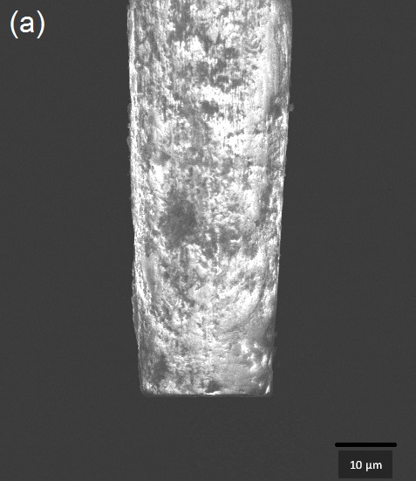 | 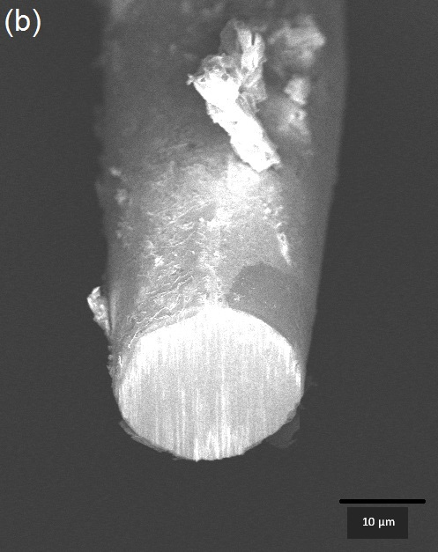
Figure S4: Tungsten needle in FIB-SEM view (a) Top view (b) Front view

S.5 Device Sensitivity Characterization
In principle, the diameter and the gap of electrodes affect the sensitivity of the measurement [4]. Sensitivity is improved by reducing the electrodes gap and diameter. Therefore minimizing the gap of electrodes for single-cell measurement is desirable. The sensitivity (S) of microfluidic IFC device can be represented as [5,6]:

$$S=\frac{Z_{mix} - Z_{solution} }{Z_{solution}}$$

where $Z_{solution}$ and $Z_{mix}$ are the complex impedance of the PBS and PBS with presence of particle, respectively. The device sensitivity of various electrode gaps with two different electrode tip diameters (25 µm and 35 µm) measured at a frequency of 500 kHz is shown in Table S1 and Table S2. The 7 µm diameter microbead and was utilized for sensitivity characterization. As expected, the bigger gap between electrodes gives the lowest sensitivity: 8.65x10⁻² and 7.06x10⁻² for tip diameters of electrode 25 µm and 35 µm, respectively.
Meanwhile, the high sensitivity occurs at the smallest electrodes gap 13.23x10⁻² and 11.14x10⁻² for diameters of electrode 25 µm and 35 µm, respectively. Increased electrode diameter reduces the magnitude of impedance, which is consistent with the impedance behavior of a capacitor [7–9]. As a result, expanding the electrode width decreases overall sensitivity while increasing the sensing area [10]. This result is in agreement with the previous work, in which decreasing the gap and diameter of the electrode increases the measurement sensitivity [11]. However, due to the clogging issue when the electrodes gap near to the diameter size of the particle, the 15 µm gap of the electrode has been chosen.

Table S1: Sensitivity of the IFC device at 500 kHz frequency measurement for various electrode gaps with electrode diameters of 25 µm.
Gap | Z_{mix} (Ω) | Z_{Solution} (Ω) | S (x10⁻²)
10 µm | 42889 | 37876 | 13.23
15 µm | 43851 | 38921 | 12.67
20 µm | 45254 | 40753 | 11.04
30 µm | 46879 | 43147 | 8.65

Table S2: Sensitivity of the IFC device at 500 kHz frequency measurement for various electrode gaps with electrode diameters of 35 µm.
Gap | Z_{mix} (Ω) | Z_{Solution} (Ω) | S (x10⁻²)
10 µm | 40654 | 36579 | 11.14
15 µm | 41421 | 37433 | 10.65
20 µm | 43098 | 39265 | 9.76
30 µm | 44737 | 41788 | 7.06

S.6 Individual at Low Frequency
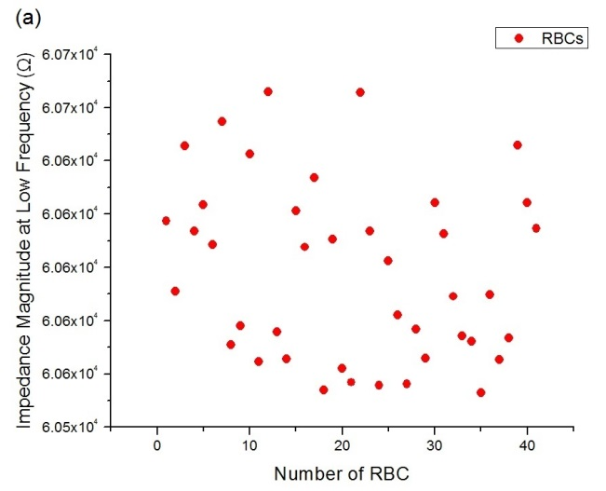 | 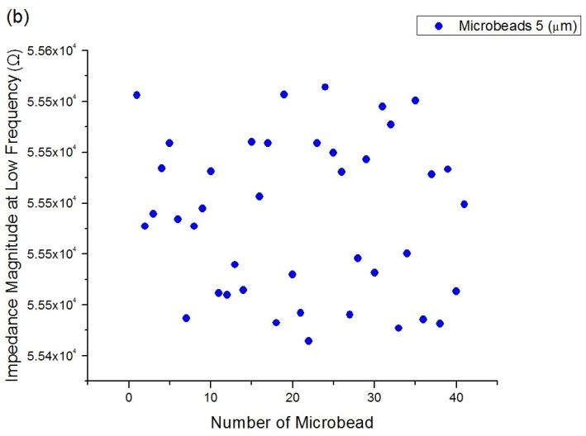
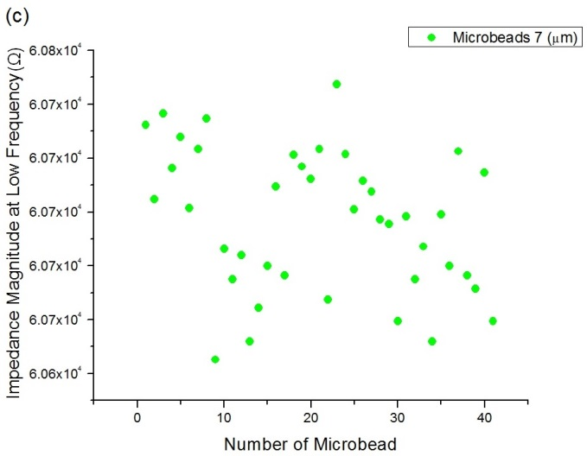 | 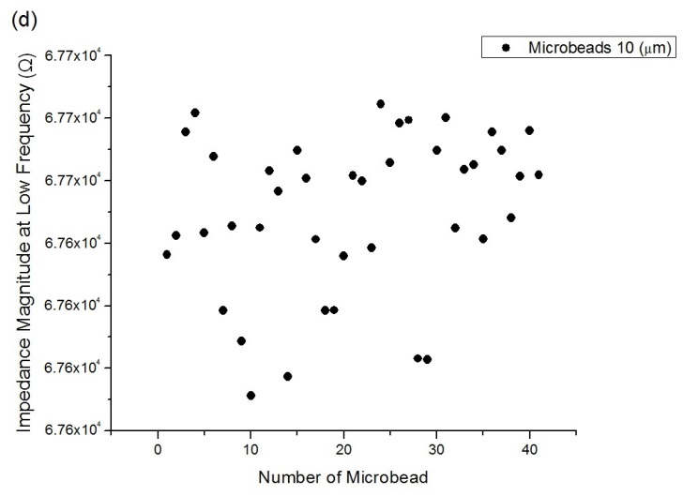
Figure S6: Impedance measurement of the individual particle (n~50) at low frequency (100 kHz) (a) RBCs (b) 5 µm diameter microbead (c) 7 µm diameter microbead (d) 10 µm diameter microbead

S.7 Individual at high frequency
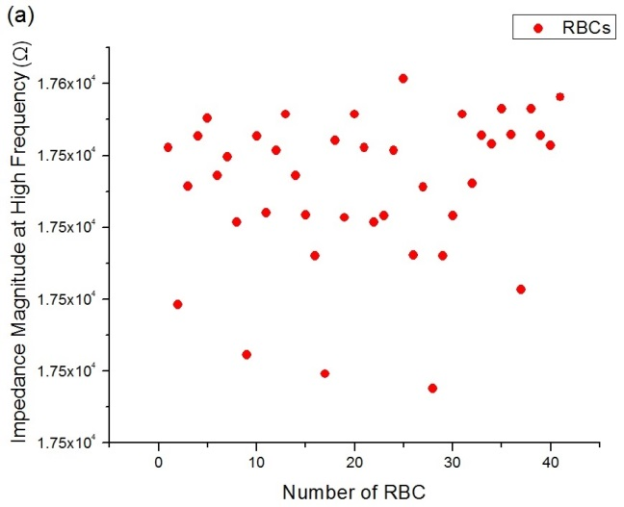 | 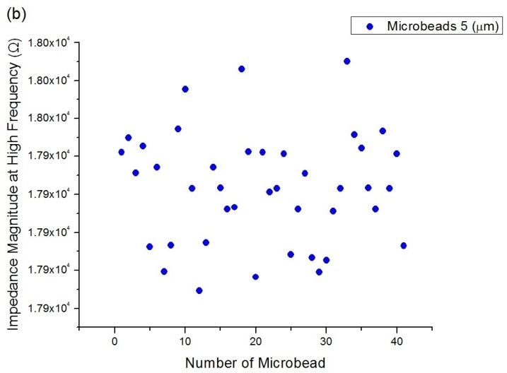
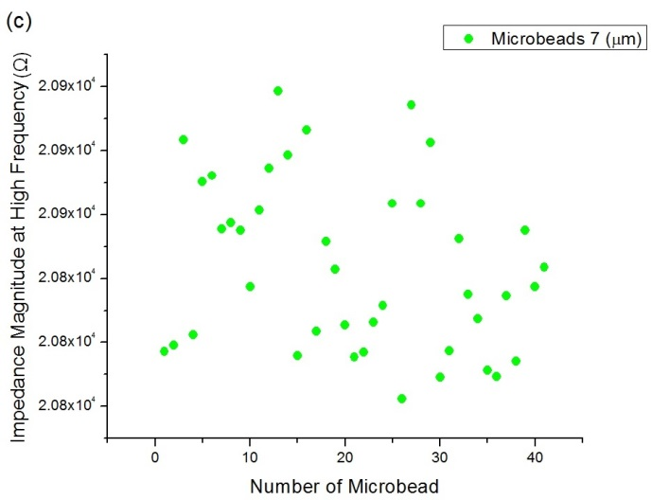 | 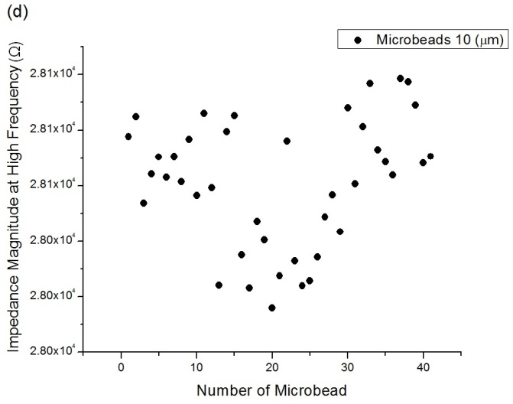
Figure S7: Impedance measurement of the individual particle (n~50) at high frequency (2 MHz) (a) RBCs (b) 5 µm diameter microbead (c) 7 µm diameter microbead (d) 10 µm diameter microbead.

S.8 RBC at sensing region
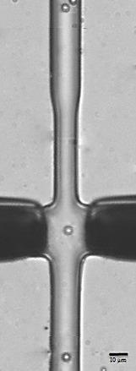
Figure S8: Image of the presence of single RBC at sensing area.

S.9 Threshold for accepted single RBC based on impedance change (ΔZ)

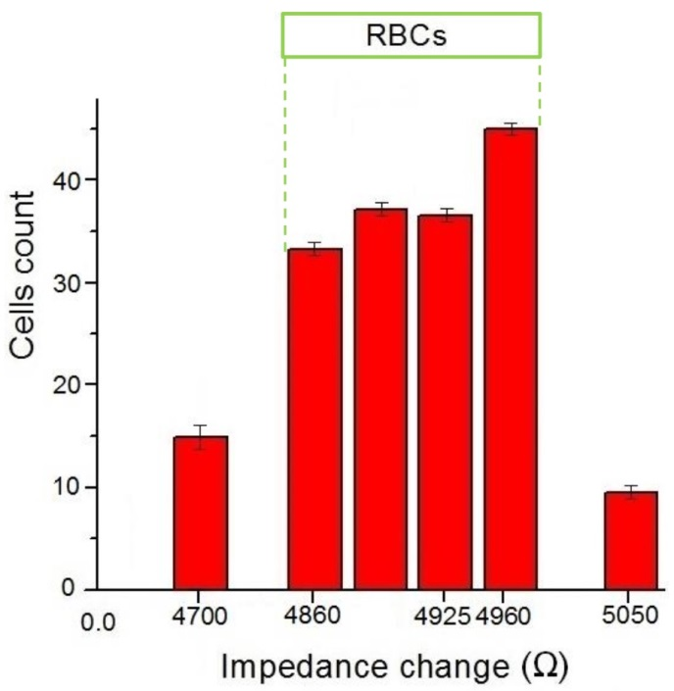  (a) | 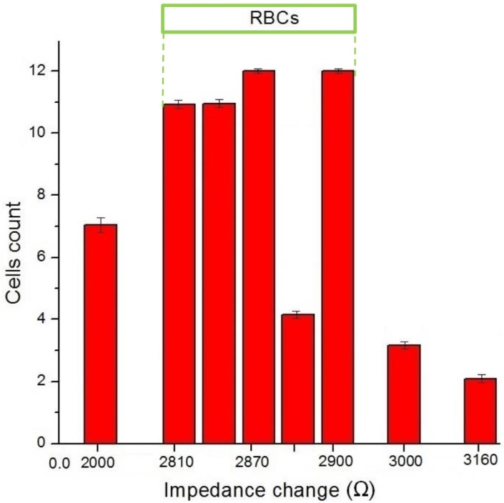  (b)
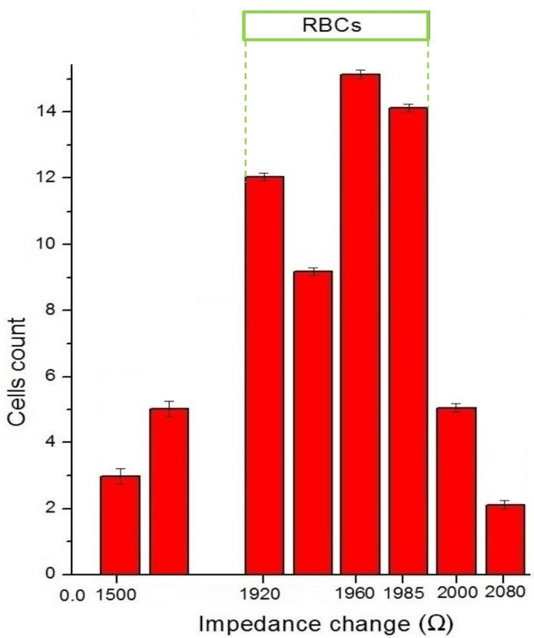  (c) | 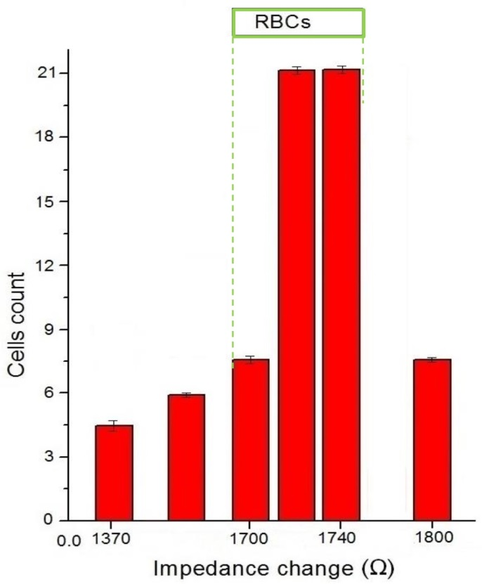  (d)
Figure S9: Threshold for accepted single RBC based on impedance change (ΔZ) (presence and absence of cell) at sensing area. (a) Threshold set in the range 4860 Ω to 4960 Ω based on data collected at low frequency (10 kHz, 50 kHz and 100 kHz) (b) Threshold set in the range 2810 Ω to 2900 Ω based on data collected at 800 kHz.(c) Threshold set in the range 1920 Ω to 1985 Ω based on data collected at 1MHz. (d) Threshold set in the range 1700 Ω to 1740 Ω based on data collected at 2 MHz.

S.10 Opacity
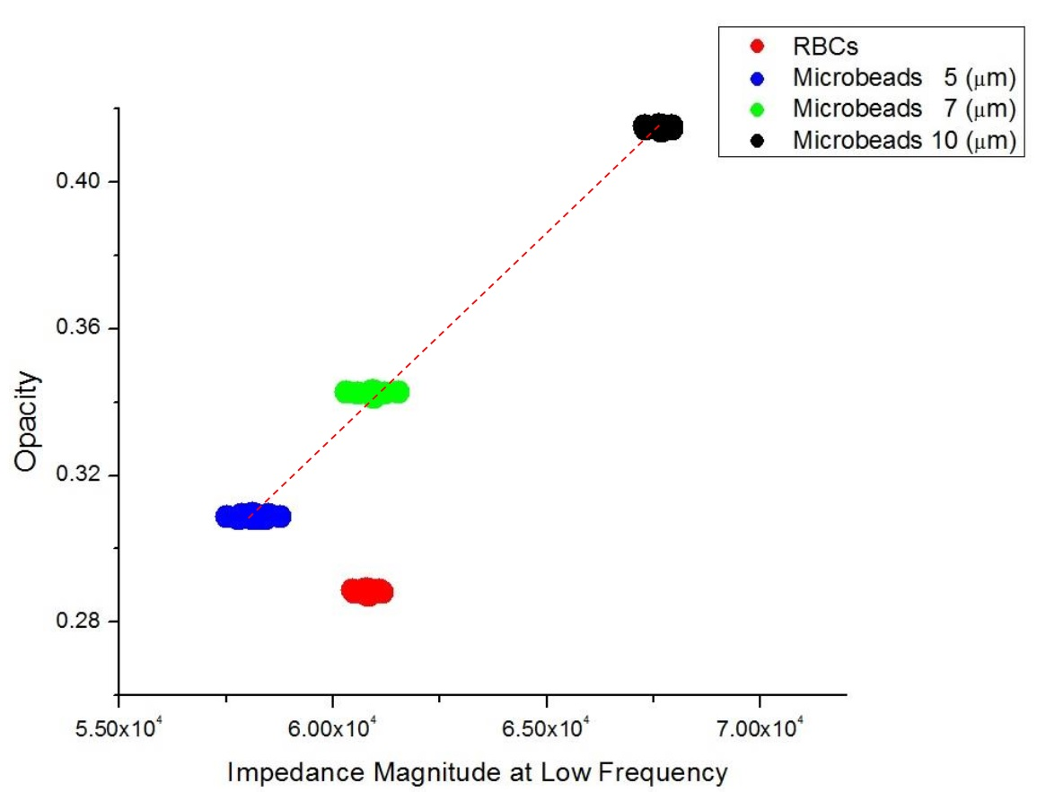
Figure S10: Opacity of three different sizes of microbeads and RBCs

References
1. Holmes D, Pettigrew D, Reccius CH, Gwyer JD, van Berkel C, Holloway J, et al. Leukocyte analysis and differentiation using high speed microfluidic single cell impedance cytometry. Lab Chip [Internet]. 2009 [cited 2014 Oct 17];9:2881–9. Available from: http://www.ncbi.nlm.nih.gov/pubmed/19789739
2. Nasir N, Al Ahmad M. Cells Electrical Characterization: Dielectric Properties, Mixture, and Modeling Theories. J Eng (United Kingdom). 2020;2020.
3. Foster KR, Schwan HP. Dielectric properties of tissues and biological materials: a critical review. Crit Rev Biomed Eng [Internet]. 1989;17:25–104. Available from: http://www.ncbi.nlm.nih.gov/pubmed/2651001
4. Iliescu C, Poenar DP, Carp M, Loe FC. A microfluidic device for impedance spectroscopy analysis of biological samples. Sensors Actuators, B Chem. 2007;123:168–76.
5. Sun T, Green NG, Gawad S, Morgan H. Analytical electric field and sensitivity analysis for two microfluidic impedance cytometer designs. IET Nanobiotechnol [Internet]. 2007 [cited 2014 Jul 15];1:69–79. Available from: http://www.ncbi.nlm.nih.gov/pubmed/17764376
6. Malleo D. Impedance Spectroscopy for Cellular and Biomolecular Analysis. 2009.
7. Cogan SF, Ehrlich J, Plante TD. The effect of electrode geometry on electrochemical properties measured in saline. 2014 36th Annu. Int. Conf. IEEE Eng. Med. Biol. Soc. EMBC 2014. 2014. p. 6850–3.
8. Vanýsek P. Impact of electrode geometry, depth of immersion, and size on impedance measurements. Can J Chem [Internet]. 1997;75:1635–42. Available from: http://www.nrcresearchpress.com/doi/10.1139/v97-194
9. Abdur Rahman AR, Price DT, Bhansali S. Effect of electrode geometry on the impedance evaluation of tissue and cell culture. Sensors Actuators, B Chem. 2007;127:89–96.
10. Wang L, Wang H, Wang L, Mitchelson K, Yu Z, Cheng J. Analysis of the sensitivity and frequency characteristics of coplanar electrical cell–substrate impedance sensors. Biosens Bioelectron [Internet]. 2008;24:14–21. Available from: https://linkinghub.elsevier.com/retrieve/pii/S0956566308001279
11. Wang J-W, Wang M-H, Jang L-S. Effects of electrode geometry and cell location on single-cell impedance measurement. Biosens Bioelectron [Internet]. 2010 [cited 2014 Jun 20];25:1271–6. Available from: http://www.ncbi.nlm.nih.gov/pubmed/19926465

