Genome-wide methylation profiling identify the hypermethylated HOXL subclass genes as potential early detection markers for esophageal squamous cell carcinoma

Supplementary figures
Supplementary figure 1. DMCs genomic distribution characteristics.
A: The distribution of NC-DMCs and ESCC-DMCs on different chromosomes. B: Distance of adjacent ESCC-DMCs and adjacent NC-DMCs across different chromosomes. C: The correlation coefficients of adjacent ESCC-DMCs and NC-DMCs.
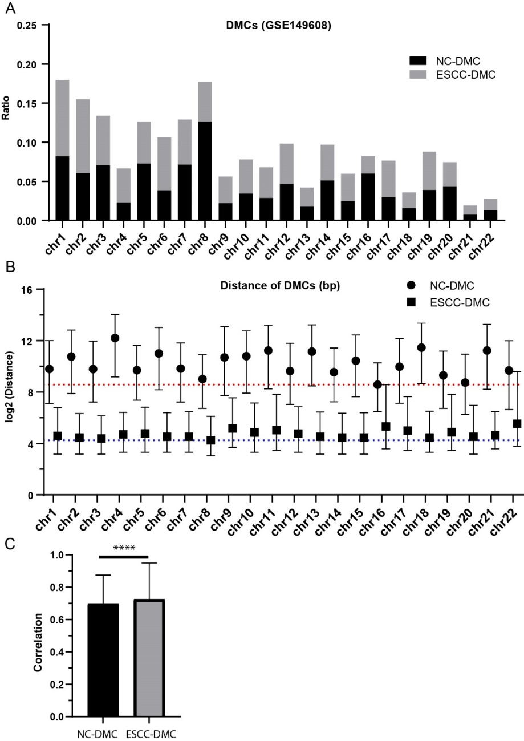

Supplementary figure 2. DMRs and DMGs genomic distribution characteristics.
A: The distribution of NC-DMRs and ESCC-DMRs on different chromosomes. B: Distance of adjacent ESCC-DMRs and adjacent NC-DMRs across different chromosomes. C: The frequency of NC-DMGs and ESCC-DMGs across different chromosomes.
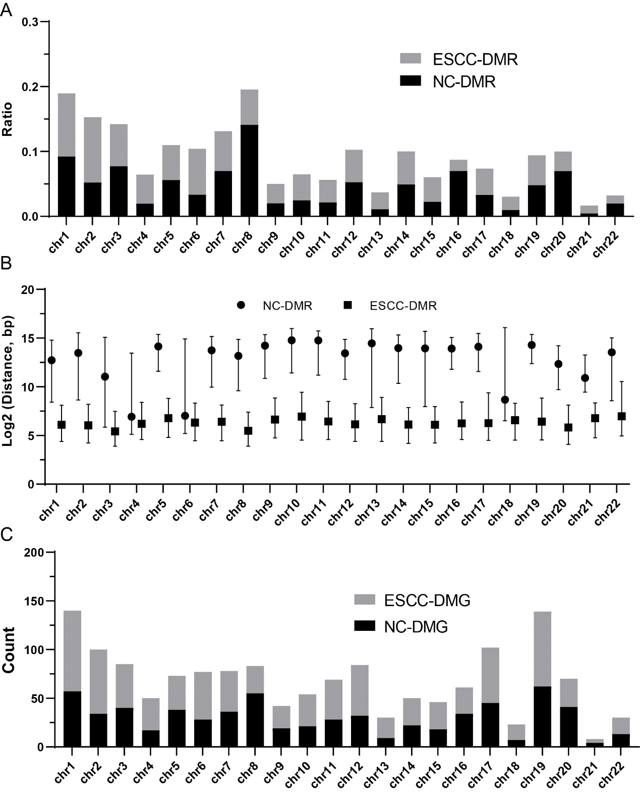

Supplementary figure 3. Similarity of the normal and ESCC samples in GSE52826 dataset. A: tree plot showing the hierarchical clustering results. B: t-SNE analysis showing the difference of normal and ESCC samples.
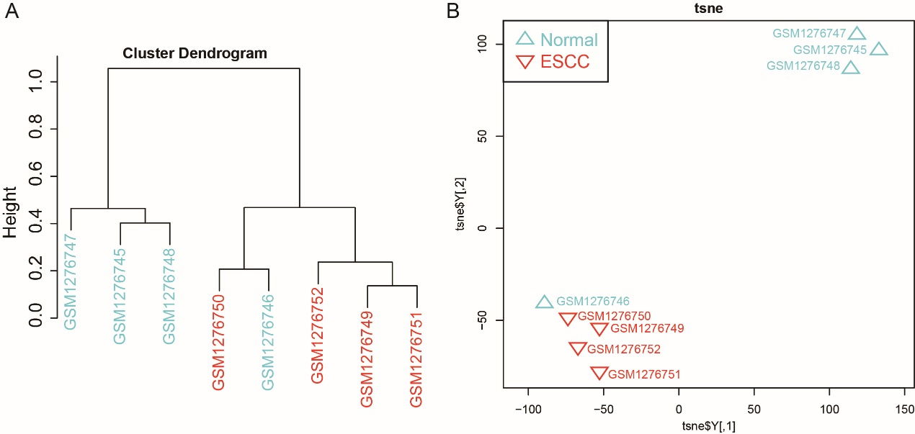

Supplementary figure 4. The methylation levels of HOXC10 (A) and HOXD1 (B) in different stages of ESCC. Kruskal test was used for multiple group comparisons.
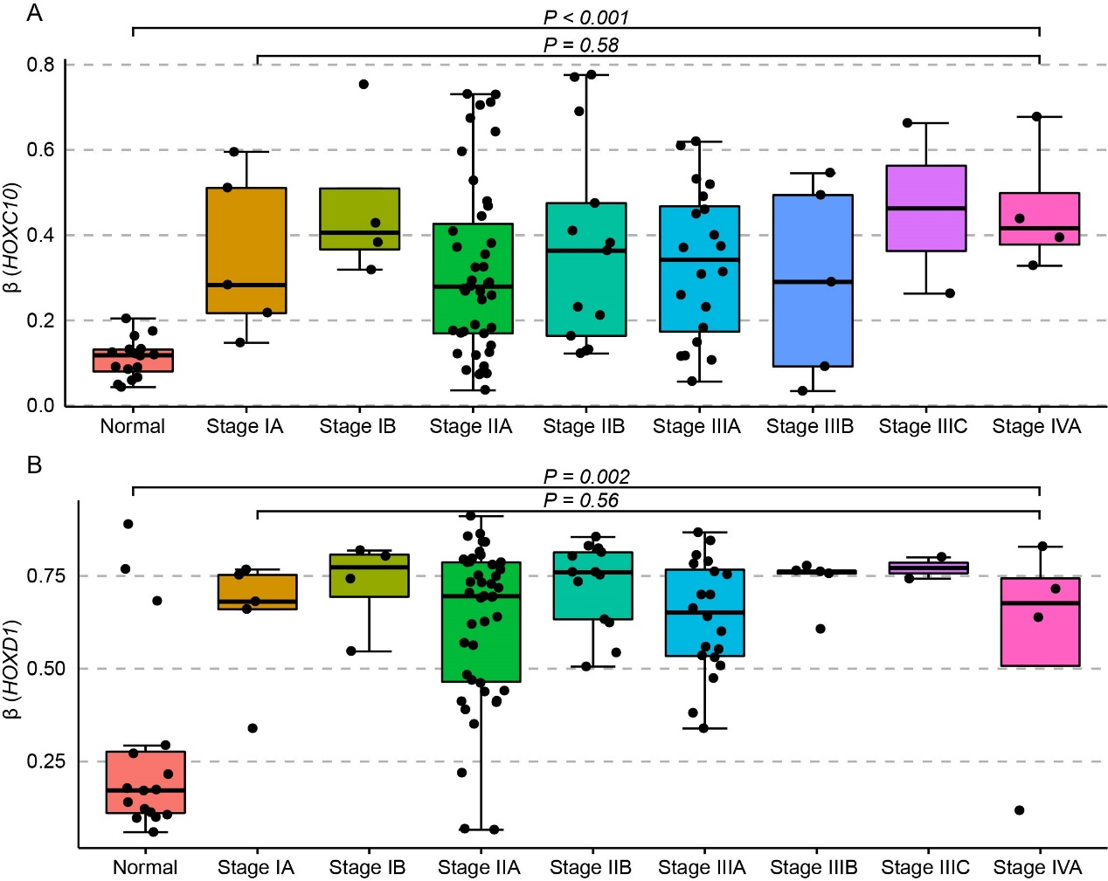

Supplementary figure 5. ROC curves of the 13 potential methylation markers showed the diagnostic performance for ESCC. A-M: CDKN2A, CDKN2B, TFF1, MGMT, MLH1, DAPK1, SCGB3A1, TFPI2, DACH1, SOX17, CHFR, CDH1, APC. The probe with the most significant differences between ESCC and normal were selected for each gene. AUC values and the 95% confidence interval (CI) were also calculated.
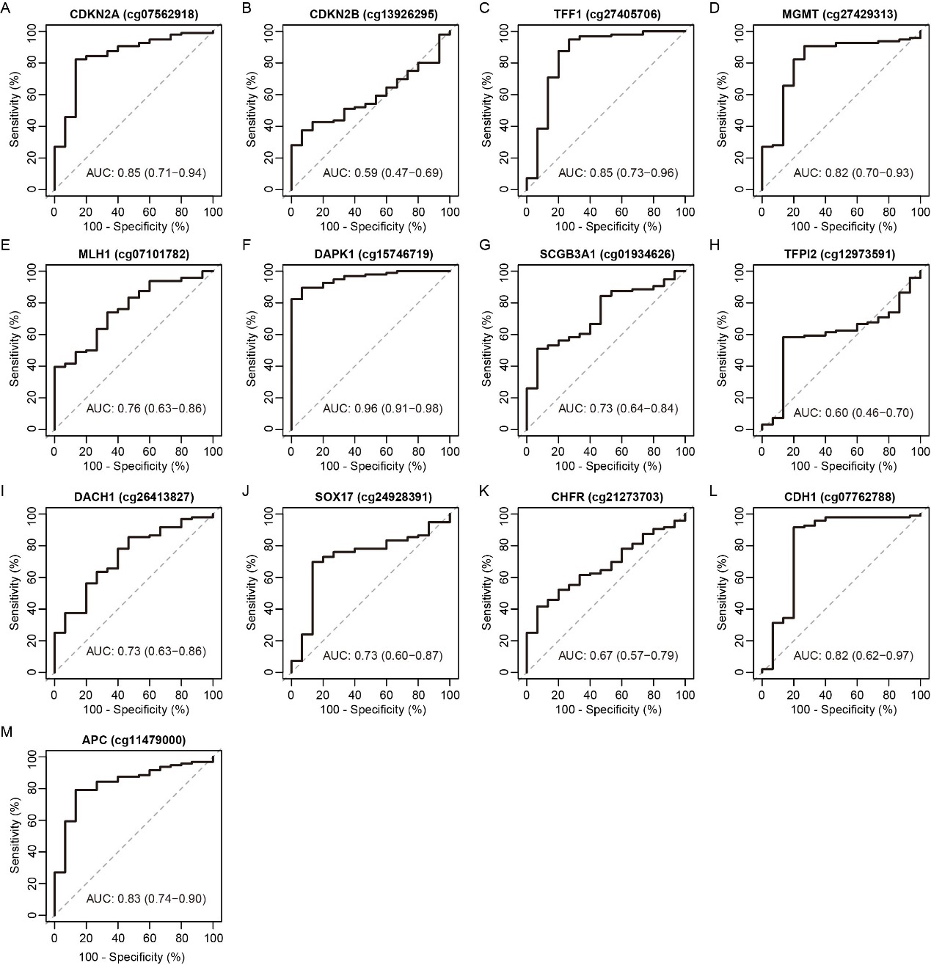

Supplementary figure 6. The correlation of methylation level with patient age. Pearson’s correlation coefficient was estimated for each gene.
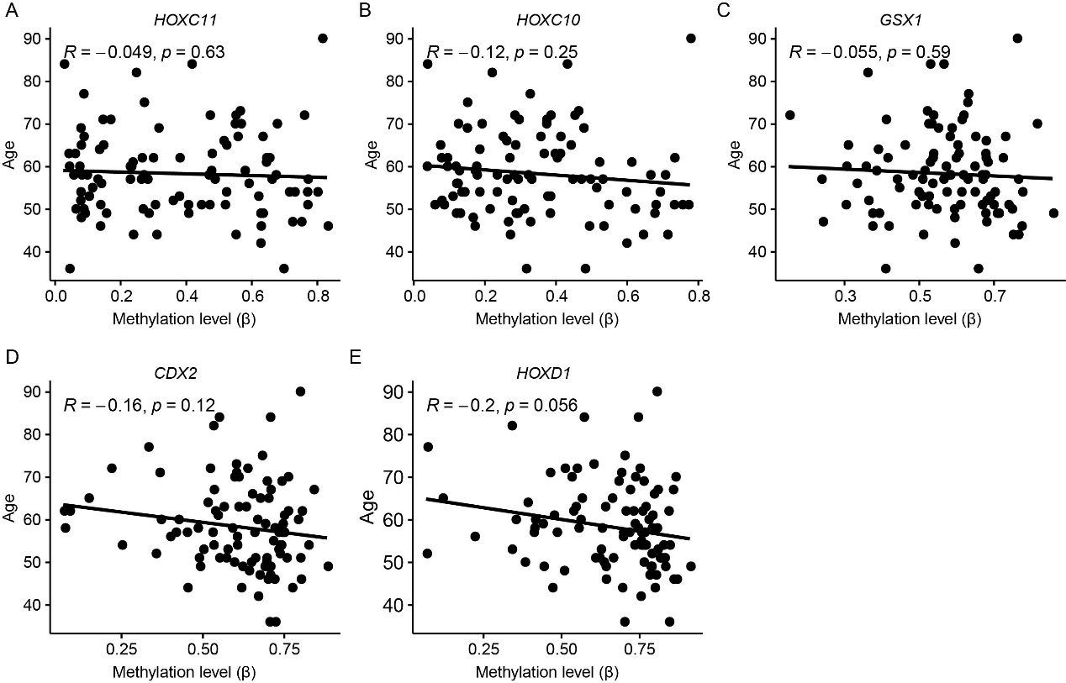

Supplementary tables
Supplementary table 1. Clinical features of GSE149608 dataset.
Specimen | Age (year) | Sex | TNM stage | Lymph node metastasis | Histologic stage
P1 | 61 | male | T3N1aM0 | Yes | G2
P2 | 77 | female | T3N0M0 | No | G3
P3 | 56 | male | T2N0M0 | No | G2
P4 | 58 | female | T3N1aM0 | Yes | G2
P5 | 59 | male | T3N0M0 | No | G2
P6 | 63 | male | T3N0M0 | No | G1
P7 | 60 | male | T3N0M0 | No | G2
P8 | 65 | male | T2N1aM0 | Yes | G3
P10 | 58 | female | T1bN0M0 | Yes | G2

Supplementary table 2. Clinical features of GSE52826 dataset.
Specimen | Age (year) | Sex | TNM stage | Histologic grade | Tumor location | Stage
T1 | 61 | male | T2N0M0 | G1 | Lower | IB
T2 | 63 | male | T1N0M0 | G2 | Middle | IB
T3 | 65 | female | T1N0M0 | G1 | Middle | IA
T4 | 65 | male | T2N0M0 | G1 | Middle | IIA

Supplementary table 3. Clinical features of the 33 ESCC samples and 20 healthy blood samples.
Sample ID | Age | Sex | Grade | TNM Stage | Lymph node metastases | Sample type
BN01 | 34 | Female |  |  |  | Healthy
BN02 | 25 | Male |  |  |  | Healthy
BN03 | 29 | Male |  |  |  | Healthy
BN04 | 39 | Male |  |  |  | Healthy
BN05 | 23 | Male |  |  |  | Healthy
BN06 | 33 | Male |  |  |  | Healthy
BN07 | 38 | Female |  |  |  | Healthy
BN08 | 33 | Male |  |  |  | Healthy
BN09 | 24 | Male |  |  |  | Healthy
BN10 | 35 | Female |  |  |  | Healthy
BN11 | 38 | Male |  |  |  | Healthy
BN12 | 34 | Male |  |  |  | Healthy
BN13 | 43 | Male |  |  |  | Healthy
BN14 | 29 | Male |  |  |  | Healthy
BN15 | 29 | Male |  |  |  | Healthy
BN16 | 36 | Male |  |  |  | Healthy
BN17 | 30 | Male |  |  |  | Healthy
BN18 | 29 | Male |  |  |  | Healthy
BN19 | 29 | Male |  |  |  | Healthy
BN20 | 28 | Male |  |  |  | Healthy
EN1 |  |  |  |  |  | Adjacent
EN2 |  |  |  |  |  | Adjacent
EN3 |  |  |  |  |  | Adjacent
EN4 |  |  |  |  |  | Adjacent
EN5 |  |  |  |  |  | Adjacent
EN6 |  |  |  |  |  | Adjacent
EN7 |  |  |  |  |  | Adjacent
EN8 |  |  |  |  |  | Adjacent
EN9 |  |  |  |  |  | Adjacent
EN10 |  |  |  |  |  | Adjacent
EN11 |  |  |  |  |  | Adjacent
EN12 |  |  |  |  |  | Adjacent
EN13 |  |  |  |  |  | Adjacent
EN14 |  |  |  |  |  | Adjacent
EN15 |  |  |  |  |  | Adjacent
EN16 |  |  |  |  |  | Adjacent
EN17 |  |  |  |  |  | Adjacent
EN18 |  |  |  |  |  | Adjacent
EN19 |  |  |  |  |  | Adjacent
EN20 |  |  |  |  |  | Adjacent
ESCC1 | 55 | Male | G1 | pT3N0Mx | NO | ESCC tissue
ESCC2 | 59 | Male | G2 | pT3N2Mx | YES | ESCC tissue
ESCC3 | 63 | Male | G2 | na | YES | ESCC tissue
ESCC4 | 61 | Male | G2 | PT3N3Mx | YES | ESCC tissue
ESCC5 | 66 | Male | G2 | pT2N1Mx | YES | ESCC tissue
ESCC6 | 67 | Male | G2 | na | NO | ESCC tissue
ESCC7 | 64 | Male | G1 | pT3N1Mx | YES | ESCC tissue
ESCC8 | 50 | Male | G2 | pT1bN0Mx | NO | ESCC tissue
ESCC9 | 71 | Male | G2 | pT2N0Mx | NO | ESCC tissue
ESCC10 | 63 | Male | G1 | pT3N0Mx | NO | ESCC tissue
ESCC11 | 67 | Male | G1 | pT3N1Mx | YES | ESCC tissue
ESCC12 | 57 | Male | G3 | pT3N1Mx | YES | ESCC tissue
ESCC13 | 70 | Male | G2 | pT3N1Mx | YES | ESCC tissue
ESCC14 | 73 | Female | G1 | pT1bNoMx | NO | ESCC tissue
ESCC15 | 60 | Female | G2 | pT1aN0Mx | NO | ESCC tissue
ESCC16 | 67 | Male | G2 | pT3N1Mx | YES | ESCC tissue
ESCC17 | 63 | Female | G2 | pT3N1Mx | YES | ESCC tissue
ESCC18 | 62 | Male | G3 | na | YES | ESCC tissue
ESCC19 | 62 | Male | G2 | pT3N0Mx | NO | ESCC tissue
ESCC20 | 54 | Male | G1 | pT3N3Mx | YES | ESCC tissue
ESCC21 | 53 | Male | G2 | pT3N0Mx | NO | cfDNA
ESCC22 | 69 | Male | NA | pT2N1Mx | YES | cfDNA
ESCC23 | 67 | Female | G1 | pT2N0Mx | NO | cfDNA
ESCC24 | 67 | Female | G2 | pT3N1Mx | YES | cfDNA
ESCC25 | 51 | Male | G2 | pT3N3Mx | YES | cfDNA
ESCC26 | 68 | Female | G2 | pT3N0Mx | NO | cfDNA
ESCC27 | 45 | Male | G1 | pT2N2Mx | YES | cfDNA
ESCC28 | 57 | Male | G1 | pT3N1Mx | YES | cfDNA
ESCC29 | 73 | Female | G1 | pT3N0Mx | NO | cfDNA
ESCC30 | 52 | Male | G1 | pT3N2Mx | YES | cfDNA
ESCC31 | 56 | Male | G2 | pT3N0Mx | NO | cfDNA
ESCC32 | 65 | Male | G2 | pT1bN0Mx | NO | cfDNA
ESCC33 | 56 | Female | G1 | pT3N0Mx | NO | cfDNA

Supplementary table 4. The MSP amplification regions of HOXD1 and GSX1.

DMR_id | Postion | Methy (N, %) | Methy (ESCC, %) | CpG_count | delta (Methy)
HOXD1-R1 | chr2: 177054188-177054237 | 3.73 | 27.45 | 3 | 23.72
HOXD1-R2 | chr2: 177054245-177054282 | 9.51 | 35.52 | 4 | 26
HOXD1-R3 | chr2: 177054303-177054350 | 5.85 | 27.72 | 5 | 21.87
HOXD1-R4 | chr2: 177054495-177054547 | 13.09 | 47.81 | 5 | 34.72
HOXD1-R5 | chr2: 177054572-177054585 | 14.53 | 47.66 | 3 | 33.13
HOXD1-R6 | chr2: 177054648-177054696 | 11.05 | 40.36 | 5 | 29.31
HOXD1-R7 | chr2: 177054836-177054888 | 19.73 | 46.52 | 3 | 26.78
GSX1-DMR16 | chr13: 28367740-28367789 | 13.54 | 37.35 | 5 | 23.8
GSX1-DMR17 | chr13: 28367815-28367852 | 10.37 | 34.46 | 5 | 24.09

Supplementary table 5. Summary of DMCs and DMRs in different genomic regions.
 | NC-DMC | ESCC-DMC | NC-DMR | ESCC-DMR
Upstream (0-2kb) | 72592 | 14254 | 1294 | 1819
innergenic | 88544 | 30002 | 1734 | 4018
Downstream (200bp) | 74686 | 11069 | 1323 | 1396
intergenic | 125519 | 13953 | 2071 | 1807

Supplementary table 6. The identified NC-DMGs and ESCC-DMGs in this study.
 | Genes
NC-DMGs | MXRA8, AL645728.1, SLC35E2B, TTC34, CHD5, TNFRSF9, CA6, SPSB1, TNFRSF8, TNFRSF1B, AADACL4, FHAD1, ZBTB17, MRTO4, MINOS1-NBL1, CDA, RAP1GAP, EPHA8, HPCA, C1orf94, ZSWIM5, TTC39A, IFI44, SYDE2, RP11-302M6.4, NTNG1, KCNA2, S100A13, RAB13, KCNN3, MSTO1, PEAR1, ATP1A4, F11R, MGST3, FAM78B, DPT, DNM3, TNFSF4, TNR, CFHR3, NR5A2, PKP1, SYT2, TMCC2, LEMD1, SPATA17, LYPLAL1, C1orf65, GGPS1, FMN2, RGS7, SCCPDH, NLRP3, GCSAML, OR2G6, LYPD8, FAM110C, MYT1L, FAM84A, DRC1, KCNK3, SLC35F6, ALK, LTBP1, PSME4, SPTBN1, LGALSL, SPRED2, RTKN, HTRA2, TRABD2A, CAPG, KRCC1, SMYD1, KIAA1211L, IL1R1, FHL2, UXS1, PSD4, CBWD2, NCKAP5, CACNB4, DAPL1, LRP2, SP9, HECW2, PLCL1, WNT6, ANKMY1, BOK, TRANK1, SNRK, PDZRN3, CRYBG3, IMPG2, CEP97, DPPA2, SPICE1, ADCY5, SLC12A8, ALG1L, CHCHD6, DNAJB8, RPN1, EFCC1, COL6A5, NEK11, MRPS22, PCOLCE2, AGTR1, CP, MME, IQCJ-SCHIP1, NLGN1, KCNMB3, ZNF639, PEX5L, MCF2L2, ABCC5, IL1RAP, GMNC, MB21D2, HES1, TNK2, SLC51A, PCYT1A, NRROS, PIGX, NCBP2, MFI2, RNF212, SPON2, JAKMIP1, AFAP1, LDB2, FAM184B, SEL1L3, GRXCR1, FRYL, FIP1L1, NOA1, IGFBP7, LPHN3, MOB1B, MAPK10, HSPA4L, PDGFC, SLC6A19, SLC6A18, TERT, MRPL36, UBE2QL1, ADCY2, ROPN1L, RP11-1C1.5, ANKRD33B, DNAH5, FBXL7, 11-Mar, CDH12, CDH6, PDZD2, NPR3, ADAMTS12, AGXT2, FYB, PLCXD3, HCN1, CTD-2117L12.1, FOXD1, ATP6AP1L, NUDT12, SNCAIP, ZNF608, CDC42SE2, KCTD16, JAKMIP2, HTR4, ABLIM3, ADRA1B, GABRB2, RANBP17, MSX2, UNC5A, RASGEF1C, DUSP22, NQO2, CDYL, F13A1, TFAP2A, NEDD9, JARID2, NRSN1, ALDH5A1, HIST1H2BC, PPARD, C6orf89, DAAM2, TREML2, GNMT, PTK7, TMEM151B, RCAN2, FBXO9, COL19A1, PGM3, KIAA1009, GJB7, MAN1A1, PKIB, TPD52L1, SMOC2, WDR27, PRKAR1B, ADAP1, AMZ1, FOXK1, MMD2, RNF216, DAGLB, CCDC129, PDE1C, AVL9, BMPER, POU6F2, HECW1, PSPH, ZNF479, ZNF716, KCTD7, WBSCR17, SRRM3, PPP1R9A, SHFM1, BAIAP2L1, MUC17, PRKRIP1, RELN, LHFPL3, MET, SPAM1, GRM8, PLXNA4, ATP6V0A4, DPP6, PAXIP1-AS2, BLACE, DNAJB6, PTPRN2, DLGAP2, CSMD1, MTMR7, DPYSL2, EXTL3, CHRNB3, SNAI2, SNTG1, ST18, FAM150A, XKR4, FAM110B, CLVS1, NKAIN3, DNAJC5B, ADHFE1, COPS5, CPA6, C8orf34, XKR9, KCNB2, GDAP1, MRPS28, CA3, CNBD1, MMP16, CPQ, C8orf47, NIPAL2, SPAG1, NCALD, RSPO2, PKHD1L1, CSMD3, SAMD12, COL14A1, ZHX2, FAM83A, ANXA13, TRMT12, OC90, KCNQ3, LRRC6, KHDRBS3, FAM135B, COL22A1, KCNK9, TRAPPC9, DENND3, AC138647.1, TSNARE1, ARC, GML, FAM83H, KIFC2, LINGO2, RP11-613M10.9, ROR2, FGD3, PTPDC1, ZFP37, ASTN2, BRINP1, PSMB7, FAM102A, NAIF1, RP11-101E3.5, C9orf171, GFI1B, RXRA, LCN1, KCNT1, GRIN1, PNPLA7, CUBN, ST8SIA6, SLC39A12, HK1, UNC5B, PLA2G12B, NRG3, CRTAC1, PAX2, INA, SH3PXD2A, ITPRIP, SORCS1, ATRNL1, PNLIPRP3, DOCK1, PTPRE, TTC40, GPR123, KNDC1, SPRN, MUC2, MUC5B, TOLLIP, BRSK2, KCNQ1, PHLDA2, CARS, ARNTL, TSPAN18, PRDM11, SLC39A13, PRG3, MS4A6E, SLC22A11, SYT12, C11orf72, FGF3, ANO1, PDE2A, POLD3, SLCO2B1, LRRC32, PIWIL4, COLCA1, NCAM1, ZBTB16, DSCAML1, KCNJ1, CACNA2D4, CACNA1C, RP11-234B24.6, ANO2, PPFIBP1, CPNE8, PRR13, DNAJC14, NDUFA4L2, TBC1D30, GRIP1, CPM, PLXNC1, NR1H4, C12orf42, WSCD2, CMKLR1, SELPLG, C12orf76, CUX2, TBX3, CCDC60, P2RX7, HPD, HCAR1, TMEM132B, TMEM132C, GLT1D1, TMEM132D, FZD10, GPR133, GALNT9, ALOX5AP, KBTBD6, KBTBD7, WDFY2, CLN5, KDELC1, FAM155A, MYO16, TMEM255B, SLC7A8, AKAP6, NPAS3, SLC25A21, MDGA2, RGS6, ACOT6, NRXN3, GALC, PSMC1, SLC24A4, RIN3, ITPK1, RP11-371E8.4, UNC79, TCL1A, WDR25, BEGAIN, DLK1, CDC42BPB, KLC1, TMEM179, GOLGA8J, OTUD7A, CHRNA7, C15orf52, BAHD1, PARP16, ANP32A, HCN4, ISLR2, CCDC33, CHRNB4, HDGFRP3, SLC28A1, AGBL1, NTRK3, SV2B, NR2F2, ADAMTS17, RHBDF1, CACNA1H, GNPTG, MEFV, ADCY9, ALG1, RBFOX1, GRIN2A, XYLT1, UMOD, DNAH3, NDUFAB1, DCTN5, PRKCB, CACNG3, AQP8, HS3ST4, IL21R, GSG1L, C16orf92, SEPHS2, ZNF689, PRSS8, TGFB1I1, ZNF423, CDH11, WDR59, RP11-77K12.1, OSGIN1, KIAA0513, JPH3, CBFA2T3, CDH15, PRDM7, RAP1GAP2, GLTPD2, AIPL1, PIK3R5, USP43, RCVRN, GAS7, MYOCD, SLC5A10, MAP2K3, PIPOX, SSH2, ASIC2, CDC6, TNS4, KRT17, AOC2, WNT3, WNT9B, ITGB3, GIP, SGCA, CA10, ANKFN1, EPX, PPM1E, ABCA10, CD300E, RAB37, GRIN2C, NUP85, ZACN, MXRA7, MGAT5B, TNRC6C, TMC8, C17orf99, AFMID, RBFOX3, CARD14, AATK, TMEM105, FSCN2, ASPSCR1, TBCD, EMILIN2, PIEZO2, HRH4, CCDC178, RIT2, SLC14A2, DCC, SHC2, ODF3L2, TPGS1, PRTN3, CELF5, SEMA6B, CATSPERD, TNFSF14, CTB-133G6.1, PEX11G, C19orf45, EVI5L, FBN3, CACNA1A, EMR3, CPAMD8, NR2F6, PLVAP, SLC27A1, UNC13A, GDF15, COPE, MEF2BNB-MEF2B, HAPLN4, CHST8, PRODH2, RYR1, CTC-435M10.3, CEACAM4, CD79A, LYPD3, CKM, NOVA2, C5AR1, SLC8A2, BSPH1, ELSPBP1, SYT3, GPR32, CD33, SIGLEC10, SIGLEC5, FPR3, PRKCG, VSTM1, LILRB5, LILRB2, LILRA4, LAIR1, LAIR2, KIR3DX1, LILRA2, LILRB1, KIR3DL1, NLRP7, TMEM150B, NLRP4, NLRP8, SMIM17, ZIM2, ZSCAN1, SLC27A5, TMC2, PAK7, OVOL2, THBD, DEFB121, SUN5, BPIFB6, BPIFA2, BPIFA3, AHCY, MYH7B, SCAND1, DLGAP4, VSTM2L, KIAA1755, BPI, ARHGAP40, MAFB, PTPRT, WFDC10B, PREX1, PTGIS, FAM65C, DOK5, CASS4, GNAS, ZNF831, PHACTR3, CDH26, CDH4, HRH3, C20orf166, NTSR1, NKAIN4, COL20A1, KCNQ2, EEF1A2, PTK6, GMEB2, ZBTB46, MYT1, LIPI, C21orf49, RIPK4, ITGB2, GAB4, CECR2, RTN4R, SGSM1, SEZ6L, AP1B1, TXN2, IL2RB, CACNA1I, KIAA0930, C22orf34, TTLL8, MOV10L1, DMD, MAMLD1,
ESCC-DMGs | PLEKHN1, AGRN, TMEM240, PLCH2, TNFRSF14, WRAP73, AJAP1, ACOT7, ESPN, PLEKHG5, KLHL21, KAZN, HSPB7, CROCC, PAX7, CAPZB, HTR6, VWA5B1, CAMK2N1, ALPL, LDLRAD2, LACTBL1, STPG1, RUNX3, MAP3K6, WASF2, CCDC28B, SMIM12, RSPO1, KCNQ4, C1orf50, PTPRF, BEST4, PTCH2, POMGNT1, FOXE3, FOXD2, DMRTA2, ZYG11A, TTC22, LEPR, C1orf141, ST6GALNAC5, PTGFR, GFI1, GPR88, STRIP1, KCNA3, ADORA3, SYT6, ANKRD35, C2CD4D, TCHH, NPR1, PKLR, FDPS, SEMA4A, HAPLN2, BCAN, LRRC71, KLHDC9, CCDC181, LHX4, KIAA1614, CACNA1E, ZNF648, RGS2, CFHR2, GPR25, SHISA4, BTG2, KLHDC8A, RASSF5, SERTAD4, KCNK2, ESRRG, HLX, CAPN2, ITPKB, WNT3A, GUK1, ACTA1, TRIM58, SOX11, OSR1, GDF7, KLHL29, UCN, CYP1B1, ARHGEF33, TMEM178A, SIX3, SIX2, NRXN1, EFEMP1, OTX1, MEIS1, CNRIP1, VAX2, AC007040.11, CYP26B1, EMX1, NOTO, EGR4, C2orf81, LBX2, TLX2, LOXL3, CTNNA2, VAMP8, VAMP5, CD8A, ITPRIPL1, ANKRD23, AC092675.3, NCK2, PAX8, EN1, SCTR, GLI2, GYPC, PTPN18, ARHGEF4, CCDC74A, NXPH2, DLX2, EVX2, HOXD13, HOXD12, HOXD10, HOXD3, HOXD1, ZNF804A, TMEFF2, BOLL, C2orf47, TNS1, CYP27A1, WNT10A, DES, PAX3, CCDC140, ECEL1, GBX2, ACKR3, MLPH, LRRFIP1, RAMP1, AC016757.3, CLASP2, CCK, PTH1R, MST1, RNF123, ARHGEF3, FEZF2, PRICKLE2, BBX, DPPA4, BOC, LSAMP, CASR, PDIA5, ROPN1B, KLF15, PLXNA1, ABTB1, KBTBD12, RUVBL1, GATA2, TRH, SOX14, ESYT3, FOXL2, C3orf72, SPSB4, GRK7, CHST2, PLSCR2, ZIC4, ZIC1, GPR149, SHOX2, GFM1, C3orf80, SLITRK3, LRRC34, GHSR, SST, LPP, FGF12, GP5, FAM43A, XXYLT1, MFSD7, RGS12, ADRA2C, MSX1, HMX1, SLC2A9, NKX3-2, FAM200B, PROM1, SOD3, PHOX2B, BEND4, SHISA3, SLC10A4, NPFFR2, CXCL5, CXCL2, FGF5, NKX6-1, BANK1, TACR3, DKK2, TRAM1L1, NDNF, TNIP3, TMEM155, TRPC3, PCDH10, MGARP, RP11-542P2.1, UCP1, POU4F2, HAND2, IRX4, C5orf38, RXFP3, PTGER4, MCIDAS, CCNO, OTP, ANKRD34B, NR2F1, GPR150, KCNN2, CDO1, SHROOM1, CTC-349C3.1, H2AFY, NEUROG1, LECT2, PROB1, CXXC5, NRG2, PCDHA1, PCDHGA1, RBM27, CD74, MYOZ3, SPARC, HAND1, SOX30, C5orf52, TLX3, NKX2-5, DRD1, HRH2, GPRIN1, MAML1, MGAT4B, IRF4, FOXF2, TUBB2B, PXDC1, PPP1R3G, NRN1, RREB1, SYCP2L, DCDC2, HIST1H4F, BTN1A1, HIST1H2BK, POM121L2, ZSCAN31, TULP1, SRSF3, FOXP4, TFEB, GUCA1A, TTBK1, NFKBIE, TFAP2D, DST, COL9A1, COL12A1, HTR1B, TBX18, CNR1, EPHA7, PRDM13, MCHR2, BVES, NR2E1, GPR6, DSE, FAM162B, VGLL2, CLVS2, RSPO3, SOGA3, TMEM200A, TCF21, MAP3K5, SLC35D3, OLIG3, NMBR, ULBP1, T, THBS2, FBXL18, GRID2IP, TWIST1, TMEM196, SP8, NPY, HOXA2, HOXA9, HOXA13, EVX1, PRR15, CRHR2, YAE1D1, CAMK2B, SUN3, C7orf57, VSTM2A, EGFR, ZNF273, AC104057.1, LIMK1, CLIP2, SEMA3D, GRM3, ABCB1, GNGT1, PDK4, DLX5, TAC1, MBLAC1, AGFG2, FEZF1, TMEM229A, PRRT4, FLNC, FAM115A, RARRES2, ZNF775, NOS3, EN2, SHH, VIPR2, SOX7, PHYHIP, NKX2-6, PNMA2, ZNF395, PURG, GPR124, ADRB3, SOX17, MOS, PENK, CRH, RP11-1102P16.1, RP11-383H13.1, STMN2, ATP6V0D2, GDF6, TSPYL5, STK3, OSR2, C8orf56, TRPS1, AARD, MAFA, MROH6, SCRT1, FOXH1, LRRC14, FOXD4, NFIB, PLIN2, ACER2, KLF9, FOXB2, C9orf129, BARX1, TRAF1, DAB2IP, LHX6, LHX2, NR5A1, OLFML2A, LMX1B, DNM1, BARHL1, RALGDS, ADAMTS13, LHX3, TRAF2, TOR4A, NSMF, KLF6, C1QL3, GAD2, FZD8, RET, HNRNPF, ZNF239, GDF10, CHAT, PHYHIPL, TMEM26, NEUROG3, ZMIZ1, PLAC9, CDHR1, CH25H, CYP26C1, CYP26A1, NKX2-3, ABCC2, SEC31B, TLX1, LBX1, FGF8, TRIM8, VAX1, EMX2, TACC2, HMX3, HMX2, EBF3, TCERG1L, PWWP2B, NLRP6, RNH1, C11orf35, MOB2, DUSP8, SYT8, IGF2, CD81, PRKCDBP, AMPD3, CALCB, MYOD1, SLC6A5, NELL1, SLC17A6, BDNF, KCNA4, PAX6, RCN1, WT1, ABTB2, RAG1, ALX4, CREB3L1, DGKZ, LRRC10B, FADS2, AHNAK, HRASLS5, MACROD1, C11orf85, TIGD3, CFL1, ADRBK1, TCIRG1, SHANK2, CCDC67, CRYAB, BSX, ROBO3, ST3GAL4, RAD52, KCNA5, VWF, RERG, BCAT1, SLC38A1, SLC38A4, HDAC7, DKFZP779L1853, WNT1, DDN, C1QL4, KCNH3, RACGAP1, METTL7A, GALNT6, GRASP, KRT86, RARG, AAAS, ATP5G2, HOXC13, HOXC12, HOXC11, HOXC10, RP11-834C11.12, HOXC4, B4GALNT1, CTDSP2, AVPR1A, HMGA2, TRHDE, MYF6, MYF5, ACSS3, SLC6A15, ALX1, USP44, PAH, ASCL1, TXNRD1, CHST11, RP11-144F15.1, ASCL4, FOXN4, FAM222A, SH2B3, LHX5, MSI1, KDM2B, RHOF, CHFR, TNFRSF19, AMER2, GSX1, PDX1, CDX2, URAD, FLT1, SERTM1, SERP2, KIAA0226L, MLNR, LECT1, PCDH8, PCDH17, KLHL1, EDNRB, SLITRK1, SLITRK5, CLDN10, FGF14, RAB20, SLC7A7, JPH4, REC8, RIPK3, FOXG1, C14orf23, NFKBIA, INSM2, PAX9, FOXA1, SSTR1, CLEC14A, PTGDR, PTGER2, OTX2, L3HYPDH, C14orf39, SIX1, SLC8A3, VSX2, GPR68, GSC, BCL11B, SLC25A29, AMN, EXOC3L4, TEX22, CRIP1, GABRB3, GOLGA8M, KLF13, GOLGA8A, ITPKA, LTK, DUOXA2, SHF, ONECUT1, ALDH1A2, FOXB1, PIF1, AC069368.3, IGDCC4, SMAD6, SMAD3, SKOR1, CYP11A1, NEIL1, ISL2, CRABP1, KIAA1024, CPEB1, ALPK3, AEN, MESP1, MESP2, LRRK1, MPG, DNASE1L2, KREMEN2, CLDN6, SNN, ERN2, TRIM72, CBLN1, IRX3, IRX5, SLC6A2, GNAO1, MT1E, HERPUD1, GPR56, TEPP, CMTM3, FBXL8, LDHD, NECAB2, C16orf74, IRF8, FOXF1, FOXC2, FOXL1, SLC7A5, ANKRD11, ABR, RTN4RL1, HIC1, TRPV3, VMO1, SLC13A5, TNK1, PER1, HS3ST3A1, HS3ST3B1, PMP22, TEKT3, CCDC144A, RAI1, KCNJ12, SARM1, TMEM132E, MMP28, LHX1, SRCIN1, ARL5C, STAC2, THRA, NR1D1, RAPGEFL1, IGFBP4, PLEKHH3, WNK4, SOST, RUNDC3A, FZD2, GFAP, C1QL1, SP6, HOXB3, HOXB7, PRAC1, HOXB13, CALCOCO2, PHOSPHO1, SPOP, DLX4, SAMD14, ACSF2, USP32, TBX4, LIMD2, CDC42EP4, KIF19, BTBD17, CD300A, OTOP2, EVPL, 9-Sep, TMC6, RP11-1055B8.6, UTS2R, ADCYAP1, TMEM200C, ZNF397, ZNF396, ST8SIA5, SKOR2, SMAD7, LIPG, MBD1, RAX, CDH7, CBLN2, TSHZ1, LINC00908, GALR1, NFATC1, CDC34, PTBP1, SBNO2, MUM1, APC2, ONECUT3, KLF16, GNA11, NFIC, HMG20B, ZNF177, ICAM5, S1PR5, ZNF69, ZNF625-ZNF20, NFIX, LYL1, RFX1, SLC1A6, NOTCH3, BRD4, KLF2, F2RL3, ANO8, SSBP4, ELL, KLHL26, CRTC1, UPF1, ZNF737, CTD-2561J22.3, ZNF43, GRAMD1A, HSPB6, NPHS1, ZNF529, ZNF568, ZNF573, ACTN4, SARS2, L34079.2, LYPD5, CTC-512J12.6, MARK4, VASP, CCDC8, PNMAL1, PPP5D1, ZNF541, GRIN2D, PPFIA3, CTD-3148I10.1, SLC17A7, ZNF577, ZNF615, ZNF614, ZNF880, ZNF808, ZNF701, ZNF83, CACNG8, EPS8L1, ZSCAN5A, ZNF471, ZNF470, AC003005.4, ZNF549, ZIK1, ZNF134, ZNF551, AC003006.7, ZNF814, ZNF418, ZNF256, ZNF606, ZSCAN18, ZNF329, TCF15, RP5-850E9.3, FAM110A, ANGPT4, PROKR2, BTBD3, PCSK2, NKX2-4, NKX2-2, PAX1, FOXA2, CST3, VSX1, DEFB124, XKR7, SOGA1, SLC32A1, TOX2, KCNS1, RBPJL, ZNF334, SALL4, CBLN4, BMP7, ANKRD60, SLC17A9, BHLHE23, UCKL1, ZNF512B, CYYR1, OLIG1, SIM2, TMPRSS2, MICAL3, TBX1, SCARF2, KIAA1671, MN1, TTC28, ZNRF3, RASL10A, NEFH, OSBP2, LGALS2, GALR3, MAFF, FAM83F, MCHR1, WNT7B, CELSR1
Shared by both | PRDM16, TP73, PTCHD2, GRIK3, NTRK1, LHX9, PXDN, DNMT3A, AFF3, FBLN7, DPP10, DLX1, CERKL, SATB2, ALPP, KIAA1257, ZBTB38, KCNAB1, CLDN11, EIF2B5, DGKG, PITX2, SLC6A3, IRX2, CTNND2, UGT3A1, MEF2C, PITX1, ZSCAN12, PNPLA1, TFAP2B, OSTM1, PDE10A, HOXA3, HOXA11, ADCYAP1R1, EPDR1, GRB10, NPTX2, CNPY1, GATA4, CA8, TCF24, NDRG1, BAI1, DMRT1, NPAS4, FLI1, FBRSL1, ZIC2, NKX2-8, NID2, GPR135, CCDC88C, EML1, ZNF598, HS3ST2, TK2, PTRF, TBX21, C18orf42, CELF4, ADAMTS10, PDE4C, ZNF536, RTN2, ZNF667, RIN2, SLC12A5, NFATC2, EDN3

Supplementary table 7. The enriched gene families of NC-DMGs.
Gene family | Genes | P value | P adj
CD molecules | TNFRSF9,TNFRSF8,TNFRSF1B,F11R,TNFSF4,ALK,IL1R1,MME,NCAM1,PLXNC1,SELPLG,FZD10,IL21R,ITGB3,CD300E,TNFSF14,CD79A,C5AR1,CD33,SIGLEC5,LILRB5,LILRB2,LILRA4,LAIR1,LAIR2,LILRA2,LILRB1,KIR3DL1,THBD,ITGB2,IL2RB | 3.50E-05 | 2.76E-02
Zinc fingers C2H2C-type | MYT1L,ST18,MYT1 | 6.61E-04 | 5.22E-01
Receptor tyrosine kinases | NTRK1,ALK,PTK7,MET,ROR2,NTRK3,AATK | 8.18E-04 | 6.45E-01
Calcium voltage-gated channel alpha1 subunits | CACNA1C,CACNA1H,CACNA1A,CACNA1I | 8.98E-04 | 7.09E-01
5-hydroxytryptamine receptors, G protein-coupled | HTR4 | 3.74E-01 | 1.00E+00
A-kinase anchoring proteins | AKAP6,CBFA2T3 | 2.97E-01 | 1.00E+00
AAA ATPases | PSMC1 | 8.36E-01 | 1.00E+00
Acid sensing ion channel subunits | ASIC2 | 1.82E-01 | 1.00E+00
Activating leukocyte immunoglobulin like receptors | LILRA4,LILRA2 | 2.66E-02 | 1.00E+00
Acyl-CoA synthetase family | SLC27A1,SLC27A5 | 2.35E-01 | 1.00E+00

Supplementary table 8. The enriched gene families of ESCC-DMGs.
Gene family | Genes | P value | P adj
NKL subclass homeoboxes and pseudogenes | HLX,VAX2,EMX1,NOTO,LBX2,TLX2,EN1,DLX1,DLX2,MSX1,HMX1,NKX3-2,NKX6-1,TLX3,NKX2-5, DLX5,EN2,NKX2-6,BARX1,BARHL1,NKX2-3, TLX1,LBX1,VAX1,EMX2,HMX3,HMX2,BSX,NKX2-8,DLX4,NKX2-4,NKX2-2 | 3.27E-21 | 3.06E-18
HOXL subclass homeoboxes | EVX2,HOXD13,HOXD12,HOXD10,HOXD3,HOXD1,GBX2,HOXA2,HOXA3,HOXA9,HOXA11,HOXA13,EVX1,HOXC13,HOXC12,HOXC11,HOXC10,HOXC4,GSX1,PDX1,CDX2,HOXB3,HOXB7,HOXB13 | 5.48E-16 | 5.12E-13
Zinc fingers C2H2-type | PRDM16,GFI1,ZNF648,OSR1,EGR4,GLI2,FEZF2,KLF15,ZBTB38,ZIC4,ZIC1,RREB1,ZSCAN31,ZSCAN12,SP8,ZNF273,FEZF1,ZNF775,ZNF395,OSR2,TRPS1,SCRT1,KLF9,KLF6,ZNF239,WT1,ZIC2,INSM2,BCL11B,KLF13,ZNF598,HIC1,SP6,ZNF397,ZNF396,TSHZ1,KLF16,ZNF177,ZNF69,KLF2,ZNF737,ZNF43,ZNF536,ZNF529,ZNF568,ZNF573,ZNF541,ZNF577,ZNF615,ZNF614,ZNF880,ZNF808,ZNF701,ZNF83,ZSCAN5A,ZNF667,ZNF471,ZNF470,ZNF549,ZIK1,ZNF134,ZNF551,ZNF814,ZNF418,  ZNF256,ZNF606,ZSCAN18,ZNF329,ZNF334,SALL4 | 1.18E-10 | 1.11E-07
Forkhead boxes | FOXE3,FOXD2,FOXL2,FOXF2,FOXP4,FOXH1,FOXD4,FOXB2,FOXN4, FOXG1,FOXA1,FOXB1,FOXF1,FOXC2,FOXL1,FOXA2 | 5.25E-10 | 4.90E-07
Basic helix-loop-helix proteins | HAND2,NEUROG1,HAND1,TFEB,TCF21,OLIG3,TWIST1,TCF24,NEUROG3,MYOD1,NPAS4,MYF6,MYF5,ASCL1,ASCL4,MESP1,MESP2,LYL1,TCF15,BHLHE23,OLIG1,SIM2 | 7.56E-09 | 7.06E-06
LIM class homeoboxes | LHX4,LHX9,LHX6,LHX2,LMX1B,LHX3,LHX5,ISL2,LHX1 | 3.67E-08 | 3.43E-05
PRD class homeoboxes and pseudogenes | PAX7,OTX1,PAX8,PAX3,SHOX2,PHOX2B,PITX2,OTP,PITX1,PAX6,ALX4,ALX1,OTX2,VSX2,GSC,RAX,VSX1 | 9.95E-07 | 9.30E-04
Paired boxes | PAX7,PAX8,PAX3,PAX6,PAX9,PAX1 | 1.24E-05 | 1.15E-02
Endogenous ligands | RSPO1,RGS2,WNT3A,UCN,CCK,TRH,SST,CXCL5,CXCL2,FGF5,RSPO3,NPY,TAC1,RARRES2,PENK,CRH,GDF10,FGF8,CALCB,VWF,WNT1,ADCYAP1,BMP7,EDN3,WNT7B | 2.04E-05 | 1.90E-02
Kruppel like factors | KLF15,KLF9,KLF6,KLF13,KLF16,KLF2 | 2.47E-04 | 2.30E-01

Supplementary table 9. The methylation values of HOXL subclass homeobox genes in normal and pan-cancer samples.
Symbol | Mean (Normal) | Sd (Normal) | Mean (Cancer) | Sd (Cancer) | Delta beta
HOXD10 | 0.2297 | 0.2084 | 0.6031 | 0.1429 | 0.3734
HOXD12 | 0.2227 | 0.1739 | 0.5127 | 0.1029 | 0.2900
HOXD1 | 0.3095 | 0.2061 | 0.5824 | 0.1439 | 0.2730
GSX1 | 0.2787 | 0.0946 | 0.5384 | 0.0931 | 0.2597
HOXC5 | 0.2352 | 0.2203 | 0.4948 | 0.1679 | 0.2596
HOXD8 | 0.3018 | 0.2290 | 0.5599 | 0.1374 | 0.2581
HOXB13 | 0.2173 | 0.0774 | 0.4552 | 0.1384 | 0.2379
PDX1 | 0.2556 | 0.0972 | 0.4619 | 0.0796 | 0.2064
GSX2 | 0.1098 | 0.0729 | 0.2996 | 0.1327 | 0.1899
HOXA2 | 0.5362 | 0.1587 | 0.7165 | 0.1043 | 0.1803
EVX2 | 0.1485 | 0.0663 | 0.3265 | 0.0864 | 0.1780
HOXC12 | 0.4846 | 0.0959 | 0.6550 | 0.0812 | 0.1704
HOXA9 | 0.2845 | 0.0700 | 0.4544 | 0.1143 | 0.1700
HOXB4 | 0.3583 | 0.2103 | 0.5271 | 0.1356 | 0.1688
HOXC13 | 0.2781 | 0.1445 | 0.4414 | 0.1246 | 0.1633
MEOX2 | 0.0902 | 0.0738 | 0.2488 | 0.1154 | 0.1586
HOXD3 | 0.3805 | 0.1272 | 0.5249 | 0.0692 | 0.1444
HOXD4 | 0.4485 | 0.3301 | 0.5916 | 0.1817 | 0.1430
HOXB8 | 0.2657 | 0.1106 | 0.4014 | 0.1407 | 0.1357
HOXC9 | 0.0943 | 0.0372 | 0.2290 | 0.1425 | 0.1347
HOXA5 | 0.6241 | 0.1565 | 0.7564 | 0.0668 | 0.1323
HOXA6 | 0.2145 | 0.1304 | 0.3395 | 0.0824 | 0.1250
HOXD13 | 0.1656 | 0.0625 | 0.2814 | 0.1287 | 0.1158
HOXA7 | 0.2943 | 0.1346 | 0.4084 | 0.1251 | 0.1141
HOXD11 | 0.1804 | 0.0715 | 0.2918 | 0.1037 | 0.1114
HOXC8 | 0.0873 | 0.0669 | 0.1986 | 0.1124 | 0.1113
EVX1 | 0.1356 | 0.2286 | 0.2420 | 0.1918 | 0.1064
MEOX1 | 0.0914 | 0.0636 | 0.1967 | 0.0646 | 0.1053
HOXA4 | 0.4112 | 0.1031 | 0.5072 | 0.1422 | 0.0959
HOXC11 | 0.1610 | 0.1200 | 0.2562 | 0.1410 | 0.0953
HOXD9 | 0.2444 | 0.1815 | 0.3310 | 0.1279 | 0.0866
GBX2 | 0.1980 | 0.0794 | 0.2786 | 0.0798 | 0.0806
HOXA1 | 0.0508 | 0.0360 | 0.1199 | 0.0811 | 0.0690
HOXB6 | 0.7254 | 0.1541 | 0.7826 | 0.0802 | 0.0572
HOXB2 | 0.7629 | 0.1319 | 0.8182 | 0.0869 | 0.0553
HOXB1 | 0.8146 | 0.1758 | 0.8644 | 0.1023 | 0.0498
GBX1 | 0.0470 | 0.0246 | 0.0805 | 0.0390 | 0.0335
HOXA11 | 0.2798 | 0.0654 | 0.3119 | 0.0869 | 0.0321
HOXC4 | 0.4709 | 0.1732 | 0.5015 | 0.1340 | 0.0305
HOXA13 | 0.3964 | 0.1698 | 0.4240 | 0.1930 | 0.0277
HOXC10 | 0.1296 | 0.0682 | 0.1539 | 0.0721 | 0.0243
HOXB9 | 0.1165 | 0.0448 | 0.1289 | 0.0348 | 0.0124
HOXA10 | 0.4462 | 0.1232 | 0.4399 | 0.1250 | -0.0063
MNX1 | 0.1174 | 0.0589 | 0.1086 | 0.0266 | -0.0089
HOXC6 | 0.1052 | 0.0486 | 0.0956 | 0.0327 | -0.0096
CDX4 | 0.6191 | 0.0918 | 0.6047 | 0.0905 | -0.0144
HOXB5 | 0.8190 | 0.1165 | 0.7942 | 0.0672 | -0.0249
CDX1 | 0.6106 | 0.1321 | 0.5738 | 0.1384 | -0.0369

Supplementary table 10. The frequency of methylation events between normal and ESCC samples for CpG sites of HOXD1 and GSX1. Methylated and unmethylated CpGs were represented by Um and M, respectively.
 |  | Normal (n) |  | ESCC-tissue (n) |  | ESCC-cfDNA (n)
 | CpG site | Um | M | Um | M | Um | M | P value
HOXD1 | CpG1 | 6 | 0 | 0 | 18 | 0 | 8 | 1.10E-06
HOXD1 | CpG2 | 14 | 1 | 0 | 19 | 0 | 12 | 6.25E-11
HOXD1 | CpG3 | 13 | 3 | 0 | 19 | 3 | 10 | 2.45E-07
HOXD1 | CpG4 | 16 | 5 | 0 | 19 | 0 | 13 | 2.10E-09
HOXD1 | CpG5 | 16 | 7 | 0 | 19 | 1 | 12 | 2.21E-07
HOXD1 | CpG6 | 15 | 8 | 0 | 19 | 0 | 13 | 1.14E-07
HOXD1 | CpG7 | 16 | 7 | 1 | 18 | 2 | 11 | 1.05E-05
HOXD1 | CpG8 | 14 | 9 | 0 | 19 | 0 | 13 | 6.23E-07
HOXD1 | CpG9 | 14 | 9 | 0 | 19 | 0 | 13 | 6.22E-07
HOXD1 | CpG10 | 14 | 9 | 0 | 19 | 0 | 13 | 6.23E-07
GSX1 | CpG1 | 9 | 14 | 0 | 19 | 2 | 7 | 4.54E-03
GSX1 | CpG2 | 10 | 16 | 0 | 19 | 1 | 12 | 1.56E-03
GSX1 | CpG3 | 15 | 17 | 0 | 19 | 0 | 13 | 1.76E-05
GSX1 | CpG4 | 13 | 20 | 1 | 18 | 0 | 13 | 1.50E-03
GSX1 | CpG5 | 11 | 22 | 0 | 19 | 1 | 12 | 3.72E-03
GSX1 | CpG6 | 16 | 17 | 0 | 19 | 1 | 12 | 6.44E-05
GSX1 | CpG7 | 22 | 11 | 0 | 19 | 0 | 13 | 6.51E-09
GSX1 | CpG8 | 18 | 15 | 0 | 19 | 0 | 13 | 1.15E-06
GSX1 | CpG9 | 12 | 21 | 0 | 19 | 0 | 13 | 3.69E-04

