High Stability of Ti₃C₂Tx MXene in PDLC-Based Energy Efficient Smart-Windows
Sunil Kumar¹, Hyun Min Park¹, Van Huy Nguyen¹, Minwook Kim¹, Naila Nasir¹, Manjeet Kumar², Yongho Seo^{1*}
¹Department of Nanotechnology and Advanced Materials Engineering and HMC, Sejong University, Seoul 05006, South Korea
²Department of Electrical Engineering, Incheon National University, Incheon 406772, South Korea
*Corresponding author: yseo@sejong.ac.kr (Yongho Seo)

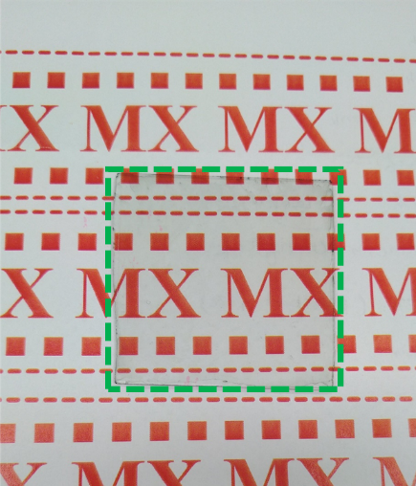
Figure S1. Actual photograph of MXene coated glass

Table S1. Electrical properties of MXene coated at glass substrate
Parameter | Value
Carrier concentration (cm⁻³) | -1.620 x10²²
Sheet-resistance (Ω/sq.) | 5.12 x10²
Hall coefficient (cm³/C) | -3.853 x10⁻⁴
Conductivity (S/cm) | 1.941 x10³

Figure S2. Relative resistance change (R-R₀/R₀)%, (where R₀ is the initial sheet resistance) of MXene films passivated with different NOA65 concentrations (1, 5, 10, and 50 %).
Figure S3. Relative resistance change (R-R₀/R₀)%, (R₀ is the initial sheet resistance) of MXene films passivated with different polymers.

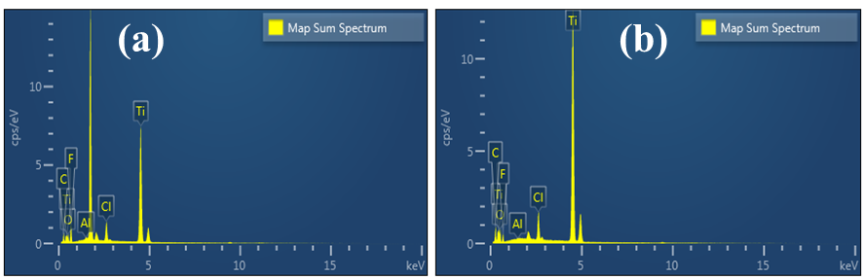
Figure S4. EDX spectra of MXene film on (a) day 1 and (b) day 30.

Table S2. EDX spectra of MXene film on day 1 and day 30.
Element | Wt.% | Atomic % | Wt.% | Atomic %
 | Day 1 |  | Day 30
C | 33.25 | 39.17 | 30.40 | 33.73
O | 16.27 | 16.95 | 24.59 | 24.45
F | 15.51 | 13.81 | 10.95 | 13.55
Al | 0.07 | 0.02 | 0.04 | 0.04
Cl | 1.16 | 1.28 | 1.05 | 1.11
Ti | 33.74 | 28.66 | 32.97 | 27.12
Total: | 100.00 | 100.00 | 100.00 | 100.00

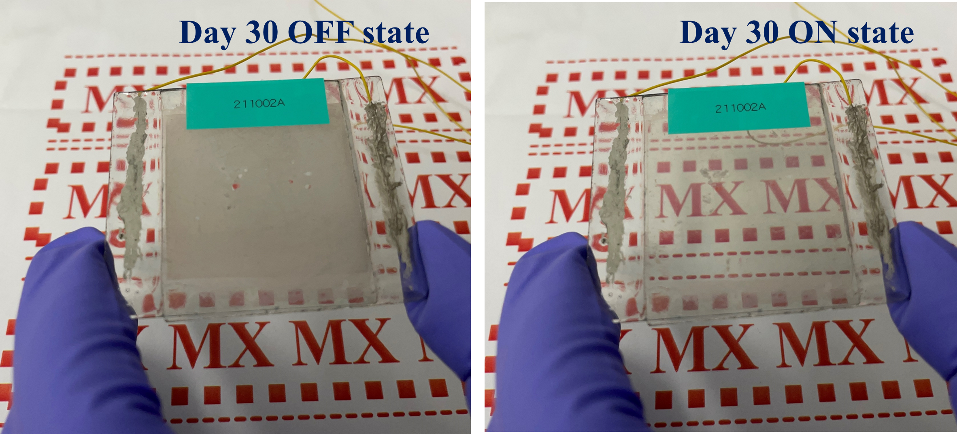
Figure S5. ON/OFF states of MXenes based PDLC smart window after 30 days.
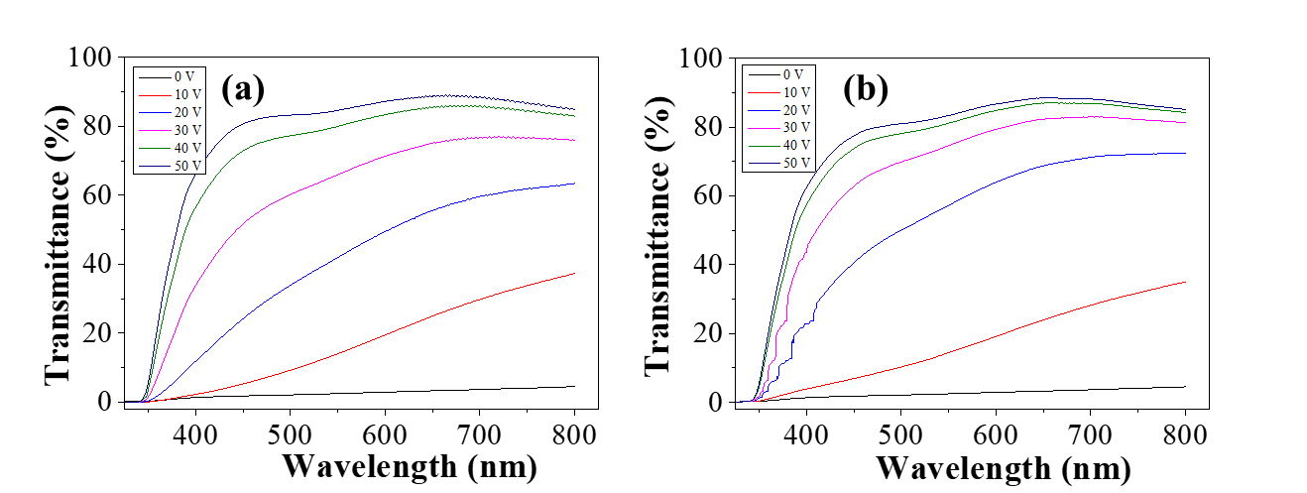
Figure S6. UV-Vis. transmittance spectra of ITO based PDLC smart-window after (a) day 1 (b) 180 days.

