Table 1. Parameters and Scores Used for Evaluation

Parameters | Scores | Description
The ICDAS II codes and criteria | 0 | 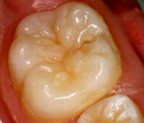 Sound.
The ICDAS II codes and criteria | 1 | 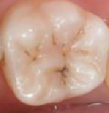 First visual change in enamel.
The ICDAS II codes and criteria | 2 | 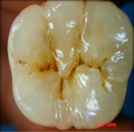 Distinct visual change in enamel.
The ICDAS II codes and criteria | 3 | 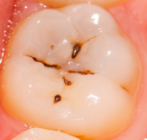 Localized enamel breakdown.
The ICDAS II codes and criteria | 4 | 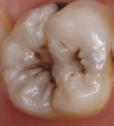 Underlying dark shadow.
The ICDAS II codes and criteria | 5 | 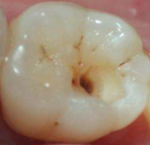Distinct cavity with visible dentin.
The ICDAS II codes and criteria | 6 | 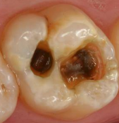Extensive distinct cavity with visible dentin.
Restoration and Sealant Codes | 0 | Not sealed or restored.
Restoration and Sealant Codes | 1 | Sealant, partial.
Restoration and Sealant Codes | 2 | Sealant, full.
Restoration and Sealant Codes | 3 | Tooth colored restoration.
Restoration and Sealant Codes | 4 | Amalgam restoration.
Restoration and Sealant Codes | 5 | Stainless steel crown.
Restoration and Sealant Codes | 6 | Porcelain, gold, FPM crown or veneer.
Restoration and Sealant Codes | 7 | Lost or broken restoration.
Restoration and Sealant Codes | 8 | Temporary restoration.
Scores for teeth loss | 97 | Tooth missing because of caries.
Scores for teeth loss | 98 | Tooth missing for reasons other than caries.
Scores for teeth loss | 99 | Not erupted.

