DFT study on the disproportionation of methylchlorosilane catalyzed by AlCl₃/ZSM-5(4T)@MIL-53(Al) core-shell catalyst
Wenyuan Xu , Hongkun Huang¹, Mengsha Shen¹, Junjie Fan¹, Yu Xu¹, Siqi Liu¹, Yan Wang¹, Xi Chen ¹, Mengyin Liao ¹, Shaoming Yang ¹
Abstract：Dimethyldichlorosilane is one of the most widely used monomers in the organic silicon industry chain. In the preparation process, it can be obtained by exchanging functional groups through disproportionation reaction. In this research, the disproportionation mechanism catalyzed by ZSM-5(4T)@MIL-53(Al) and AlCl₃/ZSM-5(4T)@MIL-53(Al) core-shell catalysts was studied by using the density functional theory on the level of M06-2X/Def2-TZVP. The results showed that the two catalysts possessed different catalytic effect assigning to different acidic actives. The surface activity of ZSM-5(4T)@MIL-53(Al) core-shell catalyst modified by AlCl₃ became the Lewis acid center of Al-Cl bond, which had better disproportionation activity than that before modification. Energies, frequency vibrations and IRC calculations, bond orders, ELF and LOL analyses can verify the reaction mechanism proposed in this research.
Keywords: core-shell catalyst; disproportionation reaction; density functional theory; ZSM-5; MIL-53(Al)

3. Results and Discussion:

3.1 ZSM-5(4T)@MIL-53(Al) core-shell catalyst
The corresponding transition state structural patterns of active sites (No 2-5) are shown in Fig.S1-S4, and the key atom mark is consistent with the active site M. At the same time, reactants, transition states and bond length or distance of products in the route are also included. The transition state of each step mainly comes from the stretching vibration between the key atoms. Finally, the reactant Rx and product Px were found by calculating the transition state TSx along the forward and reverse directions. The longitudinal length or radial extensional vibration between the key atoms was found to be the equivalent, confirming the authenticity of all transition state structures.
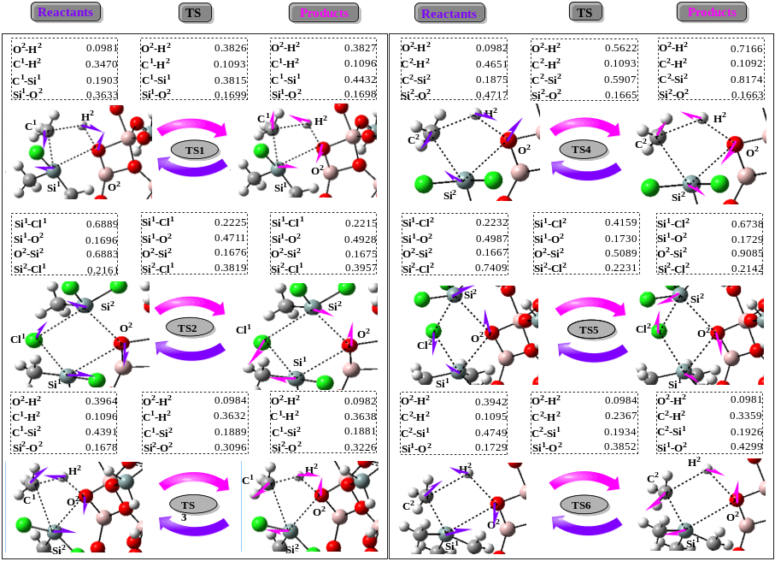

Fig.S1 The vibrational modes of the transition states of active site 2, its key atomic number and distance of each reactant, product and transition state
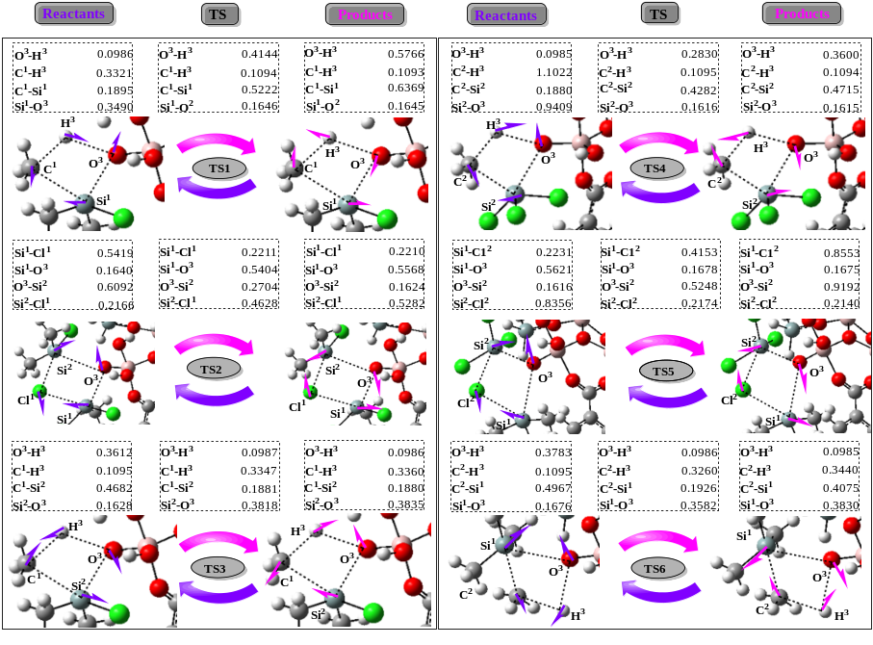

Fig.S2 The vibrational modes of the transition states of active site 3, its key atomic number and distance of each reactant, product and transition state
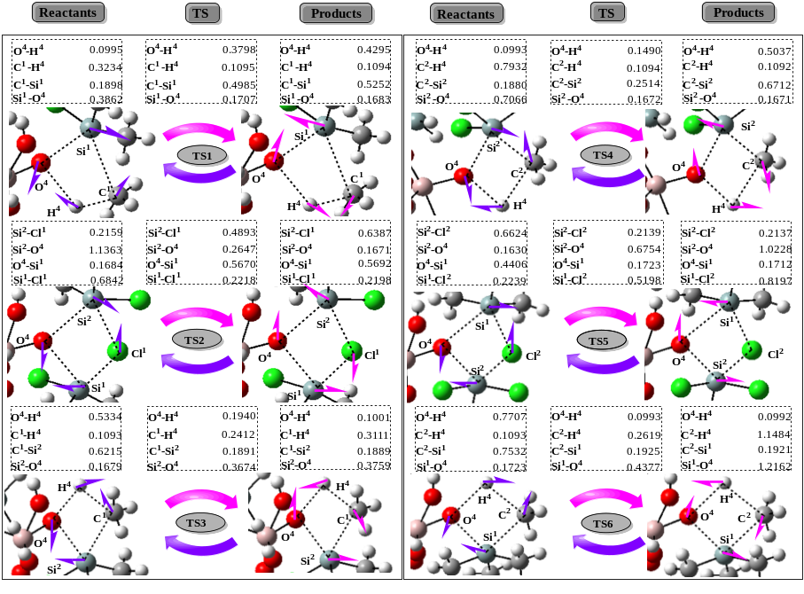
Fig.S3 The vibrational modes of the transition states of active site 4, its key atomic number and distance of each reactant, product and transition state
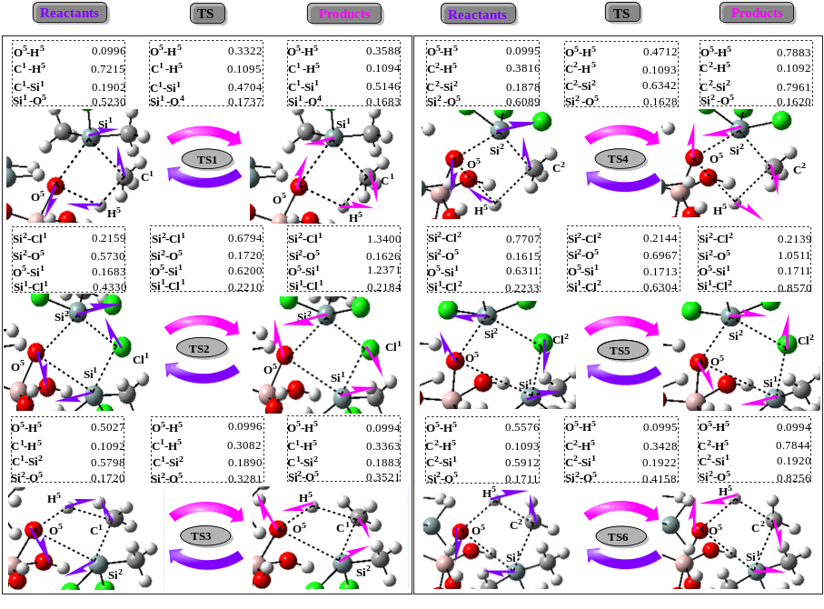
Fig.S4 The vibrational modes of the transition states of active site 5, its key atomic number and distance of each reactant, product and transition state
IRC analyses of active sites 4 and 5 were shown in Fig.S5, it can be seen from the figure that the disproportionation reaction started from the reactants and passed through the transition state to generate the product, and the distance between the key atoms showed a trend of lengthening or shortening. It was consistent with the vibrational trends of the transition stat, which proved the correctness of the reaction mechanism.

Fig.S5 Variation trend of key atom spacing along IRC in ZSM-5(4T)@MIL-53(Al) catalytic system; (a)-(f) represent the IRC of transition states TS1-TS6, respectively

Wenyuan Xu xwyktz@163.com School of Materials Science and Engineering, East China Jiaotong University, Nanchang 330013, China

