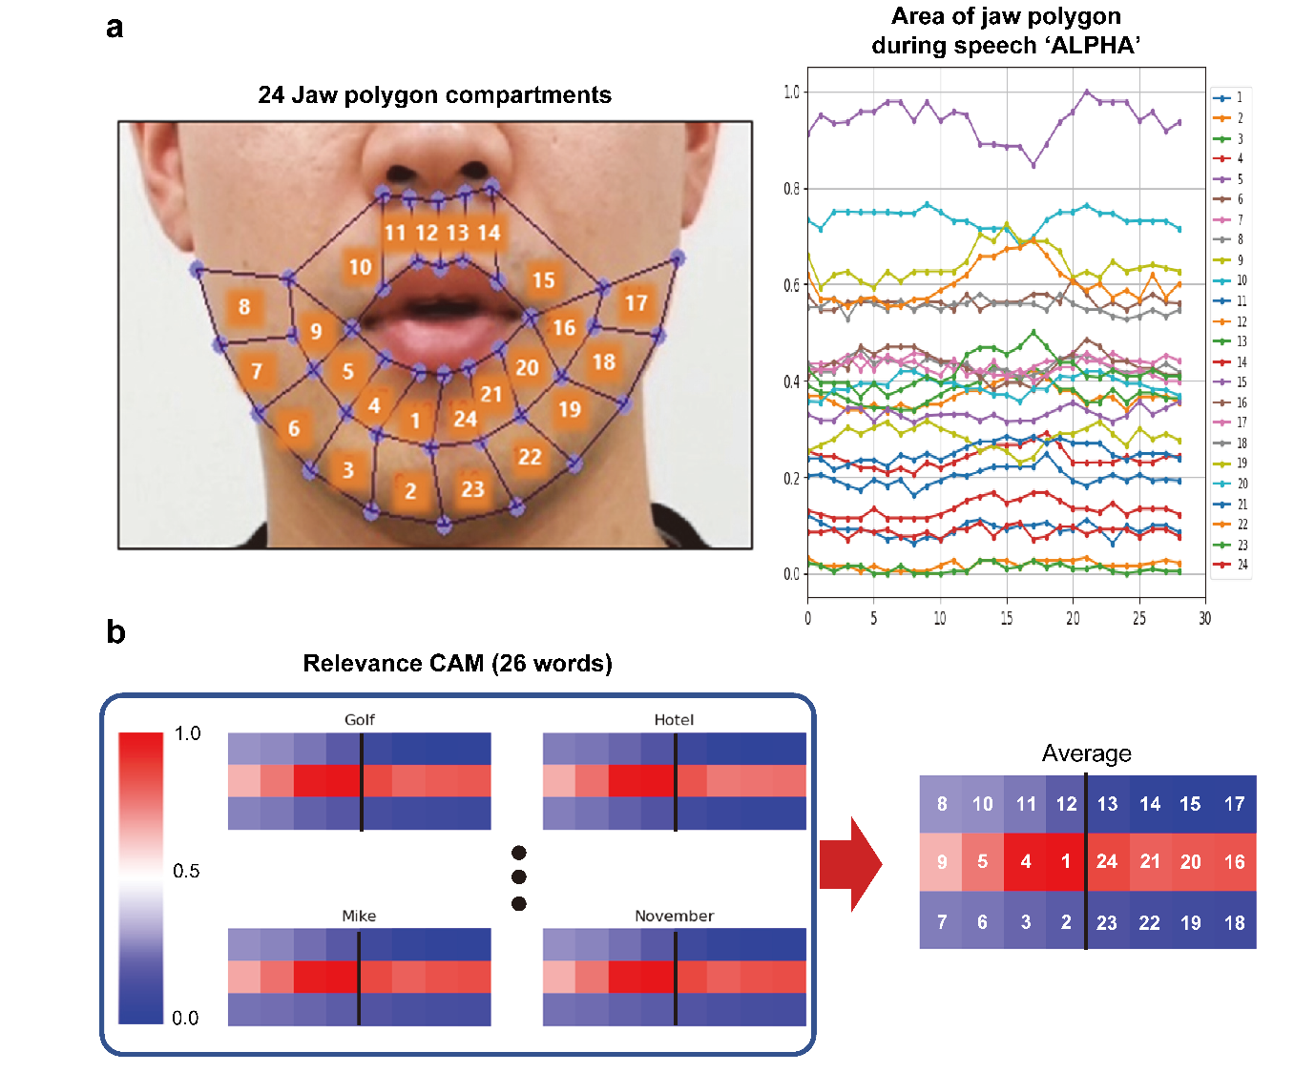
Supplementary Figure 1. Decision of sensor locations through area feature analysis (R-CAM). a, Picture of 24 randomly partitioned compartments of facial skin near the mouth (left) and area change of 24 jaw polygons in the time domain while the word “ALPHA” is silently spoken (right). b, R-CAM analysis of 26 NATO words, indicating which compartments have significant areal change. It was confirmed that the areal change of the sections under the lower lip was the most remarkable while speaking the words silently.

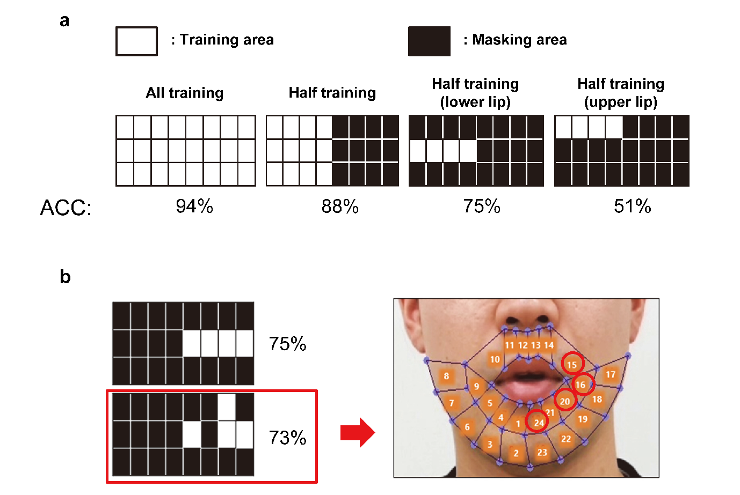
Supplementary Figure 2. Decision of sensor locations through area feature analysis (ablation study). a–b, Recognition accuracy of 26 NATO codes with some designated compartments masked.
This experiment evaluated the effectiveness of the sensor positioning. The dataset is classified into 26 NATO codes. A model based on a 3D convolutional network is used. When we trained using all the area features, the model’s accuracy is 94%. When we use half of the area feature on the left side while masking the other half on the right side, the accuracy is 88%. This can be interpreted as having sufficient information with only half of the area feature because the whole muscles move symmetrically from side to side when we speak. When the performance of about four lower lip areas is compared with that of about four upper lip areas, the result of the former (75%) is better than that of the latter (51%). Additionally, we evaluated the performance with the area features of three lower lip areas and one upper lip area. Although the result (73%) is slightly lower than that of four lower lip areas (75%), a position shift of one sensor to an upper lip area enables a more convenient attachment of the sensors.

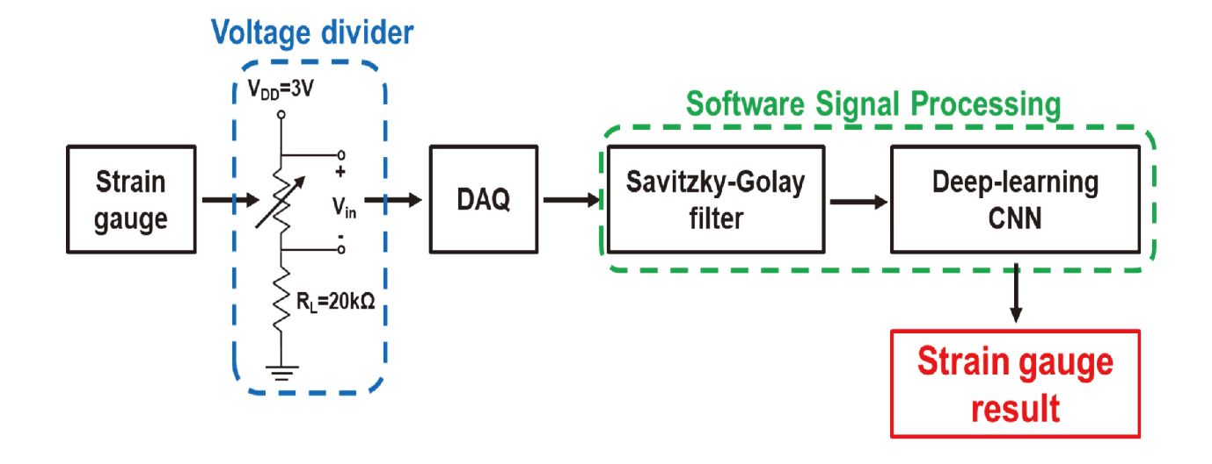
Supplementary Figure 3. Block diagram of sEMG data acquisition flow. The facial skin movements during silent speech are captured in the form of resistance change by epidermal strain sensors. The resistance change induces the voltage change by the voltage divider (V_{s} = 3V and R_{L} = 20 kΩ) and is monitored by the voltage input module of the DAQ system. The collected raw data are pre-processed with the Savitzky–Golay filter and converted to a 3D array format before being feature-extracted with a 3D convolutional neural network (CNN).

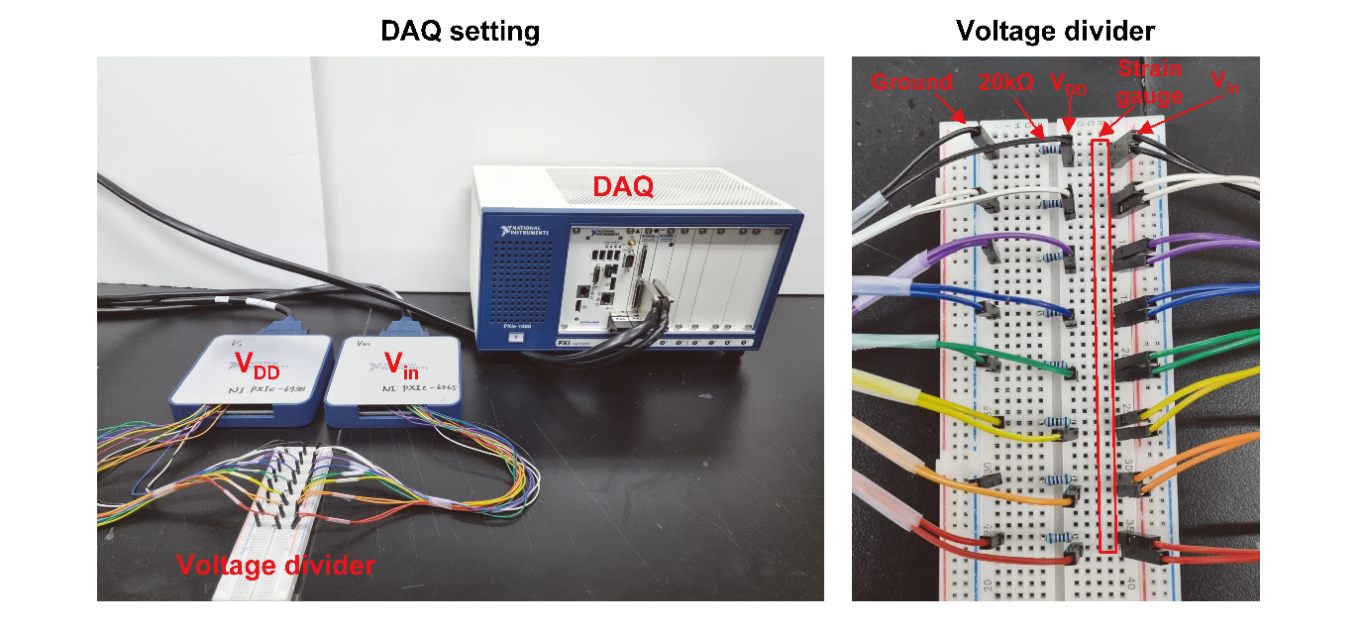
Supplementary Figure 4. Photograph of the strain data monitoring DAQ setup. The photograph consists of a voltage output module (NI PXIe-6738), voltage input module (NI PXIe-6365), voltage divider circuit, and an embedded controller (NI PXIe-8840) for measuring strain data with a frequency of 300 Hz.

Supplementary Note 1. Details in FEA simulation
The uniaxial stretching of the serpentine Si strain sensors in the mesh layout was simulated with the Piezoresistive Multiphysics model in COMSOL. Without loss of generality, the multilayered structures (i.e., PI/Au/Cr/PI and PI/Si/PI) were modeled using a composite 2D shell with an effective Young’s modulus of $E_{effective}={\sum{E_{i}h_{i}}}/{\sum{h_{i}}}$, where $E_{i}$ and $h_{i}$ are the Young’s modulus and thickness of each layer, respectively (Supplementary Table 1). The resistance change ($Δρ$) of the piezoresistive sensor is related to the piezoresistive coefficient ($π$) and stress tensor (S) as $Δρ=π∙S$. In the COMSOL simulation, the piezoresistive coefficient of p-type, single-crystal Si is given as
$π=\left[\begin{matrix}\begin{matrix}6.6 & -1.1 & -1.1 \\ -1.1 & 6.6 & -1.1 \\ -1.1 & -1.1 & 6.6\end{matrix} & \begin{matrix}0 & 0 & 0 \\ 0 & 0 & 0 \\ 0 & 0 & 0\end{matrix} \\ \begin{matrix}0 & 0 & 0 \\ 0 & 0 & 0 \\ 0 & 0 & 0\end{matrix} & \begin{matrix}138.1 & 0 & 0 \\ 0 & 138.1 & 0 \\ 0 & 0 & 138.1\end{matrix}\end{matrix}\right]$·${10}^{-10} (1/Pa)$.
As the electrical resistance can be easily obtained as the ratio of the applied electrical potential (e.g., 5 V) to the measured current, applying the tensile strain along the given direction yields a change of resistance in the Si strain sensor with 45° orientation^{1, 2} upon stretching, which agrees reasonably well with the experimental measurements (Figs. 2d–e).

Supplementary Table 1. Material properties and thickness of each layer
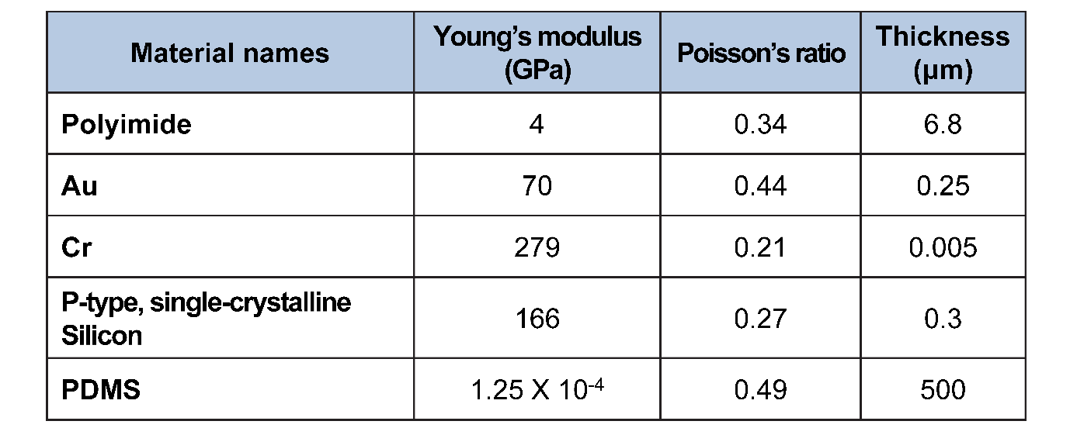

Supplementary Table 2. Hyperparameters for 3D CNN-based deep-learning model
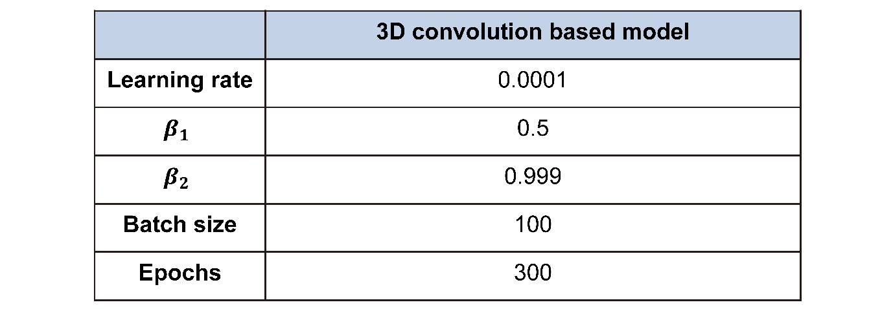

Supplementary Table 3. Statistics of strain datasets
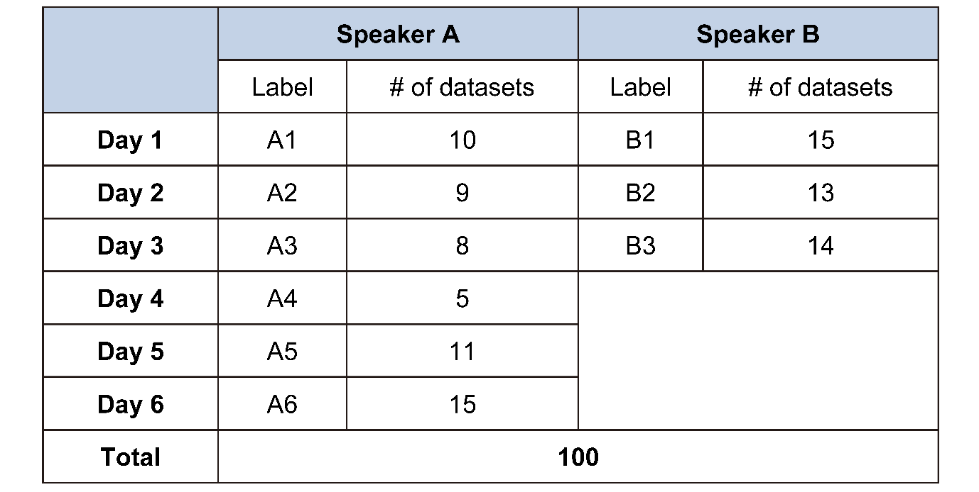

Supplementary Table 4. Recognition accuracy of all words (1–50) for 3 different classifier models.
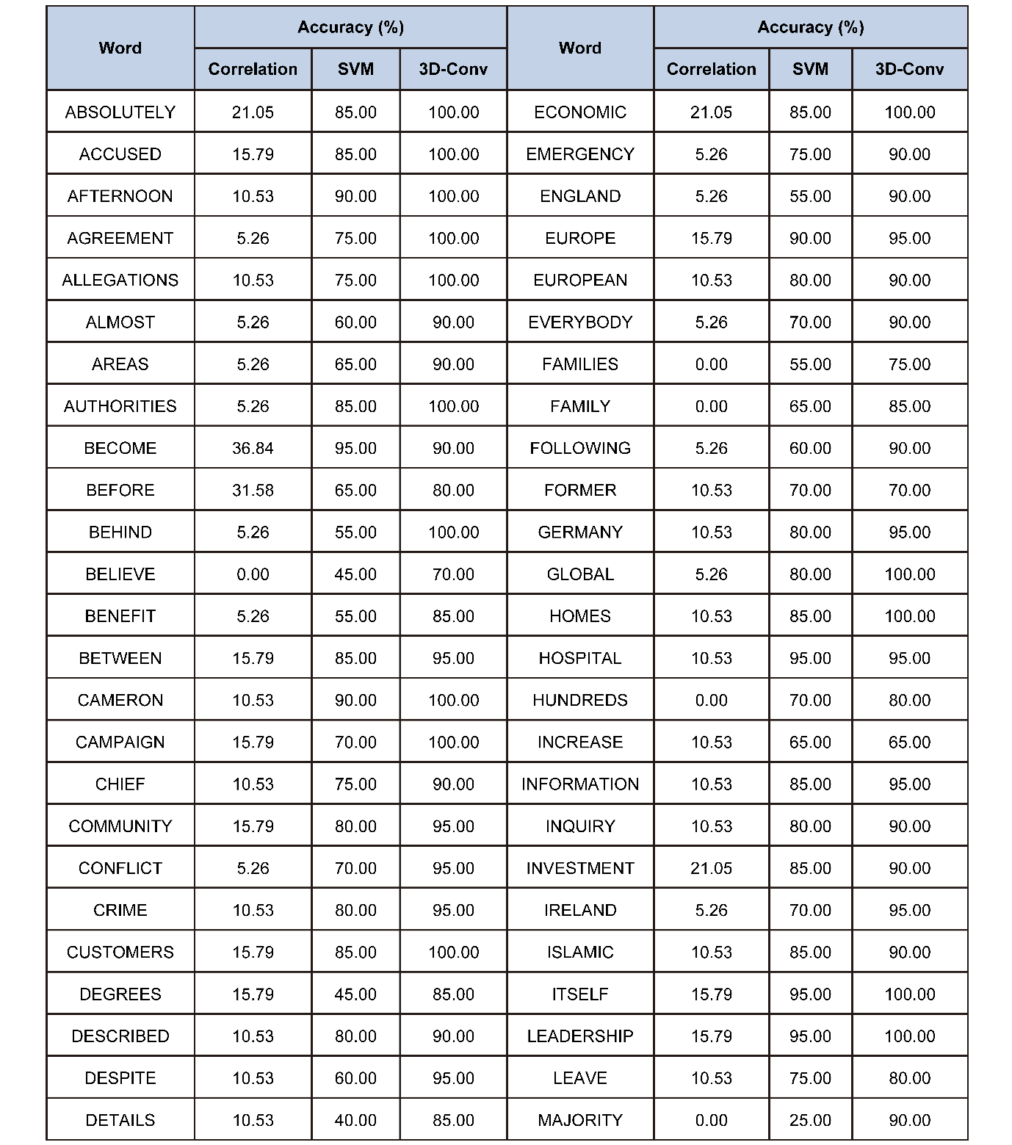

Supplementary Table 5. Recognition accuracy of all words (51–100) for 3 different classifier models.
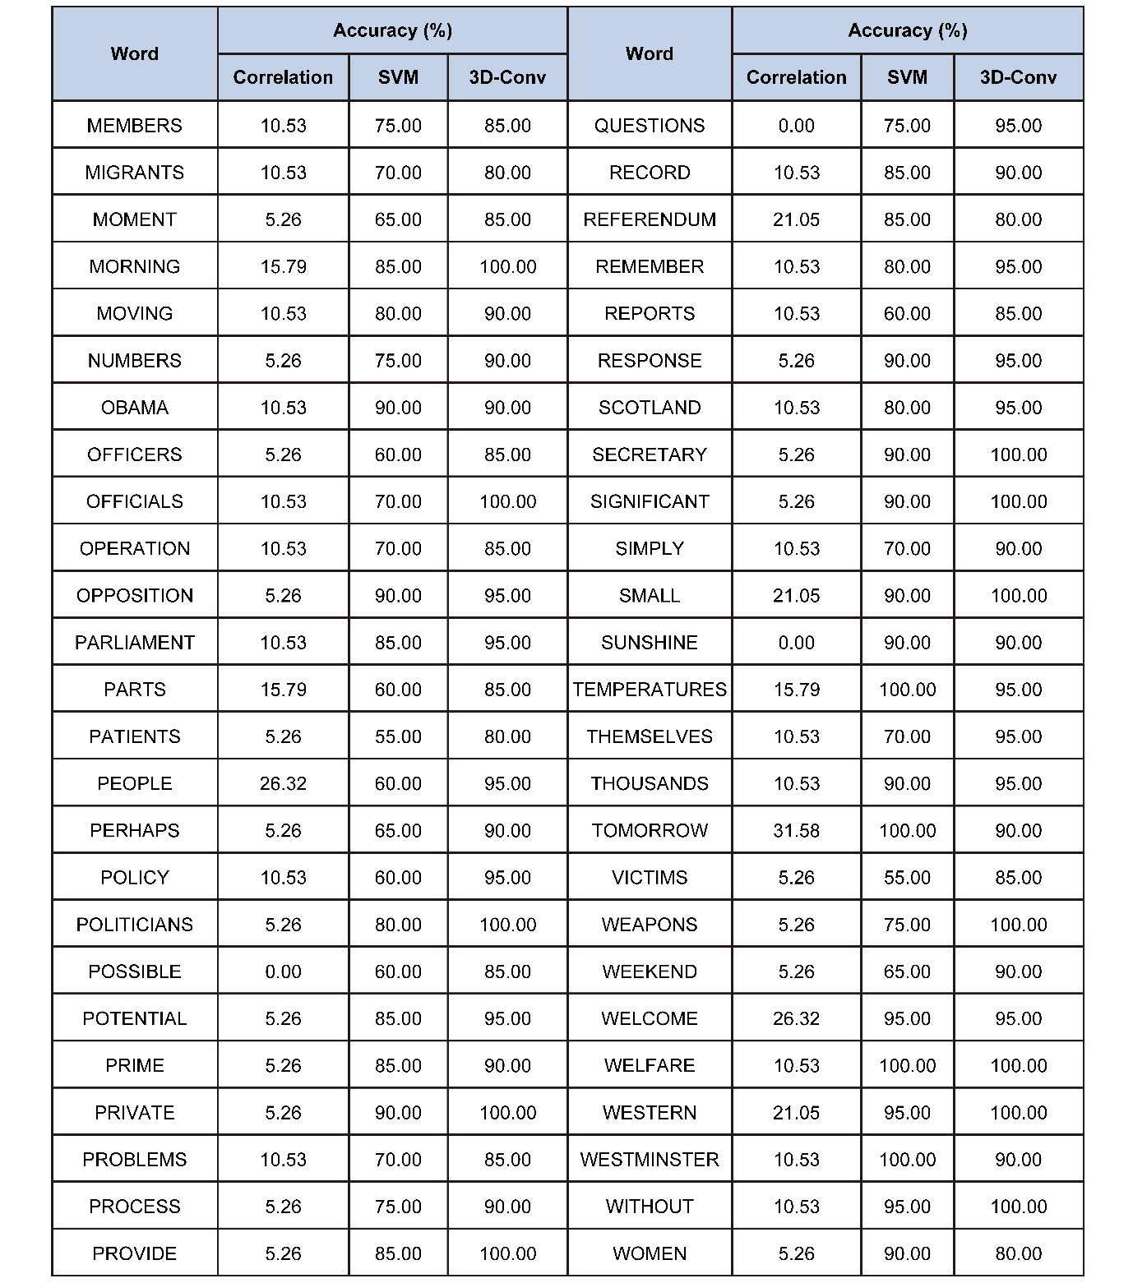

Supplementary Table 6. Recognition accuracy change as training of unseen data increases.
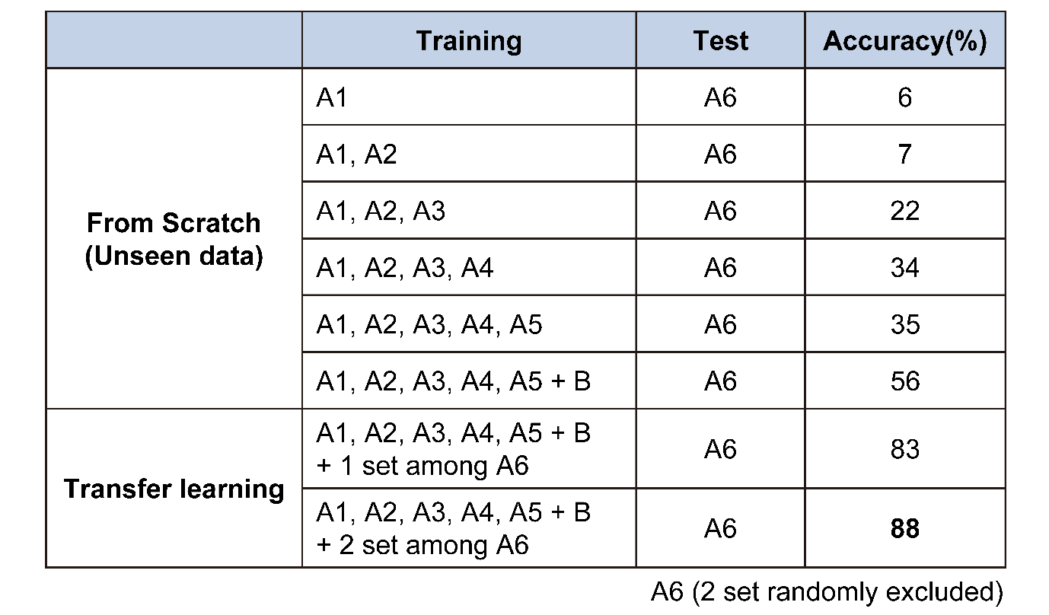
In this experiment, A6 datasets are fixed as test datasets, with two datasets chosen at random to be excluded for the transfer learning. Therefore, all of the training datasets are in a domain different from that of the test datasets (unseen data). When only A1 datasets are trained, the system classifies A6 datasets with very low accuracy due to the shortage of training datasets and the slight mismatch of sensor locations between the A1 and A6 datasets. However, this accuracy tends to gradually increase, even though the additional training datasets are all unseen data. Training B datasets from even different subjects increases the accuracy. It demonstrates that the low recognition rate of unseen data due to sensor or subject replacement can be gradually improved as the number of users of this system increases. Furthermore, the simple transfer learning of pre-excluded A6 datasets sharply increases the accuracy. Only two cycles of transfer learning increase the accuracy up to 88%, which enables the manageable customization for the initial use of the system.


Supplementary Figure 5. Expanded view of t-SNE (strain). It shows the 100 words given in Fig. 4a in different colored points.

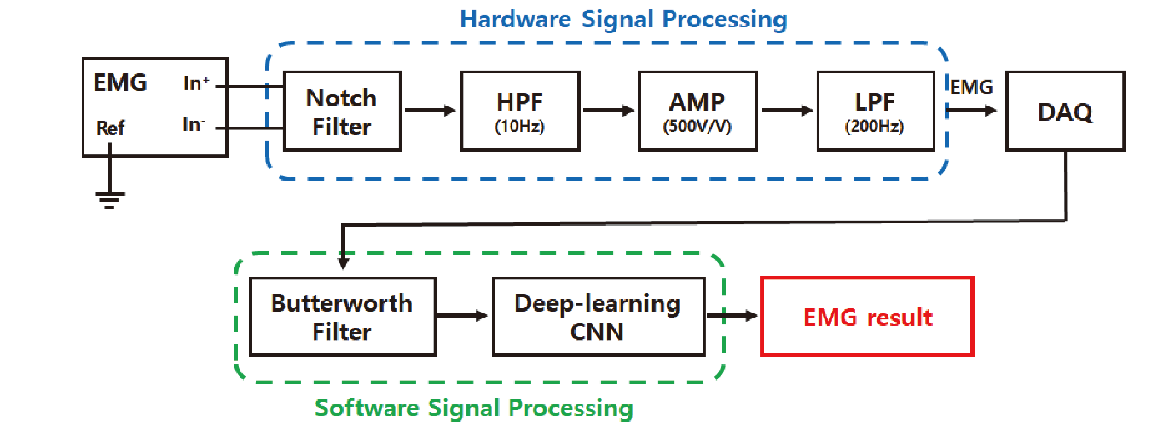
Supplementary Figure 6. Block diagram of sEMG data acquisition flow. The facial sEMG during silent speech is captured by epidermal EMG electrodes. This raw sEMG signal is pre-processed by a commercial EMG module (notch filter at 50 Hz, high-pass filter at 10 Hz, low-pass filter at 200 Hz, and amplifier at 500V/V), and collected by the voltage input module of the DAQ system. The resistance change induces the voltage change by the voltage divider (V_{s} = 3V and R_{L} = 20kΩ) and is monitored by the voltage input module of the DAQ system. The collected data is reprocessed using the Butterworth filter and converted to a 3D array format before being feature-extracted with a 3D CNN.

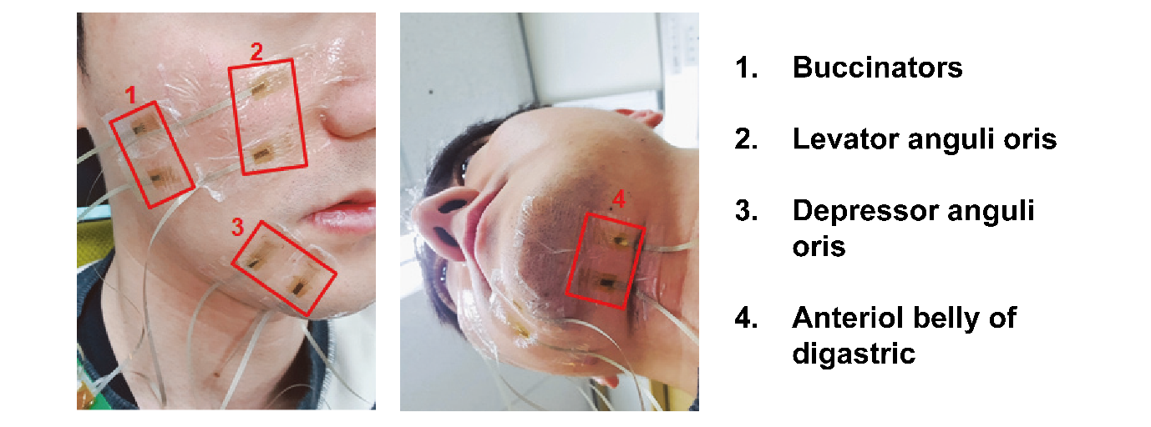
Supplementary Figure 7. Surface electrode attachment locations for monitoring EMG signals of facial muscles. Attachment locations 1–4 are buccinators, levator anguli oris, depressor anguli oris, and anteriol belly of digastric, respectively. Two electrodes are attached at a 2-cm interval in each location, and a common reference electrode is attached near the posterior mastoid.

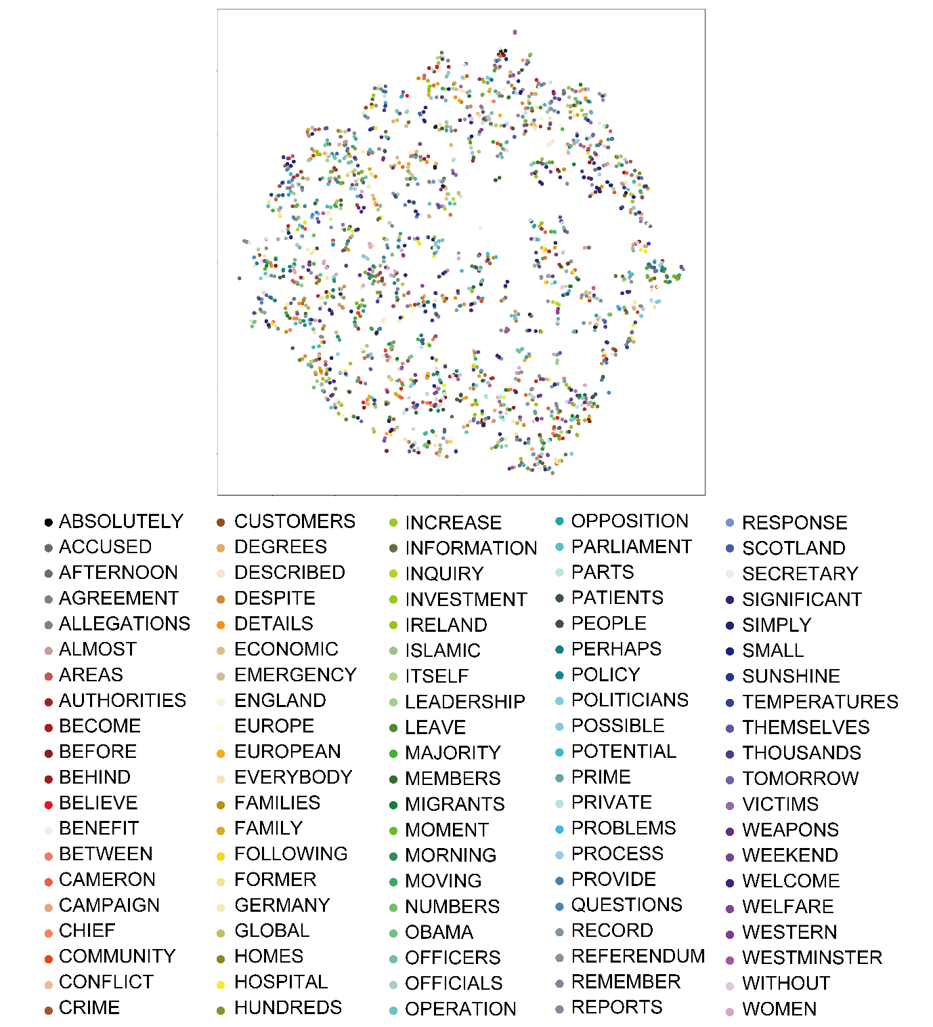
Supplementary Figure 8. Expanded view of t-SNE (sEMG). It shows the 100 words given in Fig. 5h in different colored points.

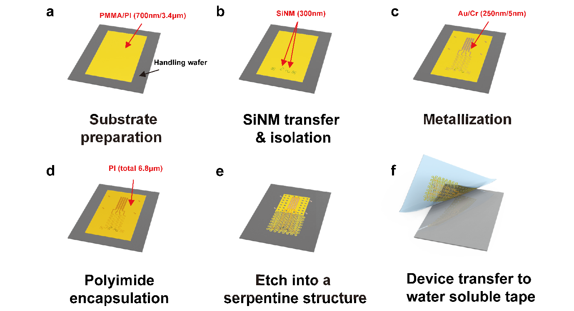
Supplementary Figure 9. Schematic diagram showing the fabrication procedures of the SiNM-based biaxial strain sensor. a, Spin coating PMMA and PI double-layer; b, Defining biaxial strain gauges by the transfer of SiNM using elastomer stamp and cell isolation; c, Metallization of Au/Cr interconnects by thermal evaporation; d, Device encapsulation with another PI double-layer; e, Device cutting using Cu mask and dry etching; f, Device release and transfer onto water-soluble tape.

Supplementary Note 1. Details of the fabrication steps to achieve a SiNM-based strain sensor.
SiNM doping
- Surface cleaning of SOI chips (Device layer of 300 nm, BOX layer of 1µm, handling wafer of 730 µm) using piranha solution (3:1) at 100°C for 15 min;
- BOE (6:1) to remove native/chemical oxide for 5 s;
- Dope the entire area with boron by ion implantation (power of 30 keV, dose of 5 × 10¹⁴ cm⁻²⁾;
- Rapid thermal annealing at 1050°C for 90 s.
Microhole
- Piranha and BOE cleaning;
- UV-lithography to define microhole array (diameter of 3 µm, pitch of 50 µm) using positive PR (MICROPOSIT S1805) and developer (AZ 300 mif);
- Dry etch of Si by RIE (Torr of 150 m, SF6 of 40 sccm, power of 150 W for 50 s).
Substrate preparation
- Piranha cleaning of thermal oxide wafer (SiO₂ of 500 µm);
- Spin coat PMMA A8 (500 rpm for 10 s, 1000 rpm for 35 s); Soft bake at 110°C for 1 min; Cure at 180°C for 3 min;
- Spin coat PI (500 rpm for 10 s, 3000 rpm for 30 s); Soft bake at 110°C for 3 min and then at 150°C for 3 min; Cure at 210°C for 120 min.
Transfer printing
- Cure PDMS stamp (4:1) at 40°C for 24 h;
- Spin coat the second PI on the above substrate (500 rpm for 10 s, 3000 rpm for 30 s); Soft bake at 110°C for 40 s;
- HF wet etch BOX layer of SOI chips for 25 min;
- Water rinsing of SOI chips;
- Transfer of the device layer of SOI chips onto the PDMS stamp; Press the stamp onto the substrate;
- Bake at 110°C for 40 s;
- Lift off PDMS stamp;
- Bake at 150°C for 3 min;
- PR removal using acetone, IPA, and DI water;
- Cure at 210°C for 120 min.
Strain gauge isolation
- UV-lithography to define biaxial strain gauges using positive PR (MICROPOSIT S1805) and developer (AZ 300 mif);
- Dry etch of Si by RIE (Torr of 150 m, SF6 of 40 sccm, power of 150 W for 50 s);
- PR removal using acetone, IPA, and DI water.
Metallization
- BOE (6:1) cleaning for 5 s to remove native oxide;
- Deposit Au/Cr, 250 nm/5 nm by thermal evaporation;
- UV-lithography to define metal interconnects using positive PR (AZ 5214E) and developer (AZ 300 mif);
- Wet etch using Au etchant for 15 s; Cr etchant for 10 s;
- PR removal using acetone, IPA, and DI water.
Encapsulation
- Spin coat the third PI (500 rpm for 10 s, 3000 rpm for 30 s); Soft bake at 110°C for 3 min and then at 150°C for 3 min;
- Spin coat the fourth PI (500 rpm for 10 s, 3000 rpm for 30 s); Soft bake at 110°C for 3 min and then at 150°C for 3 min;
- Cure at 210°C for 120 min.
Patterning into serpentine design
- Deposit Cu, 150 nm by thermal evaporation;
- UV-lithography to define metal masks using positive PR (AZ 5214E) and developer (AZ 300 mif);
- PR removal using acetone, IPA, and DI water;
- Dry etch of PI by RIE (Torr of 390 m, SF6 of 100 sccm, power of 200 W for 30 min);
- Wet etch of metal masks using Cu etchant.
Transfer to water-soluble tape
- Dissolve the PMMA layer by immersing in acetone at 100°C for 10 min;
- Solder with ACF cable;
- Attach water-soluble tape, and lift off the release device.

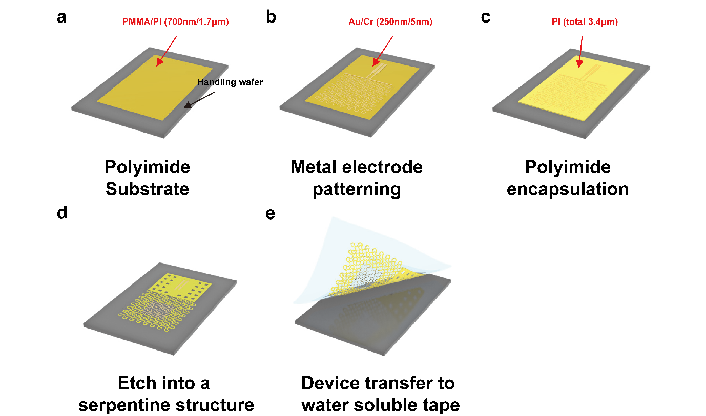
Supplementary Figure 7. Schematic diagram showing the fabrication procedures of the sEMG electrode. a, Spin coating PMMA and PI layer; b, Defining metal electrode and interconnects; c, Device encapsulation with another PI layer; d, Device cutting and through-opening using Cu mask and dry etching; e, Device release and transfer onto water-soluble tape.

Supplementary Note 2. Details of the fabrication steps to achieve a stretchable sEMG sensor.
Substrate preparation
- Piranha cleaning of thermal oxide wafer (SiO₂ of 500 µm);
- Spin coat PMMA A8 (500 rpm for 10 s, 1000 rpm for 35 s); Soft bake at 110°C for 1 min; Cure at 180°C for 3 min;
- Spin coat PI (500 rpm for 10 s, 3000 rpm for 30 s); Soft bake at 110°C for 3 min and then at 150°C for 3 min; Cure at 210°C for 120 min.
Metal electrode and interconnect define
- Deposit Au/Cr, 160 nm/5 nm by thermal evaporation;
- UV-lithography to define metal electrodes and interconnects using positive PR (AZ 5214E) and developer (AZ 300 mif);
- Wet etch using Au etchant for 15 s; Cr etchant for 10 s;
- PR removal using acetone, IPA, and DI water.
Encapsulation
- Spin coat the second PI (500 rpm for 10 s, 3000 rpm for 30 s); Soft bake at 110°C for 3 min and then at 150°C for 3 min; Cure at 210°C for 120 min.
Electrode via opening and patterning into serpentine design
- Deposit Cu, 150 nm by thermal evaporation;
- UV-lithography to define metal masks using positive PR (AZ 5214E) and developer (AZ 300 mif);
- PR removal using acetone, IPA, and DI water;
- Dry etch of PI by RIE (Torr of 390 m, SF6 of 100 sccm, power of 200 W for 15 min);
- Wet etch of metal masks using Cu etchant.
Transfer to water-soluble tape
- Dissolve the PMMA layer by immersing in acetone at 100°C for 10 min;
- Solder with ACF cable;
- Attach water-soluble tape, and lift off the release device.

References
1. Basov, M. & Prigodskiy, D. Modeling of sensitive element for pressure sensor based on bipolar piezotransistor. (2021).
2. Romdhane, M.C.B., Mrad, H., Erchiqui, F. & Mrad, R.B. In IOP Conference Series: Materials Science and Engineering, Vol. 521 012004 (IOP Publishing, 2019).

