Supplementary Materials

Two Fe mining sub-products and three thiol compounds alleviate Fe deficiency in soybean (Glycine max L.) grown in a calcareous soil in greenhouse conditions
Zahra Gheshlaghi, Reza Khorassani, Javier Abadía

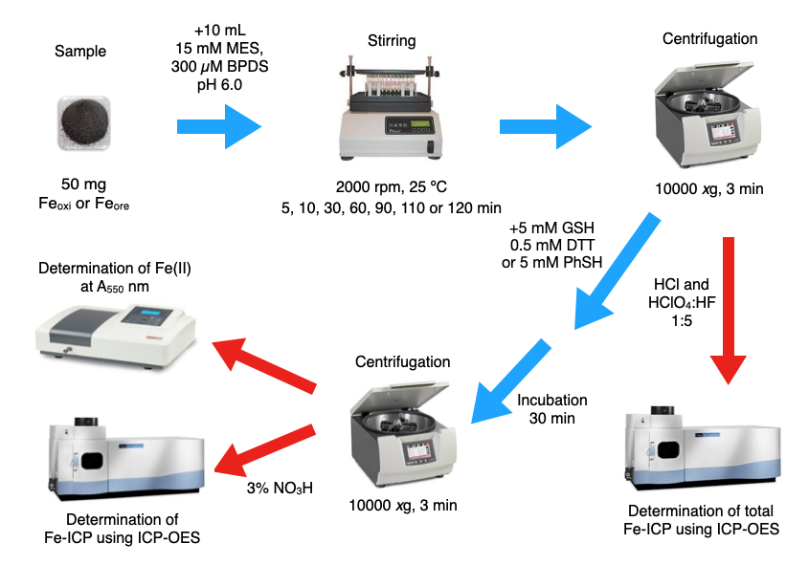
Figure S1. Solubilization procedure for the Fe_{oxi} and Fe_{ore} mining sub-products in the absence and presence of thiols.
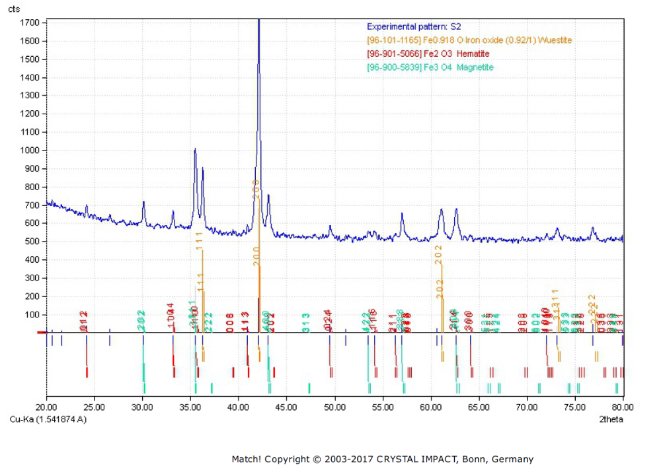

Figure S2. Characteristics of the Fe_{oxi} Fe-mining sub-product. (A) X-ray diffraction analysis. (B) Scanning electron microscopy (SEM) pictures.
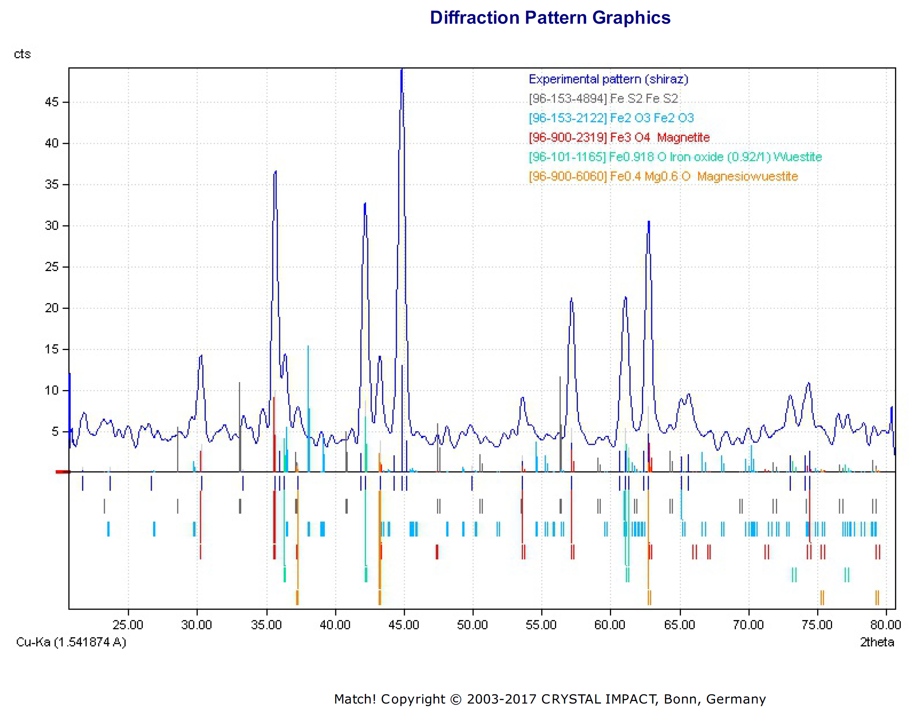

Figure S3. Characteristics of the Fe_{ore} Fe-mining sub-product. (A) X-ray diffraction analysis. (B) Scanning electron microscopy (SEM) pictures.
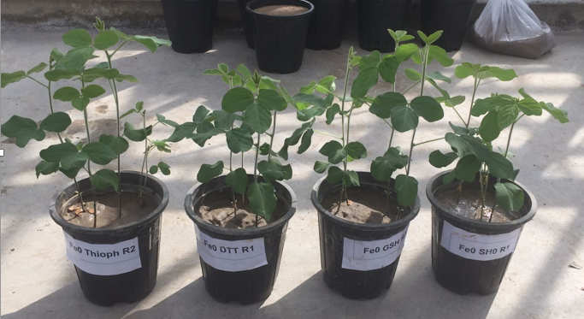
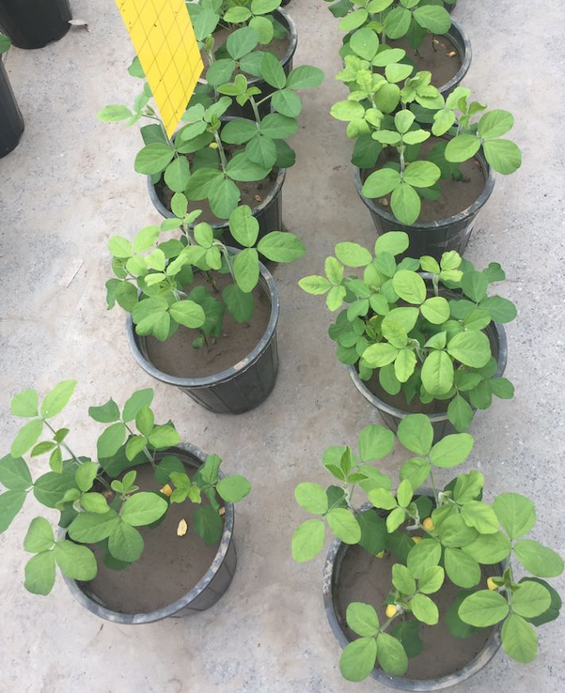
Figure S4. Pictures of Glycine max plants at day 50 after the initiation of the treatments.

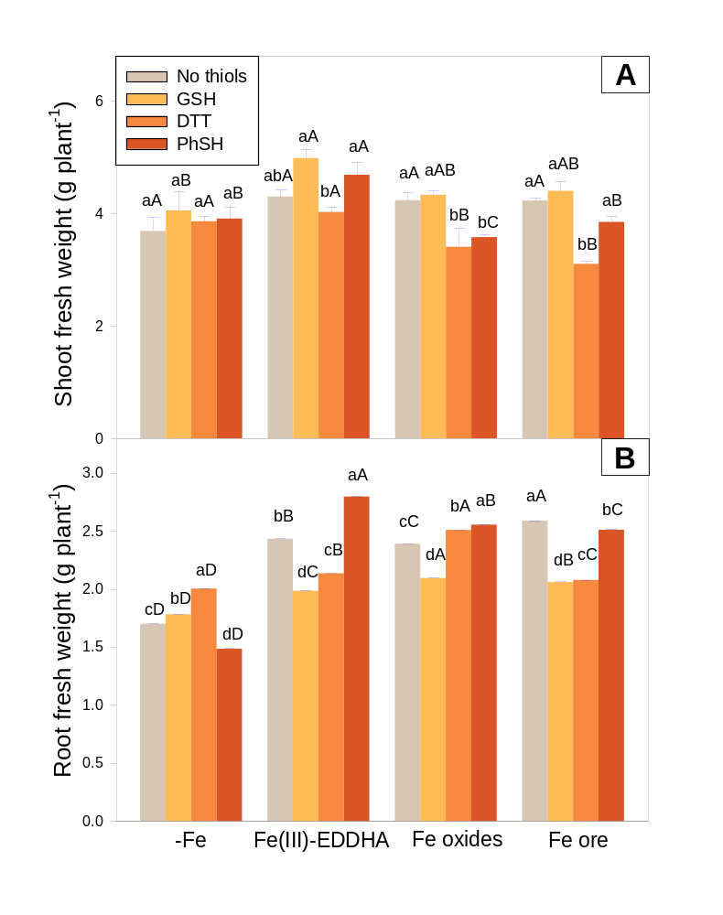
Figure S5. Plant fresh weight (FW) at the end of the experiment (at day 60). Treatments are as described in Figure 1. Shoot FW (A) and root FW (B) (in g plant⁻¹). Values shown are means ± SE (n = 9). Letters above the columns indicate significant differences at p ≤ 0.01 for the thiol treatments in a given Fe treatment (in lower case) and for the Fe treatments in a given thiol treatment (in capitals).
Changes in plant fresh weight in leaves and roots with Fe and thiol treatments
When no thiols were applied, none of the Fe products led to changes in shoot FW (grey bars in Figure S5A). In plants grown with zero Fe and the Fe-chelate, the FW was not changed with any of the thiol treatments. In the case of plants treated with Fe_{oxi}, the FW decreased with DTT and PhSH (by 19 and 15%, respectively), and in plants treated with Fe_{ore}, the FW decreased only with DTT (by 27%). When plants were treated with GSH and PhSH, only supplementation with Fe-EDDHA led to increases in shoot FW when compared to the zero Fe treatment. On the other hand, decreases in shoot FW were found when DTT was applied with Fe_{oxi} and Fe_{ore}, and when PhSH was applied with Fe_{oxi}.
In the absence of thiols, supplementation with all Fe sources led to increases in root FW when compared to the zero Fe treatment (1.4- to 1.5-fold; grey bars in Figure S5B). In plants grown with zero Fe, the FW increased when GSH and DTT were applied (1.1- and 1.2-fold, respectively) and decreased with PhSH (by 13%). In plants treated with the Fe-chelate, the FW decreased when GSH and DTT were applied (by 18 and 12% respectively), and increased with PhSH (1.1-fold). In plants treated with Fe_{oxi}, the FW decreased with GSH (12%) and increased with DTT and PhSH (1.1-fold). In plants treated with Fe_{ore}, the root FW decreased with all thiol compounds tested (in the range 3-20%). For any thiol treatment, supplementation with all Fe products led to increases in root FW when compared to the zero Fe treatment.

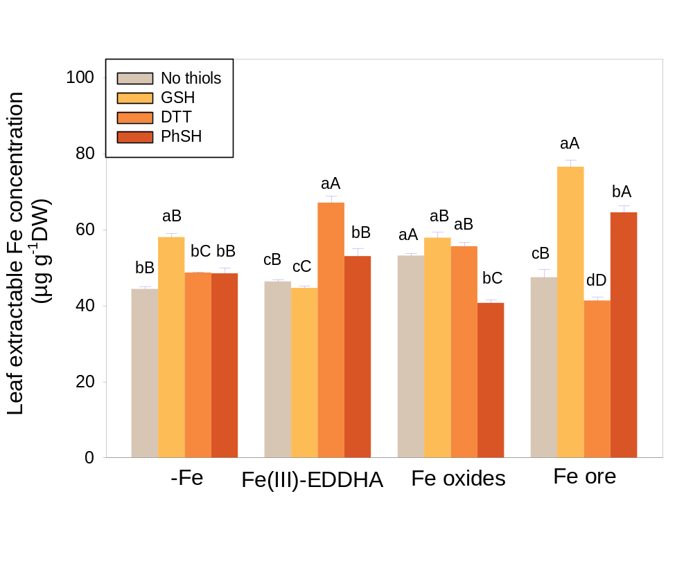
Figure S6. Extractable Fe concentrations in young leaves at the end of the experiment (at day 55) (in µg g⁻¹DW). Treatments are as described in Figure 1. Values shown are means ± SE (n = 3). Letters above the columns indicate significant differences at p ≤ 0.01 for the thiol treatments in a given Fe treatment (in lower case) and for the Fe treatments in a given thiol treatment (in capitals).

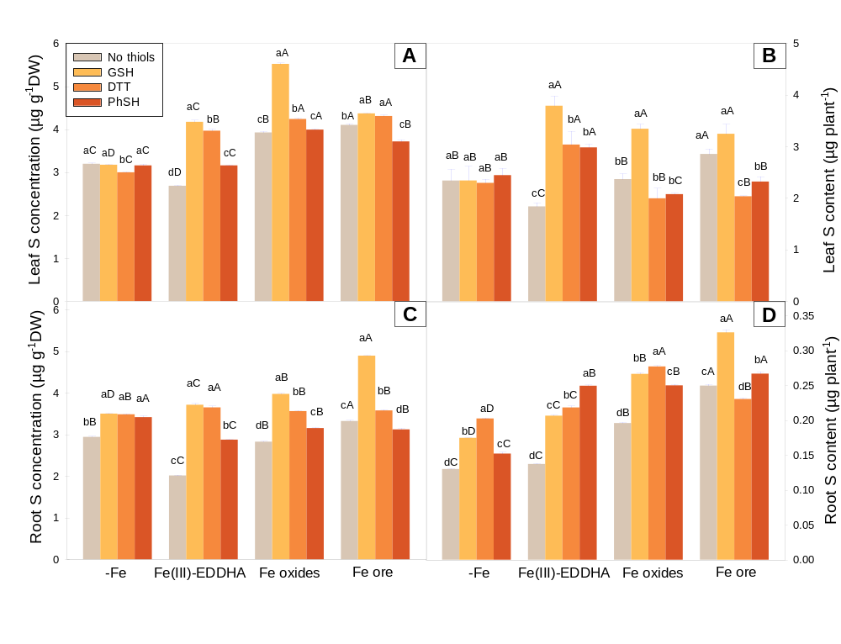
Figure S7. Total S concentrations (A, C; in µg g⁻¹ DW) and contents (B, D; in µg plant⁻¹) at the end of the experiment (at day 60) in young leaves (A, B) and roots (B, C). Treatments are as described in Figure 1. Values shown are means ± SE (n = 3). Letters above the columns indicate significant differences at p ≤ 0.01 for the thiol treatments in a given Fe treatment (in lower case) and for the Fe treatments in a given thiol treatment (in capitals).

Figure S8. Example of the time dependent solubilization of Fe mining products. Fifty mg of Fe_{oxi} was homogenized with 10 mL of 15 mM MES, pH 6.0, supplemented with 300 µM BPDS (for 5, 10, 30, 60, 90, 110 and 120 min), centrifuged and then GSH added. Measurements were made after 30 more min and a second centrifugation step.
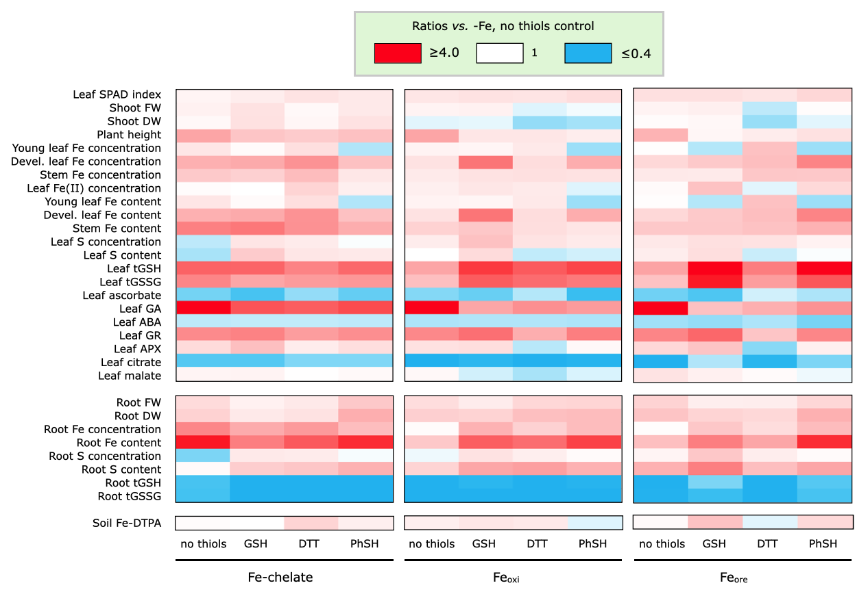
Figure S9. Heatmap summarizing the changes observed with the Fe-containing products and thiols were applied in combination.

