Phenylethanoid glycosides as a possible COVID-19 protease inhibitor: a virtual screening approach
Mario Bernardi^{[1, 2]} Mohammad Reza Ghaani*^{[1]} and Omer Bayazeid*^{[3]}
[1] School of Chemical and Bioprocess Engineering, University College Dublin, Belfield, Dublin 4, Ireland
[2] Scuola Normale Superiore, piazza dei cavalieri 7, 56126, Pisa (PI), Italy
[3] Department of Pharmacognosy, Faculty of Pharmacy, Hacettepe University, Ankara 06100, Turkey

Supporting information

(a)
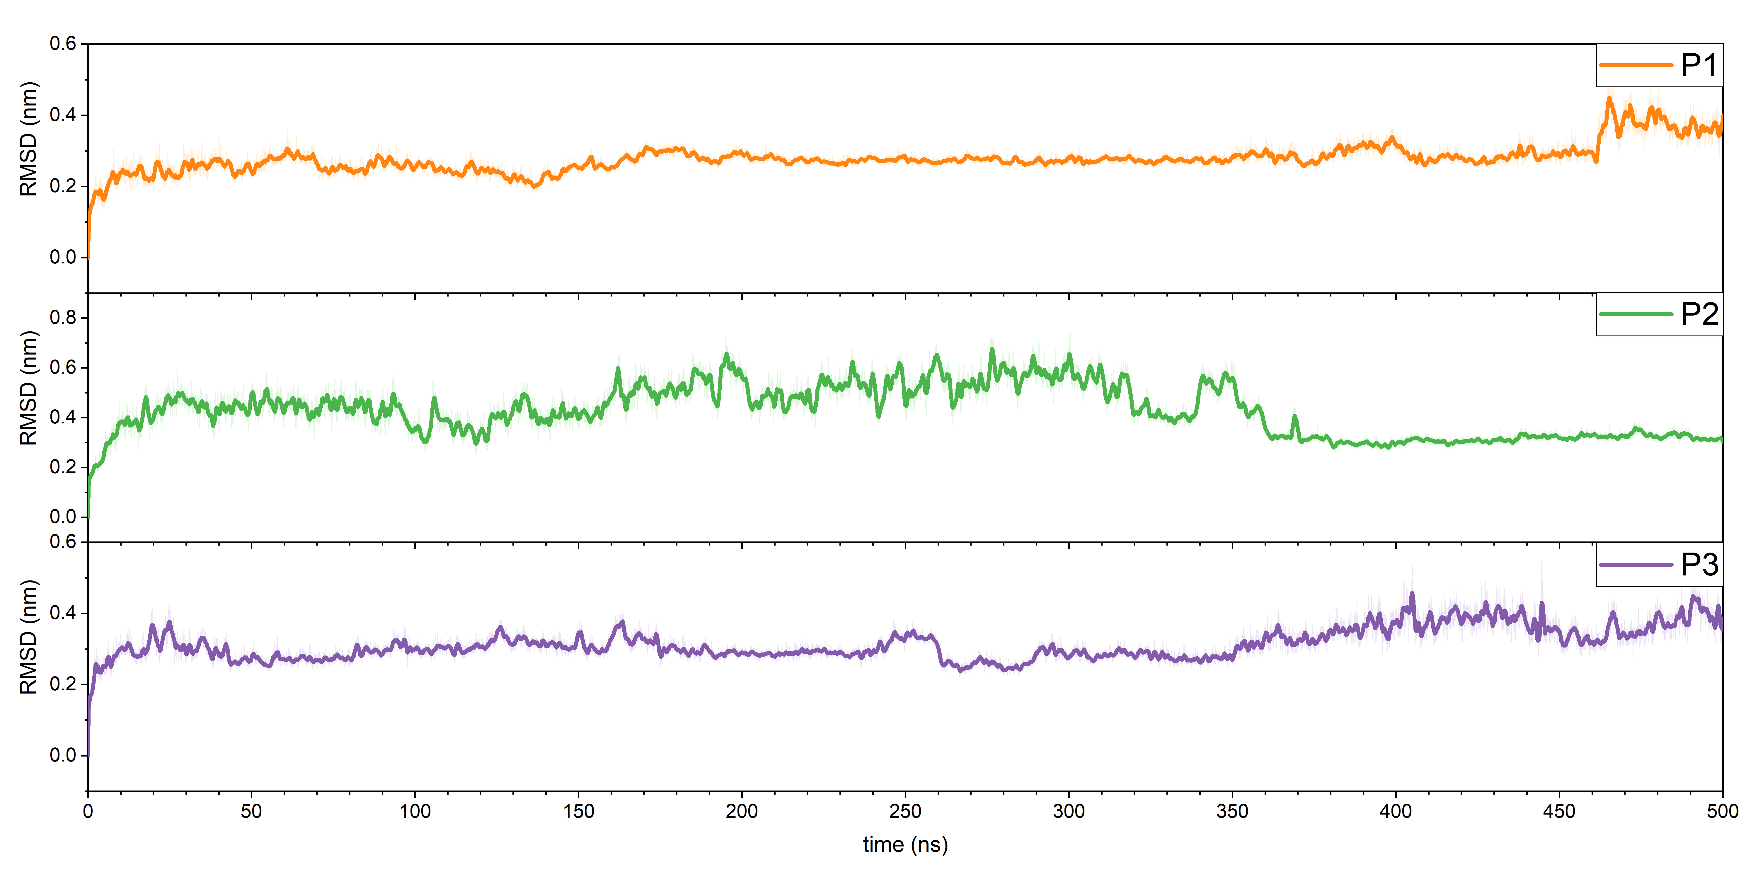
(b)
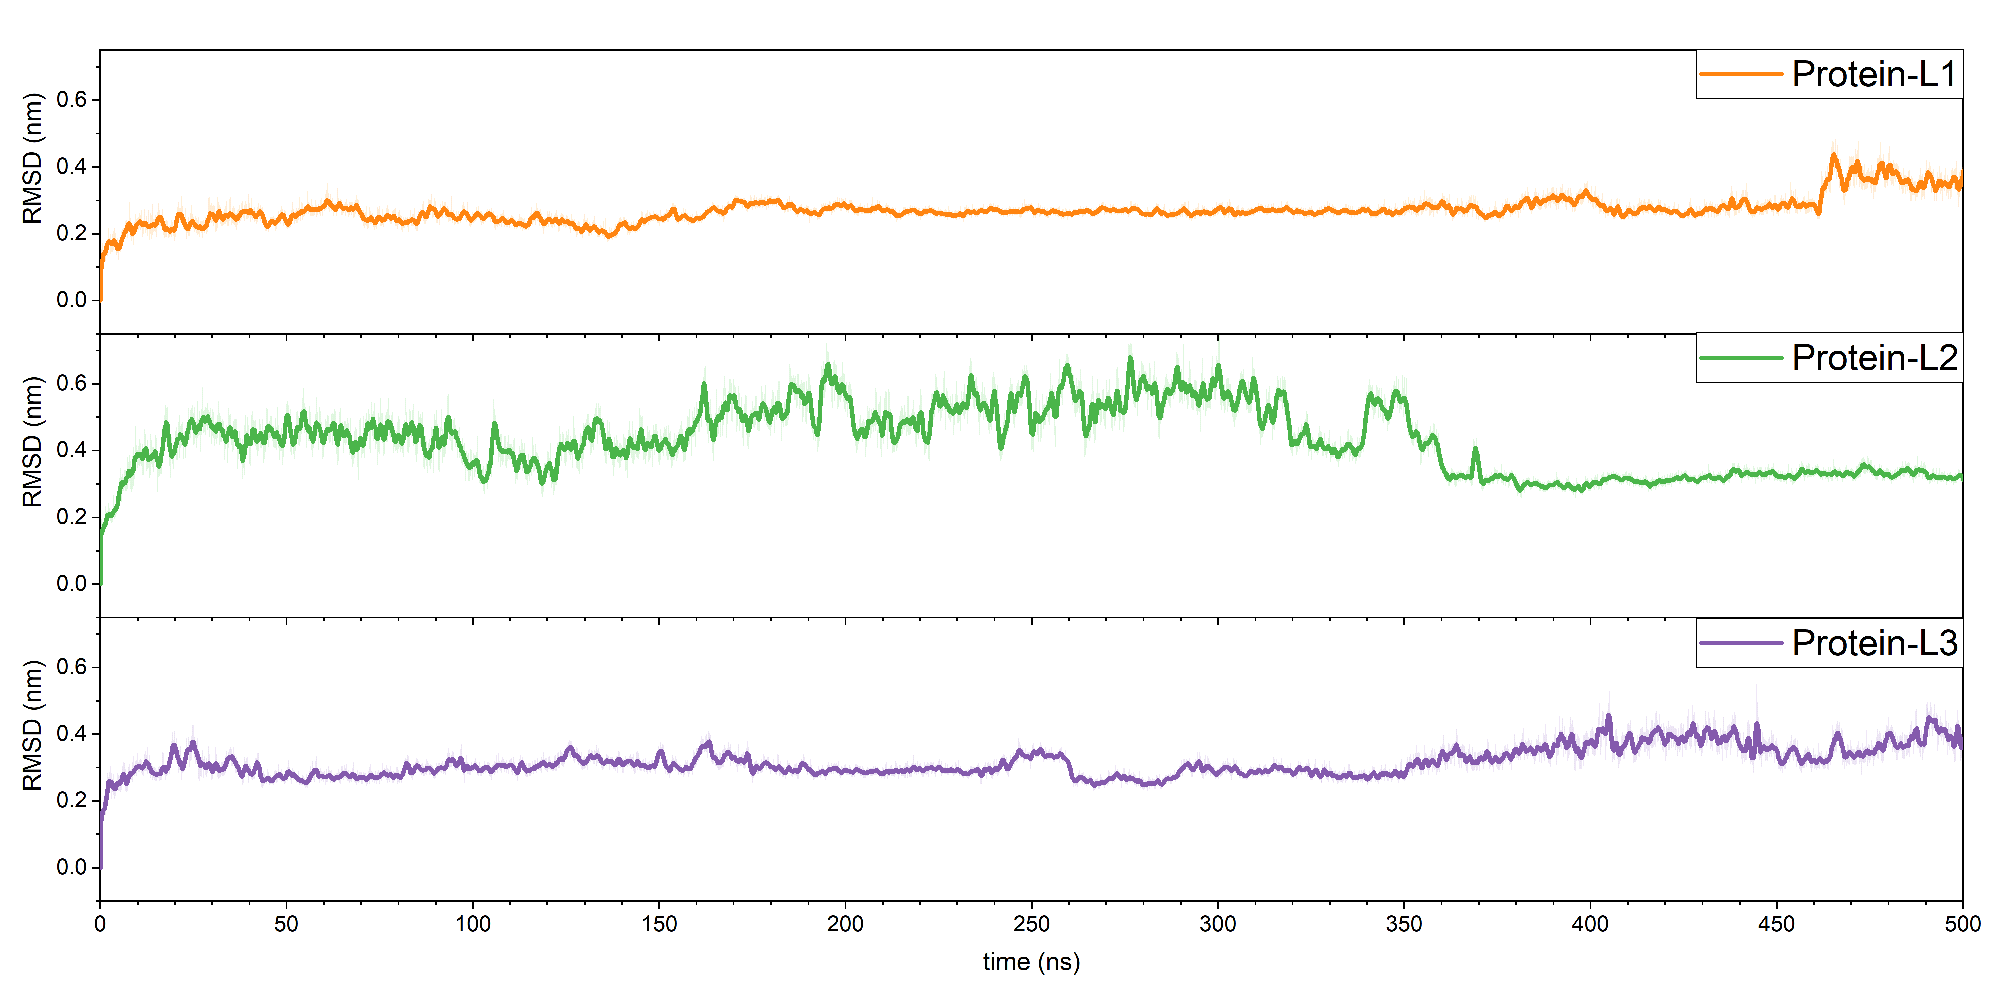

Figure S1. (a) RMSD of the whole protein, (b) RMSD of the whole protein with binded ligand

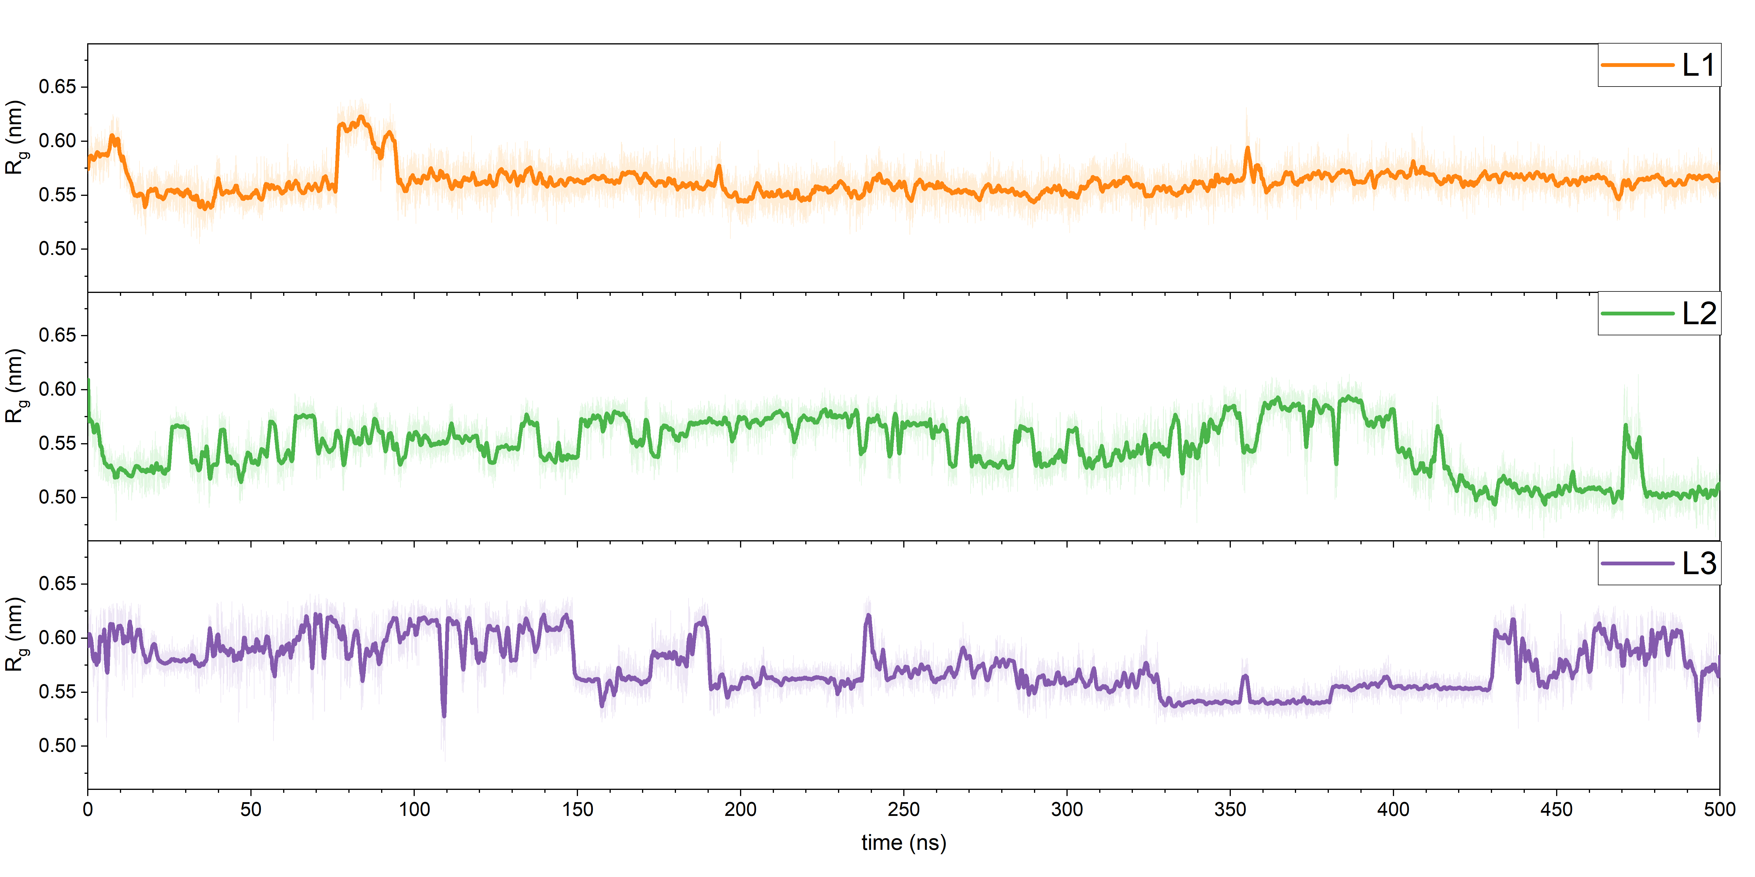
Figure S2. Gyration radius of the ligands

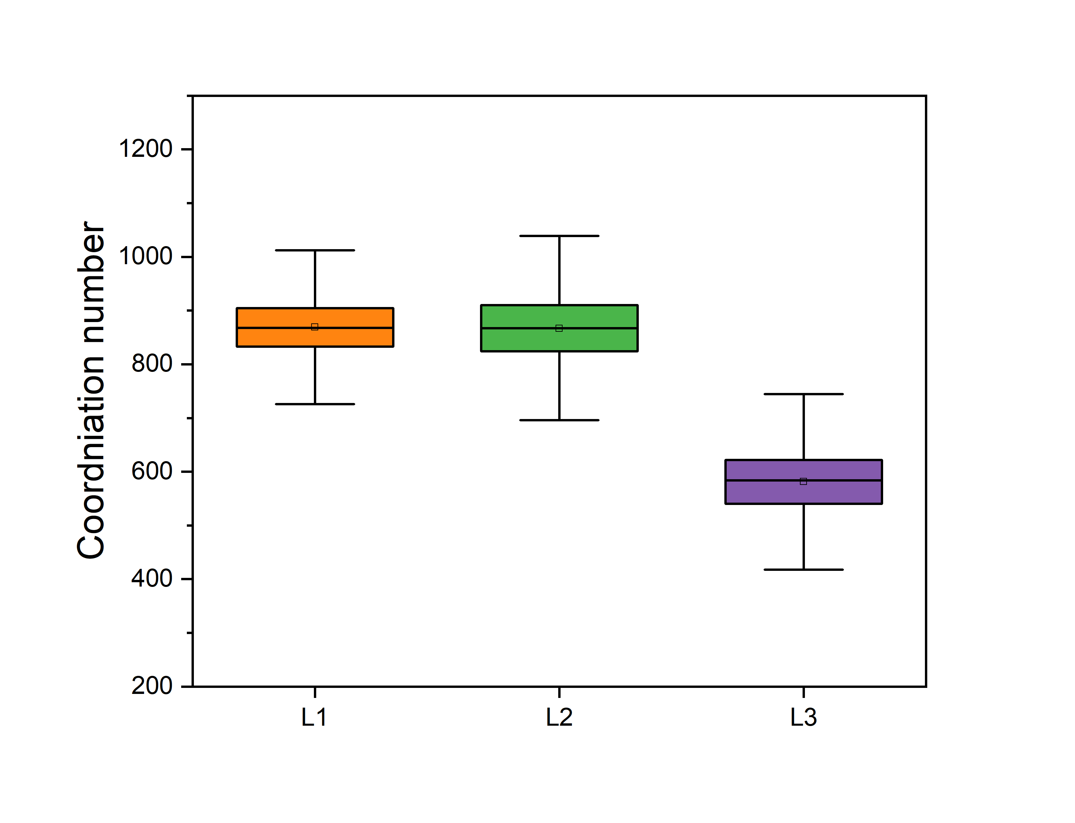
Figure S3. Ligand/pocket contact analysis (rcut<0.38 A) during the simulation tim

(a) | 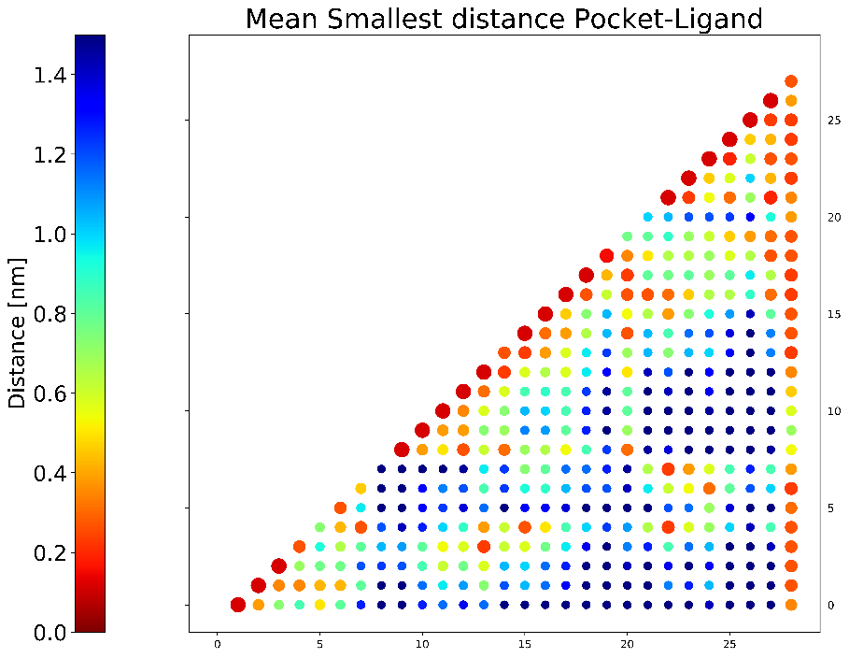
(b) | 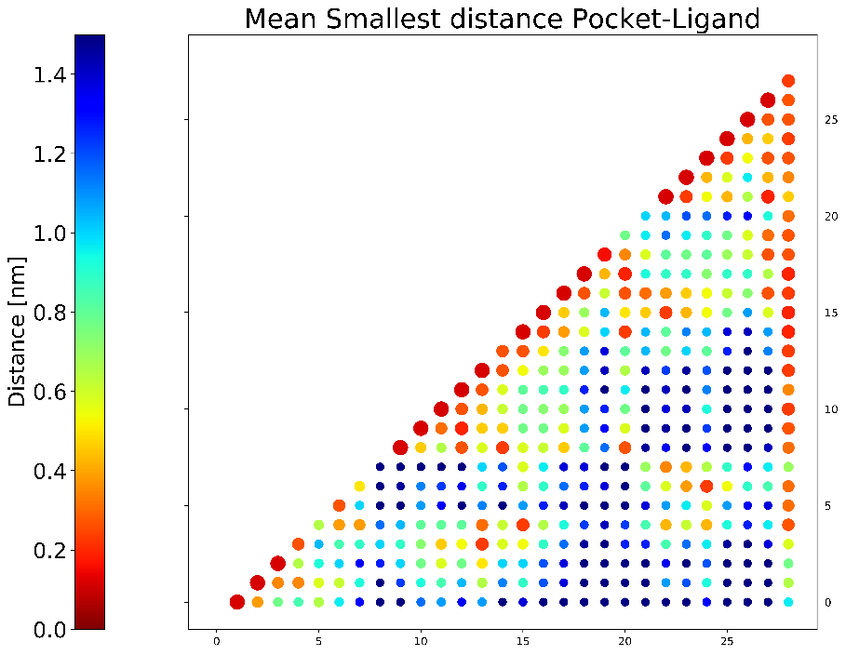
(c) | 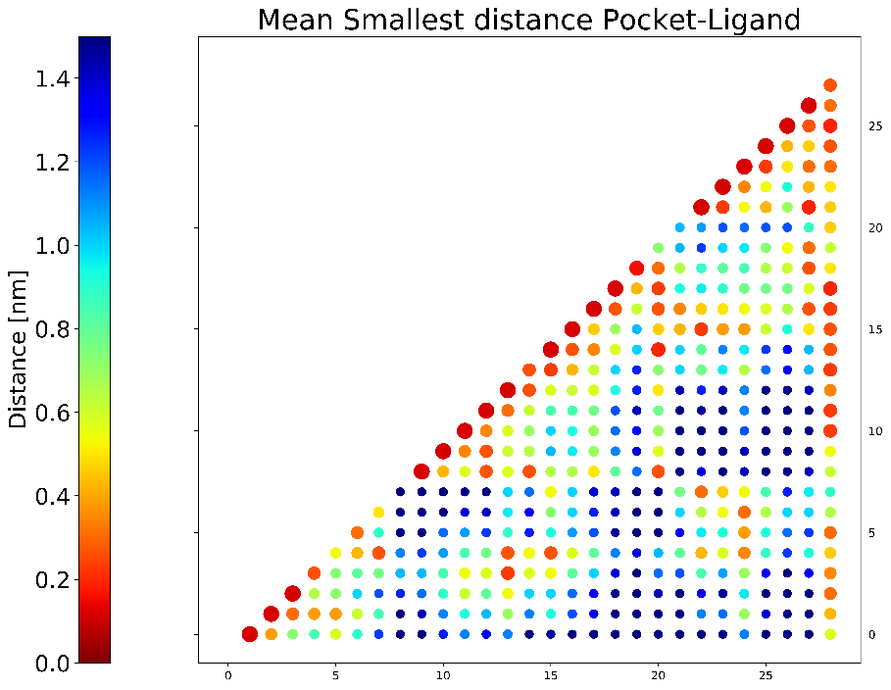
Figure S4. Ligand/Pocket Contact map for (a) Ligand 1, (b) Ligand 2, and (c) Ligand 3

