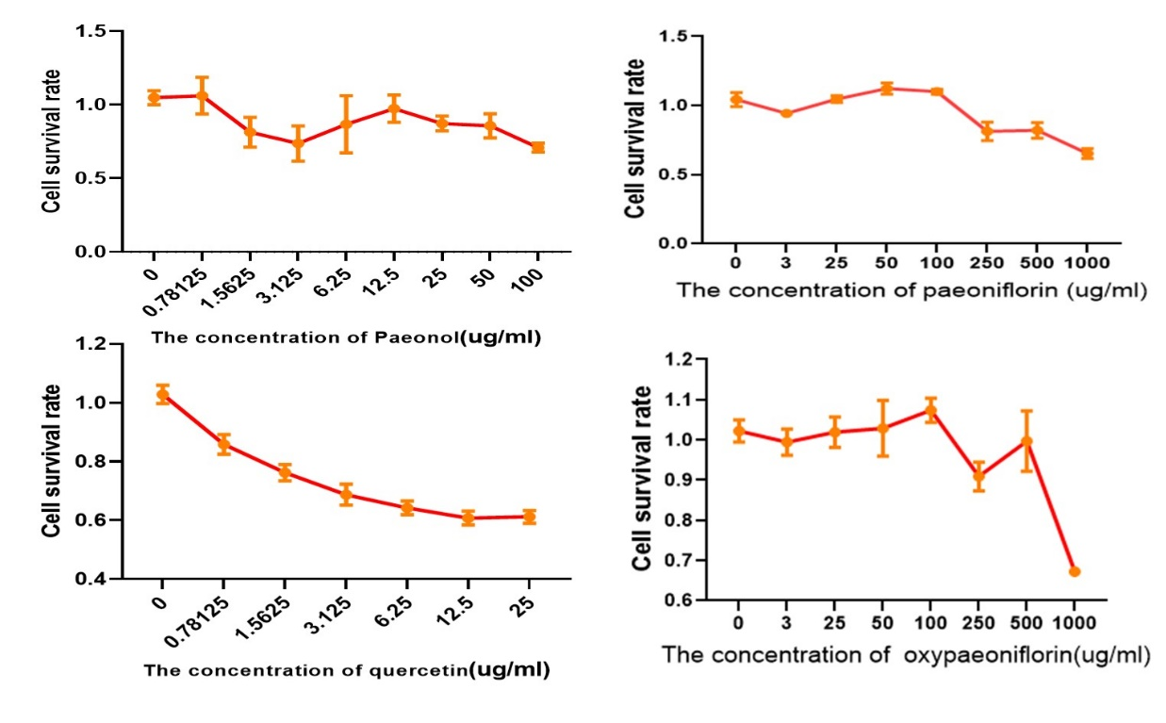

Figure 1. Inhibitory effect of 4 compounds on HUVEC(MTT)

Table 1 Binding sites of the compounds and the interaction
Compounds | Hydrogen bond amino acids  F2(3tu7) | Hydrogen bond amino acids  MAPK14(ID =1a9u)
paeonol | --- | ASP168, MET109
quercetin | PHE227, GLU192,SER195 | ASP168,LEU104
Paeoniflorin | GLY216,GLY219,CYS220,GLU192 | PHE169, LYS53
oxypaeoniflorin | --- | PHE169,LYS53,ALA51,LEU104

