Frequency-swept feedback interferometry for non-cooperative-target ranging with the stand-off distance of hundred meters: supplemental material
Yifan Wang¹, Xin Xu¹, Zongren Dai¹, Ziyu Hua¹, Chenxiao Lin¹, Yubin Hou², Qian Zhang², Pu Wang¹, Yidong Tan^{1,*}
¹The State Key Laboratory of Precision Measurement Technology and Instruments, Department of Precision Instrument, Tsinghua University, Beijing, 100084, China
² Institute of Laser Engineering, Faculty of Materials and Manufacturing, Beijing University of Technology, Beijing 100124, China
*Corresponding author: tanyd@tsinghua.edu.cn
Received XX Month XXXX; revised XX Month, XXXX; accepted XX Month XXXX; posted XX Month XXXX (Doc. ID XXXXX); published XX Month XXXX

This document provides supplementary information to “Frequency-swept feedback interferometry for non-cooperative-target ranging with the stand-off distance of hundred meters”. The supplement provides more detailed information about the laser, frequency-shifted laser feedback technique, signal processing methods, experimental setups for comparison, and effects of fiber dispersion

1. Laser characteristics
The laser source used in ranging is a DFB fiber laser attached to a PZT actuator, and tuning is realized by stretching the whole laser cavity mechanically. More characteristics of the DFB laser are tested. Without cavity-length tuning, the source can be regarded as a stable single-frequency laser, which can be proved by the fine spectrum through a scanning Fabry-Perot interferometer in Fig. S1(a). Then, a delayed self-heterodyne spectrum measurement system is set up to evaluate the linewidth of the laser. The modulating frequency is 100MHz and the delay line is over 30 km long. As shown in Fig. S1(b), the spectral linewidth of the laser is 1.6 kHz, which corresponds to the coherent length up to 18.75 km. Fig.S1(c) illustrates the spectrum of the output signal monitored by a photodetector. The frequency of relaxation oscillation (RO) is about 250 kHz. When the driving signal is loaded on PZT, the wavelength tuning range is listed in Fig. S1(d). The working point is selected at 7Vpp which provides a 200GHz bandwidth.
Fig.S1 Characteristics of the laser. (a) Spectrum analyses through a scanning Fabry-Perot interferometer. (b) Linewidth tests based on a delayed self-heterodyne spectrum measurement system. (c) The frequency spectrum of the signal from a photodetector. (d) The modulation bandwidth vs. amplitude of PZT driving signal when the sweeping frequency is 1Hz.

2. Frequency-Shifted Laser Feedback
As a heterodyne modulation method in laser feedback techniques, the interference between the frequency-shifted feedback light and oscillator will generate an optical beat. Like the FSFI, the beat signal will be enhanced in the laser cavity and makes the weak feedback power detection possible, except that the beat frequency of DC-LFI depends on the shifted frequency, i.e. the modulation frequency of AOM. By Eq. (2) in the main text, a high gain is obtained when the beat frequency is near the RO of the laser. However, the RO of the used solid-state microchip laser is usually 2-5MHz, much lower than the working frequency of a single AOM. Consequently, a pair of AOMs are used to provide a proper shifting frequency $f_{AOM}=\left|f_{1}-f_{2}\right|$. The configuration is shown in Fig.S2. Note that, the echo signal from the non-cooperative target will be modulated by AOMs one more time, thus the total shifting frequency, i.e. the beat frequency, is $2f_{AOM}$.

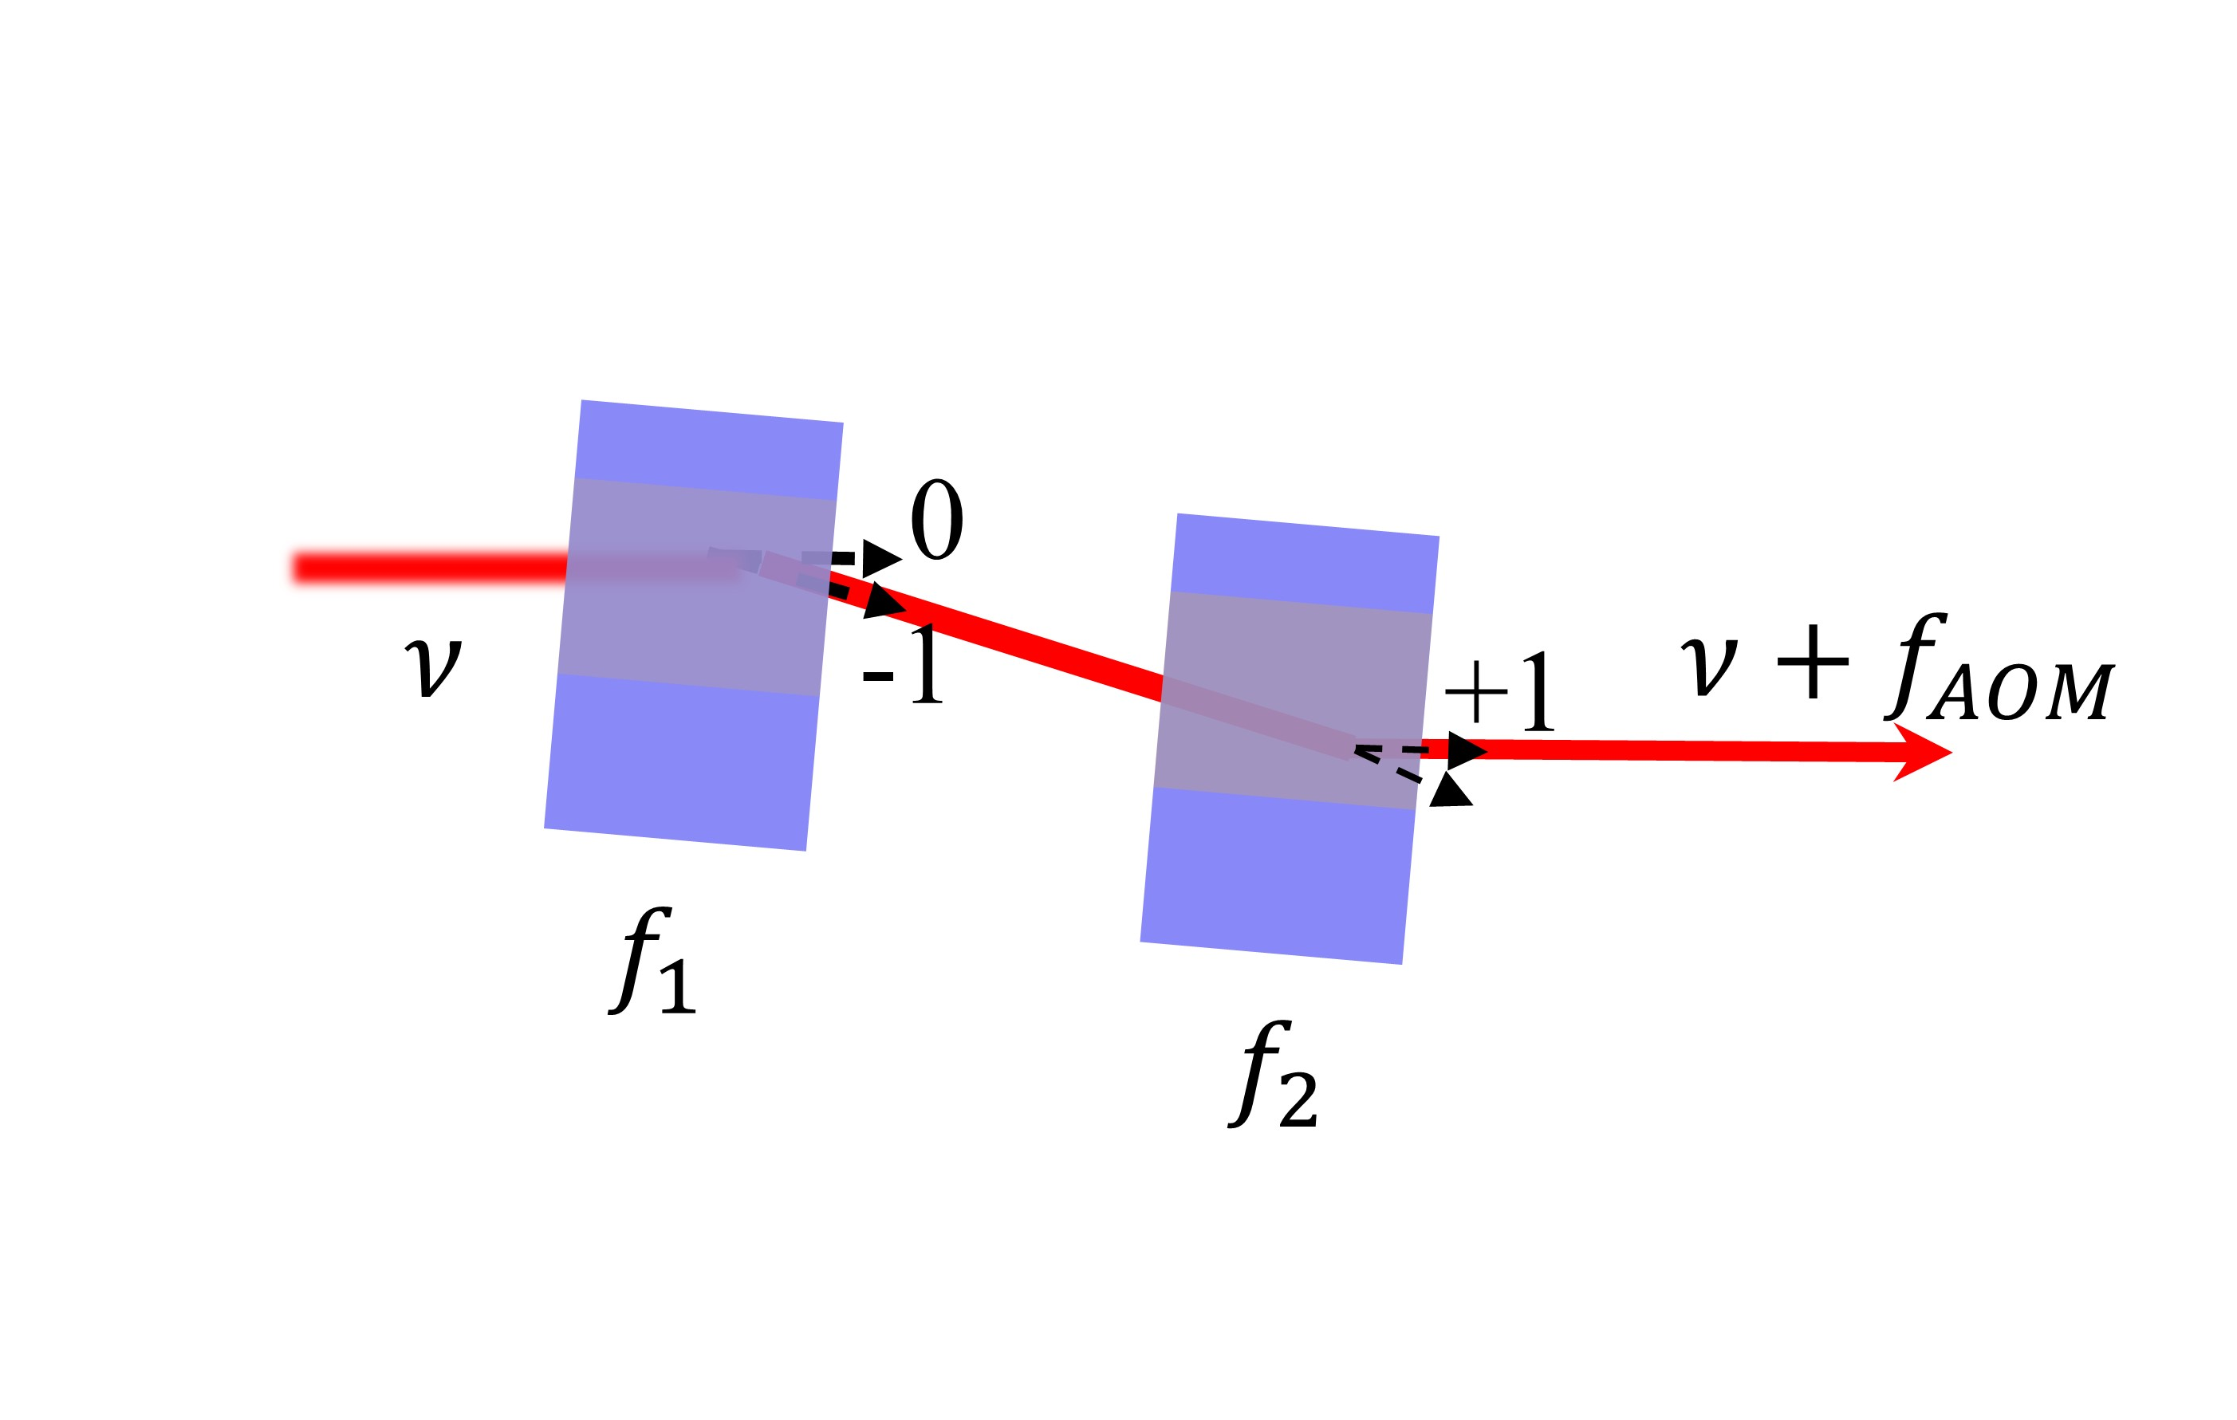
Fig.S2 Differential modulation of AOMs
3. Data processing
Fig. S3 shows the signal processing algorithm used in this paper. The raw data in four channels corresponds to the ranging signal, auxiliary interferometrical signal, the real, and the imaginary part of the modulated signal from DC-LFI. Firstly, the phase drift $φ_{D}(t)$ in the DC-LFI can be calculated through the demodulation results. Then, $e^{±iφ_{D}\left(t\right)λ_{FS}/λ_{R}}$ will be multiplied by the raw ranging signal to eliminate the impacts of the Doppler effect, where $λ_{FS}$ and $λ_{R}$ represent the wavelength of the DC-LFI and the central wavelength of the frequency swept laser source. The sign depends on the frequency swept direction. Later, the compensated signal is resampled according to the auxiliary interferometrical signal [1]. In this step, the nonlinearity of tuning can be corrected. Note that the auxiliary interference signal also contains the ranging signal. However, the ranging components are lower than auxiliary components in frequency, because the length of the delay line is always longer than the stand-off distance. Therefore, the two signals can be separated using a filter. After FFT, we get the frequency spectrum of ranging and the signal peak can be identified. To obtain the precious position of the signal peak, zero padding is necessary. If the range of stand-off distance can be estimated in advance, the chirp-z transform is more efficient than FFT in peak searching. The dispersion of the auxiliary delayed line affects the target distance and it is corrected numerically. The correction method is demonstrated in section 5. With correction, the final measured distance is obtained.

Fig. S3. Signal processing algorithm for ranging.

4. Comparison with the conventional FSI-based ranging system
The setup of the conventional FSI-based ranging system and FSFI-based ranging system are shown in Fig.S4. The two systems employ the same optical devices except for the box-marked part. In the conventional system, an extra isolator is inserted before the BS₂ to avoid the optical feedback. The echo signal passes through the circulator (CIR) and then interferes with the local oscillator. In FSFI, the ISO₂, as well as the CIR is removed. To compensate for the insertion loss of the devices in the conventional FSI-based system, an adjustable attenuator is inserted. Finally, the two systems have equal probe beam power emitted to the target and collect equal echo power from the target. The power detected by PD in the two systems is also similar. Under such conditions, we record the signal from the two systems and analyze them in the same way. The comparison is shown in the main text.
Fig. S4 Schematics of experimental setups. BS, beam splitter; ISO, isolator; CIR, circulator; PD, photodetector. (a) Conventional LFI-based ranging system; (b) FSFI-based ranging system.
5. Effects of Fiber Dispersion
The usage of a long piece of fiber in the auxiliary interferometer brings the material dispersion which leads to a chirp broadening on the ranging signal. Finally, the range peak is broadened and shifted in the spectrum. Especially with a large frequency swept bandwidth, the signal peak will distort which makes the peak searching ineffective. However, the bandwidth in our system, 200GHz, is relatively small. The dispersion-induced bandwidth broadening is inapparent compared with the intrinsic value, $∆R=c/2B$ defined in the main text, and the signal peak is still easy to distinguish. Therefore, we neglect the effect of the chirp broadening and focus on the peak shift. With approximation, the shift in value is a half of broadening, which can be expressed as [2, 3]:
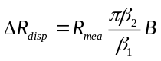 (S1)

where, $β_{1}=v_{g}$ is the reciprocal of the group velocity, $β_{2}=dβ_{1}/dω$, is the dispersion coefficient, and B is the frequency swept bandwidth. Consequently, the dispersion corrected ranging result can be: rewritten as Eq. S2, where the sign depends on the frequency swept direction.
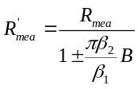 (S2)
Numerical simulations are performed to verify the effectiveness of the dispersion correction. The critical parameters are listed in Fig. S5, which coincides with experimental conditions. With dispersion, the ranging peak is shifted, the peak value decreases slightly, but the bandwidth is almost unchanged. Contrarily, with correction, the peak position is consistent with the theoretical value. Fig. S5(b) shows the peak position deviation with or without compensation in different stand-off distances. The corrected results are all less than 1μm, which can be neglected compared with other errors in our system. Consequently, we use this method to correct the impacts of the dispersion.

Fig. S5. Numerical simulations of dispersion correction. Parameters value: B=200 GHz; β₁=4.9×10⁻⁹ s/m; β₂=-23 ps²/km; (a) Dispersion induced peak shift and the results of correction when R_{mea}=200m. (b) Distance deviation from the theory.
References
1. Gouaux F, Servagent N, Bosch T. Absolute distance measurement with an optical feedback interferometer. Applied Optics. 1998;37(28):6684-9. doi: 10.1364/ao.37.006684.
2. Xu X, Liu G, Liu B, Chen F, Zhuang Z, Gan Y, et al. Research on the fiber dispersion and compensation in large-scale high-resolution broadband frequency-modulated continuous wave laser measurement system. Optical Engineering. 2015;54(7). doi: 10.1117/1.Oe.54.7.074102.
3. Barber ZW, Babbitt WR, Kaylor B, Reibel RR, Roos PA. Accuracy of active chirp linearization for broadband frequency modulated continuous wave ladar. Applied Optics. 2010;49(2):213-9. doi: 10.1364/ao.49.000213.

