Supplementary Materials

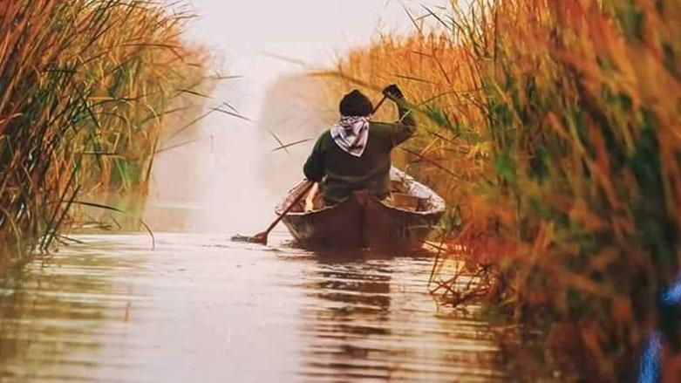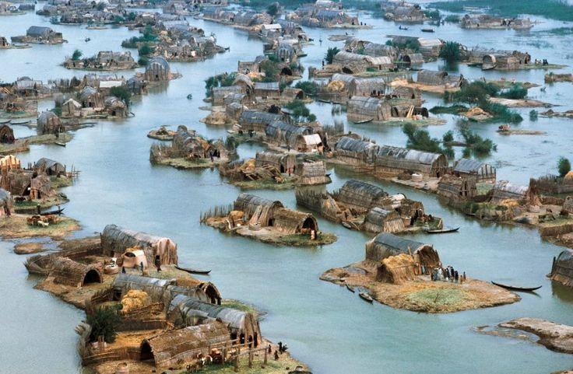
(b)
(a)

Supplementary 1. (a) A Sumerian inhabitant using a reed-made boat for transport; (b) a village in one of the Sumerian communities (Al-Chibayish) with each “island” or Chibayicha being made of mixed reed and mud that floats up and down depending on the water level. These two photos are examples of amazing Mesopotamian wetlands that were listed as a "World Heritage Site" by UNESCO in 2016 (Source: UNESCO-World Heritage Centre 2016; photos were taken from Hammar marsh by Nessy Chic-Pinterest).

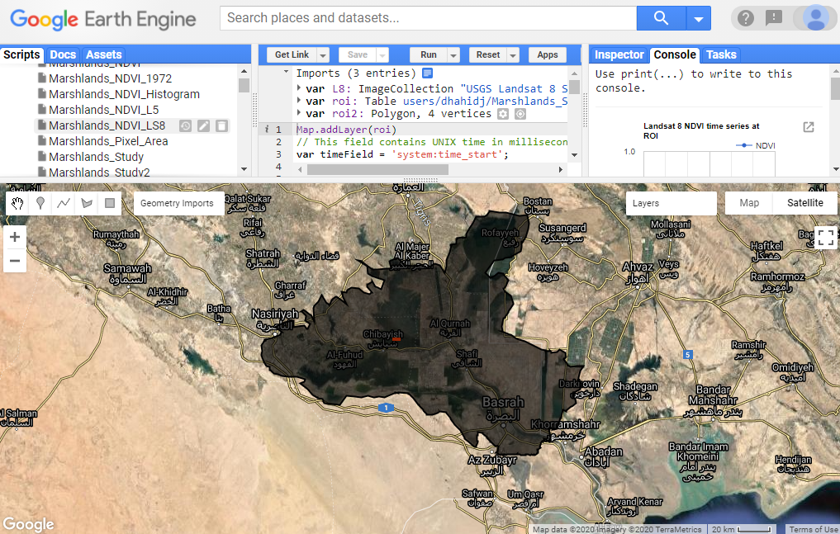
Supplementary 2. An example of the Google Earth Engine (GEE) platform centred with the study site polygon border.

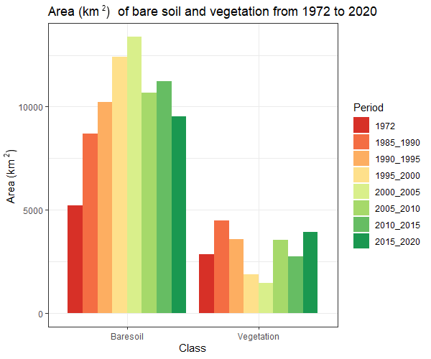
Supplementary 3. NDVI changes per class between 1972 and 2020 showing the areas (km²) of bare soil and vegetation

Supplementary 4. Quantification of water transition classes in the study area.
Transition class | Area (km²)
No Change | 8,222
Permanent | 294
New permanent | 215.
Lost permanent | 533
Seasonal | 556
New seasonal | 1,253
Lost seasonal | 2,061
Seasonal to permanent | 3
Permanent to seasonal | 461
Ephemeral permanent | 100
Ephemeral seasonal | 2,010

