Biochemical control of DNA condensation

Siddharth Agarwal^{1,2}, Dino Osmanovic¹, Melissa Klocke¹ and Elisa Franco^{1,2,*}
¹ Department of Mechanical and Aerospace Engineering, University of California at Los Angeles
² Bioengineering, University of California at Los Angeles

* Corresponding author efranco@seas.ucla.edu

1. Sequences 2
2. Methods 8
2.1 Oligonucleotide preparation 8
2.2 Assembly of motifs using thermal annealing: 8
2.3 Preparation of the observation chamber: 8
2.4 Fluorescence microscopy 9
2.5 Image processing 9
3. Controls and additional experiments 10
3.1 Droplet dissolution and regrowth via sequential addition of invader and anti-invader at different concentrations 10
3.2 Regrowth of invaded droplets by adding excess of anti-invader 14
3.3 Annealing nanostars in the presence of invader 17
3.4 Annealing nanostars at different concentrations (no invader) 21
3.5 Invaders with different toehold length 25
3.6 Invaders with different depth of invasion into the nanostar arm 29
3.7 Nanostars with different arm length 34
3.8 Four and six arm nanostars and their invasion 42
3.9 Example images of six arm nanostars with adjacent and staggered invasion points after 24 hours 53
3.10 Invasion and Anti-invasion of 6-nt NS at RT (27°C) 54
4. Mathematical models 55
4.1 Mean Field Theory Model 55
4.2 Impact of Reverse Rate Reactions on Theoretical Phase Diagrams 59
4.3 Other Features 62
5. References 62

1. Sequences
The sequences of the oligonucleotide strands were designed using the web software NUPACK. Standard desalted sequences were ordered from IDT DNA (Coralville, IA, USA). To ensure the efficient formation of motifs, flexibility of the stem was introduced by inserting two spacer bases (TT) at the center of the junction. Bold domains correspond to sticky ends.

3-arm – 16 bp arm
Y1_4_16 | GCGCCAGTGAGGACGGAAGTTTGTCGTAGCATCGCACC
Y2_4_16 | GCGCCAACCACGCCTGTCCATTACTTCCGTCCTCACTG
Y3_4_16 | GCGCGGTGCGATGCTACGACTTTGGACAGGCGTGGTTG
Y1_0_16_cy3 | cy3-CAGTGAGGACGGAAGTTTGTCGTAGCATCGCACC

3-arm – 16 bp arm - TATA sticky end
Y1_4_16_TATA | TATACAGTGAGGACGGAAGTTTGTCGTAGCATCGCACC
Y2_4_16_TATA | TATACAACCACGCCTGTCCATTACTTCCGTCCTCACTG
Y3_4_16_TATA | TATAGGTGCGATGCTACGACTTTGGACAGGCGTGGTTG
Y1_0_16_cy3 | cy3-CAGTGAGGACGGAAGTTTGTCGTAGCATCGCACC

3-arm – 8 bp arm
Y1_4_8 | GCGCCAGTGAGGTTGTCGTAGC
Y2_4_8 | GCGCCCTGTCCATTCCTCACTG
Y3_4_8 | GCGCGCTACGACTTTGGACAGG
Y1_0_8_cy3 | cy3-CAGTGAGGTTGTCGTAGC

3-arm – 24 bp arm
Y1_4_24 | GCGCCAGTGAGGACGGAAGTGAAGGAACTTGTCGTAGCATCGCACCGACAAAGC
Y2_4_24 | GCGCGTCGCATCCAACCACGCCTGTCCATTGTTCCTTCACTTCCGTCCTCACTG
Y3_4_24 | GCGCGCTTTGTCGGTGCGATGCTACGACTTTGGACAGGCGTGGTTGGATGCGAC
Y1_0_24_cy3 | cy3-CAGTGAGGACGGAAGTGAAGGAACTTGTCGTAGCATCGCACCGACAAAGC

3-arm – 32 bp arm

Y1_4_32 | GCGCCAGTGAGGACGGAAGTGAAGGAACTCTCCGCGTTGTCGTAGCATCGCACCGACAAAGCGAACACGT
Y2_4_32 | GCGCGCCTCTGTGTCGCATCCAACCACGCCTGTCCATTCGCGGAGAGTTCCTTC ACTTCCGTCCTCACTG
Y3_4_32 | GCGCACGTGTTCGCTTTGTCGGTGCGATGCTACGACTTTGGACAGGCGTGGTTGGATGCGACACAGAGGC
Y1_0_32_cy3 | cy3-CAGTGAGGACGGAAGTGAAGGAACTCTCCGCGTTGTCGTAGCATCGCACCGACAAAGCGAACACGT

Invaders and Anti-invaders for 3-arm – 16 bp arm
Y2_4_16_I0 | GCGCTGATAGGCAATGC
Y2_4_16_I3 | TTGGCGCTGATAGGCAATGC
Y2_4_16_I6 | TGGTTGGCGCTGATAGGCAATGC
Y2_4_16_I9 | GCGTGGTTGGCGCTGATAGGCAATGC
Y2_4_16_AI0 | GCAUUCCCUAUCAGCGC
Y2_4_16_AI3 | GCAUUCCCUAUCAGCGCCAA
Y2_4_16_AI6 | GCAUUCCCUAUCAGCGCCAACCA
Y2_4_16_AI9 | GCAUUCCCUAUCAGCGCCAACCACGC
Y2_4_16_I_AI | CCTATCAGCGCCAACCACGCCTGTCCATTACTTCCGTCCTCACTG

4-arm – 16 bp arm
Y1_4_16 | GCGCCAGTGAGGACGGAAGTTTGTCGTAGCATCGCACC
Y2_4_16 | GCGCCAACCACGCCTGTCCATTACTTCCGTCCTCACTG
F3_4_16 | GCGCCCATGGTCCCAAGTGATTTGGACAGGCGTGGTTG
F4_4_16 | GCGCCTCAGAGAGGTGACAGTTTCACTTGGGACCATGG

Invaders and Anti-invaders for 4-arm – 16 bp arm
Y2_4_16_I_AI | CCTATCAGCGCCAACCACGCCTGTCCATTACTTCCGTCCTCACTG
Y2_4_16_I6 | TGGTTGGCGCTGATAGGCAATGC
Y2_4_16_AI6 | GCAUUCCCUAUCAGCGCCAACCA
F3_4_I_AI | GATGTCGGCGCCCATGGTCCCAAGTGATTTGGACAGGCGTGGTTG
I6_F3_4 | CCATGGGCGCCGACATCTAAACG
AI6_F3_4 | CGTTTAGATGTCGGCGCCCATGG

6-arm – 16 bp arm
Y1_4_16 | GCGCCAGTGAGGACGGAAGTTTGTCGTAGCATCGCACC
Y2_4_16 | GCGCCAACCACGCCTGTCCATTACTTCCGTCCTCACTG
F3_4_16 | GCGCCCATGGTCCCAAGTGATTTGGACAGGCGTGGTTG
P4_4_16 | GCGCCTCAGAGAGGTGACAGTTTCACTTGGGACCATGG
S5_4_16 | GCGCGCTGGACTAACGGAACTTCTGTCACCTCTCTGAG
S6_4_16 | GCGCGGTGCGATGCTACGACTTGTTCCGTTAGTCCAGC

Invaders and Anti-invaders for 6-arm – 16 bp arm
Y2_4_16_I_AI_7toe | CCTATCAGCGCCAACCACGCCTGTCCATTACTTCCGTCCTCACTG
Y2_4_16_I_AI_5toe | TATCAGCGCCAACCACGCCTGTCCATTACTTCCGTCCTCACTG
Y2_4_16_I_AI_3toe | TCAGCGCCAACCACGCCTGTCCATTACTTCCGTCCTCACTG
Y2_4_16_I6 | TGGTTGGCGCTGATAGGCAATGC
Y2_4_16_AI6 | GCAUUCCCUAUCAGCGCCAACCA
F3_4_I_AI | GATGTCGGCGCCCATGGTCCCAAGTGATTTGGACAGGCGTGGTTG
I6_F3_4 | CCATGGGCGCCGACATCTAAACG
AI6_F3_4 | CGTTTAGATGTCGGCGCCCATGG
P4_4_I_AI | TCAGTCCGCGCCTCAGAGAGGTGACAGTTTCACTTGGGACCATGG
I6_P4_4 | TCTGAGGCGCGGACTGACACGAC
AI6_P4_4 | GTCGTGTCAGTCCGCGCCTCAGA

Invaders and Anti-invaders for 3-arm – 8 bp arm
Y2_8_I_AI_7toe | CCTATCAGCGCCCTGTCCATTCCTCACTG
Y2_8_I_AI_5toe | TATCAGCGCCCTGTCCATTCCTCACTG
Y2_8_I_AI_3toe | TCAGCGCCCTGTCCATTCCTCACTG
I_Y2_8_3toe | GACAGGGCGCTGA

Invaders and Anti-invaders for 3-arm – 24 bp arm
Y2_24_I_AI_7toe | CCTATCAGCGCGTCGCATCCAACCACGCCTGTCCATTGTTCCTTCACTTCCGTCCTCACTG
Y2_24_I_AI_5toe | TATCAGCGCGTCGCATCCAACCACGCCTGTCCATTGTTCCTTCACTTCCGTCCTCACTG
Y2_24_I_AI_3toe | TCAGCGCGTCGCATCCAACCACGCCTGTCCATTGTTCCTTCACTTCCGTCCTCACTG
I_Y2_24_3toe | TGCGACGCGCTGA

Invaders and Anti-invaders for 3-arm – 32 bp arm
Y2_32_I_AI_7toe | CCTATCAGCGCGCCTCTGTGTCGCATCCAACCACGCCTGTCCATTCGCGGAGAGTTCCTTCACTTCCGTCCTCACTG
Y2_32_I_AI_5toe | TATCAGCGCGCCTCTGTGTCGCATCCAACCACGCCTGTCCATTCGCGGAGAGTTCCTTCACTTCCGTCCTCACTG
Y2_32_I_AI_3toe | TCAGCGCGCCTCTGTGTCGCATCCAACCACGCCTGTCCATTCGCGGAGAGTTCCTTCACTTCCGTCCTCACTG
I_Y2_32_3toe | AGAGGCGCGCTGA

Orthogonal design sequences:
Orange design: Nanostar 1
Orange_6bSE_Y1 | GGATCCCAGTGAGGACGGAAGTTTGTCGTAGCATCGCACC
Orange_6bSE_Y2_I_AI | CCTATCAGGATCCCAACCACGCCTGTCCATTACTTCCGTCCTCACTG
Orange_6bSE_Y3 | GGATCCGGTGCGATGCTACGACTTTGGACAGGCGTGGTTG
Orange_6bSE_Y2_I6 | TGGTTGGGATCCTGATAGGCAATGC
Orange_6bSE_Y2_AI6 | GCATTCCCTATCAGGATCCCAACCA

Green design: Nanostar 2
Green_6bSE_Y1 | TGCGCAGAAGGAACTCTCCGCGTTGACAAAGCGAACACGT
Green_6bSE_Y2_I_AI | AATCGGATGCGCAGCCTCTGTGTCGCATCTTCGCGGAGAGTTCCTTC
Green_6bSE_Y3 | TGCGCAACGTGTTCGCTTTGTCTTGATGCGACACAGAGGC
Green_6bSE_Y2_I6 | AGAGGCTGCGCATCCGATTAGATTC
Green_6bSE_Y2_AI6 | GAATCTAATCGGATGCGCAGCCTCT

2. Methods

2.1 Oligonucleotide preparation
Oligonucleotides were purchased from IDT DNA. Fluorophore-labeled strands were purified to high-performance liquid chromatography (HPLC) grade. All strands more than 60 bases in length were polyacrylamide gel electrophoresis (PAGE) purified. Oligonucleotide sequences and modifications are provided in the SI section ‘Sequences’.

2.2 Assembly of motifs using thermal annealing:
All the motifs were formed by mixing the desired concentration of each component oligomer in a buffer consisting of 20 mM Tris-HCl (pH 8.0) and 350 mM NaCl. To fluorescently label the condensates, one of the strands was modified using a fluorescently labeled dye without SEs, which was mixed at a 10% molar ratio in the solution. This solution was placed in a thermocycler, held at 95°C for 5 min, and then cooled to room temperature at a rate of −1°C/min. Once the anneal process was over, condensates were allowed to grow at room temperature (set as 27°C in an incubator), unless otherwise specified.

2.3 Preparation of the observation chamber:
Coverslips (Fisherbrand™, cat: 12-545-JP) measuring 60 x 22 mm, with a thickness between 0.13 to 0.17 mm were soaked in 5% (w/v) bovine serum albumin (BSA) and dissolved in 20 mM Tris-HCl (pH 8.0) for over 30 min to prevent nonspecific interactions of the DNA on the glass surface. After the BSA coating, the glass slides were washed two times with distilled water and dried under an airflow. A square parafilm (Parafilm M® from Fisher Scientific, cat:S37440) slice with a punched hole in the middle was stuck to the BSA-coated glasses by heating the slides to 50°C for 1 min before imaging. After the coverslips returned to room temperature, 2.5uL of sample was pipetted out in the punched hole. Another smaller coverslip (Fisherbrand™, cat: 12-545-AP) measuring 30 x 22 mm, with a thickness between 0.13 to 0.17 mm was placed on top of the parafilm to avoid evaporation of the sample solution during the observation period. The BSA coating causes partial dewetting which slows down the process of droplets adhesion to the surface, and allows us to observe near-spherical DNA droplets.

2.4 Fluorescence microscopy
Droplet samples were imaged using an inverted microscope (Nikon Eclipse TI-E) with Nikon CFI Plan Apo Lambda 60X Oil (MRD01605) objective. Cy3 and FAM were visualized at excitation wavelengths of 559 nm and 488nm respectively.

2.5 Image processing
We extracted DNA condensate size, number, and eccentricity measurements from epifluorescence micrographs using a custom Python script available on Github:

https://github.com/klockemel/Condensate-Detection

This script implements several Python packages, including scikit-image, pandas, and others (van der Walt et al. 2014; Reback et al. 2021; McKinney 2010).

Epifluorescence images capture objects both inside and outside of the plane of focus. Objects outside of the plane of focus may be a different size or shape than they appear in an image and have softer edges than objects in the plane of focus. To maintain confidence in our measurements of condensate characteristics, we sought to measure only objects within the plane of focus by implementing an edge-based threshold method. First the image is smoothed with a Gaussian filter to limit the influence of noise inherent to a fluorescence micrograph in detection of condensates. A Sobel filter is then applied to the smoothed image to find the edges within the image. An Otsu threshold is used to separate condensate edges from the background of the image, followed by binary operations to clean the resulting binary image of edges. The image is thinned such that each feature or edge is 1-pixel thick. Enclosed edges are then filled with a binary fill holes method. A binary opening of the image removes any unenclosed regions such as lines or speckles. Finally, the image is dilated using a disk of radius 5 pixels. Without the dilation, objects larger than about 1.5 um in diameter are systematically underestimated in the threshold process. As a majority of the condensates observed in this work are larger than 1.5 um in diameter, we chose to include the dilation although it systematically overestimates small objects. Finally, the area, diameter, and eccentricity for individual condensates are measured, as well as the total number of condensates. Diameter is estimated as the diameter of a circle with the same area as a given condensate. All user-input parameters for each image are saved in a csv file, and a diagnostic image with labeled condensates is generated. We processed 8 images (identical size of field of view) for each time point and condition. Within a set of 8 images, if there were less than 16 condensates with either an average diameter less than or equal to 1.5 µm or total area less than 28.32 µm² (which is the sum area of 16 1.5 µm diameter condensates) we considered the amount of condensate for that condition to be 0. This criterion is followed for all plots in the main paper and SI, excluding the histograms and normalized histograms in which all droplets are reported. All results were visually inspected, and if more than 1 in 20 of the detected objects were not condensates (such as dark specks or blobs on the slide), or if such objects were more than twice the diameter of actual condensates in the image, the measurements for those objects were removed from the results prior to further processing or plotting.

Normalization and bootstrapping: The normalized average area reported for condensates was found by dividing the total area of condensates at a given time and condition by the total area of condensate at the initial t=0 minute observation. In this way, the first observation is always reported to be 1, while a decreased area of condensate relative to the initial observation is less than 1, and an increased area of condensate is more than 1. Unless otherwise noted, the data we report are from single experimental replicates. The average and standard error of the mean (SEM) were generated via bootstrapping. To bootstrap the data, three sub-samples were generated by grabbing a random assortment of half the observations at each time and condition. The normalized average area was calculated for each of the three sub-samples as described above, and the average and SEM were calculated for these three values.

3. Controls and additional experiments
Throughout this section, the word nanostars is abbreviated as “NS”.

3.1 Droplet dissolution and regrowth via sequential addition of invader and anti-invader at different concentrations
The figures reported in this section complement the data reported in Fig. 2D of the manuscript. We consider 5µM DNA nanostars, annealed and incubated at 27°C for 30 minutes before the start of the experiment. Different concentrations of invader and anti-invader are added as described in the caption. We report histograms of droplet diameter, normalized total droplet area and droplet number over time. (The normalized average droplet area is reported in Fig. 2D).

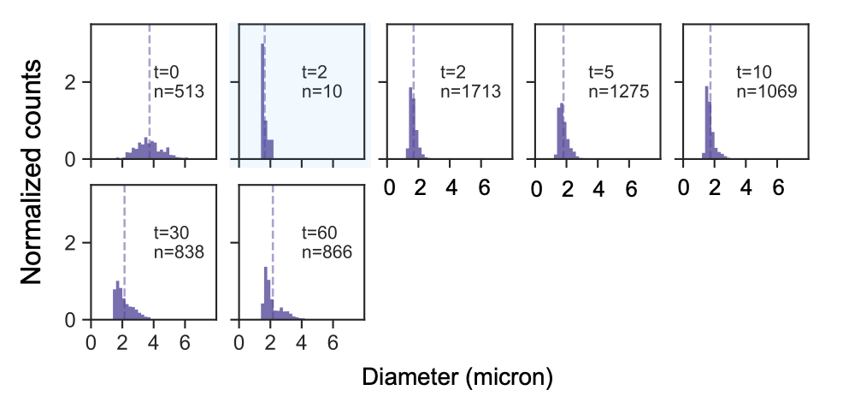
Figure S1: Normalized histograms of droplet diameter over time, Inv = 5 μM, AI = 5 µM (1X NS). Histograms are normalized such that the area of each histogram is 1. Cyan shaded histograms correspond to samples taken after addition of invader but prior to addition of anti-invader. Bin width is set to 0.2 μm. Vertical dashed line indicates the mean for each observed time.

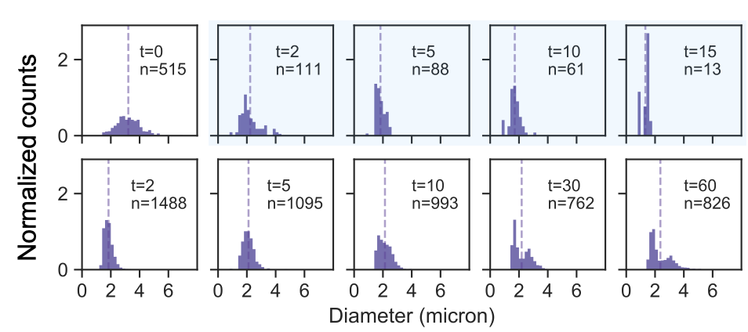
Figure S2: Normalized histograms for NS = 5 μM and post incubation addition of Inv = 2.5 μM (or 0.5X NS) Histograms of droplet diameter over time, Inv = 2.5 μM and AI 2.5 µM (0.5X NS). Histograms are normalized such that the area of each histogram is 1. Cyan shaded histograms correspond to samples taken after addition of invader but prior to addition of anti-invader. Bin width is set to 0.2 μm. Vertical dashed line indicates the mean for each observed time.

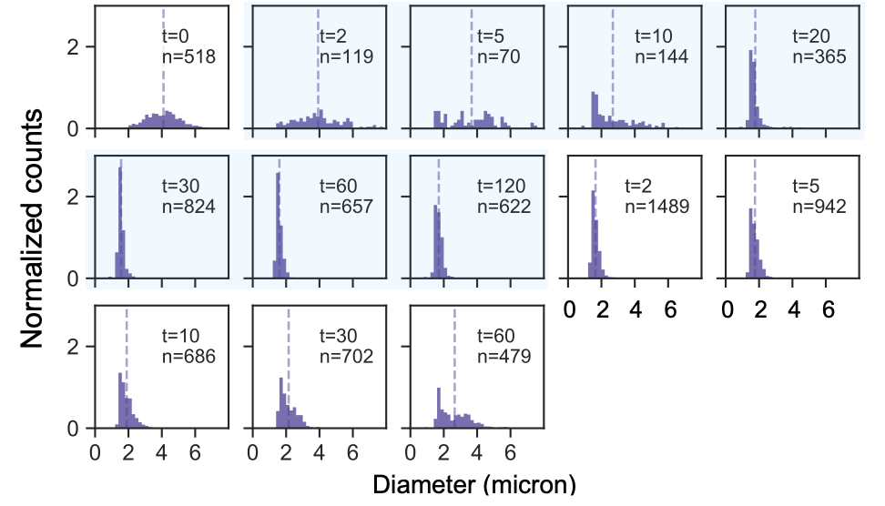
Figure S3: Normalized histograms of droplet diameter over time, Inv = 1.25 μM and AI 1.25 µM (or 0.25X NS). Histograms are normalized such that the area of each histogram is 1. Cyan shaded histograms correspond to samples taken after addition of invader but prior to addition of anti-invader. Bin width is set to 0.2 μm. Vertical dashed line indicates the mean for each observed time.

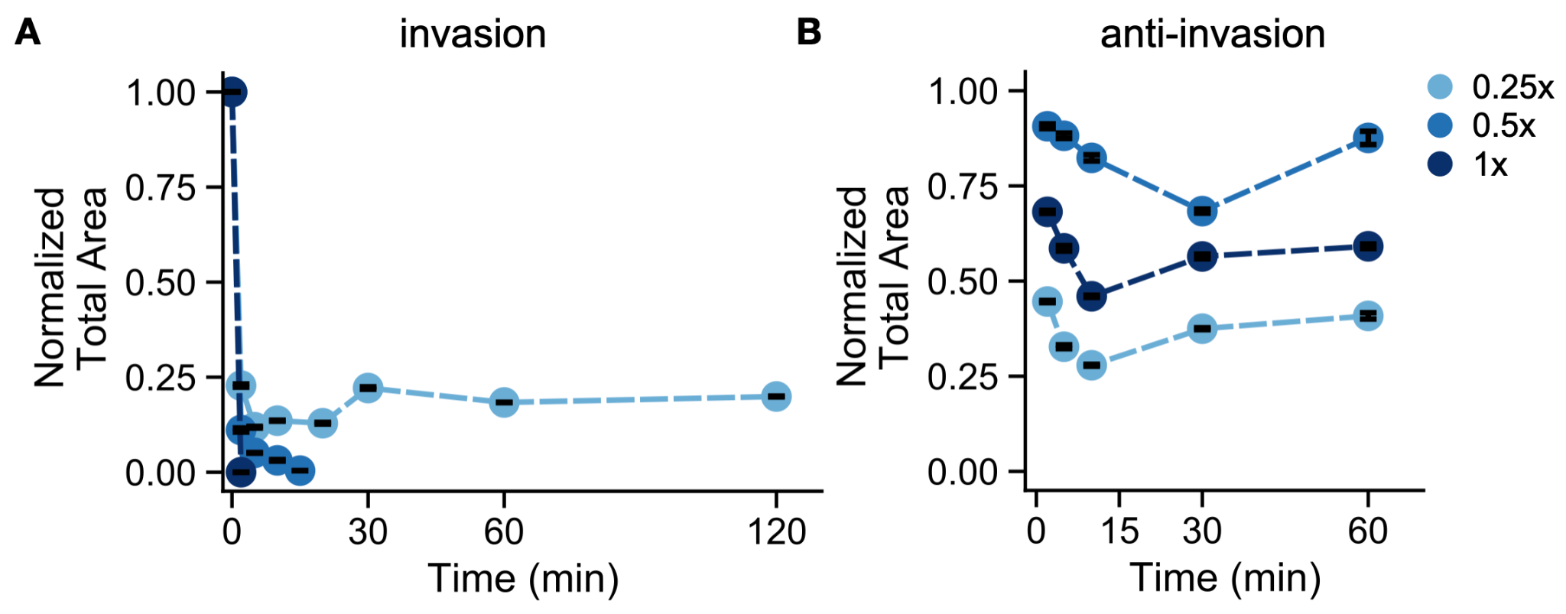
Figure S4: Normalized total area of condensate following addition of invader strand (A) and addition of anti-invader strand for different concentrations of invader and anti-invader strands. The area is normalized such that the initial observation prior to addition of the invader strand is 1. Error bars are the standard error of the mean derived from bootstrapping data from a single experimental replicate.

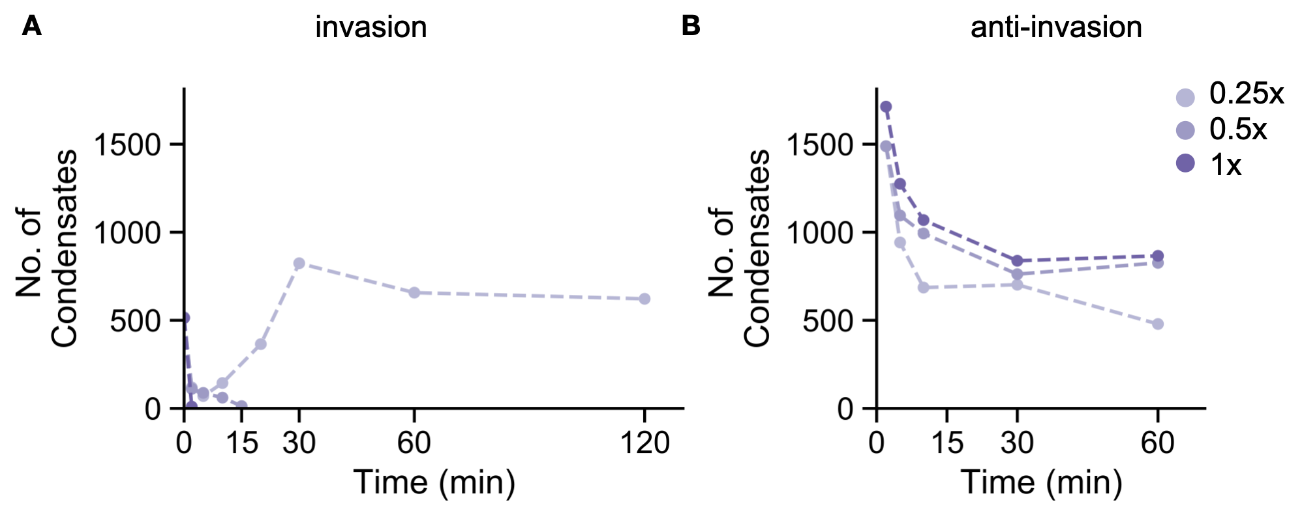
Figure S5: Number of condensates detected following addition of invader strand (A) and addition of anti-invader strand for different concentrations of invader and anti-invader strands.

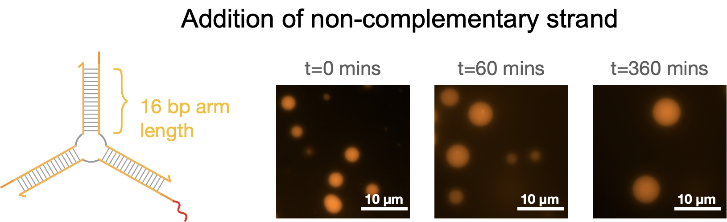
Figure S6: Addition of a scramble sequence has no effect on the droplets: Nanostars with 16 bp arms and a toehold on one its arms continue to condense into droplets if a strand with no complementarity to the toehold is added to the solution. Microscopic images represent time after 30 mins of incubation at room temperature (27° C) after anneal process. NS = 5 μM, Scramble sequence (Green_6bSE_Y2_AI6) = 5 µM (1X NS). Scale bars as represented.

3.2 Regrowth of invaded droplets by adding excess of anti-invader
The figures reported in this section complement the data reported in Fig. 2E of the manuscript. We consider 5µM DNA nanostars, annealed and incubated at 27°C for 30 minutes before the start of the experiment. Different concentrations of invader and anti-invader are added as described in the caption. We report histograms of droplet diameter, normalized total droplet area and droplet number over time. (The normalized average droplet area is reported in Fig. 2E).

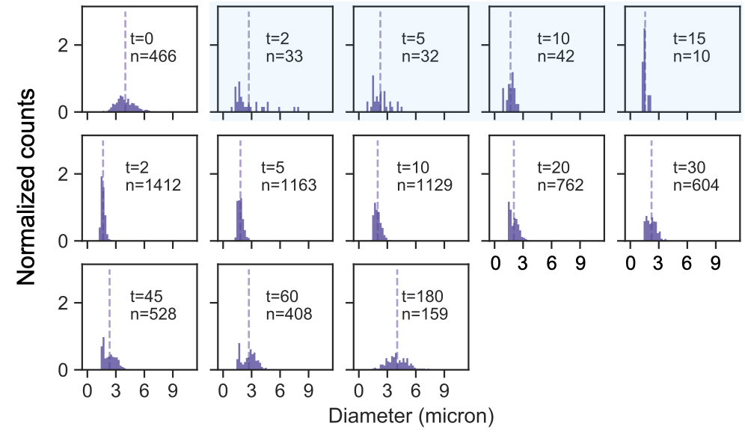
Figure S7: Normalized histograms for NS = 5 μM, post incubation addition of Inv = 2.5 μM (or 0.5X NS) and thereafter addition of Anti-Invaders = 10 μM (or 4X Inv or 2X NS). Histograms are normalized such that the area of each histogram is 1. Cyan shaded histograms correspond to samples taken after addition of invader but prior to addition of anti-invader. Bin width is set to 0.2 μm. Vertical dashed line indicates the mean for each observed time.

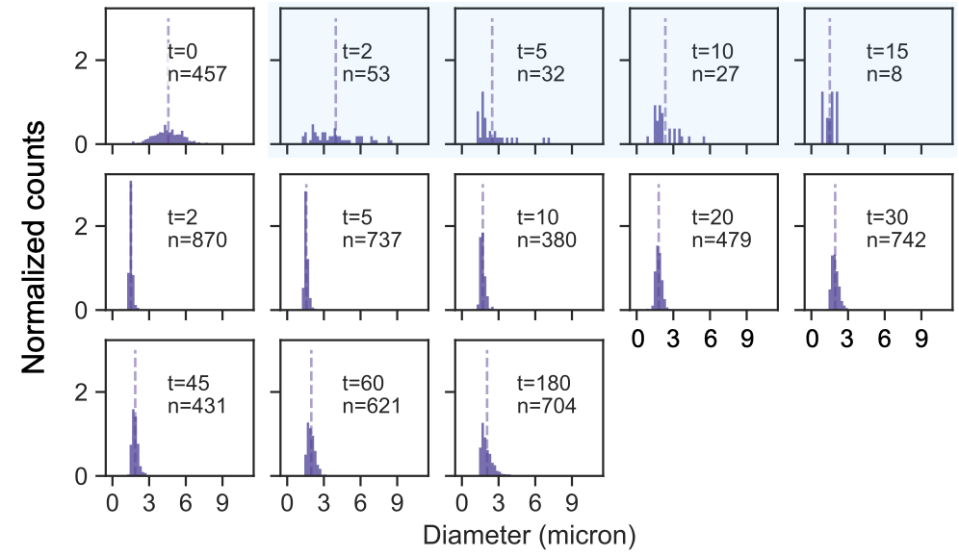
Figure S8: Normalized histograms for NS = 5 μM, post incubation addition of Inv = 2.5 μM (or 0.5X NS) and thereafter addition of Anti-Invaders = 20 μM (or 8X Inv or 4X NS). Histograms are normalized such that the area of each histogram is 1. Cyan shaded histograms correspond to samples taken after addition of invader but prior to addition of anti-invader. Bin width is set to 0.2 μm. Vertical dashed line indicates the mean for each observed time.

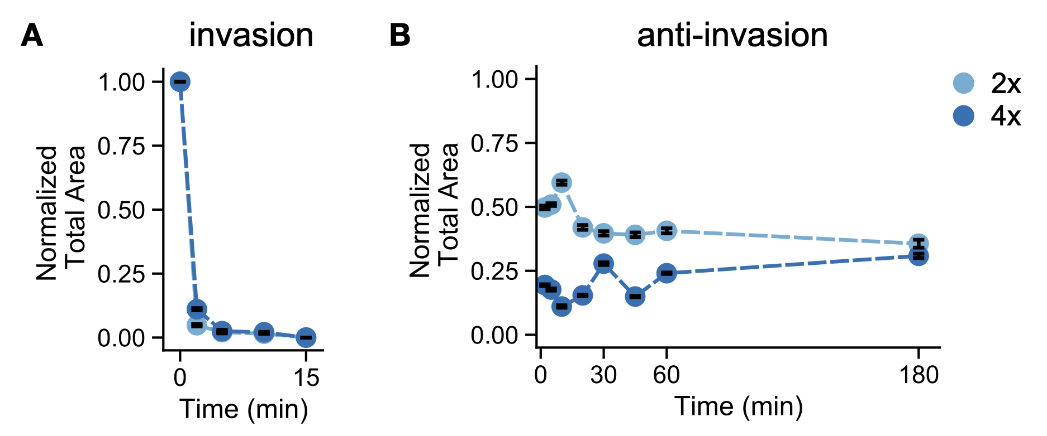
Figure S9: Normalized total area of condensate following addition of invader strand (A) and addition of anti-invader strand for excess of anti-invader strand experiments. The area is normalized such that the initial observation prior to addition of the invader strand is 1. Error bars are the standard error of the mean derived from bootstrapping data from a single experimental replicate. The data for addition of 10 μM anti-invader (or 2x NS) is plotted in light blue, while the data for addition of 20 μM anti-invader (or 4x NS) is plotted in darker blue.

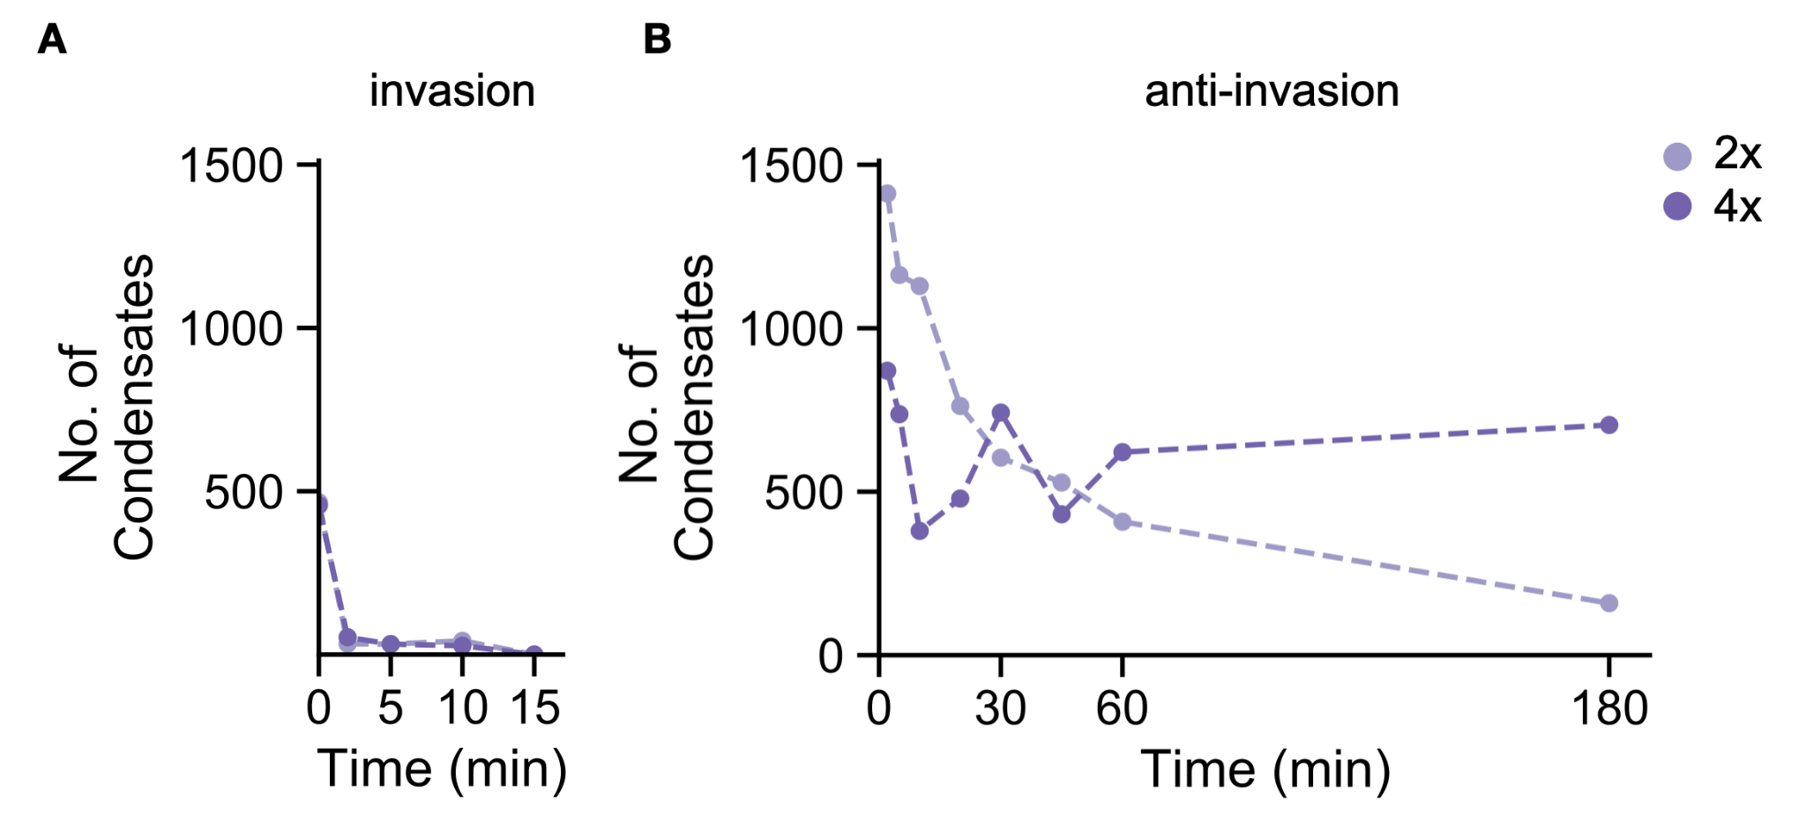
Figure S10: Number of condensates detected following addition of invader strand (A) and addition of anti-invader strand for different concentrations of invader and anti-invader strands. The data for addition of 10 μM anti-invader (or 2x NS) is plotted in light purple, while the data for addition of 20 μM anti-invader (or 4x NS) is plotted in darker purple.

3.3 Annealing nanostars in the presence of invader

The figures reported in this section complement the data reported in Fig. 3 of the manuscript. As before, we consider 5µM DNA nanostars annealed in the presence of different concentrations of invader as reported in the captions. We report histograms of the droplet diameter, normalized average droplet area, total droplet area, and droplet number over time.

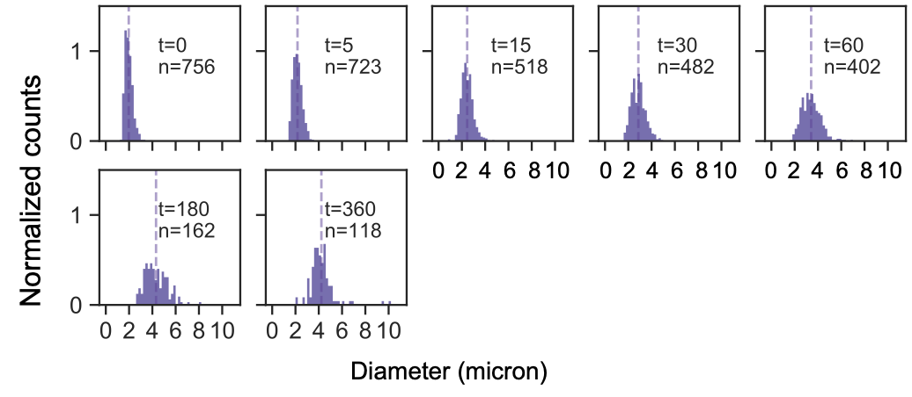
Figure S11: Normalized histograms for simultaneous anneal of NS = 5 μM, Inv = 1.25 μM (or 0.25X NS). Histograms are normalized such that the area of each histogram is 1. Bin width is set to 0.2 μm. Vertical dashed line indicates the mean for each observed time.

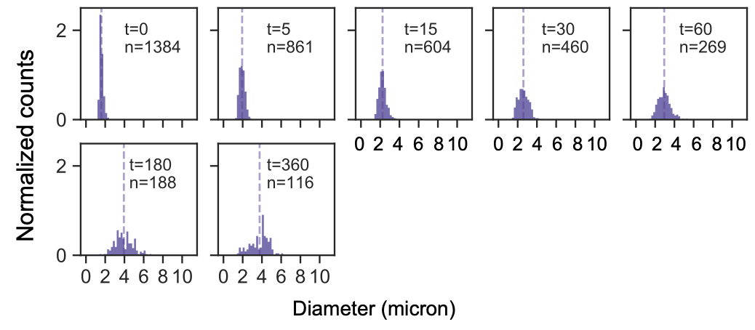
Figure S12: Normalized histograms for simultaneous anneal of NS = 5 μM, Inv = 1.875 μM (or 0.375X NS). Histograms are normalized such that the area of each histogram is 1. Bin width is set to 0.2 μm. Vertical dashed line indicates the mean for each observed time.

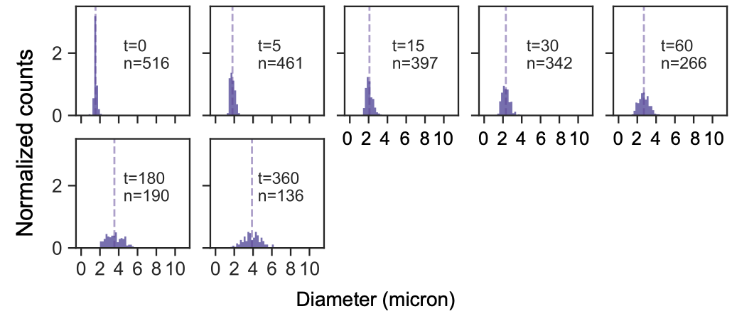
Figure S13: Normalized histograms for simultaneous anneal of NS = 5 μM, Inv = 2.25 μM (or 0.45X NS). Histograms are normalized such that the area of each histogram is 1. Bin width is set to 0.2 μm. Vertical dashed line indicates the mean for each observed time.

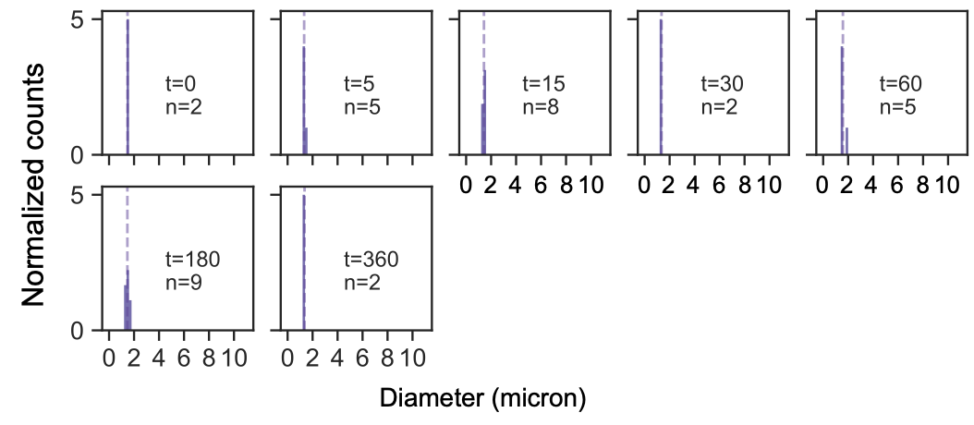
Figure S14: Normalized histograms for simultaneous anneal of NS = 5 μM, Inv = 2.5 μM (or 0.5X NS). Histograms are normalized such that the area of each histogram is 1. Bin width is set to 0.2 μm. Vertical dashed line indicates the mean for each observed time.

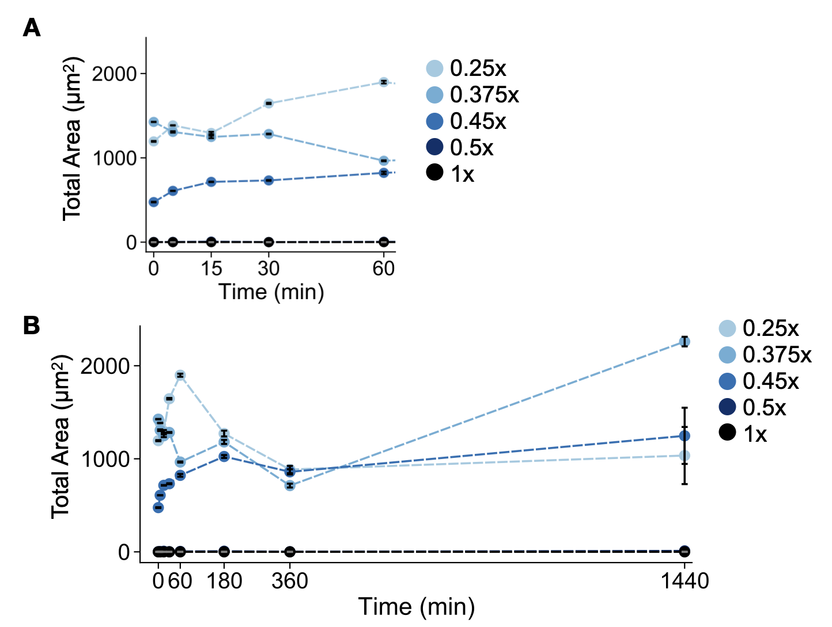
Figure S15: Total area of condensate for nanostars annealed with different concentrations of invader strand through 1 hour (A) and through 24 hours (B). Error bars are the standard error of the mean derived from bootstrapping data from a single experimental replicate.

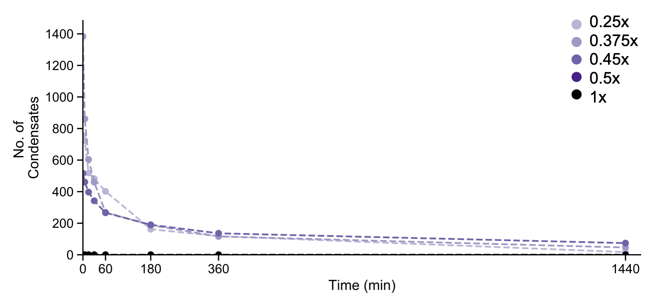
Figure S16: Number of condensates for nanostars annealed with different concentrations of invader strand.

3.4 Annealing nanostars at different concentrations (no invader)

The figures reported in this section complement the data reported in Fig. 3 of the manuscript. We consider DNA nanostars annealed at different concentrations. We report histograms of the droplet diameter, normalized average droplet area, total droplet area, and droplet number over time.
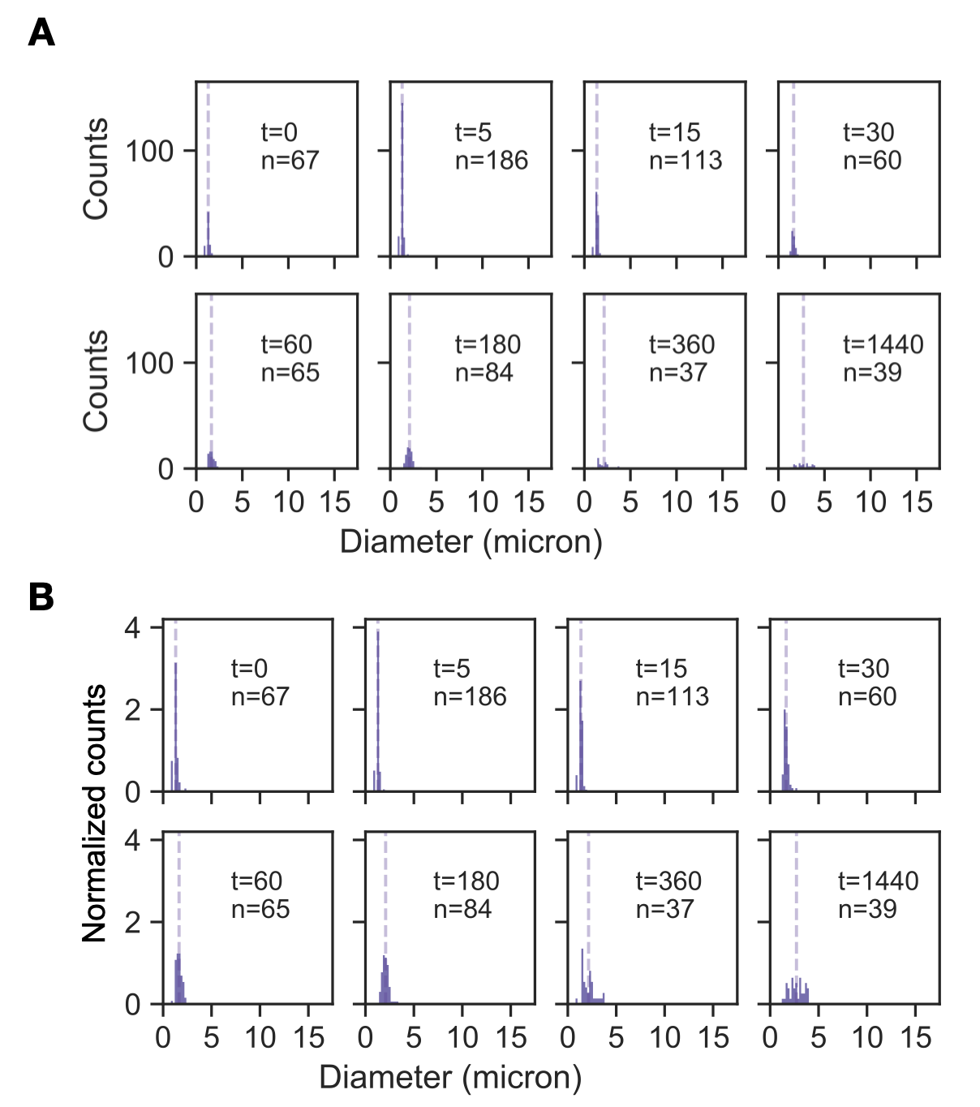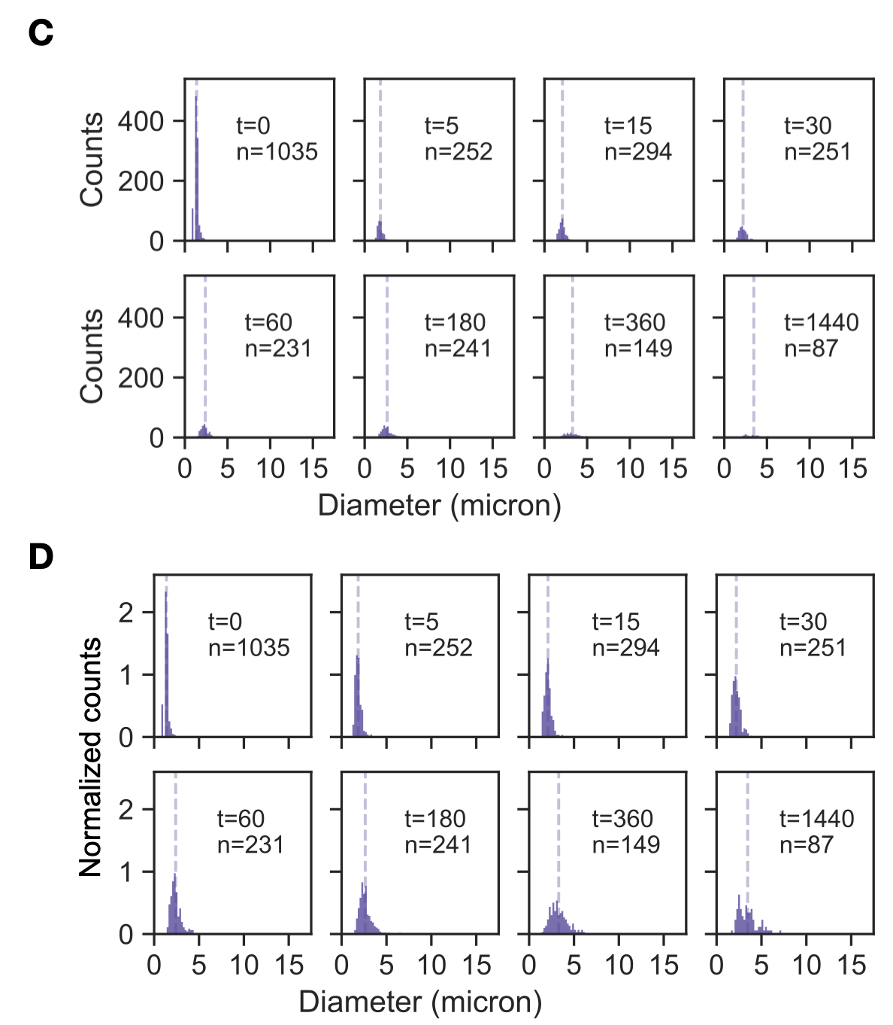
Figure S17: Histograms and normalized histograms for 0.25 µM (AB) and 1 µM (CD) 16-arm nanostars. Histograms are normalized such that the area of each histogram is 1. Bin width is set to 0.2 μm. Vertical dashed line indicates the mean for each observed time.

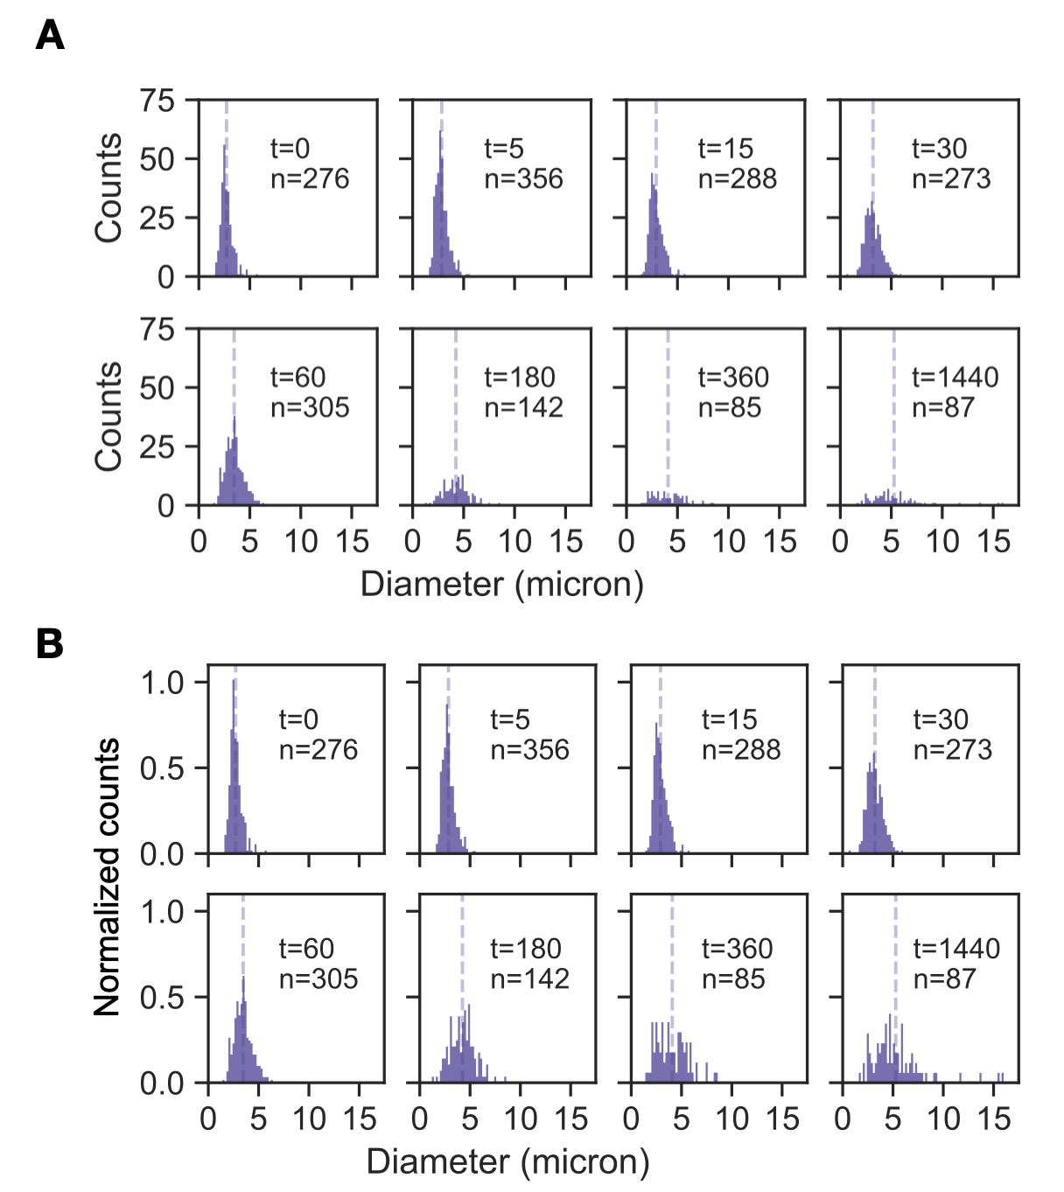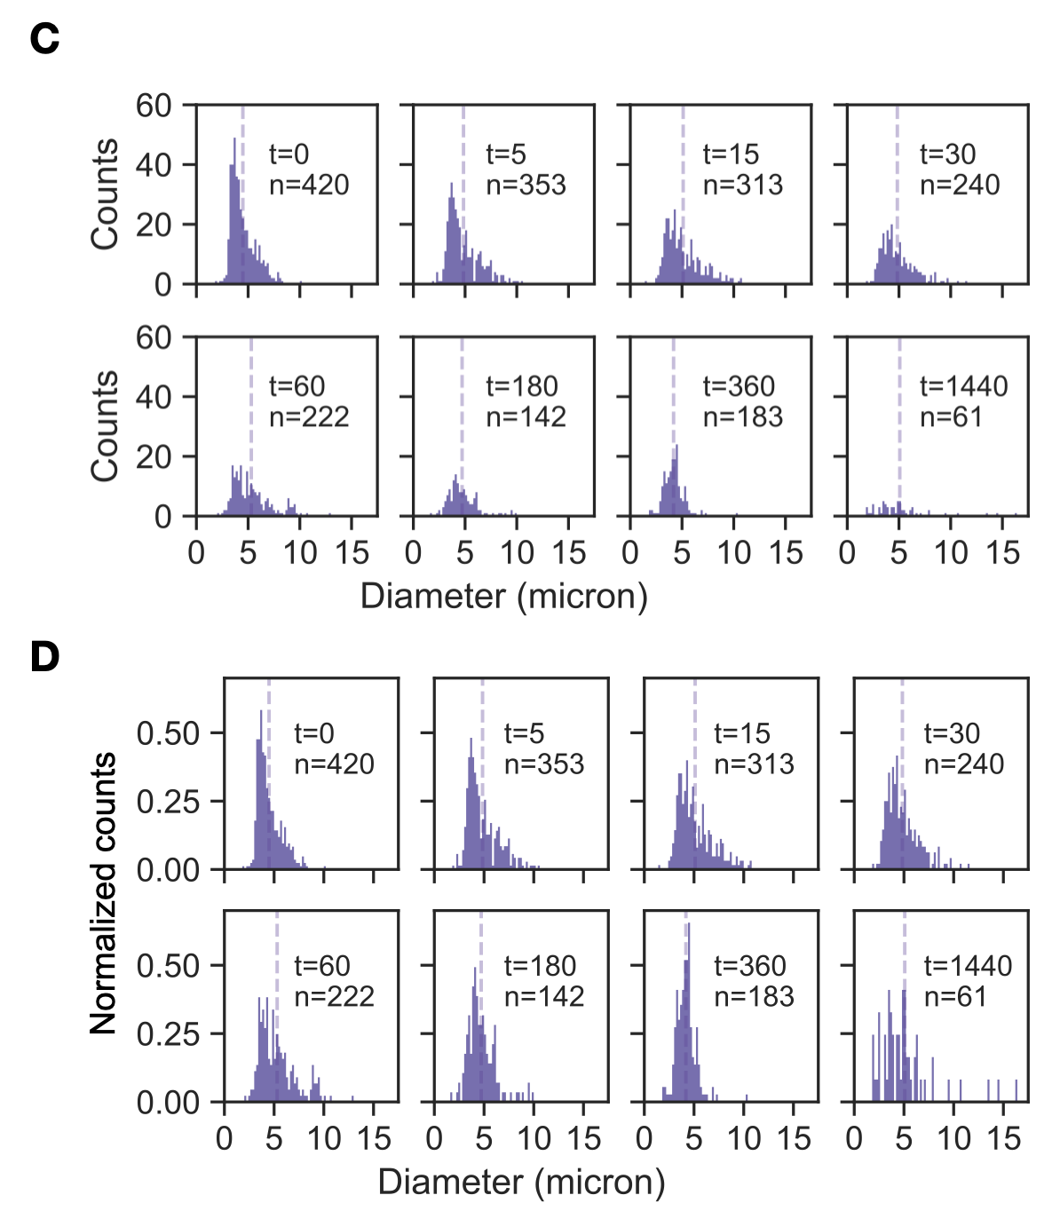
Figure S18: Histograms and normalized histograms for 2.5 µM (AB) and 5 µM (CD) 16-arm nanostars. Histograms are normalized such that the area of each histogram is 1. Bin width is set to 0.2 μm. Vertical dashed line indicates the mean for each observed time.

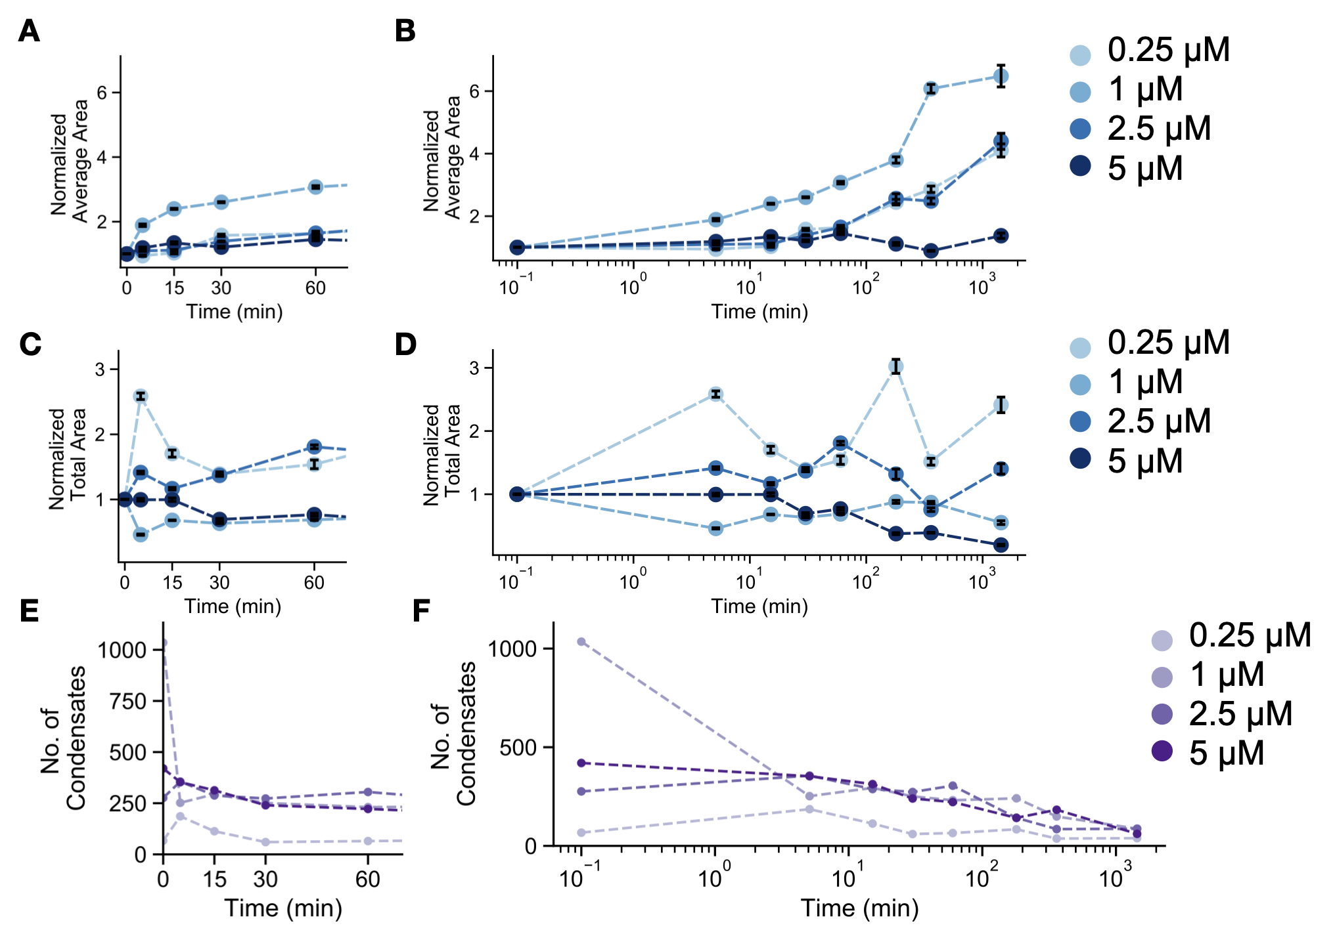
Figure S19: Further characterization of nanostars annealed and incubated without invader at different concentrations. Normalized average area of each condensate through 1 hour (A) and 24 hours (B). Normalized total area of condensate through 1 hour (C) and 24 hours (D). Both normalized average and total areas are normalized such that the initial observation is 1. Error bars are the standard error of the mean derived from bootstrapping data from a single experimental replicate. Number of condensates for nanostars annealed with different concentrations of invader strand through 1 hour (E) and 24 hours (F).

3.5 Annealing nanostars (no invader)
The figures reported in this section complement the data reported in Fig. 4b of the manuscript.. We report histograms of the droplet diameter, normalized average droplet area, total droplet area, and droplet number over time.
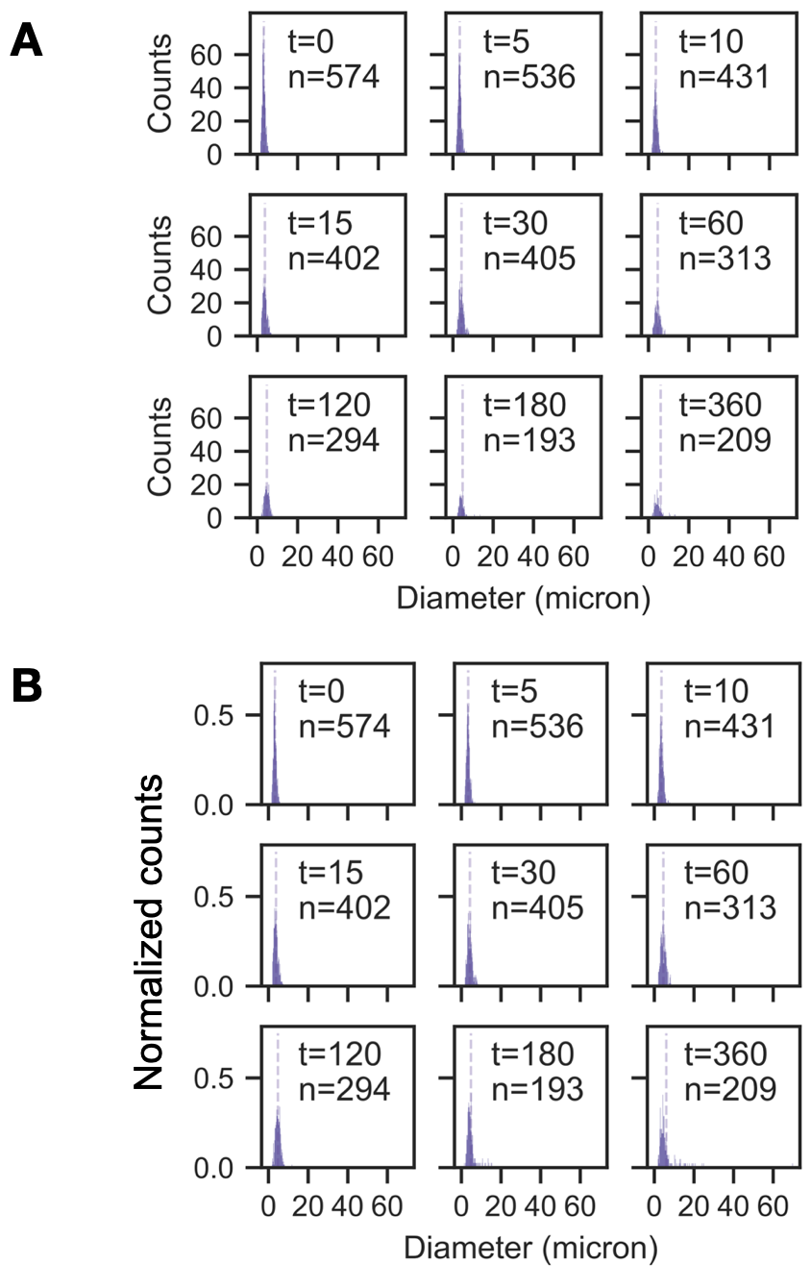
Figure S20: (A)Histograms and (B) normalized histograms of condensate size for NS = 5 μM, no invader control (16-arm nanostars). Histograms are normalized such that the area of each histogram is 1. Bin width is set to 0.2 μm. Vertical dashed line indicates the mean for each observed time.

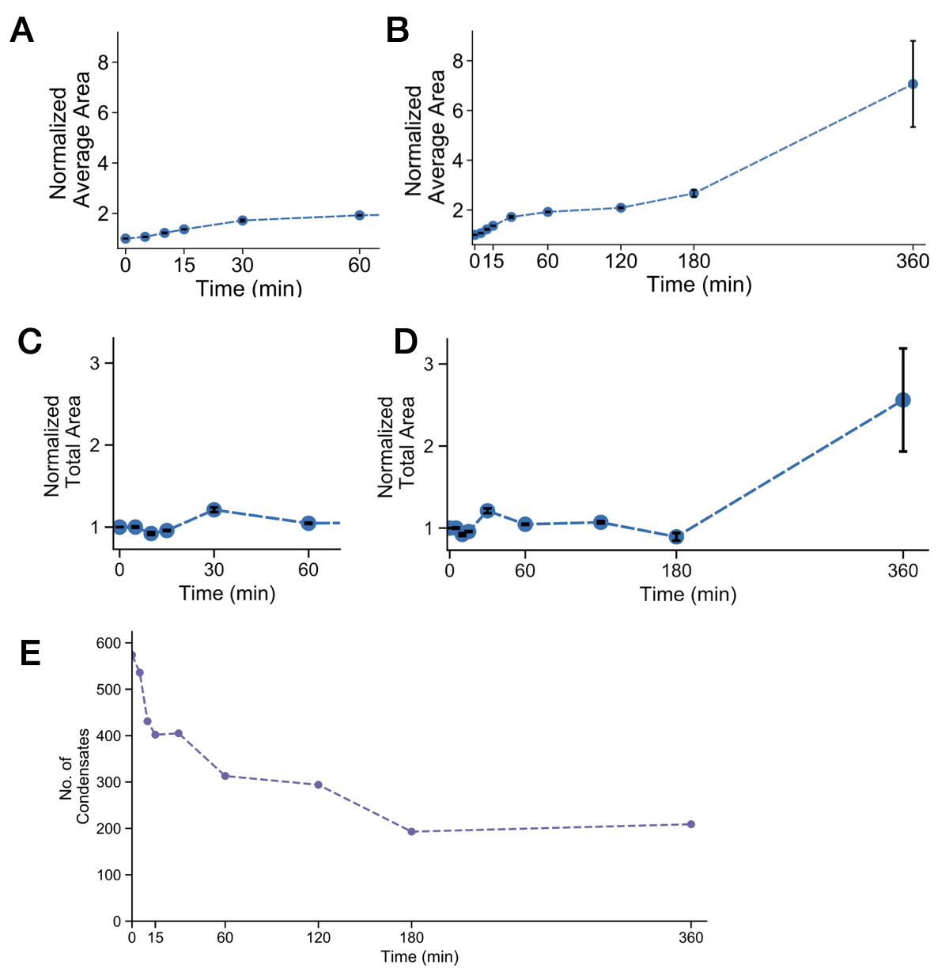
Figure S21: Normalized average area of each condensate following anneal through 60 min (A) and through 360 min (B) for the no invader control experiment. The area is normalized such that the initial observation is 1. Normalized total area of condensate following anneal through 60 min (C) and through 360 min (D) for the no invader control experiment. The area is normalized such that the initial observation is 1. (E) Number of condensates detected for no invader control following anneal. Error bars are the standard error of the mean derived from bootstrapping data from a single experimental replicate.

3.6 Invaders with different toehold length

The figures reported in this section complement the data reported in Fig. 4B of the manuscript. We consider 5µM DNA nanostars, annealed and incubated at 27°C for 30 minutes before the start of the experiment. Different concentrations of invader are added as described in the caption. We report histograms of droplet diameter, normalized total droplet area and droplet number over time. (The normalized average droplet area is reported in Fig. 4B).

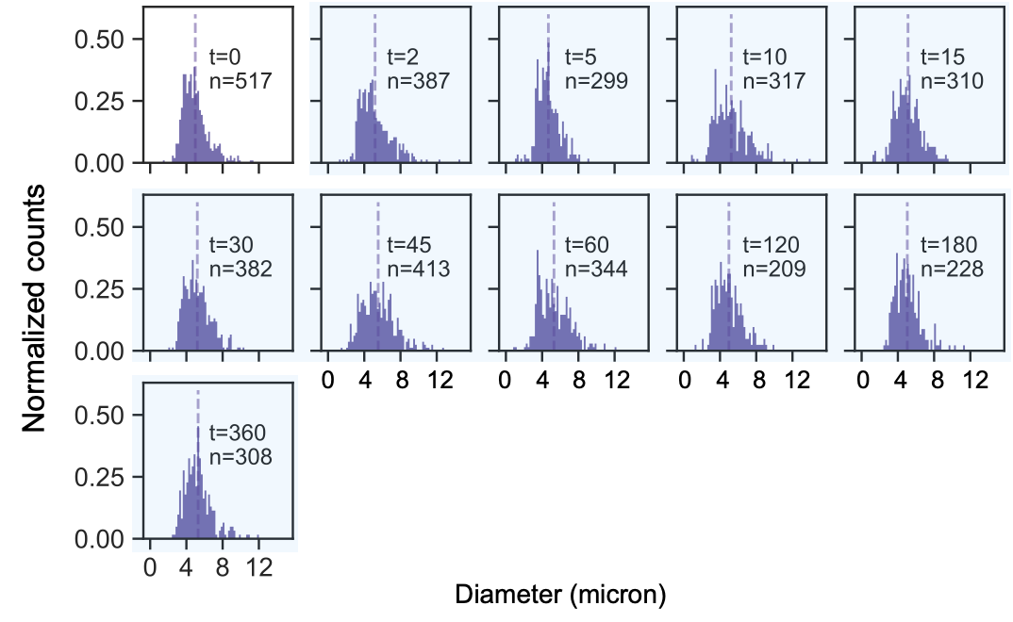
Figure S22: Normalized histograms for invasion without a toehold; NS = 5 μM, post incubation addition of Inv = 5 μM (or 1X NS). Histograms are normalized such that the area of each histogram is 1. Cyan shaded histograms correspond to samples taken after addition of invader. Bin width is set to 0.2 μm. Vertical dashed line indicates the mean for each observed time.

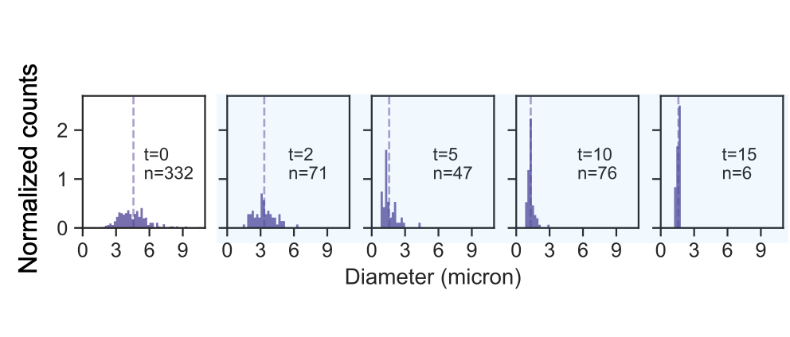
Figure S23: Normalized histograms for invasion with a toehold length of 3 bases; NS = 5 μM, post incubation addition of Inv = 5 μM (or 1X NS). Histograms are normalized such that the area of each histogram is 1. Cyan shaded histograms correspond to samples taken after addition of invader. Bin width is set to 0.2 μm. Vertical dashed line indicates the mean for each observed time.

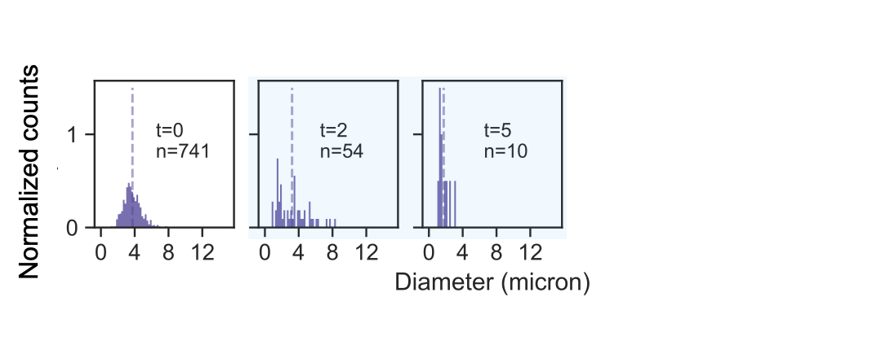
Figure S24: Normalized histograms for invasion with a toehold length of 5 bases; NS = 5 μM, post incubation addition of Inv = 5 μM (or 1X NS). Histograms are normalized such that the area of each histogram is 1. Cyan shaded histograms correspond to samples taken after addition of invader. Bin width is set to 0.2 μm. Vertical dashed line indicates the mean for each observed time.

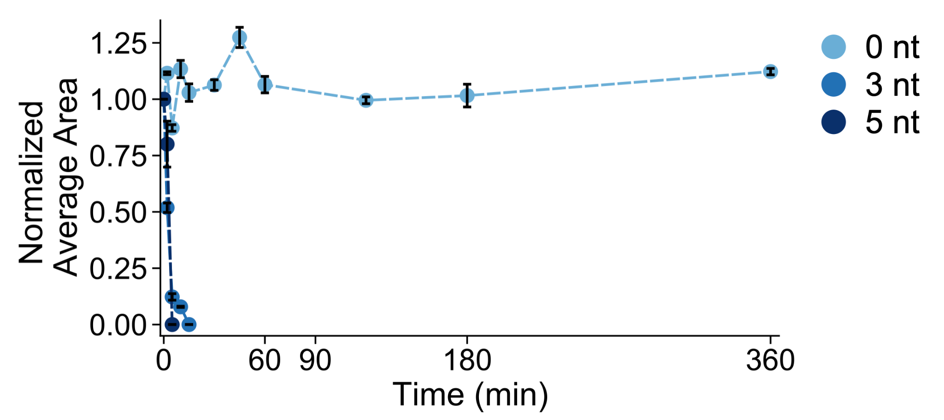
Figure S25: Extended observation of normalized average area of each condensate following addition of invader strand for the invader with different toehold length experiments. The area is normalized such that the initial observation is 1. Error bars are the standard error of the mean derived from bootstrapping data from a single experimental replicate.

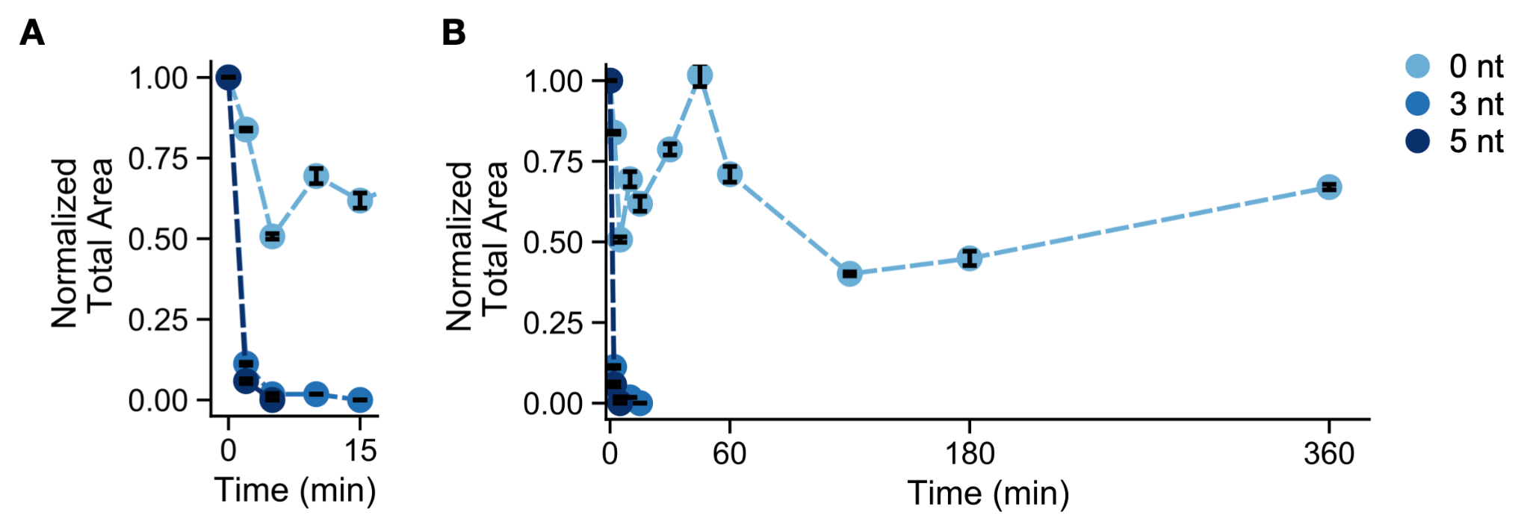
Figure S26: Normalized total area of condensate detected following addition of invader strand through 15 min (A) and through 360 min (B) for invader with different toehold length experiments. The area is normalized such that the initial observation is 1. Error bars are the standard error of the mean derived from bootstrapping data from a single experimental replicate.

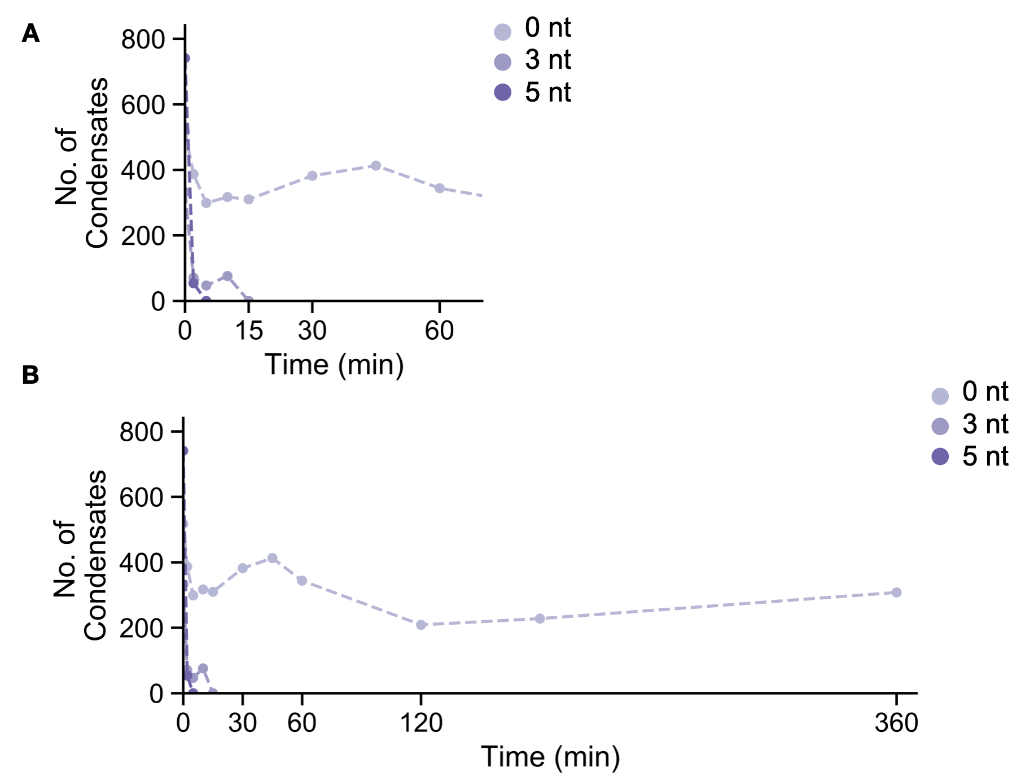
Figure S27: Number of condensates following addition of invader strand for invader with different toehold length experiments through 60 min (A) and through 360 min (B).

3.7 Invaders with different depth of invasion into the nanostar arm
The figures reported in this section complement the data reported in Fig. 4E of the manuscript. We consider 5µM DNA nanostars, annealed and incubated at 27°C for 30 minutes before the start of the experiment. Different concentrations of invader are added as described in the caption. We report histograms of droplet diameter, normalized total droplet area and droplet number over time. (The normalized average droplet area is reported in Fig. 4E).

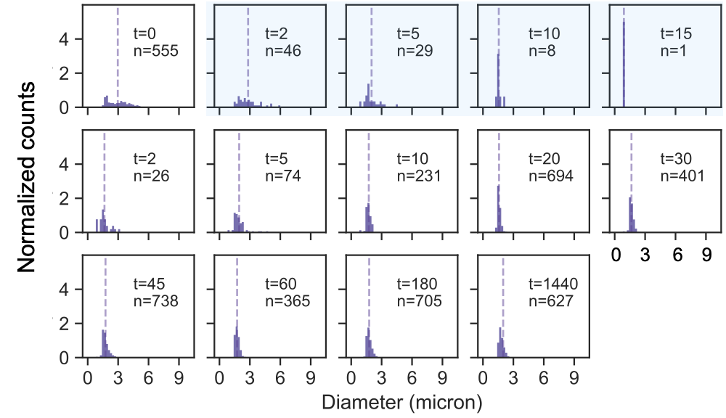
Figure S28: Normalized histograms for invasion with invasion depth of 0 bases in the NS arm; NS = 5 μM, post incubation addition of Inv = 2.5 μM (or 0.5X NS) and thereafter addition of Anti-Invaders = 2.5 uM (or 1X Inv or 0.5X NS). Histograms are normalized such that the area of each histogram is 1. Cyan shaded histograms correspond to samples taken after addition of invader but prior to addition of anti-invader. Bin width is set to 0.2 μm. Vertical dashed line indicates the mean for each observed time.

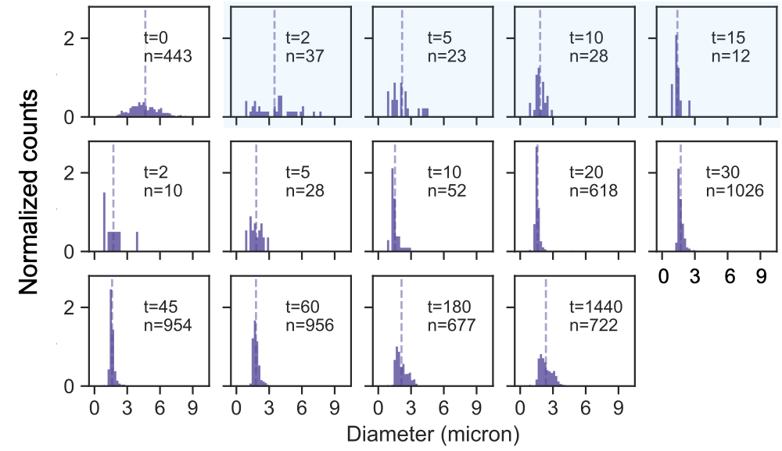
Figure S29: Normalized histograms for invasion with invasion depth of 3 bases in the NS arm; NS = 5 μM, post incubation addition of Inv = 2.5 μM (or 0.5X NS) and thereafter addition of Anti-Invaders = 2.5 uM (or 1X Inv or 0.5X NS). Histograms are normalized such that the area of each histogram is 1. Cyan shaded histograms correspond to samples taken after addition of invader but prior to addition of anti-invader. Bin width is set to 0.2 μm. Vertical dashed line indicates the mean for each observed time.

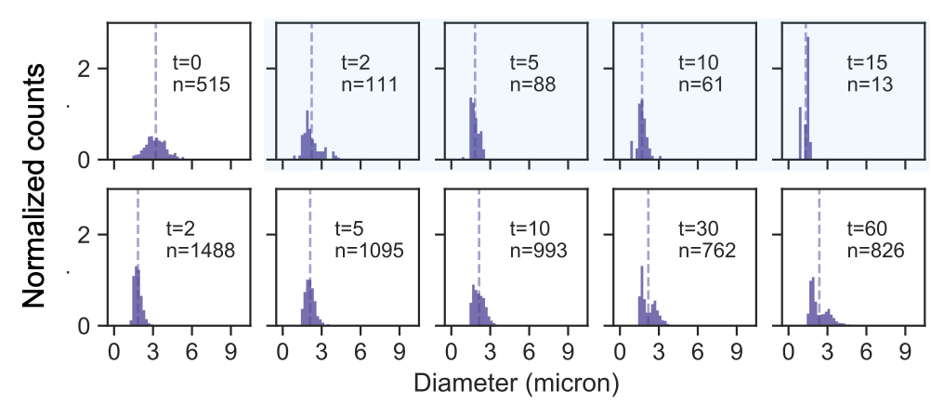
Figure S30: Normalized histograms for invasion with invasion depth of 6 bases in the NS arm; NS = 5 μM, post incubation addition of Inv = 2.5 μM (or 0.5X NS) and thereafter addition of Anti-Invaders = 2.5 uM (or 1X Inv or 0.5X NS). Histograms are normalized such that the area of each histogram is 1. Cyan shaded histograms correspond to samples taken after addition of invader but prior to addition of anti-invader. Bin width is set to 0.2 μm. Vertical dashed line indicates the mean for each observed time.

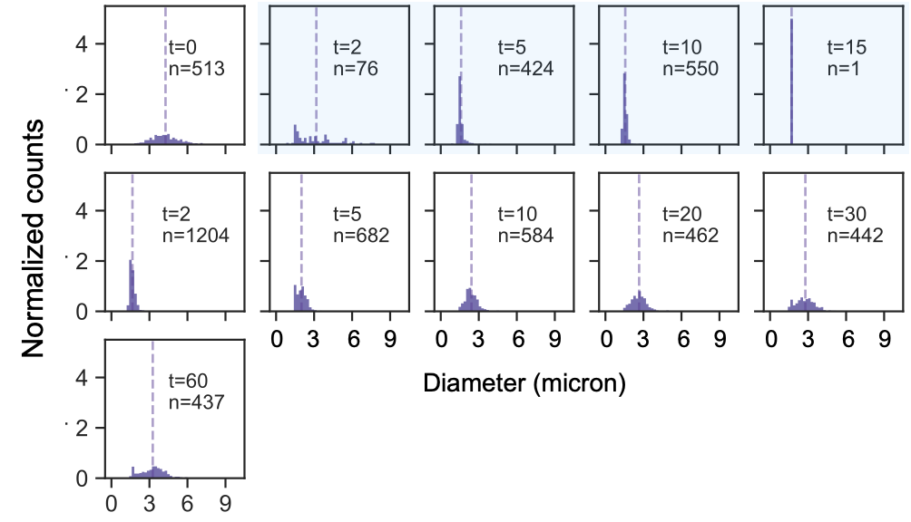
Figure S31: Normalized histograms for invasion with a invasion depth of 9 bases in the NS arm; NS = 5 μM, post incubation addition of Inv = 2.5 μM (or 0.5X NS) and thereafter addition of Anti-Invaders = 2.5 uM (or 1X Inv or 0.5X NS). Histograms are normalized such that the area of each histogram is 1. Cyan shaded histograms correspond to samples taken after addition of invader but prior to addition of anti-invader. Bin width is set to 0.2 μm. Vertical dashed line indicates the mean for each observed time.

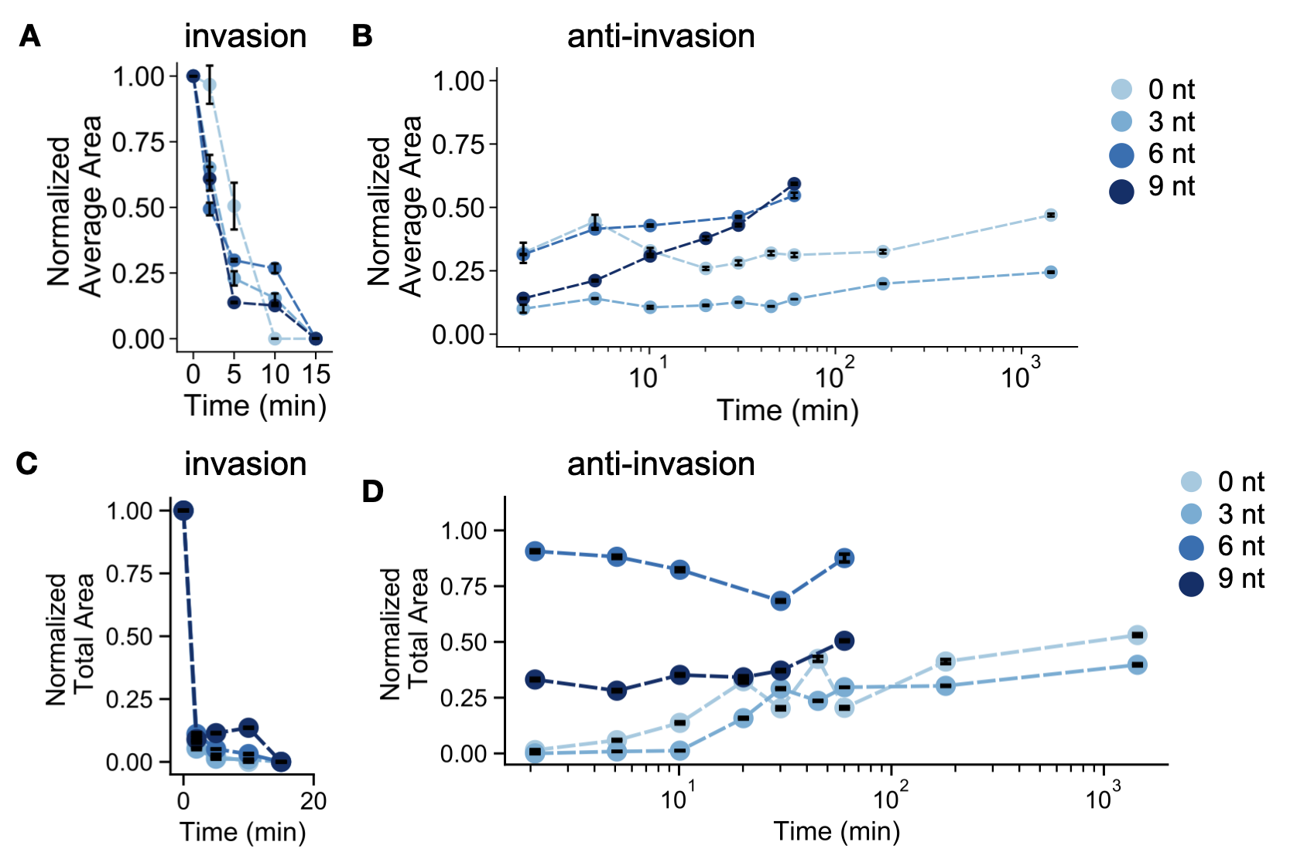
Figure S32: Extended observation of normalized average area following addition of invader strand (A) and addition of anti-invader strand through 1440 min (B) for the different depth of invasion experiments. Extended observation of normalized total area of condensate following addition of invader strand (C) and addition of anti-invader strand through 1440 min (D) for the different depth of invasion experiments. The areas are normalized such that the initial observation is 1. Error bars are the standard error of the mean derived from bootstrapping data from a single experimental replicate.

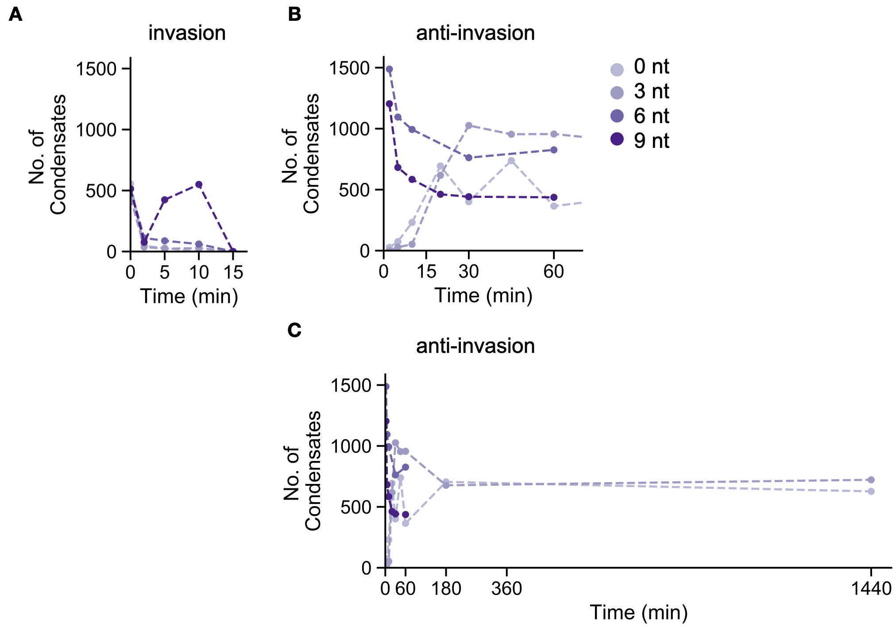
Figure S33: Number of condensates following addition of invader strand (A) and addition of anti-invader strand through 60 min (B) and 1440 min (C) for different depth of invasion experiments.

3.8 Nanostars with different arm length
The figures reported in this section complement the data reported in Fig. 5 of the manuscript. We consider 5µM DNA nanostars, annealed and incubated at 27°C for 30 minutes before the start of the experiment. 1X or 0.5 invader is added as described in the captions. We report histograms of droplet diameter, normalized total droplet area and droplet number over time. (The normalized average droplet area and number are reported in Fig. 5).

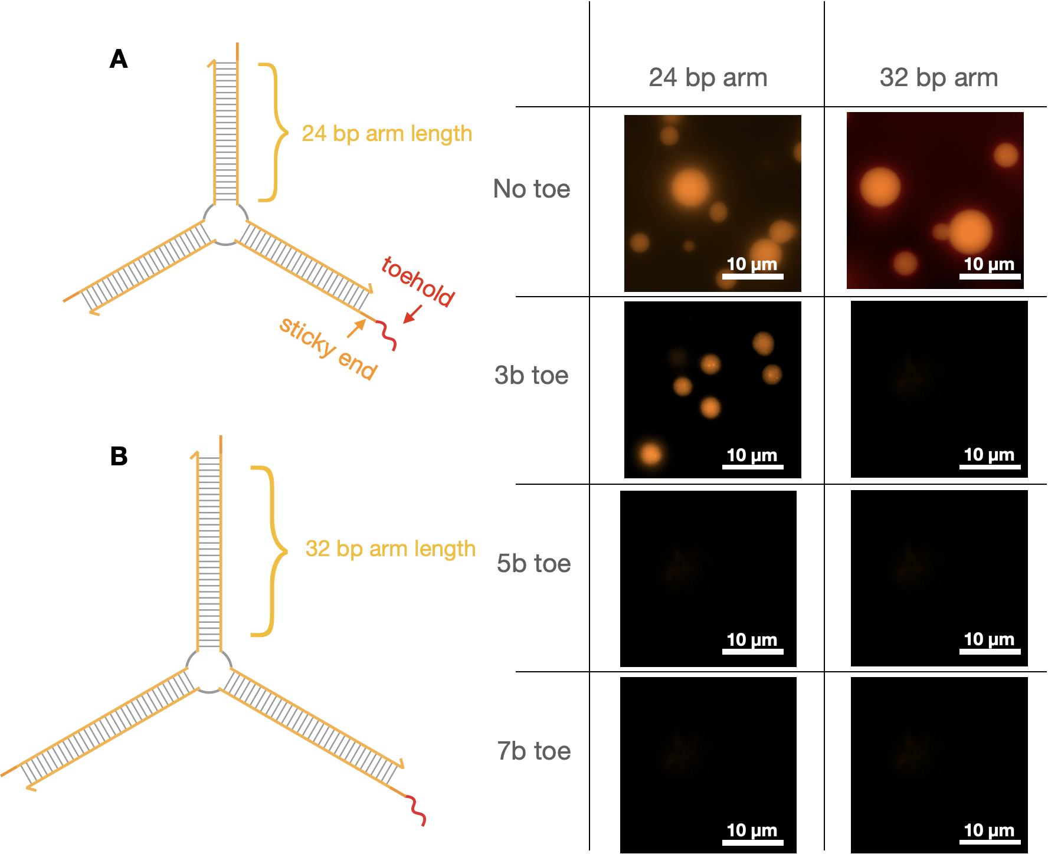
Figure S34: 24 bp arm and 32 bp arm design with a toehold for invasion with different lengths of toehold. Microscopy images representing the condensates after 30 mins of incubation at room temperature (27° C) after anneal process. Scale bars as represented.

1x invader addition
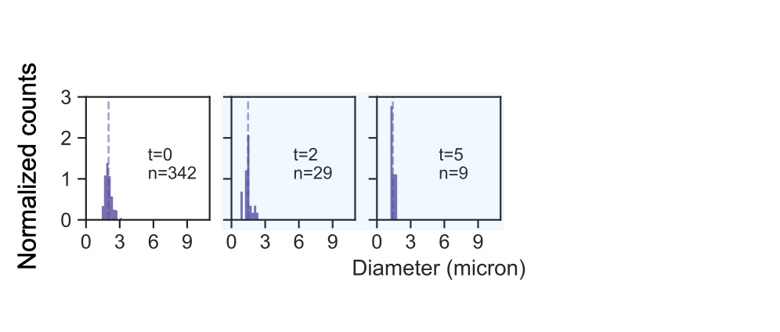
Figure S35: Normalized histograms for NS with arm length of 8 bases; NS = 5 μM, post incubation addition of Inv = 5 μM (or 1X NS). Histograms are normalized such that the area of each histogram is 1. Cyan shaded histograms correspond to samples taken after addition of invader. Bin width is set to 0.2 μm. Vertical dashed line indicates the mean for each observed time.

Figure S36: Normalized histograms for NS with arm length of 16 bases; NS = 5 μM, post incubation addition of Inv = 5 μM (or 1X NS). Histograms are normalized such that the area of each histogram is 1. Cyan shaded histograms correspond to samples taken after addition of invader. Bin width is set to 0.2 μm. Vertical dashed line indicates the mean for each observed time.

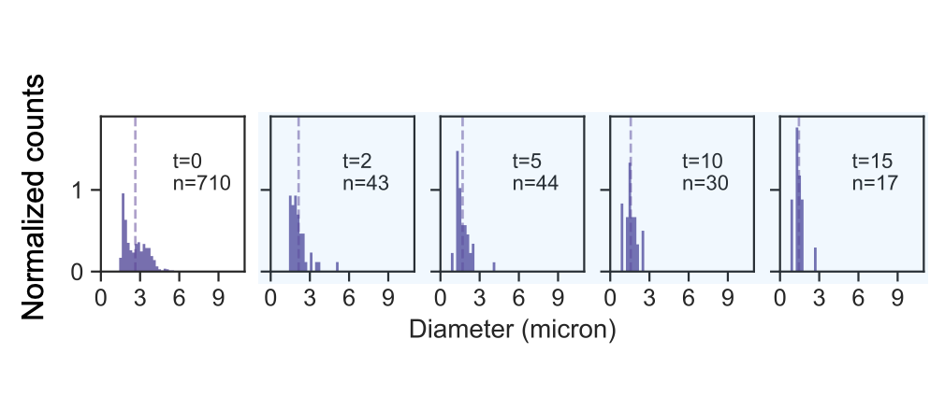
Figure S37: Normalized histograms for NS with arm length of 24 bases; NS = 5 μM, post incubation addition of Inv = 5 μM (or 1X NS). Histograms are normalized such that the area of each histogram is 1. Cyan shaded histograms correspond to samples taken after addition of invader. Bin width is set to 0.2 μm. Vertical dashed line indicates the mean for each observed time.

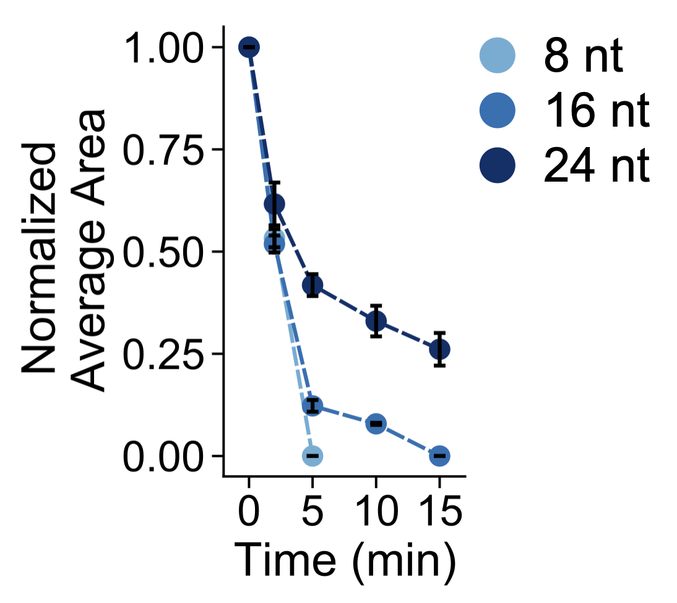
Figure S38: Normalized average area of each condensate following addition of invader strand for different arm length experiments; NS = 5 μM, post incubation addition of Inv = 5 μM (or 1X NS). The area is normalized such that the initial observation is 1. Error bars are the standard error of the mean derived from bootstrapping data from a single experimental replicate.

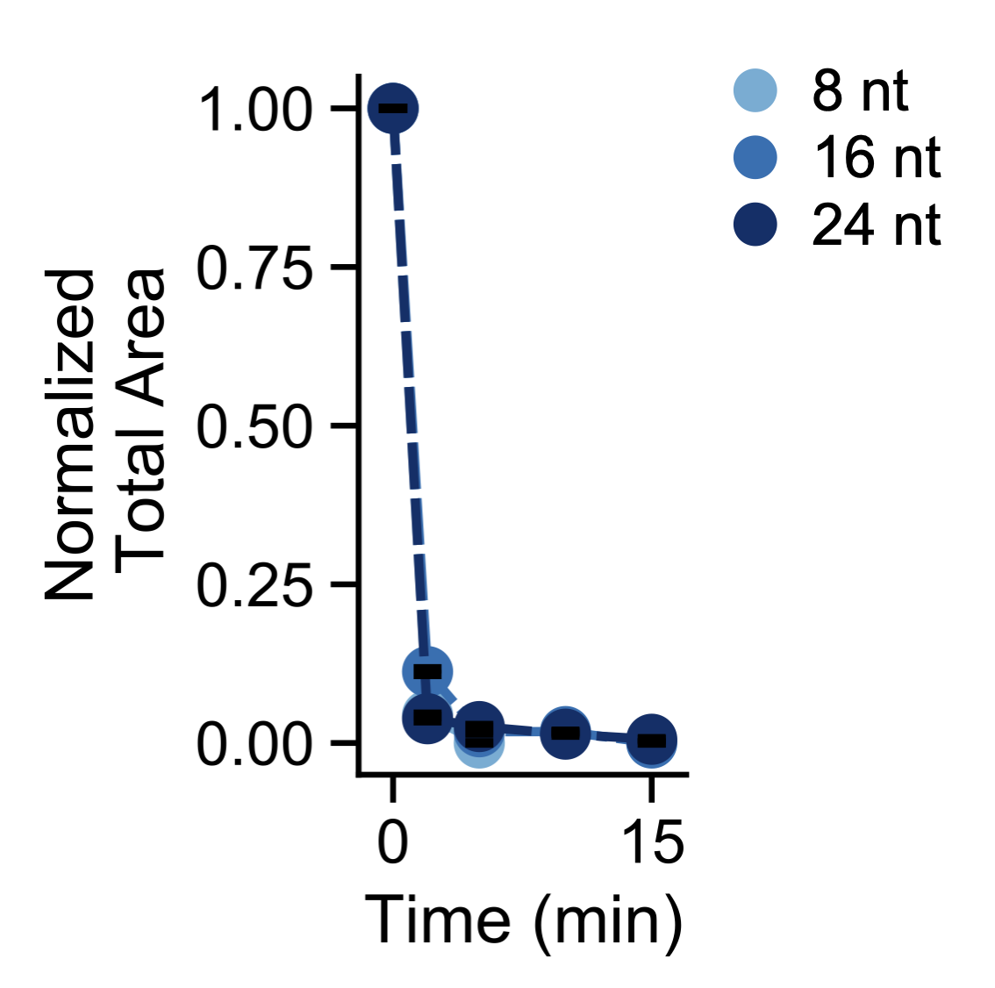
Figure S39: Normalized total area of condensate following addition of invader strand for different arm length experiments; NS = 5 μM, post incubation addition of Inv = 5 μM (or 1X NS). The area is normalized such that the initial observation is 1. Error bars are the standard error of the mean derived from bootstrapping data from a single experimental replicate.

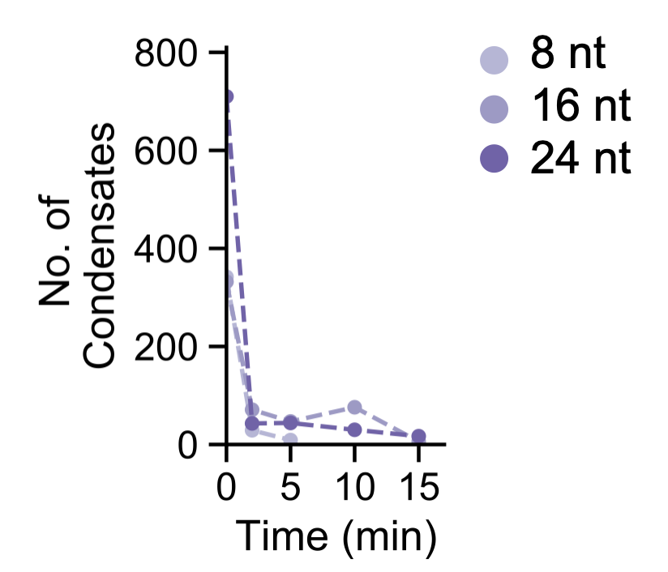
Figure S40: Number of condensates detected following addition of invader strand for different arm length experiments; NS = 5 μM, post incubation addition of Inv = 5 μM (or 1X NS).

0.5x invader addition
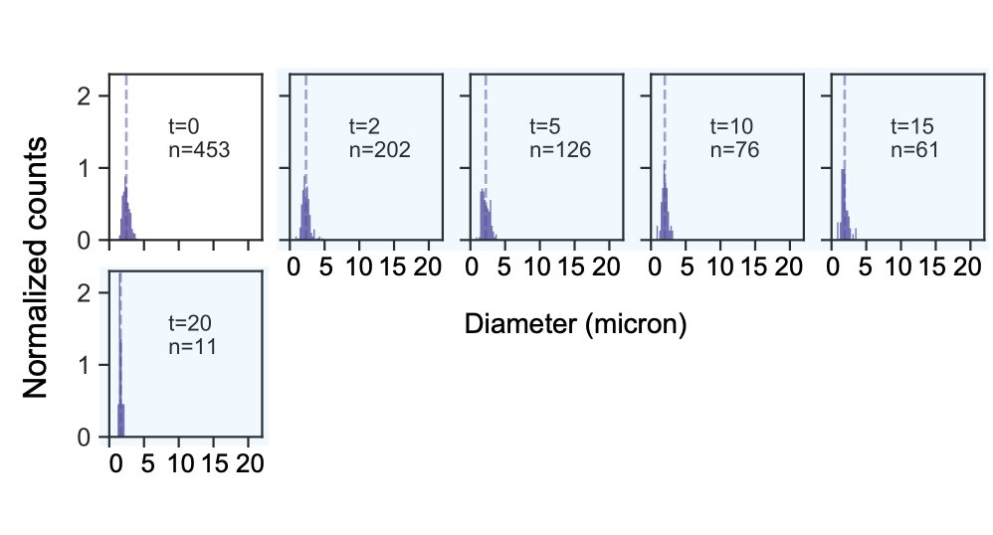
Figure S41: Normalized histograms for NS with arm length of 8 bases; NS = 5 μM, post incubation addition of Inv = 2.5 μM (or 0.5X NS). Histograms are normalized such that the area of each histogram is 1. Cyan shaded histograms correspond to samples taken after addition of invader. Bin width is set to 0.2 μm. Vertical dashed line indicates the mean for each observed time.

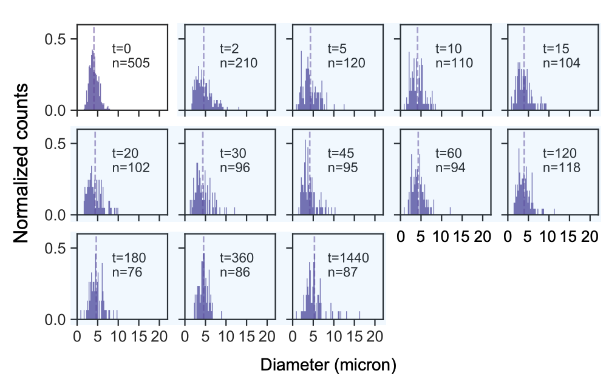
Figure S42: Normalized histograms for NS with arm length of 16 bases; NS = 5 μM, post incubation addition of Inv = 2.5 μM (or 0.5X NS). Histograms are normalized such that the area of each histogram is 1. Cyan shaded histograms correspond to samples taken after addition of invader. Bin width is set to 0.2 μm. Vertical dashed line indicates the mean for each observed time.

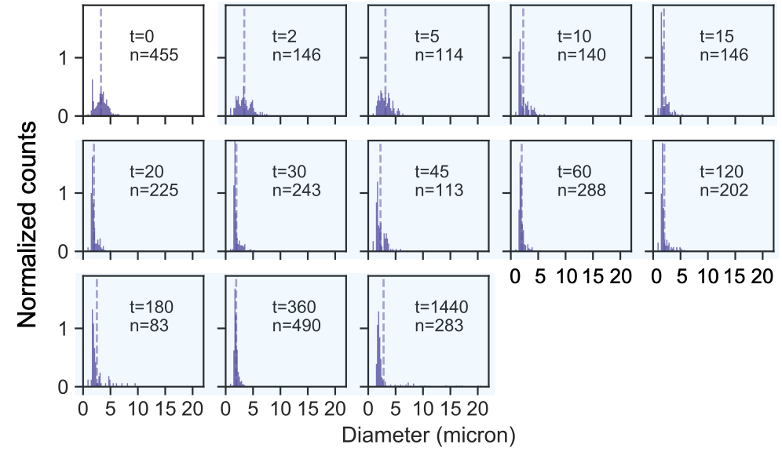
Figure S43: Normalized histograms for NS with arm length of 24 bases; NS = 5 μM, post incubation addition of Inv = 2.5 μM (or 0.5X NS). Histograms are normalized such that the area of each histogram is 1. Cyan shaded histograms correspond to samples taken after addition of invader. Bin width is set to 0.2 μm. Vertical dashed line indicates the mean for each observed time.

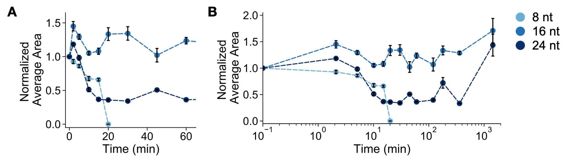
Figure S44: Normalized average area of each condensate following addition of invader strand through 60 min (A) and through 1440 min for different arm length experiments; NS = 5 μM, post incubation addition of Inv = 2.5 μM (or 0.5X NS). The area is normalized such that the initial observation is 1. Error bars are the standard error of the mean derived from bootstrapping data from a single experimental replicate.

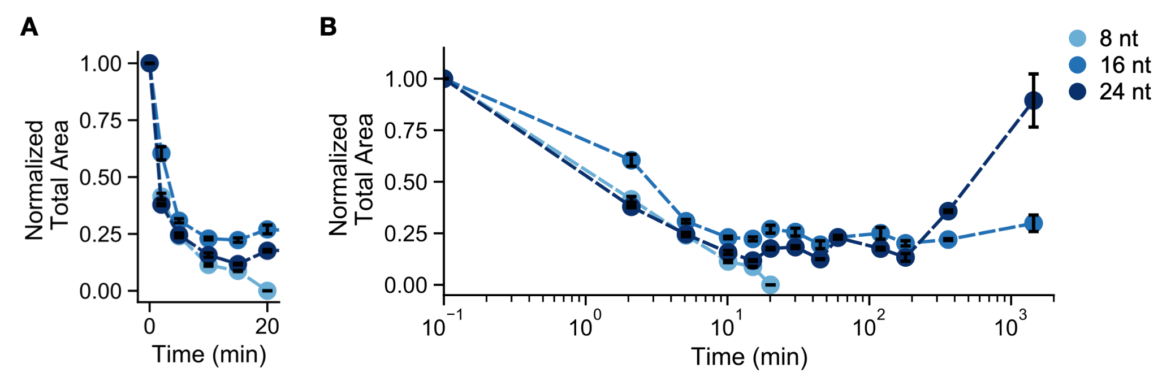
Figure S45: Normalized total area of condensate following addition of invader strang through 20 min (A) and through 1440 min (B) for different arm length experiments; NS = 5 μM, post incubation addition of Inv = 2.5 μM (or 0.5X NS). The area is normalized such that the initial observation is 1. Error bars are the standard error of the mean derived from bootstrapping data from a single experimental replicate.

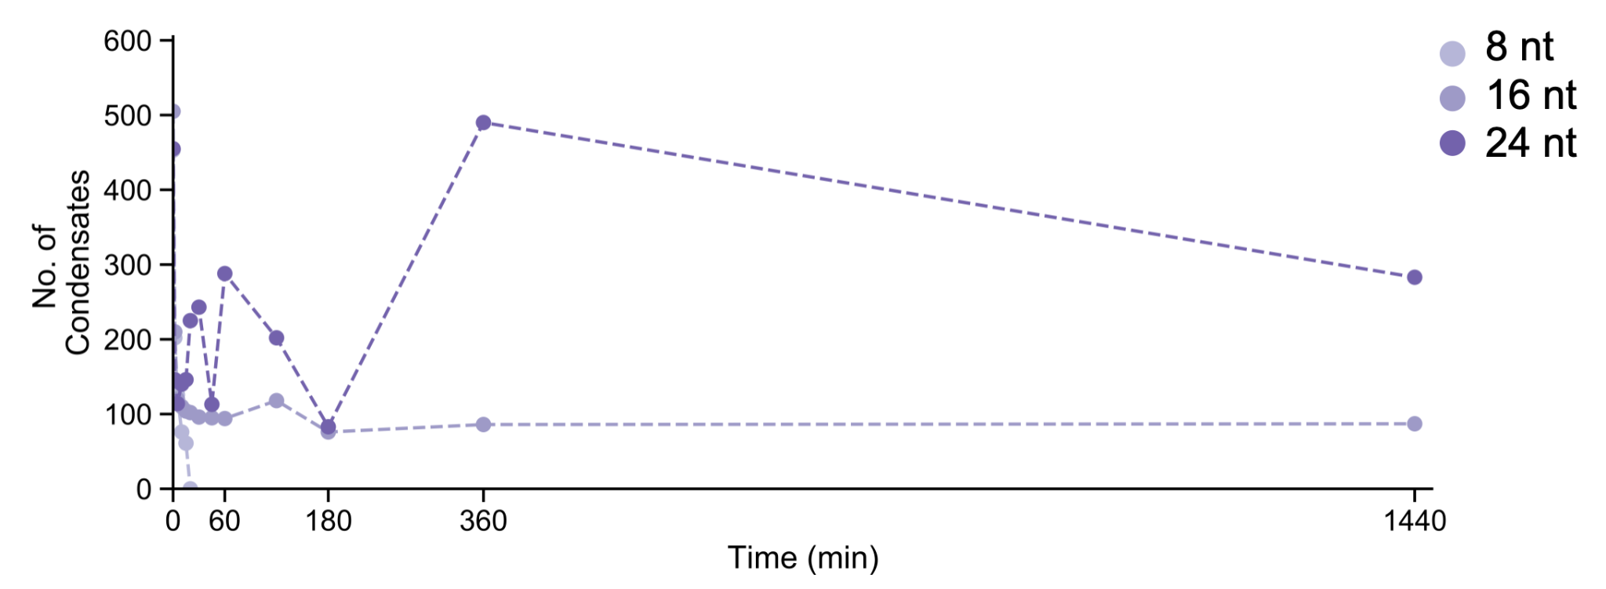
Figure S46: Number of condensates following addition of invader strand for different arm length experiments; NS = 5 μM, post incubation addition of Inv = 2.5 μM (or 0.5X NS).

3.9 Four and six arm nanostars and their invasion
The figures reported in this section complement the data reported in Fig. 6 of the manuscript. We consider 5µM DNA nanostars, annealed and incubated at 27°C for 30 minutes before the start of the experiment. Different concentrations of invader are added as described in the caption. We report histograms of droplet diameter, normalized total droplet area and droplet number over time. (The normalized average droplet area and number are reported in Fig. 6).

4 arm nanostars, 1x invader
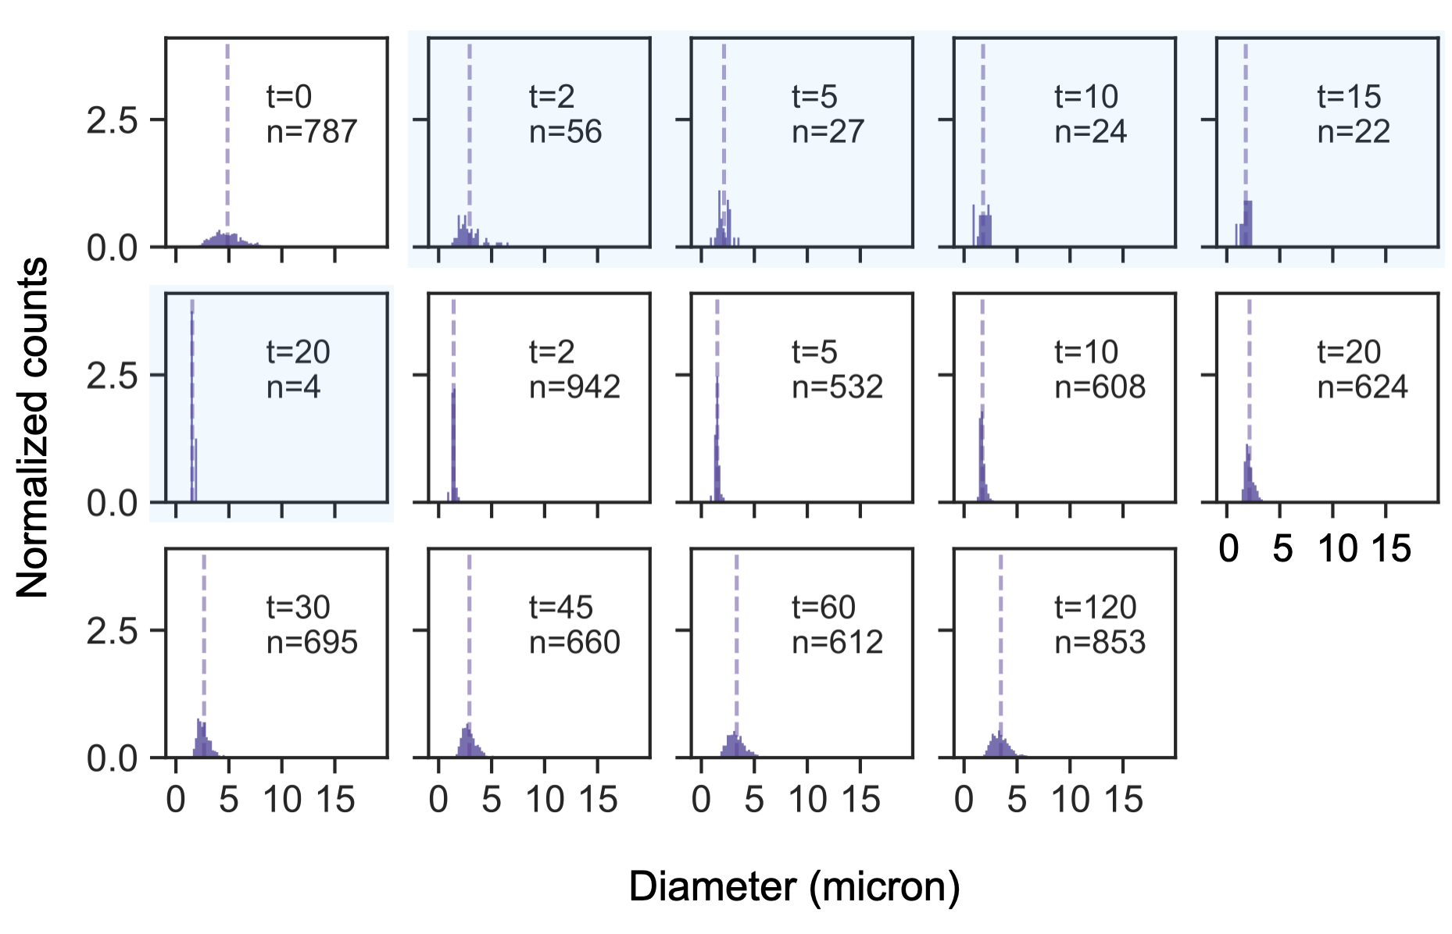
Figure S47: Four arms, one invader. Normalized histograms for 4 armed NS = 5 μM, post incubation addition of one Inv = 5 μM (or 1X NS). Histograms are normalized such that the area of each histogram is 1. Cyan shaded histograms correspond to samples taken after addition of invader but prior to addition of anti-invader. Bin width is set to 0.2 μm. Vertical dashed line indicates the mean for each observed time.

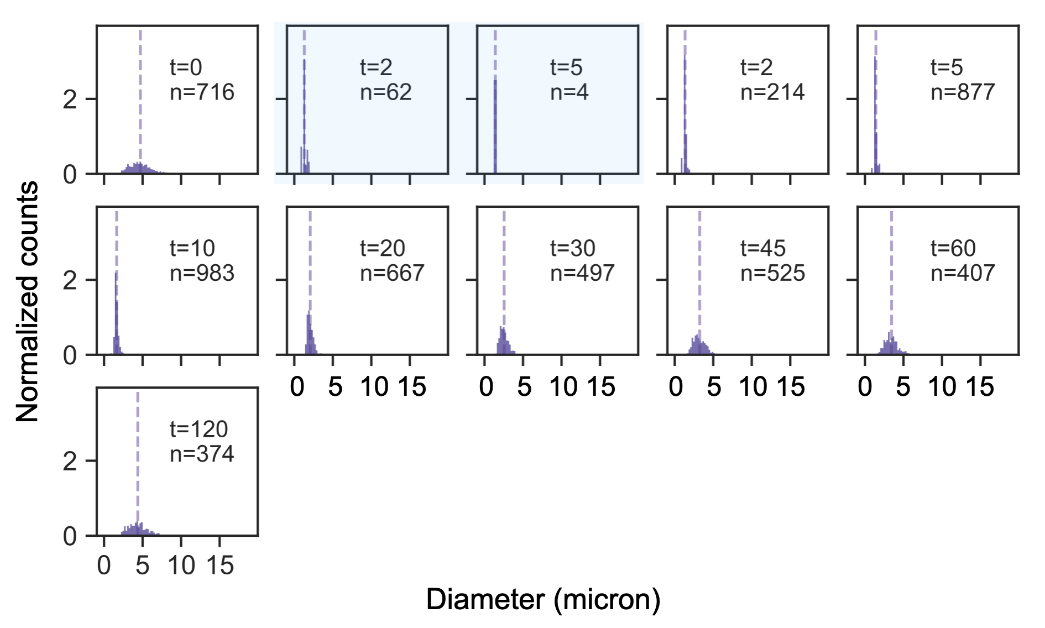
Figure S48: Four arms, two invaders. Normalized histograms for 4 armed NS = 5 μM, post incubation addition of two Inv = 5 μM (or 1X NS) each. Histograms are normalized such that the area of each histogram is 1. Cyan shaded histograms correspond to samples taken after addition of invader. Bin width is set to 0.2 μm. Vertical dashed line indicates the mean for each observed time.

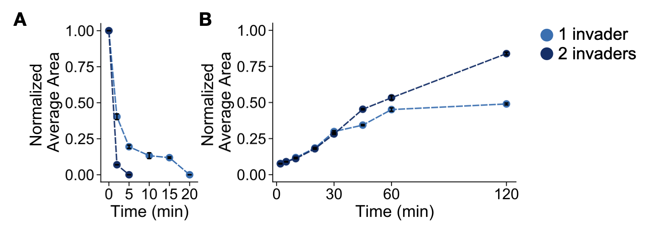
Figure S49: Four arms, invasion and anti-invasion. Normalized average area of each condensate following addition of invader strand(s) (A) and addition of anti-invader strand(s) for 4-arm nanostar experiments. The area is normalized such that the initial observation is 1. Error bars are the standard error of the mean derived from bootstrapping data from a single experimental replicate.

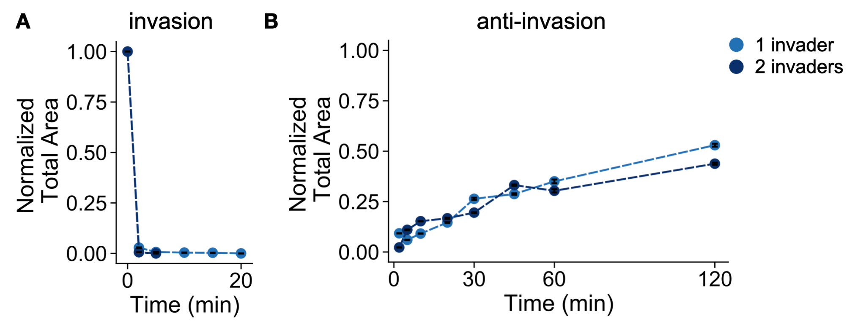
Figure S50: Four arms, invasion and anti invasion. Normalized total area of condensate following addition of invader strand(s) (A) and addition of anti-invader strand(s) for 4-arm nanostar experiments. The area is normalized such that the initial observation is 1. Error bars are the standard error of the mean derived from bootstrapping data from a single experimental replicate.

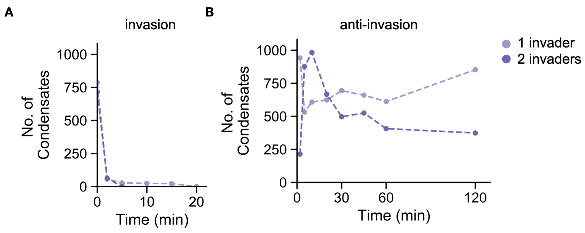
Figure S51: Four arms, invasion and anti invasion. Number of condensates following addition of invader strand(s) (A) and following addition of anti-invader strand(s) (B) for 4-arm nanostar experiments.

6 arm nanostars, 1x invader
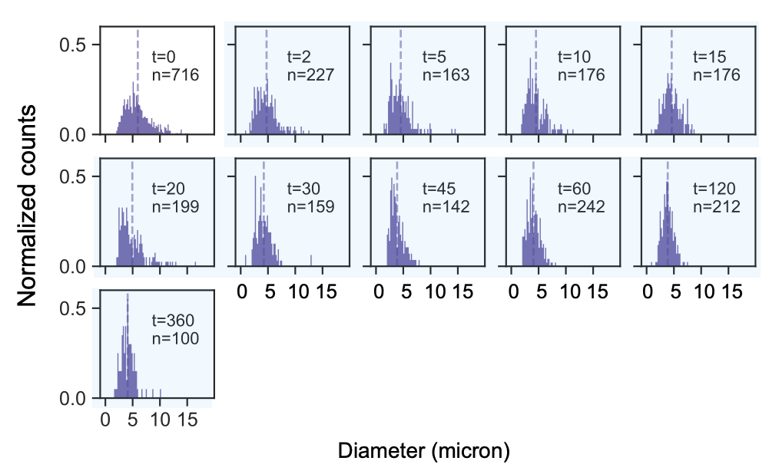
Figure S52: Six arms, one invader. Normalized histograms for 6 armed NS = 5 μM, post incubation addition of one Inv = 5 μM (or 1X NS). Histograms are normalized such that the area of each histogram is 1. Cyan shaded histograms correspond to samples taken after addition of invader. Bin width is set to 0.2 μm. Vertical dashed line indicates the mean for each observed time.

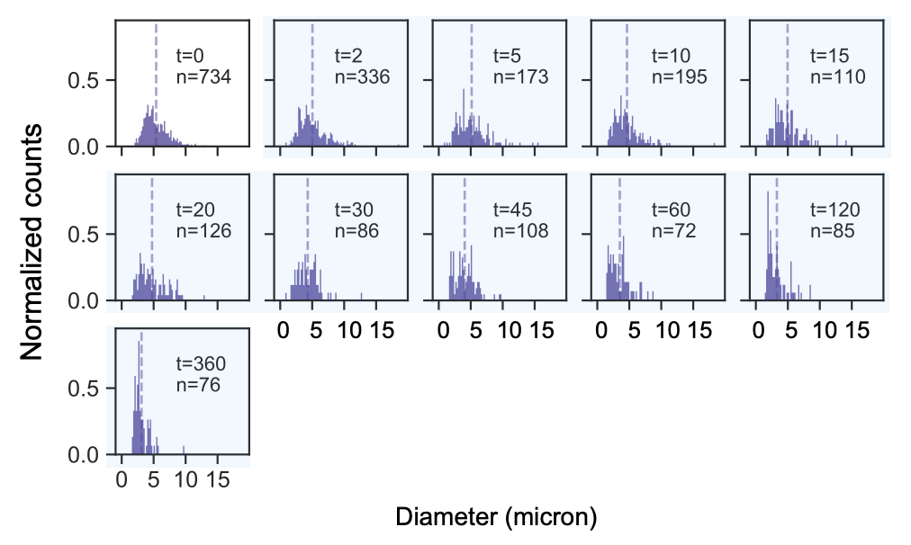
Figure S53: Six arms, two invaders. Normalized histograms for 6 armed NS = 5 μM, post incubation addition of two adjacent Inv = 5 μM (or 1X NS) each. Histograms are normalized such that the area of each histogram is 1. Cyan shaded histograms correspond to samples taken after addition of invader. Bin width is set to 0.2 μm. Vertical dashed line indicates the mean for each observed time.

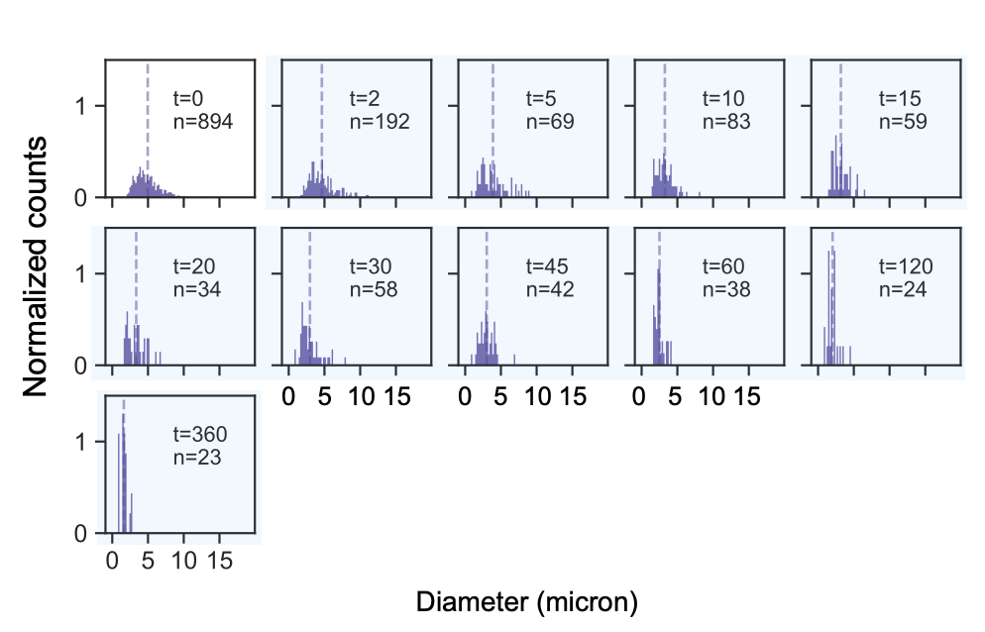
Figure S54: Six arms, three adjacent invaders. Normalized histograms for 6 armed NS = 5 μM, post incubation addition of three adjacent Inv = 5 μM (or 1X NS) each. Histograms are normalized such that the area of each histogram is 1. Cyan shaded histograms correspond to samples taken after addition of invader. Bin width is set to 0.2 μm. Vertical dashed line indicates the mean for each observed time.

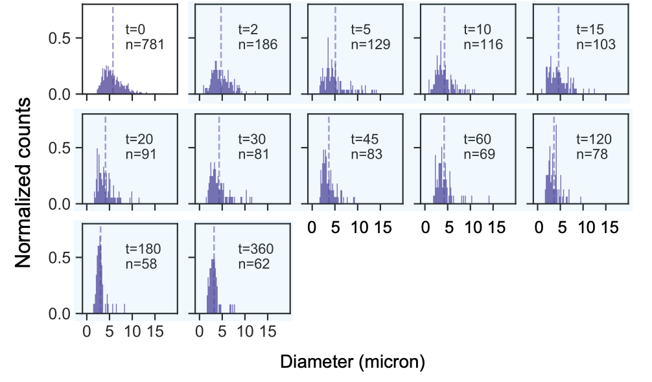
Figure S55: Six arms, three staggered invaders. Normalized histograms for 6 armed NS = 5 μM, post incubation addition of three staggered Inv = 5 μM (or 1X NS) each. Histograms are normalized such that the area of each histogram is 1. Cyan shaded histograms correspond to samples taken after addition of invader. Bin width is set to 0.2 μm. Vertical dashed line indicates the mean for each observed time.

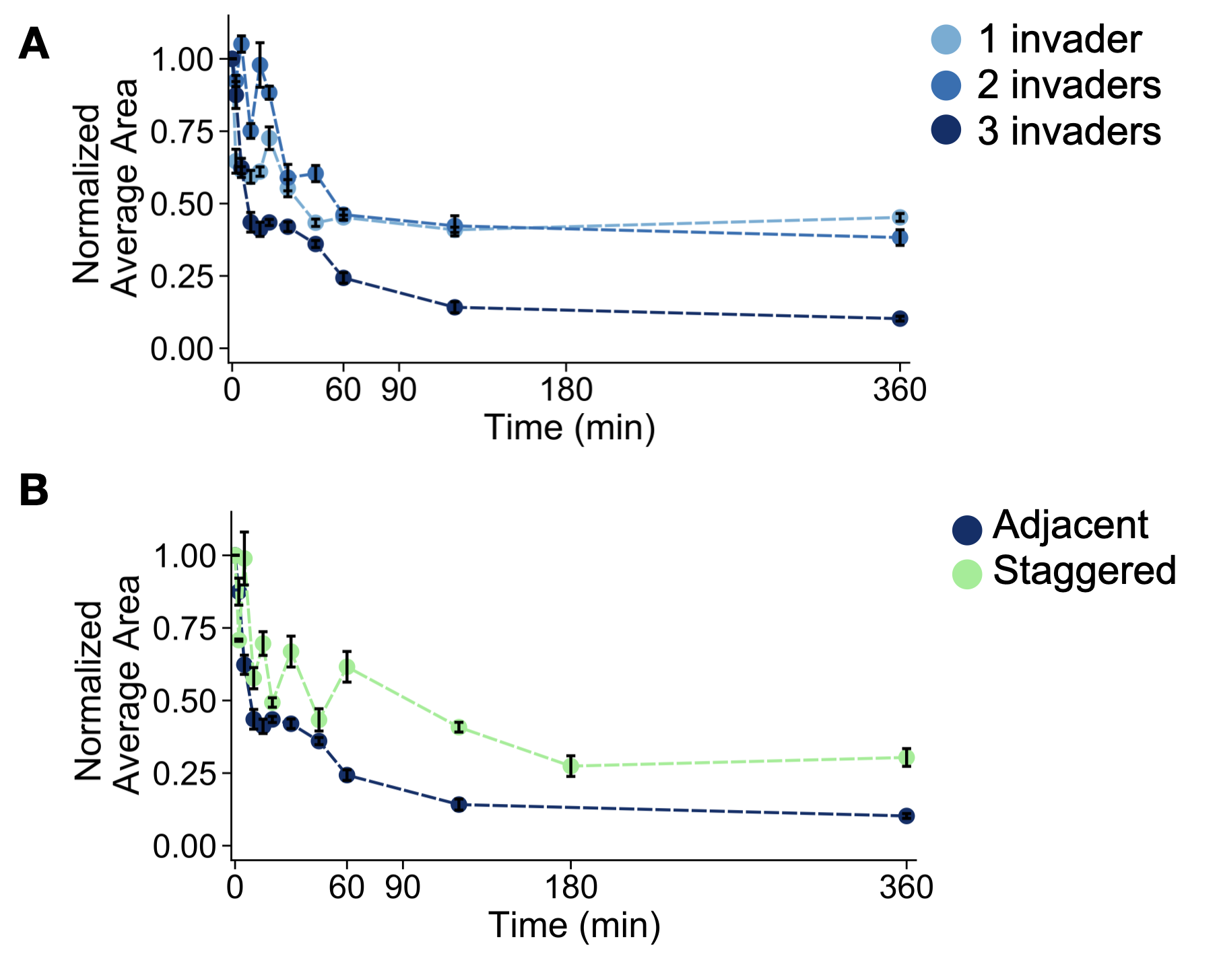
Figure S56: Normalized average area of each condensate following addition of invader strand with 1, 2, or 3 invader stands (A) and with 3 adjacent or 3 staggered invader strands (B) for 6-arm nanostar experiments. The area is normalized such that the initial observation is 1. Error bars are the standard error of the mean derived from bootstrapping data from a single experimental replicate.

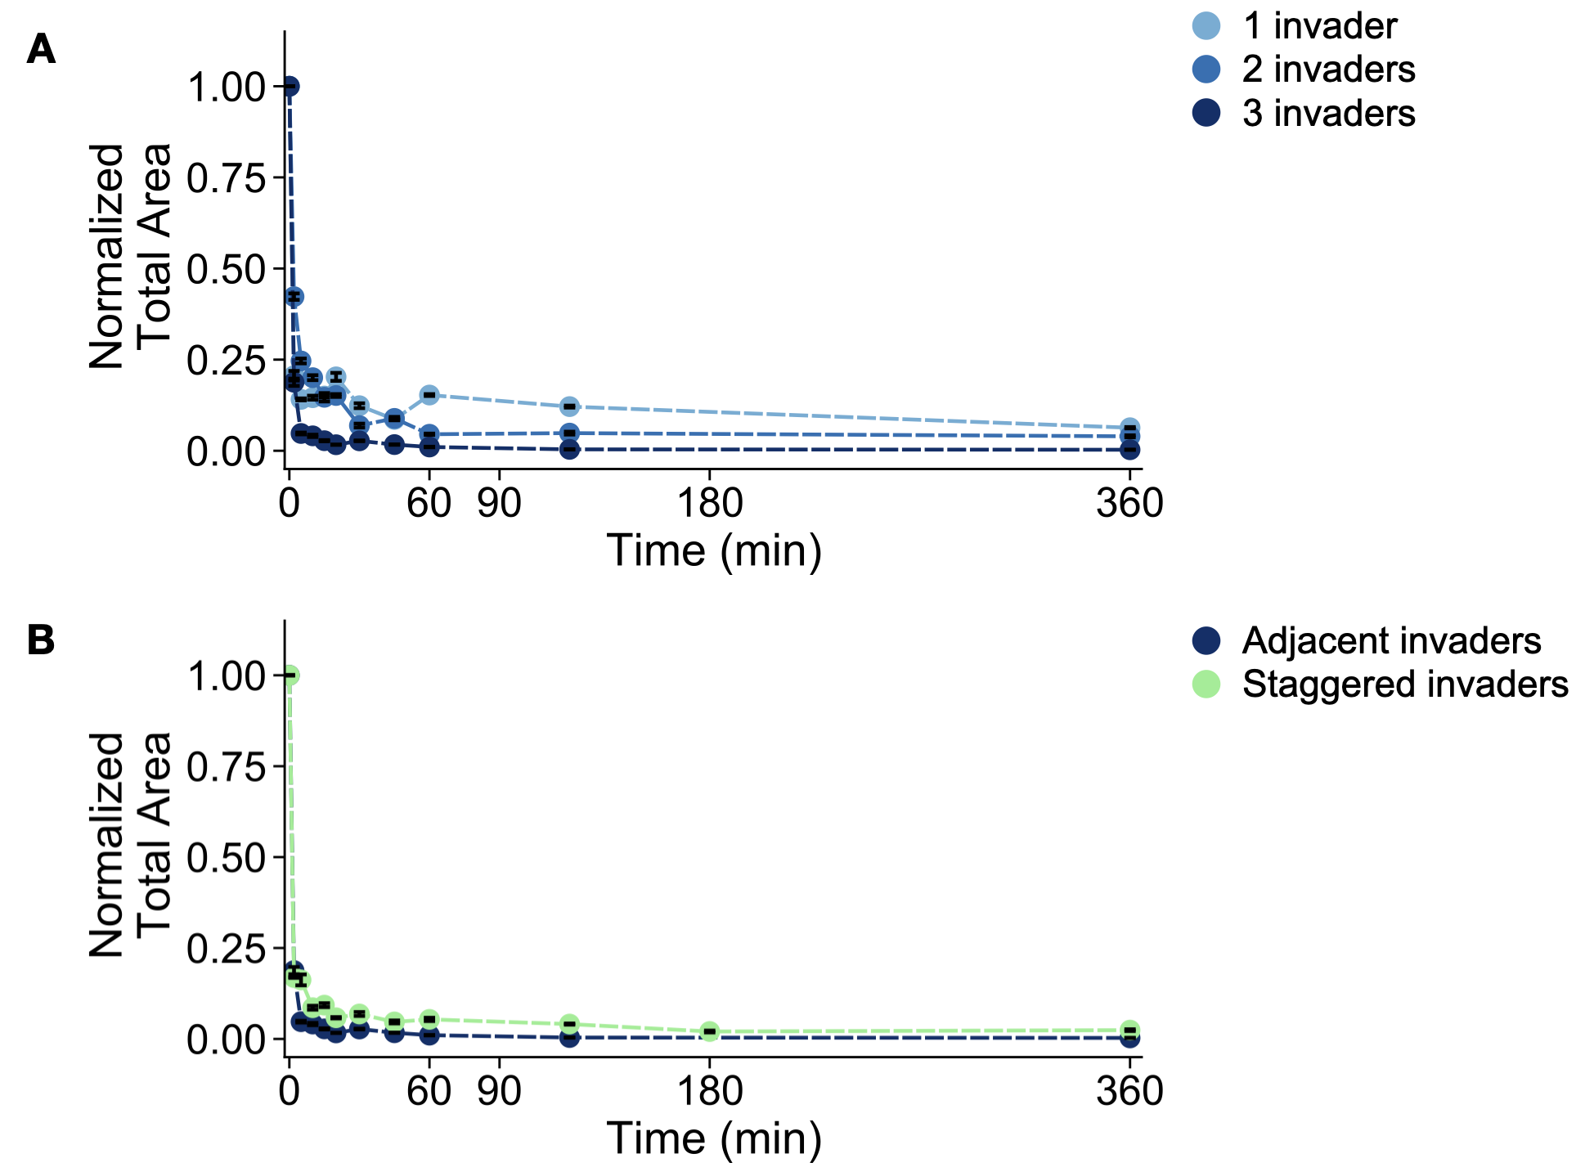
Figure S57: Normalized total area of condensate following addition of invader strand with 1, 2, or 3 invader stands (A) and with 3 adjacent or 3 staggered invader strands (B) for 6-arm nanostar experiments. The area is normalized such that the initial observation is 1. Error bars are the standard error of the mean derived from bootstrapping data from a single experimental replicate.

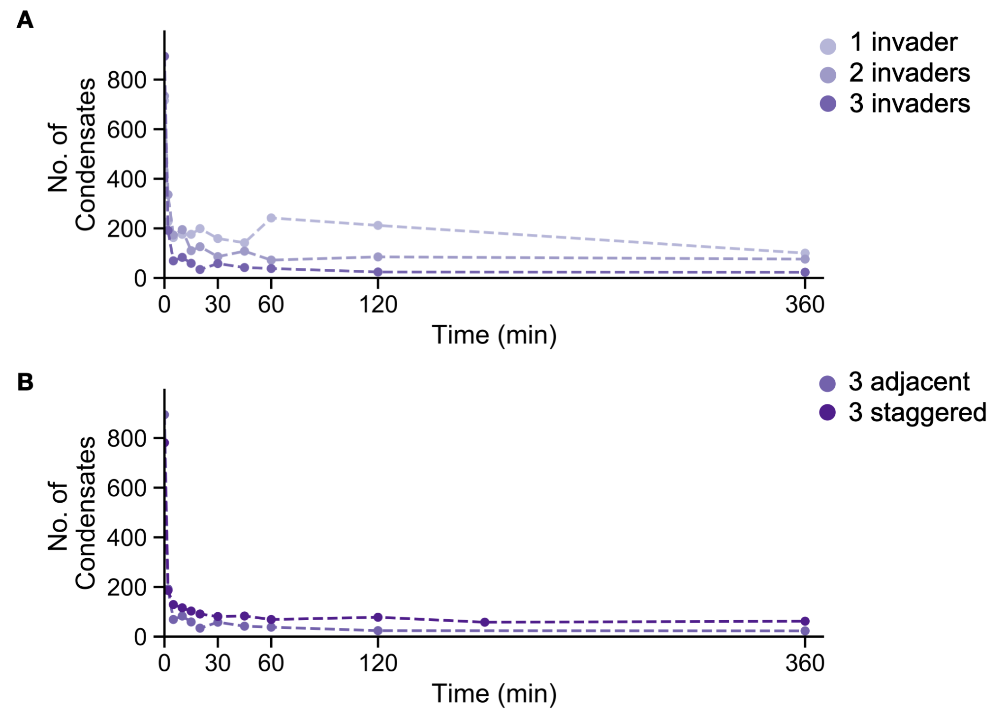
Figure S58: Number of condensate following addition of invader strand with 1, 2, or 3 invader stands (A) and with 3 adjacent or 3 staggered invader strands (B) for 6-arm nanostar experiments.

Example images of six arm nanostars with adjacent and staggered invasion points after 24 hours
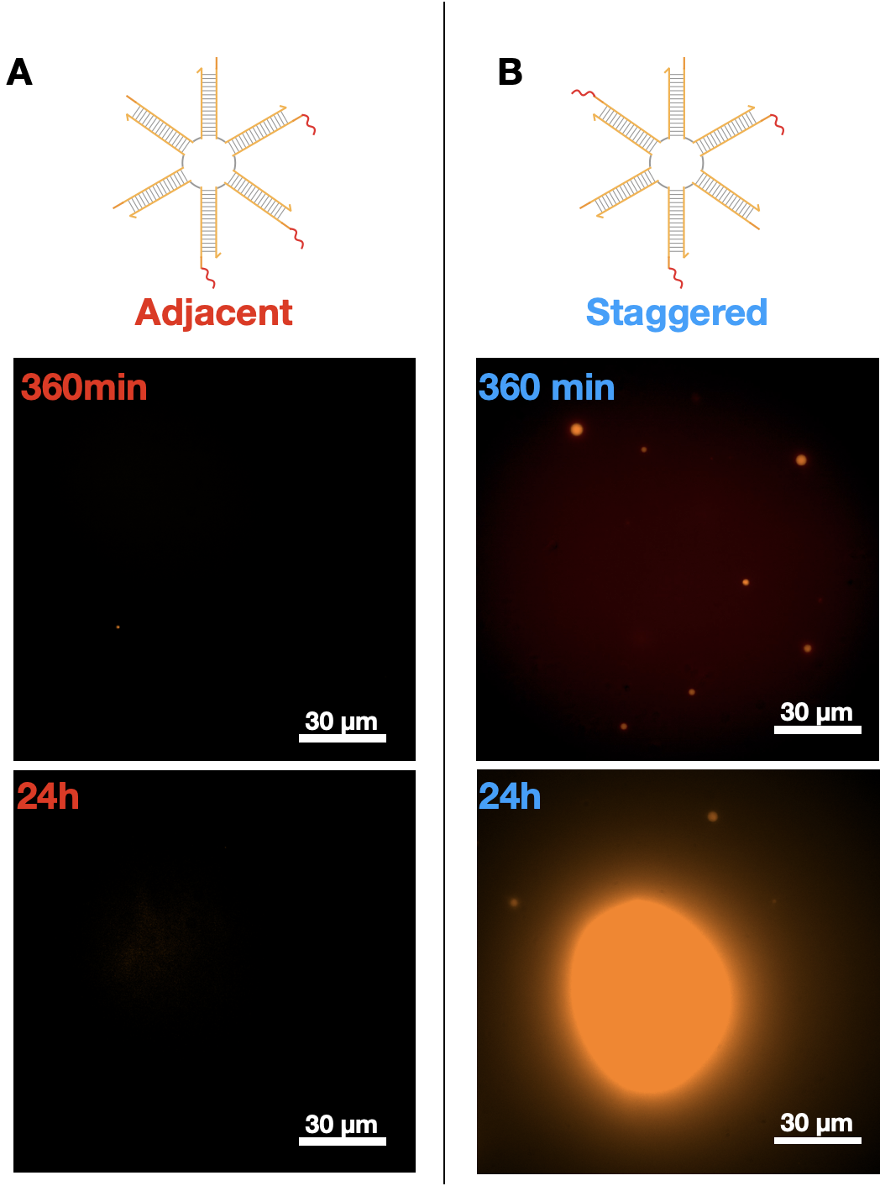
Figure S59: Microscopy images representing the DNA condensates in 3 toehold invader Adjacent and Staggered designs at 360 mins and 24 h after invader addition at room temperature (27° C). [NS] = 5μM, Inv = 5 μM (or 1X NS). Scale bars are 30 μm.

3.10 Orthogonal DNA condensates

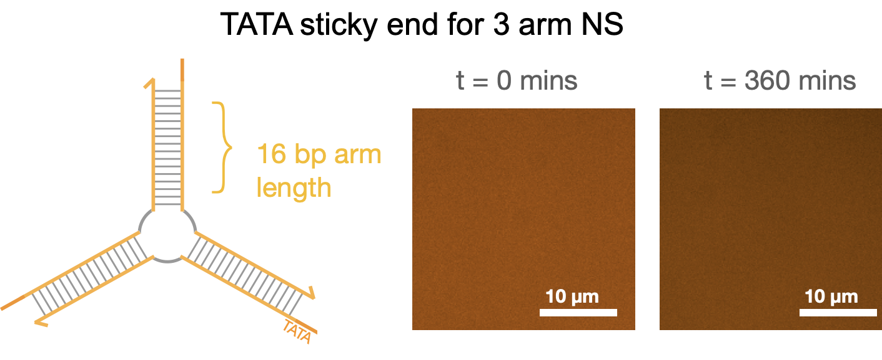
Figure S60: Palindromic 4 nt sticky-ends containing only ‘A’s and ‘T’s do not yield condensates: Nanostars with 16 bp arms and a TATA Sticky end do not form condensates after 6 hours of incubation. Microscopic images represent time after 30 mins of incubation at room temperature (27° C) after anneal process. NS = 5 μM. Scale bars as represented.

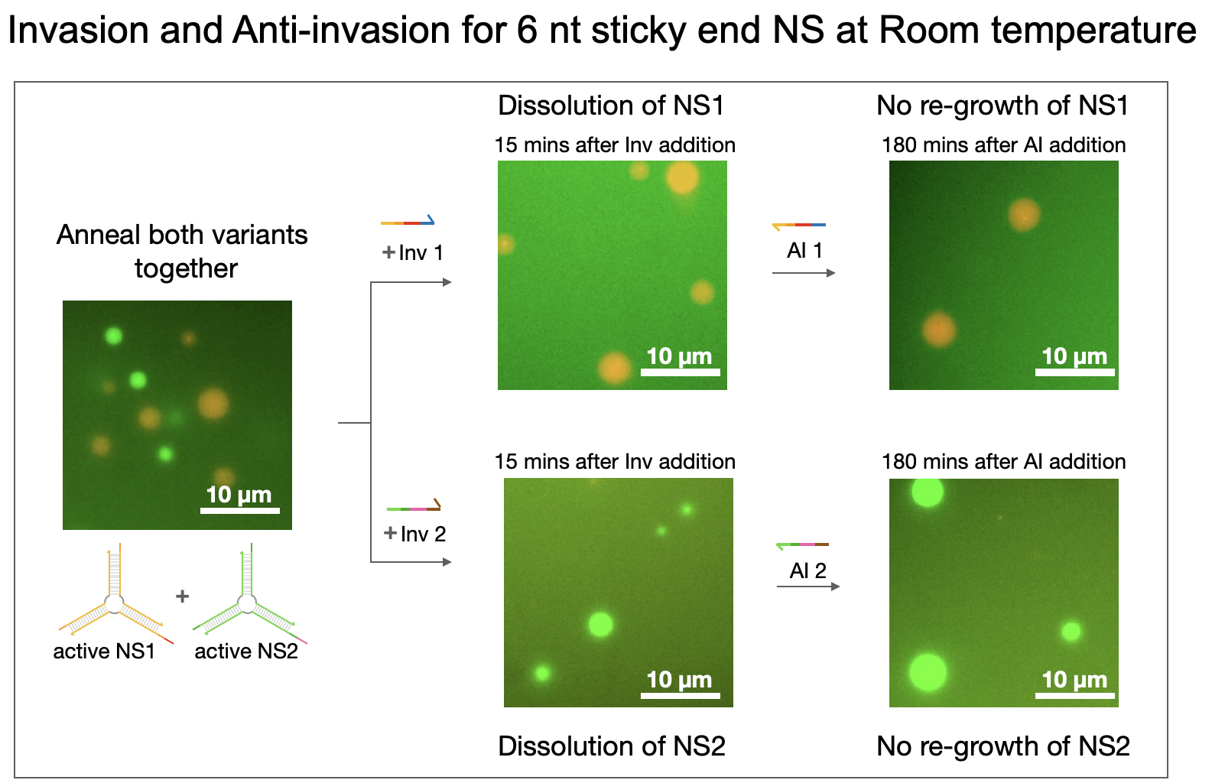
Figure S61: Invasion and Anti-invasion of 6-nt NS at RT (27°C): Orthogonal Nanostars with 16 bp arms and a 6 nt Sticky end can be dissolved after invader addition within 15 minutes but do not regrow even after 3 hours of anti-invader addition. NS = 5 μM. Scale bars as represented.

4. Mathematical models

4.1 Mean Field Theory Model

In this section we introduce the mathematical background behind the construction of the model used in the main text. We start by including the following chemical reaction:
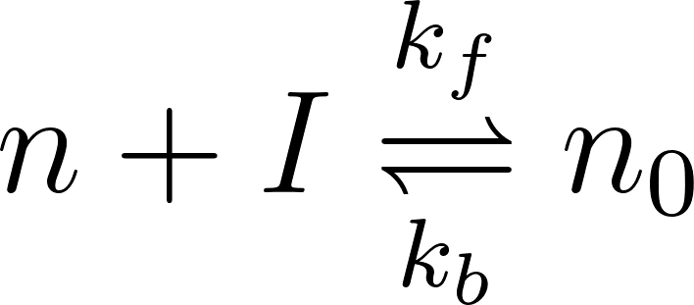
In the minimal model, we don't treat the finite valency of nanostars, instead the invading molecule completely inactivates the phase separating molecule from participating in phase separation. One could imagine suitable modification of the theory to include the effects of valency by using a more general Flory-Huggins theory with multiple phase separating elements, however in the present model we are most interested in expounding upon the most generic behavior.

We introduce a free energy to account for the phase separation aspect of the dynamics. For this purpose, we use the Cahn-Hilliard free energy, which is standard in phase separating systems

.

The first part is the standard Cahn-Hilliard free energy for phase separation. By itself it describes the fact that a system of phase separating subunits can undergo phase separation. We supplement this with an additionally coupling between the active and inactivated subunit with a coupling constant 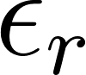. Note these powers are taken to the second power as the first order term would include the effect of a field with initially no inactivated nanostars would spontaneously produce inactivated nanostars recruited from the bulk. The second order nature allows for local density conservation, i.e., if we start with a field with no inactivated subunit, after a short amount of time the subsequent field will also be zero everywhere (in the absence of chemical reactions). However, it is seen that none of the properties we are interested in depend critically on this parameter, it merely accounts for the fact that there is an effective repulsive interaction due to steric effects between the inactive and active subunit.

The dynamics of this model is uses hybrid model AB dynamics:(Hohenberg and Halperin 1977)

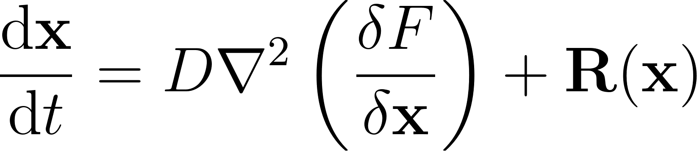

we make the assumption that the diffusion constant  for all the molecules in the material is the same, for simplicity. The term  arises from the mass action kinetics corresponding to chemical reactions of inhibition and activation presented in the main text. As this term does not arise from the free energy, the model described is inherently non-equilibrium, as it assumes that the inhibition and activation reactions proceed at some rate rather than defining the energies of the inhibited and activated molecules. We do not expect this to matter for the phenomena we seek to address, as we are not interested in the equilibrium behavior but the response of a non-equilibrated steady state to the introduction of additional chemical elements. Additionally, we are working in the regime where the reactions are essentially irreversible.

Computational Integration

Our mean field equations are solved in Fourier space with periodic boundary conditions using a semi-implicit scheme with in-house C++ code apart from the fast fourier transforms, which are performed using the FFTW library. Analysis of the areas was performed in Wolfram mathematica.

Effective parameters underpinning Chemical Dissolution

The models we have described are non-equilibrium, therefore in order to analyze the static properties of these systems, we shall proceed by analyzing whether the homogeneous state is stable to small perturbations. The homogeneous state arises from considering the fixed points in the chemical dynamics. Around this state we apply a wavelength dependent perturbation:
for a small perturbation 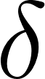 around the homogeneous value 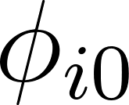 . By studying how the growth rate  is different for different wave vectors  we can answer (to first order) whether the homogeneous state is stable. By looking at the system for different parameters, therefore, we can generate a "phase diagram" of the system under chemical attack.

Furthermore, we can study the dynamical properties of the system by numerically solving the equations outright, however, prior to doing this it is worth reasoning over the possible dynamics we might expect to arise from chemical disruption

There are two different dynamical factors to consider for droplets in this case, growth and decay. It is easy to see that the nature of the growth process is not affected by the attacking chemical, i.e., we should expect the same kinds of coarsening dynamics of droplets to occur whether there is chemical invader or not, as if we introduce chemical invader which is not sufficient to homogenize the system, it will merely inactivate a certain proportion of the nanostars, leaving the rest intact. One could then consider the subsystem containing only the active nanostars, which would then be identical to the coarsening dynamics of the same system without invader, under the caveat that there will be a small additional effect due to steric repulsion.

On the other hand, the process by which droplets decay away has the potential for novel phenomena. In contrast to the standard process of evaporation, which occurs from the surface, the case with an invasive species could have qualitatively different behavior depending on how much the invading species can penetrate into the droplet before it inactivates it. This is something which is qualitatively different dynamically to the ordinary process of raising the temperature.

Doing dimensional analysis with this in mind, we wish to consider two different time scales. One timescale is the diffusion time for an invader inside the droplet:

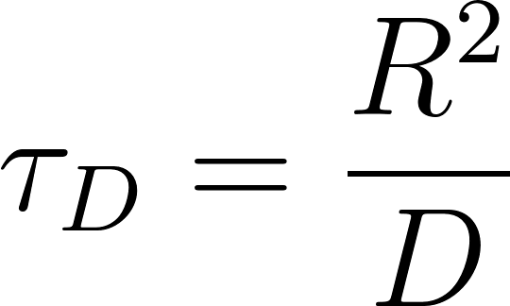

where  is the effective droplet size and  is the diffusion constant of the invader inside the droplet. This is the only way we can obtain a timescale from a length and a diffusion constant which has dimensions 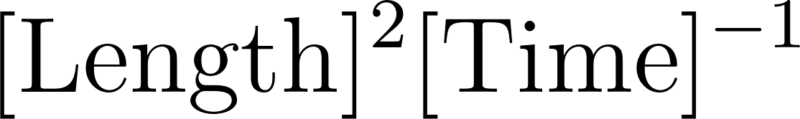 This parameter roughly characterizes how long it would take for the invader to diffuse a distance in the droplet. To supplement this we need to consider how quickly the invading reactions occur. We characterize that with the following timescale:

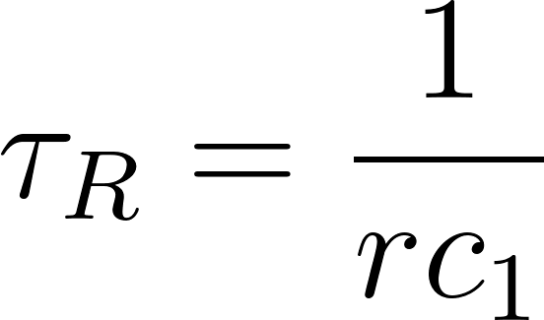

where $r$ is the rate of reaction of conversion from a phase separating species and inactivating species into an inactivated complex, which would have the following equation in mass action kinetics:

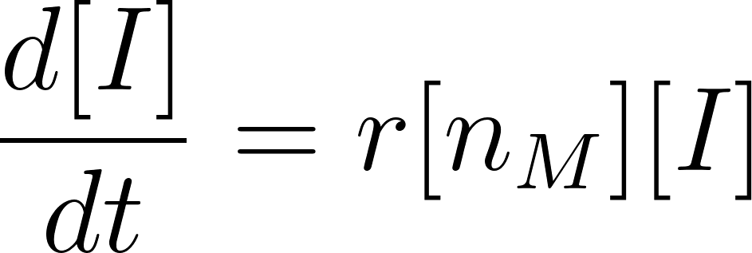

from which we can see that the dimensions of the rate are given by 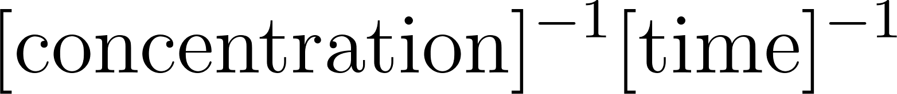. The concentration used in the time scale is the concentration of the phase separating material in the droplet 

We postulate that the effective qualitative differences in evaporation scenarios arise from the dimensionless parameter:

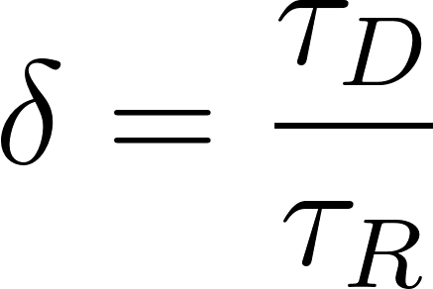

From which we can identify different regimes as a function of this parameter. For instance if 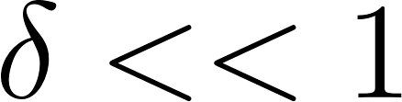 then the diffusion time is much shorter than the reaction time, and we would expect that the inactivator principally acts at the surface of the droplet. By contrast, if 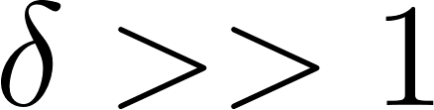 the invader can diffuse freely through the droplet before it has even had time to react and we might therefore expect that the subsequent dynamics depend more on the volume of the droplet. In full this parameter is given by:

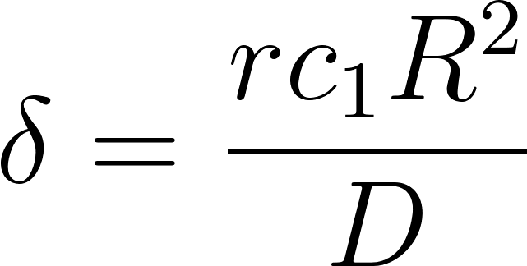

In a simulation 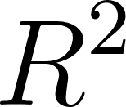 is a result, not something we can tune. However all the other parameters we control.

If equilibria depends on 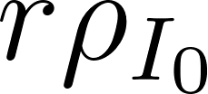 then we can tune dynamical response by keeping this factor fixed while we change . In actuality, our system has a natural length scale , given by the surface tension, leading to:
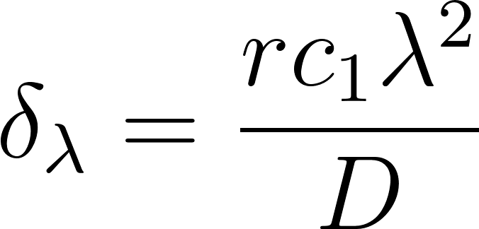

Non-dimensionalizing the model equations directly leads to the appearance of parameter 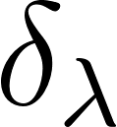 (not shown)

Depending on the regime in which the system is in, the timescales 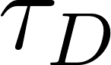 and 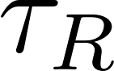 tell us how quickly they should proceed. So while rescaling both by a factor  should lead both unchanged, leading to a similar type of dynamical evolution, the process itself should be sped up by a factor a.

4.2 Impact of Reverse Rate Reactions on Theoretical Phase Diagrams

The results in the main text consist of the reactions:
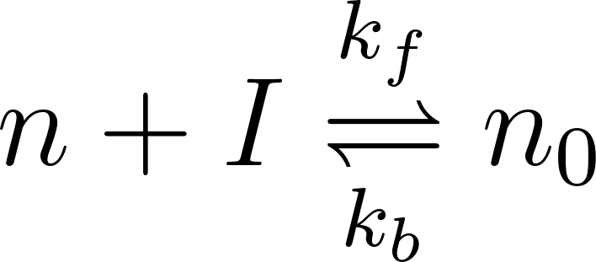
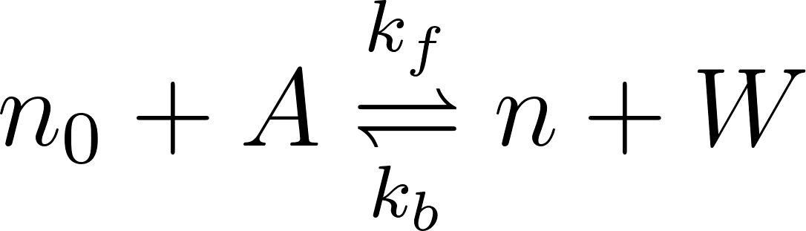
but with the backwards rate set to zero. The primary reason the analysis was performed in this regime was that we wanted to observe the “bare” effect associated with chemical dissolution, and not convolute it with additional factors corresponding to reverse rates (which should promote growth of droplets when the inhibition reaction is reversed, and vice versa for the activation reaction.

In this section we present supplementary figure S62, which illustrates the effect on the phase diagram of considering reverse rates in our system:
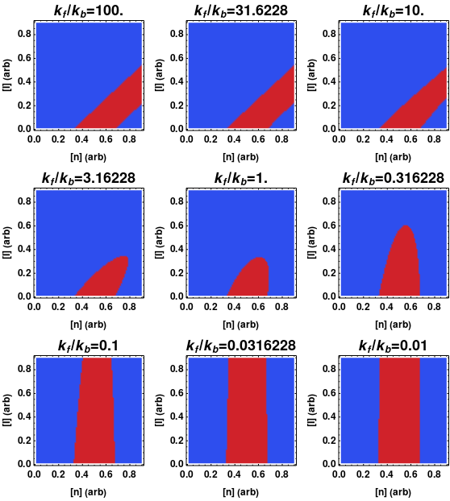
Figure S62: Phase diagrams for inhibition when we allow a reverse reaction of inactivated nanostar spontaneously turning back into active nanostar + inhibitor. In all plots, we show the region where the system undergoes phase separation in red, and where the homogeneous state is the most stable in blue. The diagrams are plotted against concentration of nanostar [n] and the concentration of inhibitor [I] with the choice of dilute and dense concentrations for the nanostar as 0.2 and 0.8, respectively. It can be seen that modification of the relative magnitudes of the rates leads to rather different phase diagrams in [n]-[I] space.

These results are presented in Supplementary Figure XX. We can observe that a change in the relative reaction rates leads to an interpolation between two limiting behaviors, which is a stripe of phase separation justified to the right, and a stripe of phase separation going straight upwards (as a function of [I]). Both of these cases can be readily understood physically. The former arises from the fact that in the absence of invader, the system undergoes phase separation within some region of concentrations 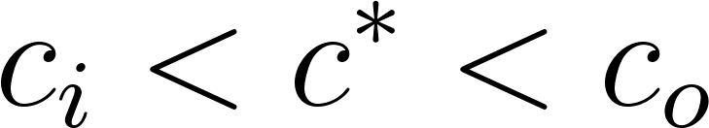, and, to first order, when we add inhibitor we merely deactivate a proportion of the nanostars (forever in the case of an irreversible reaction), such that the new condition would appear as 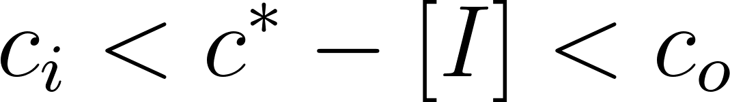 depending on the stoichiometry of the invasion. This would lead to the stripe of the phase diagram heading to the right. The latter case, where the reverse rate is very large, is also simply understood from the idea that if the reverse rate is infinite, there is no inhibitor effect. The preceding discussion ignores realities such as steric repulsion and additional interactions between the participating elements, however, we do not expect that the qualitative behavior should change greatly as a function of this.

The regimes in between these two consist in what appears to be an interpolation between these two limits. Interestingly, in the case that the rates are comparable to one another, we obtain a phase diagram that strongly resembles liquid-liquid phase separation with concentration on the x-axis and temperature T on the y-axis. This is suggestive that similar control over droplets that can be obtained via temperature could be obtained through the action of inhibitive chemical dynamics, but without changing temperature itself (which is a very all encompassing control parameter).

4.3 Other Features

As a counterpart to figure 1. of the main text, we show the different modes of dissolution (volume driven or surface driven) in supplementary figure SX
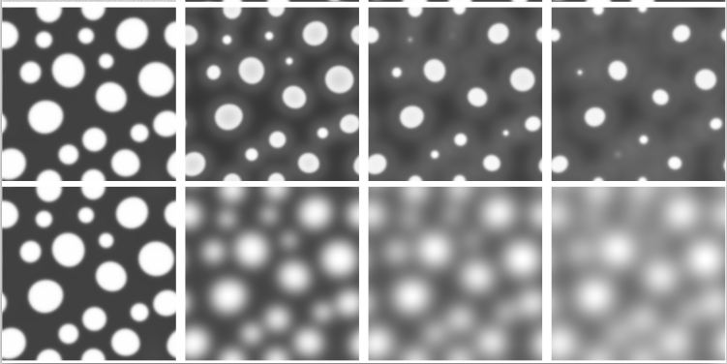
Figure S63 Different mechanisms of dissolution for droplets, as one changes the diffusion constant of the invader, the droplets will either slowly decay from their surface, or the deactivation process occurs throughout the volume of the droplet. In the former case, we observe the droplets becoming smaller in size, but retaining their shape. In the latter, we observe a “smearing” of the droplets.

5. References
McKinney, Wes. 2010. “Data Structures for Statistical Computing in Python.” In Proceedings of the 9th Python in Science Conference. SciPy. https://doi.org/10.25080/majora-92bf1922-00a.
Reback, Jeff, jbrockmendel, Wes McKinney, Joris Van den Bossche, Tom Augspurger, Phillip Cloud, Simon Hawkins, et al. 2021. Pandas-Dev/pandas: Pandas 1.3.5. Zenodo. https://doi.org/10.5281/ZENODO.3509134.
Walt, Stéfan van der, Johannes L. Schönberger, Juan Nunez-Iglesias, François Boulogne, Joshua D. Warner, Neil Yager, Emmanuelle Gouillart, Tony Yu, and scikit-image contributors. 2014. “Scikit-Image: Image Processing in Python.” PeerJ 2 (June): e453.

