Supporting Information

Natural polymer nanocapsules containing eugenol for nectarine coating to control brown rot caused by Monilinia fructicola

Joslaine Jacumazo^{a & b}, Gabriela Pereira Parchenª, Meira Janete Ballesteros Garcia^{b & c}, Nayana Cristina Silva Santos^{b}, Louise Larissa May De Mio^{c}, Francisco de Assis Marques^{b} & Rilton Alves de Freitas^{*a}

ªBIOPOL. Chemistry Department. Universidade Federal do Paraná (UFPR). R. Coronel F. H. dos Santos. Curitiba 210–81531-980. PR. Brazil
^{b}LECOSIN. Chemistry Department. Universidade Federal do Paraná (UFPR). R. Coronel F. H. dos Santos. Curitiba 210–81531-980. PR. Brazil
^{c}LEMID. Crop Protection Department, Universidade Federal do Paraná (UFPR), R. dos Funcionários, Curitiba 1540–80035-050, PR, Brasil

E-mail: joslainejacumazo@ufpr.br, gabrielaparchen@ufpr.br, meira.ballesteros@ufpr.br, nayanacristina@ufpr.br, maydemio@ufpr.br, tic@ufpr.br

∗Corresponding author
E-mail address: rilton@ufpr.br (R.A. DE FREITAS).
Number phone: +55-41-33613260
Thermogravimetric analysis
The determination of mass loss (%) in the function of the temperature was performed by thermogravimetric analysis (TGA). The thermogravimetric curves of eugenol, a mixture of chitosan-carboxymethylcellulose, and the Ne-LbL₁₋₂ NCs are presented in Fig. S1 and Table S1.
For eugenol, a volatilization phase was observed with loss of mass (97.4%) between 60 and 260 °C (T_{p}: 170 °C), with the typical slightly below that reported in the literature (T_{p}: 195 °C)¹ indicating that it is a compound that cannot be processed at high temperatures. The mass losses of the chitosan-carboxymethylcellulose mixture and the Ne-LbL₁₋₂ NCs below 100 °C were 15.0% and 8.0%, respectively, due to the vaporization of the residual moisture present in the samples. The second stage of mass loss for the chitosan-carboxymethylcellulose mixture (44.5%) occurred between 97 and 264 ºC (T_{p}: 208 ºC) and can be attributed to depolymerization and decomposition of the glucosamine unit of chitosan.

Fig. S1 – TGA thermograms of eugenol, chitosan-carboxymethylcellulose mixture and the Ne-LbL₁₋₂ NCs under nitrogen atmosphere.

Table S1 – Thermal parameters of the obtained eugenol, chitosan+carboxymethylcellulose mixture and NCs containing eugenol from thermogravimetric analysis in a nitrogen atmosphere
 | First stage |  |  |  | Second stage |  |  |  | Third stage |  |  |  | Fourth stage
 | T_{p}  (ºC) | T_{i}  (ºC) | T_{f}  (ºC) | mass (%) | T_{p}  (ºC) | T_{i}  (ºC) | T_{f}  (ºC) | mass (%) | T_{p}  (ºC) | T_{i}  (ºC) | T_{f}  (ºC) | mass (%) | T_{p}  (ºC) | T_{i}  (ºC) | T_{f}  (ºC) | mass (%)
Eugenol | 170 | 60 | 260 | 97.4 | - | - | - | - | - | - | - | - | - | - | - | -
Chitosan+carboxymethylcellulose mixture | 45 | 25 | 90 | 15.0 | 208 | 97 | 264 | 44.5 | 350 | 303 | 380 | 19.8 | 480 | 370 | 600 | 18.0
Ne-LbL₁ NCs | 60 | 45 | 83 | 8.0 | 145 | 100 | 180 | 10.5 | 230 | 180 | 325 | 68.8 | 345 | 325 | 380 | 11.0
Ne-LbL₂ NCs | 75 | 45 | 95 | 8.0 | 150 | 118 | 170 | 9.4 | 228 | 176 | 304 | 55.4 | 345 | 325 | 380 | 25.0
T_{i} - initial temperature
T_{f} - final temperature
T_{p} - peak temperature

The third stage between 303 to 380 ºC (T_{p}: 350 ºC) with a mass loss of 19.8% may be related to the decomposition of the hydroxyl group of carboxymethylcellulose.² In the case of Ne-LbL₁₋₂ NCs, the mass loss of approximately 10.0% between 100-180 ºC (T_{p}: 145 ºC) may be due to the presence of eugenol on the surface of the NCs, as it has not been encapsulated or has been released from inside the NCs. In the next stage, the loss of mass (68.8%) in the range between 180 and 325 ºC (T_{p}: 230 ºC) can be attributed to the thermal decomposition of the structure of chitosan, carboxymethylcellulose, and encapsulated eugenol³ as observed by Hu, Zhang, Xiao, & Wang (2018)⁴ when assigning the range of mass loss between 160 to 460 ºC for the thermal decomposition of chitosan and encapsulated aromatic compounds. Finally, the fourth stage between 325-600 ºC may be related to the decomposition of both polymers.^{2,5}

Antioxidant activity

The DPPH radical tests followed the methodology described by Thaipong, Boonprakob, Crosby, Cisneros-Zevallos & Byrne (2006),⁶ with some modifications. The DPPH radical (24 mg) was solubilized in ethyl alcohol (100 mL), kept under refrigeration, and protected from light. The stock solution was diluted in ethyl alcohol (1:4.5 V V⁻¹) for absorbance of 1.04 ± 0.03 a.u. in the wavelength of 515 nm. The reactions of the samples with the DPPH radical (in the dark) were monitored at times of 0, 10, 20, 30 min, 1 h, 2 h, 4 h, and 24 h. The scan was carried out from 600 to 450 nm, with maximum absorption at 515 nm. The concentration of the samples containing eugenol was fixed at 140 µg mL⁻¹. The negative control used was ultrapure water and the positive control was vitamin C solution (176.1 µg mL⁻¹). The results were expressed as a percentage of antioxidant activity (AA_{t}%), as a function of time, following Equation S1.

${AA}_{t}\text{\%=}\left(\frac{{\text{A}}_{\text{0}}-A_{t}}{{\text{A}}_{\text{0}}}\right)\text{100}$ (Eq. S1)
where A₀ is the absorbance value of the DPPH solution and A_{t} is the absorbance value of the DPPH solution in the presence of samples at time t.

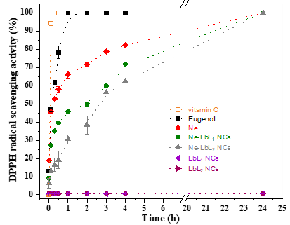
Fig. S2 – (A) DPPH• inhibition at different times for vitamin C (-□-), free eugenol (-■-), Ne (-♦-), Ne-LbL₁ (-●-), Ne-LbL₂ (-▲-) and NCs in the absence of eugenol LbL₁ (-◄-) and LbL₂ (-►-).

Fig. S2 presents the results of the antioxidant activity of the eugenol in overtime about DPPH. It is possible to observe that the inhibition of the radical by eugenol increases overtime regardless of the sample analyzed. For free eugenol, 100% inhibition of DPPH occurs within 1 h. The remaining samples reach 100% inhibition after 24 h. The Ne presents faster inhibition when compared to Ne-LbL₁ and Ne-LbL₂ NCs. Thus, it can be inferred that the polymer layers on the Ne reduced the eugenol diffusibility, making its release and, consequently, DPPH inhibition, slower. These results corroborate the in vitro release. Regarding NCs in the absence of eugenol (LbL₁ and LbL₂ NCs), considerable DPPH inhibition activities were not observed. Similar effects were observed by Das et al. (2019) and Shao et al. (2018) with chitosan nanoparticles.^{1,7}

Macroscopic appearance of the surface of nectarines
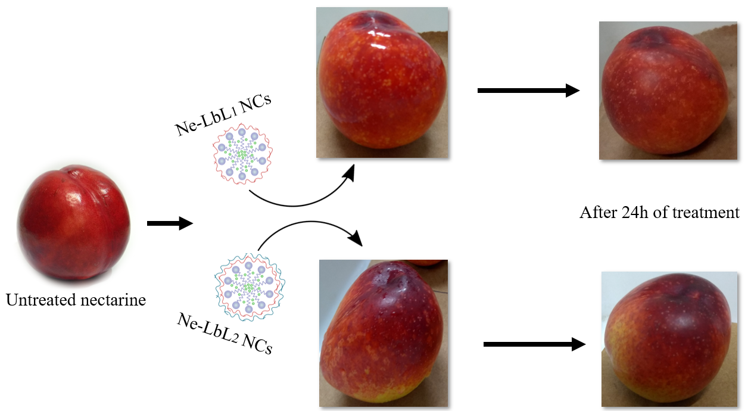
Fig. S3 – Macroscopic aspect of treatments (Ne-LbL₁₋₂ NCs) performed on nectarines, 0 h, and 24 h after treatment.

Values referring to the OWRK model

Table S2 – Total surface tension (𝛾^{total}), dispersive (𝛾^{D}) and polar (𝛾^{P}) components values for water, formamide and diiodomethane liquids. Values referring to the OWRK model.
Liquids | 𝛾^{total} / mN m⁻¹ | 𝛾^{D} / mN m⁻¹ | 𝛾^{P} / mN m⁻¹
Water | 72.1 | 19.9 | 52.2
Formamide | 56.9 | 23.5 | 33.4
Diiodomethane | 50 | 47.4 | 2.6
Source: SCA20 software database.

- Aqueous solution of eugenol
Day 1  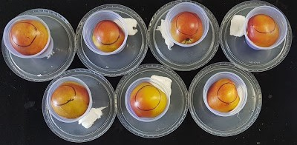 | Day 2  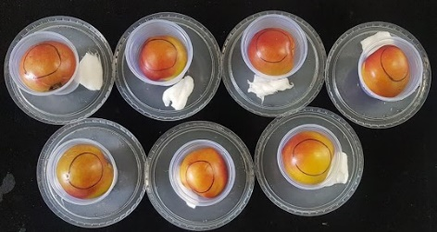 | Day 3  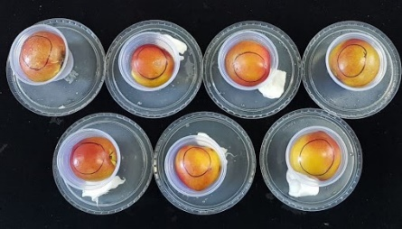 | Day 4  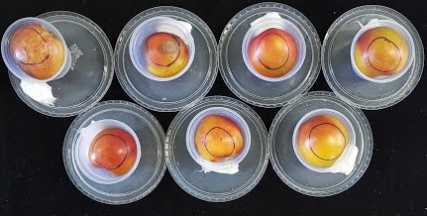
Day 5  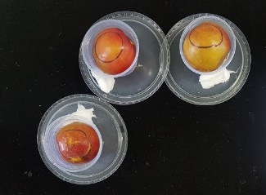 | Day 6  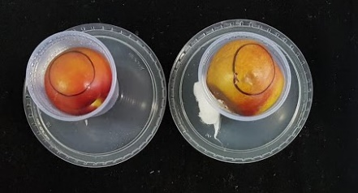 | Day 7

Day 1  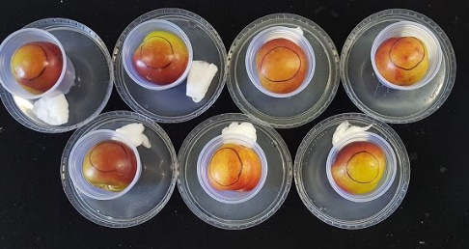 | Day 2  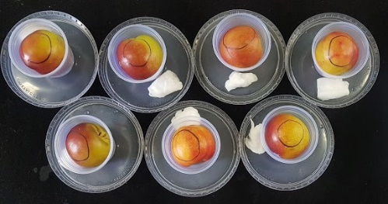 | Day 3  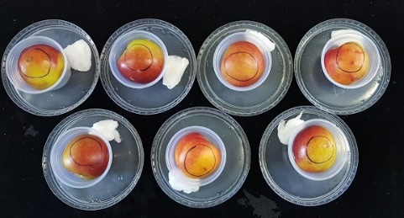 | Day 4  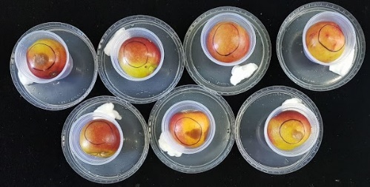
Day 5  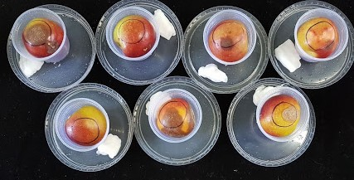 | Day 6  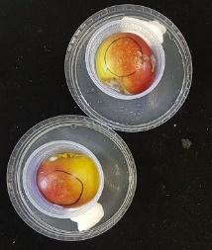 | Day 7

- Iprodione fungicide
Day 1  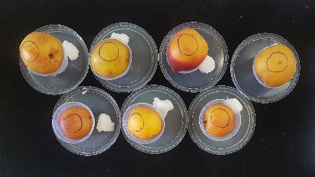 | Day 2  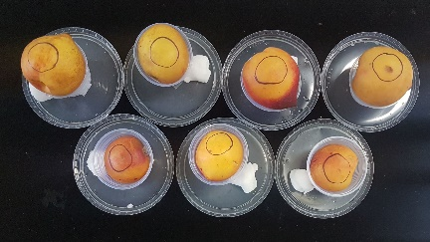 | Day 3  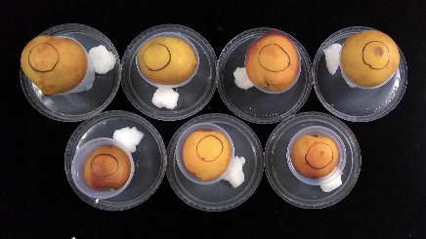 | Day 4  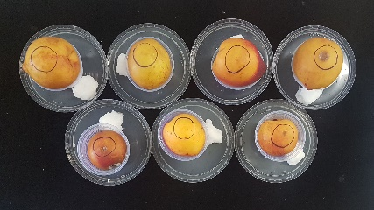
Day 5  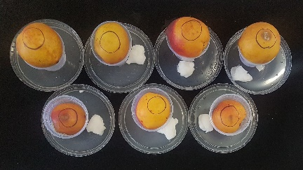 | Day 6  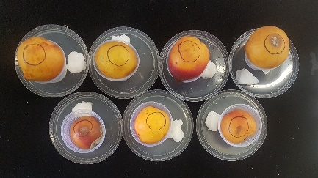 | Day 7  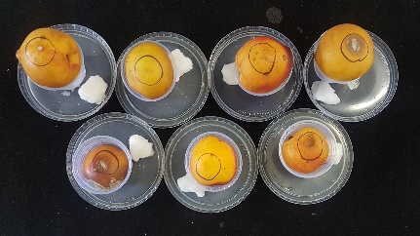

Day 1  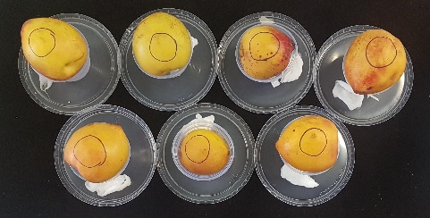 | Day 2  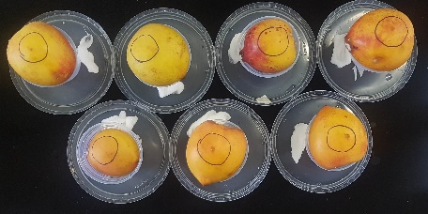 | Day 3  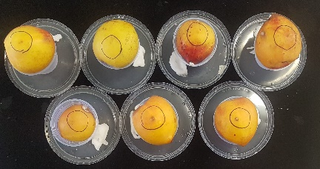 | Day 4  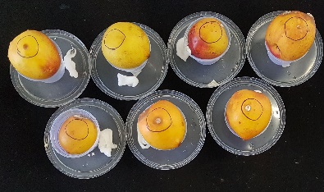
Day 5  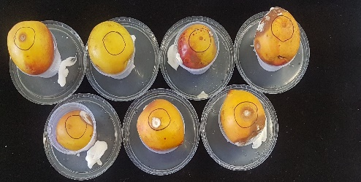 | Day 6  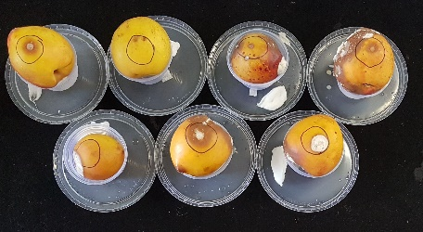 | Day 7  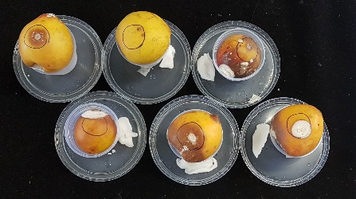

- Control
Day 1  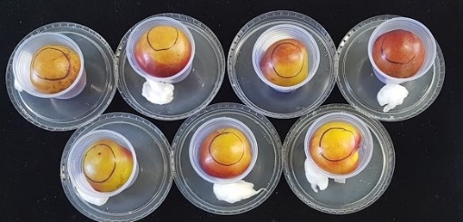 | Day 2  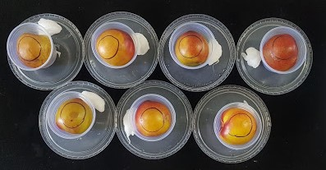 | Day 3  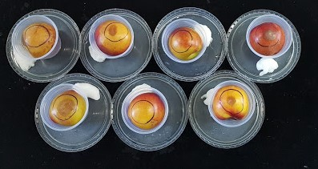 | Day 4  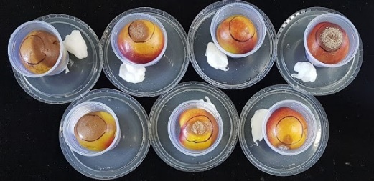
Day 5 | Day 6 | Day 7

Day 1  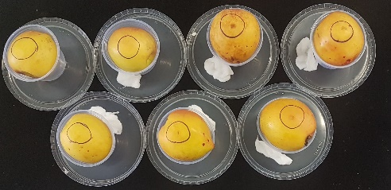 | Day 2  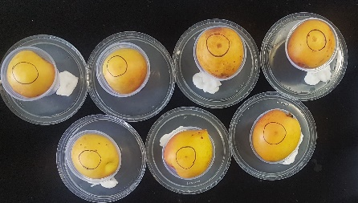 | Day 3  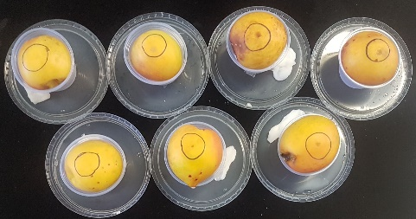 | Day 4  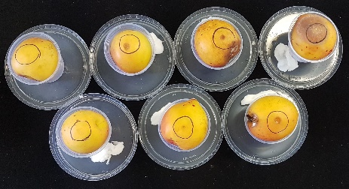
Day 5  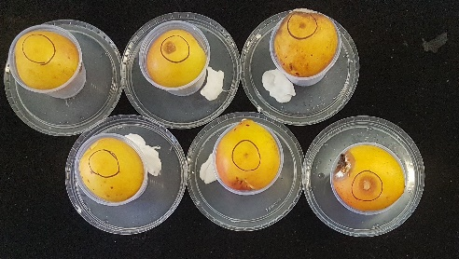 | Day 6  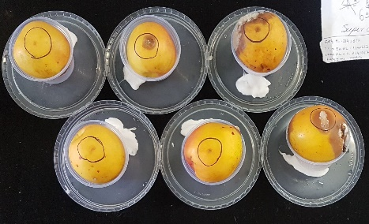 | Day 7  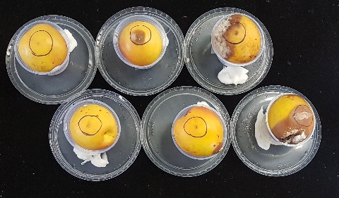

- NCs without eugenol
Day 1  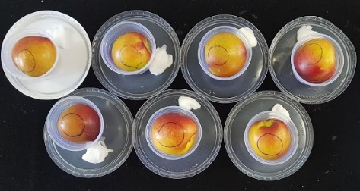 | Day 2  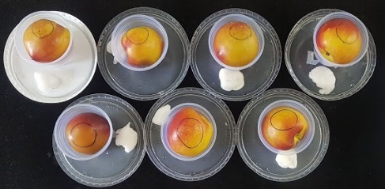 | Day 3  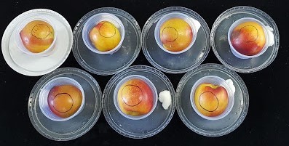 | Day 4  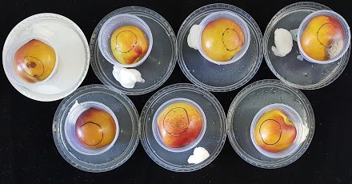
Day 5  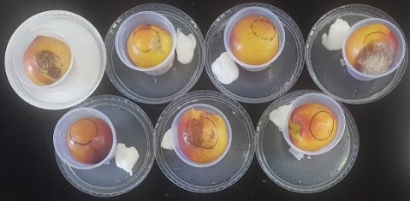 | Day 6 | Day 7

Day 1  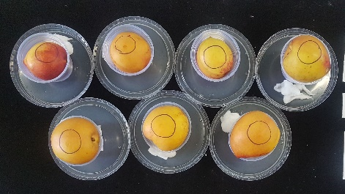 | Day 2  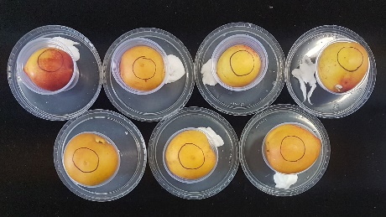 | Day 3  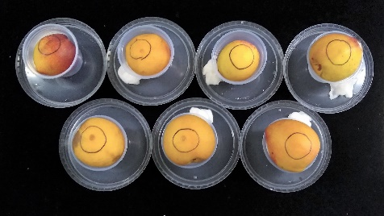 | Day 4  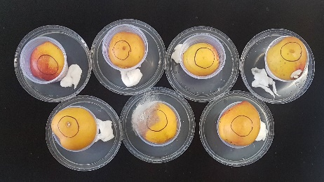
Day 5  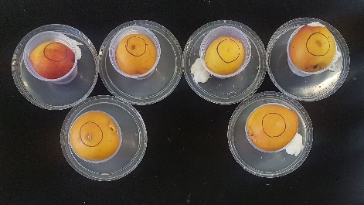 | Day 6  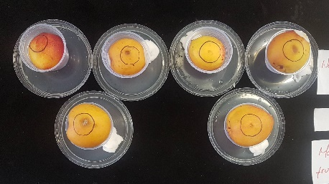 | Day 7  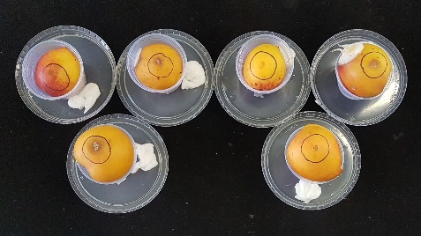

- Ne-LbL₁ NCs
Day 1  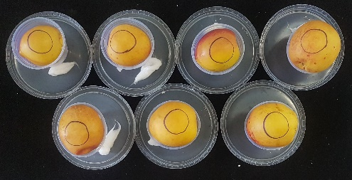 | Day 2  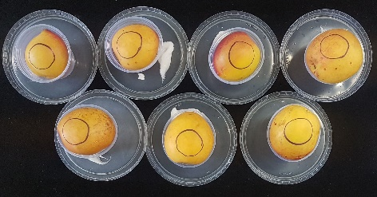 | Day 3  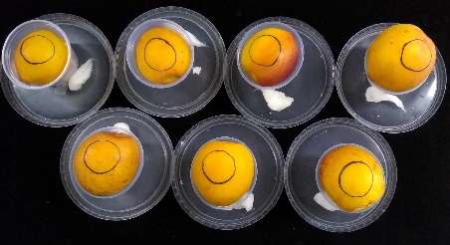 | Day 4  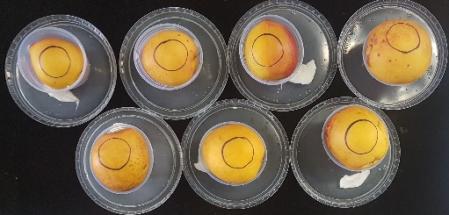
Day 5  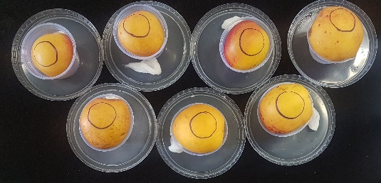 | Day 6  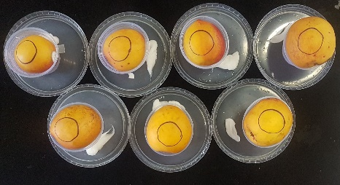 | Day 7  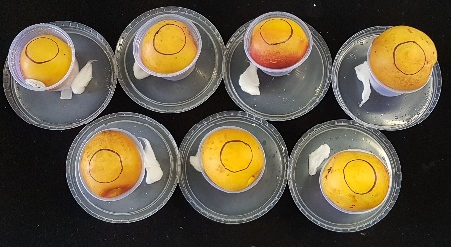

Day 1  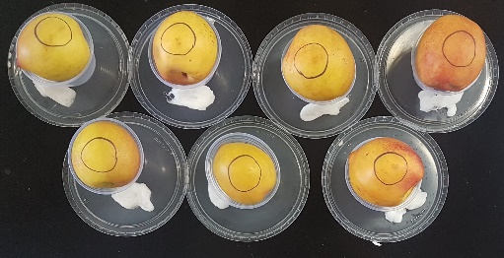 | Day 2  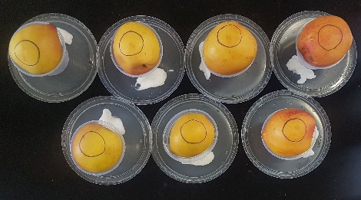 | Day 3  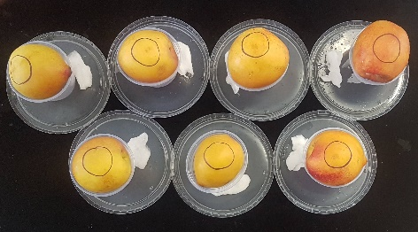 | Day 4  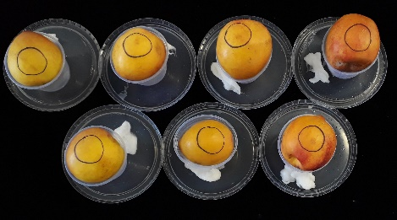
Day 5  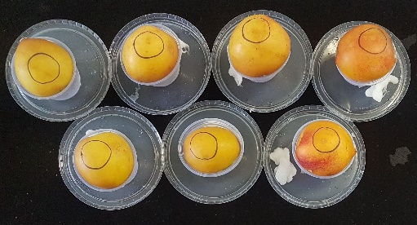 | Day 6  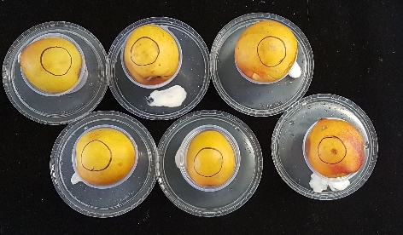 | Day 7  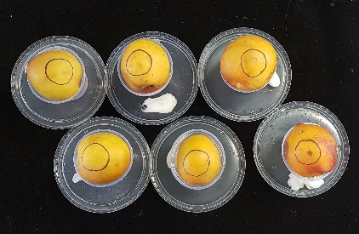

- Ne-LbL₂ NCs
Day 1  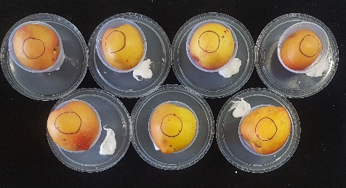 | Day 2  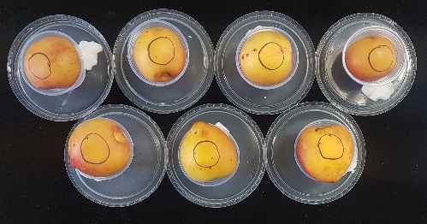 | Day 3  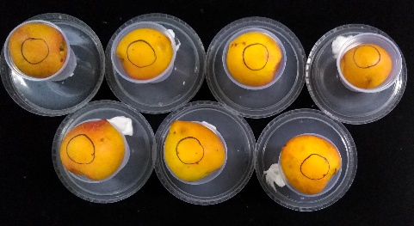 | Day 4  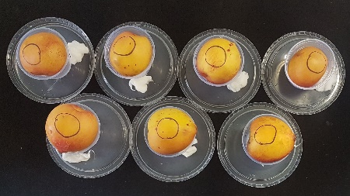
Day 5  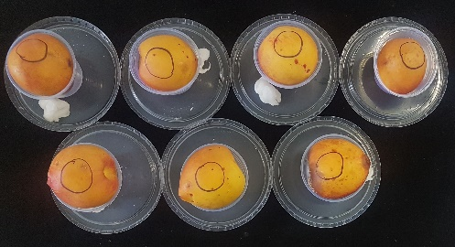 | Day 6  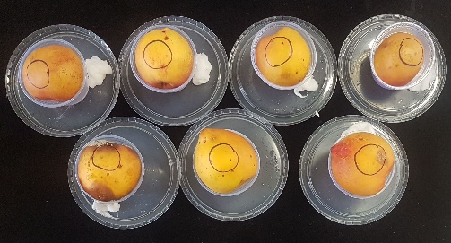 | Day 7  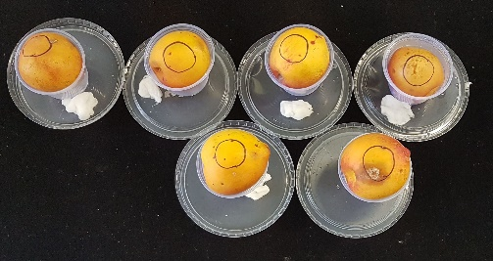

Day 1  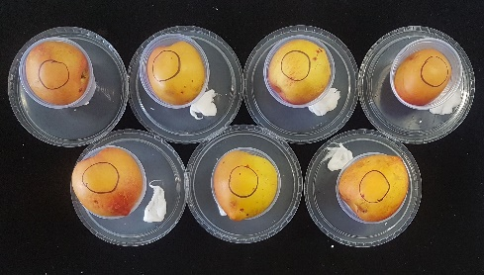 | Day 2  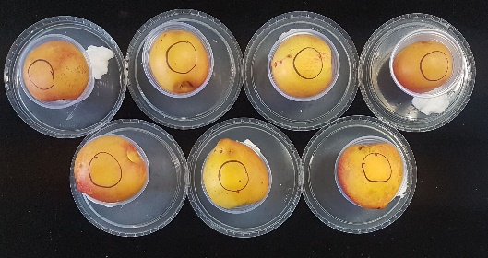 | Day 3  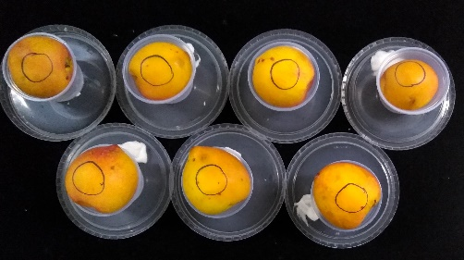 | Day 4  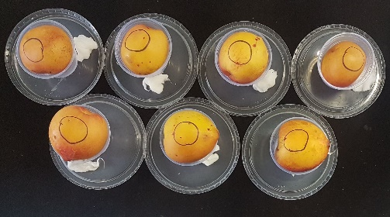
Day 5  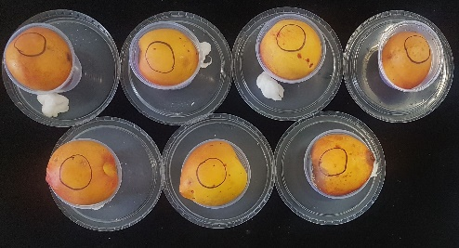 | Day 6  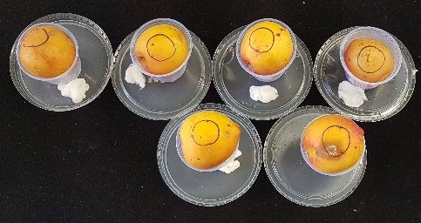 | Day 7
Fig. S4 – Inhibition tests of the fungus Monilinia fructicola for 7 days using (a) aqueous solution of eugenol, (b) iprodione fungicide, (c) control. (d) NCs without eugenol (e) Ne-LbL₁ and (f) Ne-LbL₂ NCs.

REFERENCES
(1) Shao, Y.; Wu, C.; Wu, T.; Li, Y.; Chen, S.; Yuan, C.; Hu, Y. Eugenol-Chitosan Nanoemulsions by Ultrasound-Mediated Emulsification: Formulation, Characterization and Antimicrobial Activity. Carbohydr. Polym. 2018, 193, 144–152. https://doi.org/10.1016/j.carbpol.2018.03.101.
(2) Yue, Y.; Zheng, L.; Wang, Y.; Wu, J.; Li, S.; Han, X.; Wu, L. A Novel Polyamidine-Grafted Carboxymethylcellulose : Flocculation Performance Test. Polymers (Basel). 2019, 19, 225–234.
(3) Woranuch, S.; Yoksan, R. Eugenol-Loaded Chitosan Nanoparticles: I. Thermal Stability Improvement of Eugenol through Encapsulation. Carbohydr. Polym. 2013, 96, 578–585. https://doi.org/10.1016/j.carbpol.2012.08.117.
(4) Hu, J.; Zhang, Y.; Xiao, Z.; Wang, X. Preparation and Properties of Cinnamon-Thyme-Ginger Composite Essential Oil Nanocapsules. Ind. Crops Prod. 2018, 122 (October 2017), 85–92. https://doi.org/10.1016/j.indcrop.2018.05.058.
(5) Zhang, H.; Zhao, Y. Preparation, Characterization and Evaluation of Tea Polyphenol-Zn Complex Loaded β-Chitosan Nanoparticles. Food Hydrocoll. 2015, 48, 260–273. https://doi.org/10.1016/j.foodhyd.2015.02.015.
(6) Thaipong, K.; Boonprakob, U.; Crosby, K.; Cisneros-Zevallos, L.; Byrne, D. Comparison of ABTS, DPPH, FRAP, and ORAC Assays for Estimating Antioxidant Activity from Guava Fruit Extracts. J. Food Compos. Anal. 2006, 19 (6–7), 669–675. https://doi.org/10.1016/j.jfca.2006.01.003.
(7) Das, S.; Singh, V. K.; Dwivedy, A. K.; Chaudhari, A. K.; Upadhyay, N.; Singh, P.; Sharma, S.; Dubey, N. K. Encapsulation in Chitosan-Based Nanomatrix as an Efficient Green Technology to Boost the Antimicrobial, Antioxidant and in Situ Efficacy of Coriandrum Sativum Essential Oil. Int. J. Biol. Macromol. 2019, 133, 294–305. https://doi.org/10.1016/j.ijbiomac.2019.04.070.

